Dialysis Frequency as a Determinant of Nutritional Status: Evidence on BMI and Bone Mass in Haemodialysis Patients

ABSTRACT
The frequency of haemodialysis sessions is an important determinant of the nutritional status of patients with end-stage renal disease. Among anthropometric indicators, body mass index (BMI) and body composition parameters estimated by bioelectrical impedance are commonly used to assess nutritional balance and the risk of morbidity and mortality. Several studies have reported that a higher dialysis frequency (≥ 3 sessions per week) improves uraemic toxin clearance, protein-energy metabolism, and chronic inflammation, thereby helping to stabilise BMI and preserve lean tissue. Conversely, reduced dialysis frequency is often associated with fluid overload, increased catabolism, and poor appetite, contributing to progressive undernutrition. This cross-sectional, descriptive study included 132 haemodialysis patients from several nephrology departments in Togo, with exhaustive sampling. BMI and body composition were measured using a ZOETOUCH impedancemeter scale. Results showed that a notable proportion of patients had low BMI, ranging from 7.63% to 10.69% across different durations of haemodialysis, without a clear trend with dialysis vintage. These findings suggest that dialysis frequency may contribute to better preservation of nutritional status, but its impact must be interpreted within a multidimensional framework that also accounts for diet quality, inflammation, and biochemical parameters
Key words: haemodialysis; frequency of dialysis; body mass index; nutritional status; chronic renal failure.
1.INTRODUCTION
Chronic renal failure (CRF) is a progressive disease characterised by irreversible loss of renal function (Bensaha, 2024), which often progresses to end-stage renal disease requiring renal replacement therapy. Haemodialysis remains the most widely used modality worldwide and the most accessible option in Togo (Djiguiba, 2023). Beyond its role in blood purification, haemodialysis has a major impact on patients’ nutritional and metabolic status (Chen et al., 2024). Anthropometric indicators such as body mass index (BMI) and estimates of body composition, although imperfect, are widely used to evaluate nutritional status and predict morbidity and mortality in this population (Dahel, 2020). Among the determinants of nutritional balance, dialysis frequency appears particularly influential: more frequent sessions promote better clearance of uraemic toxins, limit fluid overload and improve metabolic tolerance, thereby helping to preserve BMI and body composition (Jean et al., 2017). Conversely, insufficient dialysis frequency can exacerbate protein catabolism, reduce appetite, and favour protein-energy malnutrition, ultimately leading to a decline in BMI and body reserves (Fadlallah et al., 2025). However, interpretation of anthropometric data in haemodialysis patients remains challenging due to fluctuations in hydration status and alterations in body composition, requiring integration with biochemical and nutritional markers (Ruperto & Barril, 2023). In this context, studying the impact of dialysis frequency on BMI and body composition is essential to better understand the links between therapeutic management, nutritional status, and clinical prognosis in haemodialysis patients.
2. MATERIAL AND METHODS
2.1. Type and scope of the study
This was a cross-sectional and descriptive study of haemodialysis patients in the nephrology departments of a number of hospitals in Togo.
2.2. Study population
Patients suffering from chronic renal failure and receiving haemodialysis in the hospitals concerned.
Inclusion criteria
All haemodialysis patients who gave informed consent were included in this study.
Exclusion criteria
Patients with amputations or persistent massive oedema that could prevent anthropometric parameters from being measured were excluded.
Non-inclusion criteria
This study did not include haemodialysis patients who had not given their consent.
2.3. Sampling
Sampling technique
Sampling was exhaustive and included all patients with chronic kidney disease (CKD) undergoing haemodialysis treatment in the hospitals concerned.

2.4. Data collection technique for body mass index and bone mass
Height was measured using a measuring tape, with patients barefoot, heels together and head slightly extended.
Body mass index was assessed before the dialysis session using a ZOETOUCH impedancemeter scale. The patients, as light as possible, removed their shoes before stepping on the scale, placing their feet on the electrodes (one or two on each side). Data was recorded for each patient's age, height and sex. An electric current was then emitted by the sensors on one side (left or right) and recovered by those on the opposite side, after passing through the whole body. The results were displayed a few moments later on an Android smartphone connected to the scale via Bluetooth, and then recorded.
2.5. Data processing and analysis
Data were entered using Excel spreadsheets. The qualitative variables in proportion, mean and the test of correlation (ANOVA) between the variables were established for a value of p < 0.05 (significance threshold of 5%) using GraphPad Prism 10 software.
2.6. Ethical provisions
The study protocol was approved by the national ethics committee (opinion no. 034/2023/CBRS, 30 September 2022). Authorisations were also obtained from the administrative authorities of the participating health centres. The objectives and procedures of the study were clearly explained to haemodialysis patients and their accompanying relatives. Only patients who provided free and informed consent were included in the study sample. Data were collected confidentially and handled exclusively by the research team, with strict respect for anonymity. The main results were subsequently communicated to the participants in an appropriate manner.
3. RESULTS AND DISCUSSION
3.1. Results
Body mass index (BMI)
Among one hundred and thirty-two haemodialysis patients surveyed, the proportion with a low body mass index (BMI) was 9.16% for a haemodialysis duration < 1 year, 10.69% (1 to 2 years), 8.40% (2 to 3 years), 10.69% (3 to 4 years), 7.63% (4 to 5 years) and 10.69% (> 5 years). In contrast, the proportion of patients with a very high BMI was much lower: 1.53% for a duration of less than 1 year, and 0.76% for durations of 1 to 2 years, 2 to 3 years, 3 to 4 years and > 5 years. No cases of very high BMI were observed in patients with a haemodialysis duration of between 4 and 5 years (Table 1).

Table 1. Distribution of haemodialysis patients according to BMI
BMI | <1 year (%) | 1-2 years (%) | 2-3 years (%) | 3-4 years (%) | 4-5 years (%) | > 5 years (%)
Low (< 18,5) | 9.16 | 10.69 | 8.40 | 10.69 | 7.63 | 10.69
Normal (18,5 – 24,9) | 7.63 | 6.87 | 4.58 | 5.34 | 3.82 | 3.82
Low High (25 – 30) | 1.53 | 1.53 | 0.76 | 0.76 | 0.76 | 0.76
Very high (> 30) | 1.53 | 0.76 | 0.76 | 0.76 | 0.00 | 0.76
Bone mass (BM)
Among the haemodialysis patients surveyed, low bone mass was observed in 4.55% of patients in groups < 1 year and 2-3 years, 6.82% in groups 1-2 years and 3-4 years, 5.30% (4-5 years) and 7.58% (> 5 years). In contrast, high bone mass was found in 3.79% of patients in the < 1 year group, 1.52% (2-3 years), 0.76% (3-4 years), and no cases (0.00%) in the 1-2 years, 4-5 years and > 5 years groups (Table 2).

Table 2. Distribution of haemodialysis patients according to BM
BM (%) | < 1 year (%) | 1-2 ans (%) | 2-3 years (%) | 3-4 years (%) | 4-5 years (%) | > 5 years (%)
Low (<3,5) | 4.55 | 6.82 | 4.55 | 6.82 | 5.30 | 7.58
Normal (3,5- 5) | 12.12 | 12.88 | 8.33 | 9.85 | 6.82 | 8.33
High (>5) | 3.79 | 0.00 | 1.52 | 0.76 | 0.00 | 0.00

Average values for BMI and bone mass in the study population
In the population studied, the mean value of the body mass index (BMI) associated with malnutrition was 15.00 ± 1.00. Of these patients, 12.67 ± 0.71 had a low BMI and 1.00 ± 0.26 a very high BMI. With regard to bone mass, the mean value associated with malnutrition was 9.17 ± 0.60, of which 7.83 ± 0.70 corresponded to low bone mass and 1.33 ± 0.80 to high bone mass (Figures 1 and 2).
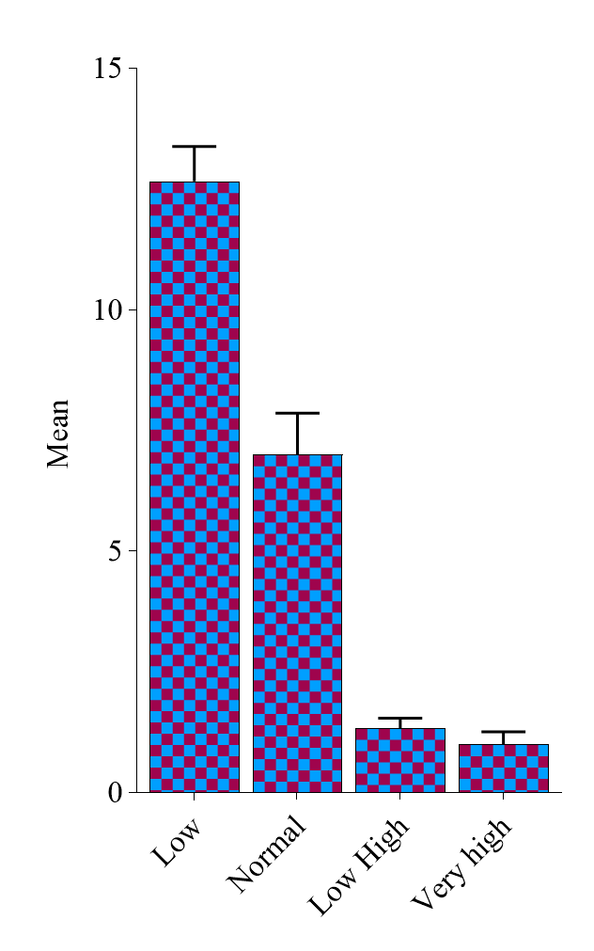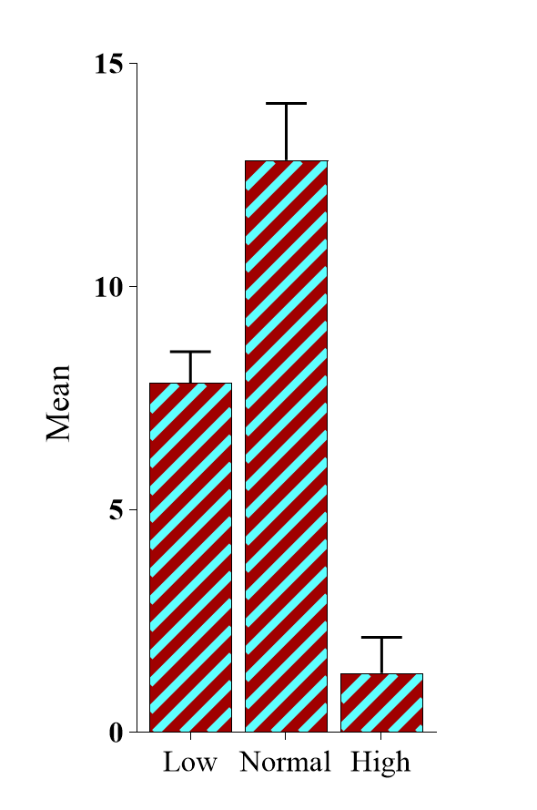
Figure 2: Mean value of malnutrition according to BM

Figure 1: Mean value of malnutrition according to BMI

Comparison between dialysis frequency and body mass index and bone mass
The analysis of variance (ANOVA) performed to assess the effect of frequency of dialysis sessions on body mass index (BMI) and bone mass (BM) showed no statistically significant difference (p > 0.05), as shown in Table 3.
Table3. Comparison between dialysis frequency and body mass index and bone mass
Tests statistiques | Body mass index (Kg/m2) | Bone mass (%)
ANOVA | 0.081 (p>0.05) | 0.10 (p>0.05)

3.2. Discussion
Body mass index (BMI)
A BMI below 18.5 kg/m² was found in more than half of the haemodialysis patients (52.38%), suggesting a high prevalence of protein-energy malnutrition in this population (Jiang et al., 2023), consistent with previous findings (Kalantar-Zadeh et al., 2010). This condition is likely multifactorial, combining uraemia-induced anorexia, dietary restrictions, chronic inflammation, metabolic acidosis, and protein losses during dialysis (Kovesdy & Kopple, 2001 ; Fouque et al., 2008). Malnutrition showed a slight male predominance (28.57% vs. 23.81%), which may be related to hormonal, metabolic, or behavioural differences (García-Montero et al., 2022). Conversely, obesity (BMI > 30 kg/m²) was present in 9.52% of patients, equally distributed between men and women. This prevalence may reflect associated comorbidities such as diabetes, hypertension, or cardiovascular disease (Djaouida, 2024). Interestingly, a higher BMI can sometimes be associated with greater nutritional reserves and attenuated inflammation, consistent with the so-called “obesity paradox” in dialysis populations (Kalantar-Zadeh et al., 2005).
Average values for BMI and estimated bone mass.
Mean BMI and estimated bone mass values in our population reflect nutritional and metabolic disturbances common in haemodialysis patients (Wung et al., 2021). Low BMI is indicative of frequent undernutrition (Batool et al., 2015), whereas high values illustrate the double burden of obesity (Mère, 2025). Similarly, reduced bone mass may signal mineral loss linked to disordered phosphate–calcium metabolism (Philippoteaux et al., 2025), while elevated values could reflect renal osteodystrophy (Lafage-Proust, 2025). These findings emphasise the need for integrated management combining nutritional monitoring with correction of mineral and bone metabolism disorders (Delarue, 2021).
Dialysis frequency, BMI, and bone mass.
No significant association was observed between dialysis frequency and BMI or bone mass. This suggests that simply increasing the number of weekly sessions does not guarantee improved nutritional status or body composition. Indeed, these parameters are influenced by numerous other factors such as dietary intake, inflammation, age, physical activity, and dialysis vintage, which may attenuate the direct effect of dialysis frequency (Rinonapoli et al., 2021). While more frequent dialysis may enhance uraemic clearance and fluid balance, its nutritional benefits remain debated (Stuard et al., 2024). Some studies report stable BMI regardless of dialysis frequency (Moores et al., 2018), whereas others show improvements when combined with dietary support (Bose et al., 2019). In our cross-sectional context, the absence of a difference likely reflects the multifactorial complexity of undernutrition and bone alterations in this population rather than a lack of physiological effect (Diagne, 2024). This underscores the need for a multidimensional approach that includes nutritional counselling, supplementation, and correction of metabolic disorders alongside optimisation of dialysis regimens (Awan et al., 2025).
4.CONCLUSION
The present study did not reveal any statistically significant relationship between dialysis frequency and the body mass index (BMI) or estimated bone mass (BM) of haemodialysis patients. These findings suggest that no significant variation in BMI and BM occurs with dialysis frequency, and that these indicators, although widely used, may not adequately reflect the complex nutritional alterations commonly observed in this population. The absence of association does not imply that dialysis has no impact on nutritional status, but rather highlights the limitations of relying solely on BMI and BM. It is therefore essential to complement these parameters with more specific anthropometric and biochemical markers to better assess nutritional status and to detect imbalances related to haemodialysis treatment at an early stage.

Authors’ contributions
This manuscript investigates how dialysis frequency affects nutritional status, specifically body mass index (BMI) and bone mass (BM), in haemodialysis patients with end-stage renal disease. Highlighting nutrition's vital role in patient outcomes, the study provides valuable data from Togo, adding geographic diversity to existing research. Findings reveal malnutrition’s complex, multifactorial nature, stressing that dialysis frequency alone does not determine nutritional status. This underscores the importance of comprehensive, individualized care approaches to improve management in this vulnerable population. Authors MM & AKS: Conceived and designed the study, supervised the experimental work, and contributed to data analysis and interpretation. Authors MM & KS: Collected and analyzed the data, drafted the manuscript, and coordinated its revisions. Authors KS, MM & AKS: Contributed to the literature review, assisted in the experimental procedures, and participated in the critical revision of the manuscript.

DISCLAIMER (ARTIFICIAL INTELLIGENCE)
Author(s) hereby declares that NO generative AI technologies such as Large Language Models (ChatGPT, COPILOT, etc.) and text-to-image generators have been used during the writing or editing of this manuscript.
REFERENCES
Lanasri, S., Oussama, B., Boukhalfa, S., Chourak, M., Saoud, Z., & Hadjoudj, O. (2024). Prevalence of malnutrition according to HAS criteria in elderly hemodialysis patients over 70 years of age in the Algiers region. NPG Neurologie-Psychiatrie-Gériatrie, 24(141), 155-160.
Djiguiba, Y. S. O. (2023). Quality of Life in Chronic Hemodialysis Patients in the Nephrology and Hemodialysis Department of the Point G University Hospital.
Wandji Ngueyep, M. D. (2024). Epidemiology of Chronic Kidney Disease in the Nephrology and Hemodialysis Department of the Point G University Hospital.
Manel, H. A. M. A. N. A. C. H. E., & Chahinez, B. O. U. G. U. E. D. A. D. (2023). Lipid Abnormalities in Three Patient Categories: Hemodialysis, Continuous Ambulatory Peritoneal Dialysis, and Kidney Transplant Patients.
Djaouida Kerbi, D. K. (2024). Obesity Profile in the Hemodialysis Population: Prevalence Study and Multifactorial Analysis. Algerian Journal of Medical and Health Research, 3(3), 55-66.
Kalantar-Zadeh K, Abbott KC, Salahudeen AK, Kilpatrick RD, Horwich TB. (2005). Survival advantages of obesity in dialysis patients: a possible explanation for the obesity paradox. Am J Clin Nutr. 81(3):543–554.
Dahel, C. C. (2020). Assessment of the nutritional status of adults: Case of undernutrition. Nutrition & Health, 9(2), 52-73.
Ketteler, M., Block, G. A., Evenepoel, P., Fukagawa, M., Herzog, C. A., McCann, L., ... & Leonard, M. B. (2017). Executive summary of the 2017 KDIGO Chronic Kidney Disease–Mineral and Bone Disorder (CKD-MBD) Guideline Update: what’s changed and why it matters. Kidney International, 92(1), 26-36.
Jean, G., Daugas, É., Roth, H., Drueke, T., Bouchet, J. L., Hannedouche, T., ... & Fouque, D. (2017). The management of mineral and bone metabolism disorders before the dialysis stage still remains perfectible. Based on data from the National Observatory of Mineral and Bone Metabolism Photo-Graphe. Nephrology & Therapeutics, 13(6), 470-478.
Kalantar-Zadeh, K., Streja, E., Kovesdy, C. P., Oreopoulos, A., Noori, N., Jing, J., ... & Anker, S. D. (2010, November). The obesity paradox and mortality associated with surrogates of body size and muscle mass in patients receiving hemodialysis. In Mayo Clinic Proceedings (Vol. 85, No. 11, pp. 991-1001). Elsevier.
Bensaha, H. (2024). CHRONIC KIDNEY FAILURE IN DIABETICS IN THE GHARDAIA REGION.
Kovesdy CP, Kopple JD. (2001). Effect of nutritional supplementation on mortality in malnourished hemodialysis patients. Am J Kidney Dis. 38(5):988–996.
Fouque, D., Kalantar-Zadeh, K., Kopple, J., Cano, N., Chauveau, P., Cuppari, L., ... & Wanner, C. (2008). A proposed nomenclature and diagnostic criteria for protein–energy wasting in acute and chronic kidney disease. Kidney International, 73(4), 391-398.
Diagne, N. K. (2024). Mineralo-bone disorders in chronic hemodialysis patients at the Ziguinchor Regional Hospital.
Nora, B. E. N. A. I. C. H. E. T. A. (2025). Biological assessment of metabolic risks in hemodialysis patients (Doctoral dissertation, Department of Biological Sciences).
Mère, P. (2025). Clinical assessment of obesity. Practical clinical nutrition: In adults, children, and the elderly, 27(97), 266.
Philippoteaux, C., Paccou, J., Chazard, E., & Cortet, B. (2025). Proton pump inhibitors, bone and phosphocalcic metabolism. Rheumatism Review.
Lafage-Proust, M. H. (2025). Mineral and bone disorders in chronic kidney disease. Revue Francophone des Laboratoires, 2025(569), 20-27.
Delarue, J. (2021). Nutrition: Integrated Teaching - Nutrition EU. Elsevier Health Sciences.
Chen, Z. Q., Luo, L., Chen, X. X., Zhang, X. Y., Yin, S. Q., Xiao, G. H., ... & Su, C. Y. (2024). Dietary nutrient intake and nutritional status in maintenance hemodialysis patients: a multicenter cross-sectional survey. Renal Failure, 46(2), 2363589.
Fadlallah, H., El Masri, D., Bahmad, H. F., Abou-Kheir, W., & El Masri, J. (2025). Update on the Complications and Management of Liver Cirrhosis. Medical Sciences, 13(1), 13.
Ruperto, M., & Barril, G. (2023). Clinical significance of nutritional status, inflammation, and body composition in elderly hemodialysis patients—A case–control study. Nutrients, 15(24), 5036.
Jiang, W., Zhao, Y., Wu, X., Du, Y., & Zhou, W. (2023). Health inequalities of global protein-energy malnutrition from 1990 to 2019 and forecast prevalence for 2044: data from the Global Burden of Disease Study 2019. Public Health, 225, 102-109.
García-Montero, C., Ortega, M. A., Alvarez-Mon, M. A., Fraile-Martinez, O., Romero-Bazán, A., Lahera, G., ... & Álvarez-Mon, M. (2022). The problem of malnutrition associated with major depressive disorder from a sex-gender perspective. Nutrients, 14(5), 1107.
Wung, C. H., Chung, C. Y., Wu, P. Y., Huang, J. C., Tsai, Y. C., Chen, S. C., ... & Chang, J. M. (2021). Associations between metabolic syndrome and obesity-related indices and bone mineral density T-score in hemodialysis patients. Journal of Personalized Medicine, 11(8), 775.
Batool, R., Butt, M. S., Sultan, M. T., Saeed, F., & Naz, R. (2015). Protein–energy malnutrition: a risk factor for various ailments. Critical reviews in food science and nutrition, 55(2), 242-253.
Rinonapoli, G., Pace, V., Ruggiero, C., Ceccarini, P., Bisaccia, M., Meccariello, L., & Caraffa, A. (2021). Obesity and bone: a complex relationship. International journal of molecular sciences, 22(24), 13662.
Stuard, S., Ridel, C., Cioffi, M., Trost-Rupnik, A., Gurevich, K., Bojic, M., ... & Arkossy, O. (2024). Hemodialysis procedures for stable incident and prevalent patients optimize hemodynamic stability, dialysis dose, electrolytes, and fluid balance. Journal of Clinical Medicine, 13(11), 3211.
Moores, C. J., Bell, L. K., Miller, J., Damarell, R. A., Matwiejczyk, L., & Miller, M. D. (2018). A systematic review of community‐based interventions for the treatment of adolescents with overweight and obesity. Obesity Reviews, 19(5), 698-715.
Bose, I., Baldi, G., Kiess, L., & de Pee, S. (2019). The “Fill the Nutrient Gap” analysis: An approach to strengthen nutrition situation analysis and decision making towards multisectoral policies and systems change. Maternal & child nutrition, 15(3), e12793.
Awan, A. A. Y., Anumudu, S. J., Alghafir, E. B., & Navaneethan, S. D. (2025). Integrative Approach to Chronic Kidney Disease. In Nutrition, fitness, and mindfulness: An evidence-based guide for clinicians (pp. 349-360). Cham: Springer Nature Switzerland.

