Post-Harvest Preservation of Dessert Bananas Using Rapeseed and Olive Oil-Based Wax in Côte d’Ivoire

ABSTRACT
In Côte d'Ivoire, dessert bananas account for 8-10% of agricultural gross domestic product (GDP), 3-4% of national GDP and directly employ 11,000-12,000 people. It is the leading fresh fruit export, accounting for around 95% of production. This makes the country the leading African supplier to the European Union market. However, many losses, estimated at between 30% and 70%, due to export conditions and post-harvest diseases, have been noted on a regular basis. With the aim of proposing a solution to minimise these losses, a trial on the effectiveness of wax based on a proportional mixture of rapeseed and olive vegetable oil (100g/l) was carried out to provide solutions linked to the quality requirements of fruit for export. The aim of this study was to evaluate the effectiveness of different doses of wax (with or without fungicide) for better post-harvest preservation of dessert bananas. The experiments were carried out in a randomised complete block design with 9 treatments and 5 replications. Fruits of the 'Grande naine ' variety were treated either by spraying/or soaking. The fruit was kept in a cold room for 20 days before being removed and exposed to room temperature for 10 days. Parameters such as green life (GLS), fresh mass, pH, titratable acidity and crown rot disease were assessed every 5 days. The data collected was analysed using Statistica version 7.1 software. The results showed that treatments T1T (Fungicide + 5% rapeseed and olive wax applied by dipping) and T1P (Fungicide + 3% rapeseed and olive wax applied by spraying) were the most effective. These treatments maintained a very long DVV for up to 30 days, with no adverse effect on mass or firmness. In addition, the coating on the banana had no detrimental effect on the physicochemical change in the pulp of the treated fruit. On the other hand, the occurrence of anthracnose symptoms for treatments T2T (Fungicide + 7% rapeseed and olive wax applied by soaking) and T5T (Fungicide + 5% rapeseed and olive wax applied by soaking) was higher, with values of 100% and 80% respectively. The application of wax, either by soaking or by spraying, may be recommended in Côte d'Ivoire for the post-harvest preservation of dessert bananas.

Keywords: Vegetable oil, Rapeseed, Olive, Banana, Preservation, Post-harvest, Ivory Coast

INTRODUCTION
The dessert banana (Musa spp.) is a perennial monocotyledonous plant of the Musaceae family whose fruits are widely consumed in Central and West Africa [1]. It is native to Southeast Asia, and its cultivation has migrated to India, East Africa, the Pacific Islands, the Caribbean and South America. It contributes significantly to food security, job creation, income diversification in rural and urban areas, gross domestic product (GDP) and, in doing so, to the fight against poverty. In Côte d'Ivoire, dessert banana production was estimated at around 450,000 tonnes in 2020. It represents approximately 8 to 10% of agricultural GDP, 3 to 4% of national GDP and directly employs 11,000 to 12,000 people [2]. Dessert banana is Côte d'Ivoire's leading fresh fruit export. An estimated 95% of its production is exported, making the country the leading African supplier of Cavendish dessert bananas to the European Union market [3]. The fruit is usually harvested when mature and unripe for commercial use and refrigerated during transportation to the importing nations. Upon arrival at their destination, the green bananas are held in modified atmospheric rooms at the distribution centers, where they are treated with chemicals like ethylene gas before selling. By lowering the metabolic rate, minimising peel degreening, and preventing fruit degradation, several other preservation techniques have been investigated, such as regulated and controlled atmospheres (Ngoko Tchamba et al., 2024; Cooper et al., 2025). However, post-harvest loss of fresh fruit is one of the problems in tropical regions. Fruit perishability is attributed to adverse physiological changes, namely, weight loss due to respiration and transpiration, softening of the flesh and lack of resistance to microbial attacks on the flesh. Exported bananas must meet European market standards in terms of mass, fruit taste quality and health status [4, 5]. However, despite the application of fungicides and other preservatives, numerous losses estimated between 30 and 70% due to post-harvest diseases have been repeatedly observed. There are recurrent post-harvest diseases such as fruit crown rot. This disease manifests itself as softening of the infected tissue, accompanied by blackening. They are caused by the main fungal complex species Colletotrichum musae, Botryodiplodia theobromae and Fusarium sp (Didier et al., 2025). In addition, residues of some active substances are detected in various food products, sometimes at quantities exceeding the maximum residue limits (MRLs) set by the Codex Alimentarius [6]. These products have a carcinogenic effect on humans, are the cause of the emergence of resistant pathogenic strains, and constitute a source of environmental pollution [7, 8]. In order to limit the significant losses caused by post-harvest diseases of dessert bananas and in the interest of respecting human health and the environment, it is therefore preferable to adopt new methods of post-harvest preservation of fruits. Previously, similar work was carried out by [9]. Their results showed that wax is very effective for the post-harvest preservation of pineapple. It is in this context that this test was conducted in a cold room at the University Félix HOUPHOUET-BOIGNY. The objective of this study is to evaluate the effectiveness of vegetable oil based on rapeseed and olive (100g/l) for better post-harvest preservation of bananas. Specifically, it was a question of: (i) evaluating the effect of different doses of vegetable oil based on rapeseed and olive (100g/l) on the green life (GLL) of dessert bananas, (ii) determining the impact of vegetable oil based on rapeseed and olive (100g/l) on the titratable acidity, pH and soluble sugar content and on the loss of mass and firmness of dessert bananas and (iii) evaluating the impact of the effect of vegetable oil based on rapeseed and olive (100g/l) on the health status of dessert banana crowns.

Material

Plant material
The trials were conducted with the dessert banana of the Grande Naine (Cavendish) variety. The bananas used were harvested at 12 weeks of age. The bunches used consisted of 10 fingers.

Tested preservation products
All fruits were previously treated with citric acid (50g/L of water), which is a reference product. The mixture of vegetable oil based on rapeseed and olive (100g/l) was used at different doses for the treatment of dessert bananas. These two oils were used in equal proportions, i.e. 50%. ENERPACK 40 SP, whose active ingredient is gibberellic acid, approved in Ivory Coast, was used as a reference control.

Technical equipment
During this study, the equipment used for the different treatments consisted of a graduated cylinder for measuring the quantities of products to be sampled. A precision balance was used to weigh the products and the bunches of dessert bananas. The immersion blender (STPE-871 P) was used for homogenising the slurry. The firmness of the bananas was determined using a hand-held crossbow-type penetrometer, and then the refractometer was used to determine the Brix of the bananas.

Methodology

Experimental site
The treatments took place on the agricultural perimeter of the Société de Cultivation Bananière (SCB), precisely at the Tiassalé packing station. The treated boxes were then transported to the Félix HOUPHOUET-BOIGNY University. They were stored in a cold room at a temperature maintained at 14 °C.
Preparation of porridges and applications
The randomised complete block experimental design was used with 5 replications (Figure 1). Previously, all fruits were treated with citric acid (50g/L of water). In total, 9 treatments were tested, namely:
- Three (03) doses coded T1P, T2P and T3P: designating the application by spraying of vegetable oil based on Rapeseed and Olive (100g/l) at the doses of 5%, 10% and 12% respectively;
- Three doses T1T, T2T and T3T: designating the soaking of the bouquets in solutions of vegetable oils based on Rapeseed and Olive (100g/l) at 3%, 7% and 9% respectively;
- T5P treatment refers to spray treatment with synthetic fungicide only, without the application of vegetable oils and the reference control;
- Two controls were used: the reference control (T4), designating the application of ENERPACK at 1500 ppm by dipping, commonly used, whose active ingredient is gibberellic acid and the control negative (T0), designating the banana bunches not treated by application (Table I).
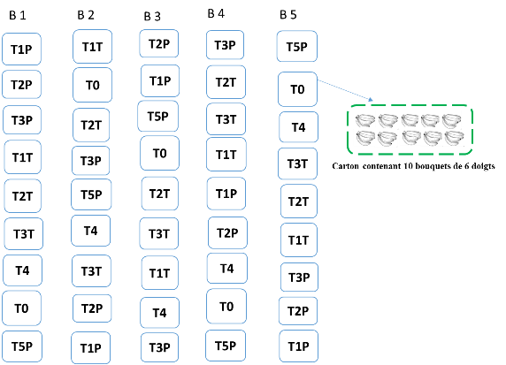
Figure 1: Diagram of the experimental device
Table I: List of treatments
Codification | Definition of treatments | Treatments
T0 | Fungicide only | Witness
T4 | Fungicide +ENERPACK at 1500 ppm | Reference products
T1P | Fungicide + Vegetable oils (Rapeseed + Olive (100g/l)) at 5% | Spray-applied wax
T2P | Fungicide + Vegetable oils (Rapeseed + Olive (100g/l)) at 10% | Spray-applied wax
T3P | Fungicide + Vegetable oils (Rapeseed + Olive (100g/l)) at 12% | Spray-applied wax
T1T | Fungicide + Vegetable oils (Rapeseed + Olive (100g/l)) at 3%; | Wax applied by dipping
T2T | Fungicide + Vegetable oils (Rapeseed + Olive (100g/l)) at 7% | Wax applied by dipping
T3T | Fungicide + Vegetable oils (Rapeseed + Olive (100g/l)) at 9%; | Wax applied by dipping
T5T | Vegetable oils (Rapeseed + Olive (100g/l)) at 5% without fungicide; | Wax applied by dipping
Conducting the trial
The treatments were carried out with 50 bouquets of 6 fingers distributed in 5 boxes. The preparation of the different doses of slurries was carried out by mixing in a volume of 10 l of water. The slurries were then homogenized using an STPE-871P immersion blender according to the method described by [10] . All the boxes of the T1T, T2T, T3T and T5T treatments were treated by soaking the bouquets in the slurry for 2 min. As for the T1P, T2P and T3P treatments, they were carried out by spraying using a backpack sprayer. Regarding T4, it was treated with ENERPACK at 1500 ppm, whose active ingredient is gibberellic acid; it was applied according to the standard application method. Also, cartons previously treated with the fungicide and not treated with vegetable oil based on rapeseed and olive (100g/l), nor with ENERPACK served as a control (T0). The bananas were placed on plastic shelves at room temperature for 30 minutes before being packaged in export packaging. The cartons were transported and stored in a cold room at 14 °C for 20 days to simulate the duration of maritime transport to Europe at the University Félix HOUPHOUET-BOIGNY. The cartons were identified with clear, indelible and precise marking. The mass of each batch of fruit was determined before being placed in the cold room.

Green Lifespan Assessment (GLA)
During the time the cartons were stored in the cold room, six observation periods were carried out with an interval of 5 days. The evaluation started from the 5th day of packaging until the "green turning" stage, corresponding to the onset of the climacteric crisis according to the methodology described by [11]. The proportion of green (unripe) bananas at the different observation dates was determined for each treatment. The Green Life of bananas was defined by calculating the time elapsed between harvest and this stage. Then, after 20 days of storage in the cold room, the bananas were removed from the room and kept in an air-conditioned room whose temperature was maintained at 17°C. They were exposed for a period of 10 days. The DDV evaluations were still carried out every 2 days.

Assessment of Mass Loss and Firmness
The observations and evaluations were carried out at the exit of the cold room at a temperature of 14°C, i.e. 20 days and 10 days in an air-conditioned room with a temperature of 17°C. The mass loss was determined by making the ratio of the mass of the bunches at the entrance and at the exit in the different packaging rooms. A penetrometer of the "Arbalète" type with a tip measuring 1 cm long and 0.5 cm in diameter was applied to the skin or the pericarp of the bananas. The resistance to the penetration force of the tip in the pulp, which represents the penetrometric hardness or the firmness of the fruit, is noted and expressed in kilograms per square centimetre (kg/cm²). The measurement was made at 4 points (2 on the lateral side, one dorsal and one ventral), and the average of the measurements was calculated for each fruit.

Titratable acidity, pH and soluble sugar content
The external quality of the fruits that was taken into account in this study concerned the skin colour of the dessert bananas [12]. Observations were made during the 20 days of storage and upon removal from the cold room, and during 10 days of storage at room temperature. The soluble solids content of each juice was measured using a PR1-ATAGO digital refractometer. To do this, a few drops of banana juice were poured onto the surface of the prism. The brix value was read directly on the screen. It indicates the content of soluble sugars in the banana juice in grams of sucrose per 100 ml of extract. The soluble solids content also corresponds to the refractometric index (RI) according to the method of [13]. The pH and titratable acidity were determined according to the methodology described by [14]. A quantity of 10 g of sample was diluted in 100 ml of distilled water, and then the mixture was filtered through filter paper (Whatman). A direct reading of the pH was taken from the collected filtrate using a Benchtop pH meter /mV meter (210). Titratable acidity was assessed using 10 ml of the filtrate. The solution was titrated with NaOH solution (0.1N) in the presence of 3 drops of phenolphthalein until it turned pink. The titratable acidity was determined according to the following relationship:$T (meq/100g) =\frac{N × Veq × 10000}{me × V0}$
V0: volume (mL) of the test sample; Veq: volume (mL) of NaOH (0.1 N) poured at equivalence; me: mass (g) of the sample; N: normality of the NaOH solution (0.1 N); AT: Titratable Acidity

Health status of the bouquets
The antifungal activity of the test product was studied by counting the number of fruits infected by crown rot attacks. Observations were made when the fruits were removed from the cold room and every other day for 10 days. The symptoms appearing on the fruits were described. The nature of the rot and the extent of damage to the fruits were carefully estimated according to the method of [15].

Data analysis
Statistica V 7.1 software was used for statistical analyses of the efficacy of the nine (9) treatments. The normal distribution and homogeneity of the data relating to the efficacy of the treatments were verified by performing the Shapiro-Wilk and Levene tests. A series of analysis of variance (ANOVA) tests was performed; in case of significant differences, the Newman-Keuls post hoc test was used to separate the means at a 5% level. A principal component analysis (PCA) was performed to distinguish the treatment groups according to all the parameters.
RESULTS AND DISCUSSION

Effect of treatments on fruit mass and firmness
Data analysis showed a significant difference between treatments for banana mass at entry and exit. Treatments T1T (Fungicide + Rapeseed and Olive Vegetable Oil (100g/l)) and T3P (Fungicide + Rapeseed and Olive Vegetable Oil (100g/l)) had the highest average mass at entry of the fruits, with respective masses of 12420.8 g and 12369.2 g per box. The same treatments had the highest masses at exit with an average loss estimated at 625.4 g per box (T3P). The lowest masses at entry were noted for T3T (Fungicide + Rapeseed and Olive Vegetable Oil (100g/l)) and the Control (T0), with respectively 10912.0 g and 10615.80 g per box. These treatments had output masses ranging between 10210.40 g and 10497.80 g per carton (Table II).
Table II: Mass at entry and exit of fruits according to treatments
Treatment | Input mass (g) | Mass at outlet (g) | Mass Loss (g) | Loss rate (%)
T0 | 10615.80±243.75b | 10210.40±272.3b | 405.4c | 3.82b
T4 | 11910.60±337.8ab | 11420.60±318.7ab | 490.0bc | 4.11ab
T1P | 11902.20±348.3ab | 11454.00±329.9ab | 448.2 | 3.77b
T2P | 11891.40±176.4ab | 11432.20±302.0ab | 459.2bc | 3.86b
T3P | 12369.20±158.1a | 11743.80±95.3a | 625.4a | 5.05a
T1T | 12420.80±293.0 a | 11969.80±311.5a | 451.0bc | 3.63b
T2T | 11454.40±284.9ab | 10921.80±283.0ab | 532.6b | 4.65ab
T3T | 10912.00±434.0b | 10497.80±413.7b | 414.2c | 3.80b
T5T | 11774.20±365.3ab | 11220.20±425.6ab | 554.0b | 4.71ab
Average | 11694.51 | 11207.84 | 486.67bc | 4.16ab
P | 0.001 | 0.03 | 0.021 | 0.031
T0: Fungicide only, T1T: Fungicide + Vegetable oils (Rapeseed + Olive (100g/l)) TM at 3%; T2T: Fungicide + Vegetable oils (Rapeseed + Olive (100g/l)) at 7%; T3T: Fungicide + Vegetable oils (Rapeseed + Olive (100g/l) at 9%; T4: Fungicide + ENERPACK 40 SP at 1500 ppm; T1P: Fungicide + Vegetable oils (Rapeseed + Olive (100g/l)) at 5%; T2P: Fungicide + Vegetable oils (Rapeseed + Olive (100g/l)) at 10%; T3P: Fungicide + Vegetable oils (Rapeseed + Olive (100g/l)) at 12%; T5T: Vegetable oils (Rapeseed + Olive (100g/l)) at 5%;

The treatments had no significant effect on fruit firmness. Overall, this firmness was decreasing throughout the duration of the experiment (Figure 2). However, the T5T treatment (Fungicide + rapeseed and olive vegetable oil (100g/l) at 5% applied by) induced lower firmness. The establishment of appropriate storage conditions is one of the most important methods to reduce post-harvest losses in export bananas. These results demonstrate that the application of the product would reduce fruit transpiration. The effect of coatings on limiting fruit weight loss suggests that the transpiration rate is reduced by blocking lenticels [16] and by inhibiting the respiratory intensity of fruits. Indeed, the coatings reduced gas exchange of fruits as well as weight loss during storage [17]. Furthermore, according to the work of [18], the decrease in weight loss of coated fruits can be attributed to the gas diffusion barrier properties of stomata, organs that regulate the process of transpiration and gas exchange between the fruit and the environment.

T0: Fungicide only, T1T: Fungicide + Vegetable oils (Rapeseed + Olive (100g/l)) TM at 3%; T2T: Fungicide + Vegetable oils (Rapeseed + Olive (100g/l)) at 7%; T3T: Fungicide + Vegetable oils (Rapeseed + Olive (100g/l) at 9%; T4: Fungicide + ENERPACK 40 SP at 1500 ppm; T1P: Fungicide + Vegetable oils (Rapeseed + Olive (100g/l)) at 5%; T2P: Fungicide + Vegetable oils (Rapeseed + Olive (100g/l)) at 10%; T3P: Fungicide + Vegetable oils (Rapeseed + Olive (100g/l)) at 12%; T5T: Vegetable oils (Rapeseed + Olive (100g/l)) at 5%;
Figure 2: Evolution of the firmness of treated fruits
Effect of treatments on titratable acidity, pH and soluble sugar levels
Fruit treatments had no significant effect on titratable acidity. Titratable acidity values ranged from 12.20 to 14 mEq.10 ⁻² g on day 30. ^{On} day 30, these values ranged from 12.33 and 15 mEq.10 ⁻² g. At the pH level, the analysis did not reveal any significant difference. The values obtained ranged between 6.65 and 6.73 (Figure 3 and Table III). The treatments also did not influence the soluble sugar level between the 30th and 33rd day (Table IV). The soluble sugar levels fluctuated between 17.6° and 19.4° on the 30th ^{day} and between 18.4 and 19.6° on the 33rd ^{day}. On the 30th ^{day}, the sugar levels obtained were significantly influenced by the treatments. Treatments T4 (20.4), T0 (20) and T1P (20.4) had the highest soluble sugar levels. On the other hand, treatment T3P (17.4) had the lowest soluble sugar level. The soluble sugar level changed. The increase was greater in the control and T1T with respective changes of 2 and 1.6° Brix (Table V). The methods used induced good fruit firmness and almost constant levels of acidity, soluble sugars and pH (6-7) throughout the experiment. The increase in reducing sugar can be attributed to the enzymatic conversion of starch into reducing sugar [18]. According to [19], titratable acidity increased from 1.75 to 2.06% during development. During ripening, pH increases and acidity decreases by conversion of acids into salts [20]. Moreover, this phenomenon is explained by the rapid loss of citric acid associated with a slight decrease in the amount of malic acid [21].

30e jour
33e jour
Figure 3: Average acidity level depending on the treatments

Table III : pH of bananas according to treatments
Treatments | D1 | D2
T0 | 6.72±0.06a | 6.66±0.01a
T1T | 6.65±0.02a | 6.64±0.03a
T2T | 6.69±0.08a | 6.68±0.05a
T3T | 6.66±0.06a | 6.69±0.07a
T1P | 6.67±0.03a | 6.73±0.005a
T2P | 6.72±0.07a | 6.71±0.06a
T3P | 6.66±0.07a | 6.70±0.03a
T4 | 6.65±0.08a | 6.62±0.06a
T5T | 6.70±0.07a | 6.69±0.04a
P | 0.052 | 0.061

Table IV. Soluble sugar levels and ° Brix depending on the treatments

Treatments | Soluble sugar levels at D-30 | Soluble sugar levels at D-33 | Soluble sugar levels at D-35 | ° Brix
T4 | 19.4±0.8a | 19.4±0.89a | 20.4±0.5a | 1.0a
T0 | 18±2.3a | 19.6±0.89a | 20.0±0.0a | 2.0a
T2P | 18.8±1.6a | 18.8±2.16a | 18.84±2.07ab | 0.4c
T1T | 17.6±1.8a | 18.4±1.67a | 19.2±1.09ab | 1.6b
T3P | 17.4±2.0a | 19.6±0.89a | 17.4±2.3b | 0.0c
T3T | 18.8±1.0a | 18.6±0.54a | 18.84±2.0ab | 0.4c
T2T | 18.8±1.0a | 18.6±1.34a | 18.84±1.6ab | 0.4c
T5T | 19.2±0.8a | 19.4±1.9a | 19.80±1.3ab | 0.6c
T1P | 19.2±1.0a | 19.0±1.0a | 20.4±0.8a | 1.2a
P | 0.211 | 0.122 | 0.022 | 0.042

Table V. Proportion of green bouquets as a function of time

Treatments | % of green bouquet on D10 | % of green bouquet on D15 | % of green bouquet at D20 | % of green bouquet at D25 | % of green bouquet at D30 | % of green bouquet at D35
T0 | 100a | 100a | 100a | 100a | 22.0b | 0.0a
T1 P | 100a | 100a | 100a | 100a | 54.0a | 0.0a
T2 P | 100a | 100a | 100a | 100a | 8.0c | 0.0a
T3 P | 100a | 100a | 100a | 100a | 14.0bc | 0.0a
T1 T | 100a | 100a | 100a | 100a | 24.0b | 0.0a
T2 T | 100a | 100a | 100a | 100a | 18.0bc | 0.0a
T3 T | 100a | 100a | 100a | 100a | 30.0b | 0.0a
T4 | 100a | 100a | 100a | 100a | 58.0a | 0.0a
T5 T | 100a | 100a | 100a | 88b | 26.0b | 0.0a
P | 0.061 | 0.071 | 0.021 | 0.081 | 0.003 | 0.002
T0: Fungicide only, T1T: Fungicide + Vegetable oils (Rapeseed + Olive (100g/l)) TM at 3%; T2T: Fungicide + Vegetable oils (Rapeseed + Olive (100g/l)) at 7%; T3T: Fungicide + Vegetable oils (Rapeseed + Olive (100g/l) at 9%; T4: Fungicide + ENERPACK 40 SP at 1500 ppm; T1P: Fungicide + Vegetable oils (Rapeseed + Olive (100g/l)) at 5%; T2P: Fungicide + Vegetable oils (Rapeseed + Olive (100g/l)) at 10%; T3P: Fungicide + Vegetable oils (Rapeseed + Olive (100g/l)) at 12%; T5T: Vegetable oils (Rapeseed + Olive (100g/l)) at 5%;

Effect of treatments on green lifespan
The treatments allowed the bouquets to be preserved for a green life of 30 days (Figure 4). Between the 10th ^{and 25th} day, the treatments allowed all the bouquets to be preserved green at 100%. From the 30th ^{day}, the majority of the bouquets began to ripen. The green bouquet rate varied according to the treatments. Treatments T4 and T1P induced the highest and statistically identical green bouquet rates with values of 58 and 54%. The other treatments T0, T2T, T2P, T3P, T1T, T3T and T5T had the lowest green bouquet rates with values between 8 and 30% of bouquet (Table V). This treatment also induced an extension of the green life (GLD) up to 30 days at 14°C. Extending the shelf life of bananas is necessary to reduce post-harvest losses. Therefore, rapeseed and olive oil would be a good product for preserving fruits intended for export with a prior treatment with fungicide against bunch rot. The coatings limited the respiratory intensity of bananas, which allows extending the shelf life of the fruits after harvest. Our result is similar to previous studies by other authors on mangoes [ 18]. By forming a thin film layer surrounding the fruit, the coatings modify the internal atmosphere by reducing the gas permeability of the fruit skin [22]. This, therefore, leads to an increase in the carbon dioxide content and a decrease in the oxygen content inside the fruit [23].

Health status of the bouquets
Analysis of the health status of the bouquets revealed symptoms of anthracnose and crown rot. Bouquets treated with T5T (80%), T2T (40%), T3T (20%) and T0 (40%) showed the most symptoms of crown rot. On the other hand, the other treatments T1T, T1P, T2P, T3P and T4 showed no symptoms of crown rot (Figure 5). Regarding the severity of anthracnose symptoms, treatments T2T and T5T had the highest damage rates, estimated at 100% and 80% respectively. Treatments T3T, T2P and T3P had an identical attack rate of 20%. Regarding the other treatments T0, T1T, T1P and T4, no symptoms of anthracnose were observed. Treatments T0 (Fungicide only), T2T (Fungicide + Vegetable Oils (Rapeseed + Olive (100g/l)) at 7% and T5T (Fungicide + Vegetable Oils (Rapeseed + Olive (100g/l))), the presence of rot symptoms on the crown of the bunches was observed and the green life was similar, therefore, they are not efficient enough for the preservation of banana fruits. This treatment showed better effectiveness against post-harvest diseases of banana. These methods are effective and have effects comparable to synthetic products. Previous work by [24] showed that weight losses are reduced with polyethylene+KMnO4 and by soaking fruits in benzimidazole-based fungicides (Table VI).

Table VI: Health status of fruits depending on treatments
Treatments | Proportion of rotten crowns (%) | Proportion of fruits affected by Anthracnose (%)
T0 | 40ab | 0b
T1T | 0b | 0b
T2T | 40ab | 100a
T3T | 20ab | 20ab
T1P | 0b | 0b
T2P | 0b | 20ab
T3P | 0b | 20ab
T4 | 0b | 0b
T5T | 80a | 80a
P | 0.001 | 0.001

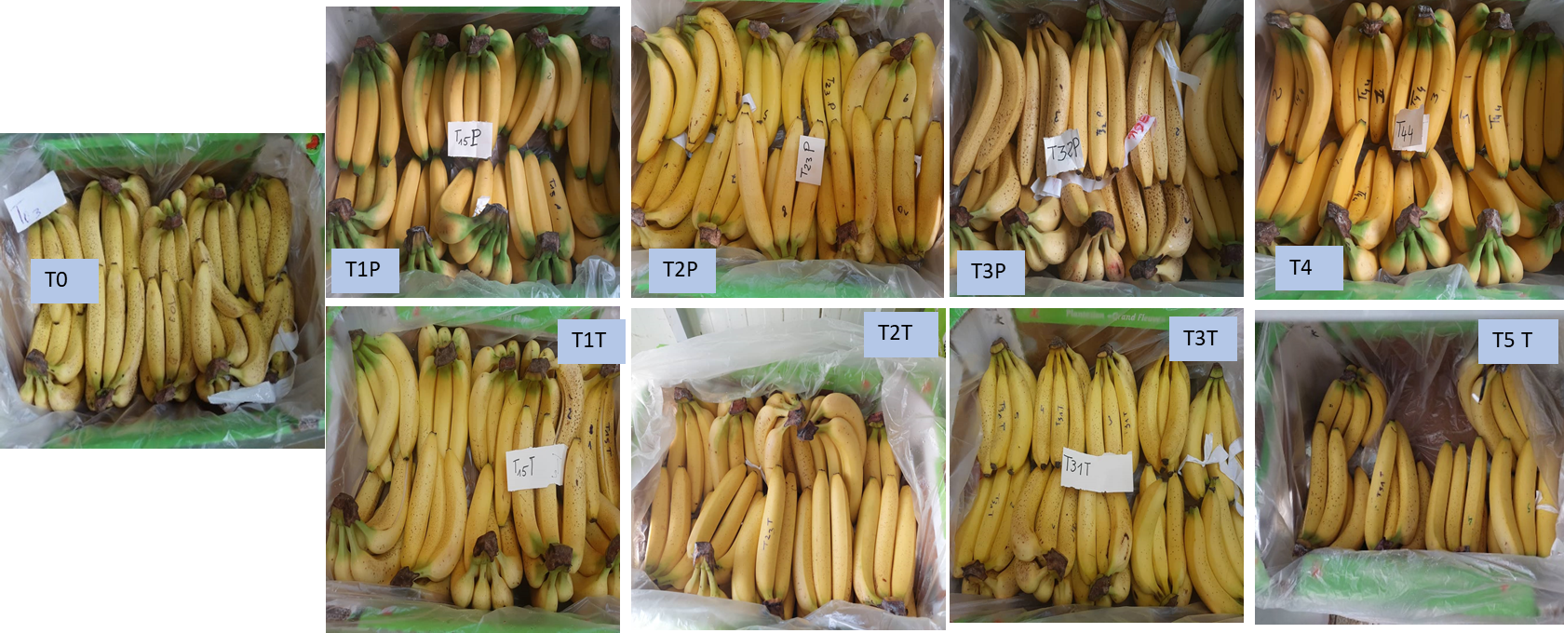

T0: Fungicide only, T1T: Fungicide + Vegetable oils (Rapeseed + 0live (100g/l)) TM at 3%; T2T: Fungicide + Vegetable oils (Rapeseed + Olive (100g/l)) at 7%; T3T: Fungicide + Vegetable oils (Rapeseed + Olive (100g/l) at 9%; T4: Fungicide + ENERPACK 40 SP at 1500 ppm; T1P: Fungicide + Vegetable oils (Rapeseed + Olive (100g/l)) at 5%; T2P: Fungicide + Vegetable oils (Rapeseed + Olive (100g/l)) at 10%; T3P: Fungicide + Vegetable oils (Rapeseed + Olive (100g/l)) at 12%; T5T: Vegetable oils (Rapeseed + Olive (100g/l)) at 5%;
Figure 4: Appearance of treated fruits after 30 days of packaging

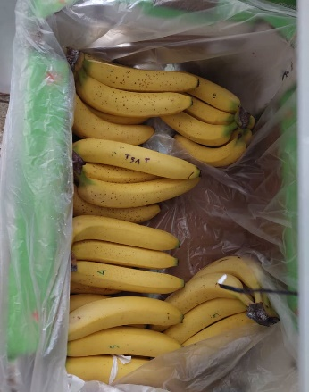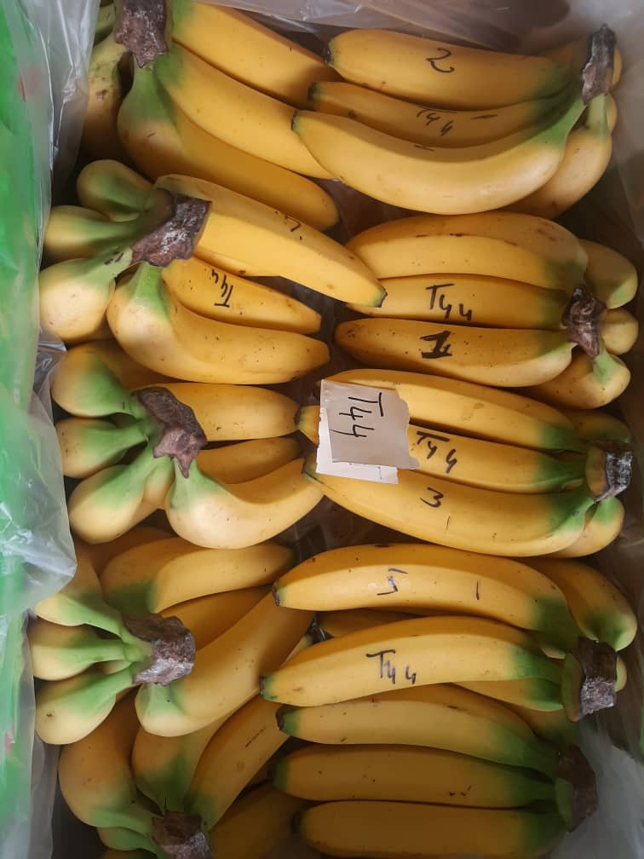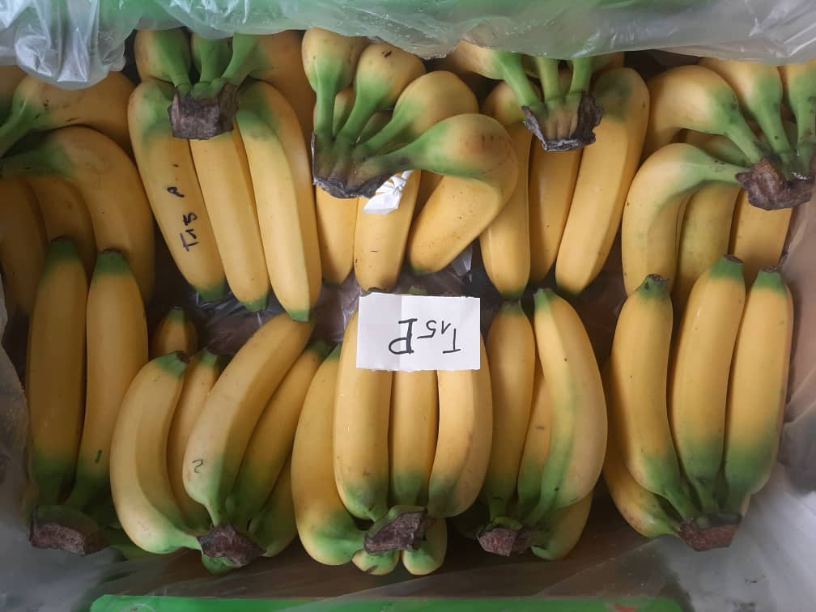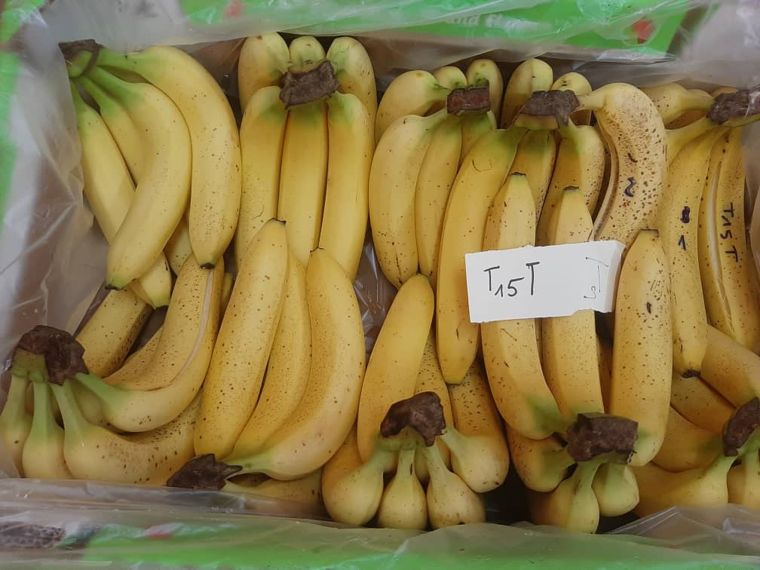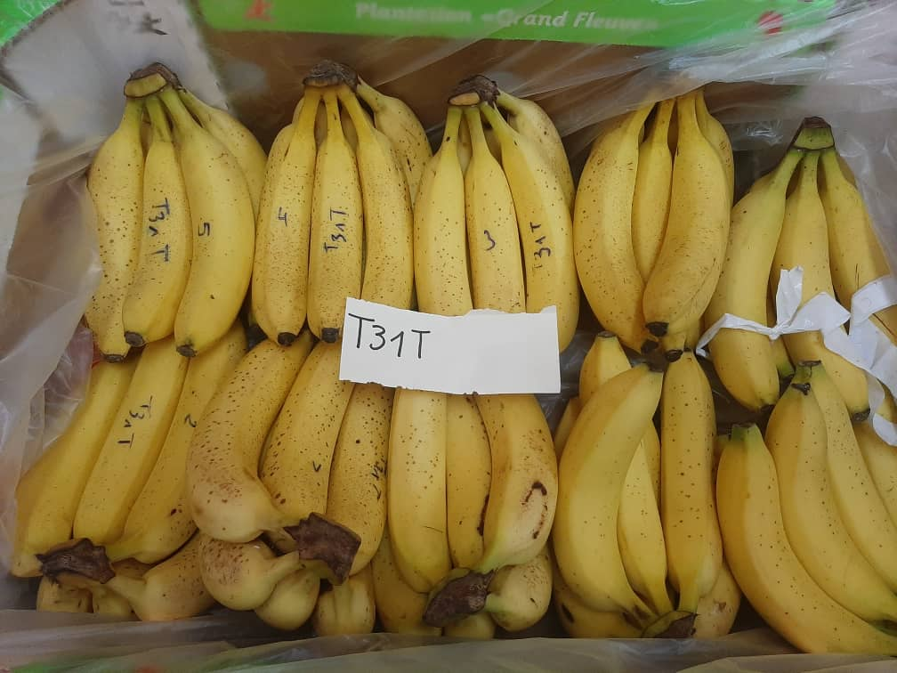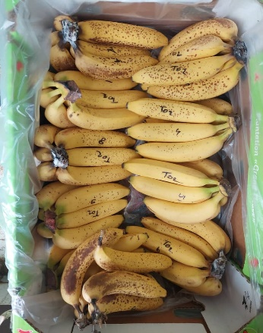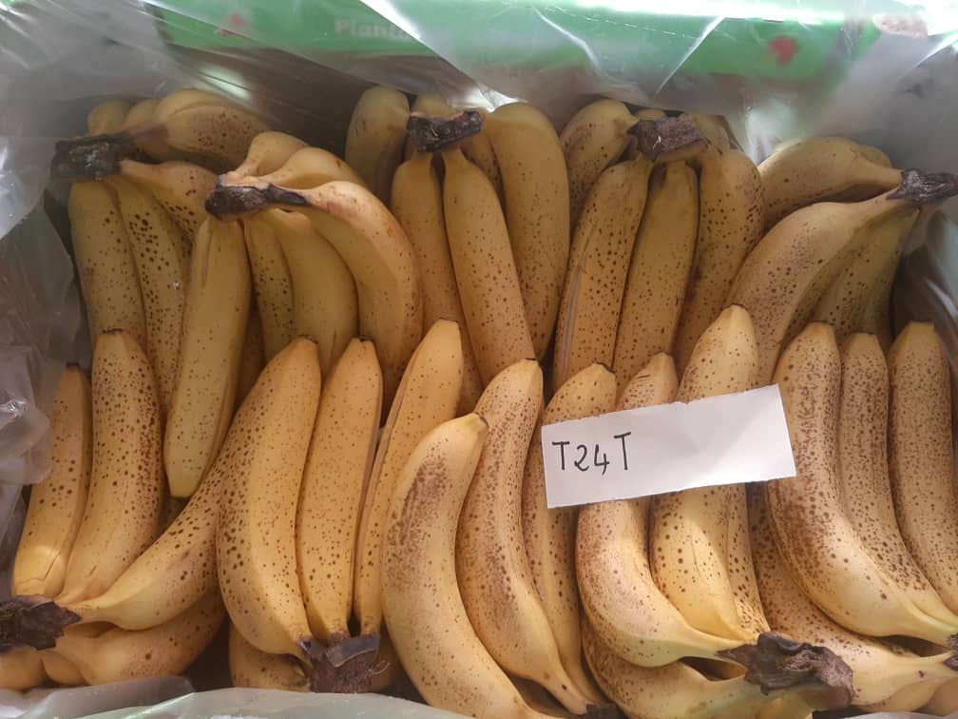
T1T
T1P
T2
T4
T0
T3T
T5T
T0: Crown rot and anthracnose on fruit
T1T: No symptoms of crown rot and anthracnose
T1P: No symptoms of crown rot or anthracnose
T4 :
No symptoms of crown rot or anthracnose
T3T: Anthracnose on fruit
T2T: Crown rot and anthracnose on fruit
T5: Anthracnose on fruit

T0: Fungicide only, T1T: Fungicide + Vegetable oils (Rapeseed + 0live (100g/l)) TM at 3%; T2T: Fungicide + Vegetable oils (Rapeseed + Olive (100g/l)) at 7%; T3T: Fungicide + Vegetable oils (Rapeseed + Olive (100g/l) at 9%; T4: Fungicide + ENERPACK 40 SP at 1500 ppm; T1P: Fungicide + Vegetable oils (Rapeseed + Olive (100g/l)) at 5%; T2P: Fungicide + Vegetable oils (Rapeseed + Olive (100g/l)) at 10%; T3P: Fungicide + Vegetable oils (Rapeseed + Olive (100g/l)) at 12%; T5T: Vegetable oils (Rapeseed + Olive (100g/l)) at 5%;
Figure 5: Health status of the fruits on the 30th ^{day} of packaging

Choosing effective treatments
The ACP individuals' dispersion plan for the different treatments highlights three treatment groups (Figure 6). Group 1 consists of T4, T1T and T1P. They are characterised by a green life (GLD) conservation of up to 30 days at 14°C (T4 and T1P), a good acidity level, a good soluble sugar level with a constant pH between 6 and 7, and good fruit firmness. This group is characterised by better efficacy against post-harvest banana diseases such as anthracnose and crown rot. Group 2 consists of treatments T3P, T3T and T2P. These treatments are characterised by a loss of fruit mass, a loss of firmness, a good titratable acidity level and a good green life (GLD) conservation of up to 25 days at 14°C. Group 3 includes only treatments T0, T2T and T5T, which are marked by the presence of rot symptoms on the crown of the bouquets. These treatments allow the green life (DVV) to be comparable to the control T0; therefore, they are not efficient enough for the preservation of banana fruits. Rapeseed and olive vegetable oil are rich in 28% polyunsaturated acids and essential fatty acids, 20% omega-6 and 8% omega-3 (alpha linoleic acid). These proportions give it a very relevant omega-6 / omega-3 ratio (around 2.5). Omega-3 makes this oil essential for our health. Thus, the treatment of bananas with this oil not only allows it to preserve the organoleptic quality but also has no effect on the health of the consumer.
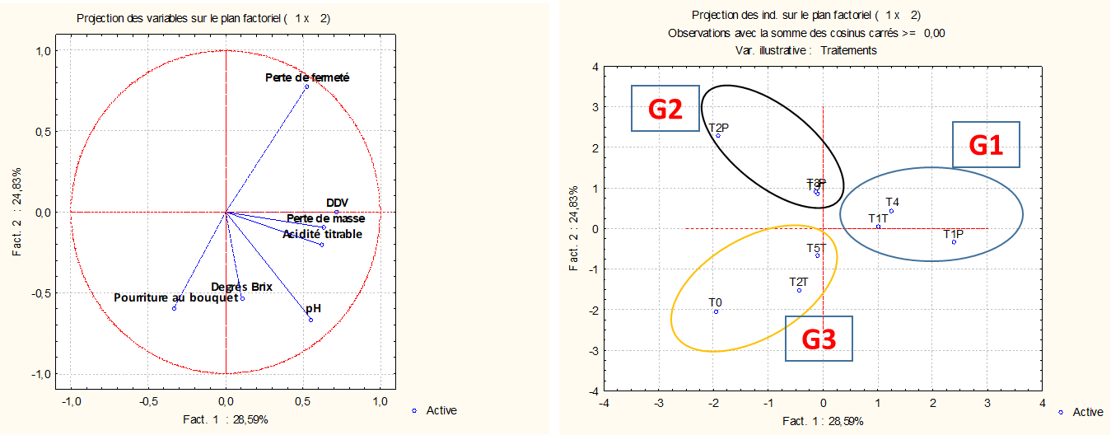
b
a
Circle of correlations (a) and dispersion of treatments (b)
Figure 6. Circle of correlations and dispersion of treatments according to PCA
T0: Fungicide only, T1T: Fungicide + Vegetable oils (Rapeseed + Olive (100g/l)) TM at 3%; T2T: Fungicide + Vegetable oils (Rapeseed + Olive (100g/l)) at 7%; T3T: Fungicide + Vegetable oils (Rapeseed + Olive (100g/l) at 9%; T4: Fungicide + ENERPACK 40 SP at 1500 ppm; T1P: Fungicide + Vegetable oils (Rapeseed + Olive (100g/l)) at 5%; T2P: Fungicide + Vegetable oils (Rapeseed + Olive (100g/l)) at 10%; T3P: Fungicide + Vegetable oils (Rapeseed + Olive (100g/l)) at 12%; T5T: Vegetable oils (Rapeseed + Olive (100g/l)) at 5%;

CONCLUSION
In this context of compliance with the requirements of fruit quality for export and consumer satisfaction, the effectiveness test of a wax based on rapeseed and olive vegetable oil (100g/l) was conducted. This study showed that the treatments T1T (fungicide + rapeseed and olive vegetable oil (100g/l) at 5% applied by dipping), and T1P (fungicide + rapeseed + olive vegetable oil (100g/l) at 3% applied by spraying) are more effective for better post-harvest preservation of dessert bananas and has similar effects to those of ENERPACK 40 SP (Gibberellic acid). The treatment increased the green life (GLD) of the fruits, without adverse effects on mass and firmness. In addition, it reduced the impact of post-harvest fruit diseases and had no adverse effect on the physicochemical change of the fruit pulp in all batches. The application of wax, either by dipping or spraying at a dose between 3 and 5%, can be recommended in the Ivory Coast for post-harvest preservation of bananas.

REFERENCES
1 Lassoudière A The banana tree. A century of technical innovations . Editions Quae , France 2012; 352p.
2 OMBD. Dessert Banana Market Observatory, Monthly Information Bulletin on Banana Markets. 2018; 001, 4.
3 FAO. https://www.fao.org/statistics/fr/; 2020 visited on 05/13/2023
4 Ewané CA, Lepoivre P, de Lapeyre de Bellaire L and L Lassois Involvement of phenolic compounds in the susceptibility ofbananas to crown rot. A review . Biotechnology , Agronomy, Society and Environment . 2012; 16(3): 393-404.
5 Abd-Alla MA, El-Gamal NG, El- Mougy NS and MM Abdel-Kader Post- harvest treatments for controlling crown rotdisease of Williams banana fruits ( Musa acuminata L. ) in Egypt.Plant Pathology & Quarantine , 2014; 4(1) : 1-12. Doi 10.5943/ ppq /4/1/1.
6 Codex Alimentarius . Standard for Bananas, CODEX STAN 205-1997 . 2005. 5p. -404.
7 Dadzié BK and JE Orchard Post-harvest evaluation of banana and plantain hybrids: criteria and methods. Inibap Technical Guides , 1997; 60 P.
8 Ketsa S And T Prabhasavat Effect of skin coating on shelf life and quality of ' Nang Klangwan ' mangoes . Acta Horticulture . 1992; 321(2) : 764-770.
9 Didier KK, Jean-Martial KKF, Marial KN, Patrik NH, Edouard YKJ and KK Gaston Study of the Effectiveness of a Vegetable Oil-Based Wax on Post-Harvest Conservation of Pineapple in Ivory Coast. European Scientific Journal, ESJ . 2023; 19 (5): 54. https://doi.org/10.19044/esj.2023.v19n5p54
10 Kouadio KT, Agneroh TA, Pohé J, Tienebo EO and NILV Ohoussou Inventory of Post-Harvest Pathogenic Fungi of “Cavendish” Dessert Banana and Evaluation of Their Sensitivity to Azoxystrobin in Ivory Coast. European Scientific Journal, ESJ. 2017; 13(21): 26. https://doi.org/10.19044/esj.2017.v13n21p26
11 John P and J Marchal Ripening and biochemistry of the fruit, in: Gowen S. (Ed.), Bananas and plantains, Chapman & Hall, London, UK 1995;
12 Saftner RA and WS Conway Effects of postharvest calcium and fruit coating treatment on postharvest life, quality maintenance and fruit surface injury in 'Golden Delicious ' apples . J. Amer. Soc. Hort . Sci. 1998; 123 (2) : 294-298.
13 Alavoine P, Crochon M, Fady C, Fallot J, Moras P and JC Pech The taste quality of fruits, practical methods of analysis. Publication of CEMAGREF, Aix-en- Provence 1986; 10 p.
14 AOAC. Official Methods 942.15 Acidity ( titratable ) of fruit product read with AOAC Official preparation of test sample . 2000.
15 Sawant SG and DU Gawai Biochemical changes in bananafruits due to post- harvest fungal pathogens . Current Botany , 2011; 2 (1) : 41-42.
16 Ketsa S And T Prabhasavat Effect of skin coating on shelf life and quality of ' Nang Klangwan mangoes . Acta Horticulturae , 1992; 321(2) : 764-770.
17 Saftner RA and WS Conway Effects of postharvest calcium and fruit coating treatment on postharvest life, quality maintenance and fruit surface injury in 'Golden Delicious ' apples . J. Amer. Soc. Hort . Sci. 1998; 123(2) : 294-298.
18 Diaz- Sobac R, Luna AV, Beristain CI, De La Cruz J and HS Garcia Emulsion coating to external postharvest life of mango ( Mangifera indica cv. Manila ). J.FoodProc . ​Press. 1996; 20 :191-202
19 Deka SC and Z Harmine Variation in biochemical constituents of Banana fruits cv. Borjahaji (AAA) at different stages of development . Annuals of AgriBio-Research . Dept.​ Biochem . Agril . Chem ., Assam Agril . Univ ., Assam, pp. 1997; 71-75
20 Bhadra S and SK Sen Postharvest storage of custard apple ( Annona squamosa L.) fruit var. Local green under various chemical and wrapping treatments . Approximately. Ecol .. 1997; 1(4): 322-328.
21 Haryana Kumar N J. Hort . Sci . Physico- chemical characteristics of some South and West Indian mangoes . 1997; 26(1 and 2) : 99-100.
22 Medlicott AP and AK Thompson Analysis of sugars and organic acid in ripening mango fruit ( Mangifera indica L. var. Keitt ) by high performance liquid chromatography . J.Sci . ​Food Agriculture . 1985; 36 :561-566.
23 Saftner RA and WS Conway Effects of postharvest calcium and fruit coating treatment on postharvest life, quality maintenance and fruit surface injury in 'Golden Delicious ' apples . J. Amer. Soc. Hort . Sci . 1998; 123(2) : 294-298.
24 Olorunda AO and OC Aworh Effects of Tal- prolong , a surface- coating agent, on the shelf life and quality attributes of plantain. J.​ Sci . Food Agriculture . 1984; 325 :573-578.
25 Mainnheim CH And T Soffer Permeability of different wax coatings and their effect on citrus fruit quality . J.Agri. Food Chem . 1996; 44 :919-923.
26. Didier, K. K., Henri, N. G. P., Martial, K. K. J. F., Edouard, Y. K. J., Gaston, K. K., Tata, S. Y. L. L. A., ... & Martial, K. N. G. (2025). Proposed Use of Limocide 60 ME (An Extract of Sweet Orange Essential Oil) to Control Pathogens of Crown Rot in Dessert Bananas. Journal of Advances in Microbiology, 25(4), 152-168.
27. Ngoko Tchamba, E.-I., Tybussek, T., Muranyi, P., Nguetsop, V. F., Aghofack-Nguemezi, J., & Schwab, W. (2024). The Combined Effect of Lemon Peel Extract and Calcium Chloride on the Physical and Biochemical Quality Parameters of the Dessert Banana (Musa acuminata var. Dwarf Cavendish) Fruit. Agriculture, 14(2), 222.
28. Cooper, T., Phillips, A., Daniells, J., Stewart, Z., Matovu, M., Harding, R., ... & Paul, J. Y. (2025). Towards Iron Biofortification of Banana (Musa spp.): A Comparative Study of Fruit Mineral Micronutrient Concentrations and Phylogenetic Insights Into Iron Homeostasis. Food and Energy Security, 14(3), e70104.

