Comparative Sensory Evaluation of Bread Prepared with Wild Yeast from Sweet Potatoes and Commercial Yeast
.
ABSTRACT

Sweet potato is a starchy, sweet-tasting root vegetable belonging to the Convolvulaceae family. Sweet potatoes are considered a key crop for food security in Africa, making them a strategic choice for sustainable development projects focused on value-added products. Their high carbohydrate content essential for microbial fermentation, has made essential biotechnological research. They increasingly used as substrates for fermentation to produce bioethanol, enzymes, and microbial biomass, including yeast products. The aim of this study was the production and sensory evaluation of yeast from sweet potatoes. Yeast production involves growing yeast from a starter culture. The experiment was carried out in the Laboratory of Food, Forestry, Environment Protection and Conservation Society Kumba. The experiment was laid on a completely randomized design (CRD). After producing yeast using sweet potato, two bread samples were baked, one with yeast produce from sweet potato and the other baked with commercial yeast. The questionnaire was the main instrument for data collection. The sample of the study constituted 50 respondents with age range 20-29 years. The result showed that bread made with commercial yeast had a more appealing appearance, possibly due to better fermentation and dough handling, there is strong and more characteristic aroma associated with commercial yeast fermentation, there is superior leavening power and gas retention abilities of commercial yeast. Based on the result, it was recommended that the further method designed should be applied to improve the production of yeast and encourage the cultivation and consumption of sweet potatoes.

Keywords: Sweet potatoes, Yeast, Sensory evaluation, Bread, Commercial yeast

1 INTRODUCTION
Yeast plays a vital role in various culinary and baking processes, contributing to fermentation and the leavening of dough (Akba et al., 2019). Traditionally, commercial yeast is widely available in stores, but historically, natural methods of yeast cultivation have been used, often involving natural ingredients like fruits and vegetables. One such method involves using potatoes which are rich in starch and nutrients, to cultivate yeast. Homemade yeast was common before the 20th century before industrialized yeast production, bakers and households relied on natural fermentation processes, often using ingredients like potatoes to create starter cultures. This method allowed for the production of homemade bread and other fermented foods in a sustainable and low-cost manner. The rationale behind using potatoes in yeast production lies in their carbohydrate content. Potatoes serve as an excellent substrate for yeast fermentation, as the natural sugars in the potato feed the yeast organisms, allowing them to multiply and form a viable culture. This makes potato yeast an attractive option for those interested in self-sufficiency, reducing waste, or exploring traditional culinary methods Cui and Pozzobon (2022).
The process of making yeast from potatoes generally involves boiling the potatoes, mashing them, and adding sugar and water to create a mixture. After cooling, the mixture is often left exposed to the air, allowing wild yeast from the environment to inoculate the solution. This method relies on natural yeast strains, which can be unpredictable but often effective in creating a fermentation starter (Ajayi et al., 2019). Some recipes involve the addition of flour to provide more nutrients for the yeast, and others recommend using potato skins to harness more wild yeast that may be present on the surface. A few studies have explored the use of alternative starch sources, such as potatoes, for yeast production. Research has shown that Saccharomyces cerevisiae can efficiently metabolize the sugars derived from potatoes, although wild yeast strains vary in their efficiency depending on environmental conditions, temperature, and the specific yeast strain. Some investigations into indigenous fermentation techniques highlight how potatoes can support microbial growth in resource-constrained environments, providing a sustainable method for yeast cultivation. Studies also compare the yeast activity derived from potato starters to commercial yeast (Ajayi et al., 2019). While commercial yeast offers a more consistent and rapid rise, potato yeast starters have been noted for adding unique flavors and aromas to the end product due to the variety of wild yeast and bacteria present. The concept of producing a yeast-like product from sweet potatoes involves fermenting sweet potato substrates with specific yeast strains to yield a product with nutritional and sensory properties liken to traditional nutritional yeast. Nutritional yeast is valued for its high protein content, B-vitamins, and savory flavor, commonly used as a dietary supplement or flavor enhancer. While direct studies on producing nutritional yeast from sweet potatoes are limited, the successful fermentation of sweet potato substrates by yeast suggests potential for developing such products techniques (Campbell et, al 2016)
Sweet potato is a starchy, sweet-tasting root vegetable belonging to the Convolvulaceae family (Islam (2024) Sweet potatoes are considered a key crop for food security in Africa, making them a strategic choice for sustainable development projects focused on value-added products. Their high carbohydrate content (starch and sugars), essential for microbial fermentation, has made them a focus of biotechnological research and sweet potatoes are increasingly being explored as substrates for fermentation to produce bioethanol, enzymes, and microbial biomass, including yeast products (Udemezue and Eluagu 2021)
Cameroon is one of Africa's notable producers of sweet potatoes, particularly in the Northwest and West regions. The crop is primarily cultivated by smallholder farmers and plays a critical role in local diets, especially in rural areas. The country produces both white- and orange-fleshed varieties, with the latter being rich in beta-carotene and other essential nutrients. Despite the widespread cultivation of sweet potatoes, their industrial application in Cameroon remains limited. Research on microbial fermentation processes using sweet potatoes as substrates is still in its infancy. However, the country’s growing interest in biotechnology and value-added agricultural products presents a significant opportunity. In Cameroon and Africa, the development of yeast-like products from sweet potatoes can be a game-changer for food and industrial biotechnology. By optimizing fermentation processes and engaging local stakeholders, researchers can create scalable solutions that benefit both farmers and consumers. Therefore, this study seeks to bridge the gap as well as create an awareness of the utilization of sweet potatoes in the production of yeast like product (Mfewou et al., 2019).

1.1 Types of sweet potato
There are five main types of sweet potato that are commonly consumed today namely; Garnet, Hannah, Japanese, Jewel, and Purple Stoke. While all are delicious, each variety has its own distinct flavor and texture that lends itself to a variety of cooking applications. They are also high in vitamin A and potassium, and are low glycemic food (Yuxin et al., 2022).
A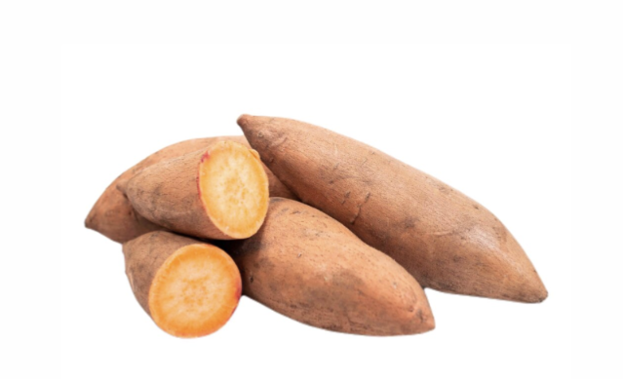 B 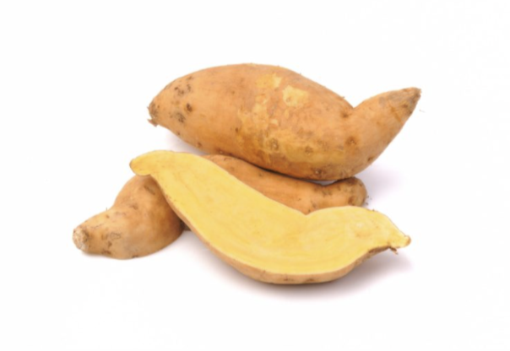
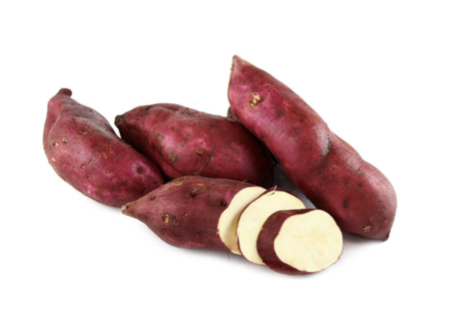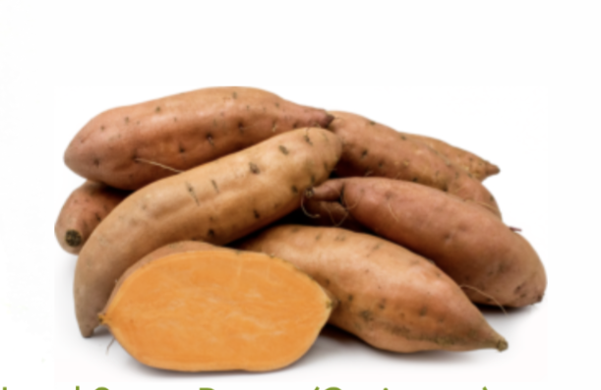
C D
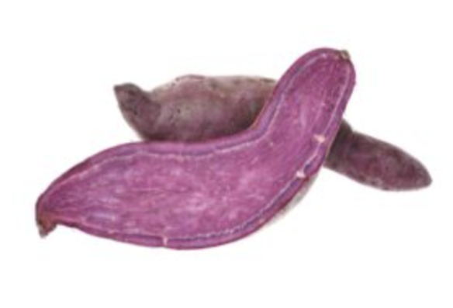
E

Figure 1: Garnet sweet Potatoes (A), Hannah Sweet Potatoes (B) (Cui, and Pozzobon (2022)., Japanese Sweet Potatoes (C) (Cui, and Pozzobon (2022), Jewel Sweet
Potatoes (D) (Yuxin et al., 2022) and Purple Stokes Sweet Potatoes (E) (Hamad et al., 2024).

1.2 Production of yeast using different raw materials:
According to Lakew (2022), a study was carried out to characterize the indigenous yeast isolates recovered from fruits. The indigenous yeast isolates were retrieved from fruits following standard methods. Based on the results from a total of 88 yeast isolates, three of them were selected on the basis of not producing H2S and their high sugar fermentation abilities. Based on colonial, morphological parameters and biochemical tests, the three yeast isolates were identified as members of the genus Saccharomyces. The optimum growth pH and temperature values for the three selected yeast isolates were recorded as 5 and 30⁰C, respectively in Yeast Extract Peptone Dextrose medium. The results indicated that 30% (w/v) D-glucose and 5% (w/v) NaCl concentrations supported optimum growth of the isolates in the same medium. In all cases, the maximum biomass was achieved at 96 hours of incubation but decreased rapidly afterwards. It was then concluded that, these three non-H2S but sufficient CO2 producers indigenous yeast isolates can be used to bake bread and as well, serve as a potential leavening agent for the bakery industry and can be used to produce ethanol (Lakew (2022).
Moreover, Osumah and Tonukari 2020 did research on how to develop a method for producing glucose and simple sugars from cassava (a locally available raw material) through acid hydrolysis and combining this with poultry manure for yeast production. Based on the result gotten, an analysis for yeast production was carried out using 20% cassava flour for acid hydrolysis and the glucose produced was used for yeast production. This analysis was aimed at determining the amount of yeast as well as determining the amount of residual glucose and the pH level (whether acidic or alkaline) after the yeast culture (Lakew 2022). The results obtained showed that, the hydrolysis of cassava flour gave a high yield of glucose which serves as good and cheap carbon source for yeast production. It was then concluded that, the methods described in this work could be used in the development of a rapid method for producing glucose and simple sugars from cassava through acid hydrolysis and combining this with poultry manure for yeast production (Osumah and Tonukari 2020).
Nguyen et al., 2023 in a study tried to isolate yeast strands from some fruits samples (mango, orange, pineapple, and mango) without growth stimulants and pesticides collected from the farms in ThuaThien Hue province, Vietnam. Yeasts were isolated in accordance with a previous study of Nguyen et al., (2023) with some modifications. 30 different yeast isolates which belonged to different species: S. cerevisiae, L. fermentati, and C. fructus were obtained. Among them, seven S. cerevisiae isolates grew well in medium containing 20-100 g/L glucose and 2-5% (v/v) ethanol at 30°C, and used a wide range of other sugars in addition to glucose. Remarkably, D14 isolate was able to grow in harsh conditions (up to 45°C, 12% ethanol, 500 g/L glucose, and highly flocculation), that make it a potential candidate for industrial applications ( Nguyen et al., 2023)
Yeast is a crucial microorganism in the process of fermentation, which has been used for centuries in baking, brewing, and winemaking. Saccharomyces cerevisiae commonly referred to as bakers or brewer’s yeast is most frequently utilized (Nguyen et al. 2023). In addition to commercial yeast, there are natural methods for cultivating yeast, one of which includes using starchy substrates like potatoes. Historically, before the mass production of commercial yeast, many cultures relied on homemade yeast starters, derived from natural sources like fruits, grains, and tubers. Potatoes, in particular, were popular because of their rich starch content, which can act as a food source for yeast growth. Early baking and brewing practices involved fermenting potato water, flour, or mashed potatoes to create a yeast starter. The starch in potatoes is broken down into simpler sugars during the process, which yeast cells metabolize, producing carbon dioxide and alcohol as byproducts (Hamad et al., 2024).
Previous studies have highlighted the feasibility of using other agricultural substrates, such as cassava and fruits, for natural yeast production. However, research on the use of sweet potatoes for this purpose remains limited, underscoring the need to explore and optimize the fermentation process for maximum yeast yield and quality (Osumah and Tonukari, 2020). This study aims to investigate the production of natural yeast using fermented sweet potatoes, contributing to the development of sustainable fermentation. The exploration of sweet potatoes (Ipomoea batatas) as a substrate for producing yeast-like products presents a promising avenue for sustainable food innovation. Sweet potatoes are rich in carbohydrates, particularly starch, which can be hydrolyzed into fermentable sugars to support microbial growth. Their global availability and nutritional profile make them an attractive candidate for biotechnological applications (Abdulhakim et al 2024).

2 Materials and Methods
This study used an experimental design. The experiment was carried out in the Laboratory of Food, Forestry, Environment Protection and Conservation Society Kumba. The experiment was laid on a Completely Randomized Design (CRD). After producing yeast from sweet potato, two bread samples were baked: one with the sweet potato yeast and the other with commercial yeast. The flow diagram below describes the steps followed in the methodology to achieve the various objectives of this study

Figure 2: Flow chat for methodology

Sweet Potatoes: it was bought freshly from the Kumba main market, the samples were carefully selected to avoid spoiled once. The sweet potatoes were peeled, chopped into smaller pieces, boiled and pounded then kept, ready for fermentation process. The water used in boiling the sweet potatoes was kept to be used later during fermentation. Flour: Was also gotten from the Kumba main market and sieved before adding to the pounded potatoes. Reagents such as sugar were gotten locally and was added to the pounded potatoes and flour waiting for the start of fermentation process. Sugar was also used to give the baked bread a sweet taste and for preservation of the end product. Commercial yeast was bought locally and used in baking the control sample bread.

2.1 Production of yeast from sweet potatoes
The sweet potatoes were collected, selected and washed using clean running tap water. After washing, the sweet potatoes were peeled and chopped into small pieces using a sharp knife. The chopped pieces were then put in a clean pot; water added to it and boiled on medium heat for about 30-45 minutes. After boiling, it was removed and put in a bowl and smashed into a paste using a wooden spoon. It was then set aside alongside the water used in boiling ready for the fermentation process. The paste was later mixed with the water from boiling, sugar and all-purpose flour were added and properly mixed and then allowed to ferment. The mixture was allowed to ferment for 24 hours, which the change of color from white to brown indicated that proper fermentation occurred, accompanied by release of bubbles and a yeast smell confirming the completion of the fermentation process.

Figure 3 Flow Chart for the Production of Yeast from Sweet Potatoes

2.2 Baking of bread using yeast produce from sweet potatoes and commercial yeast
Ingredients: 360g of flour, 200g of grind sugar, 227g of butter, 250g yeast, 2 eggs, A pinch of salt, 240g of milk,1 sachet flavor, 2.3g bicarbonate, 240g of water.
Three cups of all-purpose flour were sieved in a bowl and mixed with all dried ingredients. yeast, sugar and warm milk were mixed in a small bowl and stirred to dissolve the yeast. The mixture was allowed to seat for 5 -10 minutes. yeast mixture and dried ingredients mixture were added together and allowed for 10-15 minutes, until the dough forms (smooth and elastic). The dough was set in a baking tin, covered with warmth cloth and set aside to rise for about 45 minutes and baked in a preheated oven for 50 minutes. The same process was done using yeast produced from sweet potatoes and commercial yeast.

2.3 Sensory Evaluation
Bread baked with yeast made from sweet potatoes and commercial yeast were subjected to sensory evaluation for acceptance of the sample. Scoring was given to 50 untrained panelists (students) on different parameters to asses. Each untrained panelist was presented with two bread samples labeled A and B to taste and give their opinions about it. The panelist rinsed their mouth with portable water after tasting each of the samples so as to enable correct results. The following characteristics were tasted; taste flavor, color, texture, appearance and overall acceptability. Structural sensory questionnaires were used to obtain views of respondents on the organoleptic properties of the different samples and their overall acceptability. The questionnaires as a research instrument were designed to help the respondent in expressing their preference of the two samples. The parameters for the bread were categorized using the 5 point hedonic scale method as described by Cabello-Olmo et al 2023, where scores range from highest point 5 to lowest point 1 which represents like very much and dislike very much respectively

2.4 Statistical Analysis
Each sample was duplicated in experiments and they were in a Completely Randomized Design (CRD). Data gotten with the help of the questionnaires were analyzed using an Excel Spread Sheets. The data gotten from the sensory parameters were analyzed with the help of a Software Package for Statistical Science (SPSS) software. The analysis was guided by the research objectives and research questions. The hypotheses were concluded based on the results gotten from sensory evaluation of the respondents. A total number of 50 questionnaires were sent out and all were received (100%) fully ticked. The untrained panelists were made up of both male and female students with ages ranging between 20-29 years. The mean and standard deviation of the data collected were calculated and the results presented.

3 RESULTS AND DISCUSSION
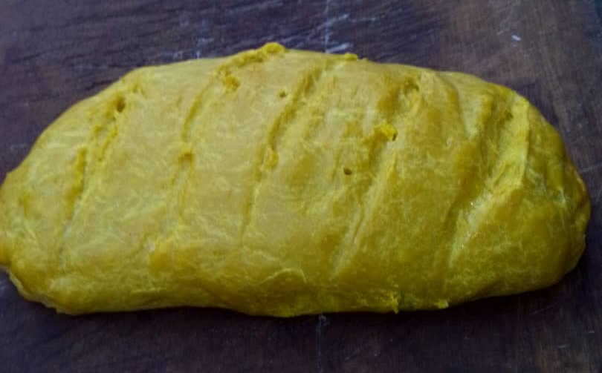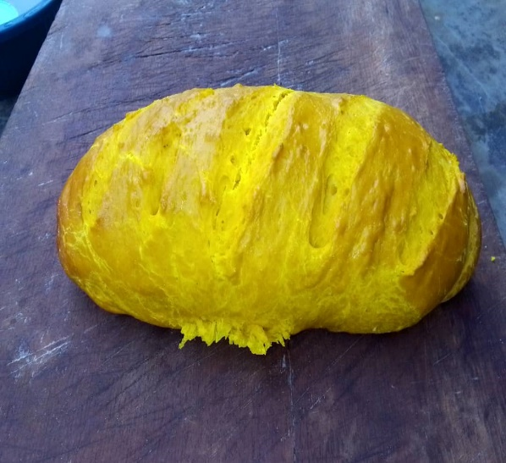
A B
Figure 4: A (bread baked with yeast produced from sweet potatoes), B (bread baked with commercial yeast respectively) (Akama 2025)

3.1 Sensory Scores of Bread Samples (Sample A and Sample B)
The sensory analysis parameters for bread made with Sweet Potato Yeast (Sample A) and Commercial Yeast (Sample B) as shown in figure 4 were evaluated across five sensory attributes: Appearance, Aroma, Taste, Texture, and Overall Acceptability. The following results were obtained and shown under each heading in Figure 5 below

3.1.1 Appearance:
Sample B scored significantly higher (4.2) compared to Sample A which scored 3.6. as shown in Figure 5 under Appearance. This suggests that the bread made with commercial yeast had a more appealing appearance, possibly due to better fermentation and dough handling.
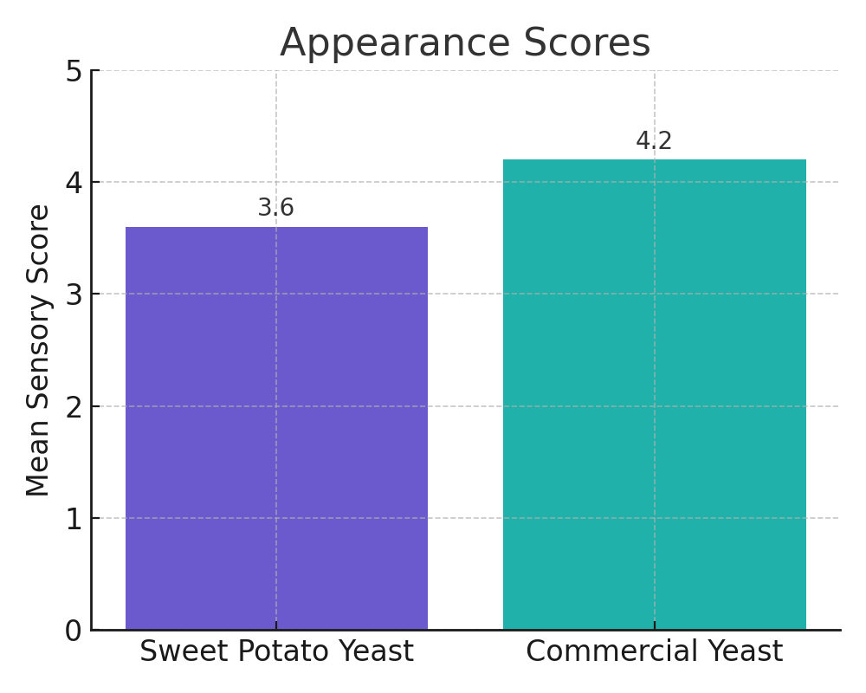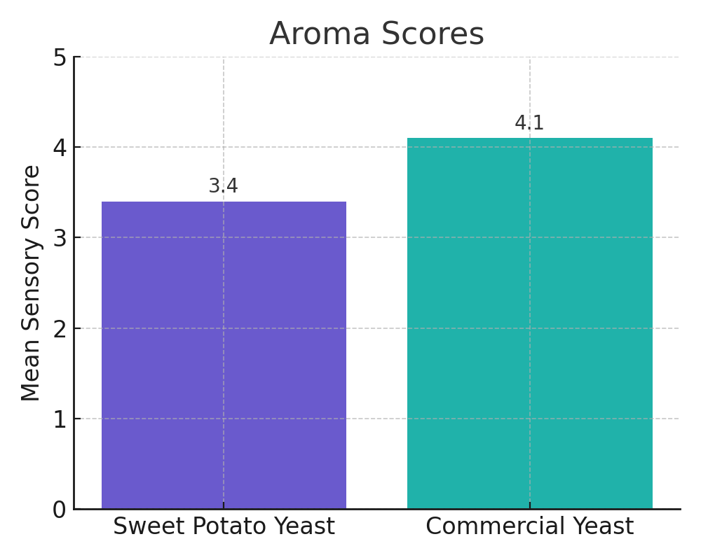
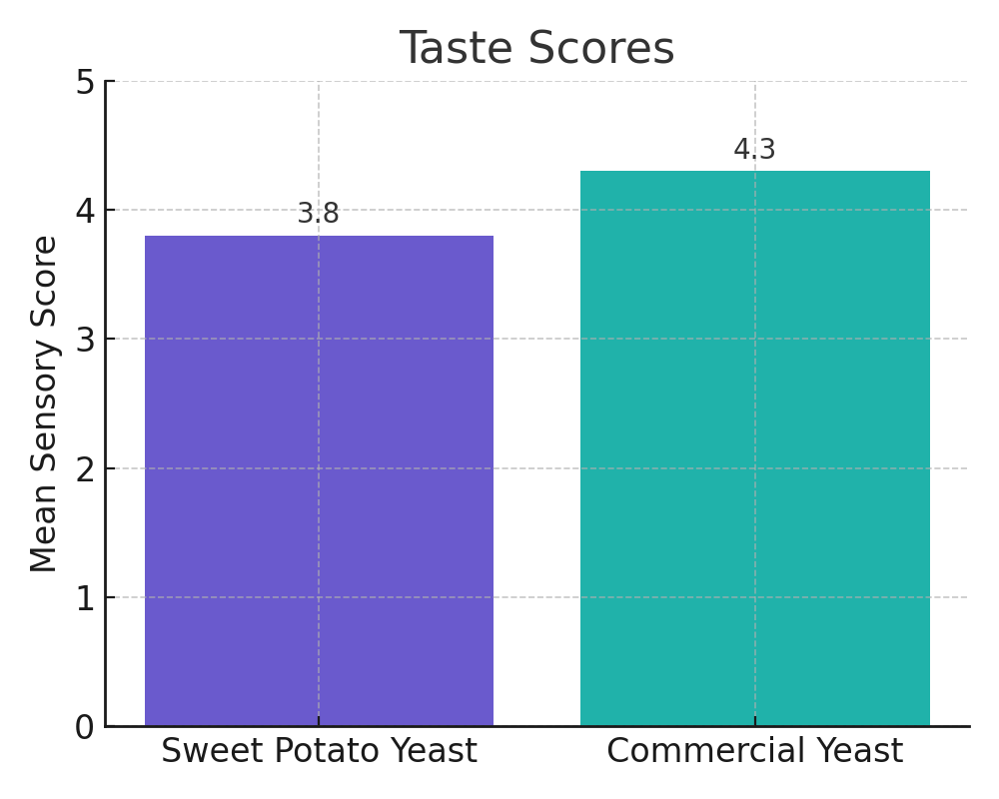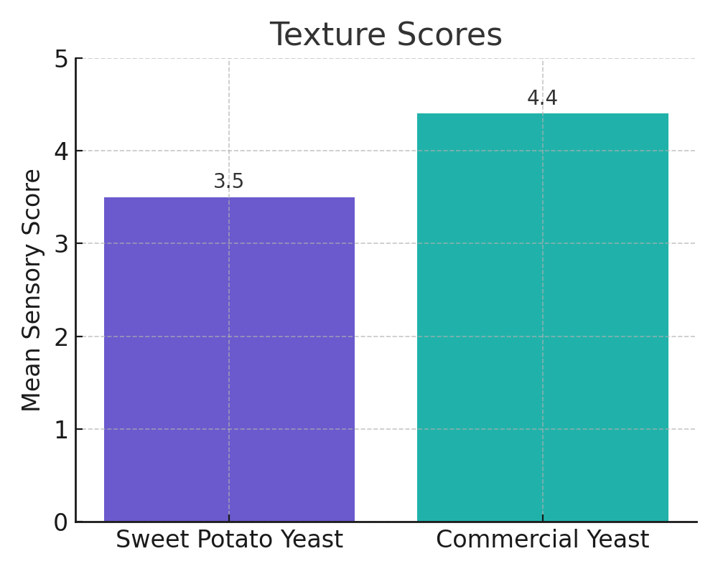
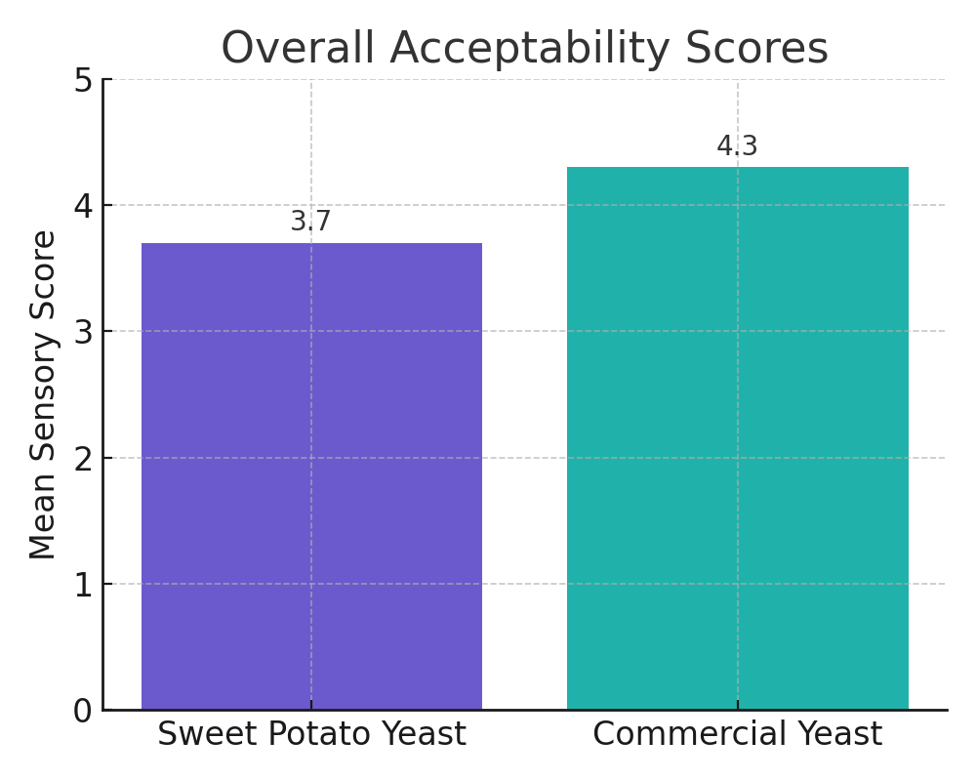
Figure 5: Bar chart for appearance

3.1.2 Flavor:
Sample B again outperformed Sample A with a score of 4.1 versus 3.4. The higher score for Sample B could be attributed to the stronger and more characteristic aroma associated with commercial yeast fermentation.

3.1.3 Taste:
Sample B scored 4.3, while Sample A scored 3.8. Despite a lower score, Sample A still had a pleasant taste, indicating that sweet potato yeast can impart a unique flavor, though commercial yeast is preferred for its more refined taste.

3.1.4 Texture:
The most significant difference between the two samples was observed in the texture attribute. Sample B achieved a score of 4.4, while Sample A scored 3.5. This large gap highlights the superior leavening power and gas retention abilities of commercial yeast, which likely contributed to the lighter and more uniform texture of the bread.

3.1.5 Overall Acceptability:
Finally, Sample B (Commercial Yeast Bread) scored 4.3, while Sample A scored 3.7. While Sample A was moderately acceptable, the overall preference was for Sample B, as it excelled in the majority of sensory attributes.

3.2 Summary presentation of scores of Sensory Scores of Bread Samples
The sensory properties of bread baked using yeast produced from sweet potatoes and bread made with commercial yeast were evaluated by 50 untrained panelists. The panelists assessed the samples based on appearance, aroma, taste, texture, and overall acceptability, using a 5-point hedonic scale where 1 = Dislike Extremely and 5 = Like Extremely. The mean scores and standard deviations for each attribute are presented in the Table 1 below.

Table 1 Summary presentation of scores of Sensory Scores of Bread Samples
Attributes | Sample A  (sweet potatoes yeast bread)  (mean ± SD) | Sample B  (commercial yeast bread)  (mean ± SD) | Statistical analysis  (P-value)
Appearance | 3.6 ± 0.7 | 4.2 ± 0.5 | 0.002
Aroma(flavor) | 3.4 ± 0.8 | 4.1 ± 0.6 | 0.001
Taste | 3.8 ± 0.6 | 4.3 ± 0.5 | 0.003
Texture | 3.5 ± 0.7 | 4.4 ± 0.5 | 0.000
Overall acceptability | 3.7 ± 0.6 | 4.3 ± 0.5 | 0.001
N.B. All data presented as the mean± S.D (Akama 2025)

3.3 Discussions
As shown in the Table above, bread produced with commercial yeast recorded higher mean sensory scores across all sensory attributes compared to bread produced with sweet potato yeast. The highest mean score for commercial yeast bread was observed in texture (4.4 ± 0.5), while the lowest was in aroma (4.1 ± 0.6). In contrast, bread made with sweet potato yeast had its highest score in taste (3.8 ± 0.6) and the lowest in aroma (3.4 ± 0.8).
Although the bread produced with sweet potato yeast generally scored lower, it still achieved moderate acceptance, with all attributes rated above 3.0 on the 5-point scale. This suggests that bread made with sweet potato yeast was acceptable to the untrained panelists, but less preferred compared to the commercial yeast bread. The lower scores observed for sweet potato yeast bread, particularly in texture and flavor, could be attributed to the possible variation in yeast fermentation efficiency. Sweet potato-derived yeast may have a lower gas production capacity and flavor development compared to commercial yeast, which is typically optimized for consistent and strong leavening performance. This is consistent with findings by Chen et al 2023.who reported that bread made from non-commercial yeast strains often had lower textural quality and flavor intensity compared to bread made with commercial yeast. Similar studies by
Du et al 2025, on indigenous yeast strains produced from cassava also showed lower sensory scores for aroma and appearance when compared with commercial yeast products. These authors emphasized that local yeast sources, although viable, may require strain and fermentation improvement to match commercial standards.
Statistical analysis revealed that the differences in appearance, aroma, taste, texture, and overall acceptability between the two bread samples were significant (p < 0.05). This indicates that panelists preferred the bread made with commercial yeast in all evaluated sensory parameters. Despite the observed differences, the sweet potato yeast bread maintained a good taste score (3.8 ± 0.6), suggesting that flavor perception was less affected compared to appearance and texture. This observation agrees with the work of Erci̇k (2024). who found that locally sourced yeast could impart unique flavors to bakery products, which might be appreciated differently by various consumer groups.

4 Conclusion
The main objective of this study was to produce and carryout sensory evaluation of yeast from sweet potatoes. After producing yeast from sweet potatoes, the yeast was used to bake bread alongside commercial yeast. The two samples were sent out for sensory evaluation. The results of this study indicates that while commercial yeast still produces superior bread quality, yeast derived from sweet potatoes has potential as an alternative leavening agent, especially when factors such as local resource utilization and reduced production costs, are considered. From the result of this study it can be concluded that sweet potato is a potential raw material for yeast production and yeast produced from sweet potatoes can be used to bake bread with acceptable sensory attributes.

Disclaimer (Artificial intelligence)
Option 1:
Author(s) hereby declare that NO generative AI technologies such as Large Language Models (ChatGPT, COPILOT, etc.) and text-to-image generators have been used during the writing or editing of this manuscript.

5 REFERENCES

Abdulhakim Sharaf Eddin and Salam A IbrahimA Research Perspective on The Utilization of SweetPotato as A Growth Medium for Lactobacillus Sp Global Journal of Nutrition & Food Science Volume 5-Issue 2 10.33552/GJNFS.2024.05.000606 2024
Ajayi. O., Elemo G., Onyibe. E.J. (2019). Production of fermented sweet Potatoes flour using indigenous starter culture. DOI:10 (41):1746-1758.
Akba. A., Aamir. S. Moazzam.R..k., Muhammed. A.S. Muhammed. R.A.(2019). Yeast, its type and role in fermentation during bread making process.A review. ISSN: 2226-5599 FOOD SCI., 22(3): 171-179.
Cabello-Olmo, M., Krishnan, P. G., Araña, M., Oneca, M., Díaz, J. V., Barajas, M., & Rovai, M. (2023). Development, Analysis, and Sensory Evaluation of Improved Bread Fortified with a Plant-Based Fermented Food Product. Foods, 12(15), 2817. https://doi.org/10.3390/foods12152817
Campbell C, Nanjundaswamy AK, Njiti V, Xia Q, Chukwuma F. Value-added probiotic development by high-solid fermentation of sweet potato with Saccharomyces boulardii. Food Sci Nutr. 2016 Dec 9;5(3):633-638. doi: 10.1002/fsn3.441. PMID: 28572951; PMCID: PMC5448380.
Chen A, Pan C, Chen J. Comparative Analysis of Bread Quality Using Yeast Strains from Alcoholic Beverage Production. Microorganisms. 2024 Dec 17;12(12):2609. doi: 10.3390/microorganisms12122609. PMID: 39770811; PMCID: PMC11676879.
Cui, Na & Pozzobon, Victor. (2022). Food-Grade Cultivation of Saccharomyces cerevisiae from Potato Waste. AgriEngineering. 4. 951-968. 10.3390/agriengineering4040061.
Dina. Ezzat. E., Muhammed. A., Wail. A. E., Ghoson. M. D. (2021). Yeast as Biotechnological tool in Food industry.Journal of pharmaceutical sciences. ISSN 2574-7797. Vol. 5. Issue. 2
Du P, Liang J, Zhang H, Tan W, Liang G, Paul O, Zhou Q, Lin L, Dong X, Zhang Z, He Y. Enhanced Cassava Flour Quality to Improve the Cassava Bread by Attibutes Yeast Fermentation. Food Sci Nutr. 2025 Jul 14;13(7):e70581. doi: 10.1002/fsn3.70581. PMID: 40661812; PMCID: PMC12257496.
Erci̇k, Cevat. (2024). The Impact Of Using Different Yeast Species In Bread Production On Consumer Preferences: A Comparative Analysis Of Taste. Nişantaşı Üniversitesi Sosyal Bilimler Dergisi. 12. 10.52122/Nisantasisbd.1436189.
Hamad, Myhammed Q. A., Attiqa. S., Hui. Y., Qiang. L. (2024). Biofortified sweet potatoes- an ideal source of mitigating hidden hunger. Molecular and breeding approaches pp. 239-253
Islam, Shahidul. (2024). Sweetpotatoes [Ipomoea batatas (L.) lam]: the super food of the Next Century? An intensive review on their potential as a sustainable and versatile food source for future generations. CyTA - Journal of Food. 22. 1-26. 10.1080/19476337.2024.2397553.
Lakew Eshet (2022). Characterization of indigenous yeast isolated from some fruits collected from fruit vendors. ISSN: 2232-2239. Vol.3. pp. 1-13.
Mfewou, Abdoulay & Dorothy, Fon & Tchofo, Platini. (2019). Geography of the Production of Ipomoeabatatas (Sweet Potato): An Analysis in the Space of Santchou (West-Cameroon). International Journal of Humanities and Social Science. 6. 67-72. 10.14445/23942703/IJHSS-V6I2P111.
Nguyen. T.K.C, Xuan. H. T., Le Cong. T., Nguyen. V.P. (2023). Isolation and identification of yeast from local fruits in ThuaThien Hue Province, Vietnam.Hue university journal of science. Natural science PISSN 1859-1388. Vol. 132. No.ID 43-53
Osumeh. L.I. & Tonukari. N.J. (2020). Production of yeast using acd-hydrolzed cassava and poultry manure extract.ISSN 1996-0778.Academic journal Vol. 4(5), Pp. 119-125.
Udemezue. J.C. & Eluaga C.J. (2021). Status of sweet Potatoes production in Nigeria. A collective Role for poverty reduction. Vol.4 pp. 10-11
Yuxin. Q., Nenad. N., Chaminda. S. R.,Nathan. M.D. (2022). Nutrition-related health outcomes of sweet potato (Ipomoea batatas) consumption: A systematic review. In Food Bioscience. Vol. 50, part B 102208.

