Original Research Article
Study on process optimization and flavor quality of non-fried crisps of Agaricus bisporus based on response surface method and GC-MS
Abstract
Aims: To optimize the processing technology of non-fried crisps of Agaricus bisporus and evaluate non-fried crisps of Agaricus bisporus flavor quality, providing a theoretical basis for developing healthy mushroom-based snack products.
Study design: Experimental design combining single-factor tests and response surface methodology (RSM), with additional flavor characterization and quality evaluation.
Place and Duration of Study: This study was conducted from January 2025 to July 2025 at the Food Science and Engineering Laboratory of Hebei North University.
Methodology: The effects of slice thickness, microwave power, baking time and temperature were investigated by single-factor experiments, and the process parameters were optimized by Box–Behnken RSM. Volatile components were analyzed by gas chromatography–mass spectrometry (GC–MS). ANOVA was performed on single-factor data, with P < 0.05 as the significance level.
Results: The optimal conditions were a slice thickness of 2.5 mm, baking time of 40 min, baking temperature of 40 ℃, and microwave power of 1.5 kW, producing crisps with desirable texture and sensory acceptance. GC–MS identified 78 volatile compounds, mainly alcohols and aldehydes.
Conclusion: The optimized technology enhanced the sensory and textural qualities of non-fried Agaricus bisporus crisps. Flavor formation was strongly associated with aldehydes and esters, demonstrating that RSM combined with GC–MS is effective for optimizing product quality and supporting the development of healthier mushroom-based snacks.
Keywords:Non-fried ; snacks ; agaricus bisporus ; processing technology
1.Introduction
Agaricus bisporus, commonly known as the white mushroom, is among the world's highest-yielding and most widely consumed edible mushrooms. According to the Food and Agriculture Organization of the United Nations (FAO, 2022), the annual output of mushrooms and edible fungi worldwide has exceeded 43 million tons. Agaricus bisporus dominate the market because of their excellent nutritional value and wide adaptability. Agaricus bisporus are rich in high-quality proteins, vitamin B groups, polysaccharides, polyphenols, minerals, and dietary fibers, and have antioxidant, immune regulation, and potential anticancer activities (Roupas P et al., 2012). Therefore, they are known as ' meat in plants ' or ' meat in vegetarian ', and have a broad consumption base worldwide. However, due to its high natural moisture content (approximately 90%) and loose tissue structure, it is prone to mechanical damage and microbial infection after harvest, resulting in rapid browning, water loss, and decay, which significantly affects its commodity value and processing utilization (Dawadi E et al., 2022). The processing methods of agaricus bisporus mainly include traditional methods such as canning, freezing, pickling, and drying. However, these techniques often have problems such as nutrient loss, flavor change, and high energy consumption (Zhang L et al., 2021). In recent years, with the rise of healthy consumption and the growing demand for portable snack foods, twin mushroom chips have gradually garnered market attention as a new dehydrated, ready-to-eat product.
Most traditional mushroom chips are fried to improve the taste, color, and crispness. However, this method inevitably presents problems, such as high fat content, the production of trans fatty acids, and the degradation of heat-sensitive nutrients, which do not meet the health demands of modern consumers who prefer low-fat, low-calorie, and high-nutrition diets (Zhang M et al., 2006). Therefore, non-fried processing technology is gradually becoming an ideal alternative to traditional frying. Hot air drying, vacuum freeze drying, microwave puffing, jet puffing, and their combination processes can effectively remove water while retaining the nutrition and flavor of mushrooms, and avoid oil intake (Ratti, 2001; Celen S et al., 2010). Among them, vacuum freeze-drying technology can achieve structural expansion at low temperatures and pressures, and maintain the original flavor and nutrition of the double mushrooms to the greatest extent. Microwave or jet puffing can quickly make the product crisp, improve rehydration, and enhance consumer acceptance (Maskan M, 2001). Additionally, microwave-hot air drying has been demonstrated to significantly reduce drying time, enhance energy efficiency, and improve product texture (Zhao Y et al., 2020). Although non-fried processing technology has been well applied to fruits, rhizome vegetables, and other foods, systematic research on twin mushroom chips remains relatively insufficient. Current studies have explored the anti-browning effect of blanching treatment (Giri S K et al., 2007) and the impact of drying methods on nutrient retention and physical properties; however, most of these studies focus on single variable changes, lacking in-depth investigation of multi-factor and multi-technology synergistic effects. At the same time, the comprehensive evaluation system of flavor retention, organizational structure reconstruction, and consumer sensory acceptance is not yet mature, which hinders the large-scale development and marketing of high-quality mushroom chips. Therefore, systematic research on optimizing the processing technology of non-fried twin mushroom chips has significant value in food science and technical practicability, aligning with the global trend in healthy food development. On the one hand, this study can provide a new way to maximize the high-value utilization of Agaricus bisporus and enhance the added value of edible fungi resources in the industrial sector. On the other hand, establishing a multi-factor optimization model and quality evaluation criteria can provide a theoretical basis and practical reference for the functional and standardized production of low-fat snacks. This not only promotes the development of healthy snack foods but also aligns with the food processing strategic goals of the international community in the context of "sustainable nutrition," "green food processing," and "salt and oil reduction "
In summary, the processing of non-fried twin mushroom chips has broad development prospects and important application value. Optimizing its pretreatment, drying, and puffing parameters can achieve the organic unity of nutrient retention, flavor reduction, and texture optimization, laying a solid foundation for constructing a healthy, safe, and high-quality plant-based snack food system.
2.Materials and Methods
2.1.Test materials
Agaricus bisporus (Zhangjiakou, China, the main producing area); Cumin powder ;Five-spice powder ;Chicken essence ;White sugar ;White sesame ;Pepper salt
2.2.testing equipment
19 cm stainless steel kitchen knife ;CJM-20 0-100 °C glass thermometer ;GLC02 type 302 steel leakage spoon ;Y-CH-001 grinding machine ;M1-L201B household microwave oven ;K35FK602 electric oven ;ST20H3 household cooking pot ;C21-RT2134 multi-function induction cooker
2.3.Test method
Process flow diagram has been depicted in Fig. 1
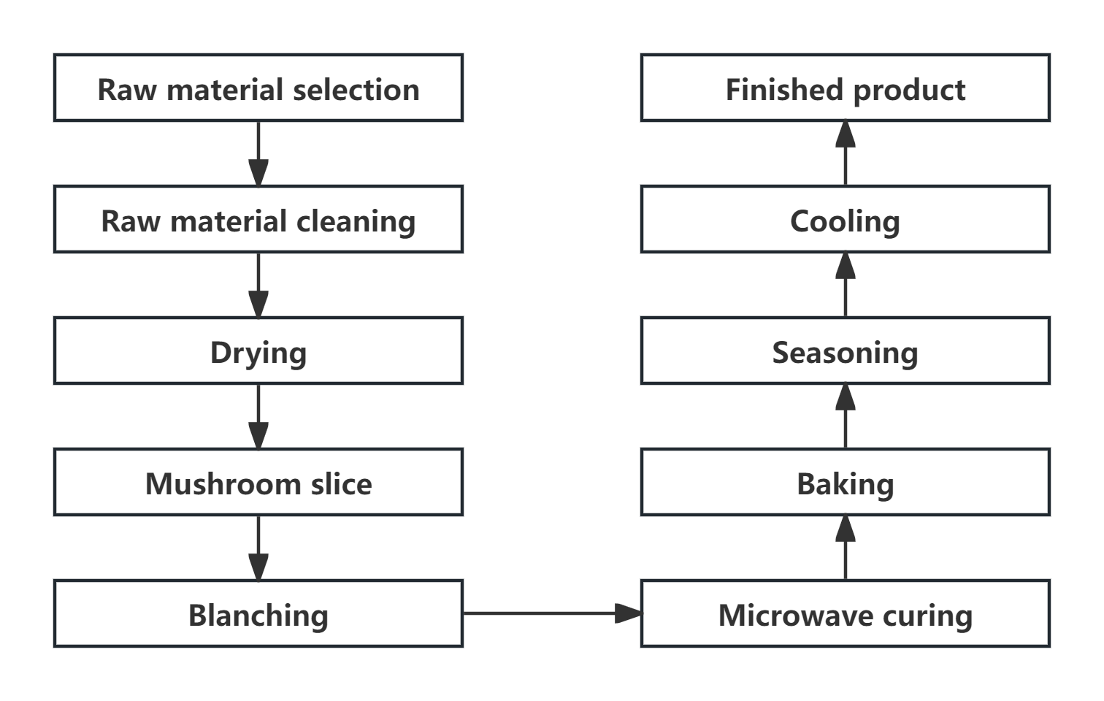
Fig. 1: Process flow diagram

2.3.2.Operation points
Pretreatment of raw materials: Select fresh Agaricus bisporus with no mildew, no mildew points, no foreign matter, no odor, complete shape, consistent size, and bright color. Remove the stipe. Use mushrooms from the same manufacturer to minimize differences in batch and quality that may affect test results.
Cleaning of A. bisporus: Wash the required amount of A. bisporus under flowing water. Make sure all impurities, such as sediment and stains, are thoroughly washed off the surface.
Drain: Place the washed Agaricus bisporus on a drain rack. Let it drain until no noticeable water stains remain on the surface.
Agaricus bisporus slices: Clean and dry the stainless steel kitchen knife. Cut the dehydrated Agaricus bisporus into uniform slices with a thickness of 1.5–3.5 mm.
Blanching: Pour the correct amount of water into the cooking pot and heat it to 80°C. Place the sliced Agaricus bisporus in the pot. Start timing with a timer and control the blanching time at 20–30 seconds.
Microwave curing: Use a leaky spoon to remove the blanched Agaricus bisporus slices. Lay them on a board. Dry the surface moisture with kitchen paper. Tilt the slices on a microwave rack and place them in the microwave oven. Adjust the power to microwave-dry the Agaricus bisporus slices to a water content of less than 20%.
Baking: The microwave-ripened Agaricus bisporus slices were laid flat on a preheated baking tray brushed with a thin layer of oil, placed evenly, and then baked in the oven. The baking temperature and baking time were adjusted. After baking, remove the Agaricus bisporus chips.
Flavoring: 5g of cumin powder, five-spice powder, monosodium glutamate, white granulated sugar, white sesame, salt, and pepper powder were weighed using a balance. The above-mentioned flavorings were then ground into a powder in the cooking machine for use as a flavoring powder. Remove the Agaricus bisporus crisps from the baking tray while they are still hot, and evenly sprinkle the prepared seasoning powder over them.
2.4.Single factor test
Taking slice thickness, baking temperature, baking time, and microwave power as single-factor variables, single-factor experiments were conducted in turn according to the process flow. The effects of different single factors on the sensory score of non-fried Agaricus bisporus chips were analyzed with sensory score as the evaluation index. The single-factor experiment design is shown in Table 1. SPSS 27 software was used to analyze the significance.
Table 1 Single factor experiment design
Test order | Test factor | Level test | Requirements
1 | Slice thickness / mm | 1.5、2.0、2.5、3.0、3.5 | Other variables are constant
2 | Baking temperature / °C | 30、35、40、45、50 | The optimal slice thickness and baking time conditions remain unchanged.
3 | Baking time / min | 30、35、40、45、50 | The optimum slice thickness and baking temperature conditions remain unchanged.
4 | Microwave power / kW | 0.5、1.0、1.5、2.0、2.5 | The optimal slice thickness, baking temperature and baking time conditions remain unchanged.
2.5.Response surface test
Based on the factor test results and the Box-Behnken principle, slice thickness (A), baking temperature (B), baking time (C), and microwave power (D) were chosen as key independent variables. Sensory score (Y) served as the response variable. The response surface test used four factors at three levels to optimize process parameters for non-fried Agaricus bisporus chips. Table 2 shows the factors and levels for this test.
Table 2 Response surface test factor level table
Level | Factors
Level | A:Slice thickness / mm | B:Baking temperature / °C | C:Baking time / min | D:Microwave power / Kw
-1 | 2.0 | 35 | 35 | 1.0
0 | 2.5 | 40 | 40 | 1.5
1 | 3.0 | 45 | 45 | 2.0
2.6.Sensory evaluation standard of non-fried Agaricus bisporus chips
The sensory evaluation of non-fried Agaricus bisporus chips was designed to reflect the specific characteristics of the product. Ten qualified evaluators, meeting the psychological and physiological criteria for sensory assessment, conducted a professional evaluation. Each evaluator used a 100-point sensory evaluation scale, with the average of their scores representing the final result. The standards used for sensory evaluation are detailed in Table 3.
Table 3 Sensory evaluation table of non-fried Agaricus bisporus chips
Sensory index | Scoring rules | Sensory score
Appearance( out of 25 points) | The shape is complete, the thickness is uniform, and there is no debris.  The shape is slightly damaged, the thickness is generally uniform, and there is slight debris.  The shape is seriously damaged, the thickness is extremely uneven, and there is more debris. | 17~25分  9~16分  1~8分
Color(out of 25 points) | The color is uniform and bright.  The color is more uniform, and the luster is dim.  Uneven color, no luster | 17~25分  9~16分  1~8分
Taste and taste( out of 25 points ) | The taste is crispy  The taste is general  Poor taste | 17~25分  9~16分  1~8分
Organizational Structure (out of 25 points ) | General organizational structure  Poor organizational structure  Poor organizational structure | 17~25分  9~16分  1~8分
2.7 Detection of volatile substances
The DVB/CAR/PDMS solid-phase microextraction head was aged at 270 ℃ for 60 min at the inlet of the gas chromatograph. A total of 3 g of Agaricus bisporus samples was accurately weighed, placed in a 15 mL headspace extraction bottle, sealed with a silicone pad lined with polytetrafluoroethylene, and then placed in a 60 ℃ water bath for 20 min to achieve equilibrium. The activated SPME extraction fiber head was inserted into the headspace extraction bottle, and the fiber head was pushed out. The distance between the Agaricus bisporus's upper surface and the fiber head's lower end was 0.5 cm. After headspace adsorption for 50 min, the extraction head was inserted into the GC inlet and thermally desorbed at 250 ℃ for 10 min.
GC conditions: DB-5MS capillary column (60 m × 1 mm × 0.32 μm); the initial temperature was maintained at 50 ℃ for 2 min, and then increased to 220 ℃ at 4 ℃/min for 10 min. The carrier gas was helium, the flow rate was 1.5 mL/min, the inlet temperature was 250 ℃, and the injection was not split.
MS conditions: ion source temperature 250 ℃, ionization mode (EI), electron energy 70 eV, mass spectrometry interface temperature 250 ℃, scanning range (m/z) 30-550 u.
Spectral analysis: The total ion chromatogram peak was analyzed, combined with NIST Library mass spectrometry library matching, artificial spectrum analysis, and retention index RI value comparison. A qualitative analysis was performed, and the chemical structure with the highest comprehensive matching degree was selected as the final result. The percentage content was calculated using the area normalization method.
3.Results and analysis
3.1.Single factor test results
3.1.1.Effect of slice thickness on the quality of non-fried Agaricus bisporus chips
The effect of different slice thicknesses on the sensory score of Agaricus bisporus chips is shown in Fig.2. The sensory score of Agaricus bisporus chips increased first and then decreased with the change of slice thickness. When the slice thickness was 2.5 mm, the sensory score was the highest, reaching 97 points. After that, the sensory score decreased with increasing slice thickness. The reason is that when the thickness of Agaricus bisporus slices is controlled below 2.5mm, excessively long baking times can lead to hardening of the tissue structure, resulting in a brittle texture and a shrinking appearance, which affects the overall quality evaluation of the finished product. On the contrary, when the slice thickness exceeds 2.5mm, the corresponding baking time cannot achieve the ideal brittleness. As a result, the finished product has a soft texture, poor chewiness, and is prone to sticking to teeth. These factors work together to reduce the comprehensive evaluation of the finished product. It can be seen from Fig. 2 that the slice thickness of 2.5mm was significantly different from that of 2.0mm (P<0.05), and the slice thickness of 2.5mm was significantly different from those of 1.5mm, 3.0mm, and 3.5mm (P<0.001). At the same time, there was no significant difference between the slice thicknesses of 3.0 mm and 1.5 mm, 2.0 mm and 3.5 mm. In summary, the best thickness of the chip is 2.5mm.
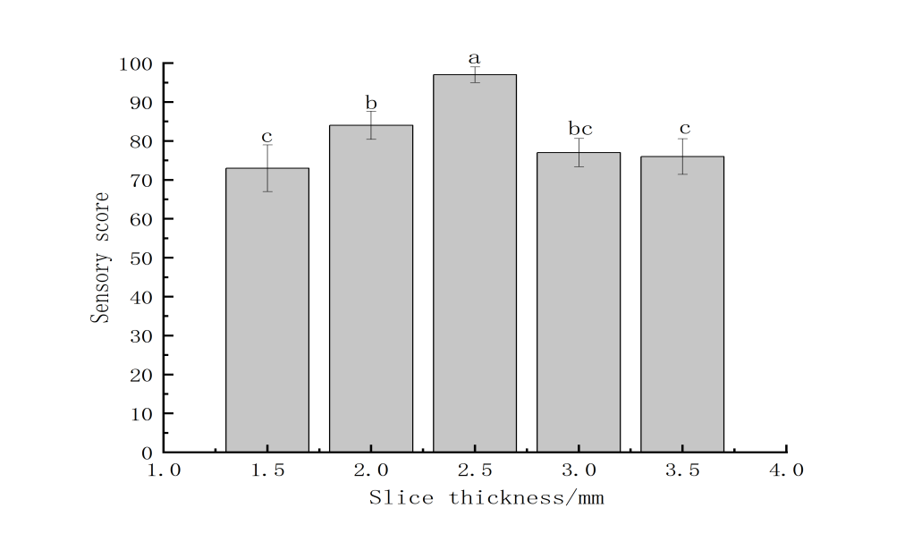
Fig. 2 Effect of slice thickness on the quality of non-fried Agaricus bisporus chips
3.1.2.Effect of baking temperature on the quality of non-fried Agaricus bisporus chips
The effect of different baking temperatures on the sensory score of Agaricus bisporus chips is shown in Fig.3. When the thickness of Agaricus bisporus slices was 2.5mm and the baking time was kept unchanged for 40 min, the sensory score of Agaricus bisporus chips increased first and then decreased with the change of baking temperature. At a baking temperature of 40°C, the sensory score was the highest, at 95 points. Subsequently, the sensory score decreased significantly as the baking temperature increased. This is mainly because when the baking temperature is below 40 °C, the moisture in the chips fails to meet the requirements under the same baking time, resulting in a soft taste and poor brittleness. Under high temperature conditions, the crisps are coking, affecting the finished product's appearance and sensory score. According to the analysis of Fig. 3, the baking temperature of 40°C was significantly different from that of 35°C (P<0.05), and the baking temperature of 40°C was significantly different from those of 30°C, 45 °C, and 50 °C (P<0.001). In summary, the baking temperature of 40 °C is the best baking condition.
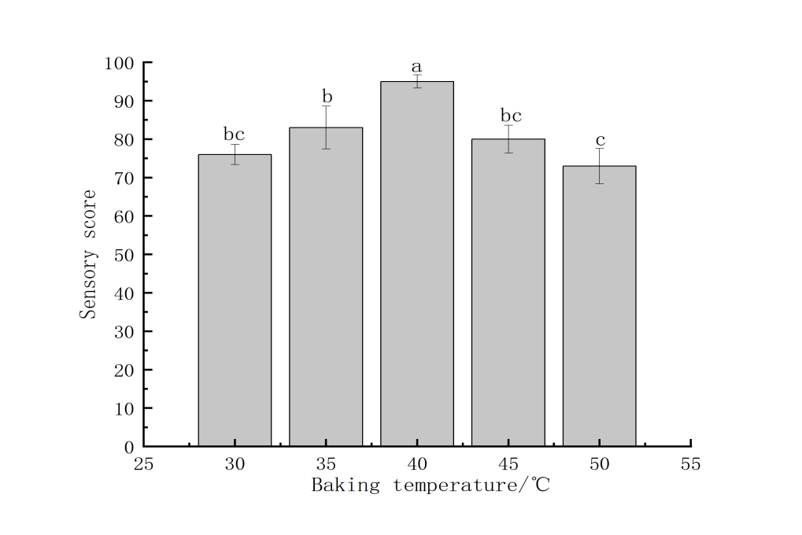
Fig. 3 Effect of baking temperature on the quality of non-fried Agaricus bisporus chips
3.1.3.Effect of baking time on the quality of non-fried Agaricus bisporus chips
The effect of different baking times on the sensory score of Agaricus bisporus chips is shown in Fig.4. When the slice thickness was 2.5 mm and the baking temperature was kept at 40 °C, the sensory score of Agaricus bisporus chips increased with the extension of time. When baking was 40 minutes, the sensory score reached its highest, 96 points. Thereafter, with the extension of time, the sensory score decreased significantly. This is because when the baking time is less than 40 min, under the same baking temperature conditions, due to the lack of baking time, the moisture content in the Agaricus bisporus chips is too high and the taste is soft, and the color does not meet the finished product standard; when the baking time was more than 40 min, the overall quality of Agaricus bisporus chips was poor, the color was dark, and the paste taste was produced. According to Figure 4, the difference between baking times of 40 min and 30 min, 50 min was highly significant (P<0.001), and the difference between baking times of 40 min and 35 min, 45 min was significant (P<0.05). At the same time, there was no significant difference in baking time between 35 min, 30 min, and 45 min. The best time for baking Agaricus bisporus chips is 40 minutes.
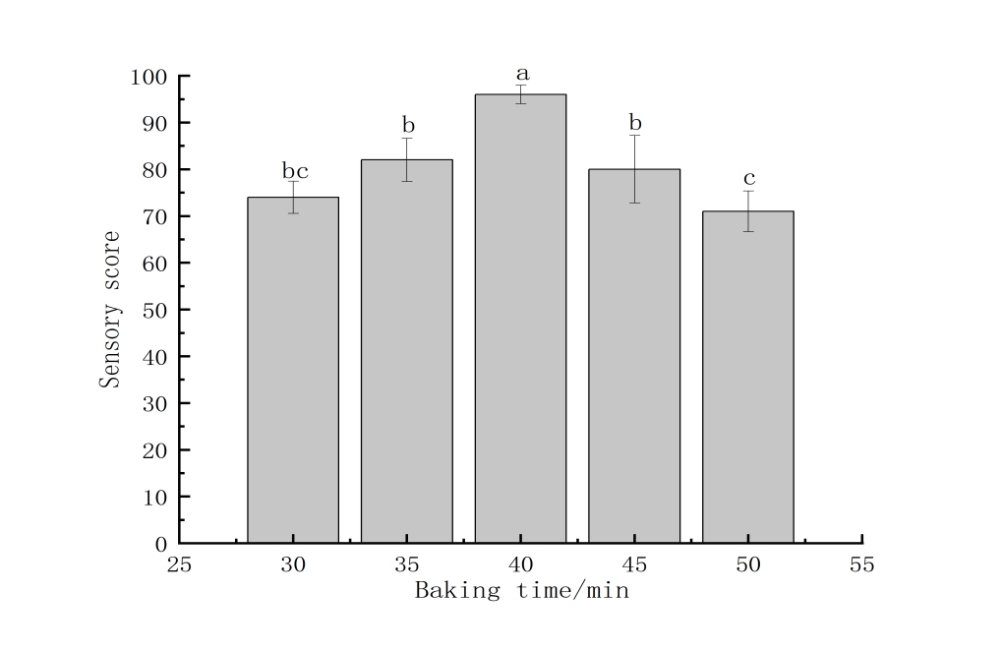
Fig. 4 Effect of baking time on the quality of non-fried Agaricus bisporus chips
3.1.4.Effect of microwave power on the quality of non-fried Agaricus bisporus chips
The effect of different microwave powers on the sensory score of non-fried Agaricus bisporus crisp skin is shown in Fig.5. When the slice thickness was 2.5 mm, the baking temperature was 40 °C, and the baking time was 40 min, the sensory score of Agaricus bisporus chips increased first and then decreased with the increase of microwave power. When the microwave power reached 1.5 kW, the sensory score was the highest, which was 97 points. This is because the Agaricus bisporus does not reach the appropriate drying degree when the microwave intensity is too small. When the microwave intensity is high, it reduces the water content of the chips excessively, resulting in dehydration and destruction of their integrity, which in turn reduces the product's flavor. It can be seen from Fig. 5 that the microwave power of 1.5kW was significantly different from 0.5kW, 2.0kW, and 2.5kW (P < 0.001), and significantly different from 1.0kW (P<0.05). At the same time, there was no significant difference in the microwave power of 0.5kW, 2.0kW, and 2.5kW. In summary, the microwave power suitable for baking Agaricus bisporus chips is 1.5 kW.
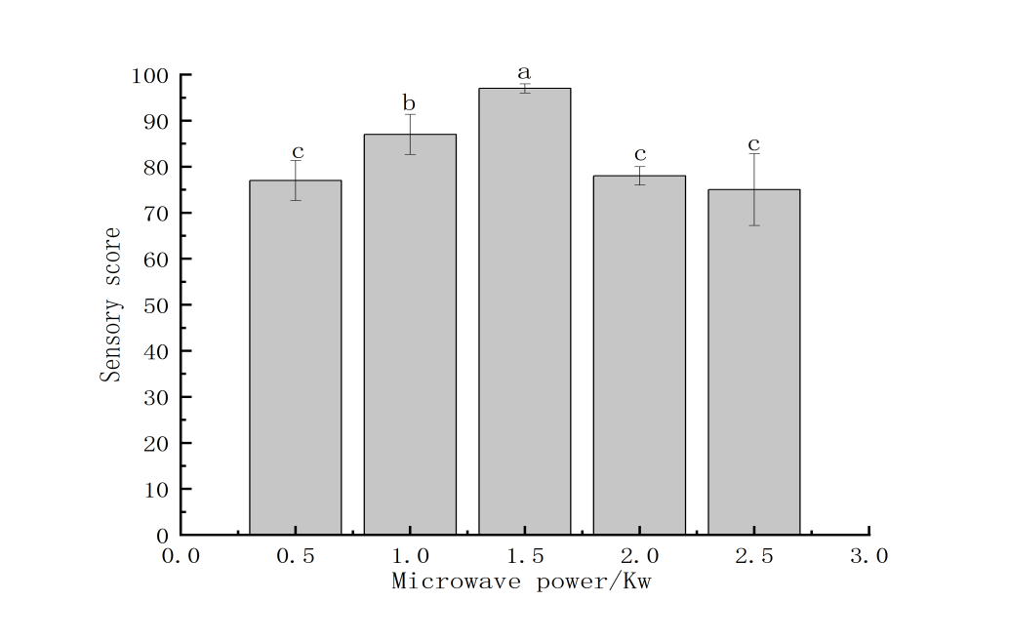
Fig. 5 Effect of microwave power on the quality of non-fried Agaricus bisporus chips
3.2 Response surface optimization test results
The results of the response surface test are shown in Table 6. Design-expert13 software was used to perform multiple regression fitting analysis on the table 6 data, and a quadratic regression equation was established:
Y=91.20+4.25A+3.50B+3.92C+2.17D-1.5AB-1.75AC-1.50AD-1.25BC-0.2500BD+0.2500CD-4.56A²-6.18B²-5.31C²-7.18D²
Table 4 Response surface test results
Test number | Factors |  |  |  | Sensory score
Test number | A | B | C | D | Sensory score
1 | -1 | -1 | 0 | 0 | 72
2 | 1 | -1 | 0 | 0 | 83
3 | -1 | 1 | 0 | 0 | 81
4 | 1 | 1 | 0 | 0 | 86
5 | 0 | 0 | -1 | -1 | 73
6 | 0 | 0 | 1 | -1 | 80
7 | 0 | 0 | -1 | 1 | 77
8 | 0 | 0 | 1 | 1 | 85
9 | -1 | 0 | 0 | -1 | 71
10 | 1 | 0 | 0 | -1 | 83
11 | -1 | 0 | 0 | 1 | 80
12 | 1 | 0 | 0 | 1 | 86
13 | 0 | -1 | -1 | 0 | 72
14 | 0 | 1 | -1 | 0 | 82
15 | 0 | -1 | 1 | 0 | 81
16 | 0 | 1 | 1 | 0 | 86
17 | -1 | 0 | 0 | 0 | 70
18 | 1 | 0 | 0 | 0 | 82
19 | -1 | 0 | 0 | 0 | 83
20 | 1 | 0 | 0 | 0 | 88
21 | 0 | -1 | 0 | -1 | 72
22 | 0 | 1 | 0 | -1 | 80
23 | 0 | -1 | 0 | 1 | 75
24 | 0 | 1 | 0 | 1 | 82
25 | 0 | 0 | 0 | 0 | 93
26 | 0 | 0 | 0 | 0 | 89
27 | 0 | 0 | 0 | 0 | 92
28 | 0 | 0 | 0 | 0 | 92
29 | 0 | 0 | 0 | 0 | 90
The significance of the model is verified. The variance analysis of the regression model is shown in Table 5, and the reliability analysis of the regression model is shown in Table 6.
Table 5 Regression model analysis of variance table
Source of variance | Sum of squares | degree of freedom | mean square | F value | P value | Significance
Model | 1230.32 | 14 | 87.88 | 42.84 | <0.0001 | **
A | 216.75 | 1 | 216.75 | 105.67 | <0.0001 | **
B | 147.00 | 1 | 147.00 | 71.67 | <0.0001 | **
C | 184.08 | 1 | 184.08 | 89.74 | <0.0001 | **
D | 56.33 | 1 | 56.33 | 27.46 | 0.0001 | **
AB | 9.00 | 1 | 9.00 | 4.39 | 0.0549
AC | 12.25 | 1 | 12.25 | 5.97 | 0.0284 | *
AD | 9.00 | 1 | 9.00 | 4.39 | 0.0549
BC | 6.25 | 1 | 6.25 | 3.05 | 0.1028
BD | 0.2500 | 1 | 0.2500 | 0.1219 | 0.7322
CD | 0.2500 | 1 | 0.2500 | 0.1219 | 0.7322
A² | 134.78 | 1 | 134.78 | 65.71 | <0.0001 | **
B² | 248.00 | 1 | 248.00 | 120.91 | <0.0001 | **
C² | 182.78 | 1 | 182.78 | 89.11 | <0.0001 | **
D² | 334.70 | 1 | 334.70 | 163.18 | <0.0001 | **
Residual term | 20.25 | 14 | 2.05
Misfit term | 10.25 | 10 | 1.79 | 0.6636 | 0.7277
Pure error | 10.00 | 4 | 2.70
Total deviation | 2373.06 | 28
Note：* * P < 0.001 means extremely significant ; * P < 0.05 means significant.
Table 6 Credibility analysis of regression model
Project | Average of response surface results | R²/% | R²_{Adj}/% | Coefficient of variation of Y /%
Results | 81.59 | 97.72 | 95.40 | 1.76
According to the results in Tables 5 and 6, a response model is obtained, indicating that the model is reliable. The correlation coefficient R² is 97.72%, indicating that the theoretical value and the actual value of the fit are good, the correlation is high, and the data are accurate and reliable. The modified correlation coefficient R²Adj is 95.40%, indicating that the model can explain 95.40% of the response value change. According to the results of the variance analysis of the regression model, it can be seen that the first term (A, B, C, D) and the second term (A², B², C², D²) have a highly significant impact on the results (P<0.001). The interaction term AC has a significant impact on the results (P<0.05). According to the F-value, the order of influence degree of each factor on the sensory score can be judged as follows: slice thickness (A) > baking time (C) > baking temperature (B) > microwave power (D).
3.3.Response surface analysis of non-fried Agaricus bisporus chips
To further elucidate the model's findings, the contour lines and response surface diagrams of slice thickness, baking temperature, baking time, and microwave power effects on the sensory score of non-fried Agaricus bisporus chips were obtained through regression simulation. The steepness of the response surface was positively correlated with the significance of the effects of various factors on the sensory score of non-fried Agaricus bisporus chips. The shape of the contour map and the intensity of the axis change were related to the strength of the interaction. From Figure 6, it can be seen that the response surface 3D diagram of AC has a large and steep bending amplitude, and the contour map shows an approximate oval shape, indicating that the interaction between slice thickness and baking time is significant (P<0.05); the response surface 3D map of AB, AD, BC, BD and CD was gentle, and the contour line was nearly circular, indicating that the interaction was not significant, which was consistent with the results of variance analysis.
Following this comprehensive analysis, a digital model was established using Design-expert13 software, which determined the optimal process conditions for the model as follows: slice thickness, 2.5 mm; baking temperature, 40 ℃; baking time, 40 min; and microwave power, 1.5 kW. Under the optimal parameter configuration, the sensory score calculated by the prediction model was 93 points. Through the verification test, the real sensory score of the non-fried Agaricus bisporus chips made according to the optimal process parameters was 91 points. This result was highly consistent with the predicted value, indicating that the optimized non-fried Agaricus bisporus chips were reliable and reasonable.
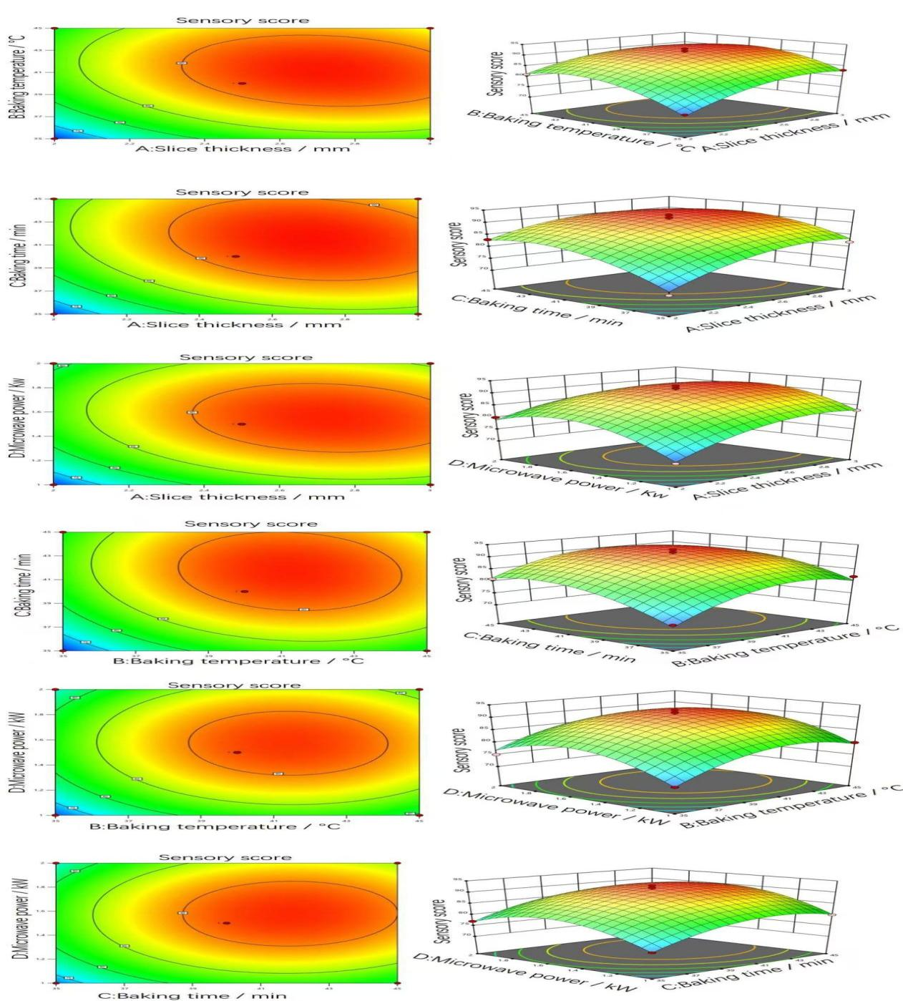
Fig. 6 Contours and response surface plots of the interaction of various factors on the sensory score of non-fried Agaricus bisporus chips
3.4 Analysis of volatile compounds
GC-MS identified 78 volatile compounds, including alcohols (14), aldehydes (11), ketones (12), esters (3), alkanes and heterocyclic compounds (11), pyrazines (16), and other compounds (11).
The formation of pyrazine compounds is related to the Maillard reaction between amino acids and reducing sugars, which is crucial to the unique aroma of many heat-treated products. As shown in Table 7, the highest levels of pyrazine compounds were detected in Agaricus bisporus samples subjected to microwave-hot air drying. This finding may explain the special roasted flavor observed in these samples. In contrast, no pyrazine compounds were detected in fresh Agaricus bisporus samples.
Table 7 GC-MS analysis results of fresh Agaricus bisporus and microwave-hot air dried Agaricus bisporus
nameofcompound | Relativecontent/%
nameofcompound | Fresh Agaricus bisporus | Fresh Agaricus bisporus
Pyrazine | - | -
2,5-Dimethylpyrazine | ND | 5.10
2-Ethyl-6-methyl-pyrazine | ND | 2.57
2,3,5-trimethylpyrazine | ND | 3.50
2-Ethyl-5-methylpyrazine | ND | 2.39
2- ( 1-methylvinyl ) -pyrazine | ND | 0.50
3-Ethyl-2,5-dimethyl-pyrazine | ND | 5.85
2-Ethyl-3,5-dimethylpyrazine | ND | 0.60
2,3-Diethyl-5-methylpyrazine | ND | 1.22
3,5-Diethyl-2-methylpyrazine | ND | 1.30
2,5-Dimethyl-3- ( 2-methylpropyl ) pyrazine | ND | 0.75
2-Methyl-5-[(E)-1-propenyl] pyrazine | ND | 0.60
2-Methyl-6-(3-methylbutyl) -pyrazine | ND | 2.90
Pyrazine,2,5-dimethyl-3-( 3-methylbutyl ) | ND | 3.15
Pyrazine,2,3,5-trimethyl-6-( 2-methylbutyl ) | ND | 0.61
3-Ethyl-2-methylpyrazine | ND | ND
2-Acetylpyrazine | ND | ND
Total content of pyrazine compounds | 0 | 31.04
Note : ND indicates that no substance was detected.
4. Discussion
The present study demonstrated that response surface methodology (RSM) is an effective tool to optimize the processing of non-fried Agaricus bisporus crisps. Similar to prior snack development studies, RSM allowed us to assess the interactive effects of multiple factors on textural and sensory outcomes with fewer experimental trials, supporting its reliability in food process optimization (Özgün Köprüalan Aydın et al., 2025;Nuño S A Y et al., 2025). The observed importance of slice thickness and baking time in determining crispness and acceptability is consistent with findings in extruded and puffed healthy snacks, where product structure and water loss kinetics are key determinants of final texture (Lee C P, Hashimoto M., 2024; Deshmukh P et al., 2024).
Flavor analysis revealed 78 volatile compounds, with alcohols and aldehydes being dominant. This is in agreement with recent reports on mushroom drying, where aldehydes such as hexanal and nonanal, products of lipid oxidation, are primary contributors to green and fatty notes (Zheng C et al., 2024;Barroetaveña C et al., 2024). Alcohols have also been identified as critical for maintaining the fresh mushroom-like aroma, particularly under low-temperature processing conditions (Xie L et al., 2024). Notably, our process also led to the formation of pyrazines, which contribute roasted and nutty notes. Similar findings were observed in fried Agaricus bisporus, where pyrazines were identified as key aroma-active compounds (Nie T et al., 2025). Pyrazines are typically associated with Maillard reactions occurring under reduced water activity and thermal input, and their presence in our non-fried crisps suggests that microwave-assisted drying effectively facilitates mild Maillard chemistry (Ai R et al., 2024).
The combined influence of microwave power and moderate hot-air baking was crucial in balancing structural dehydration and flavor retention. Literature on mushroom and plant-based snack drying confirms that mild thermal treatments preserve delicate volatiles while enabling sufficient Strecker degradation and Maillard reactions to generate desirable aroma complexity (Gómez I et al., 2022; Zhang L et al., 2021). Our optimal parameters (2.5mm thickness, 40min, 40°C, 1.5kW) fall within this favorable range, yielding crisps with both high sensory acceptance and retained nutritional value.
The results also align with recent work on healthier snack alternatives, where optimization studies emphasized that thinner slices and moderate drying enhance crispness without excessively increasing hardness, thereby improving consumer acceptance (Deshmukh et al., 2024; Aydın et al., 2025). By situating our findings within this growing body of research, it becomes evident that integrating RSM with GC–MS is a powerful approach to design non-fried snacks that achieve both textural excellence and a balanced flavor profile. This highlights the potential of mushroom-based crisps as a competitive healthy snack option.

5.Conclusion
In this experiment, we improved the process for non-fried Agaricus bisporus chips using single-factor and response surface tests. We took these steps: chose raw materials, blanched the slices, microwaved them, cured them, and baked them. The optimal parameters were: slice thickness, 2.5mm; baking temperature, 40°C; baking time, 40min; and microwave power, 1.5kW. The final product was a yellow-brown color, maintained its shape, remained uniform in thickness, had a bright appearance, and was crisp and delicate. It had the unique smell of Agaricus bisporus and great sensory quality. The chips had high nutritional value, a crisp texture, and a rich flavor. They are a good snack for all ages.
After microwave-hot air drying, Agaricus bisporus samples had low shrinkage and high rehydration rates. Their physical quality changed little, and nutritional components were well retained. Compared to fresh Agaricus bisporus, dried samples had looser tissue and better physical properties. They also had more essential amino acids, especially umami and sweet amino acids. The content of pyrazine compounds was higher, giving a unique fragrance. This new drying method is well-suited for Agaricus bisporus production.

Declaration of conflicting interests
“The authors declare no potential conflicts of interest with respect to research, authorship and/or publication of this article.”

COMPETING INTERESTS DISCLAIMER:
Authors have declared that they have no known competing financial interests OR non-financial interests OR personal relationships that could have appeared to influence the work reported in this paper.

Disclaimer (Artificial intelligence)
Author(s) hereby declare that NO generative AI technologies such as Large Language Models (ChatGPT, COPILOT, etc.) and text-to-image generators have been used during the writing or editing of this manuscript.

References
Faostat F A O. Crops and livestock products[J]. Statistics Division, Food and Agriculture Organization of the United Nations: Rome, Italy, 2022.
Roupas P, Keogh J, Noakes M, et al. The role of edible mushrooms in health: Evaluation of the evidence[J]. Journal of functional foods, 2012, 4(4): 687-709.https://doi.org/10.1016/j.jff.2012.05.003
Dawadi E, Magar P B, Bhandari S, et al. Nutritional and post-harvest quality preservation of mushrooms: A review[J]. Heliyon, 2022, 8(12).https://doi.org/10.1016/j.heliyon.2022.e12093
Zhang L, Zhang M, Mujumdar A S. Development of flavor during drying and applications of edible mushrooms: A review[J]. Drying Technology, 2021, 39(11): 1685-1703.https://doi.org/10.1080/07373937.2021.1875231
Zhang M, Tang J, Mujumdar A S, et al. Trends in microwave-related drying of fruits and vegetables[J]. Trends in Food Science & Technology, 2006, 17(10): 524-534.https://doi.org/10.1016/j.tifs.2006.04.011
Ratti C. Hot air and freeze-drying of high-value foods: a review[J]. Journal of food engineering, 2001, 49(4): 311-319.https://doi.org/10.1016/S0260-8774（00）00228-4
Celen S, Kahveci K, Akyol U, et al. Drying behavior of cultured mushrooms[J]. Journal of Food Processing and Preservation, 2010, 34(1): 27-42. https://doi.org/10.1111/j.1745-4549.2008.00300.x
Maskan M. Drying, shrinkage and rehydration characteristics of kiwifruits during hot air and microwave drying[J]. Journal of food engineering, 2001, 48(2): 177-182.https://doi.org/10.1016/S0260-8774（00）00155-2
Zhao Y, Gao R, Zhuang W, et al. Combined single-stage tempering and microwave vacuum drying of the edible mushroom Agrocybe chaxingu: Effects on drying characteristics and physical-chemical qualities[J]. LWT, 2020, 128: 109372.https://doi.org/10.1016/j.lwt.2020.109372
Giri S K, Prasad S. Optimization of microwave-vacuum drying of button mushrooms using response-surface methodology[J]. Drying Technology, 2007, 25(5):901-911.https://doi.org/10.1080/07373930701370407

Özgün Köprüalan Aydın,Nurcan Koca,Mehmet Koç,et al.Process Optimization and Storage Evaluation of Explosion Puffing Dried Reduced-Fat White Cheese Snacks.[J].Journal of food science,2025,90(7):e70353.https://doi.org/10.1111/1750-3841.70353
Nuño S A Y ,Nuño K ,Preciado M H A , et al.Design and Optimization of a Second-Generation Extruded Snack Using Carrot Waste, Blue Corn Flour, and Ellagic Acid as Functional Ingredients[J].Foods,2025,14(10):1657-1657.https://doi.org/0.3390/FOODS14101657
Lee C P, Hashimoto M. Prediction of textural properties of 3D-printed food using response surface methodology[J]. Heliyon, 2024, 10(7).https://doi.org/10.1016/j.heliyon.2024.e27658
Deshmukh P, Patil D, Bhalerao P P, et al. Optimization & characterization of chips developed from cabbage powder, maize and rice flour using simplex lattice mixture design[J]. Food Chemistry Advances, 2024, 5: 100787.https://doi.org/10.1016/j.focha.2024.100787
Zheng C, Li J, Liu H, et al. Effect of drying temperature on composition of edible mushrooms: Characterization and assessment via HS-GC-MS and IR spectral based volatile profiling and chemometrics[J]. Current Research in Food Science, 2024, 9: 100819. https://doi.org/10.1016/j.crfs.2024.100819
Barroetaveña C ,González C G ,Calvo T E , et al.Sensory Characteristics and Volatile Organic Compound Profile of Wild Edible Mushrooms from Patagonia, Argentina[J].Foods,2024,13(21):3447-3447. https://doi.org/10.3390/FOODS13213447
Xie L, Guo S, Rao H, et al. Characterization of volatile flavor compounds and aroma active components in button mushroom (Agaricus bisporus) across various cooking methods[J]. Foods, 2024, 13(5): 685.https://doi.org/10.3390/FOODS13050685
Nie T, Gao Y, Gao Y, et al. Potential effect of key aroma-active compounds identified from fried white mushrooms (Agaricus bisporus L.) on saltiness perception[J]. Food Chemistry, 2025: 145155.https://doi.org/10.1016/j.foodchem.2025.145155
Ai R ,Yuan Z ,Yu B , et al.Pyrazines in food samples: Recent update on occurrence, formation, sampling, pretreatment and analysis methods[J].Food Chemistry,2024,430137086-137086.https://doi.org/10.1016/J.FOODCHEM.2023.137086
Gómez I, Lavega González R, Tejedor-Calvo E, et al. Odor profile of four cultivated and freeze-dried edible mushrooms by using sensory panel, electronic nose and GC-MS[J]. Journal of Fungi, 2022, 8(9): 953.https://doi.org/10.3390/jof8090953
Zhang L, Zhang M, Mujumdar A S. Development of flavor during drying and applications of edible mushrooms: A review[J]. Drying Technology, 2021, 39(11): 1685-1703.https://doi.org/10.1080/07373937.2021.1875231

