Efficacy of Ash Concentration in Dry Fruit Storage of Capparis decidua (Kair): An Important Underutilised and Multipurpose Shrub of the Hot Arid Region of India

Abstract

Capparis decidua (Forssk.) Edgew., commonly known as Kair, is a desert-adapted shrub valued for its nutritional and medicinal properties. Kair is highly valued for its medicinal properties, providing benefits in managing diabetes, rheumatism, hypertension, vomiting, inflammation, and cardiac issues. Due to its seasonal availability, it is essential to process or preserve Kair for off-season use when other vegetables are scarce. Due to its seasonal availability, effective preservation methods are essential to ensure year-round utilisation. The present study aimed to evaluate and standardise traditional ash-based preservation techniques for dried Kair while assessing their efficacy in maintaining quality and minimising adulteration risks. The experiment was conducted in a completely randomised design (CRD). Treatments included sun-drying, blanching, and the use of ash at varying concentrations (5–20%), with parameters assessed over two years. Significant differences were observed in moisture content and weight loss across treatments, with T4 (blanched and sundried + 15% wood ash) demonstrating the least deterioration and best stability. Insect incidence was notably high in untreated samples (T1, T2), whereas ash-based treatments (T4–T6) recorded zero infestations over both years. Sensory evaluations revealed that T4 achieved the highest overall acceptability (mean score: 4.46), whereas excessive ash levels led to minor declines in sensory appeal. The results affirm that ash, especially at 15% concentration combined with blanching and sun drying, is effective in preserving dried Kair. The study supports the valuable traditional method of preservation and advocates against adulteration (e.g., plaster of Paris), and offers a standardised approach to safe, sustainable preservation. The study highlights the superior performance of treatments combining blanching, sundrying and wood ash, particularly T4 (blanched and sundried + 15% ash), in preserving moisture, minimising weight loss, and preventing insect infestation during storage of Capparis decidua (Kair) dry fruits.

Keywords: Capparis decidua, preservation, blanching, ash, traditional techniques, Sensory evaluations
Introduction
Capparis decidua, commonly known as Karirawhich is used as folk medicine and herbalism, is grown in drought-resistant areas. From the prior studies, it was evident that Capparis decidua possesses sterols, fatty acids, flavones and alkaloids. Thus, the plant Capparis decidua was chosen to enable better results (Thana Lakshme et al., 2020). Capparis decidua (Forssk.) Edgew., also known as the Caper tree, Karira, Kair, or Ker, is a versatile perennial woody plant belonging to the Capparaceae family. Kair, an original desert plant, thrives in the wild with minimal care. This straggling shrub produces berry-like fruits seasonally during April to May and October to November, and can be found in regions such as west Rajasthan, Gujarat, Punjab, Uttar Pradesh, and Haryana (Chandra et al., 1994). Many food-value plant species in forests produce edible leaves, fruits, seeds, roots, and rhizomes, among other things. Many of these plants are directly useful to humans. Most foods obtained from forests have excellent nutritional content, even though the nutritional value of the majority of these items is not precisely recognised. One of the many edible fruit-bearing and food-producing species found in Rajasthan's dry and semi-arid zones is Capparis decidua (Bhatnagar et al., 2023). Kair is highly valued for its medicinal properties, providing benefits in managing diabetes, rheumatism, hypertension, vomiting, inflammation, and cardiac issues (Goyal and Sharma, 2006). Due to its seasonal availability, it is essential to process or preserve Kair for off-season use when other vegetables are scarce. At the time of the harsh summer season when the temperature rises up to 48 °C and the land becomes barren of herbaceous plants, shrubs of C. decidua are seen to grow gregariously, providing shade to animals. The whole plant, especially its fruit, has medicinal value for cough, asthma, cardiac, rheumatism, asthma, diabetes, liver disorders, hypercholesterolemia, hypertension, microbial infections and many other problems (Bhatnagar et al., 2022). Each processing method affects the quality of the product differently. Preserving Kair (Capparis decidua) effectively ensures its availability during off-seasons. Here are some techniques: Drying: Sun-drying or using a dehydrator can help preserve Kair. The fruits are cleaned, blanched, and then dried until they reach a moisture content of around 10-12%. This method retains most of the nutritional value and extends shelf life but tends to attract storage pests and insect attack. Kair can be pickled using traditional methods. It can be canned in a sugar syrup or brine solution. Although less common, freezing Kair can be an effective preservation method. Fermenting Kair in a salt solution can also be an effective preservation technique; this method not only preserves the fruit but also adds probiotic benefits. These methods help ensure that Kair remains available and nutritious throughout the year (Soni et al, 2022, https://www.agricolbikaner.org/wp-content/uploads/2020/10/L-10-KAIR.pdf ). As an ancient technique, ash is effectively used as a preservative for various types of food across different cultures. The Cherokee people traditionally stored meat in hickory ash, farmers in Africa have preserved tomatoes in wood ash for generations, cheeses like gruyere and cheddar are preserved in wood ash. This method not only extends the shelf life but also imparts a unique flavor to the cheese, salmon and mackerel fish varieties, have been preserved using ash, various vegetables and root crops (Tomato, Carrots, Beets, Potatoes) have been preserved using ash, which helps in maintaining their freshness, preventing spoilage, impart flavor and preserve it (Omojasola et al 2022). Ash preservation that leverages the alkaline properties of wood ash to extend the shelf life of various food items by inhibiting microbial growth, pest deterrent, moisture absorption, nutrient retention, texture and also enhances the flavour (https://oldentech.com/ash-preservation/ ). Ash preservation stands as a testament to the ingenuity of ancient peoples and their ability to harness natural resources for food preservation. It continues to be a valuable technique in understanding the history and evolution of food preservation methods (https://blackhawkvisions.com ). Use of ash as a preservative in dry kair is an ancient technique and is also followed to date, but in the recent past, for financial benefit, people using adulterants in everything, food and food products, is a very easy targets for those culprits. In the case of kair, people are using plaster of paris (https://www.youtube.com/post/Ugkx3Q3WReYLRsomKGcKeXqTTaxzpIK70gKD) as an adulterant, mixing it with the ash in order to increase its weight, shelf life and/or to mimic certain textures. The use of plaster of Paris (POP) as an adulterant in food preservation, particularly in traditional methods like preserving kair with ash, poses significant health risks and is considered illegal under food safety regulations (https://www.fssai.gov.in). But information on the standardisation of kair's preservation using ash and sensory characteristics is limited. Thus, this study was conducted to conserve our traditional method of preservation through its standardisation and to eradicate the use of other adulterants or admixtures which are harmful for consumption to human health.
Materials and Methods
Study site and species
The plants referable to Capparis decidua were grown in a natural tract of the arid and semi-arid zone of Rajasthan. The study was conducted in the laboratory conditions of the Agricultural Research Station, Keshwana, Jalore, Rajasthan. The site is located at a latitude of 25⁰25^{ˈ}58.86^{ˈˈ}N and longitude of 72⁰29^{ˈ}726^{ˈˈ} E, elevation 149.9 msl. Jalore comes under the lower transect in the arid western.
Dry kair fruit preparation
Locally available fresh Kair were collected during April. After cleaning and sorting, Kair were processed by soaking and drying methods. Soaking was carried out for ten days with the changing of water on alternate days. The drying process was continued till the completion of drying (Moisture content 10-12%).

Ash preparation
The dry twigs and branch wood of Azadirachta indica (Neem) and Prosopis cineraria (khjeri) wood collected from an agricultural field were combusted in open air till it is completely burnt. Cool it down, and the ashes were collected, sieved to remove the unburnt wood and other pellets. Store it in a container at room temperature until used in further experimentation.
Preservation formulation (ash concentration) and treatments
Sun dried (T₁) as a control and blanched and sun dried (T₂), ash was added to the blanched and sun dried seeds kept in zipper polythene bags at the concentration of 10%, 15%, 20% and 25% of the seed weight. For 10% concentration, 5 g (T₃), 15% concentration, 7.5 g (T₄), 20% concentration, 10 g (T₅) and for 25% concentration, 12.5 g of wood ash were mixed with 50 g of dry kair fruit (T₆). The experiment was conducted in a completely randomised design (CRD) with three replicates for each combination and stored in zipper polythene bags along with the ash for 24 months at room temperature. After 12 months, the seeds were removed from storage, and preservation techniques were standardised through sensory evaluation on five-point scale.
Visual inspection
Visual inspection of insect pests in the storage condition of dry kair fruit was done as per Table 1.
Sensory evaluation
Organoleptic evaluation was done on the basis of their colour, taste, aroma/odour, texture and overall acceptability on a five-point rating scale from 5= very good, 4= good, 3= satisfactory, 2= poor, 1= very poor (Gupta and Prakash, 2011, and Mehta and Vays, 2013).
Statistical analysis
Results were expressed as the mean± the standard deviation of five reading analyses. All data generated were statistically analysed using one-way Analysis of Variance (ANOVA). Significance was accepted at p<0.05.
Result and discussion
The study evaluated the impact of different concentrations of ash as preservative treatments (T1 to T6) on the moisture content and weight of the dry kair samples across two consecutive years (2023–24 and 2024–25). It showed statistically significant variation among the treatments for moisture content and weight was noticed in both years.

Moisture Content (%) and Weight (g)
Significant variation in moisture content was observed among treatments across both years. In the year 2023–24, the moisture content ranged from 9.1% (T6) to 11.6% (T1), while in 2024–25, it ranged from 9.0% (T6) to 9.9% (T2). A notable reduction in moisture content was recorded for most treatments in 2024–25 compared to the previous year. The highest percentage reduction was observed in T1 (20.26%), followed by T2 (8.33%), indicating significant drying or moisture loss under these treatments (Fig.1.). Similar observations were made, where untreated or poorly processed samples tend to lose moisture rapidly due to lack of protective barriers, leading to instability during storage (Wang and Xi, 2005). Sun-dried or minimally treated samples often lose more moisture over time due to continued desiccation or suboptimal packaging (Obi et al., 2018). Treatments T4, T5, and T6 showed minimal changes in moisture content, suggesting better stability. Treatments involving wood ash and blanching appear to enhance the moisture-retention capacity of samples, likely due to the ash's ability to form a physical barrier against environmental moisture exchange and its possible role in reducing metabolic activity (Ariyamuthu et al., 2022). Low moisture content is essential for extending shelf life, as microbial and enzymatic activities are significantly reduced below the critical moisture threshold (Arévalo-Pinedo & Murr, 2006).
The weight of the samples also varied across treatments and years. In 2023–24, weight ranged from 48.03 g (T1) to 50.0 g (T3), while in 2024–25, it ranged from 42.65 g (T3) to 49.6 g (T5). The most substantial reduction in weight was seen in T3 (14.70%), followed by T2 (12.86%) and T1 (10.99%)(Fig.1.), indicating that these treatments may have led to greater weight loss, possibly due to moisture evaporation, oxidative degradation, or pest-related losses (Swathi et al., 2024). Such losses are often associated with high respiration rates and poor packaging or treatment strategies (Zhao et al., 2025). On the other hand, treatments T4, T5, and T6 maintained weight better, with T4 showing the least weight loss (0.34%) (Fig.2). These results imply that these treatments not only retained moisture better but also resisted structural and biological degradation. This is in line with findings from Ratti (2001), who emphasised the role of pre-treatments and controlled drying in maintaining the physical properties of stored agricultural products. Among all treatments, T4, T5, and T6 exhibited the least variation in both moisture content and weight across the two years, indicating better stability and storage performance. These results are consistent with the findings of Murdock and Margam (2012), who highlighted the importance of integrated traditional treatments such as ash and airtight storage in minimising post-harvest losses²⁰. In contrast, T1 to T3 showed considerable reductions, suggesting these treatments were less effective in preserving the physical properties of the samples over time. The coefficient of variation (C.V.) values for moisture and weight were within acceptable limits, suggesting good reliability and consistency of the experimental data (Gomez & Gomez, 1984).
The data presented in Table 2 offer a comprehensive assessment of insect infestation across different treatments (T1 to T6) over two consecutive years. The key species observed include Lesser Grain Borer (Rhyzopertha dominica), Cigarette Beetle (Lasioderma serricorne), Drug Store Beetle (Stegobium paniceum), Red Flour Beetle (Tribolium castaneum), and a parasitic wasp (Pteromalus venustus) (Fig. 3). Treatments T1 and T2 experienced the highest insect incidence, with multiple pest species present in both years. In the first year, visual inspections rated the pest levels as VF (Very Few/Moderate), but by the second year, infestations increased to LN (Large Numbers) for all species. This progression indicates a decline in pest control effectiveness over time. Untreated or minimally treated stored products are highly susceptible to gradual pest buildup, particularly under favourable environmental conditions (Subramayan and Hagstrum, 1995). Poor processing or storage conditions can exacerbate pest issues in dried products over time (Arthur, 1996). Additionally, the presence of a parasitic wasp was noted from January to March, potentially suggesting some level of natural biological control, though insufficient to suppress pest growth in the following months. Biological control agents such as Pteromalus venustus can contribute to pest suppression, but they often require complementary pest management strategies to be effective (Hagstrum and Subramanyam, 2006). However, this was insufficient to suppress the pest population growth in the warmer months; biological agents are often only partially effective in large-scale storage systems without complementary control measures (Upadhyay and Ahmad, 2011).
Treatment T3 showed no pest incidence in the first year (rated C), with only moderate levels (VF) of three key pest species observed in the second year (Fig. 4). This suggests partial efficacy, likely due to improved storage conditions or the protective role of added ash. Wood ash has traditionally been recognised for its insect-repelling properties due to its alkaline nature and physical deterrent effect (Golob, 1997). T4, T5, and T6 treatments consistently reported no pest incidence (C) across years, signifying excellent pest resistance or protection. The absence of infestation, even after extended storage periods, demonstrates the long-term stability and effectiveness of these treatments in preventing insect invasion. Integrating ash with traditional preservation methods significantly enhances insect resistance in stored products (Hussen, 2021). Ash-based treatments can effectively deter insect colonisation in stored food commodities by altering the microenvironment and creating unfavourable conditions for pests (Krzyżowski et al., 2019). Regarding the temporal occurrence of pests, activity peaked during the warmer months (March to December), while Cigarette Beetles remained active during the colder months (November to January). This seasonal pattern underscores the importance of year-round monitoring, particularly for vulnerable treatments like T1 and T2, it is in concurrence with where scientists emphasised the role of temperature and storage duration in influencing pest dynamics in stored products (Fields and White, 2002). Pest activity linked to ambient temperature is a well-documented phenomenon in stored product entomology (Fields, 1992).
Treatments T1 and T2 demonstrated high vulnerability to pest infestations, with increased pest load in the second year. These treatments are not recommended for long-term storage, echoing earlier studies that recommend avoiding simple sun drying for long-term grain or vegetable storage (Boxall, 2002).
Sensory evaluation
The sensory evaluation of the treated samples showed significant improvement in overall acceptability with the application of blanching and the incorporation of ash (Table 3). The control sample (T1: sun-dried only) recorded the lowest mean score of 2.24, reflecting poor acceptability in colour (2.5), taste (2.2), aroma (2.0), texture (2.3), and overall appeal (2.2). This suggests that sun drying alone is insufficient in retaining desirable sensory qualities. Blanching prior to drying (T2) notably improved all sensory parameters with a mean score of 2.76, indicating enhanced organoleptic properties due to enzyme inactivation and partial removal of surface contaminants. It is evident that blanching improves the colour and texture of dried vegetables (Severini et al., 2016).
The addition of wood ash at various concentrations (T3–T6) further improved the sensory attributes. Treatment T4 (T2 + 15% wood ash, 7.5 g) achieved the highest overall acceptability with a mean score of 4.46, indicating superior scores across colour (4.6), taste (4.5), aroma (4.3), texture (4.5), and overall acceptability (4.4). This trend suggests that wood ash may enhance the flavour profile and textural properties, likely due to mineral fortification and pH modulation that could affect taste and microbial stability during drying. However, increasing wood ash levels beyond 15% (T5 and T6) resulted in a slight decline in sensory scores (mean scores: 4.34 and 4.28, respectively) (Table 3), implying that excessive wood ash may begin to impart undesirable sensory changes. It is observed that moderate levels of alkaline ash in traditional food processing can improve sensory attributes, but excessive levels may lead to bitterness or textural issues³³ (Bergeson et al., 2016). Therefore, blanching followed by the addition of 15% wood ash (7.5 g) is the optimal treatment combination for enhancing the sensory quality of the dried product
Conclusion:
The study highlights the superior performance of treatments combining blanching, sundrying and wood ash, particularly T4 (blanched and sundried + 15% ash), in preserving moisture, minimising weight loss, and preventing insect infestation during storage of Capparis decidua (Kair) dry fruits. These treatments also received the highest sensory evaluation scores, indicating enhanced acceptability in colour, taste, aroma, and texture. In contrast, sun-dried and blanched and sundried treated samples (T1 and T2) showed significant deterioration in quality and increased pest incidence over time. Overall, integrating blanching with moderate wood ash application proves to be an effective, low-cost strategy for improving the storage stability, safety, and consumer appeal of dried Kair fruits preservation for a prolonged period.
Ethical Approval:
As per international standards or university standards written ethical approval has been collected and preserved by the author(s).

Consent
This study included minor sensory evaluation (colour, taste, aroma/odour, texture, and overall acceptability) of Capparis decidua (Kair) dry fruit samples by adult training participants. As the sensory evaluation posed no health risk and was conducted in a training context, all participants were informed about the purpose of the evaluation and voluntarily consented to participate. The study involved minor sensory evaluation of food samples (Capparis decidua dry fruits) by training participants; no patients were involved, all participants were informed about the nature and purpose of the study during a training session. Written informed consent was obtained from all participants before they took part in the evaluation. Participation was entirely voluntary, and no personal or sensitive data were collected.
Permission to Reproduce Material from Other Sources
This manuscript does not contain any material (such as figures, tables, etc.) reproduced from other copyrighted sources. Therefore, no permission was required.
Data availability
The original data generated for the current study have been included in the manuscript. Further inquiries can be directed to the corresponding author.
Disclaimer (Artificial intelligence)
Author(s) hereby declare that NO generative AI technologies such as Large Language Models (ChatGPT, COPILOT, etc.) and text-to-image generators have been used during the writing or editing of this manuscript.

References:
Bergeson, T. L., Opio, C., & MacMillan, P. D. (2016). Crop ash filtrate influence on cooking time and sensory preferences for dried black beans (Phaseolus vulgaris L.). African Journal of Food Science, 10(8), 132-142.
Ariyamuthu, R., Albert, V. R., & Je, S. (2022). An overview of food preservation using conventional and modern methods. Journal of Food and Nutrition Sciences, 10(3), 70-79.
Arévalo-Pinedo, A., & Murr, F. E. X. (2006). Influence of pre-treatments on the drying kinetics during the vacuum drying of carrots. Journal of Food Engineering, 76(4), 539–545. https://doi.org/10.1016/j.jfoodeng.2005.06.023
Arthur, F. H. (1996). Grain protectants: current status and prospects for the future. Journal of Stored Products Research, 32(4), 293–302. https://doi.org/10.1016/S0022-474X(96)00036-7
Boxall, R. A. (2002). Damage and loss caused by the larger grain borer Prostephanus truncatus. Integrated Pest Management Reviews, 7(2), 105–121. https://doi.org/10.1023/A:1026396315550
Fields, P. G. (1992). The control of stored-product insects and mites with extreme temperatures. Journal of Stored Products Research, 28(2), 89–118. https://doi.org/10.1016/0022-474X(92)90017-8
Fields, P. G., and White, N. D. G. (2002). Alternatives to methyl bromide treatments for stored-product and quarantine insects. Annual Review of Entomology, 47, 331–359. https://doi.org/10.1146/annurev.ento.47.091201.145217
Golob, P. (1997). Current status and future perspectives for inert dusts for control of stored product insects. Journal of Stored Products Research, 33(1), 69–79. https://doi.org/10.1016/S0022-474X(97)00002-0
Gomez, K. A., & Gomez, A. A. (1984). Statistical Procedures for Agricultural Research (2nd ed.). John Wiley & Sons.
Hagstrum, D. W., and Subramanyam, B. (2006). Fundamentals of Stored-Product Entomology. AACC International.
https://blackhawkvisions.com/combining-salt-and-ash-preservation-how-apache-hunters-used-3/
https://oldentech.com/ash-preservation/
https://www.askaprepper.com/how-to-preserve-your-food-with-wood-ash/
https://www.fssai.gov.in
https://www.youtube.com/post/Ugkx3Q3WReYLRsomKGcKeXqTTaxzpIK70gKD
Wang, J., & Xi, Y. S. (2005). Drying characteristics and drying quality of carrot using a two-stage microwave process. Journal of food Engineering, 68(4), 505-511.
Upadhyay, R. K., & Ahmad, S. (2011). Management strategies for control of stored grain insect pests in farmer stores and public ware houses. World Journal of Agricultural Sciences, 7(5), 527-549.
Krzyżowski, M., Francikowski, J., Baran, B., & Babczyńska, A. (2019). Physiological and behavioral effects of different concentrations of diatomaceous earth on common stored product pest Callosobruchus maculatus. Journal of Stored Products Research, 82, 110-115.
Swathi, Y., Rajanikanth, P., Jella, S. N., Mangala, U. N., Adithya, G., Anilkumar, V., & Sudini, H. K. (2024). Effect of sub-optimal moisture levels on the quality of groundnut (Arachis hypogaea L.) during storage in triple-layer hermetic storage bags. Frontiers in Sustainable Food Systems, 7, 1275133.
Obi, V. I., Ojimelukwe, P. C., & Agu, H. O. (2018). Effect of drying methods on the nutritional composition and storage stability of leafy vegetables. African Journal of Food Science, 12(5), 89–96. https://doi.org/10.5897/AJFS2017.1660
Omojasola P F, Abdulsalam R A and Oke M A. 2022. Extension of the shelf life of tomato fruit (Solanum lycopersicum) using wood ash, Thai Journal of Agricultural Science 55(3): 161−174.
Severini, C., Giuliani, R., De Filippis, A., Derossi, A., & De Pilli, T. (2016). Influence of different blanching methods on colour, ascorbic acid and phenolics content of broccoli. Journal of food science and technology, 53(1), 501-510.
Ratti, C. (2001). Hot air and freeze-drying of high-value foods: A review. Journal of Food Engineering, 49(4), 311–319. https://doi.org/10.1016/S0260-8774(00)00228-4
Soni N, Mudgal V D and Vardia A.2022. Post-Harvest Management of Kair, Just Agriculture: multidisciplinary e-Newsletter, 2(8): 1-6.
Subramanyam, B., and Hagstrum, D. W. (1995). Integrated Management of Insects in Stored Products. CRC Press.
Hussen, A. (2021). Impact of grain storage method on sorghum grain quality in Ethiopia: A review. Journal of Current Research in Food Science, 2(1), 40-45.
Zhao, C., He, Z., Song, X., Zhang, X., Xiao, Y., Yu, J., ... & Tang, Z. (2025). Evaluation of Different Drying Methods on the Quality Parameters of Acanthopanax senticosus Fruits. Foods, 14(7), 1100.
Thana Lakshme, P. S., Preetha, S., Jeevitha, M., & Rajeshkumar, S. (2020). Evaluation of antioxidant and cytotoxic effect of selenium nanoparticles synthesised using Capparis decidua. Journal of Pharmaceutical Research International, 32(19), 60–66. Bhatnagar, S., Khan, A. U., Tak, P. S., Suman, R. K., Sankhla, M., & Sharma, N. (2023). Augmentation of Apis mellifera for fruit yield enhancement in Capparis decidua (Forssk.) Edgew (Kair). International Journal of Environment and Climate Change, 13(10), 1248–1256.
Bhatnagar, S., Khan, A. U., Rathore, L. S., Kumar, B., & Imran. (2022). Diversity of insect visitors on blossom of Capparis decidua (Forssk.) Edgew (Kair) in Northwest Rajasthan. International Journal of Environment and Climate Change, 12(11), 616–621.

Table 1. Visual inspection notation used to study insect pest incidence in storage condition of dry kair fruit.
Visual inspection notation | Description
C = Clear or none | No obvious insects or populations signs.
VF = Moderate numbers | Insects occurring regularly and frequently, often forming populations but not obvious enough to be immediately noticeable.
LN = Large numbers | Insects immediately obvious on commencement of inspection crawling actively on walls and in other situations.
VLN = Very large numbers | Insects present in very large numbers, often forming dense populations on numerous surfaces as well as in any grain residues present on the floor, in mill augers, used sacks, machinery, bins, etc.
Table 2. Insect pest incidence and visual inspection in storage condition of dry kair fruit.
Treatment | Insect incidence
Treatment | Species |  | Occurrence |  | Visual inspection notation
Treatment | 2023-24 | 2024-25 | 2023-24 | 2024-25 | 2023-24 | 2024-25
T1 | Lesser Grain borer (Rhyzopertha dominica) | Lesser Grain borer (Rhyzopertha dominica) | Mar to Dec | Mar to Dec | VF | LN
T1 | Cigarette beetle (Lasioderma serricorne) | Cigarette beetle (Lasioderma serricorne) | Nov to Jan | Nov to Jan | VF | LN
T1 | Drug store beetle (Stegobium paniceum) | Drug store beetle (Stegobium paniceum) | Mar to Dec | Mar to Dec | VF | LN
T1 | Red flour beetle (Tribolium castaneum ) | Red flour beetle (Tribolium castaneum ) | Apr to Oct | Apr to Oct | VF | LN
T1 | - | Parasitoid/Parasitic wasp (Pteromalus venustus) | - | Jan to Mar | - | LN
T2 | Lesser Grain borer (Rhyzopertha dominica) | Lesser Grain borer (Rhyzopertha dominica) | Mar to Dec | Mar to Dec | VF | LN
T2 | Cigarette beetle (Lasioderma serricorne) | Cigarette beetle (Lasioderma serricorne) | Nov to Jan | Nov to Jan | VF | LN
T2 | Drug store beetle (Stegobium paniceum) | Drug store beetle (Stegobium paniceum) | Mar to Dec | Mar to Dec | VF | LN
T2 | Red flour beetle (Tribolium castaneum ) | Red flour beetle (Tribolium castaneum ) | Apr to Oct | Apr to Oct | VF | LN
T2 |  | Parasitoid/Parasitic wasp (Pteromalus venustus) | - | Jan to Mar | - | LN
T3 | C | Lesser Grain borer (Rhyzopertha dominica) | - | Mar to Dec | - | VF
T3 | C | Cigarette beetle (Lasioderma serricorne) | - | Nov to Jan | - | VF
T3 | C | Red flour beetle (Tribolium castaneum ) | - | Apr to Oct | - | VF
T4 | C | C | - | - | - | -
T5 | C | C | - | - | - | -
T6 | C | C | - | - | - | -
C = Clear or none, VF = Very Few/Moderate numbers, LN = Large numbers
Table 3. Sensory evaluation of treated dry kair fruit
Treatment | Color | Taste | Aroma/odor | Texture | Overall Acceptability | Mean Score
T1 (Sun dried, control) | 2.5 | 2.2 | 2.0 | 2.3 | 2.2 | 2.24
T2 (Blanched and sun dried) | 3.0 | 2.8 | 2.5 | 2.8 | 2.7 | 2.76
T3 (T2+10%, 5 g wood ash) | 3.8 | 3.6 | 3.4 | 3.6 | 3.5 | 3.58
T4 (T2+15%, 7.5 g wood ash) | 4.6 | 4.5 | 4.3 | 4.5 | 4.4 | 4.46
T5 (T2+20%, 10 g wood ash) | 4.5 | 4.4 | 4.2 | 4.3 | 4.3 | 4.34
T6 (T2+25%, 12.5 g wood ash) | 4.4 | 4.3 | 4.2 | 4.3 | 4.2 | 4.28

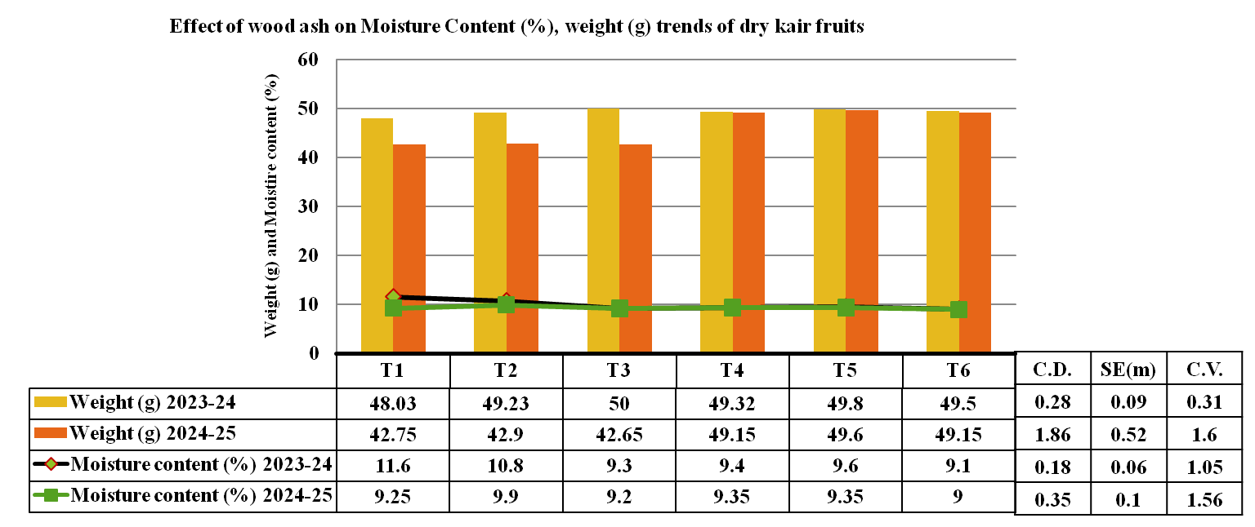
Fig.1. Effect of ash concentration on Moisture Content (%), weight (g) trends of dry kair fruits.
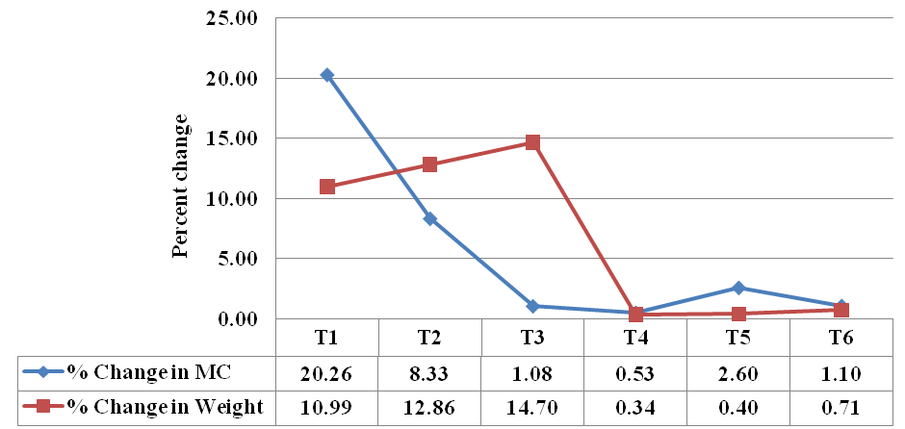
Fig. 2. Percent change in moisture content (%) and weight (g) due to different concentration of ash on dry kair fruits.
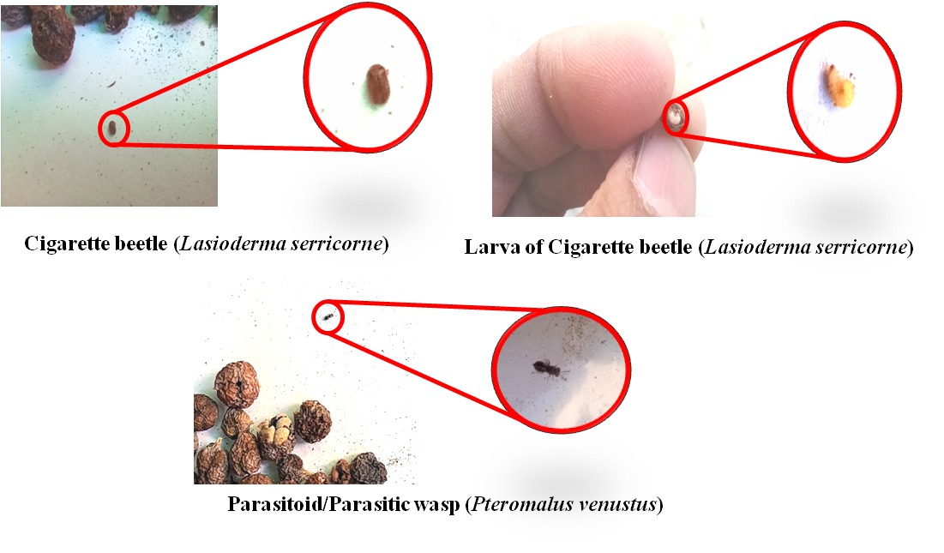
Fig.3. Insect pest in stored dry kair fruit
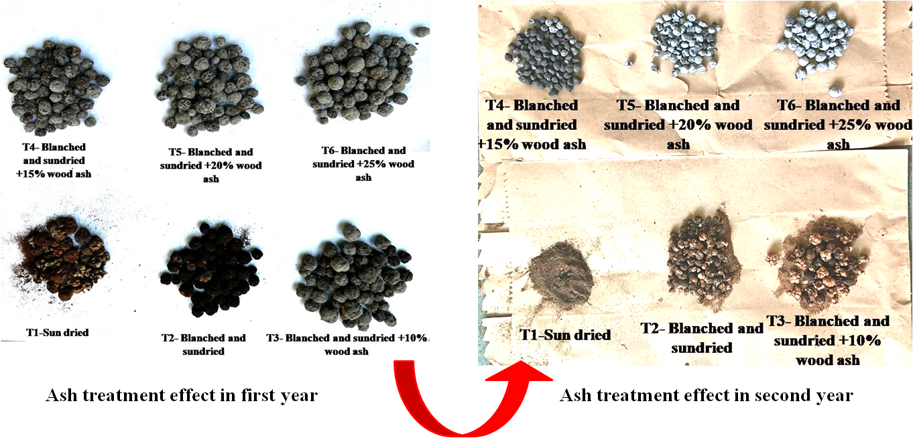
fig.4. Effect of ash treatments in storing dry kair fruit

