Synthesis, Structural characterization of a New Ethylenediammonium Hydrogenophosphate salt

.
ABSTRACT

The integration of organic species with inorganic units result to the formation of hybrid materials that combine the complementary properties of both components. These organo-inorganic systems are of greatt interest because of their potential synergistic behavior. In materials chemistry, the aim objective is to develop ssimple and efficient synthetic strategies that combine the rigidity and stability of inorganic frameworks with the versatility and tunability of organic moieties.
In this work, we report structural charaterization of a new organic–inorganic hybrid salt, ethylenediammonium hydrogenophosphate, [H₃N–CH₂–CH₂–NH₃][HPO₄], which was synthesized under aqueous reflux conditions. The compound was characterized by single-crystal X-ray diffraction and FT-IR spectroscopy. It crystallizes in the monoclinic system, space group P2₁/c, with unit cell parameters a = 7.4896(8) Å, b= 11.7702(12) Å, c = 8.0080(8) Å. The asymmetric unit consists of one ethylenediammonium dication and one monohydrogenophosphate anion.
Structural analysis reveals that the crystal packing is governed by an extended three-dimensional network of N–H···O and O–H···O hydrogen bonds, which link the cations and anions into a robust supramolecular framework. FT-IR spectroscopy confirms the presence of protonated amine groups together with hydrogenophosphate units, consistent with the crystallographic findings.
These results demonstrate the ability of ethylenediamine to promote the formation of stable hydrogen-bonded phosphate frameworks. Owing to their structural robustness and hydrogen-bonding features, such hybrids may represent promising candidates for potential applications in proton-conducting systems and functional optical materials.

Keywords: Ethylenediammonium, Hydrogenophosphate, X-ray diffraction, Hydrogen bonds

1. INTRODUCTION

Organic–inorganic hybrid materials combining organic cations with phosphate anions have attracted increasing attention owing to their rich structural chemistry and potential applications in proton-conducting membranes, nonlinear optical crystals, and thermally stable frameworks [1–3]. Among these, organoammonium phosphate-based salts incorporating mono- or di-deprotonated phosphate species (H₂PO₄⁻/HPO₄²⁻) and protonated organic amines have emerged as promising candidates for the design of advanced functional compounds [4–8]. Their structural diversity arises from the ability of both the organic and inorganic components to engage in extended hydrogen-bonding interactions, which generate low-dimensional supramolecular networks and enable specific structure–property relationships [9–15].
Ethylenediamine (H₂N–CH₂–CH₂–NH₂) is a simple aliphatic diamine that, upon protonation, yields the [H₃N–CH₂–CH₂–NH₃]²⁺ dication. Owing to its two ammonium groups, this cation acts as a versatile multidentate hydrogen-bond donor. When combined with hydrogenophosphate anions, it can stabilize extended architectures through cooperative N–H···O and O–H···O interactions, thus favoring the formation of robust supramolecular assemblies. In the present work, we report the synthesis and detailed characterization of ethylenediammonium hydrogenophosphate, obtained by slow evaporation from aqueous solution. The structural features are analyzed to highlight the role of hydrogen bonding in the crystal packing, while vibrational analyze provide complementary insights into the stability of the compound. Particular emphasis is placed on the supramolecular hydrogen-bonding network, which is expected to play a key role in the potential functional properties of this hybrid material.

2. experimental details

2.1 SYNTHESIS

Phosphoric acid (H₃PO₄, 98%) and ethylenediamine (C₂H₈N₂, 98%) were purchased from Sigma-Aldrich and used without further purification. Distilled water was employed as solvent throughout the preparation.
Ethylenediammonium hydrogenophosphate was synthesized by mixing equimolar aqueous solutions of orthophosphoric acid and ethylenediamine (1:1 molar ratio) under reflux condition with continuous stirring at 200ºC temperature. The resulting clear solution was allowed to evaporate slowly at ambient conditions. After several days, colorless single crystals suitable for single-crystal X-ray diffraction were obtained. Yield: 45%.
The formation of the compound can be represented by the following reaction scheme:

H₃PO₄ + H₂N–CH₂–CH₂–NH₂ → [H₃N–CH₂–CH₂–NH₃][HPO₄]

2.1 Characterization Methods
Infrared (IR) spectroscopy measurements were carried out to characterize the functional groups present in the compound. The spectra were recorded using the Attenuated Total Reflectance (ATR) technique in the range of 4000–400 cm⁻¹. This range allows the detection of the main vibrational modes, including stretching and bending vibrations of functional groups such as O–H, N–H, C–H, and P–O bonds for the compound. The ATR method was chosen for its simplicity, minimal sample preparation, and ability to provide high-quality spectra directly from solid-state samples. The collected spectra were subsequently analyzed to identify characteristic absorption bands associated with the molecular structure of the compound [16].
For the structural characterization, single-crystal X-ray diffraction data were collected on a suitable crystal of the compound. For the instrumentation, a Bruker APEX-II CCD diffractometer with Mo Kα radiation (λ = 0.71073 Å) was using. The crystal was maintained at 150 K during data collection. Structure solution was performed with SHELXT [18-->17] using intrinsic phasing, and refinement was carried out with SHELXL [19--> 18] by full-matrix least-squares minimization. The process was conducted within the Olex2 [17-->19] software package.

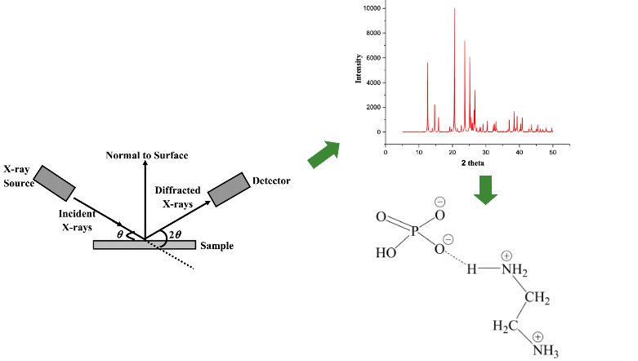
Fig.1: XRD graph and SCHEM image
3. results and discussion

3.1 Crystal Structure

Single-crystal X-ray diffraction analysis shows that the compound crystallizes in the Monoclinic system with space group P2₁/c. The refined cell parameters are a = 7.4896(8) Å, b = 11.7702(12) Å, c = 8.0080(8) Å. The asymmetric unit contains one ethylenediammonium cation and one hydrogenophosphate anion (Fig.2). Crystallographic data are summarized in Table 1.

Table 1. Crystallographic data for compound
Empirical formula | C₂H₁₁N₂O₄P
Formula weight | 158.10
Temperature/K | 150.0
Crystal system | monoclinic
Space group | P2₁/c
a/Å | 7.4896(8)
b/Å | 11.7702(12)
c/Å | 8.0080(8)
α/° | 90
β/° | 110.268(3)
γ/° | 90
Volume/Å³ | 662.23(12)
Z | 4
ρ_{calc}g/cm³ | 1.586
μ/mm⁻¹ | 0.368
F(000) | 336.0
Crystal size/mm³ | 0.18 × 0.18 × 0.13
Radiation | MoKα (λ = 0.71073)
2Θ range for data collection/° | 5.798 to 55.048
Index ranges | -9 ≤ h ≤ 9, -15 ≤ k ≤ 15, -10 ≤ l ≤ 10
Reflections collected | 27310
Independent reflections | 1527 [R_{int} = 0.0310, R_{sigma} = 0.0113]
Data/restraints/parameters | 1527/0/85
Goodness-of-fit on F² | 1.119
Final R indexes [I>=2σ (I)] | R₁ = 0.0250, wR₂ = 0.0739
Final R indexes [all data] | R₁ = 0.0280, wR₂ = 0.0774
Largest diff. peak/hole / e Å⁻³ | 0.33/-0.39

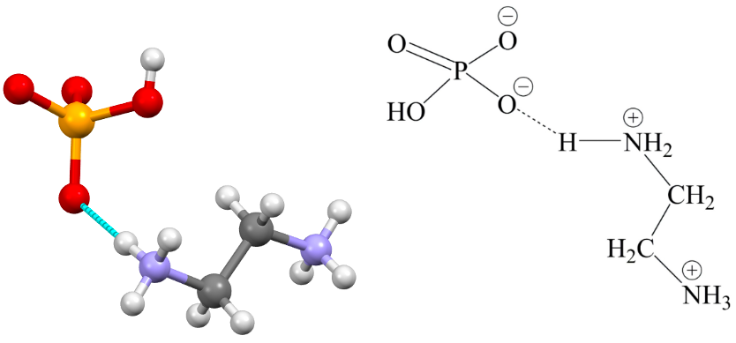
Fig. 2. Asymmetric unit Scheme 1: Chemical Scheme

The [H₃N–(CH₂)₂–NH₃]²⁺ cation is fully protonated, with both nitrogen atoms bearing three protons. The anion of the title compound consists of hydrogenophosphate groups, each interacting with the ethylenediammonium cation through multiple hydrogen bonds, forming ${(C}_{2}H_{10}N_{2})[{HPO}_{4}]$ units. In the hydrogenophosphate anion, the phosphorus atom is surrounded by three oxygen atoms covalently bonded to phosphorus and one hydroxyl group (–OH), completing the tetrahedral geometry (Fig. 3).
The presence of the hydrogenophosphate anion is clearly confirmed by the observed P—O bond distances. In particular, the detection of a significant electron density peak near the oxygen atom Ob (Ob = O004) confirms the existence of the hydroxyl group associated with the anion. The terminal oxide ligands bonded to phosphorus, namely P–Ot (Ot = O002, O003, O005), exhibit bond lengths of range of)–1.5353(9) Å, 1.5205(2) Å and 1.5223(9) Å respectively, which are shorter and characteristic of strong single P–O bonds [20,21]. In contrast, the bond length of 1.588(1) Å observed for the hydroxyl oxygen atom bonded to phosphorus (P–Ob) is slightly longer, reflecting the weaker bonding interaction of the hydroxyl group compared to the terminal oxides [20]. This difference in bond lengths, together with the uniform single-bond character of all P–Ot bonds, not only confirms the stronger bonding of the terminal oxides to phosphorus but also suggests delocalization effects among the three terminal oxygen atoms, indicative of a mesomeric interaction within the phosphate group [20] (Fig. 3).
The corresponding bond angles further corroborate the near-ideal tetrahedral environment around the phosphorus atom. The Ot–P–Ot angles, measured at 110.65(5)°, 111.67(5)°, and 112.57(5)°, and the Ot–P–Ob angles, measured at 108.72(5)°, 108.62(5)°, and 104.32(5)°, are very close to the ideal tetrahedral angle of 109.5°, confirming only a slight distortion from from ideal tetrahedral geometry around the phosphorus atom (Fig. 3) [20, 21].
Bond valence sum calculations indicate that the phosphorus atom is in the +5-oxidation state. To maintain charge neutrality within the crystal lattice, each hydrogenophosphate anion is effectively stabilized by coordination with an organic diammonium cation. This arrangement ensures both electrostatic balance and reinforcement of the crystal packing through the extensive hydrogen-bonding interactions involving the cation and anion.

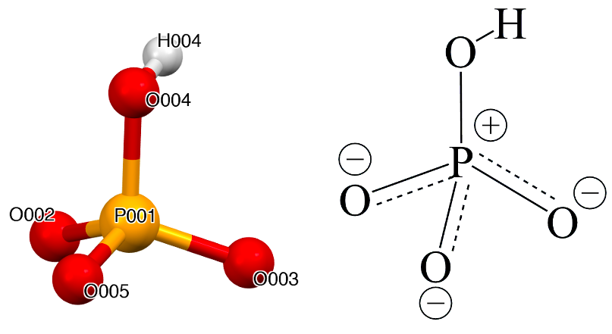
Fig. 3: Tetrahedral geometry of the anion and resonance representation of the anion

Table 2: of bond angles for the compound
Atom | atom | Length/Å
P001 | O002 | 1.5353(9)
P001 | O003 | 1.5205(8)
P001 | O004 | 1.5880(9)
P001 | O005 | 1.5223(9)

Table 3: of bond angles for the compound
Atom | Atom | Atom | Angle/˚
O002 | P001 | O004 | 108.72(5)
O003 | P001 | O002 | 110.65(5)
O003 | P001 | O004 | 108.62(5)
O003 | P001 | O005 | 112.57(5)
O005 | P001 | O002 | 111.67(5)
O005 | P001 | O004 | 104.32(5)

Each ammonium group participates in multiple hydrogen bonds with surrounding phosphate oxygens. As shown in figure 5, the crystal structure is dominated by an extensive and multidirectional hydrogen-bonding framework involving both the ethylenediammonium cations and the hydrogenophosphate anions. The cations (C₂H₁₀N₂)²⁺ act as efficient hydrogen-bond donors, establishing multiple N—H···O contacts with terminal and bridging oxygen atoms of the anionic units [(HPO₄]²⁻. These directional nonbonding interactions not only stabilize the lattice electrostatically but also reinforce the cohesion of the extended framework.
In addition to these cation–anion linkages, two monomers hydrogenophosphate groups exhibit a strong propensity for self-association through O—H···O hydrogen bonds. The hydroxyl group act as hydrogen-bond donors toward terminal oxo ligands of neighboring anions, leading to the gradual formation of higher-order supramolecular assemblies such as dimers, trimers, and tetramer’s structure. This hydrogen bonds network propagates along one crystallographic direction, resulting to the formation of an infinite one-dimensional (1D) zigzag chain (Figure 4). Such a supramolecular arrangement highlights the cooperative nature of hydrogen bonding in directing crystal growth and long-range ordering.
The ethylenediammonium cations and the Hydrogenophosphate anions are particularly noteworthy, as they simultaneously engage in N—H···O and O—H···O interactions. This typical H···A hydrogen bonds observed in the crystal structure exhibit bond lengths ranging from 1.778 Å (H004……O003) to 1.969 Å (H00A……O002), with D–H···A angles varying between 154.86º ( O004—H004……O003) and 177.09° (N007—H00D……O002). This dual functionality is consistent with previous reports on organic–inorganic hybrid phosphates, where ammonium or diammonium cations are frequently observed to template the architecture of extended frameworks through directional hydrogen bonding [20-24]. Similar one-dimensional chain motifs have also been documented in related organoammonium hydrogenophosphates, underscoring the structural robustness and recurrence of this self-assembly pattern [25]. Thus, the present compound exemplifies how the interplay between cation–anion hydrogen bonding and anion–anion self-association governs supramolecular organization, reinforcing the broader principle that hydrogen bonding is a decisive force in the design and stabilization of organophosphate-based crystalline materials.
These interactions between the ethylenediammonium cation (H₃N(CH₂)₂NH₃)²⁺, and the oxygen atoms of the hydrogenophosphate anion [(HPO₄]²⁻ is possible due to proton transfer. As result, the organic unit acquires a positive charge, while the inorganic counterpart carries a negative charge.
H00E, which moves from N007 to O002;
H00F, which moves from N007 to O005;
H00D, which moves from N007 to O002;
H00C, which moves from N006 to O003;
H00B, which moves from N006 to O005;
H00A, which moves from N006 to O002
H004, which moves from O004 to O003.
These interactions occur between the cation and oxygen atoms of neighboring anions and parallel chain, leading to the formation of a three-dimensional supramolecular network (Figure 5). This network enhances the cohesion of the crystal and contributes to its overall structural integrity. Such cation-mediated hydrogen bonding is a common feature in coordination compounds, often playing a key role in directing crystal packing.
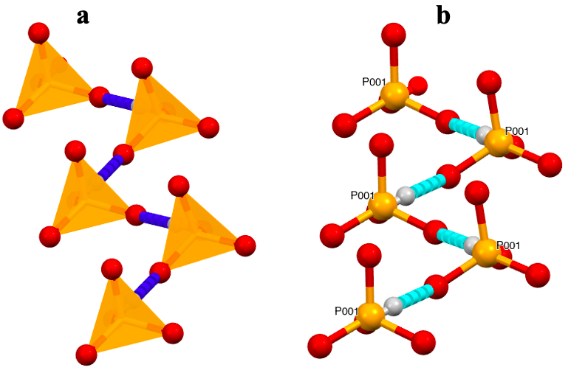
Fig. 4. Infinite 1D chain in zig-zag: (a): tetrahedral form, (b): Ball and Stick

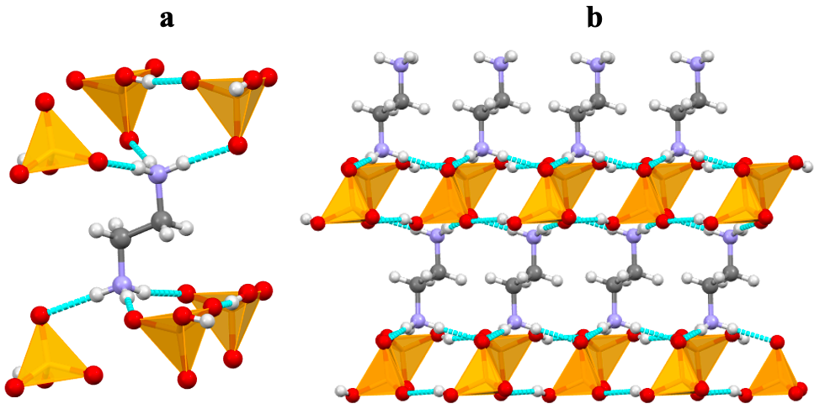
Fig. 5. (a): organo-ammonium cation comportment, (b): three-dimensional supramolecular network

Table 4: Hydrogen bonds geometry ( Å, º)
D—H……A | D—H | H……A | D……A | D—H……A
N007—H00E……O002 | 0.9100 | 1.881 | 2.787 | 174.41
N007—H00F……O005 | 0.9100 | 1.807 | 2.713 | 174.01
N007—H00D……O002 | 0.9100 | 1.911 | 2.820 | 177.09
N006—H00C……O003 | 0.9100 | 1.847 | 2.741 | 166.87
N006—H00B……O005 | 0.9100 | 1.802 | 2.710 | 176.07
N006—H00A……O002 | 0.9100 | 1.969 | 2.877 | 174.99
O004—H004……O003 | 0.8400 | 1.778 | 2.563 | 154.86
x,1/2-y,-1/2+z ; -1+x,y,z ; x,y,z ;-x,-1/2+y,1.5-z ;1-x,-1/2+y,1.5-z ; -x,1-y,1-z ; 1-x,1-y,2-z

3.2 Vibrational Spectroscopy

The IR spectrum of the title compound is showing in figure 6. The IR spectrum exhibit the characteristic vibrational bands of protonated organic cations, and the hydrogenophosphate anion. It displays broad absorption bands in the 3200–3400 cm⁻¹ region, assigned to N–H stretching vibrations of the organoammonium groups, with contributions from O–H stretching of the hydrogenophosphate unit due to extensive hydrogen bonding. Weak bands observed from 3300 to 2800 cm⁻¹ correspond to the C–H stretching modes of methylene groups in the organic cations. A distinct band around 1607–1516 cm⁻¹ arises from the N–H bending vibrations modes of the –NH₃⁺ cations [26-29]. Additional absorptions between 1500–1400 cm⁻¹ are associated to the deformation modes of -NH₃³⁺/NH₄⁴⁺​ species and CH₂ scissoring [26, 27]. The mainly characteristic vibrations bands of the [HPO₄]− anion are observed from 1100 to 650 cm⁻¹. The strong absorptions bands at 1091 and 1021 cm⁻¹ correspond to the asymmetric and symmetric P–O stretching vibrations, respectively, whereas the band near 887 cm⁻¹ correspond to the characteristic vibration of the P–O–H bending mode [10, 25]. The low-frequency absorption at 658 cm⁻¹ further supports the presence of phosphate skeletal vibrations. These spectroscopic features are consistent with the coexistence of protonated ethylenediammonium cations and hydrogenophosphate anions, confirming the salt formulation [H₃N–CH₂–CH₂–NH₃][HPO₄].

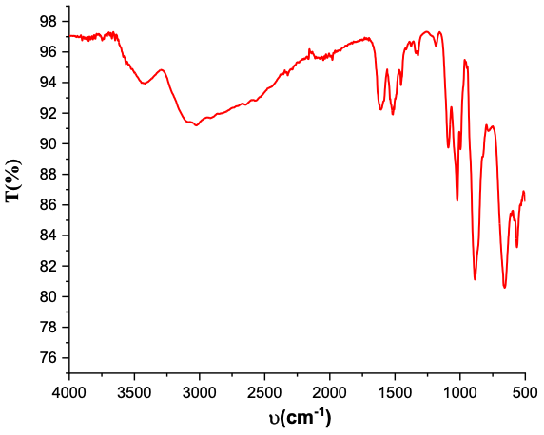
Fig 6. IR spectra of compound
4. Conclusion
In summary, a new organic–inorganic hybrid material, [H₃N–CH₂–CH₂–NH₃][HPO₄], has been successfully synthesized under reflux conditions in distilled water and fully characterized by single-crystal X-ray diffraction. The crystallographic analysis revealed that the compound crystallizes in to the monoclinic crystal system with space group P2₁/c. The crystal packing is governed by an extensive supramolecular framework in which ethylenediammonium cations (C₂H₁₀N₂)²⁺ and hydrogenophosphate anions [HPO₄]²⁻ are interconnected through a robust three-dimensional network of N—H···(O) and (O)—H···(O) hydrogen bonds. These interactions are crucial not only for maintaining the stability and cohesion of the structure but also for ensuring charge balance across the lattice.
The successful isolation of this compound enriches the growing family of organic–inorganic hydrogenophosphates, a class of materials that continues to attract considerable interest due to their structural versatility and tunable properties. In addition to the fundamental crystallographic insights, the observed hydrogen-bonding arrangement points to possible functional applications. In particular, the continuous hydrogen-bonded network may facilitate proton mobility, making this material a promising candidate for proton-conducting devices such as fuel cells and solid electrolytes. Additionally, the hybrid nature of the structure, combining both inorganic rigidity and organic flexibility, could be exploited in optical systems, pharmaceutical formulations, and other fields where multifunctional materials are required.
Overall, this study highlights the central role of hydrogen bonding in directing supramolecular assembly and structural stability in hybrid hydrogenophosphates, while also underlining their potential for future technological applications.

Disclaimer (Artificial intelligence)
Author(s) hereby declare that NO generative AI technologies such as Language Models ( ChatGPT, COPILOT, etc) and text-to-image generators have been used during the writing or editing of this manuscript

References

[1] Mobin, R., Rangreez, T. A., Chisti, H. T. N., & Rezakazemi, M. (2019). Organic-inorganic hybrid materials and their applications. In Functional polymers (pp. 1-22). Springer, Cham.
[2] García-Martínez, J. M., & Collar, E. P. (2021). Organic–Inorganic Hybrid Materials II: Some Additional Contributions to the Topic. Polymers, 13(15), 2390.
[3] García-Martínez, J. M., & Collar, E. P. (2020). Organic–inorganic hybrid materials. Polymers, 13(1), 86.
[4] Heck, J. G., Napp, J., Simonato, S., Möllmer, J., Lange, M., Reichardt, H. M., ... & Feldmann, C. (2015). Multifunctional phosphate-based inorganic–organic hybrid nanoparticles. Journal of the American Chemical Society, 137(23), 7329-7336.
[5] Alhendawi H.M.H., Brunet E., Rodríguez-Payán E. (2017) Phosphate-based organic-inorganic hybrid materials: design, construction and technological applications. In: Schorr Wiener M, Valdez B (eds) Phosphoric acid industry—problems and solutions. InTechOpen, London.
[6] Rafik, A., Abderrahmane, E., Dagdag, O., Kim, H., Zouihri, H., Sabbar, E., & Guedira, T. (2024). Investigation of hybrid phosphate by complex impedance spectroscopy. Chemical Physics Impact, 8, 100590.
[7] Zeng, H., Tang, Y., Luan, L., Dong, X., Zou, G., & Lin, Z. (2023). Ionothermal synthesis and proton conductive behaviors of an organic–inorganic hybrid nickel dihydrogen phosphate. Inorganic Chemistry Communications, 151, 110559.
[8] Wang, C., Li, J. R., Li, Y., Tu, H. L., Tzou, D. L. M., & Wang, C. M. (2021). Stable Crystalline Organic–Inorganic Hybrid Indium Phosphate with Dye Removal and Ractopamine Detection Applications. Inorganic Chemistry, 60(15), 11655-11660.
[9] Ittyachan, R., Ahigna, M. S., & Jagan, R. (2016). Crystal structure of bis (2-aminoanilinium) hydrogen phosphate. Structure Reports, 72(4), 530-533. [10] Guelmami, L., Hajji, M. Structural and theoretical insights into the charge-assisted hydrogen bonding network of a synthesized diaminodipropylammonium pyrophosphate salt. Monatsh Chem 156, 759–770 (2025). https://doi.org/10.1007/s00706-025-03334-4
[11] Mangstl, M., Wied, J. K., Weber, J., Pritzel, C., Trettin, R., & auf der Günne, J. S. (2019). Synthesis and characterization of methylammonium phosphates as crystalline approximants for anhydrous, low melting phosphate glasses. RSC advances, 9(4), 1822-1830.
[12] Balamurugan, P., Jagan, R., & Sivakumar, K. (2010). Dihydrogen phosphate mediated supramolecular frameworks in 2-and 4-chloroanilinium dihydrogen phosphate salts. Crystal Structure Communications, 66(3), o109-o113.
[13] Suriya, M., Boaz, B. M., Chakkaravarthi, G., Vinitha, G., & Murugesan, K. S. (2019). Synthesis, crystal growth, structural, spectral, thermal, optical characteristics and density functional theory calculations of a novel third-order nonlinear optical material: 4-acetylanilinium dihydrogen phosphate (4AADP) single crystals. Journal of Molecular Structure, 1180, 330-343.
[14] Budzikur, D., Kinzhybalo, V., & Ślepokura, K. (2022). Crystal engineering and structural diversity of 2-aminopyridinium hypodiphosphates obtained by crystallization and dehydration. CrystEngComm, 24(24), 4417-4429.
[15] Macetti, G., Loconte, L., Rizzato, S., Gatti, C., & Lo Presti, L. (2016). Intermolecular recognition of the antimalarial drug chloroquine: A quantum theory of atoms in molecules–density functional theory investigation of the hydrated dihydrogen phosphate salt from the 103 k x-ray structure. Crystal Growth & Design, 16(10), 6043-6054.
[16] FT-IR Spectroscopy-Attenuated Total Reflectance (ATR), Perkin Elmer Life and Analytical Sciences (2005)
[17] Sheldrick, G. M. (2015). SHELXT–Integrated space-group and crystal-structure determination. Foundations of Crystallography, 71(1), 3-8.
[18] Sheldrick, G. M. (2015). Crystal structure refinement with SHELXL. Crystal Structure Communications, 71(1), 3-8.
[19] Dolomanov, O. V., Bourhis, L. J., Gildea, R. J., Howard, J. A., & Puschmann, H. (2009). OLEX2: a complete structure solution, refinement and analysis program. Applied Crystallography, 42(2), 339-341.
[20] R. Ittyachan, M. S. Ahigna & R. Jagan, Bis(2-aminoanilinium) hydrogen phosphate, 2C₆H₉N₂⁺ · HPO₄²⁻, Acta Cryst. E72, (2016), 530-533
[ 21]Joshua Birch, Eric Cyriel Hosten and Richard Betz, IUCrData 9, (2024). x241061.
[22] Eder, F., & Weil, M. (2024). Cadmium phosphates Cd2 (PO4) OH and Cd5 (PO4) 2 (OH) 4 crystallizing in mineral structures. Structure Reports, 80(2), 207-212.
[23]H. Dhaouadi, H. Marouani & M. Rzaigui, Crystal structure of o-aminopyridinium dihydrogenmonophosphate, (NH₂C₅H₄NH)[H₂PO₄], Ζ. Kristallogr. NCS 220 (2005) 433-434.
[24] A. Neels, H. Stoeckli-Evans, J. Neels, A. Clearfield, D. Poojary, Ab Initio Structure Determination of Ammonium Hydrogen, Acta Cryst. B54 (4), (1998), 478-484. [H…B]
[25] E. M. Majdi, S. E. Makhloufy, A. Ouasri, M. Saadi, L. E. Ammari, S. Belaaouad, (2021). Chemical preparation, crystal structure reinvestigation, and vibrational study of meta-carboxyphenyl ammonium dihydrogenomonophosphate (C₇H₄NH₃OOH)H₂PO₄ (m-C AMP). Molecular Crystals and Liquid Crystals 714(1), 14–25.
[26] SOUMANO, A., ALY, G. P., YAFFA, L., SEYE, D., TOURE, A., FALL, B., ... & SIDIBE, M. (2024). TWO NEWS HEPTAMOLYBDATES COMPOUNDS: SYNTHESIZES, ELECTROCHEMICAL PROPERTIES AND THERMAL STABILITY. INTERNATIONAL JOURNAL, 12(12), 122-132.
[27] K.I.Rakhimov, and N.KH.Usanbayev.. “The Synthesis of Polymer-Encapsulated Urea Fertilizers by Incorporating Hydroquinone As a Nitrification Inhibitor”. Chemical Science International Journal 34 (4), (2025), 12-22.
[28] ALY, G. P., YAFFA, L., DIOUF, A., BLAISE, K. A., NDOYE, D., TRAORE, B., ... & GAUTIER, R. (2024). ANDERSON-TYPE POMS, SYNTHESIS AND ELECTROCHEMICAL AND PHOTO-CHROMISM PROPERTIES STUDIES. INTERNATIONAL JOURNAL, 12(12), 152-162.
[29] Gueye, Papa & Lamine, Yaffa & Seye, Dame & Pouye, Serigne & Stoica, Alexandru-Constantin & Cheikh A K, Diop & Sidibe, Mamadou. (2024). Synthesis and Characterization of a New Hybrid Polyoxometalate Compound: Bis(3-aminopropyl)ammonium Hexatungstotellurate(VI) Octahydrate. Science Journal of Chemistry. 12. 117-123. 10.11648/j.sjc.20241206.11.

