Biopolymer composites: Integrating agro waste-Fillers with LDPE for Enhanced Mechanistic and Moisture Properties
Abstract
Availability of sustainable materials has been closely linked to the development of new technologies. In this study, agro-waste materials; Coconut shell (CS) and Saw dust (SD) were employed as filler materials in the production of polymer composites using low density polyethylene (LDPE) as matrix at varying composition ratios ranging from 10/90 to 50/50 of filler/LDPE. A total of fifteen (15) composites materials (Coconut shell (CS) and Saw dust (SD) and Hybrid (HB) bio-polymer composites) were fabricated and studied. SEM micrographs showed a homogeneous distribution of particles with a good interfacial bonding at the filler/matrix interface, FTIR analysis identified peaks at 1500 cm-1 for Ethylene and 3000 cm-1 for hydrophilic hydroxyl (OH) groups. The mechanical characterization showed higher filler ratios enhanced material stiffness and reduced elasticity, SD 40/60, HB 50/50 and CS 50/50 were in cluster I, while CS 10/90, SD 30/70 and HB 20/80 in cluster III had the most tolerance for moisture. The principal component analysis (PCA) could explain 87% variation while cluster analysis (HCA) identified the second day of testing to have the most impact on composites in presence of moisture. The findings provide a pathway to reduce environmental pollution and offers valuable insights into the design of bio-polymer composites with enhanced performance. for application in packaging, construction, automobile and other industries.
Keywords: Polymer composites, agro wastes, alkali pretreatment, mechanical properties, PCA analysis,

1.0 Introduction
The growing world population and economic indices suggests that social resources like construction materials are in increasing demand for housing and other economic activities. The availability of suitable materials has been closely linked to the development of technologies that improve the convenience of human existence. (Chamas et al., 2020; Guna et al., 2019). One of the most common problems in developing economies around the world such as Nigeria is proper management of waste materials and sustainable consumption of resources. Research has also shown that using agricultural waste and by products in the development of materials, and in combination with polymer wastes, is a viable sustainable approach that not only addresses environmental pollution but enhance sustainable consumption of resources. Global plastic waste has risen by 7.11% since 2021(Pilapitiya & Ratnayake, 2024: UNEPA, 2024). Nigeria for instance produced 5.2 million tons of wood waste and 1.8 million tons of sawdust annually compared to the United States' 64 million tons in 2021 (Owoyemi et al., 2016). In several fields, including packaging, construction, aerospace, and the automotive industries, where significant load bearing capacities are not necessary, agro-waste reinforced polymer composites have previously been used effectively (Sethuraman et al., 2020). Additionally, there is a great chance to produce superior composites for automotive, aircraft, and recreational uses. The most appealing qualities of agro-waste polymer composites are their comparatively low weight, high specific strength, ease of formability, and significant resistance to corrosion and fatigue. When compared to composites with synthetic fillers, biodegradable materials have some drawbacks, such as a high degree of anisotropy and moisture absorption ((Ezeudu & Ugochukwu, 2024; Rosso, 2006). Also, composites reinforced with agricultural waste have a significant deal of promise to replace synthetic composites, which could result in more affordable, durable, and ecologically friendly products (Yogitha et al., 2020), even though, there are many problems with their manufacture. For a better interface and improved mechanical properties, the compatibility of recycled/virgin adhesive matrices and agro-waste materials with other components in the composite system presents significant hurdles (Owuamanam and Cree, 2020; Salifu et al., 2022). For instance, agricultural wastes contain extraneous material that can prevent the polymer matrix from bonding with them. In most cases, researchers used various pre-treatment techniques to remove the interfering substances from the fiber components. By incorporating lignocellulosic agro-wastes into polymer matrices, it is feasible to produce bio-polymer composite materials with increased durability and moisture tolerance since bio-polymer composite materials require less energy and easily degrade into water-soluble polymers as functional groups like ester and amide bonds in their chemical structure deteriorate (Yogitha et al., 2020).
2.0 Materials and Methods
2.1 Processing of filler materials
The saw dust (SD) and coconut shell (CS) was granulated to reduce their particle size and stored to serve as filler materials, while the polyethylene waste was cut into tiny pieces with a pair of scissors and stored to serve as polymer matrix. The saw dust (SD) and coconut shell (CS) was washed with tap water and dried to remove moisture. Alkali pretreatment of the filler materials was then carried out by immersing the filler materials in 2M NaOH solution while stirring for 1 hour at room temperature after which it was washed severally with water and oven dried at 100 ^{O}C before storage.
2.2 Composition of Polymer composite Materials
The mixing process involves the introduction of the filler material while the polymer is rolled on the mill machine for a period of five (5 ) minutes at 170 °C to homogenize the mixture. After which a metal mould of dimensions 120mm x100mm x 3.2 mm was placed on the hydraulic hot press (Compression Moulding Machine) for shaping at 150ºC and pressure of 2.5 MPa for 5mins. The composition ratios for both coconut shell (CS) and saw dust (SD) and hybrid (H) is shown in Table 1.
Table 1: Composite ratios (LDPE/CS and LDPE/SD)
Sample |  | LDPE/CS  Composites |  | LDPE/SD  Composites
 | LDPE (wt%) | CS (wt%) | SD (wt%) | SD (wt%) | CS (wt%)
A | 100 | 0 | 0 | 0 | 0
B | 90 | 10 | 0 | 10 | 0
C | 80 | 20 | 0 | 20 | 0
D | 70 | 30 | 0 | 30 | 0
E | 60 | 40 | 0 | 40 | 0
F | 50 | 50 | 0 | 50 | 0

Table 2: Composite ratios (LDPE/CS/SD)
Sample | LDPE (wt%) | CS (wt%) | SD (wt%)
A | 90 | 5 | 5
B | 80 | 10 | 10
C | 70 | 15 | 15
D | 60 | 20 | 20
E | 50 | 25 | 25

2.3 Characterization of materials
The bio-polymer composites were characterized for morphology using scanning electron microscope (SEM), while the functional groups was monitored using Fourier transformed infrared spectroscopy (FTIR).
2.4 Preparation of bio-polymer composites for Testing
For the mechanical test, test samples were cut from the composites in accordance with the suggested standard for each test. According to ASTM D618, each sample underwent conditioning at a temperature of 23 °C and a relative humidity of 65% before the test.
2.5 Mechanical Properties of bio-polymer composites
The following mechanical properties were determined on the prepared bio-polymer composites.
2.5.1 Hardness test
The ASTM D2583 method was used to gauge the composites' hardness. Prior to testing, the test specimens were preconditioned for 40 hours at 23°C and 50% relative humidity. The samples were sliced from the composites, and a micrometer screw gauge was used to measure their thickness. The test was performed using a durometer, which forced the indentor pin to penetrate the sample while displaying the sample's hardness on the display screen. For every sample, the procedure was carried out three times.
Average Hardness = $\frac{1st + 2nd + 3rd }{3}$ (Hv) ……………………………………….. (i)
2.5.2 Impact test
The materials were subjected to an impact test in line with ASTM D6110. The specimen samples were cut into 64, 12.7, 6.4 mm dimensions. In a pendulum impact test fixture, a specimen was clamped, and when the pendulum was released, it struck the specimen. The energy that the sample had absorbed was used to determine the impact strength, which was displayed on screen.
2.5.3 Tensile test
A material testing machine was used to conduct the tensile strength measurement experiment at a constant strain rate of 0.5 mm/minute. According to ASTM D638, the composite samples was cut into dumbbell shapes with cross-sectional dimensions 135 by 114 by 14 4.0 mm. Up until it fractures, the load handle was constantly turned. The determinations; ultimate tensile strength, strain, and elastic modulus (E) were done using equations i, ii, and iii:
δ = F/A …………………………………. (ii)
ε = e/l ……………. ……………………..(iii)
E= δ/ε ………………………………. (3.3)
where F is the breaking load, A is the cross-sectional area, e is the extension, and l is the original length.
2.6 Moisture Testing
According to ASTM D570-98, moisture absorption tests was performed on bio-polymer composites with dimensions of 50 mm x 10 mm x 10 mm (l x w x t) at room temperature for 10 days. Every 24 hours, the composites, submerged in 50ml distilled water in a beaker was removed, dried and weighed. Equation (i) was used to calculate absorbed in % weight gain as % moisture absorption by composites.
$W\%=\frac{W_{1}-W_{2}}{W_{2}} X 100$……………………………………………(i)
where, W% is the composite weight gain in percentage, W₁ is the weight of composite after each day, and W₂ is the dry weight of sample before immersion in distilled water. Principal component analysis (PCA) and Hierarchical cluster analysis (HCA) was carried out on data.
3.0 Results and Discussion
3.1 Characterization of bio-polymer composites
The following characterizations were carried out on prepared bio-polymer composites from Coconut shell (CS), Saw dust (SD) and Hybrid (H).
3.1.1 Surface morphology of bio-polymer composites
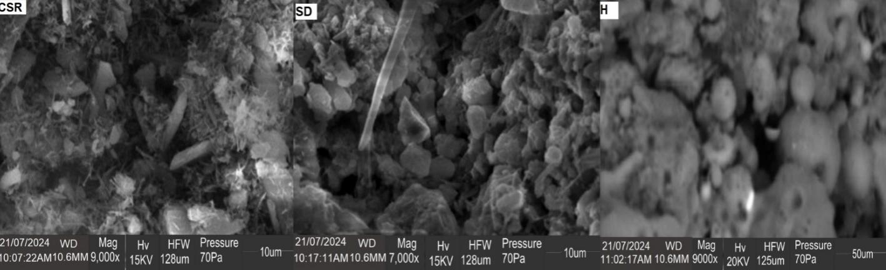
Figure1: SEM images for bio-polymer composites (CSR, SD and H)
The morphology of bio polymer composite material depends on the processing conditions, nature components, weight fractions, and component melt viscosities. The SEM images for Coconut shell residue (CSR), Saw dust (SD) and Hybrid (H) filler bio-polymer composites are shown in Figure1, the images showed rough and heterogenous surfaces from the various filler additions to polymer matrix. The micrographs show that the particle distribution is essentially homogeneous and that there is a strong interfacial adhesion at the filler/matrix contact. The filler particles are not coming off but are still firmly linked to the matrix material indicating ideal bonding. Also at the constituents' bonding sites, void areas are not seen. In general, the micrographs demonstrate a notable impact of the filler elements on the composites. Reitman et al., (2019) suggested that the reduction to finer particle sizes will greatly improve interfacial contact of the two distinct fillers used in the composites and the polymer matrix and in turn enhance the mechanical properties and moisture absorption. Ogudo, et al., (2021) noted a degree of homogeneity in agro-waste to LDPE composites and this was observed to influenced their moisture absorptivity as the hydrophobic and hydrophilic components of the materials played a significant role in the degradation of the composites.

3.1.2 FTIR Analysis
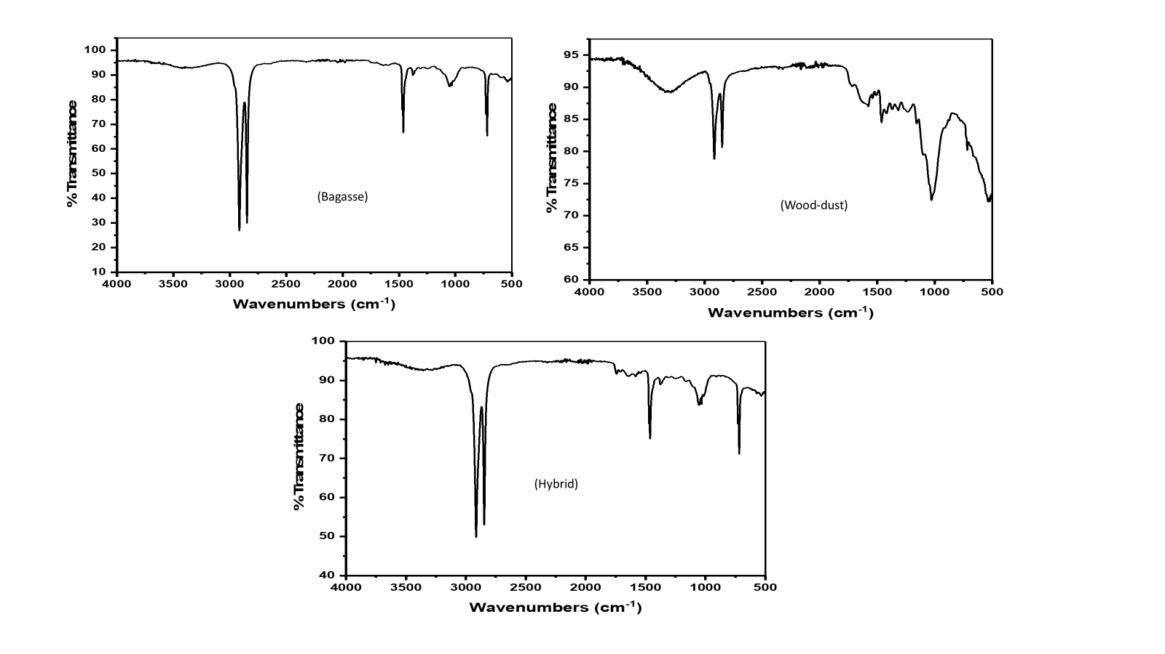
Figure 2: FTIR spectra for Coconut shell (CS), Saw dust (SD) and Hybrid (HB) bio-polymer composites
Figure 2. shows the FTIR spectra for Coconut shell (CS), Saw dust (SD) and Hybrid (HB) bio-polymer composites, the characteristic peaks of polyethylene such as the C-H stretching vibrations between 2915 cm⁻¹ and 2848 cm^{−1,} the CH₂ bending vibrations from 1461 to 1501 cm⁻¹, and the vibrations from 716 to 1000 cm⁻¹, were observed, also, a small peak at 1370 cm⁻¹ appears for the composites due to CH₃ symmetric deformation vibrations. A far reduction in the hydroxyl (OH) peak for saw dust was observed after alkali pretreatment and also enhanced its performance in mechanical testing. The presence of OH peak between 3000-3600 cm⁻¹ can be attributed to the hydroxyl groups from cellulosic component of the filler materials and also residual moisture absorbed during the preparation of the composite, similar frequencies were noted by Hamin et al., (2023) in sugarcane bagasse as filled polymer composites. The treatment of agro wastes with alkaline has been observed to reduce moisture absorption in cellulosic fibers as in replaces th hydroxy groups with metallic groups thereby increasing hydrophobicity (Gautam et al., 2024; Rahman et al., 2021; Dinh et al., 2018). Rahman et al., (2021) found treatment of pineapple leaf fiber (PALF) with 7% NaOH to enhance mechanical properties by improving homogeneity and in turn moisture tolerance in reinforced LDPE composites.

3.2 Mechanical properties
The mechanical properties were determined for the prepared bio-polymer composites as follows;.

Figure 3: Hardness test for coconut shell (CS), saw dust (SD) and Hybrid (HB) bio-polymer composites
3.2.1 Hardness of bio-polymer composites
The hardness test was determined for the Coconut shell (CS), Saw dust (SD) and Hybrid (HB) bio-polymer composites. The hardness plot is shown in Figure 3, the hardness of the bio-polymer composites was observed to increase for all the prepared composites as the filler concentration was increased. This is expected since the elasticity of the polymer matrix decreases as more filler material is added, resulting in the development of a more rigid polymer composite material. The polymer composites recorded values ranging between 50/50 to 90/10 filler ratios as 69.27-82.33 (Hv) for coconut shell (CS), 66.15- 77.84(Hv) for saw dust (SD) and 70.19-82.97 (Hv) for hybrid (HB) composites. Although the average hardness of the polymer composites is observed to increase with additional filler loads, individual variations are also seen to exist with the various ratios, this is due to the inadequate phase interaction between the two highly cellulosic fillers and the polyethylene matrices. Kundie et al., (2018) also observed that the filler load had a significant impact and enhanced the hardness of prepared dental composites.

Figure 4: Average impact energy (J) for Coconut shell (CS), Saw dust (SD) and Hybrid (HB) bio-polymer composites

Figure 5: Impact strength (Jmm) for Coconut shell (CS), Saw dust (SD) and Hybrid (HB)
bio-polymer composites

3.2.2 Impact strength of bio-polymer composites
The average impact energy and impact strength for the prepared Coconut shell (CS), Saw dust (SD) and Hybrid (HB) bio-polymer composites was determined, and the results are plotted in Figures 4 and 5 respectively. The average impact energy measured in joules ranged from 50/50 to 10/90 ratios as 0.81-0.30 (J), 0.61-0.44(J) and 0.80-0.31(J) for Coconut shell (CS), Saw dust (SD) and Hybrid (HB) bio-polymer composites respectively, while the impact strength ranged from 0.25-0.09 (Jmm), 0.19-0.14 (Jmm) and 0.25-0.10 (Jmm) for Coconut shell (CS) and Saw dust (SD) filler materials and Hybrid (HB) bio-polymer composites respectively. The maximum energy that the composites may absorb upon impact is determined by the impact strength, the produced composites showed a gradual loss of this property as the concentration of the filler material was increased. The composition of the filler, the polymer, and the interfacial bonding between the filler and matrix all affect the impact properties of filler reinforced polymer composites (Navaranjan & Neitzert, 2017). The findings agree with the report of Iyer & Torkelson, (2014) for injection-molded pure PHB and pure PLA composites produced using corn cob as filler materials. Corncob fillers were observed to disrupt the PHB-PLA matrix's continuity, preventing energy absorption and transmission when the impact force was applied. This reduced the composite's resistance to deformation and accelerated its failure (Iyer & Torkelson, 2014).

Figure 6: Tensile strength for coconut shell (CS), saw dust (SD) and Hybrid (HB) bio-polymer composites

Figure 7: Tensile modulus for coconut shell (CS), saw dust (SD) and Hybrid (HB) bio-polymer composites

Figure 8: % Elongation for coconut shell (CS), saw dust (SD) and Hybrid (HB) bio-polymer composites

3.2.3 Tensile properties of bio-polymer composites
The findings of tensile strength, tensile modulus and % elongation for Coconut shell (CS) and Saw dust (SD) filler materials and Hybrid (HB) bio-polymer composites are shown in Figures 6, 7 and 8. Tensile properties were observed to vary with filler load. Betancourta & Cree (2017) reported that the filler to matrix link decreases with increasing filler load. When filler loading is increased, the tensile modulus of the composites is increased because the load is effectively transferred to the filler particles, which absorb and transmit the stress loading significantly better. The tensile strength of the prepared Coconut shell (CS) and Saw dust (SD) filler materials and Hybrid (HB) bio-polymer composites was observed to decrease with increased filler ratio as shown in figure 6, the tensile strengths were determined for the 10/90 and 50/50 ratio as 24.09 and 9.02 (MPa) for Coconut shell (CS), 22.03-9.31(MPa), for Saw dust (SD) and 23.04-8.01(MPa) and for Hybrid (HB) polymer composites, while the Modulus was determined as shown in figure 7 as 245.11 and 127.30 (MPa) for Coconut shell (CS), 241.51 and 121.50 (MPa) for Saw dust (SD), 244.08 and 126.27(MPa) for Hybrid (HB) polymer composites for the 10/90 and 50/50 ratios respectively. The results show that the filler materials significantly affect the composite's tensile characteristics. Similar investigations on polymer composites by Owuamanam et al., (2021) for PLA/corncob composites and Arrakhiz et al., (2013) for polypropylene/clay composites also reported the tensile modulus to improve with addition of filler material. Tazibt et al., (2023) the morphology and properties of composites based on poly (lactic acid) (PLA) as filler materials reported that the addition of 5 wt% of HAp into the PLA improved the thermal stability and tensile properties of the composite but decreased at higher filler ratio 15 wt%. High ratios of filler tend to occupy the voids between polymer chains, contributing to a hardened structure, the microparticles tend to agglomerate, resulting in restricted lateral movement. Consequently, the contact area with the polymer diminishes, complicating the distribution of the filler among the chains. (Owuamanam and Cree (2020). The % elongation for the prepared composites were determined as shown in figure 8 for 10/90 to 50/50 ratio as 8.21-7.06 (%) for coconut shell (CS), 8.03-7.16 (%) for saw dust (SD) and 7.92-6.17 (%) for hybrid (HB) bio-polymer composites. Increasing the concentration of fraction of filler material leads to reduction in the percentage of elongation for samples. This is due to the fact that the presence of fillers imparts the stiffening effect within the matrix and thus imposes a mechanical restraint on the composites (Tazibt et al., 2023).

Figure 9: % Moisture absorption for coconut shell (CS), saw dust (SD) and Hybrid (HB) bio-polymer composites

3.3 Moisture absorption capacity
Moisture tolerance of the prepared bio-polymer composites is shown in figure 9. for Coconut shell (CS), Saw dust (SD) and Hybrid (HB) composites. Principal component analysis (PCA) and hierarchical cluster analysis (HCA) were carried out to identify the most influential components and also evaluate the composite with the best moisture tolerance. The results are shown in Tables 3 and 4 for total variance and component scores and figure 10. for dendrogram respectively.
Table 3. shows the total variance observed for moisture absorption of the composites after 10 days. of the bio-polymer composites. The analysis identified two (2) major components. Component 1 could explain the variation to 73.533% while component 2 had 87.405%. Component 2 was used to explain the moisture absorption for the composite samples. Day 2 had the highest component score of 0.742 meaning the composites had their highest moisture absorption on day 2 as shown in table 4. this is attributed to the readily available pore spaces in the composites since they were yet to be exhausted. Figure 10. shows the cluster plots from hierarchical cluster analysis (HCA) to check for similarities in moisture tolerance among the bio-polymer composites. Three (3) clusters were identified as cluster I, II and III representing clusters having composites with high, moderate and low moisture absorption respectively. Interestingly saw dust (SD) 50/50 ratio was not clustered in cluster I for high moisture absorption when compared to hybrid (HB) 50/50 and coconut shell (CS) 50/50. SD 50/50, HB 40/60, HB 30/70 and CS 40/60 were in cluster II for moderate moisture absorption, while SD 30/70, HB 10/90, HB 20/80 and CS 10/90 were in cluster III for low moisture absorption composites. this behaviour of the prepared composites is attributed to the fact that with increasing filler load increases the hydrophilic component of the bio-polymer composites enhancing moisture absorption. Figure 9. confirms saw dust composite with the best effect of pretreatment also having the best moisture tolerance at the 50/50 ratio when compared to coconut shell and hybrid composites.

Table 3: Total variance in principal component analysis (PCA)
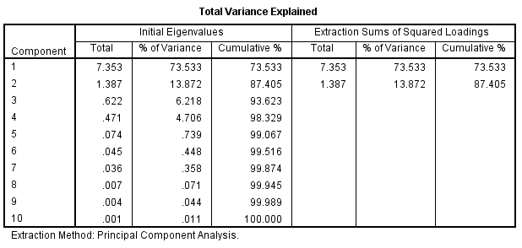
Table 4: Component scores in PCA
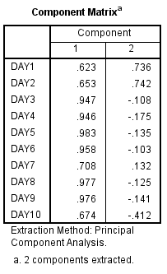

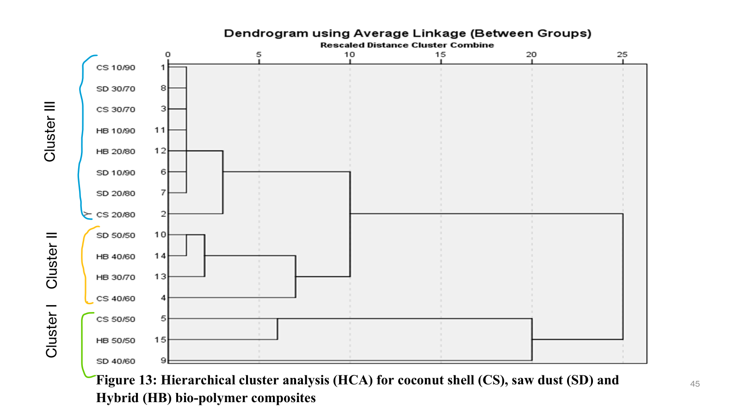

Figure 10: Hierarchical cluster analysis (HCA) for coconut shell (CS), saw dust (SD) and
Hybrid (HB) bio-polymer composites

4.0 CONCLUSION
The alkali pretreatment of the agro-wastes fibers was able to reduce hydrophilicity and improve homogeneity between filler materials and LDPE matrix. The prepared bio-polymer composites showed a good interfacial bonding at the filler/matrix interface indicating a homogenous distribution of filler particles as observed in S.E.M analysis. At the 50/50 ratio of filler/matrix, the saw dust (SD) composites were more tolerant to moisture when compared to Coconut shell (CS) and hybrid, this is attributed to the effect of alkali pretreatment as seen in it’s less prominent hydrophilic (OH) peak at 3000cm-1 from FTIR and also PCA and HCA analysis. clustered saw dust in cluster. The enhanced mechanical properties are also attributed to improved homogeneity. It is possible using the approach to obtain sustainable bio-polymer composites with enhanced mechanistic and durable properties.

Disclaimer (Artificial intelligence)
Option 1:
Author(s) hereby declare that NO generative AI technologies such as Large Language Models (ChatGPT, COPILOT, etc.) and text-to-image generators have been used during the writing or editing of this manuscript.
Option 2:
Author(s) hereby declare that generative AI technologies such as Large Language Models, etc. have been used during the writing or editing of manuscripts. This explanation will include the name, version, model, and source of the generative AI technology and as well as all input prompts provided to the generative AI technology
Details of the AI usage are given below:
1.
2.
3.

REFERENCE
1. Ali, C., Moon, H., Zheng, J., Qiu, Y., Tabassum, T., Jang, J. H., Abu-Omar, M., Scott, S. L., & Suh, S. (2020). Degradation rates of plastics in the environment. ACS Sustainable Chemistry & Engineering, 8(9), 3494-3511. (link unavailable)
2. Guna, V., Ilangovan, M., Hu, C., Venkatesh, K., & Reddy, N. (2019). Valorization of sugarcane bagasse by developing completely biodegradable composites for industrial applications. Industrial Crops and Products, 131, 25-31. (link unavailable)
3. Pilapitiya, P. G. C. N. T., & Ratnayake, A. S. (2024). The world of plastic waste: A review. Cleaner Materials. (link unavailable)
4. United Nations Environment Programme. (2024). Global tragedy. (link unavailable)
5. Owoyemi, J. M., Zakariya, H. O., & Elegbede, I. O. (2016). Sustainable wood waste management in Nigeria. Environmental Socio-economic Studies, 4(3), 1-9.
6. Sethuraman, G., Nizar, N. M. M., Muhamad, F. N., Suhair, T. A. S. T. M., Jahanshiri, E., Gregory, P. J., & Azam-Ali, S. (2020). Nutritional composition of black potato (Plectranthus rotundifolius (Poir.) Spreng.) (Synonym: Solenostemon rotundifolius). International Journal of Scientific & Engineering Research, 11(10), 1145-1150.
7. Yogitha, B., Karthikeyan, M., & Reddy, M. G. M. (2020). Progress of sugarcane bagasse ash applications in production of eco-friendly concrete–Review. Materials Today: Proceedings, 33, 695-699.
8. Owuamanam, S., & Cree, D. (2020). Progress of bio-calcium carbonate waste eggshell and seashell fillers in polymer composites: A review. Journal of Composites Science, 4(2), 70. (link unavailable)
9. Kundie, F., Azhari, C. H., Muchtar, A., & Ahmad, Z. A. (2018). Effects of filler size on the mechanical properties of polymer-filled dental composites: A review of recent developments. Journal of Physical Science, 29(1), 141-165.
10. Navaranjan, N., & Neitzert, T. (2017). Impact strength of natural fibre composites measured by different test methods: A review. MATEC Web of Conferences, 109, 01003.
11. Iyer, K. A., & Torkelson, J. M. (2014). Green composites of polypropylene and eggshell: Effective biofiller size reduction and dispersion by single-step processing with solid-state shear pulverization. Composites Science and Technology, 102, 152-160.
12. Arrakhiz, F. Z., Elachaby, M., Bouhfid, R., Vaudreuil, S., Essassi, M., & Qaiss, A. (2012). Mechanical and thermal properties of polypropylene reinforced with alfa fiber under different chemical treatment. Materials & Design, 35, 318-322.
13. Tazibt, N., Kaci, M., Dehouche, N., Ragoubi, M., & Atanase, L. I. (2023). Effect of filler content on the morphology and physical properties of poly(lactic acid)-hydroxyapatite composites. Materials, 16(2), 809.
14. Betancourt, N. G., & Cree, D. E. (2017). Mechanical properties of poly(lactic acid) composites reinforced with CaCO3 eggshell based fillers. Published online by Cambridge University Press.
15. Rahman, H., Yeasmin, F., Khan, S. A., Hasan, M. Z., Roy, M., Uddin, M. B., & Khan, R. A. (2021). Fabrication and analysis of physico-mechanical characteristics of NaOH treated PALF reinforced LDPE composites: Effect of gamma irradiation. Journal of Materials Research and Technology, 11, 914-928.
16. Gautam, S. B., Dixit, S., Yadav, V. L., Mishra, G., Sawood, G. M., & Singh, N. (2024). Utilization of Agro-waste as a reinforcement material in polymer matrix for biodegradable packaging applications. In Sustainable clean energy production using waste biomass: sustainable energy production and utilization (pp. 183-206). Singapore: Springer Nature Singapore.
17. Dinh Vu, N., Thi Tran, H., & Duy Nguyen, T. (2018). Characterization of polypropylene green composites reinforced by cellulose fibers extracted from rice straw. International Journal of Polymer Science, 2018(1), 1813847.

