Non-Linear pH shifts and Reaction Kinetics in Buffers System: The Impact of temperature variations

ABSTRACT
The study reveals how many kinetic reactions are influenced by pH with temperature variations. The temperature effect on buffer solutions is not always remains constant, and, reveals how pH properties change in a way that is not directly proportional to temperature variations. This contrasts with changes in a linearity where a change in temperature results in a expectable proportional change in the pH of buffer solutions. In kinetics, this is due to the temperature dependent nature of equilibrium constant of reaction rates, leading to non-linear pH shifts. A temperature versus rate of reaction (kinetics) graph is reveals how rates of reaction change with varying in pH value. It often shows an optimal pH where the reaction activity is at its peak, with reactivity decreasing on either side of this optimum as pH deviates. The shape of the curve can vary depending on the specific reactions.
Keywords: Reaction kinetics, non-linear pH shifts, buffer solutions, temperature variations.

[1]- INTRODUCTION:
The relationship in between pH and kinetics may be complex, but it is co-related to each other with temperature variations. The kinetics of many reactions involving such as chemical or biological are significantly influenced by the pH¹. And, buffer solution is a solution that can resists pH change by addition of an acidic or basic substances, because of presence of common ion effect and it obey the Le Chatelier’s principle ², which is the suppression of the degree of dissociation of a weak electrolyte by the addition of a strong electrolyte having a common ions with that of the weak electrolyte ^{3,4}. Generally, the pH relationship which was given by Peter Sorensen in 1909 is written as,
pH = - log[H⁺] = log(1/[H⁺]) …………. (1)
Where, the log is a base -10 logarithm, and, the [H⁺] is stands for the concentration of H+ ions in solution, as given in mole per litre. From equation (1), the pH is a negative logarithm of hydrogen (H⁺) or hydronium (H₃O⁺) ions concentration. According to the mass law, the ionization reaction of pure solution for a weak acid is as HA = H⁺ + A⁻, the equilibrium condition are defined by the equation of the concentration law, K (HA) =(H⁺)(A⁻). Where, the enclosed quantities is stand for concentrations of the respective substances and K is the ionization constant of the acid or change in pH. This relation may be written as in more convenient form is, (H⁺) = K (HA) / (A⁻) ^{5, 6}. For buffer solutions, we can apply the Henderson equation which is modified as follows⁷,
pH = pKa + log [ salt/acid] ……………… (2)
Here, the pKa is a thermodynamic value of pK of acid and, when the concentration of acid and the salt is equal then pH of buffer solution is equal to the pKa, (pH = pka). By applying equation (2) we can calculated the pH value of a given buffer solutions ⁸.For buffer solutions, the above equation (2) can be written as,
pH = pKa + log₁₀ ([A⁻]/[HA]) ………..(3)
Where, [A⁻] and [HA] is as concentration of weak acid with its salt or, conjugated acid-base pair in buffer solutions. In this article, we have reported a kinetics studies on pH determination against temperature variations for buffer solutions. Although, a literature survey have been well reported about the rate kinetics and pH value of buffers in respect to temperature behavior on its solutions⁹⁻¹⁴.

[2]- THEORETICAL APPROACHES:
[2.1]- pH and pH Scale:
A pH is defined as a measure of the hydrogen (H⁺) ion concentration in a solutions, indicating its acidity and basicity or alkalinity. It ranges from 0 to 14, with lower values indicating acidity, 7 is neutral, and higher values being alkalinity. The figure 1 elucidated the pH scale with their pH scale range is from 0 to 14. The pH scale is a measure of the concentration of hydrogen ions (H⁺) in a solution. Although, we can calculated pH of any solutions by taking the negative logarithm of the hydrogen or hydronium ions concentration, or pH = -log[H⁺] or [H₃O⁺], respectively. At 25 ˚C, the pH values below < 7 indicate acidic, a with equal as = 7 being neutral, and a value with above > 7 is basic. A buffer can prevent a sudden drop or increase in the pH of a solution after the addition of a strong base or acid up to its buffering capacity ¹⁵.
[2.2]- Buffers Solutions and its Equilibrium:
A buffer solutions resist changes in pH when small amounts of acid or base are added. However, their pH can still shift with any changes in temperature. The buffering agents or buffer solutions is an solution of a weak acid (HA) or base (A⁻) in equilibrium with its corresponding base or acid^{16, 17}. HA = H⁺ + A⁻, the equilibrium condition are defined by the equation of the mass law,
K (HA) =(H⁺)(A⁻)……………….(4)
The equilibrium constant is referred to as the acid dissociation constant Ka or ionization constant¹⁸⁻²⁰.It relates to the degree of ionization or dissociation constant of the acid, and generally it is calculated on the basis of the concentrations of the reacting species,
Ka = [H⁺] [A⁻] / [HA]…………...(5)
Notable, the negative logarithm of the hydrogen ion activity to base is considered pH, represented as –log 10 [H⁺] or [H₃O⁺], and the activity of hydrogen ions is a close approximation of their concentration. Practically, the pH scale is characterized as follows,
pH = pHS + [(E - ES) / k]……………(6)
Here, E is the measured potential where the pH meter contains the solution under test (pH), ES is measured potential where the pH meter contains the appropriate buffer solution for calibration (pHS), and k is the change in potential or unit change in pH and is derived from the applying of following Nernst equation²¹,
k = log (10) $×$ (RT/nF)…………….(7)
Where, R = 8.314 J/mole/˚K; T is the temperature (in Kelvin); n is the number of moles, and, F is the Faraday constant (96485 Coulomb /mole), respectively.
[2.3]- Temperature Variations and rate Kinetics:
The temperature variations on buffer solutions is not always remain constant²². Many buffer systems exhibit the linear relationship between pH and temperature can be a reasonable approximation within a limited temperature range. While, some other buffer systems show more complex and predictable non-linear pH changes uniformly with temperature, especially over or wider temperature ranges or when approaching extremes of temperature^{23, 24}. This is due to the temperature dependent nature of equilibrium constants with enthalpy effect and the potential for selective precipitation of buffer components at low or high temperatures. When any changes in heat capacity or temperature which can affect the enthalpy of the protonation or deprotonation reactions within the buffer, leading to non-linear pH shifts. In buffer solutions, the chemical reactions with activation energies or complex reactions mechanisms may show non-linear temperature dependency in equilibrium constants and reaction rates^{25, 26}.
In dissociation process the thermodynamic parameters have been reported at standard condition²⁷. These thermodynamic parameters are being as in term of entropy (S), heat content or enthalpy (H) and Gibbs free energy (G) in respect to temperature and pressure. For a buffer reactions, the pH dependent an equilibrium constant (K) is related to the standard Gibbs free energy change by the equation as,
∆G˚ = ∆H˚ - T∆S˚ = - RT ln K...........(8)
Since pH affects ∆G˚, it also affects the equilibrium constant. The standard free energy change (∆G˚) for a reaction is often different under standard conditions (pH 0 or 1 mole H⁺) compared to other specific conditions or state. Thus, the difference highlights how pH influences the thermodynamic favorability of the reactions in solution. The changing in pHis may alter the effective ∆G and thus the spontaneity of the reactions.
Generally, on increasing the temperature the reaction rates is increase with respect to changing in activation energy (E*) of reactants. In kinetics way the reaction rate (r) is expressed as the decrease in concentration of the reactants (-dC), or increase in concentration of products (dx). If C is a concentration of reactant at time t, the rate of reaction (r) is –dC/dt, or if the product concentration is x at time t, the reaction rate is dx/dt. The unit of rate is being of concentration divided by time (in second).

[3]- RESULTS AND DISCUSSION:

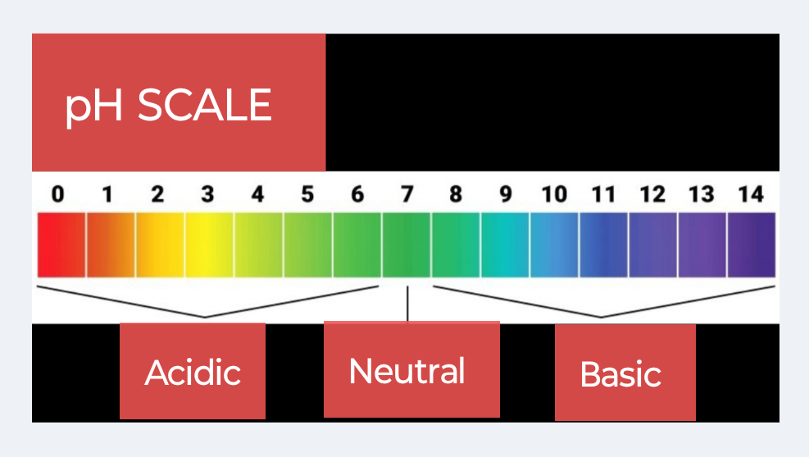
Figure 1. The pH scalewith pH scale range from 0 to 14.

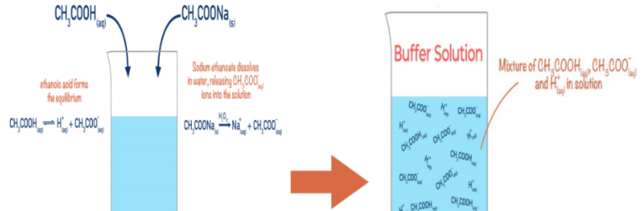
Figure 2. Schematic diagram of acetic acid (CH₃COOH)-sodium acetate (CH₃COONa) buffer.

Indeed, the study provides valuable insights into the complex relationship between pH, temperature and reaction kinetics in buffer solutions system, often revealing an optimal pH for peak activity, contributes significantly to field like biochemistry, pharmacology and in industrial chemical process to ensuring product stability. The addition of the salts of conjugate acid-base pair to a buffer solutions, an increases the pH due to the equilibrium will shift by common ion effect (Le Chatelier’s principle) with involving enthalpy (H) change. Practically, when a pH meter introduced into buffer solution of acetic acid-sodium acetate there was the pH value of sample solution is suddenly decrease before in fast and then after some gradually increase. Here, in figure 2, we have effort to show a schematic diagram for acidic buffer solution as of acetic acid (CH₃COOH) and sodium acetate (CH₃COONa) as well. Practically, at 25 ˚C temperature, the pH value have measured for CH₃COOH-CH₃COONa buffer solution, where, an initial reading was observed 4.0, and it raised up to 3.1 to 4.7 with 5.0 N basic NaOH solution.^{28,29}. Herein, a quite fluctuation may occurs when so much acid or base are added to the buffer solution they become the excess reactants. If a preparing buffer having more acid than base, a more H⁺ ions are likely to be present and then pH fall, and, if a buffer have more base than acid, more OH⁻ ions are present thus pH rise. The acetic acid-sodium acetate buffer is a buffer and having the ability to resist in changing of pH at certain pH range. In phosphate buffers the pH increases instant with decreasing in temperature, the magnitude of this changes can vary depending on concentration and influence of the temperature range. At 4 ˚C, a buffer will have slightly higher pH than the same buffer at 25 ˚C. Similarly, at 37 $˚$C, a buffer will have a lower pH as compared to one at 25 ˚C as well ³⁰.

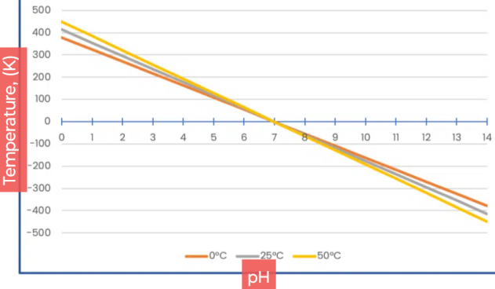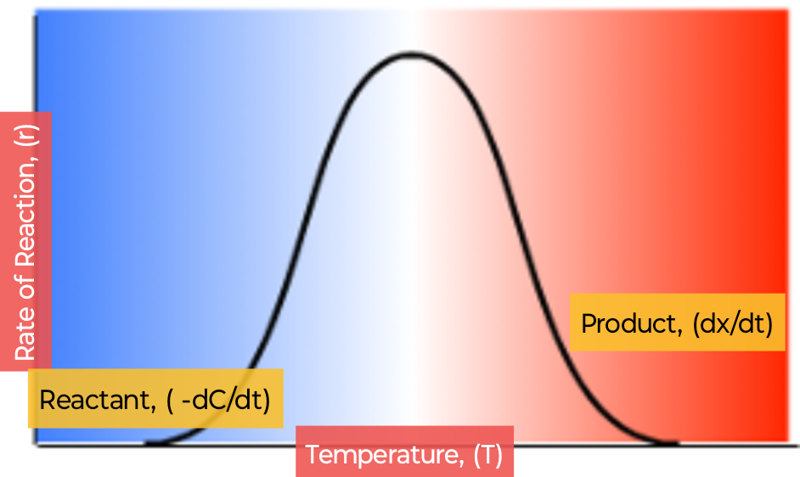
(a) (b)
Figure 3.The plot in between of; (a)- pH against temperature, and, (b)- Rate of reaction against temperature for buffers.

The temperature variations or heat behavior are often observed in physical and chemical systems, which describes how properties change in a way that is not directly proportional to temperature variations. This contrasts with linearity deviation where a change in temperature results in a predictable proportional change in the pH properties of buffer solutions. Temperature affects thermodynamic parameters like activation energy (E*), entropy (∆S˚), enthalpy (∆H˚) and Gibbs free energy (∆G*) associated with rate kinetics of chemical as well as enzyme-catalyzed reactions. The thermodynamic pKa value, which is the negative logarithm of the acid dissociation constant (K) being temperature dependent. The changes in temperature can shift the pKa, which in turn may affect the effectiveness of buffers. The pH of a buffer solution might change slightly or rapidly with respect of temperature changes at certain points. If the pH change is due to a chemical reaction of buffer solution, the reaction kinetics (rate and mechanism) will play a major role ^{18,} ^{27, 31}.
The pH and kinetics are differ but it co-related to each other and the kinetics of many chemical reactions are significantly influenced by pH. The pH describes as the acidity or basicity of an any solutions, while kinetics is studies of the mechanism and rate or speed of chemical reactions. The pH can influence the reaction pathway or rates, affecting how reactants is quickly changes into products by altering the concentration of ions which can act as catalysts. For example, in some reactions, electron transfer may be dominant at lower pH, while proton-coupled electron transfer (PCET) mechanism may become more effective at higher pH³². Notable, the changes in pH lead to switch in the rate determining step of a reaction or even a change in the overall mechanism ^{33, 34}.
In kinetics profile, a plot of graph for temperature versus rate of reaction is typically illustrates that how rates of chemical or specific reaction would changes with varying in range of pH value. It often shows an optimal pH where the reaction activity is at its peak, with reactivity decreasing on either side of this optimum as pH deviates. The shape of the curve can vary depending on the specific reactions. Graphically, as in figure 3 (a, and b); (a)- the plot between temperature against pH show a temperature variation with changes in pH, and, (b)- rate of reaction versus temperature for buffer solutions. At a variation of temperature these both plots are indicating the changes in a constant rate of reactions with pH, respectively. For linear temperature, the equation of the form can be expressed as; pH = xT + b, Where ‘x’ is the slope (rate of change) and ‘b’ is the y-intercept. It means, the rate of change between pH and temperature is not constant, and curve could be logarithmic, exponential, or any other non-linear shape. The non-linear temperature relation is required more complex equation to represent them. Thus, the straight or curve shape of the graph plots depend upon the specific co-relationship in between of temperature and pH for a given buffers³⁵.

[4]- CONCLUSIONS:
In conclusions, we have reported a kinetics study and pH shift for buffer solutions against the variation of temperature. The temperature effect on buffer solutions is not always remains constant, and, reveals how pH properties change in a way that is not directly proportional to temperature variations. This contrasts with changes in a linearity where a change in temperature results in a expectable proportional change in the pH of buffer solutions. In kinetics, this is due to the temperature dependent nature of equilibrium constant of reaction rates, leading to non-linear pH shifts. A graph plot in between of temperature against rate of reaction is reveals that how rates of chemical or specific reaction may changes with variation in pH value. It often shows an optimal pH where the reaction activity is at its peak, with reactivity decreasing on either side of this optimum as pH deviates. The shape of the curve can vary depending on the specific reactions such as for chemical or enzyme-catalysis reaction.

Disclaimer (Artificial intelligence)
Option 1:
Author(s) hereby declare that NO generative AI technologies such as Large Language Models (ChatGPT, COPILOT, etc.) and text-to-image generators have been used during the writing or editing of this manuscript.

REFERENCES:
1.O. O. Sogbein, D. A. Simmons, and L. Konermann, Effect of pH on the kinetic reaction, J. Am. Soc. Mass. Spectrom., 2000;11(4):312-319.
2. J. Arthur Campbell, Le Chatelier’s principle, temperature effects, and entropy, J. Chem. Educ., 1985;62(3):231-232.
3. F. A. Cotton, G. Wilkinson, C. A. Murillo and M. Bochmann, Advanced Inorganic Chemistry, 6th Edition, John Welly and Sons, Inc., (1999).
4. I. L. Finar, Organic Chemistry, Vol-1, 6th Edition, Dorling Kindersley (India) Pvt. Ltd., (2007).
5. Lawrence J. Henderson, Concerning the relationship between the strength of acids and their capacity to preserve neutrality, Am. J. Physiol., 1908;21(2):173-179.
6.Henry N, Po and N. M. Senozan, The Henderson-Hasselbalch equation: Its history and limitations, J. Chem. Educ., 2001;78(11):1499-1503.
7. R. Q. Blackwell, Verification of the Henderson-Hasselbalch equation, J. Chem. Educ., 1954;31(3):138.
8. Charles A. Lucy, Is your Henderson-Hasselbalch calculation of buffer pH correct ?, J. Chem. Educ., 2023;100(6):2418-2422.
9. K. R. Harris, The determination of pH of standard buffer solutions: a laboratory experiment, J. Chem. Educ., 1985;62(4):350.
10. S. P. Mishra, Introducing of thermodynamic Van’t Hoff equation in aqueous solubility and dissociation process of benzoic acid at ordinary temperature range, Chem.Sci. Int. J., 2022;31(1):8-14. S. P. Mishra and R. P. Singh, Gibbs free energy change in aqueous dissociation of benzoic acid at temperature ‘K’ : A thermodynamic study, Chem. Sci. Int. J. 2022;31(2):44-52.
11. S. P. Mishra, Titrimetric study of solubility of solute benzoic acid and their partition in water and benzene solvents,Chemical Sci. Int. J., 2021;30(3):40-45. S. P. Mishra, Concentration effect of sodium chloride salt on benzoic acid solubility and dissociation into water at 298K temperature, Int. Res. J. Pure & Appl. Chem., 2021;22(6):47-52.
12. S. P. Mishra, Phenolphthalein indicator in titrimetric estimation of benzoic acid solubility and distribution in water and benzene-buffer solutions, Asian J. of Chemical Sciences, 2022;11(4):1-7.
13. N. D. Burrows, C. R. H. Hale, and R. L. Penn, Effect of pH on the kinetics of crystal growth by oriented aggregation, Cryst. Growth Des., 2013;13(8):3396-3403.
14. S. P. Mishra, V. K. Pandey, A. S. Yadav and R. P. Singh,pH determination of Acetic Acid-Sodium Acetate Buffer: An Application of Henderson-Hasselbalch Equation at Room Temperature, Chem. Sci. Int. J. 2024;33(6):32-38.
15. F. Tollini, S. Di Bartolo, G. Storti, M. Sponchioni, and D. Moscatelli, Influence of pH and temperature on the kinetics of polylactic acid hydrolysis, Ind. Eng. Chem. Res., 2025;64(24):11733-11747.
16. M. Hayert, J.-M. P.-Cornet, and P. Gervais, A simple method for measuring the pH of acid solutions under high pressure, J. Phys. Chem. A, 1999;103(12):1785-1789.
17. S. E. Kulevich, R. S. Herrick, and K. V. Mills, A discovery Chemistry experiment on buffers, J. Chem. Educ., 2014;91(8):1207-1211.
18. M. Ghosh, R. Zhang, R. G. Lawler, and C. T. Seto, The effects of buffers on the thermodynamics and kinetics of binding between positively-charged cyclodextrins and phosphate ester guests, J. Org. Chem., 2000;65(3):735-741.
19. Adon A. Gordus, Chemical equilibrium: VI. Buffer solutions, J. Chem. Educ., 1991;68(8):656-658.
20. J. H. Jordon, H. S. Ashbaugh, J. T. Mague and B. C. Gibb, Buffer and salt effects in aqueous host-guest system: screening, competitive binding, or both ?, J. Am. Chem. Soc., 2021;143(44):18605-18616.
21. W. Nernst, Z. Phys. Chem., 1891;8:110-139.
22. M. Tanase, A. Soare, V. David, and S. C. Moldoveanu, Sources of nonlinear van’t Hoff temperature dependence in high-performance liquid chromatography, ACS Omega, 2019;4(22):19808-19817.
23. S. Brudar, and B. H.-Lee, Effect of buffer on protein stability in aqueous solutions: A simple protein aggregation model, J. Phys. Chem. B, 2021;125(10):2504-2512.
24. X. Lu, H. Xing, B. Su, and Q. Ren, Effect of buffer solution and temperature on the stability of penicillin G, J. Chem. Eng. Data, 2008;53(2):543-547.
25. H. Yamamoto, and K. Sugano, Effect of pH and buffer capacity of physiological bicarbonate buffer on precipitation of drugs, Mol. Pharmaceutics, 2025;22(3):1318-1328.
26. E. T. Urbansky, and M. R, Schock, Understanding, deriving and computing buffer capacity, J. Chem. Educ., 2000;77(12):1640-1643.
27. A. G. Rajan, J. M. P. Martirez, and E. A. Carter, Coupled effects of temperature, pressure, and pH on water oxidation thermodynamics and kinetics, ACS Catalysis, 2021;11(18):11305-11319.
28. Vogel A. Text book of Quantitative Chemical Analysis, 5th Edition, Longman, Harlow, London,(1989).
29. S. P. Mishra and R. P. Singh, A pH Measurement of Acetic Acid-Sodium Acetate Buffer Solutions Using a pH Meter at Ambient Temperature, J. Applied Chemical Science International, (IK Press), 2024;15(2):30-35.
30. A. A. Green, The preparation of acetate and phosphate buffer solutions of known pH and ionic strength, J. Am. Chem. Soc., 1933;55(6):2331-2336.
31. A. Steinegger, O. S. Wolfbeis, and S. M. Borisov, Optical sensing and imaging of pH values: Spectroscopies, materials and applications, Chem. Rev., 2020;120(22):12357-12489.
32. K. Sui, A. V. Soudackov, M. C. Kessinger, J. Xu, G. J. Meyer, and S. H.-Schiffer, General kinetic model for pH dependence of proton-coupled electron transfer: application to electrochemical water oxidation system, J. Am. Chem. Soc., 2023;145(35):19321-19332.
33. L. Su, J. Chen, F. Yang, P. Li, Y. Jin, W. Luo, and S. Chen, Electric-double layer origin of the kinetic pH effect of hydrogen electrocatalysis revealed by a universal hydroxide adsorption-dependent inflection-point behavior, J. Am. Chem. Soc., 2023;145(22):12051-12058.
34. M. Gutman, E. Nachliel, and E. Gershon, Effect of buffer on kinetics of proton equilibrium with a protonable group, Biochemistry, 1985;24(12):2937-2941.
35. A. Pergantis, L. Saridakis, A. Lyratzakis, L. Mavroudakis, and T. Montagnon, Buffer squares: A graphical approach for the determination of buffer pH using logarithmic concentration diagrams, J. Chem. Educ., 2019;96(5):936-943.

