PHYSICAL AND CHEMICAL CHARACTERIZATION OF GROUNDWATER IN THE ALLUVIAL AQUIFER OF DALLOL BOSSO IN THE FILINGUE DEPARTMENT, TILLABERI REGION : A CASE STUDY OF CERTAIN VILLAGES IN THE RURAL COMMUNITIES OF TONDIKANDIA AND IMANAN

Abstract
The alluvial aquifer of the dallol bosso constitutes an essential resource for the supply of drinking water to the rural populations of the Tillabéri region. This study chooses to evaluate the physicochemical parameters of groundwater in the villages of the communes of Tondikandia and Imanan. The analyses of the physicochemical parameters (electrical conductivity (EC), hydrogen potential (pH), Temperature (T), Turbidity (Turb), Hydrometry Title (TH), Complete Alkalimetry Title (TAC), HCO₃⁻, SO₄²⁻, Cl⁻, NO₃⁻ , Na⁺, K⁺, F⁻, NO₂⁻ Cl⁻ and Fe_{t}) were carried out. The results of the analyses of certain physicochemical parameters obtained were compared with the WHO 2017 guideline value ​​for water for human consumption and they show the water quality to be generally acceptable, but with cases of localized contamination, particularly fluoride and nitrate, due to geological and anthropological factors. These elements slightly exceed the international standard, which requires special attention to these waters. A slight excess is not necessarily dangerous in the short term, but it is necessary to monitor to avoid a chronic accumulation of fluoride and nitrate elements. Indeed, these analyses of physicochemical parameters of water could be acceptable for human consumption. Regular monitoring, resource protection and awareness-raising actions are essential to guarantee healthy clean water for communities.
Keywords : Groundwater, aquifer, socio-economic activities, market gardening
Introduction
Groundwater is of paramount importance in most regions of the world (Mostaza-Colado et al., 2018). In the Sahel, due to the seasonal nature of surface water, groundwater is often the only permanent source of fresh water (FAVRAU, 2000). It is one of the main sources of water supply for the population of the Tillabéri region. This resource, which is so fundamental to the existence and economy of a country or region, must therefore be managed in a sustainable, consistent, and rational manner, as it is threatened by various sources of geological and anthropogenic pollution. The Dallol Bosso alluvial aquifer is characterized by its shallow depth (Chae et al., 2004). This shallow aquifer has given rise to several socio-economic activities, such as market gardening. However, the shallow depth of the aquifer makes the water very sensitive to pollution, especially of anthropogenic origin, on the one hand, and to significant evaporation on the other (Mthembu et al., 2021). The physical and chemical quality of this water could be altered by the influence of these phenomena (Helena et al., 1999). It is in this context that this study sets as its general objective the analysis of groundwater in certain villages in the department of Filingué that draw water from the Dallol Bosso alluvial aquifer. This will allow the results obtained to be compared with the 2017 WHO guidelines for drinking water.
Materials and methods
Presentation of the study area
The Tillabéri region is located in the far west of Niger between 11°50 and 15°45 north latitude and 0°10 and 4°20 east longitude (INS, DR/Ti, 2016). The geological formation of this region can be divided into two zones : the part west of the river, which constitutes the crystalline basement zone, and the part east of the river, which constitutes the western end of the Iullemeden sedimentary basin. The Dallol Bosso intersects two series of the terminal continental, with the upper part comprising the clayey-sandy lignite series and the lower part comprising the Middle Niger clayey sandstone series. (Laurent BABIERO, et al., 1992)
The rural communes of Tondikandia and Imanan are crossed by the Dallol Bosso, a large fossil valley whose waters flow intermittently towards the river. The koris are used for agriculture and market gardening.
Equipment
The various equipment and devices used during this work are illustrated opposite :
A GARMIN GPS was used to record the coordinates of the sampled structures.
Physical parameters were measured in the field, such as : electrical conductivity (EC) and temperature (T) using a HANNA conductivity meter; pH using a Palintest pH meter, and turbidity (Turb.) using a Palintest turbidimeter. After sampling, the samples were stored in a cooler at a temperature of approximately 4°C. They were then transported to the water analysis laboratory of the Tillabéri Regional Directorate of Hydraulics and Sanitation approximately 48 hours after sampling for analysis of the following chemical parameters: TAC, HCO₃⁻, Cl⁻, F⁻, SO₄²⁻, NO₃⁻, NO₂⁻, Na⁺, K⁺, fer total (Fe_{t}), Ca²⁺, Mg²⁺.

Les ions Cl⁻, F⁻, SO₄²⁻, NO₂⁻ Cl⁻, F⁻, SO₄²⁻, and NO₂⁻ ions by colorimetry using a DR 2800 direct-reading spectrophotometer. NO₃⁻ and Fet ions by colorimetry using a DR 2000 direct-reading spectrophotometer. Na+ and K+ ions by atomic adsorption using a JENWAY flame spectrophotometer. And by volumetry, the TAC (Total Alkalinity), TH (Total Hardness) and Ca²⁺ using a digital titrator. Mg²⁺ ions were determined by calculation from TH and Ca²⁺, and HCO₃⁻ from TAC. The data from the analyses of certain physico-chemical parameters obtained were compared with the 2017 WHO guideline values for water intended for human consumption. The coordinates obtained by GPS were mapped using ArcGis 10.1 software, which is widely used in geographic information systems. The physico-chemical data were processed using SPSS 20 software, which is used in hydrochemistry by applying hydrochemical methods (ascending principal component analysis) to determine the origin of the correlation matrix between the elements on the one hand and, on the other hand, the Piper diagram using DIAGRAMME software to characterize the different facies of the sampled waters and the suitability of the waters for irrigation using the Wilcox diagram.
Methodology
This sampling campaign was carried out in September 2020. Samples were taken from 14 structures including the alluvium of the Bosso dallol, distributed as follows figure 1:
• ten cemented wells (PC) in the rural commune of Tondikandia;
• three auger boreholes (FPMH) in the rural commune of Tondikandia;
• one auger borehole (FPMH) in the rural commune of Imanan.
The sampling criteria focused on the structures most used by the population. The method used for water sampling and analysis of physical and chemical parameters was that described by JEAN Rodier.

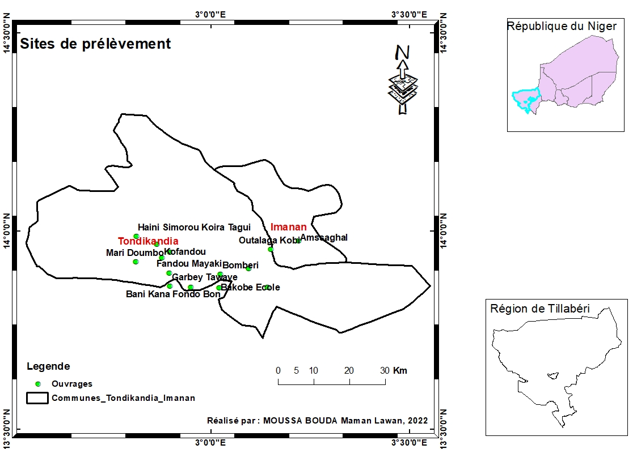

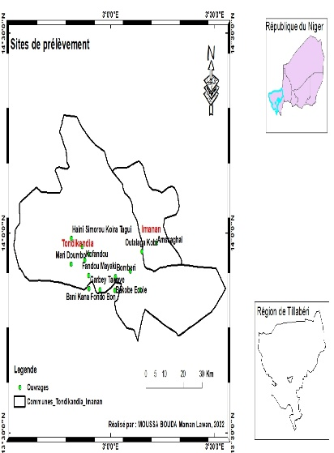

Figure 1 : simpling sites
Results :
Table 1 : Physical parameters
Villages | Types of works | CE  (µS/cm) | T  (°C) | pH | Turbidity  (NTU)
Amassaghal | FPMH | 1560 | 32,2 | 7,96 | 2,32
Bakobe école | FPMH | 200 | 32,9 | 6,7 | 0,01
Bani Kane Fondo bon | PC | 810 | 29,2 | 7,39 | 0,16
Bombéri | PC | 730 | 30,2 | 7,2 | 0,72
Boudé Sekou Koira | PC | 160 | 32,2 | 6,8 | 0,59
Fandou Mayaki | FPMH | 1100 | 31,8 | 6,92 | 0,88
Garbey Taweye | PC | 300 | 30 | 6,71 | 4,13
Goumbi Banda | PC | 300 | 31,9 | 6,29 | 0,43
Haini Simorou Koira Tagui | PC | 10 | 31,4 | 6,39 | 1,41
Kofandou | PC | 100 | 31,1 | 6,38 | 2,3
Loki Damana | PC | 590 | 33,9 | 6,41 | 0,52
Mari Doumbo | PC | 60 | 31,3 | 6,36 | 0,27
Outalaga Kobi | PC | 190 | 33,1 | 6,74 | 0,69
Tanka Worbo | PC | 830 | 31,8 | 8,04 | 16,7

Table 2 : Chemicals parameters
Villages | TH | TAC | HCO₃⁻ | Cl⁻ | SO₄²⁻ | F⁻ | NO₃⁻ | NO₂⁻ | Na⁺ | K⁺ | Fe_{t} | Ca²⁺ | Mg²⁺
Amassaghal | 210 | 340 | 414,8 | 204 | 85 | 1,51 | 98,12 | 0,5907 | 302,00 | 10 | 0,11 | 34 | 30,375
Bakobe école | 51 | 28,5 | 34,77 | 3,3 | 0 | 0,13 | 68,2 | 0,0891 | 14,00 | 1,5 | 0,02 | 12,4 | 4,86
Bani Kane Fondo bon | 155,5 | 110 | 134,2 | 107 | 1 | 0,00 | 91,96 | 0,099 | 95,40 | 9,44 | 0 | 50 | 7,4115
Bombéri | 137,5 | 112,5 | 137,25 | 69 | 27 | 0 | 137,28 | 0,0099 | 110,34 | 2,5 | 0,06 | 36 | 11,5425
Boudé Sekou Koira | 50 | 60 | 73,2 | 1,3 | 0 | 0,07 | 8,8 | 0,0396 | 10,00 | 4,5 | 0,06 | 14 | 3,645
Fandou Mayaki | 130 | 225 | 274,5 | 100 | 95 | 0,00 | 56,32 | 0,0231 | 185,00 | 25 | 0,22 | 38 | 8,505
Garbey Taweye | 66,5 | 35 | 42,7 | 14,3 | 3 | 0,00 | 85,36 | 0,7161 | 16,88 | 15 | 0,18 | 18 | 5,2245
Goumbi Banda | 87 | 65 | 79,3 | 8,9 | 4 | 0,00 | 94,16 | 0,0627 | 16,47 | 30 | 0,13 | 21 | 8,3835
Haini Simorou Koira Tagui | 67 | 68 | 82,96 | 0,5 | 0 | 0,14 | 5,28 | 0,0759 | 2,73 | 4,5 | 0,05 | 18,8 | 4,86
Kofandou | 17 | 28 | 34,16 | 1,3 | 3 | 0,00 | 14,96 | 0,033 | 14,00 | 1,5 | 0,1 | 6,16 | 0,3888
Loki Damana | 90 | 75 | 91,5 | 29 | 16 | 0,18 | 67,32 | 0,0924 | 40,00 | 20 | 0,1 | 20 | 9,72
Mari Doumbo | 43,8 | 38 | 46,36 | 0,1 | 0 | 0,32 | 11 | 0,0198 | 2,87 | 0,5 | 0,27 | 14,96 | 1,5552
Outalaga Kobi | 74 | 46,5 | 56,73 | 1,2 | 59 | 0,19 | 18,04 | 0,0264 | 18,15 | 1 | 0,04 | 25,56 | 2,4543
Tanka Worbo | 60 | 275 | 335,5 | 17,7 | 25 | 0,74 | 9,24 | 0,0231 | 110,00 | 50 | 0,24 | 14 | 6,075

Descriptive analyses of parameters physicochemicals
Descriptive analyses of fourteen physical and chemical parameters (CE, pH, T, Turb., TH, HCO₃⁻, SO₄²⁻, Cl⁻, NO₃⁻ , Na⁺, K⁺, F⁻, NO₂⁻ et Fe_{t}) of the results are recorded in Table 3.

Table 3: Statistics on physicochemical parameters and WHO standards, chemical parameters (mg/L)
Parameters | Minimum | Maximum | Moyenne | Standard deviation | OMS 2017
Number of observation | 24 | 24 | 24 | 24
CE (µS/cm) | 50 | 1560 | 440,83 | 414,63 | 180-1000
T (°C) | 29 | 35 | 31,79 | 1,55 | -
pH | 6 | 9 | 6,7 | 0,8 | 6,5-8,5
Turb. (NTU) | 0,01 | 54 | 4 | 11 | 5
TH | 17 | 210 | 80,66 | 50,42 | -
HCO₃⁻ | 20 | 415 | 107,75 | 106,33 | -
Cl⁻ | 0 | 204 | 39,375 | 54,76 | 250
SO₄²⁻ | 0 | 95 | 17,91 | 27,35 | 250
F⁻ | 0 | 1,51 | 0,19 | 0,34 | 1,5
NO₃⁻ | 5 | 137 | 52,16 | 42,62 | 50
NO₂⁻ | 0 | 1 | 0,083 | 0,28 | 3
Na⁺ | 3 | 302 | 54,41 | 72,52 | 200
K⁺ | 0 | 120 | 16,25 | 25,57 | 12
Fe_{t} | 0 | 1 | 0,041 | 0,2 | 0,3

Table 3 presents the physical parameters. Electrical conductivity (EC) varies from 50 to 1560 µS/cm with an average of 440.83 µS/cm and a standard deviation of 414.63 µS/cm. The temperature of these waters ranges from 29 to 35°C with an average of 31.79°C and a standard deviation of 2.43°C. The pH varies from 6 to 9 with an average of 6.7 and a standard deviation of 1.55. Turbidity varies from 0.01 to 54 NTU with an average of 4 NTU and a standard deviation of 11 NTU.
In terms of chemical parameters, the major cations are dominated by Na⁺, which varies from 3 to 302 mg/L with an average of 54.41 mg/L and a standard deviation of 72.52 mg/L. Next, K⁺ ions in third place vary from 0 to 120 mg/L with an average of 16.25 mg/L and a standard deviation of 25.57 mg/L. Finally, total hardness ranged from 17 to 210 mg/L with an average of 80.66 mg/L and a standard deviation of 50.42 mg/L. Anions are dominated by HCO3- ions, which range from 20 to 415 mg/L with an average of 107.75 mg/L and a standard deviation of 106.33 mg/L. Next are NO₃⁻ ions, which range from 5 to 137 mg/L with an average of 52.16 mg/L and a standard deviation of 42.62 mg/L. Then Cl⁻ ions range from 0 to 204 mg/L with an average of 39.375 mg/L and a standard deviation of 54.76 mg/L.
Finally, SO₄²⁻ ions range from 0 to 95 mg/L with an average of 17.91 mg/L and a standard deviation of 27.35 mg/L. Minor ions such as F⁻ vary from 0 to 1.51 mg/L with an average of 0.19 mg/L and a standard deviation of 0.34 mg/L. NO₂⁻ varies from 0 to 1 mg/L with an average of 0.083 mg/L and a standard deviation of 0.28 mg/L. Finally, total Fet varies from 0 to 1 mg/L with an average of 0.041 mg/L and a standard deviation of 0.20 mg/L.
Physico-chemical parameters and WHO guideline values
Overall, the physico-chemical parameters of the water in the villages analyzed comply with the 2017 WHO standard for water intended for human consumption. However, levels exceeding the WHO standard were found in some villages. With regard to physical parameters, Figure 2 shows that the EC of the water generally complies with the WHO standard, except in Amassaghal (1560 µS/cm) and Fandou Mayaki (1100 µS/cm), which are above the range recommended by the WHO (180-1000 µS/cm). A high EC compared to the recommended range does not mean that the water is of poor quality, but rather that the EC provides information on the overall mineralization of the water. Figure 3 shows the pH of the water in the villages. All of the water from the structures is slightly acidic, except in the villages of Amassaghal (7.96); Bani Kane Fondo Bon (7.39); Bombéri (7.2) and Tanka Worbo (8.04) are slightly alkaline. With regard to chemical parameters, Figure 4 shows the TH of the water in the villages. The WHO has not recommended a guideline value for total hardness. Figure 5 shows the proportions of total hardness in the water analyzed. All of the villages have soft water (50< TH < 100 mg/L), representing 50% of the water analyzed, except for Kofandou (17 mg/L); Boudé Sekou Koira (50 mg/L) and Mari Doumbo (43.8 mg/L) have very soft water (TH ≤ 50 mg/L). The water is moderately hard (100<TH≤150 mg/L) in the villages of Bombéri (137.5 mg/L) and Fandou Mayaki (130 mg/L). It is hard (TH>150 mg/L) in Amassaghal (210 mg/L) and Bani Kane Fondo Bon (155.5 mg/L). With regard to F- ions, Figure 6 shows the fluoride content of the water in the villages. All of the water sources have F- levels below the 2017 WHO standard (1.5 mg/L) except for Amassaghal (1.51 mg/L), which is slightly above the WHO standard. Consumption of water with high fluoride levels poses a risk of fluorosis. Finally, Figure 7 shows the nitrate levels in village water supplies. More than half (57.14%) of the water supplies analyzed have nitrate levels higher than the WHO standard (50 mg/L). Consuming water with high nitrate levels poses a risk of methemoglobinemia in infants and digestive cancer in adults.

Figure 2 : Electrical conductivity of village water supplies

Figure 3 : pH of village water

Figure 4 : Total hardness of village water

Figure 5 : Proportion of total water hardness
OMS, 2017 (1,5 mg/L)
Figure 6 : Fluoride levels in village water supplies

OMS, 2017 (50 mg/L)

Figure 7 : Nitrate levels in village water supplies

Correlation matrix
Table 4 shows the correlation matrices of the different elements taken in pairs from the waters that collect the alluvium from Dallol Bosso. CE correlates with the following elements: pH (0.639); HCO₃⁻ (0.908); Cl⁻ (0.906); SO₄²⁻ (0.750); F⁻ (0.688); NO₃⁻ (0.538); Na⁺ (0.943); K⁺ (0.525); TH (0.883). The pH correlates with the following elements: HCO₃⁻ (0.704); Na⁺ (0.647) and total iron (0.605). HCO₃- correlates with the following elements: Cl⁻ (0.728); SO₄²⁻ (0.761); F⁻ (0.8); Na⁺ (0.913) and TH (0.702). Cl⁻ correlates with the following elements: SO₄²⁻ (0.642); F⁻ (0.618); NO₃⁻ (0.623); Na⁺ (0.89) and TH (0.902). F⁻ correlates with Na⁺ (0.729).
Tableau 4 : Matrice de corrélation des eaux captant des alluvions du dallol Bosso
CE |  | T | pH | Turb | TH | HCO₃⁻ | Cl⁻ | SO₄²⁻ | F⁻ | NO₃⁻ | NO₂⁻ | Na⁺ | K⁺ | Fe_{t}
CE | 1
T | -0,280 | 1
pH | 0,639 | -0,292 | 1
Turb | 0,239 | -0,178 | 0,653 | 1
TH | 0,883 | -0,273 | 0,448 | 0,016 | 1
HCO₃⁻ | 0,908 | -0,236 | 0,704 | 0,286 | 0,702 | 1
Cl⁻ | 0,906 | -0,224 | 0,509 | 0,183 | 0,905 | 0,728 | 1
SO₄²⁻ | 0,750 | -0,039 | 0,574 | 0,208 | 0,628 | 0,761 | 0,642 | 1
F⁻ | 0,688 | -0,092 | 0,583 | 0,266 | 0,549 | 0,800 | 0,618 | 0,557 | 1
NO₃⁻ | 0,538 | -0,141 | 0,037 | -0,208 | 0,711 | 0,221 | 0,623 | 0,166 | 0,113 | 1
NO₂⁻ | 0,363 | -0,156 | 0,302 | -0,034 | 0,350 | 0,351 | 0,392 | 0,294 | 0,498 | 0,284 | 1
Na⁺ | 0,943 | -0,202 | 0,647 | 0,243 | 0,800 | 0,913 | 0,890 | 0,812 | 0,729 | 0,407 | 0,446 | 1
K⁺ | 0,525 | -0,291 | 0,267 | 0,128 | 0,445 | 0,449 | 0,378 | 0,232 | 0,338 | 0,381 | -0,045 | 0,268 | 1
Fe_{t} | 0,215 | -0,245 | 0,605 | 0,932 | 0,082 | 0,187 | 0,244 | 0,211 | 0,180 | -0,141 | -0,063 | 0,222 | 0,073 | 1

Coupling of curves
Conductivity and bicarbonates
Figure 8 shows the curves of variation in EC and HCO₃⁻ content in the villages' water. These two curves evolve almost together and also fall together. This confirms the good correlation between EC and bicarbonate ions.

Figure 8 : courves of CE et HCO₃⁻

Major cations and major anions
Figure 9 shows the curves for the major cations (TH, Na⁺, and K⁺) and major anions (SO₄^{2-,} Cl⁻, HCO₃⁻, and NO₃⁻) content. All of the curves are similar, increasing and decreasing together. The curves for these elements vary proportionally overall, as in the case of the Cl- and Na⁺ curves. These similarities show that these elements could be due to the dissolution of certain salts based on major cations.

Figure 9 : curves of major cations and major anions
Hydrochemical facies of waters capturing the alluvium of Dallol Bosso
Figure 10 shows the Piper diagram of the waters of the Dallol Bosso alluvium. The hydrochemical study is based on the classification of groundwater into hydrochemical facies.
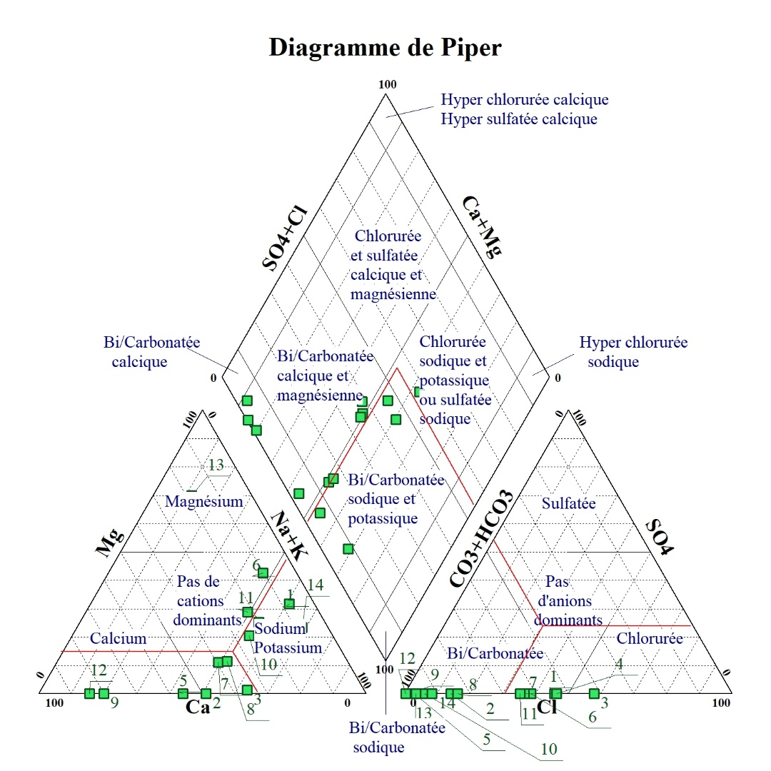

Figure 10 : Piper diagram of waters collecting alluvium from the Dallol Bosso
Four hydrochemical facies were obtained, as shown in Figure 11, which shows the percentage distribution of the hydrochemical facies of the analyzed waters. Sodium and potassium chloride facies are the most dominant with a proportion of 37.5%, followed by calcium and magnesium chloride and sulfate facies, which have the same proportion as calcium bicarbonate facies (25%). Finally, calcium and magnesium bicarbonate facies have a proportion of 12.5%.

Figure 11 : Percentage distribution of hydrochemical facies
Suitability of water for irrigation
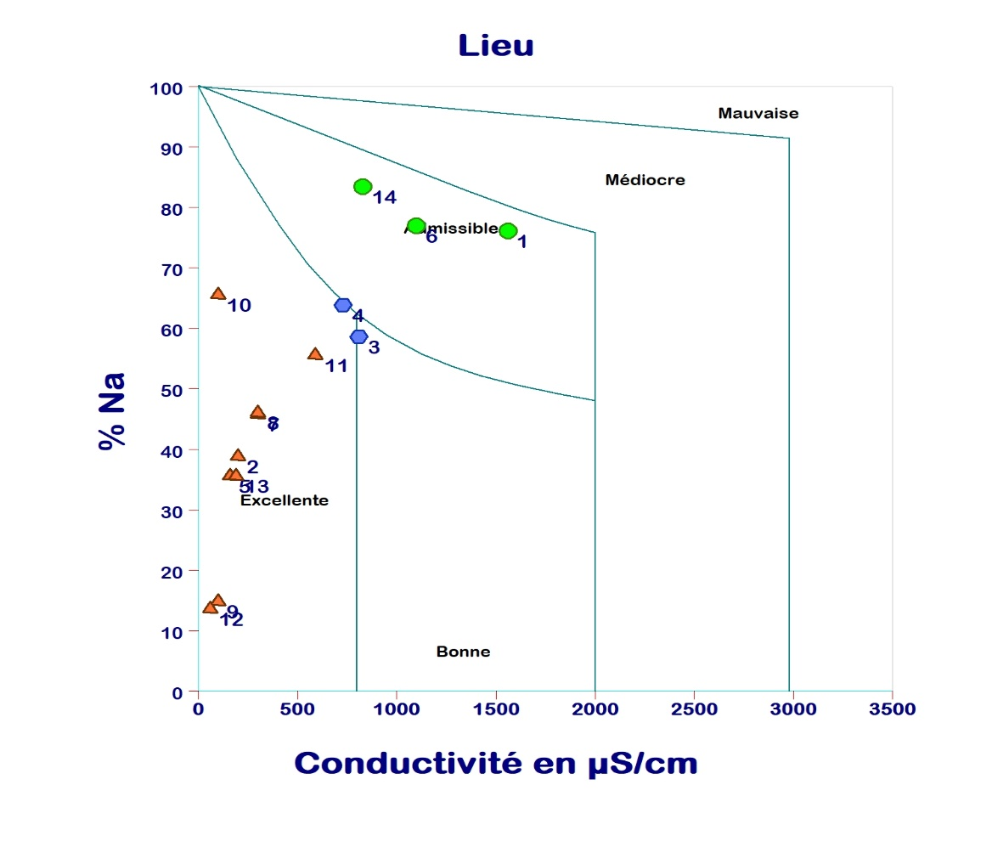
Figure 12 shows the Wilcox diagram, which provides information on the suitability of water for irrigation. All of the water analyzed is excellent for irrigation (64.29%), 24.43% of the water analyzed is acceptable for irrigation, and 14.29% is intermediate between excellent, good, and acceptable.

Figure 12 : Suitability of water for irrigation
Discussion
The results of the analysis of the physical parameters of the waters collecting the alluvium from Dallol Bosso show that they generally comply with the 2017 WHO standard for drinking water. These waters are generally low in minerals, which could be due to the quartzite deposits (sand), which are less clayey and mainly receive water from atmospheric precipitation through infiltration. These aquifers are more easily recharged. This is in line with Halimatou Sadia's 2018 studies in the Dallol Maouri sub-basin. However, a high EC is recorded in the village of Amassaghal from an auger borehole with 1560 µS/cm, exceeding the WHO guideline value (1000 µS/cm). This water is highly mineralized. Total hardness shows that 50% of the water from the structures analyzed is soft water. The WHO has not defined a guideline value for total hardness because no guideline value based on health arguments has been proposed for TH (WHO, 2017). However, hard water can lead to the formation of a deposit consisting of a calcium carbonate crust and also leads to high soap consumption. Soft water, on the other hand, may have a low buffering capacity. The F⁻ contents obtained are slightly higher than the WHO level at Amassaghal (1.51 mg/L). The work of Haoua AMADOU et al. (2020) on structure that capture alluvium from the Dallol Bosso found levels below the WHO standard, ranging from trace amounts to 0.54 mg/L. Consumption of water containing high levels of fluoride causes dental or bone fluorosis, while consumption of water low in fluoride leads to tooth decay (Haoua AMADOU et al. (2020). However, high nitrate (NO3-) levels exceeding the WHO standard (50 mg/L) are recorded in the following locations : Fandou Mayaki (56.32 mg/L), Loki Damana (67.32 mg/L), Bakobe school (68.2 mg/L), Garbey Taweye (85.36 mg/L), Bani Kane Fondo Bon (91.96 mg/L), Goumbi Banda (94.16 mg/L), Amassaghal (98.12 mg/L) and Bombéri (137.28 mg/L), representing 57.14% of the structures capturing alluvium from the Dallol Bosso analyzed. These levels are higher than those obtained by Haoua AMADOU et al. (2020), which vary from 3.08 to 108.68 mg/L in structures capturing the Dallol Bosso. These levels could be due to the fact that water flows into this aquifer, so human activities such as market gardening, which uses chemical and natural fertilizers, could contaminate the water in this aquifer with nitrates through the penetration of organic matter by rainwater leaching. This is in agreement with Rabilou et al. (2018) on the Korama basin in Zinder. They found high nitrate levels ranging from 2.2 to 127.6 mg/L, exceeding the WHO guideline value, and showed that these levels could be linked to anthropogenic activities such as market gardening, as the water from these boreholes is not far from this area. These nitrate levels could also be linked to the shallow depth of the water table (Jaouad El Asslouj, et al., 2020). In addition, a study on water from structures used for market gardening in Balleyara, which capture the alluvial aquifer of Dallol Bosso, found high nitrate levels ranging from 5.72 to 369.6 mg/L. It shows that these high levels could be linked to the use of chemical fertilizers. Consumption of this water is dangerous, particularly for newborns (those under three months old) as they could be exposed to methemoglobinemia (Haoua AMADOU et al., 2020). High Na⁺ levels ranging from 3 to 302 mg/L are higher than the results obtained by Haoua AMADOU et al., 2020, which range from 2.8 to 50 mg/L in Balleyara on the Dallol Bosso alluvial aquifer. High levels were obtained in Amassaghal (302 mg/L), which exceeds the WHO guideline value for Na⁺ (200 mg/L). The origin could be natural with a contribution linked to anthropogenic activities (Haoua AMADOU et al., 2020). High K⁺ levels were recorded in the following locations : Garbey Taweye (15 mg/L), Loki Damana (20 mg/L), Fandou Mayaki (25 mg/L), N'Boria Banifandou (25 mg/L), Goumbi Banda (30 mg/L) and Tanka Worbo (50 mg/L), all of which exceed the WHO guideline value for K⁺ (12 mg/L), representing 42.85% of the structures analyzed. These high levels could be the result of the dissolution of Na⁺ and, above all, K⁺ salts. These levels are similar to the results obtained by Haoua AMADOU et al. (2020) on waters that collect alluvium from the Dallol Bosso, where they found K+ levels ranging from 1.6 to 50 mg/L. The origin of these high levels could be natural, with a contribution from anthropogenic activities.
Conclusion
This study shows that the results of the physical and chemical analyses carried out on water collected from the Dallol Bosso alluvial aquifer are, on the whole, of acceptable physical and chemical quality for human consumption, i.e., they comply with the 2017 WHO standard. However, high levels relative to the WHO recommended values were found for certain chemical parameters. Fluoride levels slightly exceed the WHO guideline value at Amassaghal (1.51 mg/L). In terms of total hardness, 50% of the water samples analyzed are soft. More than half (57.14%) of the water samples analyzed had nitrate levels higher than the 2017 WHO guideline value of 50 mg/L. This could be explained, on the one hand, by the use of chemical fertilizers on market gardening fields located in the vicinity of these structures and, on the other hand, by the shallow depth of the Dallol Bosso alluvial aquifer. The Piper diagram of the waters that collect the alluvium of the Dallol Bosso shows that the most predominant facies are sodium and potassium chloride or sodium sulfate facies, with a proportion of 50%. Sodium levels are high at Amassaghal (302 mg/L). As for potassium, 42.85% of the water samples from the villages analyzed have high levels. In terms of the suitability of the water for irrigation, more than half (64.29%) of the water samples from the structures analyzed are excellent for irrigation. This could be due to the fact that these waters are moderately mineralized overall and have lower sodium percentages. Finally, changes in the levels of certain chemical parameters such as nitrates and fluorides should be monitored very closely.
Disclaimer (Artificial intelligence)
Option 1:
Author(s) hereby declare that NO generative AI technologies such as Large Language Models (ChatGPT, COPILOT, etc.) and text-to-image generators have been used during the writing or editing of this manuscript.
Option 2:
Author(s) hereby declare that generative AI technologies such as Large Language Models, etc. have been used during the writing or editing of manuscripts. This explanation will include the name, version, model, and source of the generative AI technology and as well as all input prompts provided to the generative AI technology
Details of the AI usage are given below:
1.
2.
3.
References
- Haoua AMADOU, Mahaman Sani LAOUALI, Abdou Salam MANZOLA, 2014. Hydrochemical characterization of groundwater in the Tahoua region (Niger). Journal of Applied Biosciences 80:7161–7172, ISSN 1997–5902. http://dx.doi.org/10.4314/jab.v81i1.6

Haoua AMADOU, Mahaman Sani LAOUALI, Abdou Salam MANZOLA, and Hama ADAMOU, 2020. Contribution of Statistical and Hydro-Chemical Methods of the Waters of the Dallol Bosso Area in the Fillingue and Ballayara Departments. International Journal of Applied Chemistry. ISSN 0973-1792 Volume 16, Number 1 (2020) pp. 1-20
- Ibrahim MAINASSARA, 2010. Water resources in the Tillabéri region (southwestern Niger) and their potential for development through irrigated agriculture. Thesis for a specialized master's degree in integrated water resources management.
- INS, Tillabéri Regional Directorate, 2016. Monograph of the Tillabéri region.
- Laurent BARBIERO and Vincent VALLES, 1992. Geochemical aspects of soil alkalization in the Dal1o1 Bosso Valley (Republic of Niger).
- Rabilou SOULEY MOUSSA, Maman Mousbahou MALAM ALMA, Mahaman Sani LAOUALI, Ibrahim NATATOU, and HABOU Issa, 2018b. Physicochemical characterization of the waters of the Continental Intercalary/Hamadian and Continentalsiems Terminal aquifers in the Zinder region (Niger). ISSN 1997-342X (Online), ISSN 1991-8631 (Print)

- Chae, G. T., Kim, K., Yun, S. T., Kim, K. H., Kim, S. O., Choi, B. Y., ... & Rhee, C. W. (2004). Hydrogeochemistry of alluvial groundwaters in an agricultural area: an implication for groundwater contamination susceptibility. Chemosphere, 55(3), 369-378.

- Mostaza-Colado, D., Carreño-Conde, F., Rasines-Ladero, R., & Iepure, S. (2018). Hydrogeochemical characterization of a shallow alluvial aquifer: 1 baseline for groundwater quality assessment and resource management. Science of the Total Environment, 639, 1110-1125.

- Mthembu, P. P., Elumalai, V., Senthilkumar, M., & Wu, J. (2021). Investigation of geochemical characterization and groundwater quality with special emphasis on health risk assessment in alluvial aquifers, South Africa. International Journal of Environmental Science and Technology, 18(12), 3711-3730.

- Helena, B. A., Vega, M., Barrado, E., Pardo, R., & Fernández, L. (1999). A case of hydrochemical characterization of an alluvial aquifer influenced by human activities. Water, Air, and Soil Pollution, 112(3), 365-387.

