Influence of Calcination Temperature on the Physicochemical Properties of Limestone from the Aktau Deposit
Abstract
Aims: To investigate the effect of calcination temperature on the physicochemical properties of carbonate rocks from the Aktau deposit in Karakalpakstan, with a focus on the relationship between firing temperature, lime reactivity, and microstructural characteristics.
Study Design: Experimental laboratory study with comparative analysis across different calcination temperatures.
Place and Duration of Study: Karakalpak Scientific Research Institute of Natural Sciences, Karakalpak Branch of the Academy of Sciences of the Republic of Uzbekistan, Nukus, from March to November 2024.
Methodology: Limestone samples from the Aktau deposit were calcined at 800, 900, 1000, 1100, and 1200 °C. Chemical composition was determined by standard wet chemistry methods. Thermal behavior was analyzed using thermogravimetric and differential thermal analysis. Functional groups were examined by infrared (IR) spectroscopy. Microstructural features were observed by scanning electron microscopy (SEM). The reactivity of the produced lime was evaluated according to hydration rate and temperature rise during slaking.
Results: Increasing calcination temperature above 1000 °C significantly enhanced the reactivity of lime, with maximum values observed at 1100 °C. SEM images revealed that higher temperatures led to coarser but more porous microstructures, improving water penetration during hydration. IR spectroscopy confirmed progressive decomposition of carbonates and formation of free CaO. Samples calcined at 800–900 °C retained partially decomposed calcite, resulting in lower reactivity. Impurity content, texture, and grain size were found to influence the hydration kinetics.
Conclusion: Calcination temperature plays a critical role in determining the physicochemical properties and reactivity of lime from the Aktau deposit. Optimal reactivity is achieved at 1100 °C due to favorable microstructural development. These findings can guide industrial processing parameters to produce lime with improved performance in construction and chemical applications.
Keywords: air binders, limestone, Aktau deposit, binding materials, mineral, carbonates, calcination temperature.
Introduction
Limestone is one of the most abundant and economically important sedimentary rocks. It consists mainly of calcium carbonate (CaCO₃), which occurs in the crystalline forms of calcite and aragonite. Due to its wide availability, low cost, and versatile properties, limestone plays a key role in many industries. In construction, it is the primary raw material for producing lime, cement, and composite binders. In metallurgy, it is used as a flux to remove impurities from molten metals, while in the chemical industry it serves as a source of calcium oxide, calcium hydroxide, and other essential derivatives.
Limestone processing typically involves calcination—the thermal decomposition of CaCO₃ into calcium oxide (CaO) with the release of CO₂. The temperature and duration of calcination are key factors determining decomposition efficiency and, consequently, the properties of the resulting lime, such as specific surface area, reactivity, phase composition, and particle morphology. Insufficient heating causes incomplete decomposition and low reactivity, whereas overheating promotes sintering, reduces activity, and impairs hydration and binding behavior.
Quicklime (CaO) is one of the oldest and most important binders in construction. It is typically produced by heating limestone or dolomite at 900–1300 °C. At these temperatures, carbonate minerals decompose, CO₂ is released, and reactive lime with distinct microstructural features is formed. The microstructure directly affects material performance: underburnt lime remains poorly reactive, while overburnt lime becomes overly dense and loses activity. Therefore, precise control of calcination parameters is essential for producing high-quality quicklime.
Numerous studies have shown that calcination conditions strongly influence lime properties. Qian et al. (2023) proposed a partial low-temperature calcination method that promotes the formation of a core–shell structure, thereby enhancing reactivity and cement strength. Pavia et al. (2023) reported that higher calcination temperatures reduce lime activity and alter mortar microstructure. Zhang et al. (2023) demonstrated that reducing particle size accelerates CO₂ release and improves reactivity, while Desmiarti et al. (2022) found that calcination at 1000 °C for 5 h yields a CaO content exceeding 90%, indicating nearly complete decomposition.
Despite these advances, the calcination behavior of Aktau limestone has not been systematically investigated. This deposit contains a high concentration of CaCO₃, with low magnesium carbonate and minimal clay and silica impurities, suggesting strong potential for producing highly reactive lime. Its distinctive mineral composition may affect decomposition kinetics, phase transitions, and microstructural evolution under varying calcination conditions.
In light of the growing emphasis on sustainable construction practices and the efficient use of local mineral resources, research on Aktau limestone is both timely and practically relevant. The aim of this study is to evaluate the effect of calcination temperature on the physicochemical properties of Aktau limestone and to identify the optimal conditions for producing highly reactive quicklime, based on chemical, thermal, infrared, and SEM analyses.
2. Materials and Methods
Calcination was performed using two types of laboratory furnaces. For treatments at temperatures up to 1100 °C, a SNOL 1.6.2.5/11-I2 muffle furnace (220 V, 50 Hz, 3.0 kW, 78 kg) was used. This unit provided a stable heating regime with deviations not exceeding ±5 °C. For higher-temperature experiments, a SEL-HORN R-8 L furnace equipped with silicon carbide (SiC) heating elements and a touchscreen control system was employed. Although designed to reach 1500 °C, in this study its operating range was limited to 1300 °C. Uniform heat distribution was ensured by spiral SiC elements, while temperature was monitored with a thermocouple and controlled by a digital regulator (accuracy ±5 °C). The choice of furnace type was determined by the required thermal conditions.
The heating rate in all experiments was maintained at 8–10 °C/min until the selected temperatures (800, 900, 1000, 1100, and 1200 °C) were reached. Each sample was kept at the target temperature for 30 min, after which controlled cooling was performed inside the closed furnace chamber in air at a rate of about 2–3 °C/min down to approximately 200 °C.
The feedstock material was limestone from the Aktau deposit, located near the right bank of the Amu Darya River, 45 km northwest of Beruni and about 1 km from the Tortkul–Nukus highway. During sampling, fragments with visible clay layers, organic inclusions, or iron oxides were deliberately avoided.
Bulk limestone samples were transported to the laboratory without pre-washing. Initial crushing was carried out using a laboratory jaw crusher, producing a 5–10 mm fraction. The material was then sieved through a 5 mm mesh (GOST 6613-86). Batch weights were measured with mechanical lever household scales (capacity 10 kg, graduation 50 g). After calcination, samples were weighed on SF-400 electronic scales (capacity 10 kg, graduation 1 g), which were used in cases where high precision was not required.
For further characterization, a portion of the calcined samples was ground manually. Initial comminution was performed in a metal mortar, followed by fine grinding in a porcelain mortar to minimize external contamination. The powdered fraction was used for X-ray diffraction (XRD) and chemical analyses, while larger fragments were reserved for thermal investigations.
Several analytical methods were employed to investigate phase composition and structural changes of the samples:
- Thermogravimetric analysis (TGA) and differential thermal analysis (DTA): carried out using a Shimadzu DTG-60 analyzer in an argon atmosphere (80 mL/min) with alumina crucibles. The sample mass was 5.477 mg, and the heating rate was 10 °C/min from room temperature up to 1000 °C.
- Fourier-transform infrared spectroscopy (FTIR): performed on a Shimadzu IRSpirit-T spectrometer (Japan, 2022) to identify functional groups and chemical bonds.
- Scanning electron microscopy (SEM): conducted with a JEOL JSM-IT210 microscope to examine morphology, pore development, and microstructural transformations.
According to the TGA/DTA and FTIR data, complete decomposition of CaCO₃ occurred above 1000 °C (Table 1). This temperature marks the transition from incomplete decarbonation to the formation of fully crystalline CaO. SEM micrographs further revealed significant morphological changes, including pore development, recrystallization, and grain boundary formation during calcination.

Table 1. Composition of CaCO₃ decarbonization products during calcination
Calcination temperature (°C) | CaO (%) | CO₂ (%) | Total (%)
Raw material | 55.49 | 42.38 | –
800 | 95.57 | 4.53 | 100.10
900 | 96.89 | 3.12 | 100.01
1000 | 98.42 | 1.59 | 100.00
1100 | 100.00 | – | 100.00
1200 | 100.00 | – | 100.00
3. Results
Infrared (IR) spectroscopy represents the most effective and rapid approach for evaluating the impact of thermal treatment on the phase and chemical composition of the samples. In the IR spectrum of CaCO₃, three distinct and well-resolved absorption bands are observed in the mid-infrared region: 713 cm⁻¹ (ν₄ – in-plane bending vibration of the CO₃ group), 874 cm⁻¹ (ν₂ – out-of-plane bending vibration of CO₃), and 1420 cm⁻¹ (ν₃ – asymmetric stretching vibration of CO₃) [5–7]. These characteristic peaks correspond to the fundamental vibrational modes of the carbonate ion and serve as reliable markers for identifying both the presence of calcium carbonate and its stage of decomposition during thermal treatment.
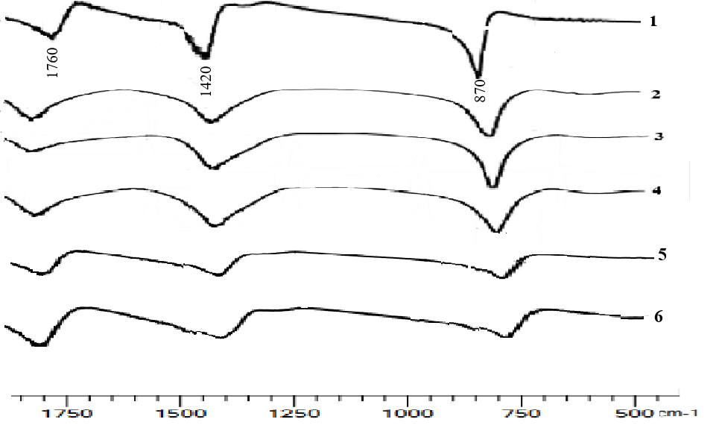
Fig. 1. IR absorption spectra of limestone from the Aktau deposit and lime after heat treatment: (1) natural limestone; (2) calcined at 800 °C; (3) calcined at 900 °C; (4) calcined at 1000 °C; (5) calcined at 1100 °C; (6) calcined at 1200 °C with a holding time of 30 min.
Infrared (IR) spectroscopic analysis (Fig. 1) revealed that the spectra of limestone from the Aktau deposit are characterized by distinct absorption bands at 870–860 cm⁻¹ (an intense, narrow band) and 1420–1430 cm⁻¹ (an intense, broad band), attributed to the vibrational modes of the CO₃²⁻ ion, which is indicative of the presence of calcium carbonate. This confirms that the limestone is composed predominantly of calcium carbonate. The IR spectra of samples calcined at 800–900 °C exhibit absorption bands at 1420–1430 cm⁻¹ corresponding to CaCO₃. At 1000 °C, the intensity of the CO₃²⁻ absorption bands decreases, and at temperatures of 1100–1200 °C the dissociation reaction is completed, resulting in the full conversion of calcium carbonate into calcium oxide (CaO).
The effect of thermal treatment on the properties of limestone from the Aktau deposit was further examined using a DTG-60 derivatograph. Differential thermal analysis (DTA) and thermogravimetric (TG) curves were recorded at a heating rate of 10 °C/min in the temperature range of 25–1000 °C under an argon atmosphere, using an aluminum crucible and a sample mass of 5.477 mg (Fig. 2). According to the thermal analysis data, three distinct stages of mass loss were observed: 28.93–552.83 °C (3.597%), 552.88–806.39 °C (44.093%), and 806.39–1001.76 °C (1.150%). The most pronounced weight reduction—approximately 44%—occurred in the second temperature interval, corresponding to the decomposition of calcium carbonate.
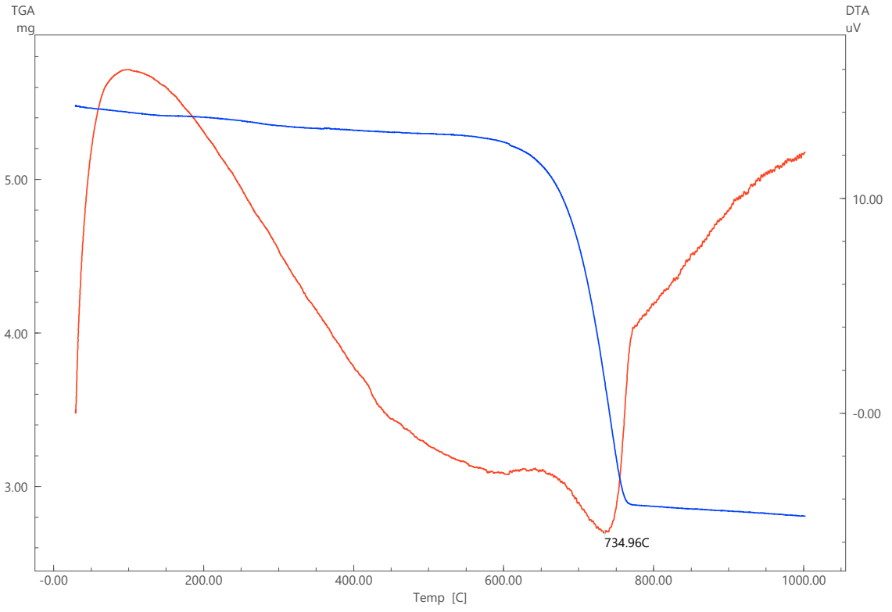
Fig. 2. Thermogram of the limestone sample from the Aktau deposit.
The DTA curve of this sample exhibits a more complex profile. This is due to the presence of thermal effects on the curve that are not associated with mass loss. Such variations occur both below and above the point of maximum mass loss rate. After the peak, the baseline shifts to a slightly lower position. The onset and end temperatures of this interval were refined by extrapolating the curves of the adjacent temperature intervals. The temperature of the thermal effect maximum, determined in this way, is 734.96 °C. This value primarily reflects the temperature of the reference material and the furnace environment. When a substance undergoes physicochemical transformations accompanied by heat absorption, its temperature during this period may be either higher or lower than that of the reference material. In the present case, an endothermic transformation occurs with the absorption of thermal energy from the heating furnace amounting to 550.34 J/g, and the temperature of the studied substance is approximately 100 K higher. Consequently, the peak of the endothermic effect in the sample corresponds to 842.95 °C (734.95 + 108 °C) and falls within the range of 825–930 °C reported in other studies. It should be noted that these results are influenced by various factors, such as the heating rate, sample mass, the presence of impurities in the analyzed substance, and its crystallochemical characteristics [8].
Analysis of the obtained data indicates that the studied sample contains a certain amount of Mg, which may be present in the form of magnesite or dolomite. At temperatures of 700–800 °C, magnesite decomposes according to:
MgCO₃ → MgO + CO₂↑
In dolomite (CaCO₃·MgCO₃), the decarbonation of MgCO₃ occurs earlier, at 650–750 °C, while CaCO₃ remains undecomposed, according to the reaction:
CaCO₃·MgCO₃ → CaCO₃·MgO + CO₂↑
Scanning electron microscopy (SEM) is an important tool in modern structural research, enabling high-precision visualization of the microstructure of lime minerals. SEM allows for the assessment of morphological changes on the surface of raw materials, as well as the processes of crystallite formation and bonding. In this study, a JEOL JSM-IT210 scanning electron microscope was used to analyze raw material samples. The samples were prepared under vacuum conditions and examined with high precision. SEM was employed to investigate the morphological structure of the minerals and the particle shapes. Each sample was scanned at different magnifications (from 100× to 10,000×) and subjected to chemical analysis using an electron beam.

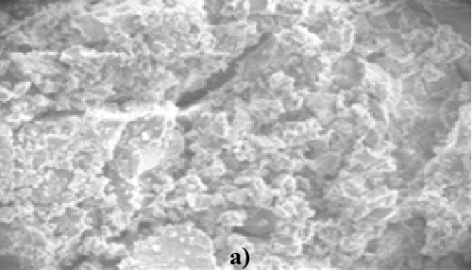 | 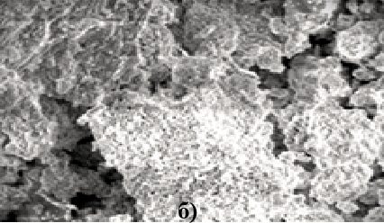 |  | 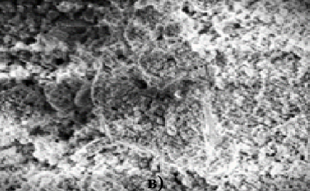
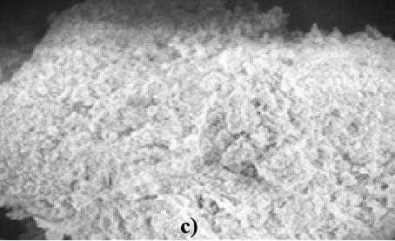 |  | 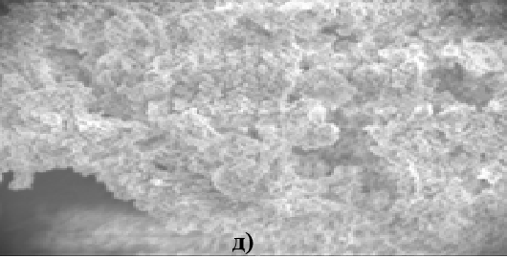
Fig. 3. SEM micrographs of the surface of limestone from the Aktau deposit and lime after heat treatment: (a) natural limestone; (b) sample calcined at 900 °C; (c) sample calcined at 1000 °C; (d) sample calcined at 1100 °C; (e) sample calcined at 1200 °C with a holding time of 30 min.
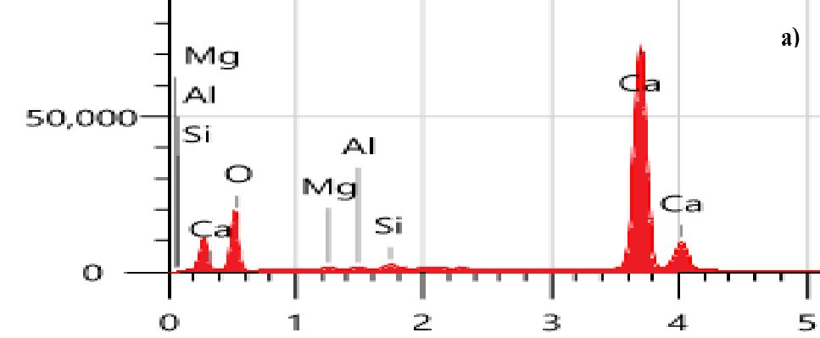 | 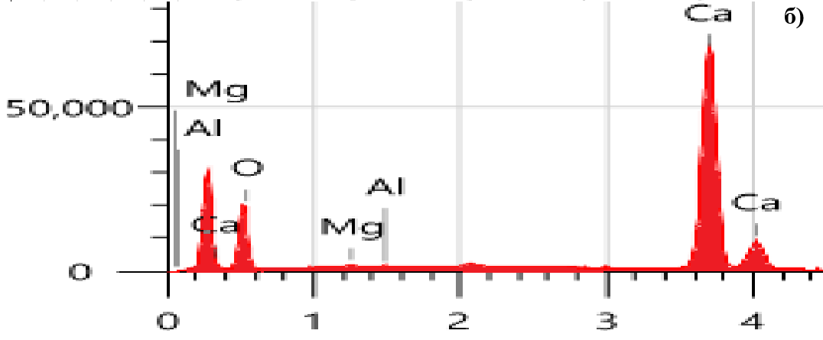 |  | 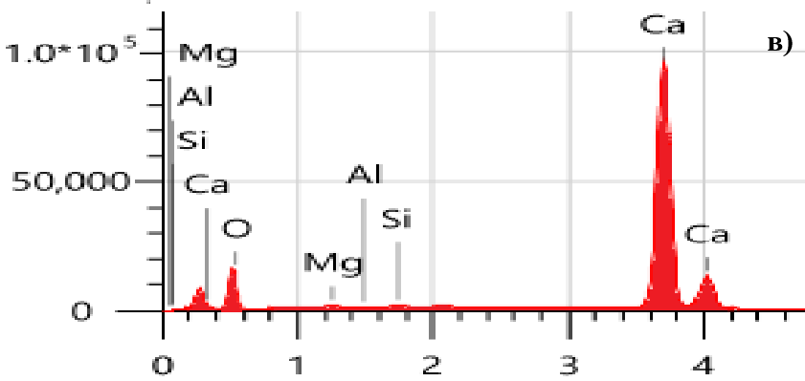
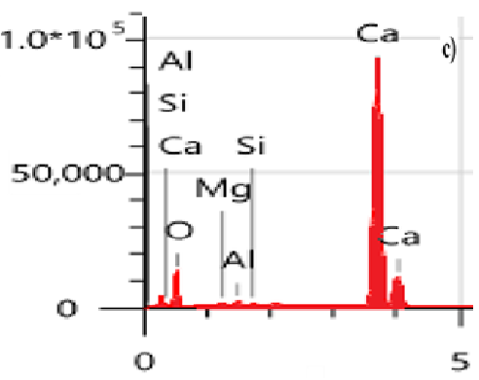 |  | 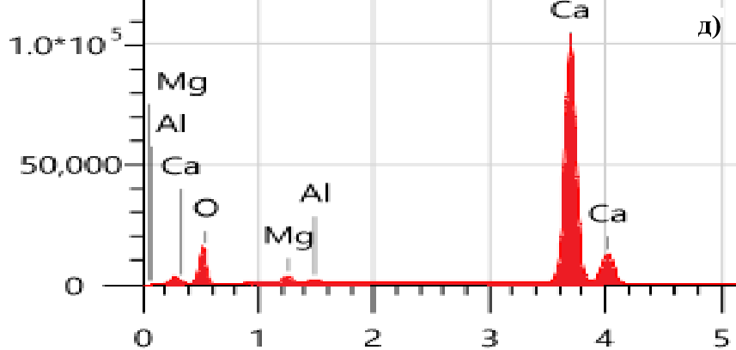
Fig. 4. Elemental composition of Aktau limestone samples calcined at different temperatures.
Based on the analysis results, the results revealed that the crystalline structure and morphological features of limestone samples calcined at different temperatures differ significantly from one another (Figs. 3–4). The microstructure is characteristic of carbonate minerals and the granular structure of calcium oxide. Decarbonation of limestone at low temperatures (800–850 °C) results in the formation of calcium oxide in the form of a spongy mass composed of crystallites approximately 0.2–0.3 μm in size, permeated by ultrafine capillaries with a diameter of about 8 × 10⁻³ μm. Increasing the calcination temperature to 900 °C, and especially to 1000 °C, results in the growth of calcium oxide crystallites to 0.5–2 μm and a significant decrease in specific surface area to 4–5 m²/g. At 1100–1200 °C, the microstructure exhibits a porous structure of calcium oxide, with possible residual carbonate and reaction products of impurities present in the raw material. Ultimately, the microstructure of the calcined limestone consists of a porous, granular structure of calcium oxide formed as a result of calcium carbonate decomposition.
4. Discussion
Lime samples obtained at 1000 °C and above, while having the same chemical composition, differ significantly in their degree of crystallization. As shown in Fig. 5, the samples calcined at 800–1000 °C display a relatively loose and porous microstructure, characteristic of incomplete decomposition of calcium carbonate and the formation of less-ordered CaO crystals. With increasing calcination temperature, the porosity gradually decreases, and the microstructure becomes denser and more homogeneous. At 1100–1200 °C, well-developed crystalline CaO structures are formed, indicating a higher degree of crystallinity accompanied by particle sintering.
Such structural evolution is consistent with the IR spectroscopy and thermal analysis data: the reduction in porosity at higher temperatures corresponds to the completion of the CaCO₃ → CaO transformation and the onset of sintering processes, which promote densification.

Fig. 5. Effect of calcination temperature on the specific surface area of lime (Aktau deposit).
The influence of calcination temperature on the specific surface area of lime is shown in Fig. 5. At lower temperatures (800–900 °C), the specific surface area remains relatively high (approximately 290–340 m²/g), due to the porous and loosely packed structure of the lime. A significant decrease in surface area is observed starting from 1000 °C, which is attributed to particle sintering and the densification of the microstructure. At 1200 °C, the surface area reaches its minimum (~140 m²/g), reflecting the formation of larger, well-crystallized CaO particles with reduced porosity.
This trend corresponds well with SEM observations and IR spectroscopy results, confirming that higher calcination temperatures lead to both structural densification and a higher degree of crystallinity.
5. Conclusion
This study demonstrates that the calcination temperature of limestone from the Aktau deposit exerts a decisive influence on the physicochemical properties of the resulting lime. At lower firing temperatures (around 800 °C), the decomposition of calcium carbonate remains incomplete, resulting in reduced reactivity and the formation of a loose, porous microstructure. Raising the calcination temperature to 1000–1100 °C ensures complete decomposition of CaCO₃, producing lime with enhanced reactivity and a more homogeneous structure. However, further heating to 1200 °C induces structural densification and particle sintering, which markedly reduce the specific surface area and reactivity. These findings provide valuable guidance for optimizing calcination parameters in the production of high-quality lime for construction and industrial applications.
Disclaimer (Artificial intelligence)
Option 1:
Author(s) hereby declare that NO generative AI technologies such as Large Language Models (ChatGPT, COPILOT, etc.) and text-to-image generators have been used during the writing or editing of this manuscript.
Option 2:
Author(s) hereby declare that generative AI technologies such as Large Language Models, etc. have been used during the writing or editing of manuscripts. This explanation will include the name, version, model, and source of the generative AI technology and as well as all input prompts provided to the generative AI technology
Details of the AI usage are given below:
1.
2.
3.

References
1. Volzhensky, A. V. (1986). Mineral binding materials (in Russian). Moscow: Stroyizdat, pp. 64–68. Schöler, A., Lothenbach, B., Winnefeld, F., & Haha, M. B. (2023). Advances in binders for construction materials. Materials, MDPI Books. https://doi.org/10.3390/books978-3-0365-6582-8
2. Potapova, E. N. (2023). Technology of dry building mixes (in Russian). Moscow; Vologda: Infra-Engineering. 376 p. ISBN 978-5-9729-1239-1. Available at: https://www.iprbookshop.ru/133079 (accessed with authorization) and https://znanium.com/catalog/product/2101993 (subscription required, accessed 06 August 2025).
3. Asamatdinov, O. (1988). Influence of calcination temperature on the physicochemical properties of lime (in Russian). Bulletin of the Karakalpak Branch of the Academy of Sciences of the Uzbek SSR, Nukus, pp. 23–26. https://portal.tpu.ru/SHARED/l/LYAMINA/uchebnaya_rabota/Tab/Thermodynamics_0.pdf
4. Turemuratov, Sh. N., & Nurumbetov, B. Ch. (2021). Influence of the carbonate calcium on processes of hydration structure-formation of lime–belite binding systems (in Russian). Science and Education in Karakalpakstan, Scientific Journal, (1), 96–101.
5. Poduska, K. M., Regev, L., Boaretto, E., Addadi, L., Weiner, S., Kronik, L., & Curtarolo, S. (2011). Decoupling local disorder and optical effects in infrared spectra: Differentiating between calcites with different origins. Advanced Materials, 23(4), 550–554. https://research.library.mun.ca/6257/
6.Turemuratov, Sh. N., Kurbaniyazov, S. K., & Akeshova, M. M. (2013). Physico-mechanical properties of limeware binding materials affected by applied substances and undergone hydrothermal treatment. Journal of Materials and Applications, 1179–1185. https://citeseerx.ist.psu.edu/document?repid=rep1&type=pdf&doi=8c621faeeaa1a30653613a5dcf122878b022cb6d
7.Turemuratov, Sh. N., Kurbaniyazov, S. K., & Akeshova, M. M. (2013). Influence of hydrothermal processing and applied substances on physicomechanical properties of limeware binding materials. World Applied Sciences Journal, 23(9), 1151–1156.
8.Shayakhmetov, A. U., Mustafin, A. G., & Massalimov, I. A. (2011). Features of thermal decomposition of oxide, peroxide, hydroxide, and calcium carbonate (in Russian). Bulletin of the Bashkir University, 16(1), 29–32.
9.Smirenskaya, V. N., Antipova, S. A., & Sokolova, S. N. (2009). Chemical technology of binding materials (in Russian). Tomsk: Tomsk Polytechnic University, pp. 13–19. https://portal.tpu.ru/SHARED/a/ANTIPINA/ucheb/Tab3/UcG.pdf
10.Turemuratov, Sh. N., Kurbaniyazov, S. K., & Akeshova, M. M. (2013). Influence of hydrothermal processing and applied substances on physicomechanical properties of limeware binding materials. World Applied Sciences Journal, 23(9), 1151–1156.
11.Tabunshchikov, N. P. (1974). Lime production (in Russian). Moscow: Khimiya, 279 p

