Postoperative Takotsubo Syndrome Presenting With Malignant Ventricular Arrhythmia: A Case Report

Abstract
Background: Takotsubo syndrome (TTS) is a stress-induced cardiomyopathy characterized by transient left ventricular systolic dysfunction, typically triggered by emotional or physical stress. While usually reversible, TTS can be complicated by severe events, with ventricular arrhythmias representing a particularly serious risk linked to increased morbidity and mortality.
Case summary: We report a 63-year-old postmenopausal woman with hypertension and type 2 diabetes mellitus who underwent elective cholecystectomy under general anesthesia without intraoperative complications. Two days postoperatively, she developed persistent chest discomfort followed by sudden-onset palpitations. Electrocardiography revealed sustained monomorphic ventricular tachycardia at 180 bpm causing hemodynamic instability, which required urgent pharmacological and electrical intervention. Cardiac biomarkers showed a peak troponin of 1.2 ng/mL, and QTc was prolonged at 510 ms. Transthoracic echocardiography demonstrated a left ventricular ejection fraction (LVEF) nadir of 35%, and cardiac MRI confirmed apical ballooning and myocardial edema, consistent with TTS. The patient was stabilized with anti-arrhythmic therapy and beta-blockers, and discharged after seven days. At follow-up, LVEF normalized to 52%, troponin returned to baseline, and no arrhythmic events occurred.
Discussion: This case underscores the risk of malignant ventricular arrhythmias in TTS, particularly in the perioperative context where surgical stress can act as a trigger. The arrhythmogenic mechanism likely involved sympathetic overdrive, postoperative inflammatory responses, and repolarization abnormalities. Prompt recognition and timely management of arrhythmias are crucial to prevent life-threatening outcomes.
Conclusion: Although TTS is generally self-limiting, it can be complicated by potentially fatal ventricular arrhythmias. Clinicians should maintain a high index of suspicion in postmenopausal women presenting with acute chest pain or arrhythmia following recent surgery, as early diagnosis and intervention are essential to improving prognosis.
Keywords : Takotsubo syndrome, Type 2 diabetes mellitus, Malignant Ventricular Arrhythmia, postmenopausal
INTRODUCTION
Takotsubo syndrome (TTS), also referred to as stress-induced cardiomyopathy or “apical ballooning syndrome,” is characterized by an acute but reversible dysfunction of the left ventricle, most often triggered by intense physical or emotional stress [5,9,14]. It occurs predominantly in postmenopausal women, and its underlying mechanisms are believed to involve excessive catecholamine release, microvascular dysfunction, and alterations in autonomic regulation [11,14].
Initially regarded as a relatively benign condition, TTS is now recognized as a potentially serious entity that may progress to complications such as acute heart failure, cardiogenic shock, and life-threatening arrhythmias [6,12,13]. Ventricular arrhythmias, in particular sustained ventricular tachycardia (VT) and ventricular fibrillation (VF), although infrequent, carry significant prognostic weight and contribute to in-hospital morbidity and mortality [6,10,12]. Reported incidence varies, but malignant arrhythmias have been observed in up to 10–15% of patients, usually within the first two days of presentation [6,10]. The mechanisms are likely multifactorial, combining sympathetic hyperactivity, QT prolongation, repolarization abnormalities, and uneven recovery of myocardial segments [10,11].
In the perioperative context, TTS is being increasingly described as a distinct entity. Surgical stress, anesthetic exposure, and postoperative inflammatory responses may serve as potent triggers [2,4]. Clinical presentation in this setting can be atypical, and the development of ventricular arrhythmias makes both diagnosis and management particularly challenging [2,6].
We present the case of a 63-year-old postmenopausal woman who developed sustained VT as a complication of TTS shortly after elective cholecystectomy. This case underlines the relevance of early recognition, continuous monitoring, and prompt treatment of arrhythmic events in the perioperative setting.
CASE REPORT
A 63-year-old postmenopausal woman, with a medical history of hypertension and type 2 diabetes mellitus, presented to the emergency department with acute palpitations and chest discomfort. She had undergone an elective laparoscopic cholecystectomy two days prior, and her postoperative course had been uneventful until the onset of symptoms. The patient was widowed for eight months and had no known prior cardiac arrhythmias.
Upon arrival, she reported persistent retrosternal chest discomfort for the preceding 48 hours, accompanied by sudden-onset palpitations. Vital signs revealed a blood pressure of 105/65 mmHg, heart rate of 150 bpm, respiratory rate of 20 breaths per minute, and oxygen saturation of 97% on room air. Physical examination was notable for a regular tachycardia with no murmurs, no signs of heart failure, and clear lung fields.
Electrocardiography demonstrated sustained monomorphic ventricular tachycardia (VT) with a rate of 170 bpm (figure 1.), requiring immediate electrical cardioversion after initial hemodynamic instability. Following successful electrical cardioversion, the patient received intravenous anti-arrhythmic therapy, IV amiodarone (150 mg bolus over 10 min, then 1 mg/min infusion). Beta-blocker therapy (carvédilol 12.5 mg twice daily) was initiated after stabilization. He was transferred to the cardiac intensive care unit for continuous monitoring. Supportive measures included close hemodynamic monitoring and electrolyte optimization.
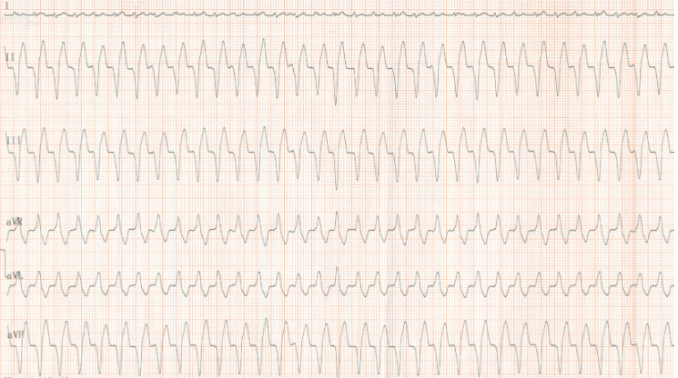
Figure 1: Electrocardiogram (ECG) demonstrating sustained ventricular tachycardia at a rate of 170 beats per minute.
A post-procedure electrocardiogram demonstrated ST-segment elevation in the anteroseptal and apical leads, with reciprocal ST-segment depression in the lateral leads. No new symptoms were reported at that time, and hemodynamic parameters remained stable. This ECG pattern raised concern for acute myocardial injury, prompting urgent echocardiographic evaluation and consideration of emergent coronary angiography to exclude obstructive coronary disease
Laboratory tests revealed mild elevation of cardiac biomarkers (high-sensitivity troponin I: 0.38 ng/mL, normal <0.04 ng/mL), normal electrolytes, and an unremarkable complete blood count. B-type natriuretic peptide was modestly elevated at 280 pg/mL.
Transthoracic echocardiography demonstrated classic apical ballooning with basal hyperkinesis, resulting in a left ventricular ejection fraction of 35%. Cardiac MRI (figure 3.) confirmed myocardial edema localized to the apical segments with preserved basal function, consistent with TTS. Coronary angiography demonstrated unobstructed coronary arteries, ruling out acute coronary syndrome.
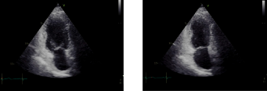
Figure 2 : Transthoracic echocardiography showing akinesis of the apical and mid-ventricular segments with preserved basal contraction

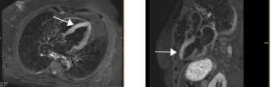
Figure 3 : Cardiac magnetic resonance imaging showing apical ballooning and myocardial edema in favor of TTS.
Diagnosis of Takotsubo syndrome (TTS) was established according to the revised Mayo Clinic criteria, including transient left ventricular dysfunction, absence of obstructive coronary artery disease on coronary angiography, new ECG changes or modest troponin elevation, and absence of pheochromocytoma or myocarditis [Ref]. Coronary angiography confirmed no obstructive lesions, ruling out acute coronary occlusion.
Over the subsequent five days, the patient remained hemodynamically stable, permanent ICD implantation was not indicated, given the reversible nature of TTS and absence of arrhythmia recurrence at follow-up. Echocardiography demonstrated progressive recovery of left ventricular function (LVEF 55%). No recurrent arrhythmic events were observed during hospitalization or at one-month follow-up.
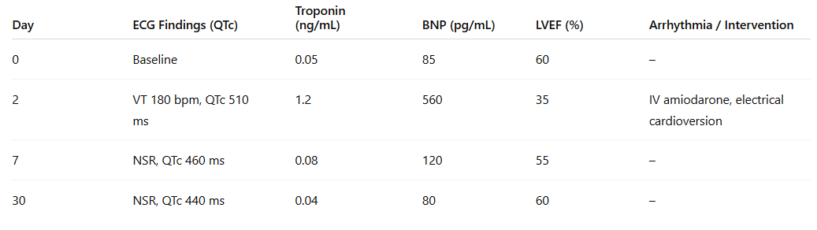
Table 1: Evolution of arrhythmia, cardiac biomarkers, and ventricular function in a patient with perioperative TTS
DISCUSSION
Takotsubo syndrome (TTS) is increasingly recognized as a condition with substantial clinical significance, rather than a benign disorder, due to its potential for serious complications such as heart failure, thromboembolic events, and malignant ventricular arrhythmias [5,6,12]. While ventricular tachycardia (VT) and ventricular fibrillation (VF) are relatively uncommon, their occurrence markedly increases in-hospital morbidity and mortality [6,10,12]. According to data from the International Takotsubo Registry, ventricular arrhythmias affect roughly 2–10% of patients during the acute phase, particularly older postmenopausal women with preexisting cardiovascular comorbidities [5,6,10].
The mechanisms underlying arrhythmias in TTS are complex and multifactorial. Acute catecholamine surges in response to emotional or physical stress can induce direct myocardial injury, calcium overload, and heterogeneous repolarization, creating a substrate for early afterdepolarizations and reentrant circuits [11,14]. Microvascular dysfunction and myocardial edema further contribute to electrical instability [11,14]. QT interval prolongation is commonly observed during the acute phase and serves as an important predictor of malignant arrhythmias [10,11]. Additional contributors, including systemic inflammation, oxidative stress, and impaired autonomic regulation, may further elevate the risk [11,14].
Perioperative TTS represents a particularly high-risk setting. Physical stressors such as surgery, anesthesia, postoperative pain, and systemic inflammatory responses may precipitate TTS, especially in patients with existing cardiovascular risk factors [2,4]. Several case reports have described postoperative VT or VF following procedures like pacemaker implantation, cholecystectomy, or abdominal surgery, highlighting the need for close cardiac surveillance immediately after surgery [1,2,3].
The electrocardiographic presentation in our patient—ST-segment elevation in anteroseptal and apical leads with reciprocal lateral changes—illustrates the diagnostic challenge of differentiating TTS from acute myocardial infarction, particularly when arrhythmias are present [5,9]. Prompt multimodal imaging, including echocardiography and cardiac MRI, alongside coronary angiography, is essential to confirm the diagnosis and guide management [5,9,13].
Management of VT in the context of TTS requires rapid stabilization, anti-arrhythmic therapy, and comprehensive supportive care. Electrical cardioversion is indicated for hemodynamically unstable VT, while beta-blockers can help modulate sympathetic overactivity and reduce arrhythmic risk in selected patients [6,11,12]. Careful correction of electrolyte disturbances and continuous monitoring of the QT interval are also critical [10,11]. Although most patients ultimately recover full ventricular function, early detection and treatment of arrhythmic complications remain pivotal to preventing sudden cardiac death [5,6,13].
As for the follow up, recurrence of TTS is uncommon but reported in up to 5–10% of cases. Our patient continued oral beta-blocker therapy and an ACE inhibitor (perindopril 5 mg daily) after discharge to reduce sympathetic activation and support myocardial recovery. Close outpatient follow-up was advised with ECG and echocardiography monitoring.
This case adds to the growing body of literature on postoperative TTS complicated by ventricular arrhythmias, demonstrating that even routine non-cardiac surgery can trigger life-threatening events in vulnerable individuals [2,4]. Continuous cardiac monitoring, early recognition of ECG abnormalities, and timely management of VT are crucial for optimizing outcomes. Clinicians should maintain a high index of suspicion in postmenopausal women with cardiovascular comorbidities who develop unexplained arrhythmias or chest discomfort during the perioperative period [2,6,10]. Furthermore, recent studies underscore the value of tailored perioperative monitoring in TTS patients, emphasizing continuous ECG surveillance, QTc assessment, and echocardiographic follow-up until both left ventricular function and cardiac biomarkers have normalized [16–18].
Conclusion
Takotsubo syndrome, while traditionally considered a reversible and benign cardiomyopathy, can be complicated by life-threatening ventricular arrhythmias such as sustained ventricular tachycardia or ventricular fibrillation. This case illustrates that even routine non-cardiac surgery may act as a potent physical stressor, precipitating TTS and creating a substrate for malignant arrhythmias in vulnerable patients, particularly postmenopausal women with cardiovascular comorbidities [2,10,14].
Early recognition of arrhythmic complications is critical. Continuous cardiac monitoring, timely electrocardiographic assessment, and prompt intervention—including electrical cardioversion, anti-arrhythmic therapy, and supportive care—are essential to prevent sudden cardiac death [6,11,12]. Multimodal imaging, including echocardiography, cardiac MRI, and coronary angiography, remains indispensable for accurate diagnosis and differentiation from acute coronary syndromes [5,9,13].
This report underscores the need for heightened clinical vigilance in the perioperative period and contributes to the growing literature emphasizing that TTS is not always benign. Awareness of the risk factors, triggers, and potential arrhythmic complications is essential for optimizing patient outcomes. Clinicians should maintain a high index of suspicion for TTS in patients presenting with acute chest discomfort and arrhythmias following physical or emotional stress, ensuring rapid and appropriate management to mitigate morbidity and mortality [2,6,10].

DISCLAIMER (ARTIFICIAL INTELLIGENCE)
Author(s) hereby declare that NO generative AI technologies and text-to-image generators have been used during the writing or editing of this manuscript.

CONSENT
As per international standards or university standards, patient(s) written consent has been collected and preserved by the author(s).

References
- Dev D, El-Din M, Vijayakumar S, et al. Takotsubo cardiomyopathy following pacemaker insertion complicated with polymorphic ventricular tachycardia: a case report. J Med Case Rep. 2024;18:238. doi:10.1186/s13256-024-04565-5.
- Bishev D, Noureldine H, Ortiz F. Reverse Takotsubo cardiomyopathy in the setting of small bowel obstruction after intubation complicated by sustained ventricular tachycardia: a case report. Ann Med Surg (Lond). 2024;86:5557-5560. doi:10.1097/MS9.0000000000002368.
- Fujiwara M, Ito H, Yamada H, Soeki T. A case of Takotsubo syndrome with polymorphic ventricular tachycardia and shark fin electrocardiogram developed during hospitalization for occlusive arterial disease of the lower extremities. J Cardiol Cases. 2024;30(4):107-110. doi:10.1016/j.jccase.2024.06.003.
- An Unusual Case of Takotsubo Cardiomyopathy with Cardiac Arrest: The Importance of Clinical Context in Implanted Cardioverter Defibrillator Candidacy. SD State Med Assoc Case Rep. 2024. PMID:39013097.
- Templin C, Ghadri JR, Diekmann J, et al. Clinical features and outcomes of Takotsubo (stress) cardiomyopathy. N Engl J Med. 2015;373(10):929-938. doi:10.1056/NEJMoa1406761.
- Santoro F, Mallardi A, Leopizzi A, et al. Ventricular arrhythmias in patients with Takotsubo syndrome. J Am Coll Cardiol EP. 2017;3(7):802-812. doi:10.1016/j.jacep.2017.02.010.
- Singh K, Carson K, Shah R, et al. Meta-analysis of clinical correlates of acute mortality in Takotsubo cardiomyopathy. Am J Cardiol. 2014;113(8):1420-1428. doi:10.1016/j.amjcard.2014.01.419.
- Regnante RA, Zuzek RW, Weinsier SB, et al. Clinical characteristics and four-year outcomes of patients in the Rhode Island Takotsubo Cardiomyopathy Registry. Am J Cardiol. 2009;103(7):1015-1019. doi:10.1016/j.amjcard.2008.12.008.
- Gianni M, Dentali F, Grandi AM, et al. Apical ballooning syndrome or Takotsubo cardiomyopathy: a systematic review. Eur Heart J. 2006;27(13):1523-1529. doi:10.1093/eurheartj/ehl032.
- Wu KC, Wittstein IS. Ventricular arrhythmic risk in Takotsubo syndrome: clinical subtype matters. JACC Clin Electrophysiol. 2022;8(12):1511-1514. doi:10.1016/j.jacep.2022.10.010.
- Pelliccia F, Kaski JC, Crea F, et al. Pathophysiology of Takotsubo syndrome. Circulation. 2017;135(24):2426-2441. doi:10.1161/CIRCULATIONAHA.116.027121.
- El-Battrawy I, Santoro F, Stiermaier T, et al. Incidence, management, and prognostic impact of arrhythmias in Takotsubo syndrome: a nationwide retrospective cohort study. J Am Heart Assoc. 2022;11(17):e026798. doi:10.1161/JAHA.122.026798.
- Di Vece D, Santoro F, Cammann VL, et al. Outcomes associated with cardiogenic shock in Takotsubo syndrome: results from the International Takotsubo Registry. Circulation. 2019;139(3):413-415. doi:10.1161/CIRCULATIONAHA.118.037933.
- Akashi YJ, Nef HM, Lyon AR. Epidemiology and pathophysiology of Takotsubo syndrome. Nat Rev Cardiol. 2015;12(7):387-397. doi:10.1038/nrcardio.2015.39.
- Scantlebury DC, Prasad A. Diagnosis of Takotsubo cardiomyopathy. Circ J. 2014;78(9):2129-2139. doi:10.1253/circj.CJ-14-0852.
- • Pillitteri M, Brogi E, Piagnani C, Di Paolo M, Vasquez M, Lattanzi F, et al. Perioperative management of Takotsubo cardiomyopathy: an overview. J Anesth Analg Crit Care. 2024;4:26.
- • Isogai T, Matsui H, Tanaka H, Fushimi K, Yasunaga H. Perioperative Takotsubo cardiomyopathy in noncardiac surgery: A nationwide retrospective cohort study and systematic review. Am J Cardiol. 2023;199:55-63.
- • Lyon AR, Bossone E, Schneider B, Seitz A, Citro R, Underwood SR, et al. Clinical perspectives: Takotsubo cardiomyopathy. Intern Med J. 2024;54(5):678-89.

