Case report
Cryptogenic Stroke with Isolated Cranial Nerve Deficits Attributable to a Small PFO: Successful Management with Cocoon Occluder

Abstract
Patent foramen ovale (PFO) is present in approximately 20–25% of the general population but is implicated in only a small subset of ischemic strokes, particularly in young adults with cryptogenic events. Stroke in individuals under 45 years accounts for only 10–15% of all ischemic strokes, and PFO-related presentations with isolated cranial nerve involvement are exceptionally rare.
We report a 40-year-old male who presented with acute slurring of speech and deviation of the mouth to the left. Neurological examination revealed dysarthria and tongue deviation without motor weakness. A thorough work-up for young-onset stroke was performed: bilateral carotid and vertebral Doppler were normal, chest radiograph was normal, antinuclear antibody (ANA) and antiphospholipid antibody (APLA) profiles were negative, homocysteine was borderline elevated, and fundus examination showed no papilledema. CT venous angiography of the lower limbs ruled out deep venous thrombosis. Magnetic resonance imaging demonstrated acute non-hemorrhagic infarcts in the right inferior frontal gyrus and right post-central gyrus. Transthoracic echocardiography with bubble contrast revealed right-to-left shunting during Valsalva, and transesophageal echocardiography (TEE) confirmed a 4-mm PFO.
Given the patient’s young age and isolated cranial nerve presentation, TEE-guided PFO closure was performed with a Cocoon 30/30 occluder device under fluoroscopic guidance, with no residual shunt post-procedure. The patient remained hemodynamically stable, developed no arrhythmia, and demonstrated marked improvement in speech function during follow-up.
This case underscores the clinical relevance of small but hemodynamically significant PFOs in young patients with cryptogenic stroke and highlights the importance of systematic etiological evaluation and timely intervention.
Keywords: Patent foramen ovale, cryptogenic stroke, young adult, dysarthria, Cocoon occluder, transcatheter closure

Introduction
Patent foramen ovale (PFO) persists in approximately 20–25% of adults [1]. While usually benign, it may permit paradoxical embolism, especially under conditions of transient right atrial pressure elevation. Stroke in individuals under 45 years accounts for 10–15% of ischemic strokes, and up to 40–50% of these are cryptogenic [2–5]. PFO is over-represented in this subset, with a prevalence of nearly 50% among young patients with cryptogenic stroke compared with 20% in matched controls [5].
Despite this epidemiological link, absolute cases of clinically significant PFO-related stroke remain rare. Moreover, neurological presentations limited to cranial nerve involvement, such as isolated dysarthria and tongue deviation without hemiparesis, are distinctly uncommon [6–8]. Most embolic strokes associated with PFO affect middle cerebral artery territories, manifesting with hemiparesis, aphasia, or visual field deficits.
We report a rare case of cryptogenic cortical stroke in a 40-year-old male with a small but functionally significant PFO, successfully managed with Cocoon device closure.

Case Presentation
A 40-year-old male presented with acute slurring of speech and deviation of the angle of the mouth to the left. Neurological examination revealed dysarthria (cranial nerves IX–X involvement) and tongue deviation to the left (cranial nerve XII involvement), without motor weakness.
MRI brain showed acute non-hemorrhagic infarcts in the right inferior frontal gyrus and right post-central gyrus, with ADC restriction and no blooming on GRE, consistent with acute ischemia. Multiple discrete FLAIR hyperintensities in bilateral frontoparietal lobes involving centrum semiovale, corona radiata, and periventricular white matter were noted, suggestive of chronic small vessel ischemic changes (Fazekas grade 1).
Systematic stroke evaluation included:
- Carotid and vertebral Doppler: normal.
- Chest radiograph: normal.
- ANA and APLA profile: negative.
- Homocysteine: borderline elevated.
- Fundus examination: no papilledema.
- CT lower limb venous angiography: no evidence of deep venous thrombosis.
Echocardiography showed no regional wall motion abnormalities (EF 60%). Bubble contrast study revealed right-to-left shunting during Valsalva. Transesophageal echocardiography (TEE) confirmed a 4-mm PFO with provokable shunt.
The patient underwent TEE-guided PFO closure under local anesthesia via femoral venous access. A sizing balloon confirmed the 4-mm PFO. A Cocoon 30/30 device was deployed under TEE and fluoroscopic guidance. Post-deployment imaging showed stable positioning, no arrhythmia, no valvular interference, no peridevice leak, and no conduction block. Post-procedure echocardiography demonstrated no residual shunting, with the device in situ.
The patient remained hemodynamically stable and was monitored in ICCU. His dysarthria improved significantly, tongue deviation reduced, and he regained near-normal speech articulation over follow-up. Continuous telemetry revealed no atrial fibrillation or other arrhythmias.

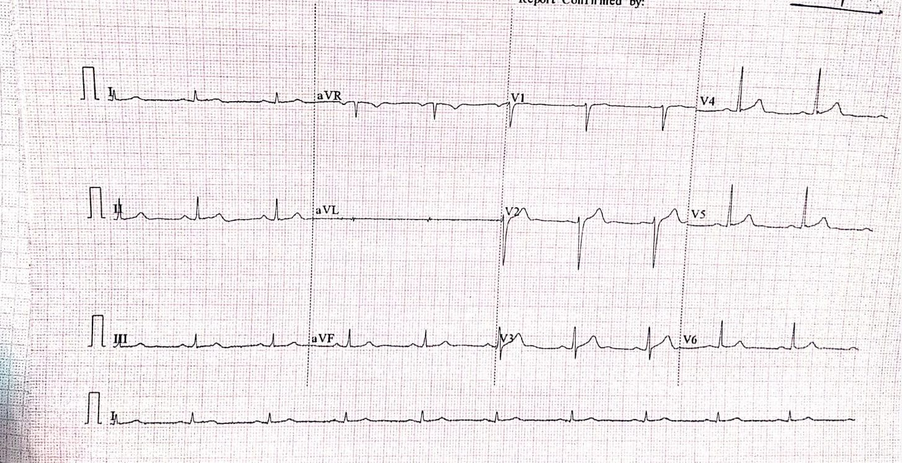
Figure 1: 12 lead standardised ECG : Normal sinus Rhytm ,no Significant ST T changes 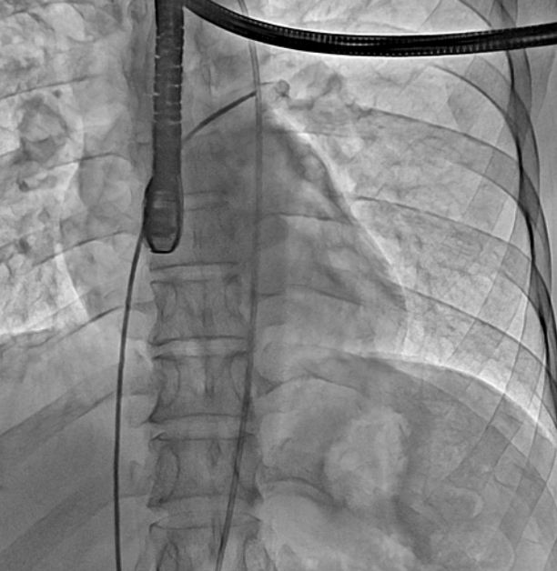 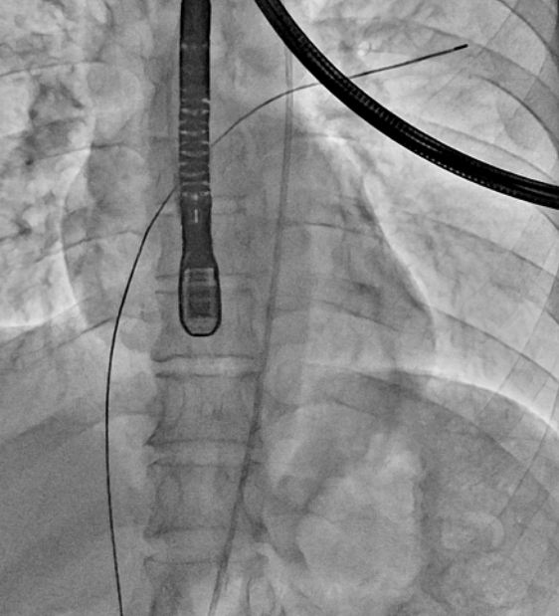 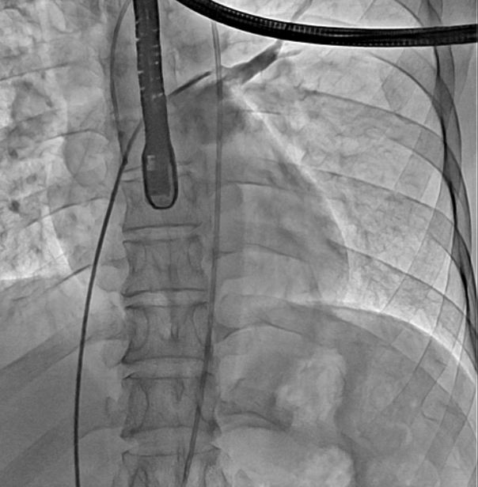 ( a) ( b) (c)
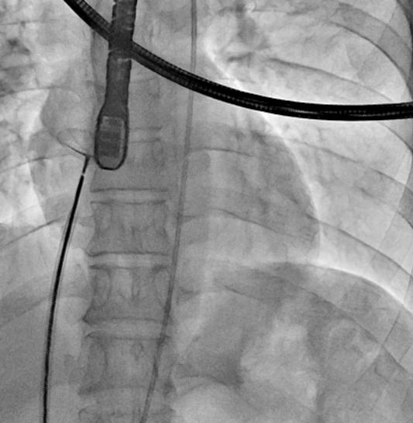 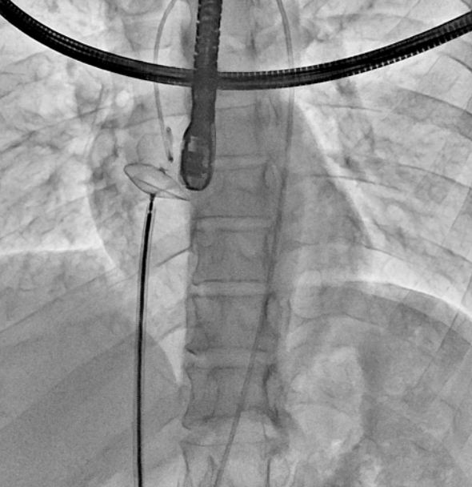 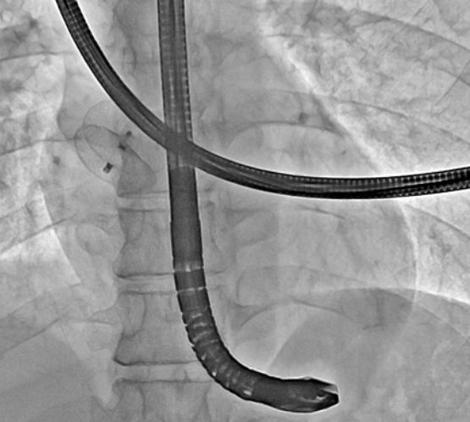 (d) ( e) ( f)

Figure 2a: Fluoroscopic image showing catheter positioning across the interatrial septum.
Figure 2b: The catheter is advanced into the right atrium into LA through PFO under fluoroscopic guidance.
Figure 2c: MPA passed through RA → LA → LSPV and LA shoot taken
Figure 2d: Balloon sizing of the PFO tunnel prior to device deployment
Figure 2e: Now Amplatzer Superstiff wire passed into LA and sizing balloon inflated COCOON Device No 30/30 passed through delivery sheath and kept across PFO
Figure 2 f :Final fluoroscopic image Device position confirmed Properly adhering to rims.with fully opened both disc .

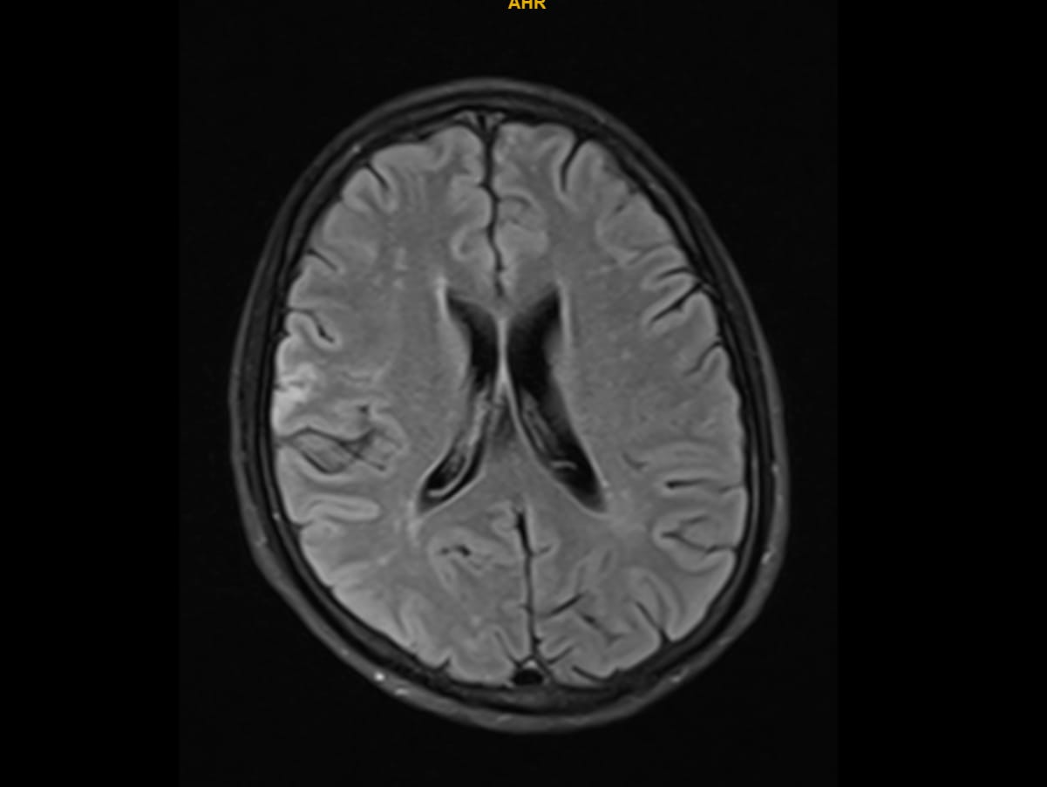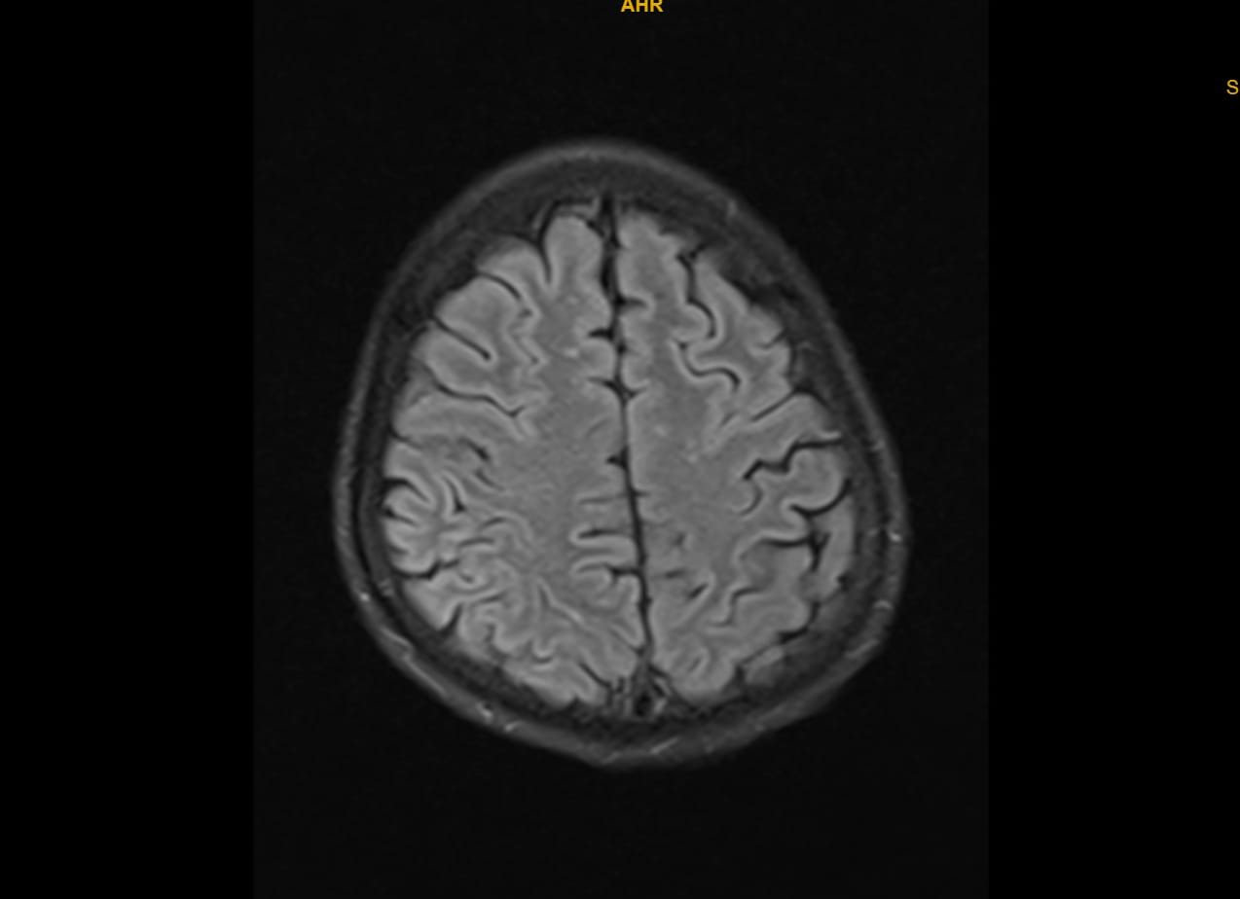
(a) (b)
Figure 3 a and b : MRI revealed acute non-hemorrhagic infarcts in the right inferior frontal gyrus and right post-central gyrus. Diffusion-weighted imaging showed hyperintensity with corresponding ADC restriction, confirming acute ischemia. No blooming on GRE ruled out hemorrhage. FLAIR sequences demonstrated chronic small vessel ischemic changes (Fazekas grade 1)

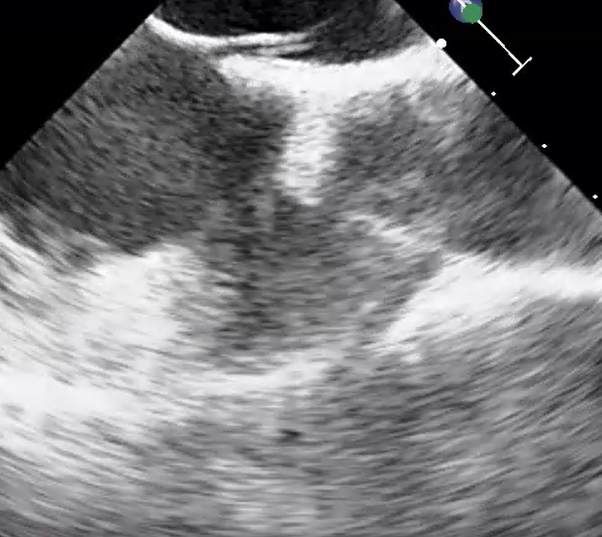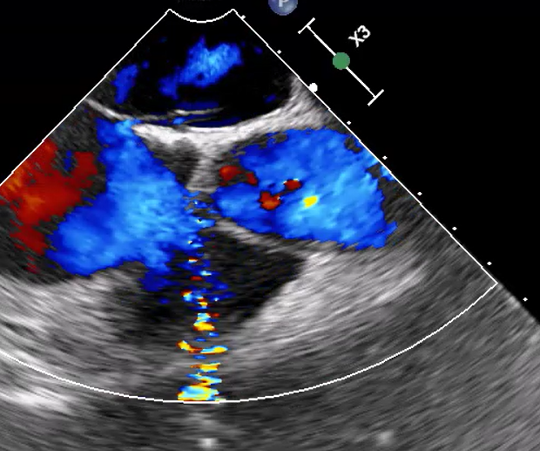
- (b)
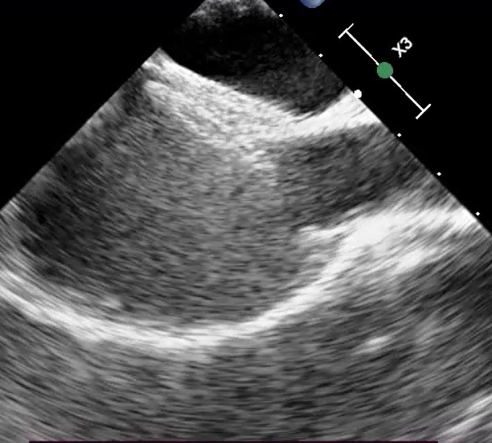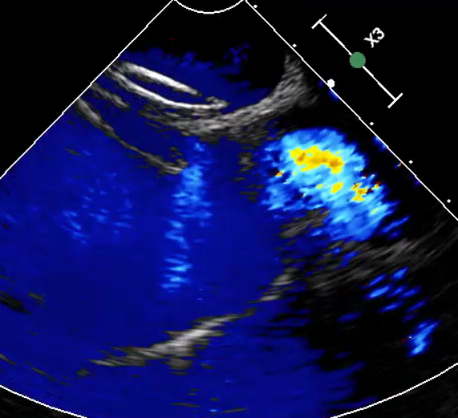
(c) (d)
Figure 4 a and b ): TEE image showing PFO of 4 mm with shunt across PFO
c and d ) TEE images post deployment of PFO device with no residual shunt across device
Video Legend1 : PFO Bubble contrast Study

Video Legend 2: MRI Loop

Discussion
This case underscores the rarity of PFO-related cortical stroke in young adults. Although PFO is common, only a small fraction of cryptogenic strokes are directly attributable to paradoxical embolism [9,10]. Our patient’s neurological presentation was unusual, with dysarthria and cranial nerve involvement without hemiparesis, which is seldom described [6–8].
Small PFOs can still be pathogenic when provokable right-to-left shunting occurs, particularly during Valsalva [11–12]. Multiple randomized controlled trials (RESPECT, CLOSE, REDUCE) have shown that device closure significantly reduces the risk of recurrent stroke compared to medical therapy in carefully selected patients [2,4,12]. More recently, guideline recommendations have reinforced that PFO closure should be considered in patients aged 18–60 years with cryptogenic stroke and high-risk anatomical features, ideally within six months of the index event [13]. Furthermore, emerging data suggest that percutaneous closure may also be safe and beneficial in selected older patients, although randomized trial evidence remains limited [14].
The Cocoon occluder, used in this patient, features a platinum nanocoating on nitinol mesh, designed to reduce nickel ion release and enhance biocompatibility. Its flexible double-disc design provides stable deployment with a low risk of erosion or arrhythmia. Post-closure complications such as atrial fibrillation are well documented, yet our patient remained free of arrhythmia during hospitalization and follow-up, while demonstrating neurological improvement. Recent multicenter data further support this safety profile, with 99.2% complete occlusion at six months and negligible complication rates using the Cocoon device [15].

Conclusion
PFO is common, but PFO-related stroke in young adults is rare, and even rarer are presentations limited to dysarthria and cranial nerve involvement. This case illustrates that small PFOs with dynamic right-to-left shunting can be pathogenic. Comprehensive etiological evaluation, including exclusion of other causes, is essential in young stroke. Timely transcatheter closure with the Cocoon device resulted in excellent outcomes, including neurological recovery and absence of arrhythmia. This report adds to the growing evidence supporting PFO closure in carefully selected patients with cryptogenic stroke.
Consent
As per international standards or university standards, patient(s) written consent has been collected and preserved by the author(s).
Ethical Approval:
As per international standards or university standards written ethical approval has been collected and preserved by the author(s).

Disclaimer (Artificial intelligence)
Option 1:
Author(s) hereby declare that NO generative AI technologies such as Large Language Models (ChatGPT, COPILOT, etc.) and text-to-image generators have been used during the writing or editing of this manuscript.
Option 2:
Author(s) hereby declare that generative AI technologies such as Large Language Models, etc. have been used during the writing or editing of manuscripts. This explanation will include the name, version, model, and source of the generative AI technology and as well as all input prompts provided to the generative AI technology
Details of the AI usage are given below:No AI Technologies Used .

References
- Hagen PT, Scholz DG, Edwards WD. Incidence and size of patent foramen ovale during the first 10 decades of life. Mayo Clin Proc. 1984;59:17–20.
- Saver JL. Cryptogenic stroke. N Engl J Med. 2016;374:2065–2074.
- Handke M, Harloff A, Olschewski M, Hetzel A, Geibel A. Patent foramen ovale and cryptogenic stroke in older patients. N Engl J Med. 2007;357:2262–2268.
- Søndergaard L, Kasner SE, Rhodes JF, et al. Patent Foramen Ovale Closure or Antiplatelet Therapy for Cryptogenic Stroke (REDUCE). N Engl J Med. 2017;377:1033–1042.
- Lechat P, Mas JL, Lascault G, et al. Prevalence of PFO in young patients with ischemic stroke. N Engl J Med. 1988;318:1148–1152.
- Bogousslavsky J, Caplan LR, editors. Stroke Syndromes. Cambridge Univ Press; 2001.
- Nedeltchev K, et al. Ischemic stroke in young adults: predictors of outcome and recurrence. Neurology. 2005;65:1502–1508.
- Putaala J, et al. Characteristics of ischemic stroke in young adults. Stroke. 2009;40:1190–1199.
- Kent DM, Ruthazer R, Weimar C, et al. An index to identify stroke-related vs incidental PFO in cryptogenic stroke. Neurology. 2013;81:619–625.
- Kent DM, et al. RoPE Study. Trials. 2011;12:185.
- Mas JL, Derumeaux G, Guillon B, et al. CLOSE trial. N Engl J Med. 2017;377:1011–1021.
- Saver JL, Carroll JD, Thaler DE, et al. RESPECT trial long-term results. N Engl J Med. 2017;377:1022–1032.
- European Stroke Organisation (ESO). Guidelines on PFO closure in cryptogenic stroke. Eur Stroke J. 2024;9(1):5–17.
- Saver JL, Thaler DE, Carroll JD, et al. Outcomes of patent foramen ovale closure in ptients over 60 years: a contemporary multicenter analysis. J Soc Cardiovasc Angiogr Interv. 2025;4(2):112–120.
- Sharma S, Trehan V, Kaul U, et al. Transcatheter closure of patent foramen ovale using the Cocoon occluder: a multicenter retrospective study. Catheter Cardiovasc Interv. 2025;105(4):627–635.

