Diffuse Coronary Artery Disease in a Young Systemic Lupus Erythematosus Patient: A Case Report

Abstract
Systemic Lupus Erythematosus (SLE) is a chronic autoimmune disease associated with an increased risk of cardiovascular disease, including coronary artery disease (CAD). Traditional risk factors for CVD can only partially account for the 50-fold rise in the incidence of atherosclerotic cardiovascular disease (CVD) in SLE patients when compared to age- and gender-matched control participants. As of right now, there is no proven way to stop CVD problems in SLE patients. There is a need for new therapeutic approaches and a better understanding of the processes behind the pathophysiology of CVD complications in SLE because traditional preventive CVD medications have not been shown to appreciably reduce the incidence of CVD in SLE. We report a case of diffuse CAD in a 36-year-old female SLE patient and review the literature on this rare but potentially life-threatening complication.

Keywords: Systemic Lupus Erythematosus, cardiovascular disease, chronic autoimmune disease, Coronary Artery Disease

Introduction
SLE is a complex and multifaceted disease that affects multiple organs and systems in the body. Cardiovascular disease is a major complication of SLE, with CAD being a leading cause of morbidity and mortality. “It is related to a higher risk of cardiovascular events, increasing it up to 50 times in young people, and 30% of deaths are attributed to coronary artery disease. The risk of developing cardiovascular disease in SLE is related not only to traditional cardiovascular risk factors such as advanced age, hypertension, dyslipidemia, and diabetes but also to disease-specific factors, such as degree of activity, autoantibodies, organ damage, and treatment. Accelerated atherosclerosis is one of the main contributors to pathogenesis. Manifestations range from angina to acute myocardial infarction and sudden death” (Sivakumaran et al., 2021).

“The degree of systemic inflammation correlates with the rapidity of development of atherosclerosis. Systemic inflammation is thought to accelerate atherosclerosis in human SLE as well” [1-7]. Autoimmune vascular injury in SLE may predispose to atherosclerotic plaque formation via a number of possible mechanisms and is an area of active research.

Of note, “whereas deaths due to lupus manifestations have decreased, those due to cardiovascular disease (CVD) in SLE have not; in some studies, the latter represent more than one-third of all deaths in SLE patients” [8] and a leading cause of mortality [9]. “The increased CVD risk in SLE has also been associated with a more aggressive development of atherosclerosis, as assessed by carotid ultrasound” [10], “coronary calcium scoring by computerized tomography” [11], “positron emission tomography analysis of coronary flow reserve” [12], and myocardial perfusion imaging [13].

Case Presentation
A 36-year-old female patient, known case of SLE with lupus nephritis since 11 years on immunosuppressive therapy including oral steroids presented with complaints of on and off chest discomfort since 1 week. Patient was non diabetic.

Diagnostic Evaluation
A thorough diagnostic evaluation was performed, including electrocardiogram (ECG), echocardiogram and cardiac enzymes. Her Routine blood tests like Complete hemogram, lipid profile, HbA1C, LFT were in normal range.
ECG revealed new onset T inversions in lead V2 to V6 and poor r wave progression.
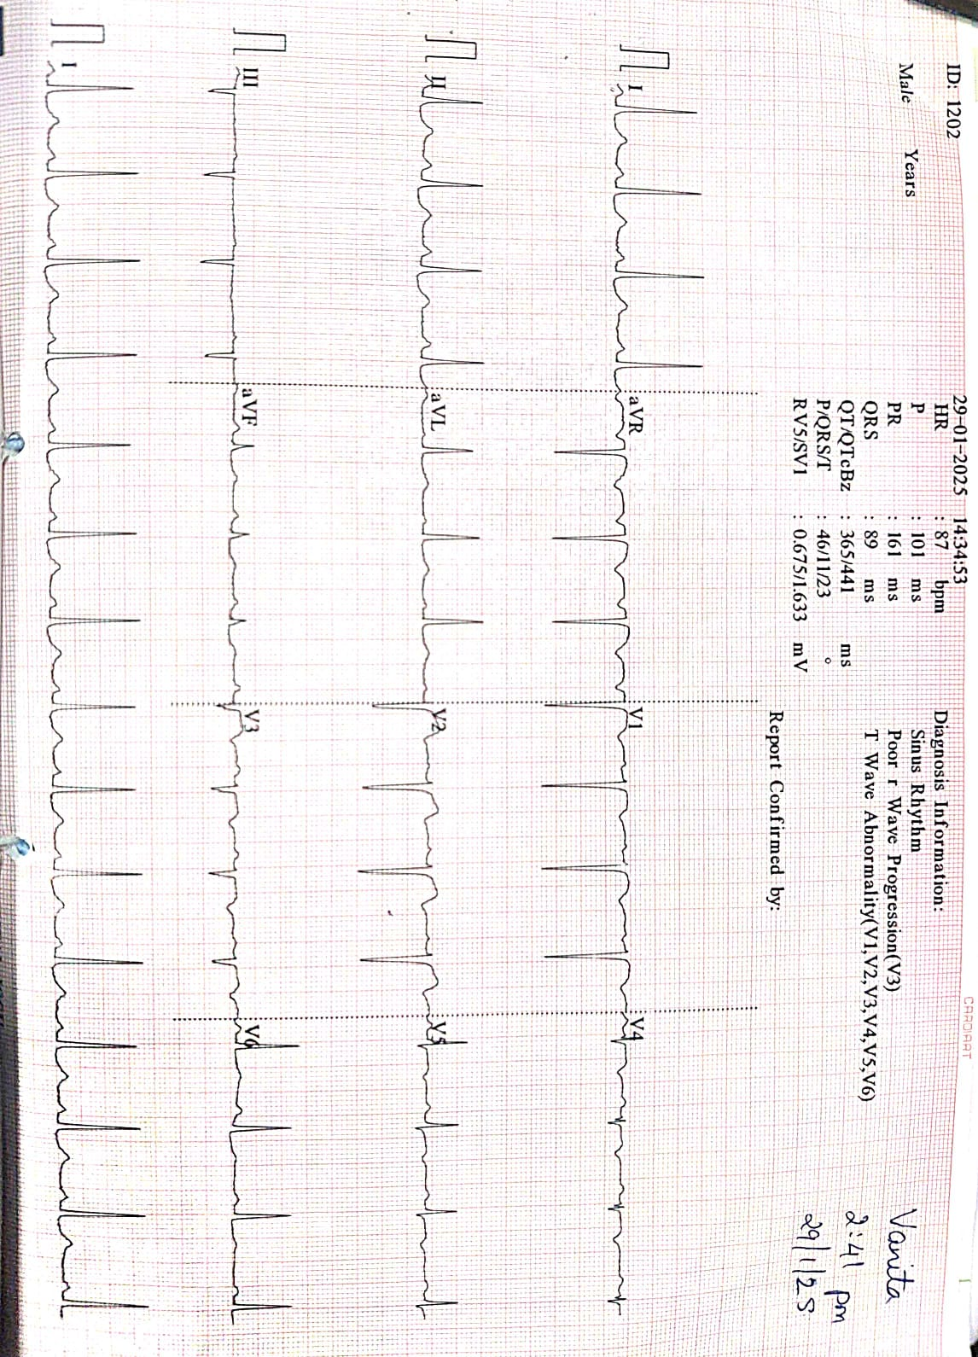
Fig 1: ECG of patient showing T inversions in lead V2 to V5.
The following laboratory results were significant: hs-Troponin I 269 ng/L (0–110 ng/L),

2D Echocardiogram showed no RWMA with an ejection fraction of 60%
However GLS was found to be reduced with average GLS of -14.6%

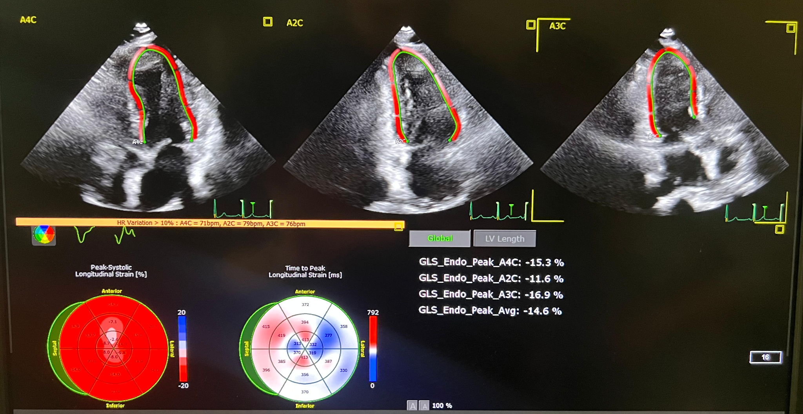
Fig 2: GLS image of the patient, showing reduced average GLS.

The patient was taken up for Coronary Angiography in view of Non ST Elevation Myocardial Infarction which revealed Diffuse Triple vessel disease.
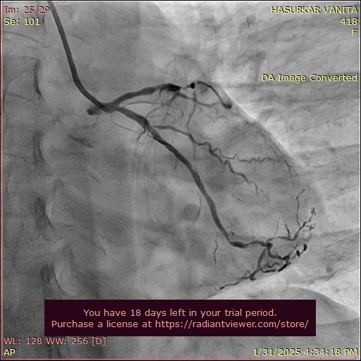
Fig 3: CAG showing diffuse involvement of LCX and LAD vessels.
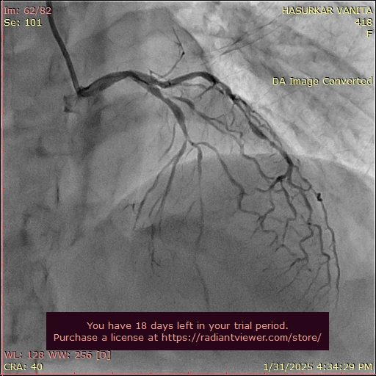
Fig 4: CAG showing diffuse involvement of LAD vessel.

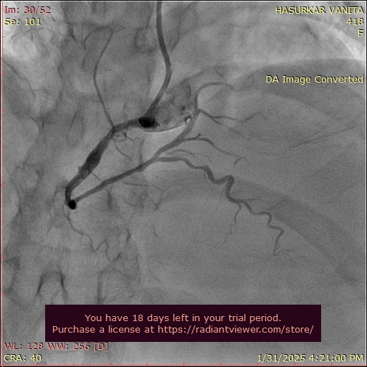
Fig 5: CAG showing diffuse involvement of RCA vessel with proximal ectatic segment.

Management
The patient was initiated on intensive medical therapy, including IV Heparin, Dual antiplatelets and statins. The patient was advised PCI to LAD. Rheumatology consultation was taken for SLE and was advised immunosuppression and close follow up in Rheumatology OPD.

Discussion
Diffuse CAD in a young SLE patient is a rare but devastating complication. The patient's age and sex made her an unlikely candidate for CAD, highlighting the importance of considering SLE-related cardiovascular risk factors.
“It should be recognized that SLE patients with nephritis and renal disease are among those with the highest risks of CAD. This is likely due to excess traditional risk factors (hypertension, hyperlipidemia), higher doses of glucocorticoids, and higher levels of systemic inflammation” [14]. Increasing overall severity of SLE, in terms of inflammation with multiorgan system involvement necessitating glucocorticoid and immunosuppressant use, is strongly associated with increasing CAD risks.
Coronary artery disease in patients with lupus could be attributed to accelerated atherosclerosis or vasculitis even if Echocardiography is normal.

“Global Longitudinal strain ( GLS) is a semi-objective quantitative means of assessing myocardial function and has been shown to detect subclinical dysfunction prior to overt changes in regional or global function” [15]. GLS specifically quantifies the shortening and lengthening of the heart muscle fibers along their long axis. This makes it a valuable tool for detecting subtle, or subclinical, changes in cardiac function that are not yet severe enough to be reflected by a drop in EF

A high index of suspicion for coronary artery disease (CAD) is warranted in patients with systemic lupus erythematosus (SLE) presenting with chest pain/pressure, dyspnea, decreased exercise tolerance or other atypical symptoms
The presence of diffuse CAD in this patient underscores the need for aggressive management of SLE-related inflammation and cardiovascular risk factors.

Conclusion
All patients with systemic lupus erythematosus (SLE) should be referred for baseline evaluation with a cardiologist for the assessment of cardiac risk factors. Aggressive management of cardiovascular risk factors: should be initiated in all SLE patients. As glucocorticoids contribute to CAD risk factors by worsening hypertension, hyperlipidemia, and diabetes, the glucocorticoid dosages should be reduced as soon as possible. Keeping SLE disease activity low, with low dose use of glucocorticoids or use of steroid sparing agents should be the goal of therapy and is associated with improved overall prognosis and reduced risk of organ damage including CAD events.

Consent
As per international standards or university standards, patient(s) written consent has been collected and preserved by the author(s).

Disclaimer (Artificial intelligence)
Option 1:
Author(s) hereby declare that NO generative AI technologies such as Large Language Models (ChatGPT, COPILOT, etc.) and text-to-image generators have been used during the writing or editing of this manuscript.
Option 2:
Author(s) hereby declare that generative AI technologies such as Large Language Models, etc. have been used during the writing or editing of manuscripts. This explanation will include the name, version, model, and source of the generative AI technology and as well as all input prompts provided to the generative AI technology
Details of the AI usage are given below:
1.
2.
3.

References
- Asanuma Y, Oeser A, Shintani AK, et al. Premature coronary-artery atherosclerosis in systemic lupus erythematosus. N Engl J Med 2003; 349:2407.
- Roman MJ, Shanker BA, Davis A, et al. Prevalence and correlates of accelerated atherosclerosis in systemic lupus erythematosus. N Engl J Med 2003; 349:2399.
- Bruce IN, Gladman DD, Urowitz MB. Premature atherosclerosis in systemic lupus erythematosus. Rheum Dis Clin North Am 2000; 26:257.
- Hansson GK. Inflammation, atherosclerosis, and coronary artery disease. N Engl J Med 2005; 352:1685.
- Hahn BH. Systemic lupus erythematosus and accelerated atherosclerosis. N Engl J Med 2003; 349:2379.
- Manzi S. Systemic lupus erythematosus: a model for atherogenesis? Rheumatology (Oxford) 2000; 39:353.
- Sherer Y, Shoenfeld Y. Mechanisms of disease: atherosclerosis in autoimmune diseases. Nat Clin Pract Rheumatol 2006; 2:99.
- 4.Elfving P, Puolakka K, Kautiainen H, Virta L, Pohjolainen T, Kaipiainen-Seppanen O. Mortality and causes of death among incident cases of systemic lupus erythematosus in Finland 2000–2008. Lupus. 2014 doi: 10.1177/0961203314543919.
- 5.Thomas G, Mancini J, Jourde-Chiche N, et al. Mortality Associated With Systemic Lupus Erythematosus in France Assessed by Multiple-Cause-of-Death Analysis. Arthritis & rheumatology. 2014;66:2503–2511. doi: 10.1002/art.38731.
- 9.Asanuma Y, Oeser A, Shintani AK, et al. Premature coronary-artery atherosclerosis in systemic lupus erythematosus. The New England journal of medicine. 2003;349:2407–2415. doi: 10.1056/NEJMoa035611.
- 10.Yiu KH, Wang S, Mok MY, et al. Pattern of arterial calcification in patients with systemic lupus erythematosus. The Journal of rheumatology. 2009;36:2212–2217. doi: 10.3899/jrheum.090312. [DOI] [PubMed] [Google Scholar]
- 11.Recio-Mayoral A, Mason JC, Kaski JC, Rubens MB, Harari OA, Camici PG. Chronic inflammation and coronary microvascular dysfunction in patients without risk factors for coronary artery disease. European heart journal. 2009;30:1837–1843. doi: 10.1093/eurheartj/ehp205.
- 12.Lin CC, Ding HJ, Chen YW, Wang JJ, Ho ST, Kao A. Usefulness of technetium-99m sestamibi myocardial perfusion SPECT in detection of cardiovascular involvement in patients with systemic lupus erythematosus or systemic sclerosis. International journal of cardiology. 2003;92:157–161. doi: 10.1016/s0167-5273(03)00106-2.
- Faurschou M, Mellemkjaer L, Starklint H, et al. High risk of ischemic heart disease in patients with lupus nephritis. J Rheumatol 2011; 38:2400.
- Duncan AE, Alfirevic A, Sessler DI, et al. Perioperative assessment of myocardial deformation. Anesth Analg. 2014;118(3):525–44. doi: 10.1213/ANE.0000000000000088.
- Sivakumaran, J., Harvey, P., Omar, A., Tayer-Shifman, O., Urowitz, M. B., Gladman, D. D., ... & Touma, Z. (2021). Assessment of cardiovascular risk tools as predictors of cardiovascular disease events in systemic lupus erythematosus. Lupus science & medicine, 8(1).

