Bleeding beyond the heart: Alveolar Hemorrhage post thrombolysis

Abstract
Alveolar hemorrhage (AH) is a rare yet severe clinical condition marked by significant bleeding into the alveolar spaces, often leading to high mortality. AH can occur following systemic thrombolysis for acute myocardial infarction (AMI), a complication that is infrequent but potentially life-threatening and may result in acute respiratory failure. This entity is rarely reported in the literature. This case report presents an instance of AH following intravenous thrombolysis for AMI in a 58-year-old male patient.
Keywords: Alveolar haemorrhage, Thrombolysis, Acute respiratory failure, acute myocardial infarction

Introduction
“Alveolar hemorrhage is a clinical syndrome resulting from bleeding into the alveolar spaces secondary to disruption of the alveolar-capillary membrane. It is a rare and serious medical emergency potentially leading to fatal acute respiratory failure (ARF)”.^{1,23}
“Systemic thrombolysis in the setting of acute myocardial infarction (AMI) remains, in the absence of contraindications, an effective treatment”.² However, “it exposes to a non-negligible bleeding risk that remains its major adverse event. Most of the latter occur at sites of vascular access and are mild, though patients may also present with other locations such as gastrointestinal, retroperitoneal, genitourinary, and cerebral bleeding”.^{3,4,23}
“Pulmonary alveolar hemorrhage is an extremely uncommon and potentially fatal complication of intravenous thrombolytic therapy. So far, only few cases have been reported in the literature”.^{5–21,23}

Case Presentation
A 58-year-old male patient was referred to us from another peripheral hospital where he was diagnosed with acute ST elevation MI. Patient had received loading dose with aspirin, clopidogrel and statin and was thrombolysed with Streptokinase as primary PCI was not available in that hospital.
Approximately three to four hours after the thrombolytic treatment, the patient began experiencing moderate hemoptysis and was transferred to our hospital. Upon examination, his blood pressure was 90/60 mmHg, and his heart rate was 102 beats per minute. His respiratory rate was 30 breaths per minute, and his oxygen saturation (SaO2) on room air was 81%. Pulmonary auscultation revealed crackles primarily at the lung bases, especially on the left side. No other signs of heart failure were observed.
The chest X-ray revealed bilateral alveolar infiltrates (Figure 1).
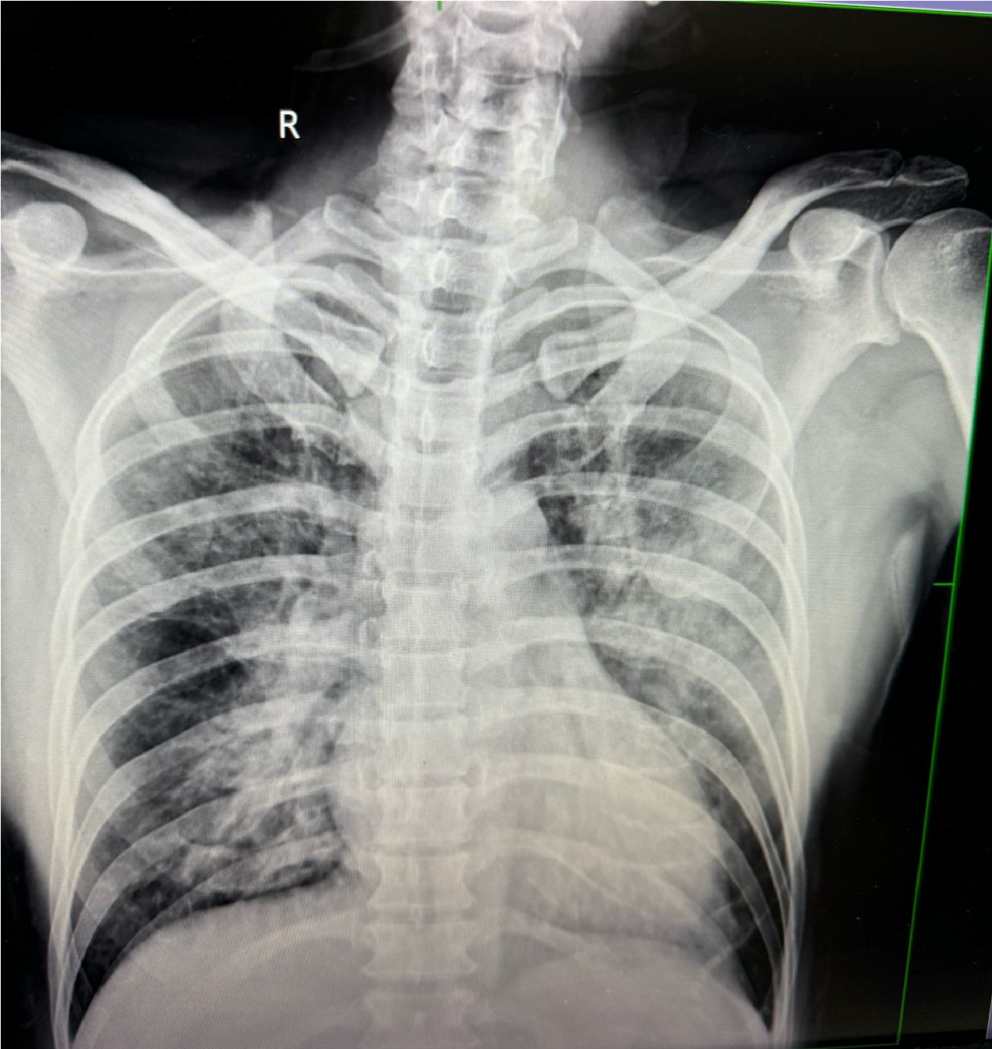
Fig. 1: Chest Xray suggestive of bilateral alveolar lung infiltrates in lung parenchyma.
The transthoracic echocardiography showed a reduced ejection fraction of 25–30%, with anterior wall hypokinesia. Initially, acute pulmonary edema was suspected, and intravenous furosemide was administered, but it had no effect.
Biological tests revealed a significant decrease in hemoglobin from 15.8 g/dL to 13.8 g/dL, with a normal platelet count and slightly elevated white blood cell count. Given the presence of hemoptysis, the drop in hemoglobin, and bilateral alveolar infiltrates on the chest X-ray, the diagnosis of alveolar hemorrhage (AH) was considered.
A high-resolution computed tomography (HRCT) of the chest, including pulmonary angiography, revealed bilateral patchy condensations and micro nodules, strongly indicating AH.
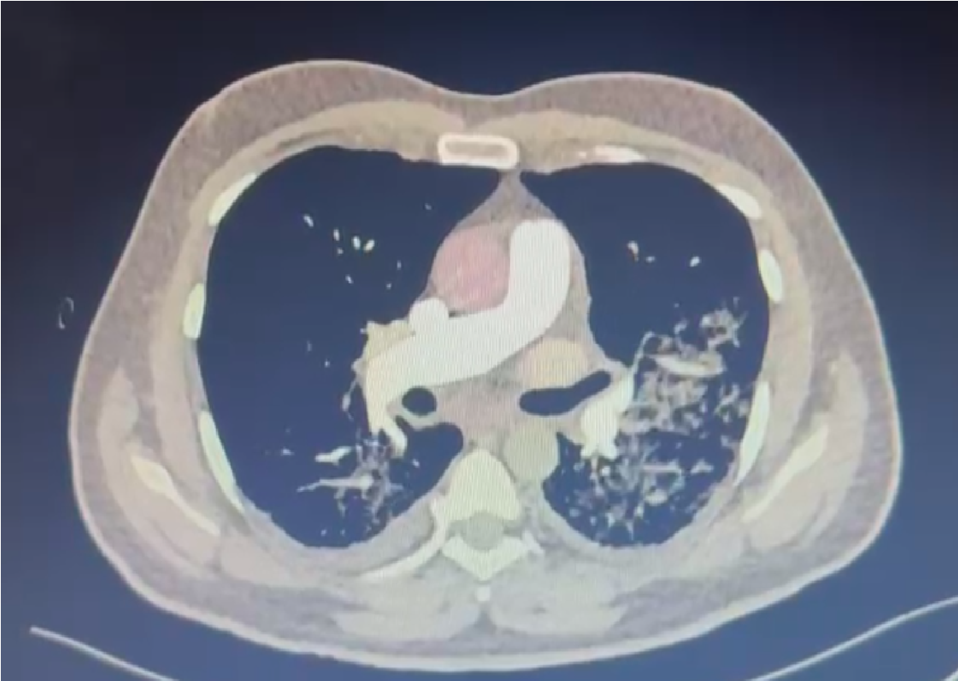
Fig 2: HRCT Chest image suggestive of patchy consolidation and micronodules.
In this case, we faced a dilemma regarding whether to continue anticoagulation and dual antiplatelet therapy (DAPT), given the patient's concurrent conditions: diffuse alveolar hemorrhage (DAH) and acute anterior wall myocardial infarction (AWMI). Additionally, the patient required coronary angiography and revascularization for acute MI.
Considering the patient was hemodynamically stable, not in cardiogenic shock, and had no arrhythmic events, we decided to delay coronary intervention to allow time for the resolution of DAH and improvement in respiratory function. The decision was made to withdraw anticoagulation and maintain the patient on a single antiplatelet agent in view of ongoing hemoptysis. Also patient was given short course of IV steroids.
Over the following 20-25 days, the patient’s respiratory function improved, and hemoptysis gradually ceased. After this stabilization, the patient was successfully posted for coronary angiography and subsequent revascularization in light of the acute myocardial infarction diagnosis.
Coronary angiogram revealed tight lesion in LAD and RCA total occlusion ( CTO) filling retrogradely from LAD.
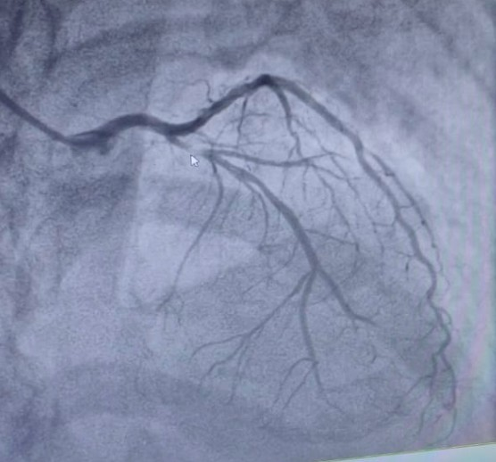
Fig 3: Coronary angiography showing tight lesion in proximal LAD.
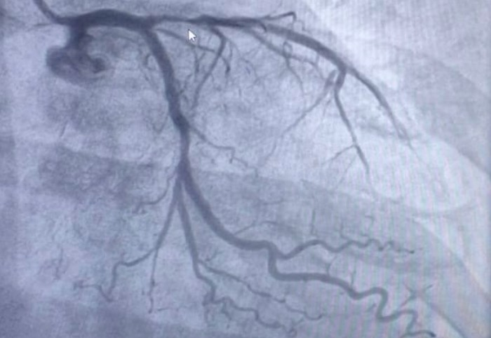
Fig 4: Coronary angiography showing significant proximal LAD lesion.
Patient underwent PTCA to LAD and RCA using two drug eluting stents and was discharged thereafter on dual antiplatelets.
On follow up, patient was vitally stable and had no complaints of hemoptysis episodes thereafter.

Discussion
“Thrombolytic therapy is a well proven strategy for reperfusion in acute myocardial infarction and has been proven to decrease the morbidity and mortality related to this condition. However, it can lead to hemorrhagic complications” (Ben et al., 2021).
“Diffuse alveolar hemorrhage (DAH) syndrome is a very unusual complication of intravenous thrombolytic treatment for acute myocardial infarction with a high mortality rate and can go unnoticed. DAH usually occurs within a few hours to 5 days after thrombolysis.This pathology is defined by bleeding within the alveoli, which is due to dislocation of the alveolar-capillary membrane caused by injury or acute inflammation of the arterioles, venules, or alveolar capillaries”.^{1,23} The available literature does not cover the exact incidence of this complication, but it rather consists of few case reports.
“The pathogenesis of DAH attributable to thrombolytic therapy remains uncertain and may be explained by the pre-existing fibrinolytic states,the presence of parenchymal abnormalities or an immune reaction to streptokinase causing pulmonary capillaritis as it has been proposed”.^{20,23} It has been mentioned that “certain potential cofactors may predispose to this complication such as underlying lung diseases (chronic obstructive pulmonary disease, prior emphysema), recent pneumonia, cardiac catheterization, arrhythmias requiring defibrillation shock or cardiopulmonary resuscitation, heart failure, and substances abuse as cocaine and tobacco”.^{21,23} The clinical presentation of DAH is often marked by hemoptysis, anemia, and radiographic infiltrates, frequently accompanied by acute respiratory failure.
In cases of myocardial infarction with acute pulmonary distress and alveolar opacities on chest X-ray, acute pulmonary edema is typically suspected. This can lead to inappropriate treatment with diuretics. Therefore, it is crucial to also consider DAH, especially when hemoptysis and/or a sudden drop in hemoglobin occur without a clear bleeding source.
“When the diagnosis is suggested, bronchial endoscopy with bronchoalveolar lavage (BAL) is the gold standard exam to confirm the diagnosis”.^{18,23} However, it is not usually possible, mainly depending on the patient’s condition. In our case, these exams were not performed.
“The management of DAH is based on two pillars: the treatment of respiratory failure and the correction of the anemia with packed red cell transfusions” (Ben et al., 2021). Discontinuing or deescalating antiplatelet and anticoagulation medication is necessary and may be life saving to allow for resolution of hemorrhage and improvement of lung function. ²²

Conclusion
An uncommon side effect of fibrinolytic treatment for MI, particularly when streptokinase is used, is diffuse alveolar bleeding. A high level of suspicion is necessary for the diagnosis of diffuse alveolar hemorrhage because the symptoms and indicators are vague and could cause a delay. Patients with acute pulmonary discomfort linked to hemoptysis, acute anemia with a sharp decline in hemoglobin, and lung infiltrates following thrombolysis should be evaluated for the diagnosis. To prevent acute respiratory failure and death, early diagnosis and therapeutic intervention are essential.

Consent
As per international standards or university standards, patient(s) written consent has been collected and preserved by the author(s).

Disclaimer (Artificial intelligence)
Option 1:
Author(s) hereby declare that NO generative AI technologies such as Large Language Models (ChatGPT, COPILOT, etc.) and text-to-image generators have been used during the writing or editing of this manuscript.
Option 2:
Author(s) hereby declare that generative AI technologies such as Large Language Models, etc. have been used during the writing or editing of manuscripts. This explanation will include the name, version, model, and source of the generative AI technology and as well as all input prompts provided to the generative AI technology
Details of the AI usage are given below:
1.
2.
3.

References
1.Parrot A, Voiriot G, Canellas A, et al. Pulmonary alveolar hemorrhage. Med Intensive Reanim.
2018;27(4):331–343. doi: 10.3166/rea-2018-0060 [DOI] [Google Scholar]
2.Ibanez B, James S, Agewall S, et al. 2017 ESC Guidelines for the management of acute myocardial infarction in patients presenting with ST-segment elevation. Eur Heart J. 2018;39(2):119–177. doi:
10.1093/eurheartj/ehx393 [DOI] [PubMed] [Google Scholar]
3.Califf RM, Fortin DF, Tenaglia AN. Clinical risks of thrombolytic therapy. Am J Cardiol.
1992;68(2):12–20. doi: 10.1016/0002-9149(92)91168-4 [DOI] [PubMed] [Google Scholar]
4.Disler LJRA. Pulmonary hemorrhage following intravenous streptokinase for acute myocardial infarction. Int J Cardiol. 1990;29(3):387–390. doi: 10.1378/chest.101.4.1150 [DOI] [PubMed] [Google Scholar]
5.Nathan PE, Torres AV, Smith AJ, Gagliardi AJRK, Rapeport KB. Spontaneous pulmonary hemorrhage following coronary thrombolysis. Chest. 1992;101(4):1150–1152. doi:
10.1378/chest.101.4.1150 [DOI] [PubMed] [Google Scholar]
6.Cuéllar Obispo E, Torrado González E, Alvarez Bueno M, et al. A diffuse pulmonary hemorrhage following thrombolytic therapy in an acute myocardial infarct. Rev Esp Cardiol. 1992;45(6):421–424.
[PubMed] [Google Scholar]
7.Tio RA, Voorbij RH, Enthoven R. Adult respiratory distress syndrome after streptokinase. Am J
Cardiol. 1992;70(20):1632–1633. doi: 10.1016/0002-9149(92)90477-g [DOI] [PubMed] [Google Scholar]
8.Awadh N, Ronco JJ, Bernstein V, Gilks BWP, Wilcox P. Spontaneous pulmonary hemorrhage after thrombolytic therapy for acute myocardial infarction. Chest. 1994;106(5):1622–1624. doi:
10.1378/chest.106.5.1622 [DOI] [PubMed] [Google Scholar]
9.Hammoudeh AJ, Haft JI, Eichman GT. Hemoptysis and unilateral intra- alveolar hemorrhage complicating intravenous thrombolysis for myocardial infarction. Clin Cardiol. 1996;19(7):595–596.
doi: 10.1002/clc.4960190714 [DOI] [PubMed] [Google Scholar]
10.Basher A, Oduwole A, Bhalodkar N, et al. Fatal hemoptysis during coronary thrombolysis. J
Thromb Thrombolysis. 1996;3(1):87–89. doi: 10.1007/bf00226416 [DOI] [PubMed] [Google Scholar]
11.Chang YC, Patz EF Jr, Goodman PC, Granger CB. Significance of hemoptysis following thrombolytic therapy for acute myocardial infarction. Chest. 1996;109(3):727–729. doi:
10.1378/chest.109.3.727 [DOI] [PubMed] [Google Scholar]
12.Swanson GA, Kaeley GGS. Diffuse pulmonary hemorrhage after streptokinase administration for acute myocardial infarction. Pharmacotherapy. 1997;17(2):390–394. [PubMed] [Google Scholar]
13.Gopalakrishnan D, Tioran T, Emanuel C, Clark VL. Diffuse pulmonary hemorrhage complicating thrombolytic therapy for acute myocardial infarction. Clin Cardiol. 1997;20(3):298–300. doi:
10.1002/clc.4960200321 [DOI] [PMC free article] [PubMed] [Google Scholar]
14.Masip J, Vecilla FPJ. Diffuse pulmonary hemorrhage after fibrinolytic therapy for acute myocardial infarction. Int J Cardiol. 1998;63(1):95–97. doi: 10.1016/s0167-5273(97)00285-4 [DOI] [PubMed] [Google Scholar]
15.Yigla M, Sprecher E, Azzam Z, Guralnik L, Kapeliovich MKN, Krivoy N. Diffuse alveolar hemorrhage following thrombolytic therapy for acute myocardial infarction. Respiration.
2000;67(4):445–448. doi: 10.1159/000029546 [DOI] [PubMed] [Google Scholar]
16.Ayyub M, Barlas S, Iqbal M, Khurshid SM. Diffuse alveolar hemorrhages and hemorrhagic pleural effusion after thrombolytic therapy with streptokinase for acute myocardial infarction. Saudi Med J.
2003;24(2):217–220. [PubMed] [Google Scholar]
17.González A, Sagardía J, Redondo A, Villaverde M, Monteverde A. Hemorragia alveolar como complicación del uso de trombolíticos. Medicina (B Aires). 2011;71(6):547–549. [PubMed] [Google Scholar]
18.Kinsara A, Abuosa A, EL-Sheikh A. Abnormal chest x-ray postmyocardial infarction. Hear Views.
2014;15(4):121. doi: 10.4103/1995-705x.151086 [DOI] [PMC free article] [PubMed] [Google Scholar]
19.Khaheshi I, Paydary K, Mahjoob M. Diffuse pulmonary hemorrhage after fibrinolytic therapy for acute myocardial infarction in a cocaine abuser patient. Hear Views. 2014;15(3):83. doi: 10.4103/1995-
705x.144797 [DOI] [PMC free article] [PubMed] [Google Scholar]
20.Narayanan S, Thulaseedharan NK, Subramaniam G, Panarkandy G, Arathi N. Pulmonary alveolar hemorrhage following thrombolytic therapy. Int Med Case Rep J. 2017;10:123–125. doi:
10.2147/imcrj.s129087 [DOI] [PMC free article] [PubMed] [Google Scholar]
21.Prasad K, Singh P, Kanabar KVR. Pulmonary haemorrhage following thrombolysis with streptokinase in myocardial infarction. BMJ Case Rep. 2020;13(1):232–308. doi: 10.1136/bcr-2019-
232308 [DOI] [PMC free article] [PubMed] [Google Scholar]
22.Green RJ, Ruoss SJ, Kraft SA, Berry GJ, Raffan TA. Pulmonary capillaritis and alveolar hemorrhage. Chest. 1996;110:1305–1316. doi: 10.1378/chest.110.5.1305 [DOI] [PubMed]
[Google Scholar]
23.Ben Mrad, I., Ben Mrad, M., Oumaya, Z., Zairi, I., Besbes, B., Ouaghlani, K., ... & Kraiem, S. (2021). Alveolar hemorrhage following thrombolytic therapy for acute myocardial infarction: Two case reports and literature review. Open Access Emergency Medicine, 399-405.

