Cardiac Papillary Fibroelastoma Mimicking Infective Endocarditis in an Octogenarian: A Case Report

Abstract
Introduction: Papillary fibroelastoma is a rare benign cardiac tumor, usually discovered incidentally or during evaluation for embolic events. Its echocardiographic appearance often mimics infective endocarditis, making diagnosis challenging.
Case Presentation: We report the case of an 83-year-old man with a history of hypertension and hypercholesterolemia, presenting with progressive dyspnea, orthopnea, and angina. Initial evaluation revealed elevated biomarkers and pulmonary edema. Transthoracic and transesophageal echocardiography showed a mobile mass attached to the posterior mitral leaflet, raising suspicion of infective endocarditis. However, blood cultures remained negative, and PET scan was inconclusive. The patient underwent surgical excision, and histopathological examination confirmed a papillary fibroelastoma. Postoperative evolution was favorable.
Conclusion: Papillary fibroelastoma should be considered in the differential diagnosis of valvular masses. Multimodal imaging is crucial, but histology remains the gold standard. Early surgical excision is recommended in symptomatic patients, even in advanced age, to prevent embolic complications.

Introduction
Cardiac papillary fibroelastoma (PFE) is the second most common benign primary cardiac tumor after myxoma. It typically arises from valvular endocardium, most frequently affecting the aortic and mitral valves. Although histologically benign, PFEs carry significant clinical implications due to their potential to cause systemic embolization, myocardial infarction, and sudden cardiac death. The majority of cases are discovered incidentally during echocardiography, cardiac surgery, or autopsy. The diagnosis is often challenging, as the echocardiographic appearance of PFEs can closely mimic that of infective endocarditis, thrombi, or other cardiac tumors. We present the case of an elderly man in whom a mitral valve fibroelastoma was initially suspected to be infective endocarditis, highlighting the importance of multimodal imaging and histological confirmation. Differential diagnoses include infective endocarditis, valvular thrombus, myxoma, Lambl’s excrescences, and other primary or secondary cardiac tumors. Careful distinction is essential, as misdiagnosis may lead to unnecessary antibiotic treatment or delayed surgery.

Case Presentation
An 83-year-old man, with a medical history of hypertension and hypercholesterolemia, presented with progressive dyspnea and orthopnea, associated with exertional angina evolving over several months. At admission, the patient exhibited tachycardia (121 bpm), blood pressure of 100/56 mmHg, and oxygen saturation of 95% on ambient air. Clinical examination revealed bilateral pulmonary crackles and lower limb edema. Laboratory tests showed elevated cardiac biomarkers (troponin I up to 6100 pg/mL, NT-proBNP 4440 pg/mL), elevated inflammatory markers (CRP 114 mg/L), and impaired renal function (MDRD 32 mL/min).
Electrocardiogram demonstrated sinus tachycardia with nonspecific repolarization abnormalities. Chest X-ray revealed cardiomegaly and bilateral alveolo-interstitial infiltrates. Transthoracic echocardiography revealed a 15x11 mm mobile mass attached to the posterior mitral leaflet with associated mitral regurgitation. Transesophageal echocardiography confirmed a pedunculated, highly mobile mass, raising suspicion of infective endocarditis. However, repeated blood cultures remained negative, urine cultures were sterile, and no infectious source was identified. PET-CT performed twice yielded inconclusive results. Given the persistence of the mass and the risk of embolic complications, surgical intervention was indicated.
The patient underwent cardiac surgery with complete excision of the mass. Histological examination confirmed the diagnosis of papillary fibroelastoma. The postoperative course was favorable, with resolution of dyspnea and normalization of inflammatory markers. The patient was discharged on optimal heart failure therapy and remained stable at follow-up. Cardiac MRI, which was not performed in our patient, may help by showing a small avascular lesion with no contrast enhancement, while FDG-PET often shows no hypermetabolic activity, which can help distinguish fibroelastoma from infective vegetations.

Figures
**Figure 1.** Insert Transthoracic Echocardiography (TTE) image here.
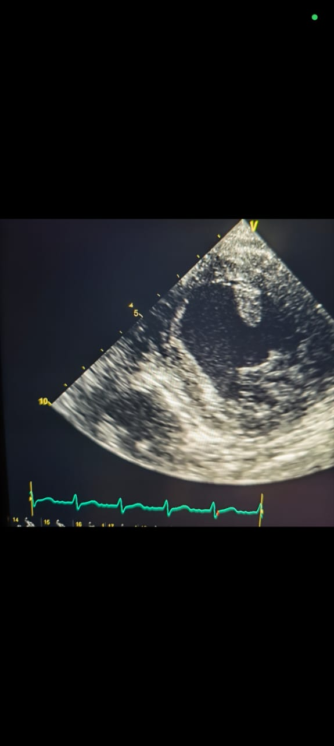
**Figure 2.** Insert Transesophageal Echocardiography (TEE) image here.
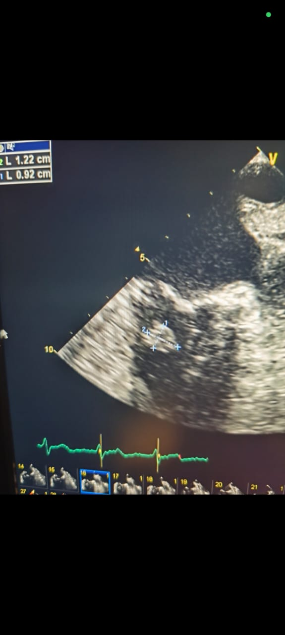
**Figure 3.** Histologic section of papillary fbroelastoma stained with hematoxylin and eosin.

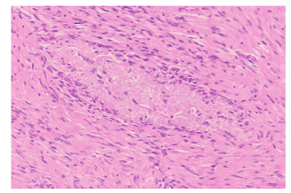

Discussion
Papillary fibroelastomas are rare benign cardiac tumors, accounting for approximately 10% of all primary cardiac tumors. They are characterized histologically by avascular fronds of connective tissue covered by endothelium. Although often asymptomatic, they may present with embolic phenomena, angina, arrhythmias, or sudden cardiac death. The mitral and aortic valves are the most commonly affected sites, followed by the tricuspid and pulmonary valves.
The clinical presentation of our patient with dyspnea and angina, associated with a mobile mitral valve mass, initially raised the suspicion of infective endocarditis. The absence of fever, persistently negative blood cultures, and lack of infectious focus argued against this diagnosis. PET imaging, although useful in differentiating tumors from infective lesions, was inconclusive. Ultimately, surgical excision and histology provided the definitive diagnosis.
This case illustrates the importance of multimodal imaging in evaluating valvular masses. Transthoracic and transesophageal echocardiography are first-line tools, but MRI and PET can provide additional information. However, histopathological examination remains the gold standard.
Management of PFE depends on tumor characteristics, symptoms, and embolic risk. Symptomatic patients, those with large or highly mobile tumors, or tumors located on the left-sided valves, should undergo surgical excision to prevent embolic events. Surgery is generally curative and associated with low recurrence rates. In elderly patients, the decision must balance surgical risk against the risk of embolization. In our case, despite advanced age, surgery was deemed necessary due to the high embolic potential of the mass, and the outcome was favorable.
Recent literature (2022–2025) supports early surgical intervention in symptomatic patients, even in octogenarians, as outcomes are generally excellent when surgery is performed in experienced centers. Newer approaches such as minimally invasive or thoracoscopic resections have also been reported. Rare cases of multiple fibroelastomas or atypical locations (papillary muscles, tricuspid valve) have been described in recent years, further emphasizing the diagnostic challenges. This underlines the limitations of PET-CT in small avascular valvular tumors, where the absence of FDG uptake cannot reliably rule out infection but may support the diagnosis of fibroelastoma.

Conclusion
Papillary fibroelastoma is a rare but clinically significant cardiac tumor that may mimic infective endocarditis. This case illustrates the importance of considering fibroelastoma in the differential diagnosis of valvular masses, particularly when blood cultures remain negative despite systemic inflammation. Histological confirmation after surgical excision remains the gold standard. Early surgical management should be discussed in symptomatic or high-risk patients, even at advanced age, to prevent embolic complications. A multidisciplinary approach, involving cardiologists, cardiac surgeons, and imaging specialists, is essential for optimal management.

Disclaimer (Artificial intelligence)
Option 1:
Author(s) hereby declare that NO generative AI technologies such as Large Language Models (ChatGPT, COPILOT, etc.) and text-to-image generators have been used during the writing or editing of this manuscript.
Option 2:
Author(s) hereby declare that generative AI technologies such as Large Language Models, etc. have been used during the writing or editing of manuscripts. This explanation will include the name, version, model, and source of the generative AI technology and as well as all input prompts provided to the generative AI technology
Details of the AI usage are given below:
1.
2.
3.

References
1. Gowda RM, Khan IA, Nair CK, et al. Cardiac papillary fibroelastoma: a comprehensive analysis of 725 cases. Am Heart J. 2003;146(3):404-410.
2. Sun JP, Asher CR, Yang XS, et al. Clinical and echocardiographic characteristics of papillary fibroelastomas: a retrospective and prospective study in 162 patients. Circulation. 2001;103(22):2687-2693.
3. Tamin SS, Maleszewski JJ, Scott CG, et al. Prognostic and bioepidemiologic insights into cardiac papillary fibroelastomas from a large retrospective study. Circulation. 2015;132(2):155-162.
4. Poterucha TJ, Kochav J, O’Connor DS, Rosner GF. Cardiac tumors: clinical presentation, diagnosis, and management. Curr Treat Options Oncol. 2019;20(8):66.
5. Yuan SM. Cardiac papillary fibroelastoma: clinical features, surgical indications, and prognosis. Braz J Cardiovasc Surg. 2016;31(3):255-259.
6. Ali M, et al. Multiple papillary fibroelastomas involving mitral and tricuspid valves: a rare case report and literature review. Front Cardiovasc Med. 2025;12:1455947.
7. Piber D, et al. Incidental finding of a left ventricular papillary fibroelastoma: case report and review. Heart Sci. 2025;8(2):90.
8. Tada T, et al. Minimally invasive thoracoscopic resection of a papillary fibroelastoma attached to the left ventricular papillary muscle: a case report. Gen Thorac Cardiovasc Surg Cases. 2025;3:216.
9. Sabharwal R, et al. Papillary fibroelastoma of the aortic valve as a source of cryptogenic stroke: a case report and review. Explor Cardiol. 2025;2(1):e1261.
10. Vincent L, et al. Embolic complications in papillary fibroelastoma: systematic review and implications. Int J Cardiol Heart Vasc. 2024;54:101249.
11. Funaishi K, Kasahara H, Oki N, et al. Papillary fibroelastoma originating from the atrial septum touching the mitral valve leading to infective endocarditis: a case report. J Cardiothorac Surg. 2024;19(1):79.
12. Vincent L, et al. Embolic complications in papillary fibroelastoma: systematic review and implications. Int J Cardiol Heart Vasc. 2024;54:101249.
13. Tada T, et al. Minimally invasive thoracoscopic resection of a papillary fibroelastoma attached to the left ventricular papillary muscle: a case report. Gen Thorac Cardiovasc Surg Cases. 2025;3:216.

