Original Research Article
SOIL FERTILITY ASSESSMENT AND MAPPING OF GAURADAHA MUNICIPALITY, JHAPA, NEPAL

ABSTRACT
The study was conducted to determine the soil fertility status and prepare the soil map of Gauradaha municipality using tools like GIS and GPS. Altogether 101 samples were collected from 9 different wards of the municipality randomly using a soil auger from a depth of 0-20 cm. The location of the samples was recorded using MWater software. Soil texture, soil pH, available nitrogen, phosphorus (P₂O₅), and potassium (K₂O) status of the samples were analyzed at the Agricultural Branch of Gauradaha municipality in coordination with the Agriculture Knowledge Center (AKC), Jhapa, following standard procedures. The soil map of observed parameters was prepared through the ArcGIS 10.8.2 software. The obtained data displayed that the maximum soil samples were sandy loam in texture, whereas only a few samples were found to be loamy. The soil was acidic, with pH ranging from 5.3 to 6.8 with a mean of 5.99. Available nitrogen was entirely low throughout the municipality. The study showed that 44.55%, 35.64% and 19.80% of soil samples were low, medium and high in phosphorus content respectively, which implies maximum soil samples were low in phosphorus content. Also, 17.82%, 22.77% and 59.40% soil samples were low, medium and high in potassium content respectively which implies that potassium content in maximum soil samples was high. To improve the potentiality of crops for the studied area, future research strategies should be made based on its soil fertility status.

Keywords: Gauradaha, GIS, GPS, soil fertility, soil mapping
INTRODUCTION:
Gauradaha Municipality, located in Jhapa district of Koshi Province, Nepal, faces challenges related to declining soil fertility due to intensive farming practices, excessive use of chemical fertilizers, and soil acidification. Soil fertility plays a crucial role in sustainable agriculture, as it affects nutrient availability, soil structure, and overall productivity. The integration of modern tools like GIS and GPS has enabled precise soil fertility assessment and mapping, providing vital information for effective land management. This study assessed the fertility status of Gauradaha’s soil and generated a digital soil map to guide appropriate agronomic interventions.
Soil fertility is defined as the ability of soil to help in growth of plants and for optimizing the crop yield. Interplay between various chemical, biological, physical and human activities determine the direction of fertility status of soil which makes its changeable according to the time (Bekunda et al., 2002). Moreover, soil fertility is dynamic and due to extraction of nutrients by plants in the soil declines the fertility status in every growing seasons. So, soil fertility should be amended to maintain its level to normal. Evaluation of the soil fertility status to keep the nutrients in balanced form is a major aspect, which guides about the amount of nutrients to be supplied for greater production and on the other hand reduces the production cost and pollution of environment (Chandrakala et al., 2018). Thus, it is important to consider that soil fertility assessment helps to increase the production and make the future plan accordingly.
Modern technology system which incorporates precision into agriculture for its precise analysis is known as precision agriculture (An et al., 2003). Geographical Information System (GIS) is one of the modern technology tools used in precision farming. It gives the information about the spatial variability in the field and allows us to make the decision according to the farmland need through digital GIS mapping. Thus, it is necessary to introduce advanced tools like GIS and GPS in the field of soil science.

METHODOLOGY:
Study area:
The study was conducted in the Gauradaha municipality of Jhapa district, which lies in Koshi province of Nepal.
Latitude: 26.56407° N
Longitude: 87.71503° E
Altitude: 98 meters above sea level
Area: 149.83 km² (Total Municipality Area)
The geographical boundary and extent of the study area are shown in Figure 1.

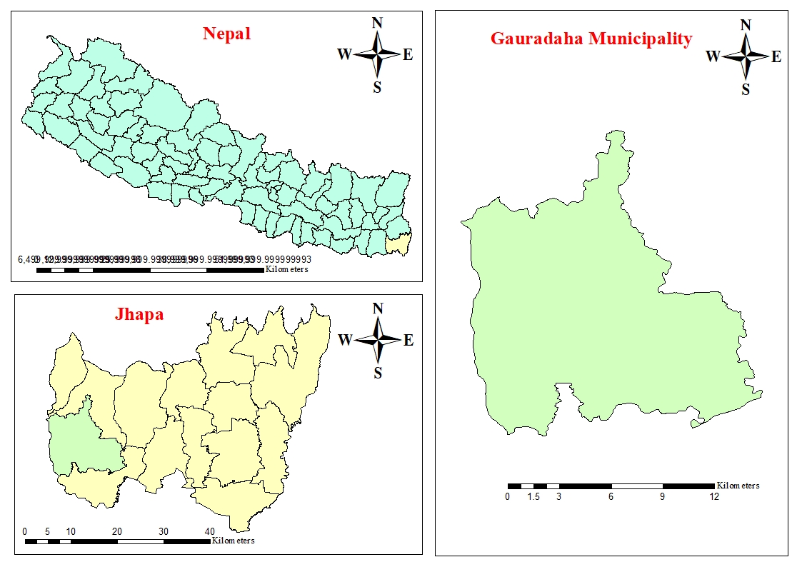
Figure 1: Map of study area, Gauradaha municipality, Jhapa, Nepal

Soil sampling and analysis:
Soil samples (n=101) were collected using a soil auger from a depth of 0-20 cm across different wards. The location of each sample was recorded using MWater software. Analyzed parameters and the methods used for analysis are illustrated in Table 1. Sampling points taken throughout the study area are shown in Figure 2. Samples were analyzed at the Agricultural Branch of Gauradaha Municipality using the following methods:

Table 1: Parameters and methods to be adopted for the laboratory analysis at the Agricultural Branch, Gauradaha municipality.
S.N. | Parameters | Methods
1  2  3  4  5 | Soil texture  Soil pH  Nitrogen  Available P₂O₅  Available K₂O | Ribbon Test Method  Digital pH meter  Kit Box Method  Kit Box Method  Kit Box Method

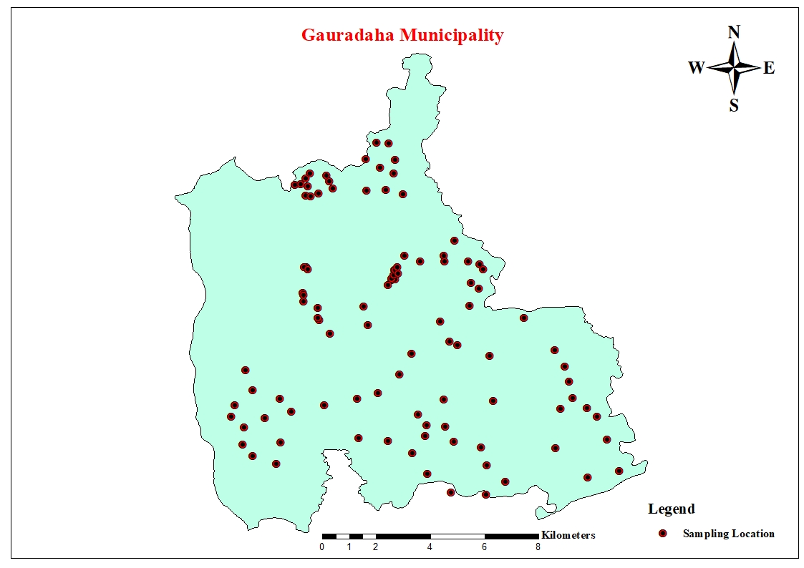
Figure 2: Sampling location, Gauradaha, 2024/25
Data analysis and mapping:
Descriptive statistics (mean, standard deviation, coefficient of variation) were calculated using R-Studio. Soil fertility maps were generated using ArcGIS 10.8.2, employing kriging interpolation for spatial representation. Nutrient indices were calculated based on standard soil classification guidelines. Similarly, the nutrient index was also determined by the formula given by Ramamurthy and Bajaj (1969).
$$\text{Nutrient Index }\left(\text{N.I.}\right)\text{= }\frac{\text{(NL × 1 + NM × 2 + NH × 3)}}{\text{NT}}$$
Where, NL, NM, and NH indicate a number of samples falling in low, medium and high classes of nutrient status, respectively and NT means total number of samples analyzed for a given area. Similarly, interpretation was done as the value given by Ramamurthy shown on the Table 2. Quantitative analysis of the tested soil samples was rated using the criterion of classification given in Table 3. Different parameters for the statistical analysis of soil pH is presented in Table 4. Each parameters of nutrients, along with its value and index, is shown in Table 5. Table 6 shows the percentage distribution of various parameters of the sampled soil.
Table 2: Rating chart of nutrient index
S.N. | Nutrient Index | Value
1  2  3 | High  Medium  Low | >2.33  1.67-2.33  <1.67

Table 3: Rating chart of soil test data for Terai region of Nepal
S.N. | Soil Parameters | Unit | Very Low | Low | Medium | High | Very High
1  2  3  4 | Soil pH  Total Nitrogen  Available P₂O₅  Available K₂O | pH Scale  %  Kg/ha  Kg/ha | 5.2-6.0  <0.03  <11  <55 | 6.0-6.5  0.03-0.07  11-28  55-110 | 6.5-7.0  0.07-0.15  28-56  110-280 | 7.0-7.5  0.15-0.25  56-112  280-500 | 7.5-8.3  >0.25  >112  >500

Table 4: Statistical analysis of soil pH
Parameters | Unit | Value
Minimum  Maximum  Mean  Standard Deviation (SD)  Standard Error (SE)  Coefficient of Variance (CV) | -  -  -  -  -  % | 5.3  6.8  5.99  0.37  0.04  6.18

Table 5: Nutrient index
S. N | Nutrients | Value | Index
1  2  3  4 | Soil pH  Nitrogen  Phosphorus  Potassium | 1.19  1  1.75  2.42 | Low  Low  Medium  High

Table 6: Percentage distribution of soil samples
S. N | Parameters | Unit | Low | Medium | High
1  2  3  4 | Soil pH  Nitrogen  Phosphorus  Potassium | %  %  %  % | 81.18  100  44.55  17.82 | 18.81  0  35.64  22.77 | 0  0  19.80  59.40

RESULTS AND DISCUSSION:
The soil fertility rank of Gauradaha municipality was assessed with respect to soil texture, soil reaction (pH) and primary nutrients i.e. nitrogen, phosphorus and potassium and the results acquired were presented and discussed in the following headings:

Soil texture:
The majority (78.21%) of soil samples were sandy loam in texture, while 21.78% were loamy as shown in the Figure 3. Sandy loam soil supports good drainage but requires careful nutrient management.
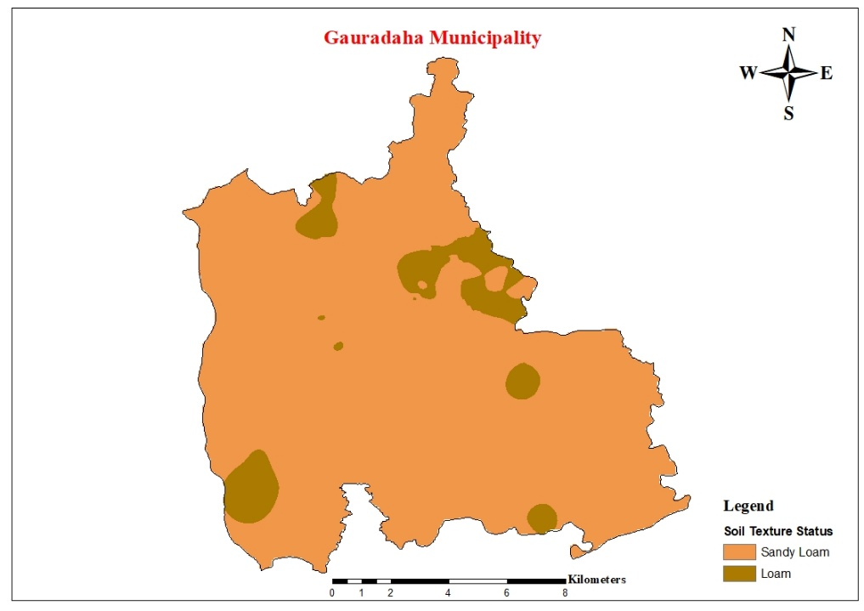
Figure 3: Soil texture status, Gauradaha, 2024/25
Soil pH:
In Figure 4, Soil pH ranged from 5.3 to 6.8, with a mean of 5.99, indicating acidic conditions is detailed. Soil acidification is common in areas with intensive cropping and excessive use of ammonium-based fertilizers. Liming is recommended to restore optimal pH levels.
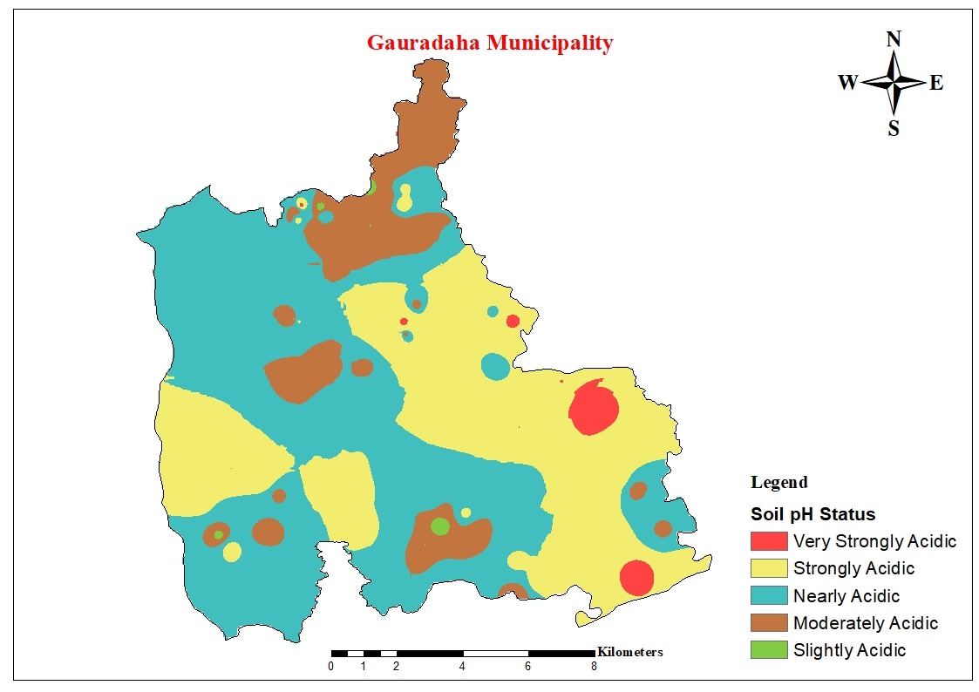
Figure 4: Soil pH status, Gauradaha, 2024/25

Total nitrogen:
Nitrogen levels were consistently low in all samples, indicating the need for regular organic amendments such as compost and nitrogen-fixing cover crops. Figure 5 exemplify the nitrogen status of Gauradaha municipality.
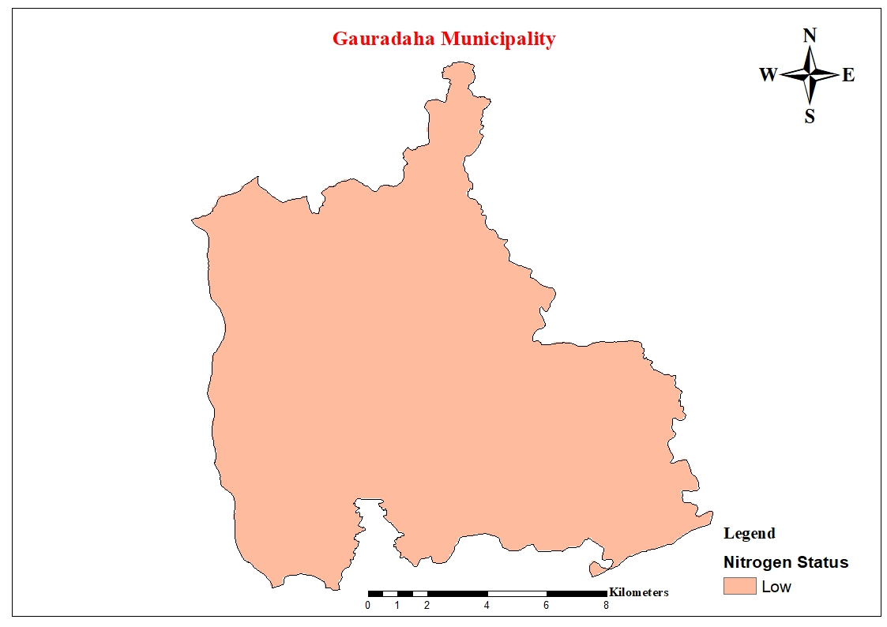
Figure 5: Nitrogen status, Gauradaha, 2024/25

Available phosphorus:
Phosphorus level of the study area is demonstrated in Figure 6 which varied as 44.55% of samples were low in phosphorus content, 35.64% were medium, and 19.80% were high. Phosphorus availability is affected by soil pH, organic matter content, and land-use practices.
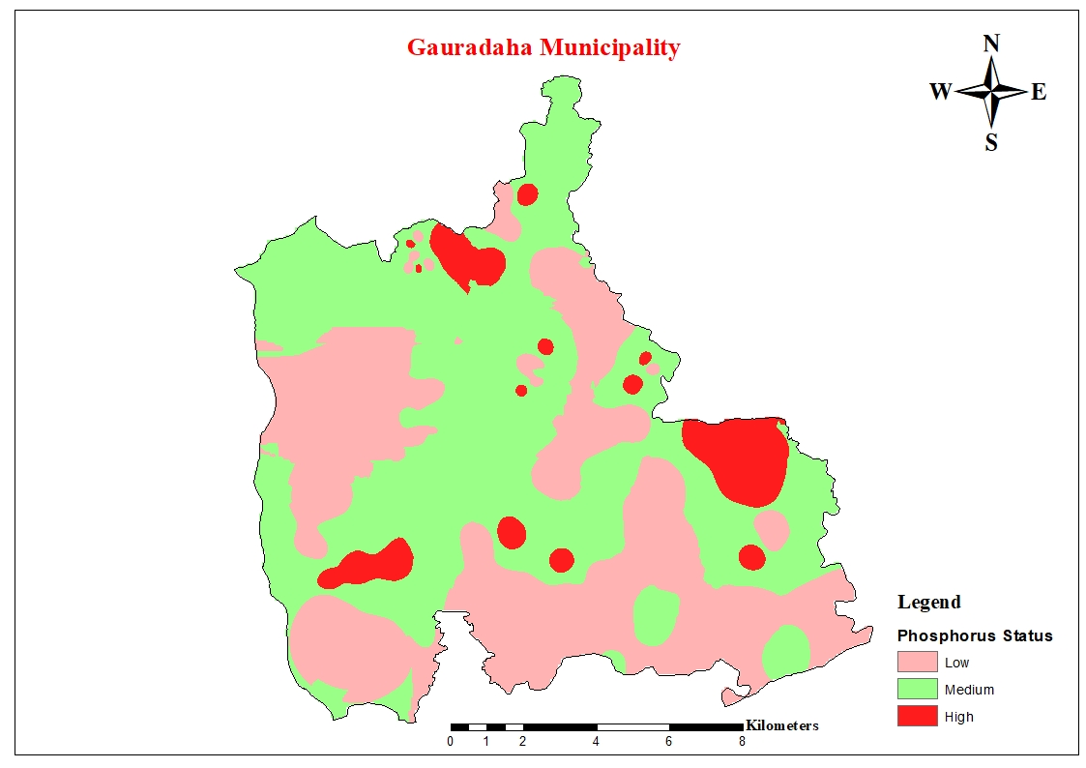
Figure 6: Phosphorus status, Gauradaha, 2024/25

Available potassium:
Potassium levels were high in 59.40% of samples, medium in 22.77%, and low in 17.82% as shown in Figure 7. Potassium loss via leaching and runoff is a concern, highlighting the importance of efficient nutrient application practices.
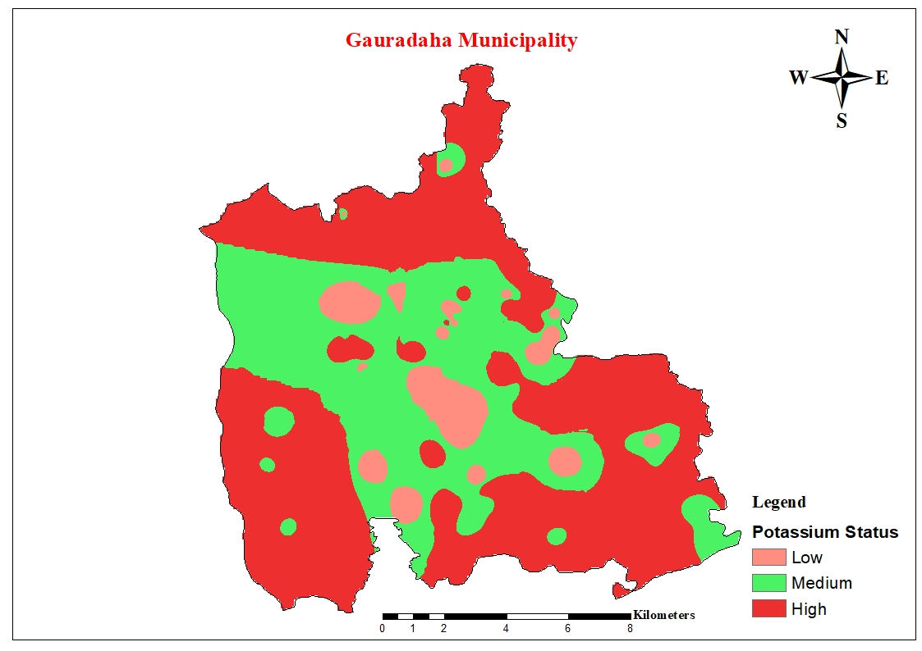
Figure 7: Potassium status, Gauradaha, 2024/25

SUMMARY AND CONCLUSION:
This study highlights spatial variability in soil fertility across Gauradaha municipality, emphasizing the need for targeted soil management strategies. The findings suggest the adoption of integrated nutrient management practices, including organic amendments, pH regulation through liming, and site-specific fertilization based on GIS-based soil maps. The research provides valuable data for farmers, agricultural planners, and policymakers, supporting sustainable soil management in the region.

Conflict of Interest:
All authors declare that there are no financial or personal conflicts of interest that could influence the research findings presented in this manuscript.

By submitting this manuscript, we affirm that we comply with the journal’s submission guidelines and ethical policies.

Disclaimer (Artificial intelligence)
Option 1:
Author(s) hereby declare that NO generative AI technologies such as Large Language Models (ChatGPT, COPILOT, etc.) and text-to-image generators have been used during the writing or editing of this manuscript

REFERENCES
Abate, K., Mohammed, M., & Kibret, K. (2016). Soil fertility assessment and mapping of spatial variability at Amareganda-Abajarso sub-watershed, north-eastern Ethiopia. East African Journal of Sciences, 10(1), 1-14.
Abdellatif, M. A., El Baroudy, A. A., Arshad, M., Mahmoud, E. K., Saleh, A. M., Moghanm, F. S., Shaltout, K. H., Eid, E. M., & Shokr, M. S. (2021). A GIS-based approach for the quantitative assessment of soil quality and sustainable agriculture. Sustainability, 13(23), 13438.
AbdelRahman, M. A., Hegab, R. H., & Yossif, T. M. (2021). Soil fertility assessment for optimal agricultural use using remote sensing and GIS technologies. Applied Geomatics, 13(4), 605-618.
Adornado, H. A., & Yoshida, M. (2008). Crop suitability and soil fertility mapping using geographic information system (GIS). Agricultural Information Research, 17(2), 60-68.
Aduramigba-Modupe, V., & Amapu, I. (2023). Climate Smart Agriculture and Soil Fertility Mapping: Nigeria Soil Information Service (NiSIS) Pilot Project.
Ahmed, M., Islam, M. M., Paul, S. K., & Khulna, B. (2005). Effect of nitrogen on yield and other plant characters of local T. aman rice, var. jatai. Research journal of agriculture and biological sciences, 1(2), 158-161.
An, K., Xie, G.-d., Leng, Y.-f., & Xiao, Y. (2003). Design of farmland GIS for precision agriculture. Chinese geographical science, 13, 20-24.
Assimakopoulos, J., Kalivas, D., & Kollias, V. (2003). A GIS-based fuzzy classification for mapping the agricultural soils for N-fertilizers use. Science of the Total Environment, 309(1-3), 19-33.
Bajracharya, R., Sitaula, B., Sharma, S., & Jeng, A. (2007). Soil quality in the Nepalese context-an analytical review. International Journal of Ecology and Environmental Sciences, 33(2-3), 143-158.
Bajracharya, R. M., & Sherchan, D. P. (2009). Fertility status and dynamics of soils in the Nepal Himalaya: A review and analysis. Soil Fertility, 111-135.
Bekunda, M., Nkonya, E., Mugendi, D., & Msaky, J. (2002). Soil fertility status, management, and research in East Africa. East African Journal of Rural Development, 20(1), 94-112.
Bista, P., Ghimire, R., Shah, S. C., & Pande, K. R. (2010). Assessment of soil fertility management practices and their constraints in different geographic locations of Nepal. Forum geografic,
Chandrakala, M., Ramesh, M., Sujatha, K., Hegde, R., & Singh, S. (2018). Soil fertility evaluation under different land use system in tropical humid region of Kerala, India. International Journal of Plant & Soil Science, 24(4), 1-13.
Chauhan, R. P. (2014). Role of earthworms in soil fertility and factors affecting their population dynamics: a review. International Journal of Research, 1(6), 642-649.
Cook, S., Henderson, C., Kharel, M., Begum, A., Rob, A., & Piya, S. (2016). Collaborative action on soil fertility in South Asia
Experiences from Bangladesh and Nepal. http://www.jstor.org/stable/resrep02749
Das, P. T., Saikia, B., Lakiang, T., Jha, D. K., Longmailai, P., & Raju, P. (2020). Soil Fertility Mapping Using Soil Health Card data and Geospatial Technology in Ri Bhoi District of Meghalaya. East African Scholars Journal of Agriculture and Life Sciences, 3(11).
Dengiz, O. (2013). Land suitability assessment for rice cultivation based on GIS modeling. Turkish Journal of Agriculture and Forestry, 37(3), 326-334.
Desbiez, A., Matthews, R., Tripathi, B., & Ellis-Jones, J. (2004). Perceptions and assessment of soil fertility by farmers in the mid-hills of Nepal. Agriculture, ecosystems & environment, 103(1), 191-206.
Dick, W. A., & Culman, S. W. (2016). Biological and biochemical tests for assessing soil fertility. Soil fertility management in agroecosystems, 134-147.
Eshetu, M., Wogi, L., & Demissie, N. (2024). Soil Fertility Assessment and Mapping under Different Land Use Types along Toposequence at Danka Watershed in Dinsho Districts of Bale Highland Oromia, Southeastern Ethiopia. International Journal of Plant & Soil Science, 36(5), 847-872.
Fathololoumi, S., Vaezi, A. R., Alavipanah, S. K., Ghorbani, A., Saurette, D., & Biswas, A. (2020). Improved digital soil mapping with multitemporal remotely sensed satellite data fusion: A case study in Iran. Science of the Total Environment, 721, 137703.
Forkuo, E. K., & Nketia, A. K. (2011). Digital soil mapping in GIS environment for cropland suitability analysis. International journal of geomatics and geosciences, 2(1), 133-146.
Ghosh, P., & Kumpatla, S. P. (2022). GIS applications in agriculture. In Geographic Information Systems and Applications in Coastal Studies. IntechOpen.
Gnyawali, B., Mandal, U. K., & Aryal, I. (2020). Soil Fertility Assessment of Sainamaina Municipality, Rupandehi, Nepal. The Geographic Base, 7, 43-53.
Goulding, K. (2016). Soil acidification and the importance of liming agricultural soils with particular reference to the United Kingdom. Soil use and management, 32(3), 390-399.
Hag Husein, H., Lucke, B., Bäumler, R., & Sahwan, W. (2021). A contribution to soil fertility assessment for arid and semi-arid lands. Soil Systems, 5(3), 42.
Hartemink, A. E. (2006). Assessing soil fertility decline in the tropics using soil chemical data. Advances in agronomy, 89, 179-225.
Havlin, J., & Heiniger, R. (2020). Soil fertility management for better crop production. In (Vol. 10, pp. 1349): MDPI.
Karlen, D. L., Andrews, S. S., Wienhold, B. J., & Zobeck, T. M. (2008). Soil quality assessment: Past, present and future.
Khadka, D., Lamichhane, S., Bhantana, P., Ansari, A., Joshi, S., & Baruwal, P. (2018). Soil fertility assessment and mapping of chungbang farm, Pakhribas, Dhankuta, Nepal. Advances in Plants & Agriculture Research, 8(3), 219-227.
Khadka, D., Lamichhane, S., Giri, R. K., Chalise, B., Amgain, R., & Joshi, S. (2020). Geostatistical based soil fertility mapping of Horticultural Research Station, Rajikot, Jumla, Nepal.
Khadka, D., Lamichhane, S., Shrestha, K., Joshi, S., Karna, M., Pant, B. B., & Yadav, S. (2017). Soil Fertility Assessment and Mapping of Agricultural Research Station, Jaubari, Illam, Nepal. International Journal of Environment, 6(3), 46-70.
Khadka, D., Lamichhane, S., Thapa, B., Baral, B. R., & Adhikari, P. (2016). An assessment of soil fertility status of national maize research program, Rampur, Chitwan, Nepal. Imperial Journal of Interdisciplinary Research, 2(5), 1798-1807.
Khadka, D., Lamichhane, S., Thapa, B., Rawal, N., Chalise, D. R., Vista, S. P., & Lakhe, L. (2015). Assessment of soil fertility status and preparation of their maps of National Wheat Research Program (NWRP), Bhairahawa, Nepal. Proceedings of the workshop, 24-25 March 2015,
Kumar, D., Yadav, S., Kaur, R., Choudhary, A., & Meena, B. (2017). Soil fertility status and nutrient recommendations based on soil analysis of Jaisalmer district of western Rajasthan. Asian Journal of Soil Science, 12(1), 103-107.
Lal, R. (2015). Restoring soil quality to mitigate soil degradation. Sustainability, 7(5), 5875-5895.
Li, G., Messina, J. P., Peter, B. G., & Snapp, S. S. (2017). Mapping land suitability for agriculture in Malawi. Land degradation & development, 28(7), 2001-2016.
Li, L., Yang, T., Redden, R., He, W., & Zong, X. (2016). Soil fertility map for food legumes production areas in China. Scientific reports, 6(1), 26102.
M, L., Hegde, R., S, D., & Koyal, A. (2022). Soil Fertility Evaluation in Rainfed Regions of Different Agro-Climatic Zones of Karnataka, India. Agricultural Research, 11(2), 215-228. https://doi.org/10.1007/s40003-021-00561-z
Maikhuri, R. K., & Rao, K. S. (2012). Soil quality and soil health: A review. Int. J. Ecol. Environ. Sci, 38(1), 19-37.
Malla, R., Shrestha, S., Khadka, D., & Bam, C. R. (2020). Soil fertility mapping and assessment of the spatial distribution of Sarlahi District, Nepal. Am. J. Agric. Sci, 7(1), 8-16.
Mandal, H. R., Shah, S. K., Oli, B., Katel, S., Yadav, S. P. S., Pant, K. R., Sharma, B., Kattel, S., Sah, S., & Yadav, B. (2023). Assessment of Soil Fertility Status in Rupani Rural Municipality, Saptari, Nepal. AgroEnvironmental Sustainability, 1(2), 111-121.
Mueller, T., Pusuluri, N., Mathias, K., Cornelius, P., & Barnhisel, R. (2004). Site‐specific soil fertility management: A model for map quality. Soil Science Society of America Journal, 68(6), 2031-2041.
Neményi, M., Mesterházi, P., Pecze, Z., & Stépán, Z. (2003). The role of GIS and GPS in precision farming. Computers and Electronics in Agriculture, 40(1-3), 45-55.
Nhunda, D., Semoka, J. M., & Tindwa, H. J. (2024). Assessment of Soil Fertility Status in Selected Fields under Maize Production in Kongwa District, Dodoma Region, Tanzania. Journal of Agriculture and Ecology Research International, 25(1), 32-47.
Okebalama, C. B., Anih, F. C., & Awaogu, C. E. (2024). Morphology and fertility evaluation of soils from different geological materials for agricultural production in Southeastern Nigeria. Technology in Agronomy(tia-0024-0017), 1-10.
Palaniswami, C., Gopalasundaram, P., & Bhaskaran, A. (2011). Application of GPS and GIS in Sugarcane Agriculture. Sugar Tech, 13, 360-365.
Panday, D., Maharjan, B., Chalise, D., Shrestha, R. K., & Twanabasu, B. (2018). Digital soil mapping in the Bara district of Nepal using kriging tool in ArcGIS. PloS one, 13(10), e0206350.
Place, F., Barrett, C. B., Freeman, H. A., Ramisch, J. J., & Vanlauwe, B. (2003). Prospects for integrated soil fertility management using organic and inorganic inputs: evidence from smallholder African agricultural systems. Food policy, 28(4), 365-378.
Pokharel, R., & Adhikari, R. Soil Analysis GIS-Based Fertility Assessment and Soil Mapping of Cardamom Growing Area, Pandam, Ilam, Nepal.
Rawal, N., Acharya, K. K., Bam, C. R., & Acharya, K. (2018). Soil fertility mapping of different VDCs of Sunsari District, Nepal using GIS. International Journal of Applied Sciences and Biotechnology, 6(2), 142-151.
Recena, R., Fernández-Cabanás, V. M., & Delgado, A. (2019). Soil fertility assessment by Vis-NIR spectroscopy: Predicting soil functioning rather than availability indices. Geoderma, 337, 368-374.
Reddy, M. N., & Rao, N. (1995). GIS based decision support systems in agriculture. National Academy of Agricultural Research Management Rajendranagar, 1-11.
Rozpondek, R., Wancisiewicz, K., & Kacprzak, M. (2016). GIS in the studies of soil and water environment. Journal of Ecological Engineering, 17(3), 134-142.
Sahu, N., Reddy, G., Kumar, N., & Nagaraju, M. (2015). High resolution remote sensing, GPS and GIS in soil resource mapping and characterization-A Review. Agricultural Reviews, 36(1), 14-25.
Scholes, R. (1990). The influence of soil fertility on the ecology of southern African dry savannas. Journal of Biogeography, 415-419.
Singh, A. (2007). Evaluation of soil quality under integrated nutrient management. Journal of the Indian Society of Soil Science, 55(1), 58-61.
Smaling, E. M., Nandwa, S. M., & Janssen, B. H. (1997). Soil fertility in Africa is at stake. Replenishing soil fertility in Africa, 51, 47-61.
Sood, K., Singh, S., Rana, R. S., Rana, A., Kalia, V., & Kaushal, A. (2015). Application of GIS in precision agriculture. Paper presented as lead lecture in national seminar on “Precision farming technologies for high Himalayas,
Tayari, E., Jamshid, A. R., & Goodarzi, H. R. (2015). Role of GPS and GIS in precision agriculture. Journal of Scientific Research and Development, 2(3), 157-162.
Thakuria, D., Hazarika, S., & Krishnappa, R. (2016). Soil acidity and management options. Indian Journal of Fertilisers, 12(12), 40-56.
Thompson, A., Shaw, J., Mask, P., Touchton, J., & Rickman, D. (2004). Soil sampling techniques for Alabama, USA grain fields. Precision Agriculture, 5, 345-358.
Tiwari, S., Subedi, D., Acharya, S., & Panthi, S. AN ASSESSMENT OF SOIL NUTRIENT STATUS UNDER DIFFERENT AGED SWEET ORANGE ORCHARDS IN SINDHULI DISTRICT OF NEPAL.
Torabian, S., Farhangi-Abriz, S., Qin, R., Noulas, C., Sathuvalli, V., Charlton, B., & Loka, D. A. (2021). Potassium: A vital macronutrient in potato production—A review. Agronomy, 11(3), 543.
Vista, S., Kumar, S., Ghimire, T., Rai, S., Kutu, B., & Karna, B. Soil fertility assessment and mapping of rice super zone, Jhapa.
Yanna, R. (2012). GPS System Application in Farmland Information Management. Software Engineering and Knowledge Engineering: Theory and Practice: Selected papers from 2012 International Conference on Software Engineering, Knowledge Engineering and Information Engineering (SEKEIE 2012),
Zhang, F., & Cao, N. (2019). Application and research progress of geographic information system (GIS) in agriculture. 2019 8th International Conference on Agro-Geoinformatics (Agro-Geoinformatics),
Zhu, X., Ros, G. H., Xu, M., Xu, D., Cai, Z., Sun, N., Duan, Y., & de Vries, W. (2024). The contribution of natural and anthropogenic causes to soil acidification rates under different fertilization practices and site conditions in southern China. Science of the Total Environment, 934, 172986.

