A review on uses of Bhilwa (Semecarpus anacardium) in the Indian context
Abstract
Semecarpus anacardium, commonly known as Bhilwa or the Marking Nut Tree, is a medicinally significant deciduous tree found throughout India and neighbouring regions. This review explores its ethnomedicinal legacy, botanical traits, phytochemistry, and multifaceted pharmacological activities. Bioactive constituents such as biflavonoids, bhilawanols, and phenolic compounds contribute to its documented anticancer, antioxidant, anti-inflammatory, antiatherogenic, and neuroprotective effects. The species demonstrates potent antimicrobial, antihyperglycemic, and antispermatogenic activities, supporting wide-ranging traditional and contemporary therapeutic applications. Despite promising preclinical evidence, challenges persist regarding standardization, clinical validation, and safety profiling. Additionally, S. anacardium’s role as a boundary tree and host for lac insects provides ecological and socioeconomic benefits. Awareness of its cultivation and responsible utilization is crucial for meeting increasing pharmaceutical demand and sustaining traditional knowledge. Bridging the gap between ethnobotanical practices and evidence-based medicine remains a key priority for future research on this versatile medicinal species.
Keywords: Bhilwa, Marking Nut, Semecarpus anacardium, Ayurveda, Anticancer Activity

Introduction
Semecarpus anacardium Linn. (Family: Anacardiaceae), commonly known ‘Ballataka’ or ‘Bhilwa’, represents a critical juncture in traditional medicine research where ancient wisdom meets modern scientific validation. The genus name, Semecarpus, derives from the Greek "Simeion," meaning "stamping" and "carpus," meaning "nut." The species epithet, Anacardium, refers to the heart-shaped marking nut. The genus Semecarpus, with only one genus worldwide, includes about 87 species distributed across the Indian subcontinent and other regions, with several species native to India. Its nuts contain a variety of biologically active compounds such as biflavonoids, phenolic compounds, bhilawanols, minerals, vitamins and amino acids, which show various medicinal properties. The fruit and nut extract shows various activities like antiatherogenic, antiinflammatory, antioxidant, antimicrobial, anti-reproductive, CNS stimulant, hypoglycemic, anticarcinogenic and hair growth promoter. This comprehensive analysis reveals a plant of significant therapeutic potential that urgently requires systematic investigation to bridge the gap between traditional use and evidence-based medicine. Current research demonstrates promising pharmacological activities including neuroprotection, antidiabetic effects, and anticancer properties, yet critical gaps in clinical validation, standardization, and safety profiling pose immediate challenges for the scientific community.
Taxonomy and nomenclature
Bhilwa (Semecarpus anacardium), commonly referred to by several names such as Oriental Cashew, the Marking Nut Tree, Marany Nut, Malacca Bean Tree, Dhobi and Varnish Tree, belongs to Anacardiaceae. It is known for its significance in Ayurveda, Siddha and various folk medicines of India. The vernacular names like Biba in Marathi, Bhilwa, Bhela in Hindi, ayurvedic name Bhallataka, unani name Bhilwan, Bhelatuki in Bengali, Balia in Oriya, Bhela, Bhaula in Asamese, Geru in Kannada, Allakacheru, Cheru, Cherkuru in Malayalam, Angika, Agnimukh, Bhallatka in Sanskrit and marking nut in English.
Table 1 : Taxonomic classification
Kingdom | Plantae
Sub-kingdom : | Tracheobionta
Superdivision : | Spermatophyta
Division : | Magnoliophyta
Class : | Magnoliopsida
Order : | Sapindals
Family : | Anacardiaceae
Genus : | Semecarpus
Species : | anacardium

Distribution and environmental condition
The tree is distributed in the outer Himalayas, from Sutlej to Sikkim, and fairly at the hottest part of India consisting of Andhra Pradesh, Karnataka, Kerala, Maharashtra, Odisha and Tamil Nadu. It is also found in the Malayan Archipelago, Singapore, Australia, Africa, Indo-Malaysia and China (Sukhadiya et al., 2019). Found in the warmer regions of India, these trees grow well in semi-arid climates, with light to medium gravelly soils and good drainage.
Botanical Description
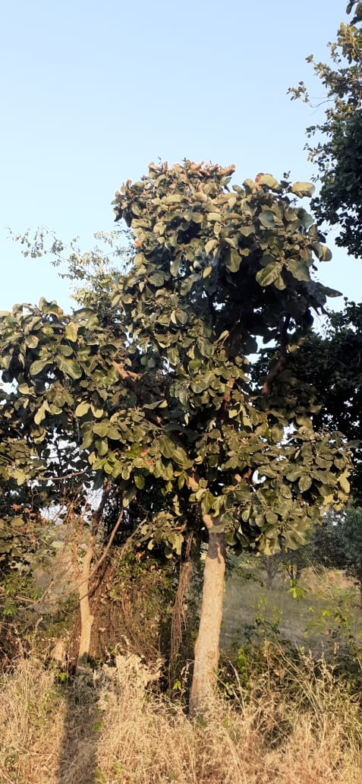
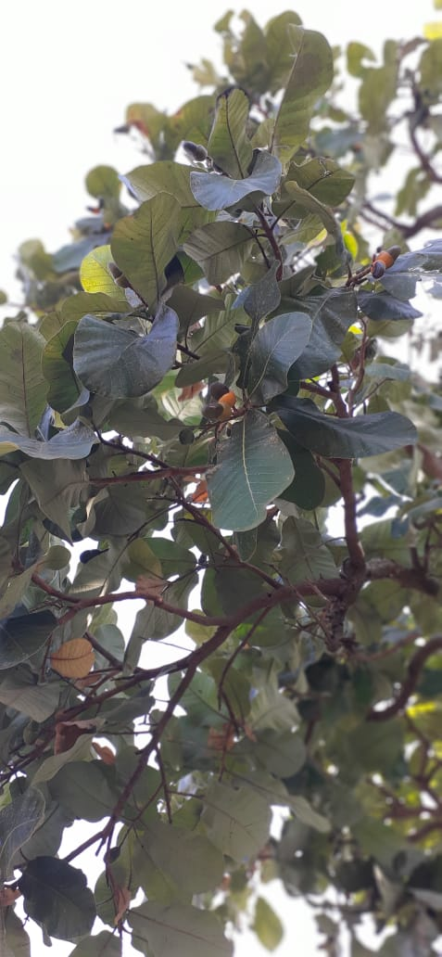
Bhilwa (Semicarpus anacardium), reaching a height of 12-15 meters is a moderate sized, deciduous tree. It is found in dry deciduous to moist deciduous, semi-evergreen forests of 1000 m. The leaves are simple and arranged alternately, with dimensions of 15-20 cm length and 10-12 cm width. Leaves have an obovate-oblong shape, culminating in a rounded tip (Jain & Sharma, 2013), while the leaf base is heart-shaped, rounded, or in the form of stalk-narrow, characterized by a leathery texture. The small flower panicles are shorter than the leaves. The fruit is a 1-inch long oblong or void drupe. It is shiny and smooth, blackened when ripe, and is on a fleshly cup. The stem produces on tapping an acrid, viscid form of a varnish. Its nut produces a potent substance known as "Dhobi Nut," widely utilized throughout India. The fruit dye gives cotton fabrics a black colour (Figure 1). The fleshy cups nuts when rest, then the kernels of the nuts are eaten. Generally, leaf fall happens in the month of February-March (Semalty et al., 2010).

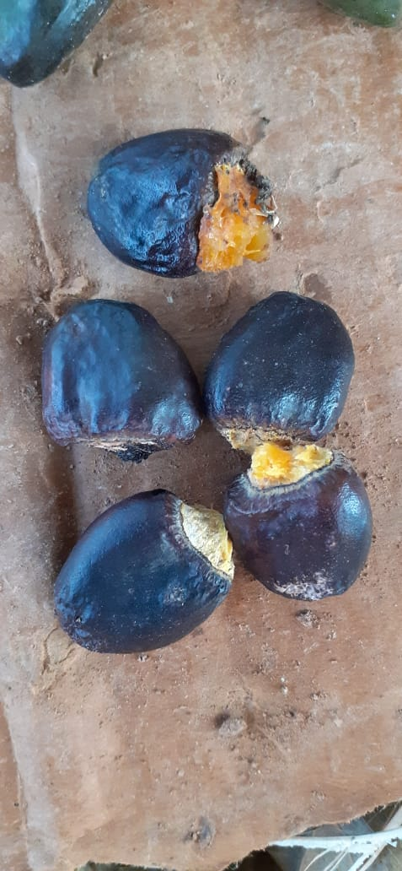
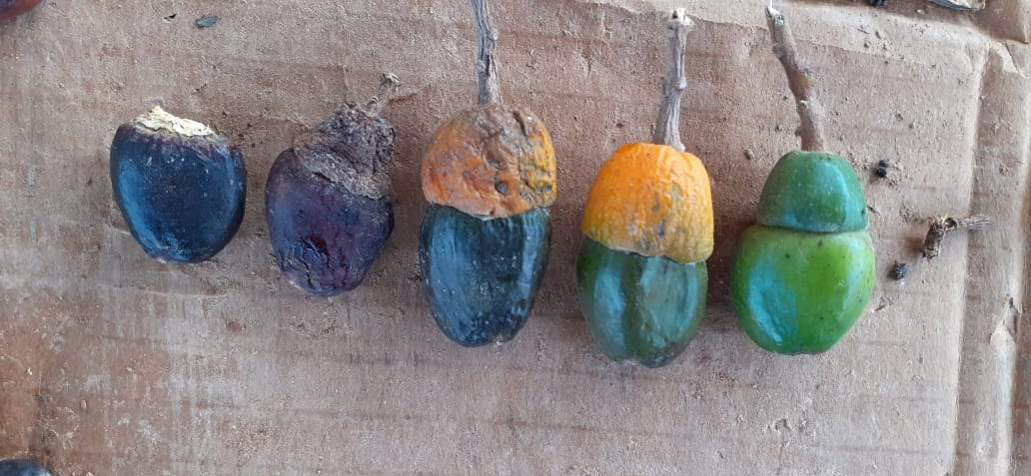
A B

C D
Figure 1: A- Semicarpus anacardium tree; B- Leaves; C- Fruits and D- Dried seeds
Reproductive biology and breeding system
The small flowers are of a dull greenish-yellow hue, dioeciously borne from May to September. The inflorescence is terminal panicles. With a diameter ranging from 0.6 to 0.8 cm, the flowers are sub-sessile and arranged in fascicles, whereas the petals are oblong, and the greenish-white filaments are subulate. Fruiting takes place from December to March, with the fruit being a drupe measuring 2 to 2.5 cm in length. The drupe is obliquely ovoid, smooth and shiny, turning black when fully ripe. It is supported by an orange-coloured receptacle and persists on the tree from February to June. Fruit - epicarp, mesocarp and endocarp are differentiated from Pericarp; the longitudinal section of the pericarp shows an outer epicarp with a single radially and lignified epidermal cell layer. Glands in the pericarp release oil globules and form small protuberances in the epicarp. The mesocarp parenchyma contains a rosette of calcium oxalate crystals and oil drops. Lysigenous cavities of mesocarp house oily vesicating substances, insoluble in water but soluble in ether, chloroform and alcohol (Jain & Sharma, 2013).
Seed collection and processing
Seed collection of Semecarpus involves collecting mature fruits from healthy trees, removing the outer shell to extract the seeds, then cleaning and shade-drying them for about 10 days before storage in a cool, dry place; for germination, seeds usually require treatments such as soaking in water for 24 hours to soften the hard outer shell, mechanical scarification or acid treatment (e.g., 98% sulfuric acid for one minute) to break dormancy, followed by sowing in well-drained nursery beds or pots with a suitable potting mix, maintaining moist but not waterlogged soil, where germination typically occurs within 2 to 4 weeks, and treated seeds show improved germination rates, faster emergence, and better seedling vigor compared to untreated seeds (Rathiesh et al., 2019; Suman et al., 2020). Also, Germination is accelerated when the seeds are soaked for alternate days and then dried in cow dung for 15 days. Approximately 60-65% germination can be achieved when seeds are treated with concentrated H2SO4 for 15 minutes and then washed in running water (Sukhadiya et al., 2019). Seedlings should be cultivated in the nursery between March and April, with a typical germination period of 30 days. Rain season is most suitable for transplanting seedlings. However, seedlings are sensitive to frost, they show robust recovery capabilities. Seedlings are prone to damping off disease at early stages.
Plantation establishment and growth
The field ploughed thoroughly followed by harrowing and planking to bring from soils to find tilth and free from weeds. After ploughing, harrowing and planking as soil work, 20 t/ha FYM was added. Bhliwa seedlings are planted at 6 m x 6 m spacing in the 60 cm x 60 cm x 60cm sized pits in the month of April- May. Every pit is filled with a soil mixture containing 15-20 kg of FYM (Farm Yard Manure). The transplantation of seedlings were done during the rainy season. About 277 seedlings or saplings are required for one-hectare land. Intercropping can be done with any short-duration crop at an early stage of planting. Intercultural operations like weeding and hoeing will be carried out periodically, and in the initial years, irrigation needs to be provided. Major pest is not noted (Sukhadiya et al., 2019).
Wood Characteristics
The sapwood is greyish-white or greyish-yellow to greyish-brown and is indistinct from the heartwood. The wood structure is diffuse-porous with indistinct growth rings and vessels large to medium solitary or in radial multiples of 2-5, rarely in clusters; often filled with tyloses. The grains are straight to slightly interlocked and the texture is coarse (Nazma et al., 1981).

Medicinal Uses
- Anticancer Activity
Multiple scientific investigations have established the cytotoxic and anticancer properties of Semecarpus anacardium across diverse models and extract types. Initial research by Arulkumaran et al. (2006) employed the brine shrimp lethality test on aqueous extracts of 120 medicinal plants, reporting Semecarpus anacardium nut extract with significant cytotoxicity (LC50 = 29.5 μg), thus suggesting its potential as a chemopreventive agent. Further studies showed that nut extract strongly inhibits proliferation of T47D human breast cancer cells, mechanistically associated with decreased Bcl-2, increased Bax, cytochrome c release, caspase activation, PARP cleavage, and ultimately, internucleosomal DNA fragmentation, confirming apoptosis as the principal mechanism (Mathivadhani et al., 2007).
Patel et al. (2009) demonstrated anticancer activity of methanolic nut extract against Hep 2 (human epidermoid larynx carcinoma), with an IC50 value of 468 μg/ml, while minimal cytotoxicity was observed in normal Vero cells (R2 = 0.008), highlighting the selectivity of the extract. In rat models, Joseph et al. (2013) established that S. anacardium milk extract treatment for 154 days led to significant restoration of liver markers and regression of hepatocellular carcinoma (HCC), in positive correlation with doxorubicin activity, affirming its therapeutic promise as an adjunct in HCC management.
More recently, Singh et al. (2018) reported the ethyl acetate leaf extract of Semecarpus species as highly cytotoxic to breast cancer cells (MCF-7), inducing apoptosis, cell cycle arrest, and reducing cancer cell migration, which was substantiated by GC-MS findings of bioactive alkaloids, steroids, polyphenols, and flavonoids. These findings are consistent with other studies showing significant anti-tumor effects in both in vitro and in vivo systems, especially with leaf extracts displaying less toxicity than nut extracts and promising oral efficacy and wound-healing inhibition in breast cancer models.
Collectively, these studies confirm Semecarpus anacardium extracts as promising candidates for anticancer therapeutics due to their selective cytotoxicity, capacity to induce apoptosis, and minimal effect on normal cells, thus providing scientific underpinning for clinical development.

- Antioxidant
Semecarpus anacardium possesses significant antioxidant and anti-mutagenic properties, which are attributed to its rich phytochemical composition, including phenolic compounds, flavonoids, and bioactive constituents like butein. The studies also suggest its potential in mitigating oxidative stress-related diseases and providing protective effects in in vivo models. Prabhu et al. (2005) reported that S. anacardium treatment in mice (intraperitoneally at doses of 250 and 500 mg/kg) effectively inhibited mutagenic abnormalities when administered 12 hours prior, indicating its protective role against mutagenesis. The anti-mutagenic effects may be linked to its antioxidant constituents that neutralize free radicals, thus preventing DNA damage. In a related study, Arulkumaran et al. (2006) observed that rats treated with S. anacardium alongside Kalpaamruthaa maintained normal lipid peroxide levels and exhibited enhanced antioxidant defense systems, such as increased activity of endogenous antioxidants in blood and organs like the liver, kidney, and breast tissue, especially under cancer-prone conditions. This combination significantly decreased lipid peroxidation (LPO), a marker of oxidative stress. Further, Veena et al. (2008) found that the S. anacardium and Kalpaamruthaa formulation markedly reduced LPO levels while elevating antioxidant enzyme levels, showcasing its protective capacity against oxidative stress.
The ethyl acetate extract of S. anacardium bark displayed notable antioxidant activity, ascribed to its high phenolic content (68.67%), measured via pyrocatechol equivalents. This extract exhibited potent free radical scavenging activity, with IC50 values of 43.28 ± 4.34 μg/ml, comparable to standard antioxidants like rutin (Sahoo et al., 2008). The active compound "Butein" isolated from this extract played a significant role in its antioxidant effects. Various assays such as DPPH, ABTS, and FRAP confirmed the robust free radical scavenging and antioxidant potential of S. anacardium extracts. The studies also report that the antioxidant compounds contributed to anti-inflammatory, cardioprotective, and anti-cancer effects, supporting its traditional use in combating oxidative stress-related diseases. Moreover, Upreti et al. (2016) highlighted the strong antioxidant potential of S. anacardium nuts, attributing this to its phenolic and flavonoid content, which help protect against oxidative damage and promote health.

- Anti-inflammatory
It exhibits anti-inflammatory properties against immunological and non-immunological pathways (Satyavati et al., 1969). The nut extricate documented immunomodulatory power, antioxidative and film stabilizing properties, tumour maker control, reclamation of glucose level and hepatocellular carcinoma mineral. It successfully detoxifies the strong hepatocarcinogen aflatoxin B1 and encourages the excretion of its metabolites through pee (Premlatha et al., 2000). The anti-inflammatory impacts of S. anacardium nut extricate on creating and creating adjuvant joint pain. The discoveries of the examination recommend that Semecarpus anacardium Linn. Nut extrication has a strong anti-inflammatory impact and restorative viability against all stages of aggravation, which is comparable to that of indomethacin. The extricate displayed a vital diminish in paw edema by carrageenan and cotton pellet granuloma. The ethyl acetic acid derivation extricate of S. anacardium is driven to the segregation of the essential dynamic compound, tetra hydro amentoflavone (THA), which is classified as a biflavonoid. The in vitro test for prostaglandin biosynthesis, catalyzed by cyclooxygenase (COX-1), uncovered an IC50 esteem of 29.5 μM for THA. Besides, at a concentration of 100 g/ml, THA illustrated a 40.5% hindrance of COX-2. Within the in-vivo measure for carrageenan-induced paw edema, THA showed a dose-dependent anti-inflammatory effect, comparable to that of ibuprofen. (Sevlam & Jachak, 2004). The inhibitory impacts of extricate on the generation of pro-inflammatory cytokines have been examined. In vitro considers were conducted utilizing fringe blood and synovial liquid mononuclear cells gotten from both solid people and patients with rheumatoid joint pain (RA). The rough ethanolic extricate of nuts was utilized for its anti-inflammatory properties, comes about appeared that extricate viably smothered the unconstrained and LPS-induced generation of pro-inflammatory cytokines IL-1beta and IL-12p40. Be that as it may, no critical affect was watched on the generation of TNF-alpha and IL-6, both at the protein and mRNA level. Besides, the unrefined extricate illustrated the capacity to hinder the atomic translocation of translation components NF-kappaB and AP-1, which are recognized to play crucial role within the direction of provocative reactions. Particularly, the restraint of NF-kappaB was accomplished through the concealment of I kappa Bα phosphorylation. Furthermore, the extricate shown the capacity to stifle LPS-induced nitric oxide generation in a mouse macrophage cell line, Crude 264.7. By and large, these discoveries propose that extricate has anti-inflammatory properties by hindering the generation of pro-inflammatory cytokines and tweaking key signaling pathways included in irritation (Singh et al., 2006). The display ponder pointed to investigate the anti-inflammatory action of different extricates, specifically methanolic, ethanolic, chloroform, ethyl acetic acid derivation, and petroleum ether, gotten from the natural products of S anacardium. The carrageenan-induced paw edema strategy was utilized in pale skinned person rats to assess the anti-inflammatory potential of the extricates. The comes about uncovered that the extricates displayed noteworthy anti-inflammatory properties, which were noted to be equivalent to those of the reference standard ibuprofen (Bhitre et al., 2008).

- Antiarthritic
Kalpaamruthaa (KA), an indigenously adjusted siddha definition, contains the extricate of S. anacardium nut drain and new dried powder of Emblica officinalis (EO) with nectar 2000 mg/kg Kalpaamruthaa is nontoxic. Advance, KA has been reported for its potent antioxidant, analgesic, antipyretic, and non-ulcerogenic properties. effect of S. anacardium in adjuvant-induced joint rodent (AIA) is illustrated with regard to arbiters of irritation (lysosomal proteins) and its influence on proteoglycans. The activities of various chemicals and levels of plasma protein-bound carbohydrate components of glycoproteins were assessed and were observed to be elevated in joint rats with respect to control animals (Mythilpriya et al., 2008).

- Antimicrobial
The alcoholic extricates of dried nuts of Semecarpus anacardium (Bhallatak) exhibited bactericidal action against three gram-negative pathogens (Escherichia coli, Salmonella typhi, and Proteus vulgaris) and two gram-positive strains (Staphylococcus aureus and Corynebacterium diphtheriae).Studies show that alcoholic extracts from various parts of the plant (leaves, twigs, and green fruit) also possess antibacterial properties, with the leaf extracts in the forefront. The mouse skin aggravation test showed no dermatoxic impact (Nair et al., 1996). Concentrated alcoholic extracts of dried nuts exhibited antifungal activity against Aspergillus fumigatus and Candida albicans. Both organisms displayed inhibited growth, a reduction in the number of cells, and a decrease in sporulation (Sharma et al., 2002). The watery and natural dissolvable extricates of S. anacardium were screened for antimicrobial (plate dissemination strategy) and phytochemical properties. The petroleum ether (PEE) and fluid extricate divisions (AQE) appeared inhibitory movement against Staphylococcus aureus (10 mm) and Shigellaflexneri (16 mm) at 100 mg/ml for each. While chloroform extricate appeared negative against Bacillus licheniformis, Vibrio cholerae and Pseudomonas aeruginosa, the ethanol extricate appeared restraint to Pseudomonas aeruginosa and S. aureus (Mohanta et al., 2007). Nut oil exhibited strong antimicrobial action against few Gram positive (Bacillus subtilis, Staphylococcus aureus) and Gram negative (Proteus vulgaris, Escheria Escherichia coli) microscopic organisms (Sharma et al., 2010). Marking nut plant has great antibacterial properties and is dynamic against Salmonella typhi. Its antibacterial activity is attributed to secondary metabolites, including such as triterpenoids, steroids, phenol and anthraquinones (Upreti et al., 2016).

- Antiatherogenic
The antiatherogenic property of Semecarpus anacardium is well documented through its potent antioxidant activity, which plays a crucial role in preventing atherosclerosis by scavenging free radicals such as superoxide and hydroxyl radicals at low concentrations. This antioxidant activity inhibits lipid peroxidation in low-density lipoproteins (LDL), which is a key factor in the initiation of atherogenesis. Early studies by Sharma et al. (2010) indicated that Semecarpus anacardium reduces tissue and serum hyperlipidemia by inhibiting intestinal cholesterol absorption and promoting peripheral lipid disposal. This gives the plant notable anti-atherosclerotic effects related to its antioxidant, anticoagulant, hypolipidemic, platelet anti-aggregation, and lipoprotein lipase releasing properties (Semalty et al., 2010).
Recent research has reinforced these findings and highlighted additional therapeutic mechanisms. For example, Ali et al. (2015) demonstrated that ethanol extracts of Semecarpus anacardium significantly lowered serum total cholesterol, triglycerides, and LDL cholesterol in diabetic rat models, along with protective antioxidant effects on liver function markers, supporting its antiatherogenic potential. More recent systematic reviews and experimental studies (IJNRD, 2024) suggest that Semecarpus anacardium nut extracts exert anti-inflammatory and immunomodulatory effects that further contribute to its cardiovascular protective effects by reducing oxidative stress and lipid abnormalities, which are central to atherosclerosis progression.
Additionally, Vikhe et al. (2024) showed that ethanol extracts of Semecarpus anacardium leaves improve lipid profiles and reduce hyperglycemia in streptozotocin-induced diabetic models, suggesting a dual role in managing metabolic risk factors for atherosclerosis by lowering blood glucose and improving lipid metabolism. Together, these studies indicate that Semecarpus anacardium possesses multifaceted antiatherogenic effects through antioxidant activity, lipid lowering, anti-inflammatory action, and improvement in endothelial function, validating its traditional use and highlighting its potential as a natural therapeutic agent for the prevention and management of atherosclerosis and related cardiovascular conditions (Semalty et al., 2010; Ali et al., 2015; Vikhe et al., 2024; IJNRD, 2024).

- Antihyperglycemic
The impact of ethanolic extricate of dried nuts of S. anacardium on blood glucose is explored in hypoglycemic and streptozotocin-induced diabetic (antihyperglycemic) rats. The ethanolic extricate of 100 mg/ kg decreased the blood glucose in rats. The blood glucose levels were noted at different time points of 1 hour, 2 hours, and 3 hours post-treatment, and the anti-hyperglycemic effect was compared with tolbutamide, a sulfonylurea derivative used in diabetes mellitus (Arul et al., 2004). The effects of KA were found to be superior to Semecarpus anacardium (Veena et al., 2006). Anti-diabetic action of Semecarpus marsupium was examined in high fat slim down streptozotocin initiated diabetic rodent. It appears to decrease blood glucose levels and glycosylated hemoglobin while improving glucose resistance in tests (Haseena et al., 2012).

- Antispermatogenic
The aqueous extricate of airborne S. anacardium depicted spermicidal action. The ethanolic extricate of Semecarpus anacardium natural product leads to spermatogenic capture in pale-skinned rats. An alarming reduction in sperm motility and thickness was observed. The natural product extricates nourishing moreover causes checked diminishment within the number of essential spermatocytes, auxiliary spermatocytes and spermatids. These results clearly demonstrate the anti-spermatogenic nature of S. anacardium (Narayan et al., 1985). Semecarpus anacardium extricate bolstering caused anti-spermatogenic impact prove by lessening in numbers of spermatogenic cells and spermatozoa in male pale skinned person rats (Sharma et al., 2003). Semecarpus anacardium extricate resulted in an anti-spermatogenic effect, as evidenced by a reduction in the numbers of spermatogenic cells and spermatozoa in male pale skinned person rodents (Vinutha et al., 2007).

- Neuroprotective activity
The advantageous impacts of nuts of Semecapus anacardium, extricated with drain, on the central apprehensive framework (CNS), basically for its locomotor and nootropic exercises which has been proven to improve cognition and support healthy brain function (Farooq et al., 2007). The loss of cholinergic cells, particularly in the basal forebrain, is accompanied by a decline in the neurotransmitter acetylcholine (ACh). The S. anacardium is successful in drawing out the half-life of acetylcholine through the restraint of ACh esterase. Semecarpus anacardium is valuable in treating cognitive decay and making strides in memory (Vinutha et al., 2007). Two lipid solvent compounds to be specific, Bhilawanol (Bh) and anacardic acid (AA) for the most part found within the nut of S. anacardium. Mugharaibi et al. (2021) observed the neuro-protective effects of Bh and AA against glutamate actuated cell passing within the adrenal pheochromocytoma cell line of rats (PC12 cells). The discoveries demonstrated that the organization of Bh and AA medicines driven to a considerable upgrade in cell practicality, a diminish in cell harmfulness and calcium deluge in PC12 cells, as well as a concealment of responsive oxygen species.

- Toxicity
Poisonous quality by verbal course organization of Semecarpus anacardium extricate with shelled nut oil is compared with the identical extract emulsified using Tween-80 saline. The usual way of organizing with shelled nut oil was found to be safe up to 25 mg/kg/day for 9 days, and increment in weight, RBCs and haemoglobin % was watched without mortality. A similar amount with Tween-80 saline was found to have antagonistic impacts with 16.5% mortality (Patwardhan et al., 1988). For its unfavourably susceptible responses like hasty, tingling and swellings, cures counting coconut oil, ghee, coriander takes off mash or butter blended with musta (Cyprus rotundus) are used (Mishra et al., 2017).
- As wood preservative
The dark coloured, googey and tall vasicant Bhilawa nut shell alcohol (BNSL) is dissolvable in natural solvents. BNSL comprises dawdle build up around 46% of bhilawanol, which is competent of shaping chelates with metals like Pb, Fe, B etc. (Ramanujam, 1963). Shukla et al., (1972) utilized these properties of BNSL in planning copper and zinc additives from it. Bit oil obtained from BNSL is utilized as grease as well as a wood additive against termites (Lakshminathan, 1988).
Other relevant information
The fruits, seeds and bark of Bhilawa exhibit ethno-medicinal purposes properties and the nut shell liquid is used for marking. The bark possesses astringent properties and produces gum resin utilized in the treatment of leprosy . Through tapping, the stem yields a pungent, sticky juice used in the preparation of varnish. The nut produces a potent and bitter substance widely used in India as a replacement for marking ink in laundry. When applied to cotton fabrics, it imparts a black color, but it requires mixing with limewater as a fixative before application. The fruits are also used as a dye. Both the fleshy cups supporting the nuts and the kernels within the nuts are edible. The tree also serves as a host plant for the lac insect. The oil extracted from the kernels is utilized as both a lubricant and a wood preservative to ward off termites. The fruits, their oil, and the seeds possess significant medicinal value, being employed in the treatment of a diverse array of diseases. Applied externally, the oil, when blended with coconut or sesame oil, is used on wounds and sores to prevent the formation of pus. When combined with shorea butter, it provides soothing relief and aids in healing foot cracks. For enhanced wound healing, the oil is effective when medicated with garlic, onion, and ajavayana in sesame oil. Applying the oil topically on swollen joints and traumatic wounds efficiently manages pain. For glandular swellings and filariasis, the oil's application aids in draining pus and fluids, providing relief. Internally, Bhilwa is extensively employed in treating a wide range of diseases due to its diverse properties. It also improves appetite, promotes bowel cleansing, relieves trapped gases, and eliminates worms (Sukhadiya et al., 2019). The seed inside black fruit known as (Semecarpus anacardium) is a lesser known tree species in the tropics. But in ayurveda and pharmaceutically important medicinal tree species. It serves as abundant reservoir of antioxidant, flavonoids & tannins and has been used in treating various form of cancer like leukaemia, hepatocellular carcinoma; heart diseases; neurological disorders etc. Therefore, awareness about species cultivation is needed to fulfill the pharmaceutical demand of the species.

Conclusion
In conclusion, Semecarpus anacardium stands out as a medicinally important and ecologically valuable species, known for a wide spectrum of pharmacological properties including anticancer, antioxidant, anti-inflammatory, antiatherogenic, and antimicrobial activities. The current body of evidence highlights the urgent need for clinical validation, standardization, and safety profiling, while reaffirming the value of traditional knowledge. Promoting sustainable cultivation and responsible utilization will help meet rising pharmaceutical demands and safeguard ethnomedicinal heritage, making further systematic research on this remarkable plant imperative for both medicine and conservation.
Disclaimer
The authors hereby declare that no generative artificial intelligence technologies, including large language models (e.g., ChatGPT, Copilot) or text-to-image generation tools, were utilized in the preparation, drafting, or editing of this manuscript. All content presented herein is solely the result of the authors’ original intellectual work.
References
Ali, M. A., Wahed, M. I. I., Khatune, N. A., Rahman, B. M., Barman, R. K., & Islam, M. R. (2015). Antidiabetic and antioxidant activities of ethanolic extract of Semecarpus anacardium (Linn.) bark. BMC Complementary and Alternative Medicine, 15(1), 138.
Arul, B., Kothai, R. and Christina, A.J. (2004). Hypoglycemic and antihyperglycemic effect of Semecarpusanacardium Linn in normal and streptozotocin- induced diabetic rats. Methods Finding in Experimental and Clinical Pharmacology. 26:759-62.
Arulkumaran. S., Ramprasath, V. R., Shanthi P. and Sachdanandam P. (2007). Alteration of DMBA-induced oxidative stress by additive action of a modified indigenous preparation- Kalpaamruthaa. Chemico-Biological Interactions. 167:99-106.
Bhitre, M.J., Patil, S., Kataria, M., Anwikar S. and Kadri, H. (2008). Antiinflammatory activity of the fruits of Semecarpus anacardium Linn. Asian Journal of Chemistry. 20:2047-50.
Farooq, S. M., Alla, T. R., Rao, N. V., Prasad, K., Nandakumar, K., Gouda, T. S., & Satyanarayana, S. (2007). A study on CNS effects of milk extract of nuts of Semecarpus anacardium. Linn,(Anacardiaceae). Pharmacologyonline, 1, 49-63.
Haseena, B. H. K., Kaladevi, S. V., Shanthi, P. &Sachdanandam, P. (2012) Anti-diabetic effect of Semecarpusanacardium Linn nut milk extract in a high fat diet STZ-induced type 2 diabetic rat model.ComparativeClinical Pathology.21(6): 1395-1400.
Jain, P. and Sharma, H. P. (2013). A potential ethnomedicinal plant Semecarpus anacardium. International Journal of research in Pharmacy & Chemistry. 3 (3): 564-572.
Lakshmikanthan, V. (1984). Chemistry and industry of tree-borne oil seeds in service to citizen. Recent Trends in Forest Utilization. International Book Distributors, Dehra Dun, 1-12.
Mathivadhani, P., Shanthi, P. and Sachdanandam, P. (2007). Apoptotic effect of Semecarpus anacardium nut extract on T47D breast cancer cell line. Cell Biology International. 31:1198-206.
Mishra, A. K., Neha, S. L., Jain, A., Jagtap, C. Y., Dane, G., Paroha, S., & Sahoo, P. K. (2024). Effectiveness of Semecarpus anacardium Linn. fruits in cancer and inflammatory diseases: A mini review. Fitoterapia, 175, 105978.
Mohanta, T. K., Patra, J. K., Rath, S. K., Pal, D. K. and Thatoi, H. N. (2007). Evaluation of antimicrobial activity and phytochemical screening of oils and nuts of Semecarpus anacardium Lf. Scientific Research and Essay. 2:486-90.
Mughairbi,F. A., Nawaz, R., Khan, F., Hassan, A., Mahmood, N., Ahamad, H. T., Alshamali, A., Ahamad, S. and Bashir S. (2021). Neuroprotective effects of Bhilawanol and Anacardic acid during glutamate-induced neurotoxicity. Saudi Pharmaceutical Journal.29: 1043-1049.
Mythilypriya, R, Shanthi, P. and Sachdanandam, P. (2008). Therapeutic effect of Kalpaamruthaa, a herbal preparation on adjuvant induced arthritis in wistar rats. Inflammo pharmacology. 16:21-35.
Nair, A. and Bhide, S.V. (1996). Antimicrobial properties of different parts of Semecarpus anacardium. Indian Drugs. 33(7):323-8.
Narayan, J. P., John, M. S., Ghosh, P. K., Singh, J. N., Jha, O. P., & Jha, I. S. (1985). Screening of some medicinal plants for spermatostatic and spermicidal properties. In Proceedings of symposium on phytochemistry and Botanical Classification (pp. 211-216).
Nazma, Ganapathy P. M., Bhat K. M., Sasidharan N and Gnanaharan R. (1981). A Handbook of Kerala Timbers. KFRI research report no.9. 260p.
Patel, S. R., Suthar, A. P., and Patel, R. M. (2009). In vitro cytotoxicity activity of Semecarpus anacardium extract against Hep 2 cell line and Vero cell line. Int J PharmTech Res, 1, 1429-33.
Patwardhan, B., Saraf, M. N. and David, S. B. (1988). Toxicity of Semecarpus anacardium extract. Ancient Science of Life. 8(2): 106-109.
Prabhu, D., Rajwani, L. S. and Desai, P. V. (2005). The antimutagenic effect of Semecarpus anacardium under in vivo condition. Asian Journal of Chemistry. 12: 13–16.
Premlatha, B. and Sachadanandam, P. (2000). Potency of Semecarpus anacardium Linn., nut milk extracts against aflatoxin B1-induced hepatocarcinogenesis: reflection on microsomal biotransformation enzymes. Pharmacological Research. 42:161-166.
Ramanujam S, 1963. The special features and application of Bhilawanol. Journal of Oil Tech. Association (India), 18(11): 370-383.
Sahoo, A. K., Narayanan, N., Sahana, S., Rajan, S. S. and Mukherjee, P. K. (2008). In vitro antioxidant potential of Semecarpus anacardium L. Pharmacologyonline, 3(3), 27-35.
Satyavati, G. V., Prasad, D. N., Das, P. K. and Singh, H. D. (1969). Anti-inflamatory activity of Semecarpus anacardium Linn. A preliminary study. Indian Journal of Physiology & Pharmacology. 13:37-45.
Selvam, C. and Jachak, S. M. (2004). A cyclooxygenase (COX) inhibitory biflavonoid from the seeds of Semecarpus anacardium. Journal of ethnopharmacology. 95:209-12.
Semalty, M., Semalty, A., Badola, A., Joshi, G. P. and Rawat, M. S. M. (2010). Semecarpus anacardium Linn.: A review. Pharmacognosy reviews, 4(7), 88.
Sharma, A, Barman, N. and Malwal, M. (2010). Antimicrobial efficacy of nut oil of Semecarpus anacardium: a marking nut tree. Biotechnology. 9(3): 383-386.
Sharma, A., Verma, P. K. and Dixit, V. P. (2003). Effect of Semecarpus anacardium fruits on reproductive function of male albino rats. Asian Journal of Andrology.5:121-4.
Sharma, K., Shukla, S. D., Mehta, P. and Bhatnagar, M. (2002). Fungistatic activity of Semecarpus anacardium Linn nut extract. Indian Journal of Experimental Biology. 40(3): 314-318.
Shukla, K.S., Jain, V. K. and Tewari, M. C. (1972). A note on the preparation of copper and zinc preservatives from Bhilawan nut shell liquid. Journal of Timber Dev. Association (India), 18(2):27-30.
Singh, D., Aggarwal, A., Mathias, A. and Naik, S. (2006). Immunomodulatory activity of Semecarpus anacardium extract in mononuclear cells of normal individuals and rheumatoid arthritis patients. Journal of Ethnopharmacology.108:398-406.
Singh, R., Tripathi, R., Ranjan, A., Sharma, V., Singh, A. and Singh, S. (2018). Seemecarpus anacardium leaf extracts shows anticancer activity in breast cancer cells. 3rd International conference Nutraceuticals & chronic disease. 155p.
Sukhadiya M., Dholariya C. A., Behera L. K., Mehta A. A., Sinha S. K. and Patel S. M. (2019). Biography of lesser known tree species marking nut (Semecarpusanacardium). MFP news Vol. XXIX no. 1. 9-13.
Upreti, S., Anam, M. S., Rajendra, S. V., Das, K. and Dang, R. (2016). SEMECARPUS ANACARDIUM VARIED M EDICINAL PROPERTIES. Journal of Pharmaceutical Research, 15(4), 162.
Veena, K., Shanthi, P. and Sachdanandam, P. (2006). The biochemical alterations following administration of Kalpaamruthaa and Semecarpus anacardium in mammary carcinoma. Chemico-biological interactions, 161(1), 69-78.
Veena, K., Shanthi, P. and Sachdanandam, P. (2007). Therapeutic efficacy of Kalpaamruthaa on reactive oxygen/nitrogen species levels and antioxidative system in mammary carcinoma bearing rats. Molecular and cellular biochemistry, 294, 127-135.
Vikhe, S., Sukhadhane, P., Vikhe, R., Bornare, S. L., & Dhavane, S. S. (2024). Antidiabetic effects of Semecarpus anacardium leaf extracts in streptozotocin-induced diabetes in rats. Journal of Applied Pharmaceutical Research, 12(6), 144-158.
Vinutha, B., Prashanth, D., Salma, K., Sreeja, S. L., Pratiti, D. and Padmaja, R. (2007). Screening of selected Indian medicinal plants for acetylcholinesterase inhibitory activity. Journal of ethnopharmacology. 109(2):359–63.

