Review Article
Unlocking the Potential of Coconut: Nutritional Value, Processing Technologies, and Product Development
Abstract:
Coconut (Cocos nucifera), often referred to as the "tree of heaven" or kalpavriksha, is one of the most economically and nutritionally significant crops in tropical regions. Its versatility stems from the wide array of products derived from its various parts, making it a cornerstone of rural livelihoods and agro-industrial development. This review aims to highlight the nutritional potential, processing technologies, and product diversification associated with coconut. Recognized as a functional food, coconut offers health benefits beyond its basic nutritional profile. Coconut water, rich in potassium and essential minerals, is naturally sterile and widely consumed as a natural sports drink. Eight-month-old coconuts are ideal for producing snowball-tender coconut, where specialized machinery grooves the shell and extracts the delicate kernel with water. Virgin Coconut Oil (VCO) is obtained from fresh, mature kernels using mechanical or natural methods, with minimal heat application to preserve its biochemical integrity. For successful commercialization, coconut-based products must be processed, packaged, and marketed in consumer-friendly formats. This presents a valuable opportunity for farmers and entrepreneurs to engage in value addition, thereby enhancing income generation and improving socio-economic standards.
Keywords: Coconut, functional food, virgin coconut oil, value addition, tropical crops
Introduction
Cocos nucifera (L.) is a significant member of the family Arecaceae popularly known as coconut, coco, coco-da-bahia, or coconut-of-the-beach. Coconut is originated from Southeast Asia (Malaysia, Indonesia, and the Philippines) and the islands between the Indian and Pacific Oceans (Karun, Ramesh, Rajesh, Niral, & Sudha, 2021). One of the most significant crops in tropical regions is the coconut. It is commonly known as the "tree of heaven" or "kalpavriksha" due to the fact that it offers people a wider variety of valuable products. All parts of the fruit of the coconut tree can be utilized for several purposes by the people (Subramanian et al., 2024). The Food and Agricultural Organization states that Indonesia is one of the top producers of coconuts with 18 million tons produced annually which was followed by the Philippines, which produces 15.86 million tons. India ranks third in the world about 10.56 million tonnes of coconuts produced annually (FAOStat, 2022). The following states produce the most coconuts in India include Kerala, Tamil Nadu, Goa, Karnataka, Maharashtra, Orissa, West Bengal, and Assam (Fig. 1). India uses 50 % of its yearly crop for religious and culinary purposes, 35% for copra, 2% for value-added product manufacturing, 11% for tender coconut water and 2% for seed purposes (Karun et al., 2022). At present, appreciation of natural coconut water is growing. Small scale Industry is using the husk fibre from the pith as resource for carpets, car seat stuffing and in agricultural sector as fertilizers. The hard core is castoff to make handcrafts. The stalk and leaves of the coconut tree are useful in construction, sugar, vinegar, and alcohol can be extracted from the inflorescence (Hebbar et al., 2015).
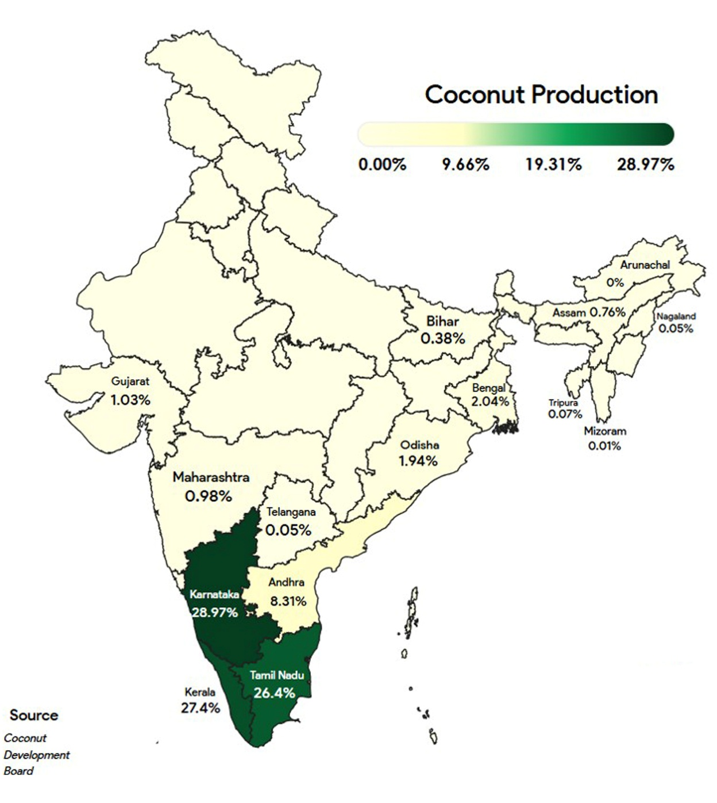
Figure 1 Coconut production in India (2022-23)

Nutrient composition
Coconut provides a healthy and nutrient-dense source of meat, water, milk, and oil. It is frequently referred to as a functional food due to its health benefits that extend beyond basic nutrition. Coconut water, in particular, is naturally sterile and rich in potassium and essential minerals, making it a popular natural sports drink. This nutritious beverage contains a variety of minerals including sodium, potassium, phosphorus, chlorides, magnesium, ascorbic acid, B vitamins, and natural sugars. It is also abundant in amino acids such as cystine, arginine, and alanine. Coconut oil is notable for its high content of lauric acid—a 12-carbon fatty acid that constitutes over half of its total fatty acids. Coconut water is especially beneficial for individuals suffering from gastroenteritis, particularly children and the elderly, as it can serve as an effective oral rehydration solution (Baharvand, Shokri, Hassani, Mirzaei, & Mahdian, 2021). According to USDA data (2018), 100% pure coconut water contains sugar (1.27g/100ml), carbohydrates (3.39 g/100 ml), calcium (17 mg/100 ml), sodium (28 mg/100 ml) and potassium (186 mg/100 ml).
Health benefits
Coconut oil extracted through enzymatic digestion yields a monoglyceride called monolaurin, which possesses antimicrobial properties effective against harmful pathogens such as bacteria, viruses, and fungi. Lauric acid, which constitutes over half of the fatty acids in coconut oil, not only helps lower blood cholesterol levels but also offers protective effects against cardiovascular diseases. Rich in antioxidants, coconut oil helps combat free radicals and may contribute to anti-aging effects (Jayathilaka & Seneviratne, 2022). When used as a hair conditioner, it maintains hydration and promotes overall hair health. Additionally, coconut oil supports digestive health by protecting against disorders such as heartburn and irritable bowel syndrome. Its consumption enhances the absorption of essential nutrients, including vitamins, minerals, and amino acids. Coconut-derived products have also been reported to aid in the management of renal and liver diseases, bladder infections, periodontal conditions, and blood sugar regulation (Baharvand et al., 2021).
Value added products from coconut
Coconut is a food crop as well as an oil seed crop. Each part of the coconut crop will be used for some purpose that’s why it is known as kalpavriksha. The coconut is used as source of fibre, timber and fuel. In many of our nation's states, the coconut palm is also grown for beverage production. The inhabitants of India's west coast eat kernels as a staple of their diet. The kernel gives nutritious milk when boiled, and it also produces oil. A vital component of many culinary recipes is coconut milk. The richest source of cooking oil in Kerala is the dried kernel, also known as copra. This oil is used nationwide for industrial, body oil, and hair oil purposes (Pavan, Lakshmi, Deena, Bhavani, & Rajendra, 2018). It also functions as a lubricant and illuminant. Most high-end cosmetics contain coconut oil as a component. The coconut oil cake after extraction of oil is a used as a good cattle feed. The coconut palm produces toddy, which is used to make arrack, vinegar, and jaggery. Coconut wood is used to build houses as well as to create furniture, wall panels, accent pieces, and floor tiles. Ayurvedic remedies are made from the inflorescence of coconuts. The soft coconut serves as a foundation for numerous ayurvedic treatments and is consumed as a wholesome sports and health beverage. Mature nut water is used to make wine, vinegar, jelly, and Nata de coco. In addition to being used to make a variety of consumer goods such ice cream cups, utility articles, show pieces, shell powder, shell charcoal, and shell-based activated carbon, the shell is also utilized as fuel. The palm's tender bud is palatable and nourishing. When preserved for a while, a delicious delicacy called haustorium develops inside the nut and can be used to create products with added value for the market. Palm leaves are used for thatching homes. In communities, dried leaves are not only utilized as a rustic torch but also as fuel. In traditional dances, the spindle leaf is used for costumes and decorations. Tongue cleaners, baskets, brooms, and fish traps are all made from the midribs of leaves. The husk produces pith and fiber. Hundreds of items, both for the domestic and international markets, are manufactured from the fiber. In addition to its many other use, pith serves as a rooting media and conditioner for soil. The various products of coconut other than copra and coconut oil offer a vast scope for further development, value addition & commercialization. Many tropical countries harvest large amounts of coconuts, with an estimated annual collection of about 60 million tonnes of nuts harvested over a surface area of 12 million hectares. In order to assess the actions of the coconut industry in light of previous and future possible liabilities, this review examined the industry's current status.
Snow Ball Tender Nut
The entire round, soft, water-tight kernel of a snowball coconut is extracted from its shell. A delectable treat is the solid endosperm or soft, sensitive kernel of a tender coconut. It is the fragile, white, ball-shaped coconut that is free of the husk, shell, and testa. To drink the tender coconut water inside this white ball, simply poke a straw through the top of the tender coconut kernel. Eight-month-mature coconuts are better suited for making snowball-tender coconut. A machine creates a groove in the shell before the globular, fragile kernel is removed with water. The snow ball is scooped out of the shell by placing the scooping tool-which is specifically designed for this purpose between the delicate kernel and the shell, then rotating the nut. It is both a snack and a drink that is nutritive. A technique developed by the Central Plantation Crops Research Institute (CPCRI), Kerala and many private sectors for fabricated the machinery to pull out the whole round soft kernel from the nut. Snow ball tender nut can be packed in LDPE film of 200 gauge, which can be stored for 15 days at about 15°C under refrigerated condition without affecting its keeping quality. The technology is yet to take off commercially (Muralidharan & Jayashree, 2011).
Fruit juice blended tender coconut water
Process for preparation of fruit juice blended tender coconut water beverage using several fruits like pomegranate, blue grapes, pineapple, mango and lemon juice which have been standardized in India by Central Food Technological Research Institute (CFTRI) under the sponsored project of CDB. Storage studies of these products at room temperature reported that the beverages were safe for consumption for a period of 6 months validity (Chauhan, Archana, Singh, Raju, & Bawa, 2014).
Bottled Coconut Water
Coconut water bottled for consumption as a soft drink is becoming more and more common. Packed and preserved coconut water can be sold as a natural soft drink. Mature nuts' coconut water can be used to make fizzy drinks. Water filtration collection, upgrading (to modify pH, taste, total soluble sugar, and shelf life), pasteurization, filtering, and bottling are all steps in the process. When kept at room temperature, the bottled beverage can be kept for three months (Rethinam & Krishnakumar, 2022).

Nata-de-coco
A gelatinous product known as nata de coco is made from mature coconut water by the use of the cellulose-forming bacterium Acetobacter aceti subspecies xylinium. A culture liquid is used to inoculate the culture solution with Acectobacter xylinium after coconut water, sugar, and acetic acid are combined in a certain ratio. It is filled into glass jars, covered with a thin cloth, and left undisturbed for two to three weeks. A material that resembles white jelly forms during this time and floats on top of the culture media. After harvesting, chopping, and a 12-hour soak in flavored sugar syrup, it is packaged in glass bottles after being thoroughly cleaned of any acids in a pure water bath. It works great in pickles, ice cream, sherbets, fruit cocktails, and sweet fruit salads, among other recipes. In a laboratory setting, CDB has created a method for turning mature coconut water into nata-de-coco (Fig. 2). It was discovered that 20 kg of raw nata could be produced from 100 liters of coconut water. Countries including the United States, Europe, the United Arab Emirates, Japan, Taiwan, and Korea have a high demand for nata de coco. The Philippines, Indonesia, and Malaysia are the main countries that produce and market it commercially (Venturelli et al., 2025).
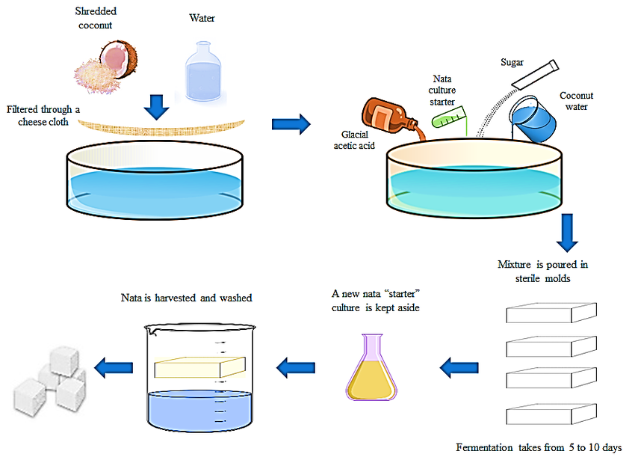
Figure 2 Schematic representation of the stepwise process involved in the preparation of nata de coco.

Coconut Vinegar
Coconut water can be converted into vinegar using a vinegar generator, which typically consists of a feed vat, an acetifier, and a receiving vat for vinegar collection. The process involves fortifying coconut water with sugar, followed by controlled oxidation and acidification. Fermentation is initiated through the inoculation of yeast and mother vinegar, leading to the gradual conversion of sugars into acetic acid. Coconut vinegar is widely utilized in the food processing industry, both as a flavoring agent and as a preservative particularly in pickled products. In export markets, natural vinegar derived from coconut water is generally preferred over synthetic vinegar produced from commercially sourced acetic acid, due to its perceived authenticity and superior flavor profile (Othaman, Sharifudin, Mansor, Kahar, & Long, 2014).
Coconut Skimmed Milk
Fresh coconut kernels are an excellent source of plant protein and may prove to be a priceless ingredient in the creation of dairy alternatives. After the cream is separated in a cream separator, the soluble parts of the coconut are combined to create coconut skim milk. Particularly in areas lacking in animal proteins, skim milk is an excellent source of high-quality protein that may be used to augment diets or to prepare a variety of practical food products. Freshly made coconut milk from peeled kernels is filtered through a vibrating screen with a mesh size of 120, and sodium hydroxide is added to increase the pH of the filtered milk from 6.3 to 7.0. After one hour of pasteurization at roughly 60°C, the milk is centrifuged in a cream separator to extract the protein-rich skim milk, or aqueous phase. For industrial usage, skim milk can be concentrated to create a solid, high-protein, low-fat product. Many goods, including spray dried powder, coconut honey, coconut jam, and sweetened condensed milk, can be made from skim milk. Furthermore, it can serve as a plant-based source of vegetable casein as a stand-in for the fermentation of beverage concentrate. Coconut milk has been shown to be an effective treatment for infants' gastrointestinal disorders. Its skim milk, which has the same 1.6% protein content as breast milk, is well-absorbed by infants (Naik, Venu, Prakash, & Raghavarao, 2014).
Bottled coconut milk
Bottled coconut milk is manufactured worldwide, especially in Malaysia and the Philippines, this product has a high market value and can be used as a substitute for cow's milk. Milk is collected from finely shredded, unpaired coconuts using water or coconut water. Cheesecloth is then used to filter the milk into an aluminium kettle that has 0.1 percent benzoic acid in it. After that, the kettle is autoclaved for three minutes at 117°C with steam injected. Then, use running water to bring the milk in the saucepan down to 80 to 85 degrees Celsius. Following approximately five minutes of homogenization, the milk is bottled at 70° to 80°C. It is a very nutritious product that is comparable in quality to cow's milk (Tulashie, Amenakpor, Atisey, Odai, & Akpari, 2022).
Coconut cream
Coconut cream is a white, smooth, and pourable liquid with a rich coconut flavor and a fat content ranging from 20% to 30%. It is aseptically packed to ensure product safety and extended shelf life. Coconut cream can be used directly as an ingredient in various culinary applications or further processed into other food products. For household use, coconut cream is typically diluted with water depending on the intended application. A threefold dilution is recommended when preparing undiluted coconut milk, while a fivefold dilution is suitable for traditional cuisine requiring thinner coconut milk. The primary applications of coconut cream include its use as a fat source in infant milk powders and as a component in the reconstitution of skimmed dairy milk. Additionally, it serves as a key ingredient in the production of filled milk and recombined milk. Coconut cream can also be utilized to formulate three types of milk-based products: beverage-type milk, evaporated milk, and sweetened condensed milk (Arachchi, Gunathilake, & Prasadi, 2016).
Coconut jam
Coconut jam is a high-sugar coconut-based food product commonly consumed as a dessert or spread on toast. It is prepared by heating sweetened coconut milk over low heat with continuous stirring until the mixture thickens significantly. A standardized procedure has been developed for producing coconut jam using soft coconut pulp, resulting in a product with a shelf life of up to six months. The process begins by grinding fresh coconuts and adding an equal volume of water to extract the milk. Brown sugar and glucose are then added at concentrations of 10.25% and 5.5%, respectively, based on the weight of the extracted milk. The mixture is cooked over low heat with constant stirring for approximately 20 minutes. It is then strained to remove suspended particles and further cooked over high heat. Before the mixture begins to thicken, citric acid is added at a rate of 0.25% of the original milk weight to enhance preservation and flavor. Cooking continues over low heat until the desired consistency is achieved. The final product is hot-filled into sterilized containers and sealed hermetically. The resulting coconut jam has a rich, creamy flavor and smooth texture, making it a popular value-added product in coconut processing (Chauhan, Archana, Singh, Raju, & Bawa, 2013).
Yoghurt Coconut milk
Yogurt is a fermented food made from cow milk that is fermented with lactic acid bacteria like Lactobacillus delbrueckii spp., Bulgaricus and Streptococcus thermophiles. Lactose intolerant people can also drink coconut milk yogurt. The process involves reconstitution of milk containing 50% non-fat dry milk and 50% coconut milk, pasteurization, inoculation with bacteria, packaging, incubation and chilling (Yaakob et al. 2012). One litre of coconut milk was preheated at a temperature of 90°C for 3 min. It was then cooled until the temperature reduced up to 40°C. After cooling, 3% of inoculum was mixed to the coconut milk and the cultured coconut milk was incubated at 37°C for 8 hours then it was stored at 4°C. Studies also shows that the there is no significant difference between the yogurt produced from skimmed cow milk and coconut milk in all sensory attributes. Thus, coconut milk can be used along with cow milk to produce acceptable and affordable yoghurt (Sanful, 2009).
Margarine
Indonesia possesses a patent on a technology that allows small and micro companies to produce margarine based on virgin coconut oil. Emulsifiers, stearine, antioxidants, β-Carotene, water, and salt are mixed with VCO in this procedure, which is then blended for 10 minutes, filled, packed, and cooled (Fig. 3). It has no trans facts and a high lauric acid content (Sonwai & Luangsasipong, 2013).
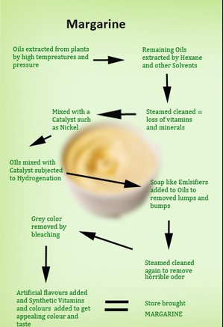
Figure 3 Flowchart illustrating the process of margarine production from coconut oil.
Mayonnaise
A semi-solid food ingredient called mayonnaise is added to cooked meat, fresh produce, or both to enhance flavor. It is prepared by mixing coconut oil, vinegar or citric acid or emulsifiers. Carbohydrates, spices and flavour enhances are added to modify the flavour and avoid crystallization. The end formulation would consist of 70% VCO, 6% natural vinegar, 7% fresh yolk and 1% emulsifiers and cooled boiled water. Mayonnaise production units can be commercially operated at home or micro level to enhance the economy of farmer families (Khairullah, Hemala, Hawa, & Meor, 2022).

Coconut Honey
Coconut honey prepared from coconut milk and is an admirable supernumerary for real honey. The milk is extracted from the gratings of unpaired fresh kernel after adding an equal quantity of water. For the extracted milk, 60 percent by weight of brown sugar and 30 percent by weight of glucose are added with it and then boiled in steam heated containers till a thick consistency is grasped. The final product of honey is then filled in containers and sealed. The colour of final product is a golden thick paste with a nutty flavour. This can also be used as an outstanding base for soft drink. Coconut honey contains many health promoting trace elements in addition glucose, fructose and levulose (Biswas, Borse, & Chaudhari, 2025).

Coconut Cheese
White soft cheese can be ended from a mixture of 50% coconut milk and 40% skimmed milk which will have the identical flavour, aroma and texture as 100% cow’s milk cheese. Fresh coconut kernel is grated and constrained to extract milk. The milk is permitted to stand for eight hours, until the cream has composed at the top. The cream is slowly lifted out and the skimmed milk heated with vinegar to coagulate the proteins. The coagulated protein is mixed with the cream and squeezed with salt. The process is simple and can be done as a household industry which makes small farmers to get sufficient income (Rahayu, Yunita, Ramadhan, Fitriani, & Dewi, 2025).
Coconut Sap
Coconut sap has many health benefits, products like vinegar, toddy, beverage, and coconut sugar/jaggery, are becoming more and more popular which was produced from it. With a low glycemic index of 35, coco sugar is suitable for both healthy individuals and those with diabetes (Tiarasari, Wulandari, Rahayoe, & Amanah, 2022). Essential vitamins and macro and micronutrients are also present in coconut sugar. The majority of producers are small- to medium-sized businesses operating at the village level. In the main coconut-producing nations, alcoholic beverages made from coconuts, especially coconut vodka, coconut wine and coconut arrack, have also grown in popularity. Toddy is the name of the sap that comes from the young inflorescence (Chinnamma, Bhasker, Binitha Hari, Sreekumar, & Madhav, 2019). Neera, Raa and Tuba are the names of unfermented sap in India, Sri Lanka, and Indonesia, respectively. The high sugar concentration of the sap varies with cultivar, ranging from 12 to 17%. Before the inner bract splits and the spike emerges from the spathe, the inflorescence is tapped to extract the sap. The term "tapping" refers to a variety of extractions and manipulations, such as tying the spathe, beating the spadix, pounding and hammering the spathe, slicing the apical tissue, and bruising and rupturing the delicate tissues of the floral bract. Between five and thirty-two days can pass between the start of the tapping and the toddy's dripping. More toddy is produced by taller cultivars than by dwarf palms. The daily yield ranges from 1.5 to 2 litres. The local microflora, which includes bacteria and yeast, ferments toddy in the natural environment. This process will begin as soon as the sap emerges and comes into contact with the atmosphere. Traditionally, lime is added to the collecting container, typically in earthen pot, to slow down the rate of fermentation (Thamban, Jayasekhar, Chandran, & Rajesh, 2020).
Refined Sugar
Toddy is treated with two percent lime to coagulate albuminous contaminants in order to recover the raw sugar. After that, the limed toddy is carbonated twice, with each carbonation being filtered to get rid of extra lime. The juice that has been clarified is evaporated until 75% of the sugar is left behind, and the resulting syrup is then concentrated in vacuum pans until crystallization starts. After the syrup is poured into crystallizers, centrifugation is used to separate the crystalline sugar. Hence coconut sugar is considered to be healthier than refined cane sugar (Saraiva et al., 2023).

Coir geotextiles
Coir geotextiles, also known as coir bhoovastra, are used to consolidate soil and control soil erosion. It disperses and breaks up the energy of water in motion. In order to prevent soil erosion on steep slopes, riverbanks, and other susceptible locations, coir geotextiles are frequently utilized. It will retain the soil in place as a protective surface cover until plant takes over (Gouda, Reddy, Srinivasan, & Dudhabaware, 2025).
Coirpith
Coir pith is the by-product obtained during the extraction of coir fibre. It works well as a mulch, rooting media, and soil conditioner. About70 percent of the husk is made up of pith. Coir pith which is known as coco peat has a growing market in the world for use in horticulture/agriculture (Bera et al., 2025).
Virgin coconut oil
Virgin Coconut Oil (VCO) is extracted from fresh, fully grown coconut kernels using either mechanical or natural methods, with or without the use of heat, so as not to change the oil's composition or characteristics. The different methods available for extracting virgin coconut oil are Fresh dry process, Desiccated coconut route, Wet processing of coconut and Cold centrifugal separation. Coconut Kernels are first disintegrated into small pieces in a Disintegrator and then fed into a screw press for milk extraction. The oil is then separated from the water using a mechanical centrifuge. The result is a clear coconut oil that retains the distinct scent and taste of coconuts. Laboratory tests show that this is a very high-quality coconut oil, with the lauric acid content being 47 to 52%. Virgin Coconut Oil (VCO) is characterized by specific quality parameters, including a maximum moisture content of 0.2%, an acid value of 0.5, and a minimum Polenske value of 0.8. Processing approximately 10,000 coconuts yields around 600 litres of VCO. The essential machinery required for a VCO production unit includes a hammer mill, bucket elevator, centrifuge, screw press, screw conveyor, crude coconut oil storage tank, vibratory sieve, micro filter, storage tanks, and a volumetric filling machine. VCO is widely used as an ingredient in personal care products such as massage oils, and it also serves as a component in various food supplements due to its nutritional and therapeutic properties. (Prasanna, Murugesan, Choudhary, & KSMS, 2024). The primary use of VCO is as a dietary supplement. Recent days in market, VCO is finding increasing popularity as a nutraceuticals and functional food, as well as good oil foundation for cosmetic and skin care products, as a scalp conditioner and as a carrier for massage and aromatherapy oils. VCO contains medium-chain triglyceride (MCT) which has a healthy advantage to the humans results in increasing the demand of oil among customers in the world.

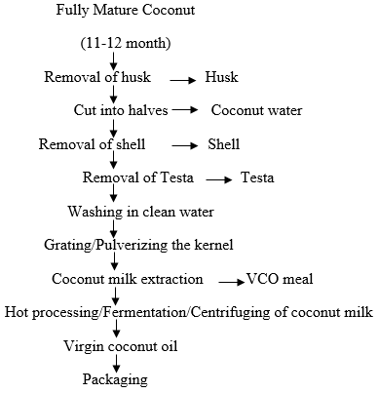
Figure 4 Stepwise process for the preparation of virgin coconut oil (VCO).
Conclusion
International demand for coconuts will rise as a result of producing countries working together to produce new products, innovate technologies, and diversify their product lines. Such efforts on the manufacture of greater value addition goods would strengthen the competitiveness of the coconut industry globally, especially in light of the declining market for traditional products like copra and coconut oil. Value addition also minimizes the waste and reduces the environmental degradation. To achieve large-scale commercial use, the products must be produced, packaged and delivered to market in a form that meets the consumer requirements. Coconut growers who taken a step to process value addition in coconut will definitely improve their economy as well as able to become an entrepreneur in a society. The person who are planning to start any value addition unit, initial cost must vary depends upon product type, they can approach bank loans with proper documents definitely can get subsidy from government side to start a small-scale business. Thus, value addition presents a promising opportunity for coconut growers and aspiring entrepreneurs particularly youth to enhance their livelihoods and contribute to sustainable rural development.

Disclaimer (Artificial intelligence)
Option 1:
Author(s) hereby declare that NO generative AI technologies such as Large Language Models (ChatGPT, COPILOT, etc.) and text-to-image generators have been used during the writing or editing of this manuscript.

References
Arachchi, L. L., Gunathilake, K., & Prasadi, V. (2016). Shelf life and quality evaluation of deep frozen coconut cream, coconut scrapings and coconut slices. Cord, 32(1), 34-40.
Baharvand, M., Shokri, M., Hassani, S., Mirzaei, H., & Mahdian, M. (2021). Antibacterial effect of coconut water and coconut oil on Aggregatibacter actinomycetemcomitans. Journal of Research in Dental and Maxillofacial Sciences, 6(3), 40-46. doi:10.52547/jrdms.6.3.40
Bera, R., Dey, P., Bhattacharya, P., Barik, A., Narasimhan, V., & Quah, E. (2025). Review of Coir Pith as Agro‐industrial Waste: Environmental Challenges and Management Approaches. Journal of Agriculture and Ecology Research International, 26(2), 19-36.
Biswas, A., Borse, B. B., & Chaudhari, S. R. (2025). Quantitative NMR analysis of sugars in natural sweeteners: Profiling in honey, jaggery, date syrup, and coconut sugar. Food Research International, 199, 115358.
Chauhan, O., Archana, B., Singh, A., Raju, P., & Bawa, A. (2013). Utilization of tender coconut pulp for jam making and its quality evaluation during storage. Food and Bioprocess Technology, 6, 1444-1449.
Chauhan, O., Archana, B., Singh, A., Raju, P., & Bawa, A. (2014). A refreshing beverage from mature coconut water blended with lemon juice. Journal of food science and technology, 51, 3355-3361.
Chinnamma, M., Bhasker, S., Binitha Hari, M., Sreekumar, D., & Madhav, H. (2019). Coconut Neera—A Vital Health Beverage from Coconut Palms: Harvesting, Processing and Quality Analysis. Beverages, 5(1), 22.
FAOStat, F. (2022). Crops and livestock products. Statistics Division, Food and Agriculture Organization of the United Nations: Rome, Italy.
Gouda, J., Reddy, D. S., Srinivasan, V., & Dudhabaware, A. (2025). Unlocking the potential of mine overburden materials and coconut coir geotextile: a full-scale study on reinforcing low-volume roads in India. Road Materials and Pavement Design, 1-25.
Hebbar, K. B., Arivalagan, M., Manikantan, M. R., Mathew, A. C., Thamban, C., Thomas, G. V., & Chowdappa, P. (2015). Coconut inflorescence sap and its value addition as sugar &#x2013; collection techniques, yield, properties and market perspective. Current science, 109(8), 1411-1417.
Jayathilaka, N., & Seneviratne, K. N. (2022). Phenolic antioxidants in coconut oil: Factors affecting the quantity and quality. A review. Grasas y Aceites, 73(3), e466. doi:10.3989/gya.0674211
Karun, A., Ramesh, S., Rajesh, M., Niral, V., & Sudha, R. (2021). Diversity in Coconut (Cocos nucifera L.). Cash Crops: Genetic Diversity, Erosion, Conservation and Utilization, 197.
Karun, A., Ramesh, S., Rajesh, M., Niral, V., Sudha, R., & Muralikrishna, K. (2022). Conservation and utilization of genetic diversity in coconut (Cocos nucifera L.). Cash Crops: Genetic Diversity, Erosion, Conservation and Utilization, 197-250.
Khairullah, M. N., Hemala, R., Hawa, A. N., & Meor, H. A. S. (2022). Egg-free low-fat mayonnaise from virgin coconut oil. Foods and Raw materials, 10(1), 76-85.
Muralidharan, K., & Jayashree, A. (2011). Value addition, product diversification and by-product utilization in coconut. Indian Coconut J, 7, 4-10.
Naik, A., Venu, G., Prakash, M., & Raghavarao, K. (2014). Dehydration of coconut skim milk and evaluation of functional properties. CyTA-Journal of Food, 12(3), 227-234.
Othaman, M. A., Sharifudin, S. A., Mansor, A., Kahar, A., & Long, K. (2014). Coconut water vinegar: new alternative with improved processing technique. Journal of Engineering Science and Technology, 9(3), 293-302.
Pavan, K. G., Lakshmi, N., Deena, C., Bhavani, B., & Rajendra, K. P. (2018). Copra oil: chemistry, production. An еxtensive review on Indian specifications and functional aspects. Ukrainian journal of food science(6, Iss. 1), 32-45.
Prasanna, N. S., Murugesan, S., Choudhary, N., & KSMS, R. (2024). Virgin coconut oil: wet production methods and food applications–a review. Sustainable Food Technology.
Rahayu, T., Yunita, D., Ramadhan, K., Fitriani, S., & Dewi, K. (2025). Chemical and microbiological characteristics of coconut spreadable cheese with addition of asam sunti extract. Paper presented at the IOP Conference Series: Earth and Environmental Science.
Rethinam, P., & Krishnakumar, V. (2022). Global scenario of coconut and coconut water Coconut Water: A Promising Natural Health Drink-Distribution, Processing and Nutritional Benefits (pp. 17-35): Springer.
Sanful, R. E. (2009). Promotion of coconut in the production of yoghurt. African Journal of Food Science, 3(5), 147-149.
Saraiva, A., Carrascosa, C., Ramos, F., Raheem, D., Lopes, M., & Raposo, A. (2023). Coconut sugar: chemical analysis and nutritional profile; health impacts; safety and quality control; food industry applications. International journal of environmental research and public health, 20(4), 3671.
Sonwai, S., & Luangsasipong, V. (2013). Production of zero-trans margarines from blends of virgin coconut oil, palm stearin and palm oil. Food Science and Technology Research, 19(3), 425-437.
Subramanian, P., Gupta, A., Gopal, M., Selvamani, V., Mathew, J., Surekha, & Indhuja, S. (2024). Coconut (Cocos nucifera L.) Soil Health Management for Plantation Crops: Recent Advances and New Paradigms (pp. 37-109): Springer.
Thamban, C., Jayasekhar, S., Chandran, K., & Rajesh, M. (2020). Sustainability of Farmer Producer Organisations-The case of producer organisations involved in the production and marketing of ‘neera’in the coconut sector in Kerala, India.
Tiarasari, E., Wulandari, R., Rahayoe, S., & Amanah, H. Z. (2022). Drying Profile of Coarse Coconut Palm Sap Sugar Using Simple Air-Oven Dryer. Paper presented at the International Conference on Sustainable Environment, Agriculture and Tourism (ICOSEAT 2022).
Tulashie, S. K., Amenakpor, J., Atisey, S., Odai, R., & Akpari, E. E. A. (2022). Production of coconut milk: A sustainable alternative plant-based milk. Case Studies in Chemical and Environmental Engineering, 6, 100206.
Venturelli, G., Villa, F., Petraretti, M., Guagliano, G., Levi, M., & Petrini, P. (2025). Bacterial cellulose for scalable and sustainable bio-gels in the circular economy. Gels, 11(4), 262.

