OBSTETRICAL EMERGENCIES IN GOATS: A REPORT OF ELEVEN CASES

Abstract
The present case report presents a series of eleven clinical cases involving various obstetrical emergencies in goats, occurring during advanced stages of pregnancy, at the time of parturition, and in the postpartum period. The documented obstetrical conditions of maternal origin include rupture of the pre-pubic tendon, narrow pelvis, ring womb, hydroallantois, postpartum uterine prolapse, and those of foetal origin include breech presentation, monocephalic monster, Perosomus horridus, internal hydrocephalus, foetal anasarca, and foetal emphysema. Every case was treated successfully through caesarean section or various mutational operations to save the life of the dam. With appropriate post-treatment, all the does had uneventful recoveries. This report highlights the importance of timely diagnosis and intervention in ensuring successful outcomes in goat obstetrical emergencies.
Key words:Caesarean section, Goat, Dystocia,Monster, Hydrops,Fetotomy, Foetus
Introduction
Obstetrical emergencies are acute and unexpected complications that arise during the advanced stage of pregnancy, at the time of parturition, and in the postpartum period, posing an immediate threat to the life or health of the dam, foetus, or both, and requiring emergency treatment to save the life of the animal. The most commonly observed obstetrical emergency in goats is dystocia. In Indian goats, the incidence of dystocia ranges from 8.57% to 15.02% (Bhattacharyya et. al., 2015; Gopal et al., 2015) of which 31.25% is from maternal and 68.75% from foetal origin (Yadav et al., 2024). The foetuses were generally relieved through various obstetrical mutation and extraction operations (51.43%) and by caesarean section (48.57%). The survival rates were 23.08% for foetuses and 94.29% for dams, respectively (Bhattacharyya et al., 2015). The present study reports maternal causes including rupture of the prepubic tendon, narrow pelvis, ring womb, hydroallantois, and postpartum uterine prolapse, and foetal origins include breech presentation, monocephalic monster, Perosomus horridus, internal hydrocephalus, foetal anasarca, and foetal emphysema. All the cases were managed by non-surgical procedure (using obstetrical interventions and fetotomy), except the case of rupture of the pre-pubic tendon, narrow pelvis, and hydroallantois. To save the life of the animal, all the reported cases were treated with caesarean section and pervaginal delivery with appropriate mutational operations. All the treated animalsrecovered uneventfully with appropriate postoperative treatment.
Presentation of Cases and Treatment
Case-1: Rupture of prepubic tendon
An advanced pregnant goat in her third parity was presented at Veterinary Clinical Complex DUVASU, Mathurawith a delay in parturition and swelling in front of the udder. Previous all kiddings were normal. The udder and teats were stretched forward and downward on the abdominal floor, indicating rupture of the pre-pubic tendon (Fig.1a). The udder was fully developed and mildly oedematous, and the teats were enlarged and filled with colostrum. The vulva was slightly oedematous.Per-vaginal examination revealed the cervix was partially dilated. Three kids (two fully grown and one partially mummified) (Fig.1b) were relieved through caesarean section. Postoperatively, the animal was treated with inj. 5% DNS (250 mL, IV), inj. multivitamin (2.5 mL, IM total dose), inj. Enrofloxacin (2.5 mg/kg BW, IM), inj. Flunixine Meglumine (1.1 mg/kg BW, IM), and inj. Pheniramine Maleate (2.2 mL, IM total dose). Treatment was continued for the next 5 days. Finally, the dam recovered uneventfully.
Case-2: Narrow pelvis
A full-term, nondescript, primiparous goat was presented at Veterinary Clinical Complex FVAS, I. Ag. Sc., RGSC, BHU, Mirzapurwith a history of severe straining and ruptured water bags since the previous night but was unable to deliver the foetus. The vulva was severely oedematous. Per vaginal examination revealedcompletely dilated cervix, and palpable foetal head and limbs. A mutational operation was performed to relieve the foetus but could not be achieved because of a narrow pelvis that caused complete obstruction. A dead kid was relieved through caesarean section (Fig. 2). Postoperatively, the goat was treated with inj. Enrofloxacin at (2.5 mg/kg BW, IM), inj. Meloxicam (0.5 mg/kg BW, IM), and inj. Neurobion(3 mL, IM total dose). Antiseptic dressing with Betadine was advised daily, and the skin suture was removed after 12 days. On follow-up, the goat recovered successfully without any complications.
Case-3: Ring womb
A full-term, non-descriptive goat in first-parity was presented at Veterinary Clinical Complex,IIVER, Rohtak, Haryanawith a history of continuous straining and watery vaginal discharge since 48 hours. The goat showed loosening of saccrosciatic ligaments (Fig. 3) and abdominal palpation revealed the presence of a foetal mass. A per-vaginal examination revealed two-finger dilatation of the cervix and soft consistency. This case was diagnosed as incomplete cervical dilatation. Cervical massage was done with liquid paraffin for 15-20 minutes, administered with inj. Cloprostenol sodium (250 µg, IM total dose), inj. Valethamate Bromide (20 mg, IM total dose), and inj. Dexamethasone (16 mg, IM total dose). After 3 hours, a per-vaginal examination revealedfully dilated cervix and palpablefoetal head and forelimbs. With adequate lubrication, a dead kid was relieved. Post-operatively treated with Inj. Oxytocin (15 IU, IM total dose), Inj. Enrofloxacin (5 mg/kg BW, IM), inj. Melonex(0.5 mg/kg BW, IM), and inj. Pheneramine maleate (2.5 mL, IM total dose). It was advised to continue the same treatment for 4 days along with Uterotone liquid (25 mL/day). The dam had recovered uneventfully with postoperative treatment.
Case-4: Malpresentation (Breech presentation)
A nondescript doe in third parity was presented at Shubhawati Pet Hospital and Surgical Centre, Amila, Mauwith the history of intermittent straining since last night and ruptured water bags. The animal was anorectic, dull, depressed and had sanguineous vaginal discharge. Per-vaginal examination revealedone tail and both the hip joints were flexed, indicating breech presentation. Epidural anaesthesia was induced administration of one mL 2% lignocainehydrochlorideto prevent straining. The vaginal cavity was adequately lubricated with liquid paraffin. Both hind limbs were amputated (Fig. 4) with saw wire in a protective manner; the kid was relieved through gentle traction. The goat was treated with inj. Ceftriaxone (10 mg/kg BW, IM), inj. Meloxicam (0.3 mg/kg BW, IM), inj. ChlorpheneramineMaleate (2 mL, IM total dose), inj. B-complex (3 mL, IM total dose), and inj. Tranixamicacid (3 mL, IM total dose) postoperatively. After 3days of follow-up, the animal was recovered successfully.
Case-5: Fetal Monster (Perosomus horridus)
A full-term primiparous goat was presented at Shubhawati Pet Hospital and Surgical Centre, Amila, Mauwith a history of continuous straining for the past 12 hours, along with a swollen vulva and watery vaginal discharge. The goat was active and alert; clinical examination revealed physiological parameters within the normal range. An obstetrical examination revealed a large-sized foetal head in the vaginal cavity with one forelimb and one hind limb. Epidural anaesthesia was induced with the help of 2% lignocaine hydrochloride (1 mL). The vaginal cavity was lubricated with liquid paraffin, after which the foetus was gently repelled. Further, the position was corrected (dorso-pubic to dorso-sacral) through rotation, and the foetus was relieved per vaginally with traction on the head and forelimbs. The foetus has the s-shaped curvature of the vertebral column (sacral region), indicating the monster condition, i.e., perosomus horridus, and ventral rupture of the abdomen (Fig. 5). Postoperatively, the goat was treated with inj. Ceftriaxone (10 mg/kg BW, IM), Flunixin Meglumine (2.2 mg/kg BW, IM), Pheniramine Maleate (3 mL, IM total dose), Ringer Lactate (500 mL, IV), inj. Mecobalamin (3 mL, IV total dose), and two boluses of urea were kept inside the uterus. On follow-up after 5days, the dam had recovered without any complications.
Case-6: Fetal Monster (Monocephalus)
A nondescript goat in second parity and full-term was presented at Shubhawati Pet Hospital and Surgical Centre, Amila, Mauwith a history of intermittent straining for the past 8-10 hours with ruptured water bags. Clinical observations revealed all the physiological parameters within normal range. The four hind limbs were hanging out through the vaginal cavity (Fig. 6). Obstetrical examination revealed a dried vaginal cavity with a fully dilated cervix, and the foetus in posterior longitudinal presentation with lumbo-iliac positioning with the body attached at the thorax level and multiple limbs inside the uterus. The birth canal was adequately lubricated with liquid paraffin and examined.It was found thatthe foetal forelimbs were obstructing the traction of the hind limbs. After flexing the forelimbs, repulsion followed by mild traction was applied on the hind limbs and foetus was delivered per-vaginally. The relieved kid was found to be a male monocephalic, thoracopagus, tetrabrachius, and tetrapus. Subsequently, the goat was administered inj. Amoxicillin (10 mg/kg BW, IM), inj. Meloxicam (3 mg/kg BW, IM), and inj. B-complex (2 mL, IM total dose). I/M and two boluses of urea were kept inside the uterus. Advised to continue the same treatment for 5 days, after which the goat recovered completely.
Case-7: Fetal dropsy (Anasarca)
A second parity recumbent goat was presented at Shubhawati Pet Hospital and Surgical Centre, Amila, Mauwith the history of ruptured water bags 12 hours before but was unable to deliver the foetus. The goat was found dull -depressed with pale mucous membranes and complete cessation of straining. Per vaginal examination revealed foetus in anterior longitudinal presentation and dorso-sacral position. The vaginal cavity was lubricated with liquid paraffinand traction was applied to forelimbs, simultaneously. The relieved foetus was oversized (generalised oedema of the whole body) and also had swelling in the neck region (Fig. 7). The postoperative goat was administered with inj. DNS (500 mL, IV) and inj. Multivitamin (2 mL, IV total dose), inj. Calcium Borogluconate(1 mL/kg BW, IV), inj. Oxytocin (10 IU, I/M), inj. Enrofloxacin (2.5 mg/kg BW, IM), inj. Meloxicam (0.3 mg/kg BW, IM), inj. Pheneramine Maleate (2.5 mL, IM total dose) and intrauterine 2 boluses of furea. It was advised to continue the same treatment for the next 4 days with Uterotone liquid (25 mL/day). The goat was recovered uneventfully.
Case-8:Fetal emphysema with Deviated head
A non-descriptive goat with the history of second parity, completed full term gestation but had not yet delivered the kids was presented at Shubhawati Pet Hospital and Surgical Centre, Amila, Mau. The doe had intermittent vaginal discharge, distended abdomen, anorexia and absence of straining. On clinical observation goat was recumbent, dull, depressed and had 101.7ºF. Per vaginal examination revealed3 finger dilatation of cervix. Epidural anesthesia was achieved with 2% lignocaine hydrochloride (1 mL) and cervix was further dilated manually by feathering after the application of liquid paraffin. Before starting the obstetrical manures goat was administrated with inj. DNS (300 mL, IV), inj. Multivitamin (3 mL, IV total dose) and inj. Dexamethasone (10 mg, IM total dose rate). Per vaginal examination revealed, extended forelimbs and largeupwarddeviated head. Fetus was found in anterior longitudinal presentation and dorso-sacral position. A small incision was made per vaginal on neck of dead foetus using BP blade to release some foul gases in order to reduce the size followedby decapitation(Fig. 8)with the help of wire saw. Finally, the fetus was relived by gentle traction. Postoperatively, the dam was treated with inj. Ceftriaxone (10 mg/kg BW, IM), inj. Flunixine Meglumine (1.1mg/kg BW, IM), inj. Chlorephenaramine Maleate (2.5 mL, IM), inj. Etamsylate (7 mg/kg BW, I/M) and inj. Oxytocin (15 IU, IM). Additionally, 2 Furea boli kept intra-uterine and uterotone liquid (25 mL/day) was given orally. The same treatment continued for 5 days. Animal recovered completely following postoperative treatment.
Case-9:Fetal dropsy (Internal Hydrocephalus) with Nap presentation
A full term Barbari goat in her first parity was presented at Shubhawati Pet Hospital and Surgical Centre, Amila, Mau with severe straining for last 2 hours with intact water bags. Clinical observations includedalertand active goat withall physiological parameters within the range. Vaginal examination revelaed large forehead stuckin the birth canal. Head was repelledand its position was corrected.Further, forelimbs were extended bytraction followed by a dead fetus was relieved. Fetus was found large head (Internal Hydrocephalus) (Fig. 9). Post-operatively goat was administered with inj. Amoxicillin (15 mg/kg BW, IM), inj. Meloxicam (0.2 mg/kg BW, IM), inj. Chlorpheniramine Maleate (2.5 mL, IM total dose) for 3 days. After fallow up of proper treatment goat recovered uneventfully.
Case-10:Fetal membrane dropsy (Hydroallantois)
A non-descript goat in third paritywas presented at Veterinary Clinical Complex DUVASU, Mathurawith history of sudden bilateral enlargement of abdomen, respiratory distress, anorexia and straining since 2 days. Bilateral enlargement of abdomen (Fig. 10 a) was noticed and per vaginal examination revealedclosed cervix surrounded by a bulge of cavity filled with fluid. Further, Ultrasonographic examination of the abdomen showed fluid filled uterus and foetal sacs, however foetal parts were not observed. Considering the general condition and gestation status of the animal, it was decided to approach the case via caesarian section, after stabilizing the hydration status of the animal. Around 2.3 litre of amber colouredwatery fluid was drained throughtransabdominal allantocentasis (Fig. 10 b)to prevent the respiratory distress. Goat was treated with inj.Ringer lactate (RL) and 5% Dextrose @ 1 L eachgiven slow IV. Further, the caesarean section was performed to remove the fetus as well as remaining fluid and fetal membrane. Finally, three dead fetouses were relived out of which one had fetal anasarca (Fig. 10.c) and around 16 liters of fluid evacuated slowly. Post operatively animal was treated with inj. RL (1.5 L, IV),inj. Haemaccel solution (500 mL, IV),inj. Dexamethasone (15mg, IV total dose),inj. B-complex (3 mL, IV total dose), inj. Ceftriaxone (10 mg/kg BW, IM), inj. Meloxicam (0.2 mg/kg BW, IM) and inj. Chlorpheniramine Maleate (0.5mg/kg BW, IM).
Case- 11: Post-partum uterine prolapse
A non-discript goatin third parity presented at Veterinary Clinical Complex DUVASU, Mathura with history of protusion of entire uterine mass through vaginal cavity fallowing normal kidding of two fetuses 5 hours earlier.General clinical examination indicated active and alert status of the goat but she was unable to stand. Obsterical examination revealed entirelyprotruded uterine out (Fig. 11). Perineumas well as prolapsed uterine mass was cleaned with mild potassium permagnet solution followed by epidural anesthesia achieved by infiltration of 2 % lignocaine hydrochloride (1mL). Reduced uterine mass was lifted after application of lignocaine jelly and Neosporin powder was sprinkled.The prolapsed mass was repositioned followed byapplication of Buhner’s vulval tape returnsion suture. Postoperatively, the goat was administrated with inj. Calcium Borocluconate (1 mL/kg BW, IV), inj. 5% DND (500 mL, IV), inj. B-complex (3 mL, IV total dose), inj. Enrofloxacine (5 mg/kg BW, IM), inj. Flunixin Meglumine (1.1 mg/kg BW, IM), inj. Chlorpheniramine Maleate (0.5mg/kg BW, IM total dose) and inj. Oxytocin (10 IU, IM). Further, it was advised to continue the same treatment for 5 days along with oral supplementation of Agrimin forte (20 gm/day).Goat recovered uneventfully after the removal of suture on seventh day.
Discussion
Any hindrance in normal birth of fetus through the birth canal of full term dam may be either fetal or maternal origin termed as dystocia (Kumar et al., 2024). It can be corrected through mutation operation and caesarean section, but only partial subcutaneous fetotomy of one or both limbs is possible (Balamurugan and Ravi, 2024). The cases reported in the present study refer to dystocia in goats. Managemental approaches vary from case to case, choice of obstetrician and availabilities of facilities as well. Several cases of dystocia and associated fetal abnormalities in goats have been reported in the previous reports, with various managemental approaches similar to the cases discussed in this report. Aleem et al. (2010) reported a case of pre-pubic tendon rupture in a Beetal goat, while Ahmed et al. (2019) described a case of narrow pelvis causing dystocia in an Assam Hill goat, where fetuses were relieved by cesarean section, similar to the approach made in our study. Ring womb is another common cause of dystocia, as reported by Sharma et al. (2023) in goats and reported by Kafi et al. (2024) in sheep where fetuses were relieved by cervical massage and cesarean section, respectively. Likewise, in our case, the fetus was delivered per vaginally using cervical massage. Senthilkumar and Murugesan (2020) documented dystocia due to breech presentation in a Jamunapari goat, managed through obstetrical intervention which isin agreement with our findings. Tripathi and Mehta (2016) reported a perosomus horridus monster fetus in a Marwari goat, managed by gentle manipulation, aligning with our approach. A monocephalic fetus was relieved in accordance with Kumar et al. (2024), while Rajkumar et al. (2021) reported vaginal delivery of an anasarca fetus in a Kanni Adu goat, a similar approach made in our case report. Kumar et al. (2014) reported fetal emphysema with a deviated head, also relieved successfully through partial fetotomy. Bhardwaj et al. (2020) reported a hydrocephalus fetus relived per vaginally, and Ahmed et al. (2019) noted a nape presentation. Additionally, Yadav and Rajoriya (2023) relived the fetus pervaginum in a goat affected with hydroallantois. Cases of postpartum uterine prolapse has been reported and managed according to Nair et al. (2019) and Azad et al. (2024). A positive interaction effect was found between small breeds and manipulation on the farm by a layperson upon diagnosis of uterine tears (Coll-Roman et al., 2023). Although such complications were not observed in the present study, it is always advisable to avoid handling cases by unskilled personnel.
Conclusion
Timely intervention in obstetrical emergencies is crucial to prevent complications which significantly improve the chances of survival for both the dam and the offspring. Effective management not only focuses on saving lives but also aims to preserve the future reproductive potential and breeding soundness of the animal.Various cases viz rupture of the prepubic tendon, narrow pelvis, ring womb, hydroallantois, and postpartum uterine prolapse, and foetal breech presentation, monocephalic monster, Perosomus horridus, internal hydrocephalus, foetal anasarca, and foetal emphysema in this report were managed using obstetrical interventions and fetotomy except the case of rupture of the pre-pubic tendon, narrow pelvis, and hydroallantois. Corrected with caesarean section and pervaginal delivery. All the treated animals recovered uneventfully with appropriate postoperative treatment.
Conflict of interest: The authors declare that there is no conflict of interest regarding the publication of this case report.
Disclaimer (Artificial intelligence): The authors hereby declare that no generative AI technologies were used in the preparation of this manuscript.

References
- Ahmed, N., Baishya, M. P., Das, J. M., Das, A., Boro, P.K., Yadav, S. N. & Sarma,B. K. (2019). Surgical management of dystocia in an assam hill goat : a case report. Haryana Veterinarian, 58 (S.I.), 114-115.
- Aleem, M., Ijaz, A. & Khan, M.I.R. (2010). Rupture of the prepubic tendon in a beetal goat. Indian Veterinary Journal, 87: 63-64.
- Azad, C.S., Sengupta, D., Sheetal, S.K., Kumar, A.& Kumar, A. (2024). Clinical management of postpartum uterine prolapse in goats. International Journal of Veterinary Sciences and Animal Husbandry, 9(2): 04-06.
- Balamurugan, B. and Ravi, S .K. (2024). Dystocia. In Balamurugan, B. and Ravi, S .K. (Eds.), Sheep and Goat Reproduction (1st ed., pp. 66-68). Elite Publishing House, New Delhi.
- Bhardwaj, A., Sheetal, S.K. & Bawaskar, M. (2020). Successful Management of Dystocia Due to Fetal Hydrocephalus in a Goat. Veterinary Research International, 08 (02); 152-153.
- Bhattacharyya,H. K., Fazili, M.R., Bhat, F.A. & Buchoo,B.A. (2015).Prevalence of Dystocia in Sheep and Goats: A Study of 70 Cases (2004-2011). Journal of Advanced Veterinary Research, 5(1): 14-20.
- Coll-Roman, L.M., Cabrera, C., Vander Broek, A.R., Bauck, A. G., Kelleman, A . A., Pozor, M. A., Stockler, J. W., Wiley, C., Scully, C., Mackay E. E., Depenbrock, S. M., Fecteau, M. E., Abraham, M., Leduc, L., Noll, C. V., Hernandez, J. A. & Luethy, D. (2023). Multicenter study of uterine tears and other reproductive complications in periparturient goats presented to veterinary teaching hospitals. Journal of Veterinary Internal Medicine, 37(6):2623‐2630. doi:10.1111/jvim.16858
- Gopal, S., Allwin, B., Senthil, N. R., Stalin, V.&Kumar, N. (2015). A retrospective study of ailments in goats at Thiruvallur district, Tamil Nadu state. International Journal of Livestock Research, 5:26-34.
- Kafi, M., Mogheiseh, A. & Mirzaei, A. (2024). Diagnosis and Management of Ringwomb in Sheep: Challenges and Approaches. World's Veterinary Journal, 14(1): 1-7. DOI: https://dx.doi.org/10.54203/scil.2024.wvj1.
- Kumar, M., Singh, A. K. & Sachan, V. (2024). Assisted per-vaginal delivery of monocephalic sternopagus fetus in non-descript doe. The Indian Journal of Animal Reproduction, 45 (2): 78-81. DOI:10.48165/IJAR.2024.45.02.14.
- Kumar, P, Purohit, G.N. & Mehta, J.S. (2014). Surgical Correction of Dystocia via Fetotomy in a Goat. IntasPolivet, 15 (2): 346-348.
- Nair, S.S., Khan, S., Anuraj, R. &Mathew,J. (2019). Management of Post-Partum Uterine Prolapse in Malabari Goats. International Journal of Current Microbiology and Applied Sciences, 8(05): 2136-2140. doi: https://doi.org/10.20546/ijcmas.2019.805.250
- Rajkumar, R., Ravikumar, C., Prabaharan, V., Raja, S. & Palanisamy, M. (2021). Management of dystocia due to fetal anasarca with ascites in a Kanniadu goat. The Pharma Innovation Journal, 10(11): 80-82.
- Senthilkumar, A. &Murugesan, S. (2020). Management of Foetal Dystocia (Triplets) due to Breech Presentation in a Jamunapari Goat: A Case Report. International Journal of Current Microbiology and Applied Sciences, 9(09): 1367-1370. doi: https://doi.org/10.20546/ijcmas.2020.909.173.
- Sharma, R., Gupta, S., Yadav, B. K., Das, G. K., &Jinagal, S. (2023). Dystocia due to Incomplete Cervical Dilatation in Goat and its Non-Surgical Management. The Indian Journal of Animal Reproduction, 44(2), 83–85. DOI: 10.48165/ijar.2023.44.02.15.
- Tripathi, A. & Mehta, J.S. (2016). Dystocia due to perosomushorridus monster fetus in a marwari goat(caprahircus) - a case report. Indian Journal of Veterinary Sciences and Biotechnology, 11(3): 43-44.
- Yadav, L. & Rajoriya, H. S. (2023). Successful management of Hydroallantois in a goat (C. Hircus). International Journal of Veterinary Sciences and Animal Husbandry, 8(5): 156-157.
- Yadav, L. R., Anil, A., Naruka, D.S., Kumar, P., Kumar, A., Dholpuria, S., Amit & Ram, R. (2024). Clinical studies on incidence of dystocia in goats with comparison of haemato-biochemical profiles. International Journal of Veterinary Sciences and Animal Husbandry, 9(1): 375-378.

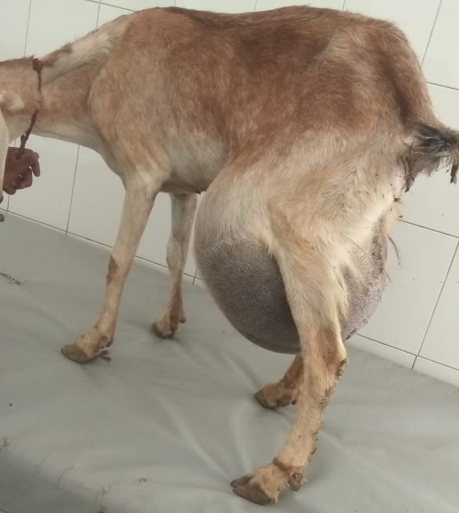 | 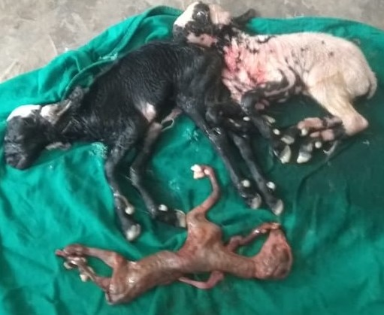 | 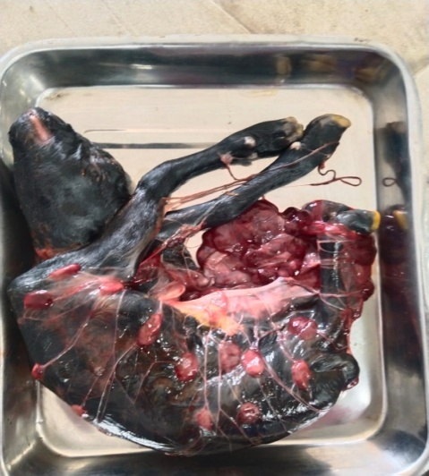
Fig. 1a: Goat showed rupture of prepubic tendons | Fig. 1b: Three kids (two fully grown and one partially mummified) | Fig. 2: Fetus relived in narrow pelvic goat through caesarean section
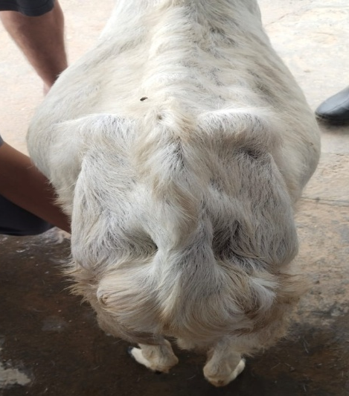 | 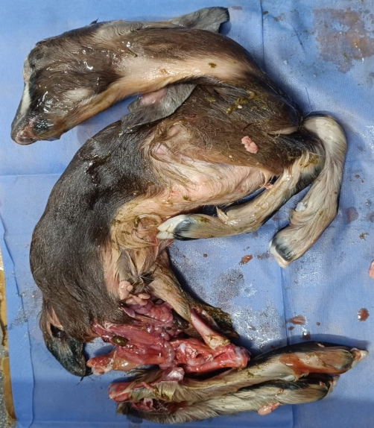 | 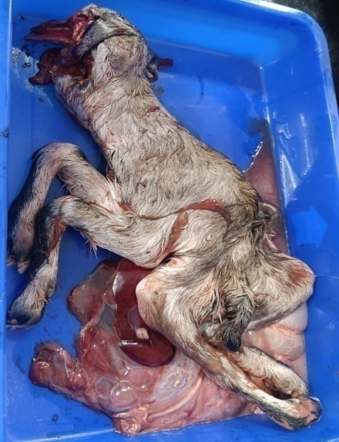
Fig. 3: Goat showed lossening of saccrosciatic ligaments having Ring womb | Fig. 4: Fetus relived by amputation of both hind limbs | Fig. 5: Foetus has s-shaped curvature of the vertebral column (perosomushorridus) and ventral rupture of the abdomen
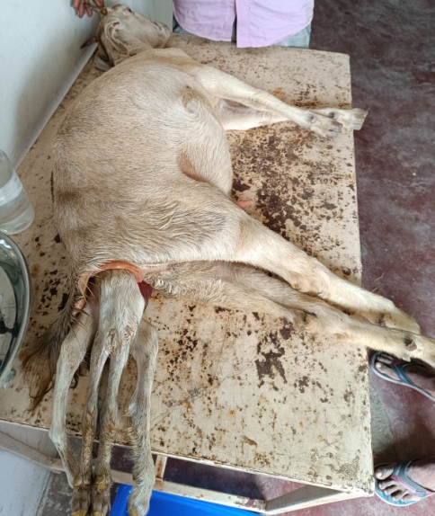 | 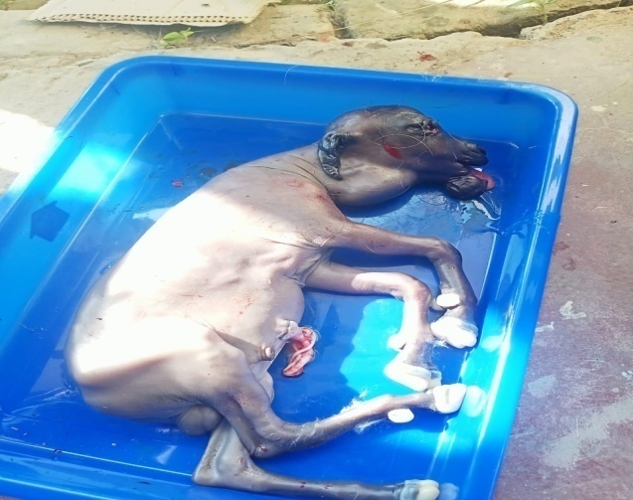 | 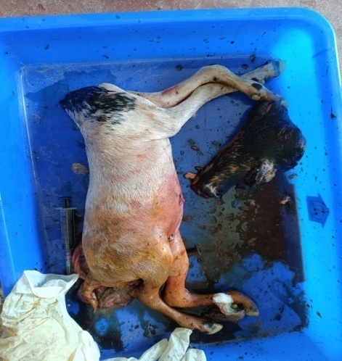
Fig. 6: Four hind limbs were hanging out through the vaginal cavity | Fig. 7: Oversized fetous (anasarca) having swelling in the neck region | Fig. 8: Fetus relived after decapitation
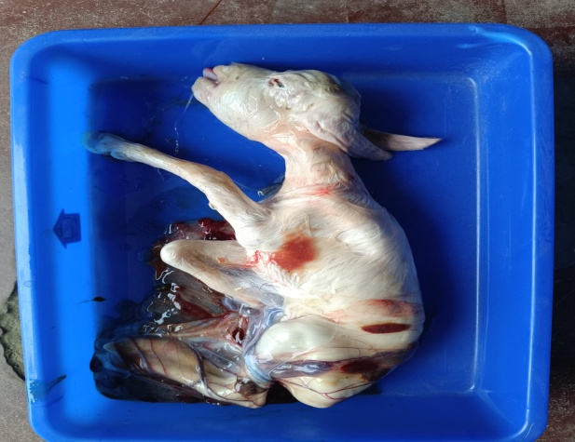 | 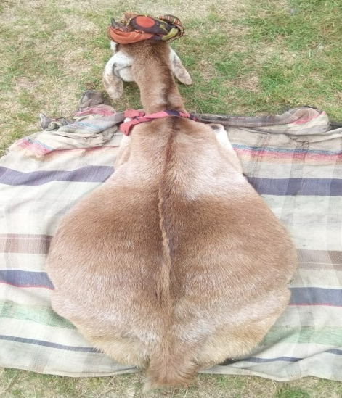 | 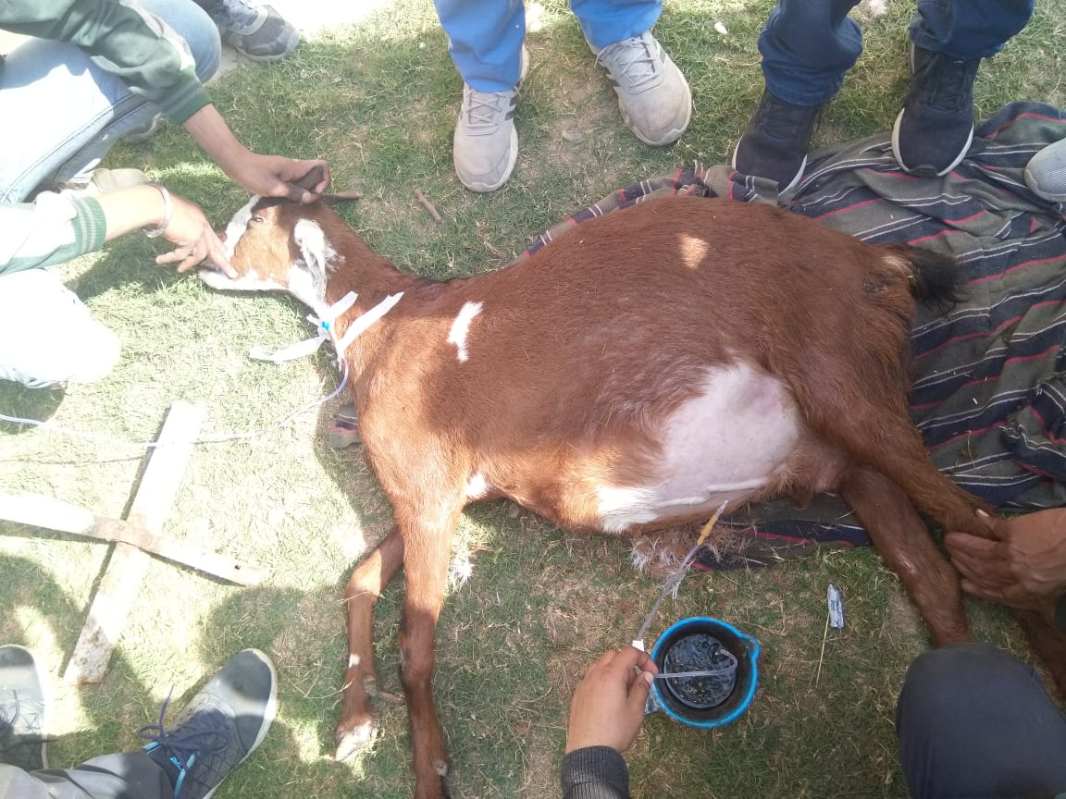
Fig. 9: Relived fetus showed large head (Internal Hydrocephalus) | Fig. 10a: Bilateral enlargement of abdomen (Hydroallantois) | Fig. 10b: Transabdominal allantocentasis to relive allantoic fluid
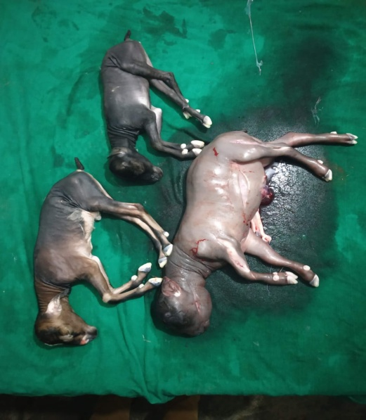 | 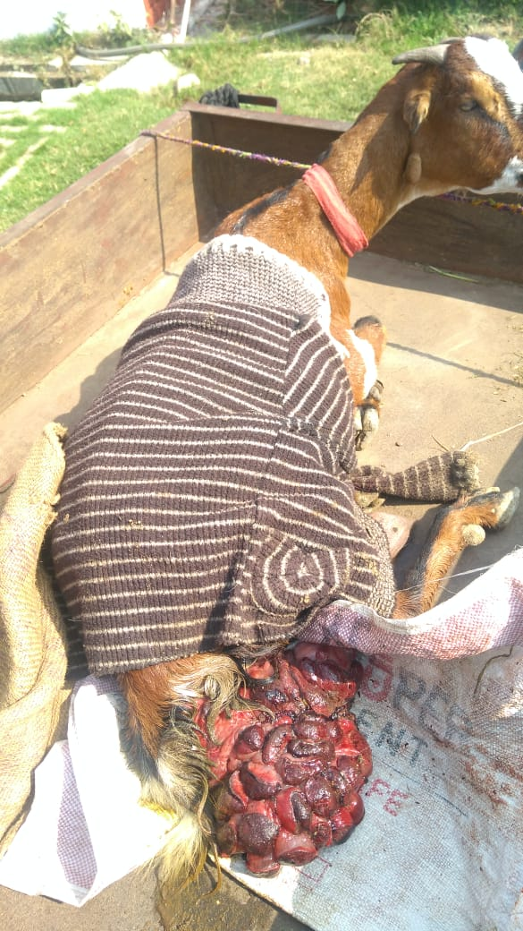
Fig. 10c: Three dead fetous were relived of which one was found to be fetal anasarca | Fig. 11:Goat showed protruded uterine mass (post-partum uterine prolapse)

