Typology of Fishing on the Ayamé 1 Dam Lake: 17 Years After Its Reopening

.
ABSTRACT
Aims: Closed in 1998 following continuous and uncontrolled exploitation of fishery resources and recurring conflicts between indigenous and non-indigenous actors, the Ayamé 1 dam lake is now experiencing an increase in the number of non-national fishermen and a decline in the size of fishery resources caught. This study aims to assess fishing activity on the Ayamé 1 dam lake.
Methodology: The study was conducted from July 2017 to June 2018. The data was collected using a questionnair survey, an interview guide, and direct observation of events in the field.
Results: Of the 733 fishermen registered, non-nationals (61.80%) are the most represented. This activity is practiced by adults between the ages of 30 and 45 (53.07%). Most fishermen are educated (55.80%), although this rate is low among non-nationals (42.82%). The majority of fishermen are married (62.89%) and most work on an occasional basis. To carry out their activities, fishermen use two types of boats, nailed plank canoes (56.09%) and dugout canoes (46.91%), with six types of fishing gear (gillnets, traps, seines, cast nets, bamboo traps, and longlines). There is a clear willingness on the part of fisheries managers to take action, but given the small number of fisheries officers and their lack of equipment, this remains insufficient.
Conclusion: The uncontrolled increase in the number of non-national fishermen and their low level of education remain a major problem for the management and stability of this activity in this region.

.

Keywords: fishing, dam lake, national, fishing gear, Ivory Coast
1. INTRODUCTION
Fishing plays a major socio-economic role in côte d'ivoire. Indeed, this sector contributes to the food security of the ivorian population, providing 70,000 direct jobs and 400,000 indirect jobs [1] and generating foreign exchange that contributes to the national gdp. Inland fishing in côte d'ivoire is mainly artisanal and relies on a number of lake fisheries, the main ones being lakes kossou, buyo, ayamé 1, taabo, and faé [2]. These fisheries are also characterized by a juxtaposition of indigenous and foreign fishing communities. However, the lack of control over fishing practices and excessive production efforts are believed to be the cause of the collapse of fish stocks and the source of conflict in many fisheries. This is the case of lake ayamé 1, which, following uncontrolled exploitation of resources and recurring conflicts between non-indigenous and indigenous fishermen, was closed in 1998 for one (01) year, with the permanent expulsion of non-national actors from the lake. Five years after its reopening, [3] work on the exploitation of the lake shows a return to equilibrium with an increase in catch sizes and a decrease in fishing pressure, but with a production of 381.8 t, which remains well below that of 1996 (1060 t) mentioned by [4]. However, a PDHRE report noted a significant presence of non-national actors and reported a conflict between indigenous and non-indigenous people in the village of ebikro-n'dakro, located 30 km from ayamé [5]. If this is the case, a new conflict at the ayamé 1 dam lake could have consequences for the economy of this area, which is heavily dependent on fishery resources. The aim of this study is to deepen knowledge of the fishing profile on lake ayamé 1 by highlighting the organization of the actors on the one hand and the gear on the other, in order to improve fisheries management on this body of water. 2. Material and methods

2. Methodology:

2.1 Study Area
Located 130.7 km from Abidjan in southeastern Ivory Coast between longitudes 3 and 3.5° West and latitudes 5.3 and 6° North (Figure 1). The Ayamé 1 dam lake was built on the Bia River in 1959 [3]. It has an average surface area of 9,320 ha [6] and measures approximately 80 km long and 27 km wide, with a maximum depth of 30 m [3]. The lake enjoys an Attian climate characterized by four distinct seasons (two dry seasons and two rainy seasons) [7]. Three stations were visited on this lake: Ayamé landing stage, Bakro (Temin landing stage), and Ebikro (Danga).
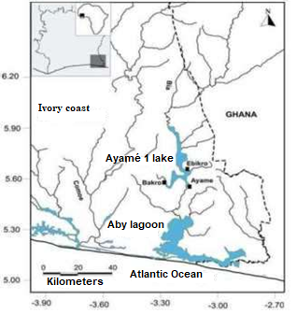
Fig. 1. Geographic location of sampling stations on Lake Ayamé 1

2.2 Sampling
Data collection took place between July 2017 and June 2018 on the Ayamé 1 dam lake, mainly at the Ayamé, Bakro (Temin), and Ebikro landing stages. This data collection on fishing activity was carried out randomly using a questionnaire survey, an interview guide, and direct observation of the facts. The survey covered the population living directly or indirectly from fishing, in particular Ivorian and non-Ivorian fishermen, traditional authorities, fisheries managers, and local administrative officials. The information collected from fishermen included the following: date, location, ethnicity, nationality, marital status, type and number of fishing gear, number of children, type and number of boats, main activity, taxes, and possession of a fishing license.
2.3 Statistical analysis
The Chi-square test was used to compare two by two the distribution of fishermen according to marital status, in order to show whether or not there is a significant variation in the evolution of this parameter.
3. results and discussion

3.1 Results
3.1.1 Fisheries managers
Fishing management at the Ayamé 1 dam lake is controlled by the fisheries department, which is under the supervision of the Aboisso Departmental Directorate of Animal and Fisheries Resources. This fisheries department is divided into three units. The first unit, in Ayamé, has four fisheries officers who are responsible for the landing sites at Ayamé, Track 2, Track 4, and Akressi. The second is the Bakro unit, which has a single fisheries officer who manages the Temin landing site. Finally, the last unit responsible for Ebikro has two (02) fisheries officers in charge of the landing sites at Danga, Kétésso, and Yaou. These officers are tasked with regulating fishing activity in the area. To this end, they identify the various stakeholders, collect various taxes, weigh the different catches, issue administrative documents, remove illegal fishermen, resolve any conflicts between stakeholders, and compile fishing statistics.
3.1.2 Fishermen's organization
3.1.2.1 Distribution of fishermen by nationality and ethnicity
A total of 733 fishermen were counted during this study. The majority of these fishermen are non-nationals, accounting for 61.80% of the population surveyed (Table 1). They are from Mali, Burkina Faso, Niger, Guinea, Togo, and Ghana. On the lake, the Ivorian community is made up of 16 ethnic groups. The Malian and Burkinabe communities comprise 12 and 11 ethnic groups respectively. The other communities are represented by few ethnic groups. These include the Togolese, comprising three ethnic groups, followed by the Nigeriens and Guineans, each represented by two ethnic groups. The Ghanaian community is represented by a single ethnic group. In terms of ethnicity, the Agni (18.96%) are the most dominant. They are followed by the Troukan (9.55%), the Bambara (8.05%), the Corôborô (7.64%), the Bozo and the Attié (5.73% each) and the Mossi (5.59%). The other ethnic groups each represent less than 5% of the population surveyed.
Table 1. Distribution of fishermen by ethnicity and nationality at the Ayamé 1 dam lake from July 2017 to June 2018
Sites | Ayamé |  | Bakro |  | Ebikro |  | Total fishermen
Nationalities/Ethnicities | Workforce | % | Workforce | % | Workforce | % | Workforce | %
Ivoirians
Agni | 72 | 9.92 | 10 | 1.36 | 57 | 7.78 | 139 | 18.96
Baoulé | 8 | 1.09 | 13 | 1.77 | 3 | 0.41 | 24 | 3.27
Yacouba | 1 | 0.14 | 0 | 0 | 3 | 0.41 | 4 | 0.54
Attié | 8 | 1.09 | 31 | 4.23 | 3 | 0.41 | 42 | 5.37
Lobi | 3 | 0.41 | 0 | 0 | 17 | 2.32 | 20 | 2.73
Adjoukrou | 0 | 0 | 0 | 0 | 1 | 0.14 | 1 | 0.14
Bété | 2 | 0.27 | 2 | 0.27 | 1 | 0.14 | 5 | 0.64
Djimini | 0 | 0 | 0 | 0 | 1 | 0.14 | 1 | 0.14
Guéré | 4 | 0.54 | 6 | 0.82 | 3 | 0.41 | 13 | 1.77
Kroumen | 1 | 0.14 | 0 | 0 | 0 | 0 | 1 | 0.14
Sénoufo | 9 | 1.23 | 7 | 0.95 | 2 | 0.27 | 18 | 2.46
Tagbana | 0 | 0 | 1 | 0.14 | 0 | 0 | 1 | 0.14
Abron | 0 | 0 | 1 | 0.14 | 2 | 0.27 | 3 | 0.41
Gouro | 0 | 0 | 0 | 0 | 2 | 0.27 | 2 | 0.27
Koyaca | 0 | 0 | 0 | 0 | 1 | 0.14 | 1 | 0.14
Malinké | 1 | 0.14 | 2 | 0.27 | 2 | 0.41 | 5 | 0.68
Total Ivoirians | 109 | 14.87 | 73 | 9.96 | 98 | 13.37 | 280 | 38.2
Malians
Sénoufo | 0 | 0 | 12 | 1.64 | 3 | 0.41 | 15 | 2.05
Bozo | 13 | 1.77 | 11 | 1.5 | 18 | 2.45 | 42 | 5.73
Bambara | 13 | 1.77 | 25 | 3.41 | 21 | 2.86 | 59 | 8.05
Corôborô | 24 | 3.27 | 10 | 1.36 | 22 | 7.64 | 56 | 7.64
Dongonon | 1 | 0.14 | 0 | 0 | 2 | 0.27 | 3 | 0.41
Somonon | 5 | 0.68 | 5 | 0.68 | 16 | 2.18 | 26 | 3.55
Maraka | 3 | 0.41 | 4 | 0.54 | 11 | 1.5 | 18 | 2.46
Peul | 2 | 0.27 | 2 | 0.27 | 3 | 0.41 | 7 | 0.95
Bougounika | 0 | 0 | 0 | 0 | 1 | 0.14 | 1 | 0.14
Mianka | 4 | 0.54 | 14 | 1.91 | 0 | 0 | 18 | 2.46
Bêla | 2 | 0.27 | 0 | 0 | 0 | 0 | 2 | 0.27
Kadô | 3 | 0.41 | 0 | 0 | 2 | 0.27 | 5 | 0.68
Total Malians | 70 | 9.55 | 83 | 11.32 | 99 | 13.51 | 252 | 34.38
Burkinabe
Mossi | 29 | 3.96 | 0 | 0 | 12 | 1.64 | 41 | 5.59
Troukan | 41 | 5.59 | 10 | 1.36 | 19 | 2.59 | 70 | 9.56
Daffi | 10 | 1.36 | 1 | 0.14 | 0 | 0 | 11 | 1.5
Sénoufo | 2 | 0.27 | 6 | 0.82 | 2 | 0.27 | 10 | 1.36
Samôgô | 4 | 0.54 | 0 | 0 | 6 | 0.82 | 10 | 1.36
Bissa | 5 | 0.68 | 0 | 0 | 0 | 0 | 5 | 0.68
Lobi | 17 | 2.32 | 0 | 0 | 5 | 0.68 | 22 | 3
Karabôrô | 2 | 0.27 | 0 | 0 | 6 | 0.82 | 8 | 1.09
Sonraille | 0 | 0 | 0 | 0 | 1 | 0.14 | 1 | 0.14
Brifor | 1 | 0.14 | 0 | 0 | 0 | 0 | 1 | 0.14
Bôbô | 1 | 0.14 | 0 | 0 | 0 | 0 | 1 | 0.14
Total Burkinabe | 112 | 15.28 | 17 | 2.32 | 51 | 6.96 | 180 | 24.55
Togolesen
Momba | 1 | 0.14 | 0 | 0 | 2 | 0.27 | 3 | 0.41
Tabière | 0 | 0 | 0 | 0 | 1 | 0.14 | 1 | 0.14
Aïgbeu | 0 | 0 | 0 | 0 | 1 | 0.14 | 1 | 0.14
Total Togolesen | 1 | 0.14 | 0 | 0 | 4 | 0.54 | 5 | 0.68
Nigeriens
Zamalaman | 1 | 0.14 | 5 | 0.68 | 0 | 0 | 6 | 0.82
Peul | 1 | 0.14 | 2 | 0.27 | 0 | 0 | 3 | 0.41
Total Nigeriens | 2 | 0.27 | 7 | 0.95 | 0 | 0 | 9 | 1.23
Guineans
Kogninaka | 0 | 0 | 3 | 0.41 | 0 | 0 | 3 | 0.41
Maniga | 1 | 0.14 | 0 | 0 | 2 | 0.27 | 3 | 0.41
Total Guineans | 1 | 0.14 | 3 | 0.41 | 2 | 0.27 | 6 | 0.82
Ghanaians
Ashanti | 1 | 0.14 | 0 | 0 | 0 | 0 | 1 | 0.14
Total Ghanaians | 1 | 0.14 | 0 | 0 | 0 | 0 | 1 | 0.14
Total by site | 296 | 40.38 | 184 | 25.1 | 253 | 34.52 | 733 | 100

3.1.2.2 Distribution of fishermen according to their level of education
On the lake, fishermen who have attended school are the most numerous (55.80%). This school enrollment rate is higher among the Ivorian community (76.78%) than among the foreign community (42.82%). In the Ivorian community, those who have completed primary school are the most represented, accounting for 43.21% of registered fishermen in this community. In contrast, in the foreign community, those with no education are the most prevalent (57.18%) (Figure 2).

Fig. 2. Distribution of fishermen according to their level of education on the Ayamé 1 dam lake from July 2017 to June 2018
3.1.2.3 Distribution of fishermen by age group
The age of fishermen surveyed on the Ayamé 1 dam lake ranges from 15 to 69 years old. Fishing activity is dominated by adults aged between 30 and 45 (53.07%). This age group is equally well represented among Ivorians (51.07%) and non-nationals (54.30%). The adult age group over 45 is less represented among nationals (12.14%) than among non-nationals (14.35%) (Figure 3).

Fig. 3. Distribution of fishermen by age group on the Ayamé dam lake from July 2017 to June 2018
2.1.2.4 Distribution of fishermen according to marital status and family responsibilities
Of all the fishermen surveyed, 62.89% are married. Among nationals, 53.57% of fishermen are married, compared to 68.67% among non-nationals (Figure 4). Each fisherman is responsible for between 1 and 17 people. The average number of dependents is 6 among Ivorians and 3 among foreigners. Furthermore, the χ² test shows that there is no significant difference between the marriage rates of nationals and non-nationals (χ² = 1.14; ddl = 1; P = 0.2867).

Fig. 4. Marital status of fishermen by nationality on Lake Ayamé Dam from July 2017 to June 2018
2.1.2.5 Distribution of fishermen by occupational category
Two (02) groups of fishermen share the fishery resources of the Ayamé 1 dam lake. These are professional fishermen, who represent 36.97% of registered actors. This group includes 47.14% of national actors and 30.68% of non-national actors. The second group consists of occasional fishermen, with 52.86% national fishermen and 69.32% non-national fishermen. Occasional fishermen remain the most numerous, combining fishing with activities such as agriculture, transport, fish farming, hairdressing, schooling, trade (1.36%), masonry assistance (0.27%), veterinary medicine, mechanics, electricity, surveying, sawing, tiling, carpentry, teaching, sewing, and livestock farming (Table 2).
Table 2. Alternative activities to fishing on the Ayamé dam lake from July 1, 2017 to June 2018
 | Nationals |  | Non-nationals |  | Total
Activities | Workforce | % | Workforce | % | Workforce | %
Fishing only | 132 | 47.14 | 139 | 30.68 | 271 | 36.97
Fishing + agriculture | 108 | 38.57 | 290 | 64.03 | 398 | 54.3
Fishing + trade | 6 | 2.14 | 5 | 1.1 | 11 | 1.5
Fishing + hairdressing | 1 | 0.36 | 0 | 0 | 1 | 0.14
Fishing + transportation | 5 | 1.78 | 0 | 0 | 5 | 0.68
Fishing + fish farming | 1 | 0.36 | 0 | 0 | 1 | 0.14
Fishing + school study | 18 | 6.43 | 0 | 0 | 18 | 2.44
Fishing + masonry assistant | 2 | 0,71 | 0 | 0 | 2 | 0.27
Fishing + farming | 1 | 0.36 | 2 | 0.44 | 3 | 0.41
Fishing + mechanics | 0 | 0 | 3 | 0.66 | 3 | 0.41
Fishing + veterinary officer | 1 | 0.36 | 0 | 0 | 1 | 0,14
Fishing + electrician | 0 | 0 | 2 | 0.44 | 2 | 0.27
Fishing + topography | 1 | 0.36 | 0 | 0 | 1 | 0.14
Fishing + sawing | 0 | 0 | 11 | 2.43 | 11 | 1.5
Fishing + tiling | 1 | 0.36 | 0 | 0 | 1 | 0.14
Fishing + carpentry | 2 | 0.71 | 0 | 0 | 2 | 0.27
Fishing + teaching | 1 | 0.36 | 0 | 0 | 1 | 0.14
Fishing + sewing | 0 | 0 | 1 | 0.22 | 1 | 0.14
Total actors | 280 | 100 | 453 | 100 | 733 | 100
Total actors engaged solely in fishing | 132 | 47.14 | 139 | 30.68 | 271 | 36.97
Total actors engaged in other activities + fishing | 148 | 52.86 | 314 | 69.32 | 462 | 63.03

2.1.2.6 Types of fishing vessels
Two types of boats are used for fishing (Figure 5). These boats are not motorized. They are dugout canoes carved from a single tree trunk (46.91%) and canoes made from nailed planks (53.09%). The first type of boat is typical of nationals, and the second is attributed to non-nationals.
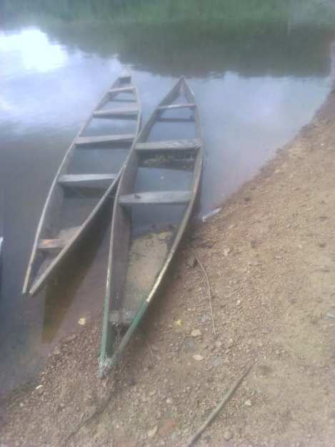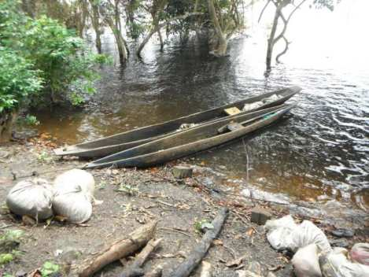
a
b
Fig. 5. Different types of boats encountered on the Ayamé dam lake from July 2017 to June 2018 a: nailed plank canoes, b: dugout canoes
2.1.2.7 Fishing gear
Six types of gear are used on the Ayamé 1 dam lake. These are gillnets, shore seines, longlines, cast nets, traps, and bamboo traps. Gillnets are divided into two groups (Figure 6). The first group refers to simple gillnets with mesh sizes ranging from 5 mm to 45 mm. These are individual gear types used in accordance with the fixed net method. They are found in all types of boats. The second group corresponds to complex gillnets (trammel nets). This type of net has two pockets (one at each end). The length of the net can vary from 200 m to 400 m. The mesh size of the pockets (10 mm) is different from that of the body or central part of the net (20 mm). The “trawl” net is a collective device operated by a team of two people. To set this type of net, one of the edges (top or bottom) is attached to stones so that it can sink into the water. To remove the net, the two operators stand on the canoe and perform synchronized movements, lifting the net in the direction of one pocket and then in the other direction toward the second pocket.
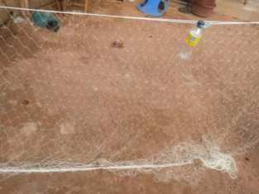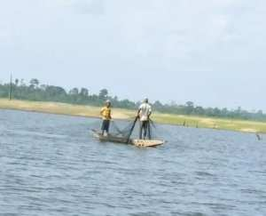
b
a
Fig. 6. Gillnets used to catch fish in the Ayamé dam lake from July 2017 to June 2018 a: Gillnet in a fishing camp, b: Fishermen working with a cast net
The shore seine is a collective gear operated by a team of 4 to 5 people (Figure 7). This gear is made from multi-filament nets with meshes ranging from 10 to 15 mm from one knot to another. It does not have a true pocket and its length varies between 250 m and 400 m. The drop of these nets varies from 2 to 3 m.
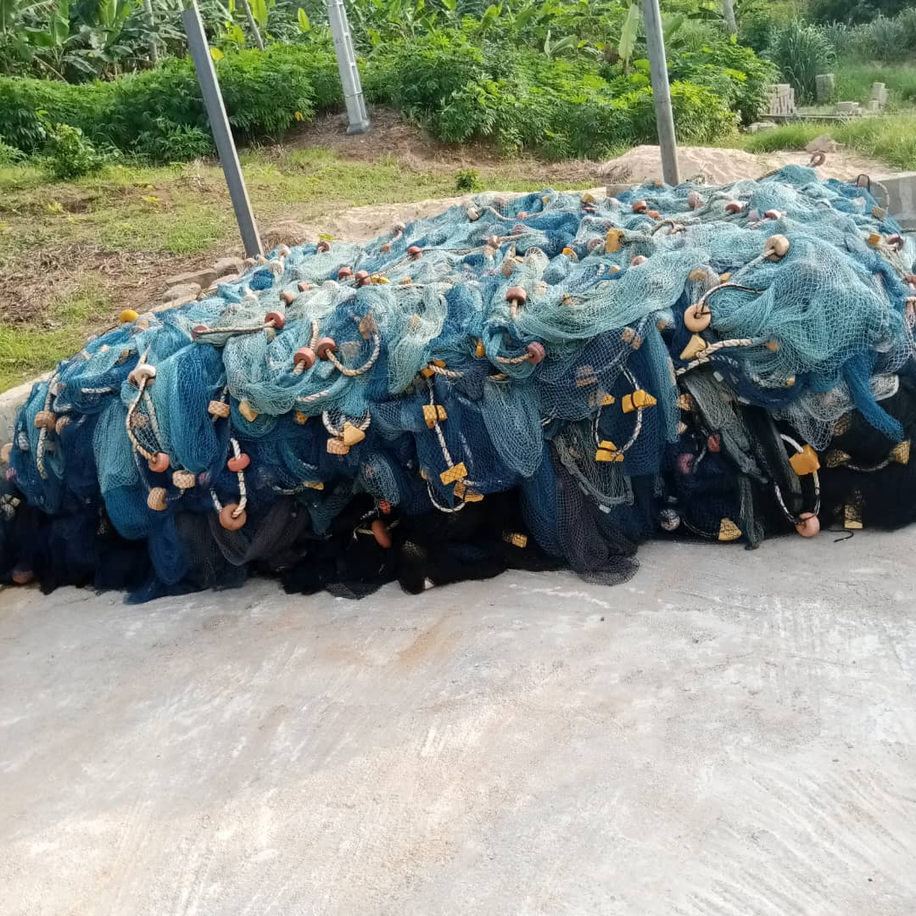
Fig. 7. Beach seine used to catch fish at the Ayamé dam lake from July 2017 to June 2018
Longlines are made from multiple hooks. The number of hooks varies from 100 to 300. The distance between hooks depends on the species being targeted (Figure 8).
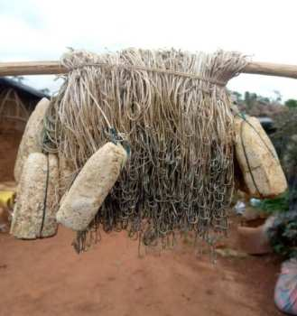
Fig. 8. Longline used to catch fish in the Ayamé dam lake from July 2017 to June 2018
The sparrowhawk is an active fishing gear. It is conical in shape and is generally used in shallow water (Figure 9). This gear consists of a circular multi-filament nylon net, equipped with weights around the perimeter. On the lake, the mesh size of this gear ranges from 10 to 30 mm.
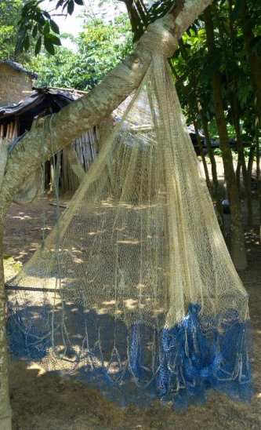
Fig. 9. Sparrowhawk used to catch fish at the Ayamé dam lake from July 2017 to June 2018
Fish traps belong to the category of passive gear. There are four types on the Ayamé 1 dam lake: (1) Wire mesh traps that do not have a specific shape and have a single opening. They can measure 1.5 m long and 1 m wide with an average mesh size of 25 mm (Figure 10 a). (2) Net traps have a frame made of sticks and vines that may or may not meet at the top. These traps are covered with multifilament netting with a mesh size ranging from 10 to 50 mm. The base diameter of these traps is between 45 and 85 cm. Small traps (diameter < 55 cm) have two clearly marked funnel-shaped openings. These traps are usually baited with corn or rice bran or pieces of rotten cassava. However, large traps (diameter > 55 cm) have a single funnel-shaped opening at the base. These traps are usually placed in the water lying on one side and are never baited (Figure 10 b). (3) Can traps are made from empty 20- to 25-liter oil cans. They have a funnel-shaped opening made with a net at the base. These traps are specialized for catching species of the genus Chrysichthys. These traps work in a unique way. The traps are baited with a mature female that will emit calls to attract males into the trap (Figure 10 c). (4) Plant fiber (raffia) traps have a diameter ranging from 20 to 30 cm. They are not baited and are often used as storage after catches (Figure 10 d).
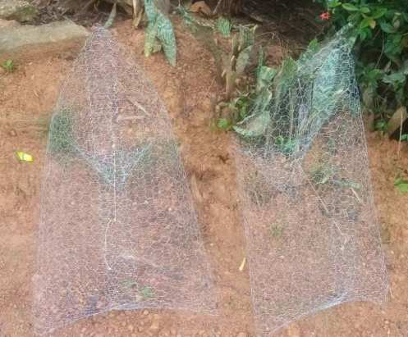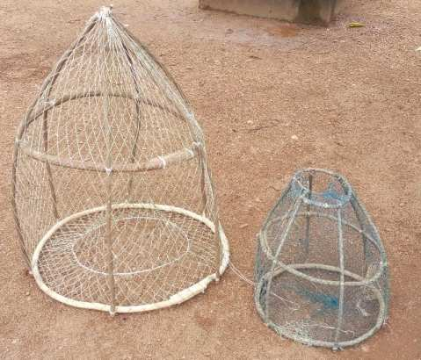
b
a
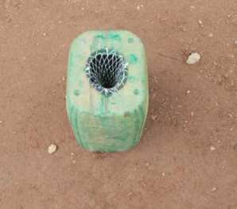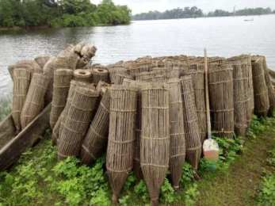
d
c
Fig. 10. Different types of traps used to catch fish on the Ayamé dam lake from July 2017 to June 2018 a: metal mesh trap, b: net or papolo traps, c: can trap, d: palm fiber traps
Bamboo traps (Figure 11) are hollow bamboo tubes with an opening at one end and a closed end at the other. They are placed in the water and are all connected to a pole by a rope. They are not baited and are specifically designed to catch species of the genus Chrysichthys.
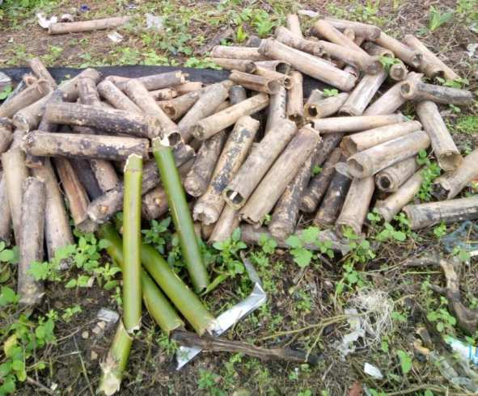
Fig. 11. Bamboo traps used to catch fish in the Ayamé dam lake from July 2017 to June 2018
3.2 Discussion
The presence of a fisheries office at the Ayamé 1 dam lake demonstrates the political will of the Ivorian authorities to manage the fishery resources in this area sustainably. These results corroborate those of [8] on the same lake. The same observation was made by [9] on the lower reaches of the Bandama River. However, the small number of fisheries officers on the lake makes this task difficult, resulting in fragmented or largely underestimated or even overestimated statistical data in the field.
With regard to the exploitation of fishery resources, non-national fishermen are relatively more represented. Similar findings were made by [10] on the Bandama River, [11] on Lake Buyo, and [12] on the Ono lagoon. The strong presence of non-national fishermen can be explained, on the one hand, by the fact that Ivorians are not traditionally fishermen in general. On the other hand, it may be related to the demotivation of national fishermen, who find fishing exhausting and unprofitable. In addition, there is the WAEMU agreement, which facilitates the settlement of non-national fishermen from the WAEMU zone, their free movement, and their freedom to carry out all activities in this zone [13]. Consequently, these results differ from those obtained by [3] on the same lake. Indeed, the results of the latter's work are correlated with the expulsion of foreign fishermen from the lake.
On the lake, fishing activity is mainly carried out by adults aged between 30 and 45 years, both among nationals and non-nationals. The low presence of young people on this body of water is explained by the scourge of rural depopulation on the one hand. On the other hand, it is justified by the fact that young people find this activity difficult, which leads them turn to other informal activities, such as transportation (apprentice drivers or drivers) which they find easier. Indeed, the fishing is physically demanding and often dangerous, where survival depends on courage, the quality of equipment and professional skills [14]. Similar results were observed by [15] and [10] on the lower course of the Bandama River. However, they differ from those obtained by [16] and [3]. The results of the latter differ because after the expulsion of Bozo fishermen from Lake Ayamé 1, many young people who had dropped out of school became interested in fishing.
In general, fishermen with a high school education are the most numerous on the lake. It should be noted that this group is made up of a large number of national fishermen. The very high rate of schooling among nationals is linked can to several factors. Firstly, many young people who dropped out of school took up fishing after the expulsion of Bozo fishermen from the lake in 1998. On the other hand, this situation is related to the lack of employment opportunities in this region. However, the very low school enrollment rate observed among non-nationals is due to the fact that they place more emphasis on passing on their cultural knowledge to their descendants than on pursuing education. Similar results were obtained by [17] on Lake Songori, [15] and [10] on the Bandama River. On the other hand, [18] reported a predominance of illiterate fishermen on Lake Bolodon. In the latter case, as the fishermen are professionals and Muslims, some young people are introduced to the fishing trade, while others study the Koran.
The majority of fishermen on the lake are married. This situation is beneficial to them. Women participate in domestic work and are responsible for processing and selling fish, which contributes to the fishermen's well-being by providing them with a well-maintained living environment. Similar observations were made by [9] on the Bandama River and by [19] on the Ayamé 2 dam lake.
With regard to the classification of fishermen by professional category, the fishermen of Lake Ayamé 1 are mainly occasional fishermen, whether they are nationals or non-nationals. This situation is related to the fact that after the closure of the lake, many fishermen, whether native to the region or not, switched to other activities. Today, fishing is practiced in many cases to meet household food needs, to provide financial resources to solve specific problems, and to pay for labor to maintain fields, particularly for nationals.
The canoes used on the lake are either nailed planks or dugouts. The predominance of nailed plank canoes is proportional to the growing number of non-national fishermen. Indeed, these types of boats are mainly used by the latter. On the other hand, it could be related to the decrease in tree trunks following the destruction of forests for export crops. Furthermore, the lack of registration of these boats leads to overfishing of the lake and shows no desire to preserve fish stocks.
Six (06) types of gear are used on the lake, as in most national reservoirs. This diversity of fishing gear shows that fishermen target different species of fish. However, the smaller mesh sizes of some of these gear types, such as gillnets (35 mm mesh) and traps (45 mm or larger mesh), which comply with fishing regulations, may be a response to the increasing scarcity of the fish species being targeted.
4. Conclusion
This study highlighted the social characteristics of fishing in the Ayamé 1 dam lake. The study shows that fishing in this reservoir is dominated by non-national fishermen, most of whom are illiterate. Given their low level of education and the fact that some of their gear does not meet the standards imposed by fisheries regulations, this poses numerous problems for the sustainability of fishing in this area.
Disclaimer (Artificial intelligence)
Author(s) hereby declare that NO generative AI technologies such as Large Language Models (ChatGPT, COPILOT, etc.) and text-to-image generators have been used during the writing or editing of this manuscript.

References

1. PND (2015). Development Vision and Strategic Directions. National Development Plan, report, Abidjan, Côte d'Ivoire, 120p.
2. Da Costa, K. S., & Dietoa, E. M. (2007). Fishing typology on the fahe lake and implications for a sustainable use of halieutic resources. BFPP-CONNAISSANCE ET GESTION DU PATRIMOINE AQUATIQUE, (384), 1-14.
3. Tah, L. (2012). Exploitation of Lake Ayamé I (Côte d’Ivoire) after the departure of the “Bozo” fishermen in 1998 and impact on the demographic structures of fish populations. Doctoral thesis, Félix Houphouet-Boigny University, Côte d’Ivoire, 177 p.
4. Gourène, G., Teugels, G. G., Hugueny, B., & Thys Van Audernaerde, D. F. E. (1999). Evaluation of the ichthyological diversity of a West African basin after the construction of a dam. Cybium, 23(2), 147-160.
5. Cissé, M., Kamelan, T. M., Siaka, B., & Kouamelan, E. P. (2021). Paramètres de population des principales espèces de poissons du lac de barrage d’Ayamé 1 sept ans après le retour des pêcheurs allogènes. [Population parameters of the main fish species in the Ayamé 1 dam lake seven years after the return of non-native fishermen]. REB-PASRES 6(1), 23-36.
6. Laë, R., Lek, S., & Moreau, J. (1999). Predicting fish yield of African lakes using neural networks. Ecological Modelling, 120, 325-335.
7. Tah, L., Goore Bi, G., & Da Costa, K. S. (2012). Length-weight relationships for 36 freshwater fish species from two
tropical reservoirs: Ayamé I and Buyo, Côte d’Ivoire. Revue de Biologie Tropicale (International Journal of Tropical Biology), 60(4), 1847 -185.
8. Koudou, D., Koulaï, D., Zran, G. M., & Anoh, K. P. (2019). Radioscopy of a recurring fishing conflict on the Ayamé I hydroelectric dam lake (Côte d'Ivoire). Revue Espace Géographique et Société Marocaine, 27, 231-246.
9. Kien, K. B. (2016). Fishing activities on the Bandama River (Côte d'Ivoire): Impact on the organization of fish populations in the lower reaches and socioeconomic consequences. Doctoral thesis, Félix HOUPHOUËT BOIGNY University, Côte d'Ivoire, 228 p.
10. Kien, K. B., Yao, S. S., Vanga, A. F., & Kouamelan, E. P. (2015). Typology of fishing on the lower reaches of the Bandama River (Côte d’Ivoire, West Africa). International Journal of Innovation and Applied Studies, 13(1), 66-77.
11. Goli Bi, B. E. P., Kien, K. B., Kamelan, T. M., Berte, S., & Kouamelan, E. P. (2019). Fishing typology in man-made lake Buyo (Sassandra River, Côte D’Ivoire). Innovation International Journal of and Applied Studies, 26 (4), 1220-1229
12. Tano, K., Konan, K. J., Aboya, N., Yao, K. A., & Anoh, K. P. (2019). Typology, actors and fishing gear in the ono lagoon (Côte d’Ivoire). Geography Review of the University of Ouagadougou, 1(8), 175-190.

13. UEMOA (2016). 2016 Annual Report on the Operation and Development of the Union. UEMOA Commission, 94 p.
14. Bedia, A. T., N’zi, K. G., Yao, S. S., Kouamelan, E. P., N’douba, V. & Kouassi, N. J. (2009). Typology of fishing in the Aghien-Potou lagoon (Côte d’Ivoire, West Africa): fishing actors and gear. Agronomie Africaine, 21(2), 197-204.
15. Boguhé, G. F. D. H., Goore Bi, G., N'Zi, K. G., Yao, S. S., Kouamelan E. P., & Kouassi, N. J. (2011). Premières données sur la pêche crevettière du fleuve Bandama (Côte d’Ivoire) : Acteurs et Engins de pêche. [ First data on the shrimp fishery in the Bandama River (Côte d’Ivoire): actors and fishing gear]. Sciences et Nature, 8(1), 107-118. https://dicames.online/jspui/handle/20.500.12177/175#:~:text=La%20p%C3%AAche%20crevetti%C3%A8re%20sur%20le,le%20monopole%20de%20cette%20p%C3%AAche.
16. Vanga, A. F. (2011). Evolution of fishing in Lake Ayamé since the expulsion of non-national fishermen (Côte d’Ivoire). Tropicultura, 29(1), 8-13.
17. N’dri, K. M. (2018). Fisheries and fish farming management in the Ivorian continental environment: current status and socio-economic aspects. Doctoral thesis, Nangui Abrogoua University, Côte d’Ivoire, 155 p.
18. N’dri, K. M. (2019). Fishing typology and level of exploited biomass in Lake Bolondo (Bagoué region; northern Côte d’Ivoire). African Agronomy, 31(1), 1-14.
18. Blahoua, K. G., Adou, Y. E., Kouame, K. A., & N’Douba, V. (2018). Fishing typology on the Ayamé 2 dam lake (Côte d’Ivoire, West Africa). International Journal of Innovation and Scientific Research, 36(2), 178-185.

