An Interesting Case of Symptomatic MRKH Syndrome with Functional Mullerian Remant and Emdometrioma

ABSTRACT:
Mayer-Rokitansky-Küster-Hauser (MRKH) Syndrome is a congenital disorder characterized by the aplasia of the uterus and the upper two-thirds of the vagina in women who exhibit normal secondary sexual characteristics and have a normal 46,XX karyotype. The condition has an estimated prevalence of approximately 1 in every 4,500 live female births. Notably, active Müllerian duct remnants are found in about 39% of patients with MRKH syndrome. Pelvic pain in such patients is often attributed to the accumulation of endometrial fluid in an obstructed functional Müllerian remnant or the presence of endometriosis. We present the case of a 29-year-old married woman who presented with primary amenorrhea and cyclical lower abdominal pain persisting for the past six months. On abdominal examination, there was marked tenderness in the left iliac fossa. Per vaginal examination revealed a blind-ending vaginal pouch. Ultrasonography showed a normal-sized uterus with a left ovarian endometrioma measuring 3.5 × 2.2 cm. These findings were further supported by contrast-enhanced CT (CECT). Vaginoscopy confirmed the presence of a blind vagina. However, diagnostic laparoscopy revealed the absence of the uterus, contradicting the ultrasound findings. A left ovarian endometrioma measuring 6 × 5 cm was noted, along with a left-sided Müllerian remnant measuring 4 × 3 cm that appeared to contain functional endometrial tissue. The patient underwent laparoscopic left ovarian cystectomy along with excision of the left Müllerian remnant and left fallopian tube. Postoperatively, she was treated with leuprolide acetate (3.75 mg IM) administered monthly for three doses to suppress any residual endometrial activity and prevent recurrence.`

Keywords: Mayer-Rokitansky-Küster-Hauser, Müllerian duct, Vaginoscopy, Mullerian Remant and Emdometrioma
.

INTRODUCTION :
“Mayer -Rokitansky-Kuster -Hauser syndrome (MRKH) syndrome is characterised by congenital aplasia of uterus and upper 2/3rd of vagina. These women show normal development of secondary sexual characters. They have a normal 46 XX karyotype. Its prevalence is estimated to be 1 in every 4500 live births. Active Müllerian remnants are found in 39% of patients with MRKH syndrome”.¹ Pain in such patients is generally attributed to collection of endometrial fluid in the obstructed functional remnant or due to endometriosis. It is often accompanied by other malformations, particularly of the kidneys, skeleton, and ears. It is diagnosed by physical examination and imaging like ultrasound or MRI. Treatment involves creating a neovagina for sexual intercourse through dilation or surgery. A psychological counselling is essential due to the emotional distress the condition can cause to the woman.

PRESENTATION OF CASE:
Here is a case of a 29-year-old married woman who presented with primary amenorrhea and cyclical pain abdomen since 6 months. She was married since 10 years and was the couple did not have any issues with coital activities. She was not interested in conception due to personal reasons as she was taking care of her late sister’s children. She had well developed secondary sexual characters (Tanner stage 5). She had attained pubarche and adrenarche but not attained menarche. On per abdomen examination , there was mild tenderness noted in the left ilia fossa, but there was no guarding or rigidity or palpable mass felt. On per vaginal examination, a blind vagina noted with a depth of 3-4 cm. On per rectal examination, a tender mass was felt on the left side. All laboratory parameters were within normal limits. Patient had visited government hospital initially and ultrasound report showed normal sized uterus with endometrial thickness of 5 mm , right ovary was 32x15 mm , with left adnexa showing a thick-walled cystic lesion with homogenous hypoechoic internal debris and thin internal septations of around 3.5x2.2 cm.(Figure 1) MRI scan showed a normal uterus with a heterogeneously enhancing hypodense peripherally enhancing cystic lesion measuring 4 x 3.3 cm in left adnexa suggestive of simple cyst. (Figure 2) CA-125 levels were 38.60 U/mL which was done to rule out ovarian carcinoma. On laparoscopy, bilateral mullerian remnants with bilateral normal fallopian tubes and normal right ovary were noted. Left enlarged ovary was seen with endometrioma of 6x5 cm adherent to pelvic side walls and rectosigmoid colon. Left mullerian remnant of 4x3 cm with functional endometrium was seen.(Figure 3) Presumptive diagnosis of MRKH Syndrome with functional endometrium in left mullerian remnant with ipsilateral endometrioma was made. Hence, laparoscopic left ovarian cystectomy with excision of left mullerian remnant and left fallopian tube was done. Postoperatively she was administered Inj Leuprolide acetate 3.75 mg intraoperatively, 3 doses, monthly. At 3 months follow up, she was relieved of her symptoms of pain abdomen.

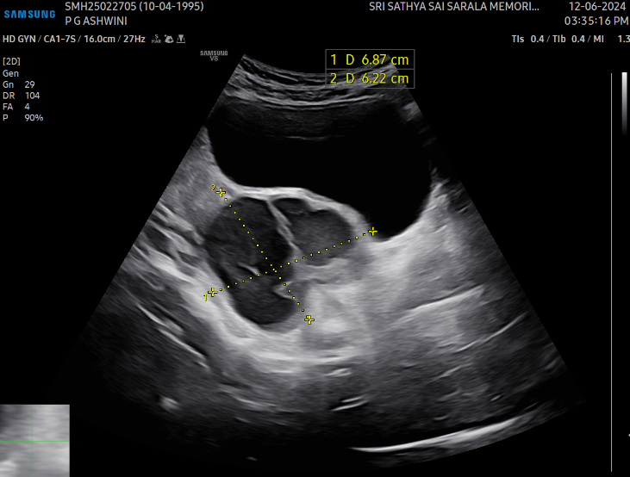
Figure 1. USG of Pelvis showing left ovarian cystic lesion with homogeneous hypoechoic internal debris with thin internal septations.

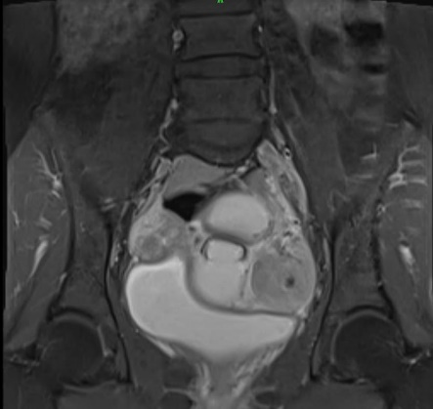
Figure 2- MRI showing a) T1W MRI image showing both mullerian remnant b)T2W MRI image showing endometrioma c)T2W MRI image showing active left mullerian remnant(yellow) and left endometrioma(green)

.
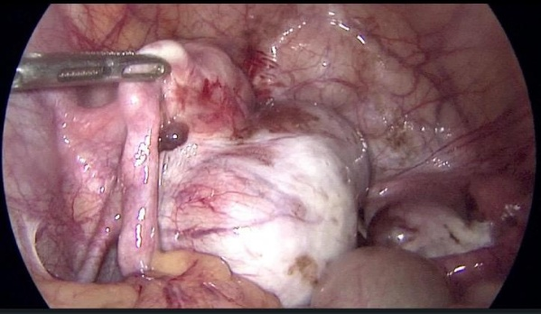
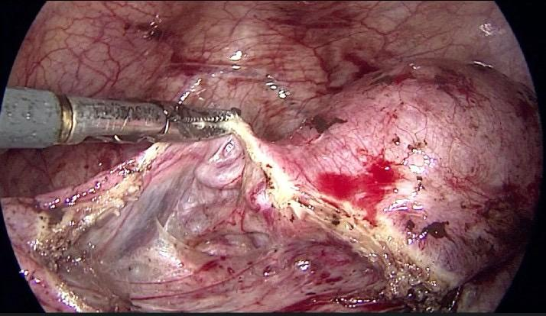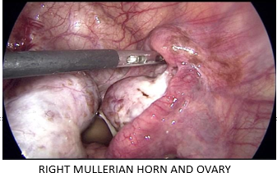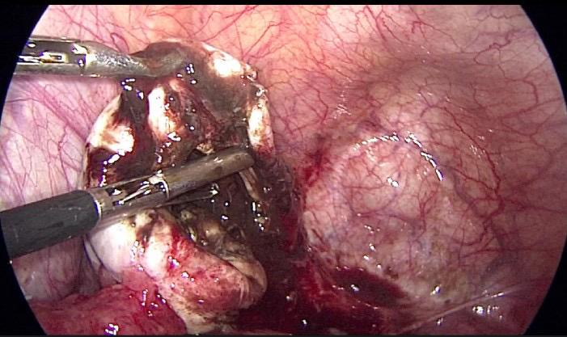
Figure 3- Laparoscopy findings a)Excision of left mullerian remnant and left fallopian tube b)Right mullerian remnant with right ovary c)Left ovarian cystectomy d)Left Mullerian Remnant with left endometrioma

DISCUSSION:
“Müllerian agenesis, also known as Müllerian aplasia, vaginal agenesis, or Mayer–Rokitansky–Küster–Hauser syndrome, is a congenital malformation characterized by a failure of the Müllerian ducts to develop, resulting in a absent uterus and variable degrees of vaginal hypoplasia of its upper portion. Endometriomas are the most common manifestation in MRKH patients , and coelomic metaplasia may have contributed to their development”.² “Cyclical pain abdomen in MRKH should raise a suspicion of endometriosis or endometrioma and should be thoroughly evaluated at the earliest. The surgical removal of uterine remnants with functional endometrial tissue is recommended to minimize the risk of developing endometriosis or reduce its extent linked to retrograde menstruation”³ Since our patient did not have any problem with intercourse and vaginal depth was around 3 – 4 cm , there was no vaginal reconstruction planned for her. “Nonsurgical vaginal elongation by dilation should be the first-line approach in such cases of blind vagina. When well-counseled and emotionally prepared, almost all patients (90–96%) will be able to achieve anatomic and functional success by primary vaginal dilation”⁴ . “In these cases of complex female genital tract malformations, a correct diagnosis is essential to avoid inappropriate or unnecessary surgery. Therefore, acquiring and applying the appropriate embryological knowledge, management and therapy is a challenge for gynaecologists”⁵ . “A correct classification of malformations of the female genital tract is essential to prevent unnecessary and inadequate surgical operations and to compare reproductive results. An ideal classification system should be based on aetiopathogenesis and should suggest the appropriate therapeutic strategy”⁶ Until now, “the more accepted classification system, namely that of the AFS, is associated with serious limitations in effective categorization of female genital anomalies. Many cases published in the literature could not be properly classified using the AFS system, yet a clear and accurate classification is a prerequisite for treatment”⁷
In a case report by Kawano Y et al, a 27-year-old woman with MRKH syndrome presented with primary amenorrhea and cyclical pelvic pain. MRI revealed bilateral Müllerian remnants containing small endometrial tissue and a 7 cm right pelvic cyst consistent with an endometriotic cyst. Treatment included preoperative oral contraceptives and laparoscopic removal of the remnants and the right ovarian endometriotic cyst, along with vaginoplasty. Histopathology confirmed a noncanalized uterine horn with functional endometrium and an ovarian endometrioma.⁸
In a study by Pradeep HV et al, “a case of primary infertility in a 35-year-old woman who presented with dull aching abdominal pain for the last 15 years. She was frequently misdiagnosed with a fibroid in the right lateral uterine wall and a left ovarian endometrioma. The diagnosis was confirmed through MRI pelvis and histopathology of the specimen. The patient underwent surgery for the same and has been symptom-free since then. She is now planning for a surrogate child”.⁹
Naem A et al, presented “the case of a 19-year-old patient that presented with primary amenorrhea and cyclic abdominal pain. Upon the exploratory laparoscopy, a right rudimentary uterine horn and left unicornuate uterus were found. In addition, a left ovarian endometrioma was also found. The unicornuate uterus was resected with an intent to resolve the pain. A left salpingo-oophorectomy was performed to minimize the risk of ovarian cancer and endometriosis recurrence”.¹⁰
Currently, “a wide range of non-invasive diagnostic procedures are available enriching the opportunity to accurately detect the anatomical status of the female genital tract, as well as a new objective and comprehensive classification system with well-described classes and sub-classes”.¹¹ Assisted reproductive techniques with use of a gestational carrier (surrogate) have been shown to be successful for women with Mullerian agenesis as ovaries are spared , and this option was also given to our patient . “The comprehensive management strategy exemplifies the challenges associated with MRKH syndrome and underscores the importance of tailored interventions and long-term follow-up. A collaborative care should be carried out in improving the quality of life and reproductive prospects for individuals with MRKH syndrome”.¹² “MRKH syndrome involves absolute uterine factor infertility and until recently, the only option for the patients to achieve biological motherhood was through gestational surrogacy, which is prohibited in most countries”.¹³ Although uterine transplantation could be considered the ideal solution for the management of infertility and the satisfaction of the reproductive and sexual needs of women with MRKH syndrome, since the first successful pregnancy after uterine transplantation is a reality in the recent years, it is early days to be considered as a safe mode of management. Hence, this case reflects the need for a collaborative and individualistic approach in management of MRKH syndrome.

CONCLUSION:
The management of MRKH syndrome is usually involves surgical creation of a neovagina by either McIndoe’s vaginoplasty or Vecchietti technique. MRKH syndrome with ovarian endometriomas should be suspected when symptomatic obstructive malformations and active endometrial remnants are present. In such cases , excision of of the endometrioma is necessary for symptomatic management. Appropriate management of endometriosis is crucial for optimizing the postoperative outcomes as well as to reduce the risk of ovarian cancer and recurrence. Newer techniques involve uterine transplantation as a replacement for gestational surrogacy.

CONSENT:
As per international standards, patient’s written consent has been collected and preserved by the author(s).
ACKNOWLEDGEMENTS:
Authors are grateful for continuing support and help from Dr. Akkamahadevi. Also gratefully acknowledge the assistance of the staff and administration.
Disclaimer (Artificial intelligence)
Option 1:
Author(s) hereby declare that NO generative AI technologies such as Large Language Models (ChatGPT, COPILOT, etc.) and text-to-image generators have been used during the writing or editing of this manuscript.
Option 2:
Author(s) hereby declare that generative AI technologies such as Large Language Models, etc. have been used during the writing or editing of manuscripts. This explanation will include the name, version, model, and source of the generative AI technology and as well as all input prompts provided to the generative AI technology
Details of the AI usage are given below:
1.
2.
3.

REFRENCES:
- J Oliver An accessory uterus distended with menstrual fluid enucleated from the substance of the right broad ligament Lancet191217946331609
- Dietrich JE, Millar DM, Quint EH. Obstructive reproductive tract anomalies. J Pediatr Adolesc Gynecol. 2014 Dec;27(6):396-402. doi: 10.1016/j.jpag.2014.09.001. Epub 2014 Sep 11. PMID: 25438708.
- V Dadhwal A Sharma K Khoiwal Juvenile Cystic Adenomyoma Mimicking a Uterine Anomaly: A Report of Two CasesEurasian J Med20174915961
- Acién P, Acién M, Fernández F, José Mayol M, Aranda I. The cavitated accessory uterine mass: A Müllerian anomaly in women with an otherwise normal uterus. Obstet Gynecol. 2010;116:1101–9.
- Acién P, Acién M. The presentation and management of complex female genital malformations. Hum Reprod Update. 2016 Jan-Feb;22(1):48-69. doi: 10.1093/humupd/dmv048. Epub 2015 Nov 3. PMID: 26537987.
- Acién P, Acién MI. The history of female genital tract malformation classifications and proposal of an updated system. Hum Reprod Update. 2011 Sep-Oct;17(5):693-705. doi: 10.1093/humupd/dmr021. Epub 2011 Jul 4. PMID: 21727142.
- Di Spiezio Sardo A, Campo R, Gordts S, Spinelli M, Cosimato C, Tanos V, Brucker S, Li TC, Gergolet M, De Angelis C, Gianaroli L, Grimbizis G. The comprehensiveness of the ESHRE/ESGE classification of female genital tract congenital anomalies: a systematic review of cases not classified by the AFS system. Hum Reprod. 2015 May;30(5):1046-58. doi: 10.1093/humrep/dev061. Epub 2015 Mar 18. PMID: 25788565; PMCID: PMC4400201.
- Kawano Y, Hirakawa T, Nishida M, et al. Functioning Endometrium and Endometrioma in a Patient with Mayer-Rokitanski-Kuster-Hauser Syndrome. Japanese Clinical Medicine. 2014;5. doi:10.4137/JCM.S12611

- Pradeep HV, Adke SB, Dhulshette SA. A Rare Case of MRKH with Adenomyosis in the Remnant Horn and Ovarian Endometrioma. J South Asian Feder Obst Gynae 2024;16(1):50–53.
- Naem A, Shamandi A, Al-Kurdy B. A rare form of Mayer-Rokitansky-Küster-Hauser syndrome associated with ovarian endometrioma: a case report. J Surg Case Rep. 2020 Sep 30;2020(9):rjaa393. doi: 10.1093/jscr/rjaa393. PMID: 33024541; PMCID: PMC7524607.
- Grimbizis GF, Di Spiezio Sardo A, Saravelos SH, Gordts S, Exacoustos C, Van Schoubroeck D, Bermejo C, Amso NN, Nargund G, Timmerman D, Athanasiadis A, Brucker S, De Angelis C, Gergolet M, Li TC, Tanos V, Tarlatzis B, Farquharson R, Gianaroli L, Campo R. The Thessaloniki ESHRE/ESGE consensus on diagnosis of female genital anomalies. Hum Reprod. 2016 Jan;31(1):2-7. doi: 10.1093/humrep/dev264. Epub 2015 Nov 4. PMID: 26537921.
- Mishra S, Sapkale B, Singh S, Jha A, Chaudhari K. Comprehensive management of Mayer-Rokitansky-Küster-Hauser syndrome management: A case report. Narra J. 2024 Aug;4(2):e755. doi: 10.52225/narra.v4i2.755. Epub 2024 Jul 9. PMID: 39280286; PMCID: PMC11391953.
- Herlin MK, Petersen MB, Brännström M. Mayer-Rokitansky-Küster-Hauser (MRKH) syndrome: a comprehensive update. Orphanet J Rare Dis. 2020 Aug 20;15(1):214. doi: 10.1186/s13023-020-01491-9. PMID: 32819397; PMCID: PMC7439721.

