Gossypiboma Following Emergency Caesarean Section Leading to Left Adnexectomy: A Case Report

ABSTRACT
Introduction: Gossypiboma refers to a mass of cotton that is accidentally forgotten in the body cavity after a surgical procedure. It is otherwise called textiloma. Gossypiboma accounts for 80% of retained foreign bodies after a surgical procedure.
Aim: Although most gossypiboma occur following gynaecological surgery, there are reports of its occurrence following emergency caesarean section.
This case is being reported to further emphasise the need for a high index of suspicion for gossypiboma in any patient with recurrent abdominal pain with a previous history of surgery. This case report also revealed that gossypiboma can have a significant consequence on the reproductive carrier of the affected patient. Preventing gossypiboma should be seen as a collective responsibility of the entire surgical team.

Case presentation: A 20-year-old P1⁺⁰ (Not alive) woman who presented with a history of abdominal pain associated with abdominal swelling and fever 8 months after an emergency caesarean section. The caesarean section was on account of placental abruption and intrauterine fetal death at a private hospital. At presentation, we found a young woman, conscious, not pale, afebrile. Vital signs were essentially normal. Abdominal examination revealed a mass at the left iliac fossa region with tenderness. Abdominopelvic ultrasound showed a thick-walled heterogeneous lesion in the left adnexal measuring 81 by 66mm in size with an echogenic part casting a posterior acoustic shadow. A computerized tomography scan was considered as it is the gold standard investigation for gossypiboma, but this is not readily available in our facility. She subsequently had an exploratory laparotomy with left adnexectomy. Intraoperative findings revealed a 6 by 8cm left adnexal mass (Incorporating the left fallopian tubes and the left ovary) that was walled off by omentum with purulent exudate. Her postoperative period was uneventful.
Discussion: Gossypiboma is a mass of cotton forgotten after a surgical procedure. Patients undergoing a multicavity procedure are at greater risk of having a gossypiboma. Its clinical presentation varies with symptoms and the timing of occurrence. Management depends mainly on the presentation of the patient. Gossypiboma is associated with significant medicolegal concerns.
Conclusion: Gossypiboma is associated with significant physical, psychological, economic, and medicolegal complications; thus, comprehensive preventive measures must be implemented to mitigate its occurrence. Preventing its occurrence should be seen as a collective responsibility of the entire surgical team.
Keywords: Gossypiboma, Gynaecological surgery, Abdominal swelling, Emergency Caesarean Section

INTRODUCTION
Gossypiboma refers to a mass of cotton that is accidentally forgotten in the body cavity after a surgical procedure.[1] It is otherwise called textiloma.[2] Gossypiboma accounts for 80% of retained foreign bodies after a surgical procedure.[3] The incidence of gossypiboma after an abdominal surgery is 1 per 1000-1500.[4] The majority occurs following gynaecological surgery, and rarely after a caesarean section.[4] The effects of gossypiboma on the patients, surgeons, and the hospital are profound and far-reaching. It could result in significant physical and psychological consequences for the patients and their relatives.[5] On the other hand, the surgeon and the hospital may be faced with significant medicolegal and economic challenges in addition to damage to their professional reputation.[6]
The clinical presentation of gossypiboma varies with symptoms and the timing of occurrence. The interval between occurrence and diagnosis varies and can range from 2 months to as long as 40 years.[7] While some patients are asymptomatic, symptomatic patients may present with non-specific symptoms, with abdominal pain and swelling being the common presenting symptoms.[8] At the time of diagnosis, complications such as abscess, fistula, adhesion, intestinal obstruction, and migration into the bowel with subsequent perforation might have developed. [1,5]
We hereby present a 20-year-old P1⁺⁰ (Not alive) woman who presented with a 3-month history of abdominal pain, abdominal swelling, and fever 8 months post-caesarean section at a private facility.

CASE PRESENTATION
A 20-year-old P1⁺⁰ (Not alive) woman. She had an emergency caesarean section at a private hospital 8 months prior to presentation at our facility. The caesarean section was on account of placental abruption with intrauterine fetal death. About 5 months after the caesarean section, she developed abdominal pain with associated abdominal swelling and a low-grade fever. Following the onset of symptoms, she presented to the facility where she had the surgery, and the swelling was aspirated, which yielded a purulent effluent. Her symptoms worsened, which necessitated her presentation at our facility. At presentation, her vital signs were essentially normal. On examining the abdomen, there was a healed Pfannenstiel scar, and a mass was felt at the left iliac fossa region extending to the left lumbar region with associated tenderness but no guarding or rebound tenderness. Vaginal examination revealed a normal-sized uterus, left adnexal fullness, right adnexal was free, and the pouch of Douglas was empty.
She had the following investigations: complete blood count, which revealed haemoglobin of 8.5g/dl (11.0-16.5g/dl); other parameters were essentially normal. Viral markers were all negative, and an abdominopelvic ultrasound showed a thick-walled heterogeneous lesion in the left adnexal measuring 81 by 66mm in size with an echogenic part casting a posterior acoustic shadow.
She subsequently had an exploratory laparotomy with left adnexectomy in our facility. Intraoperative findings revealed a 6 by 8cm left adnexal mass (Incorporating the left fallopian tubes and the left ovary) that is walled off by omentum with purulent exudate. Histology revealed a cut surface of the fallopian tube with a thick wall and occluded lumen, while the cut surface of the ovary shows a cavity containing gauze. Her postoperative period was uneventful. She was also followed up at the clinic, and she was in a stable condition.

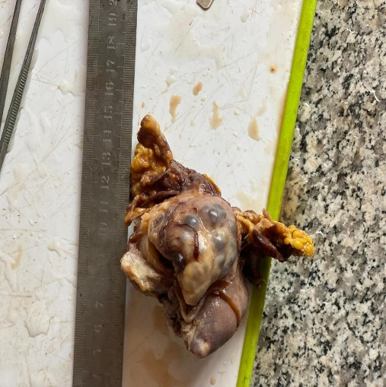
Figure 1: Complex of the ovary, gauze, fallopian tube and Omentum.

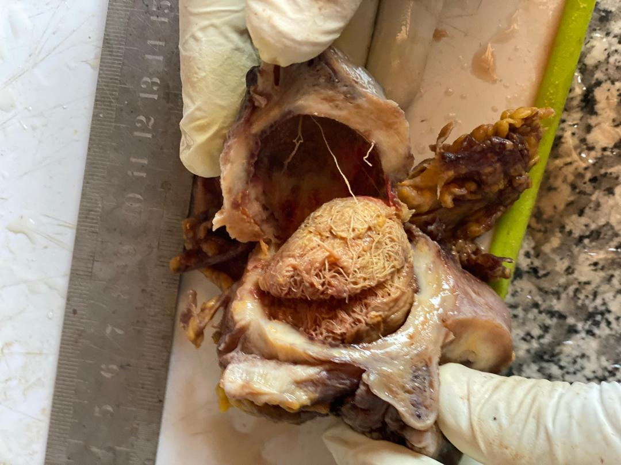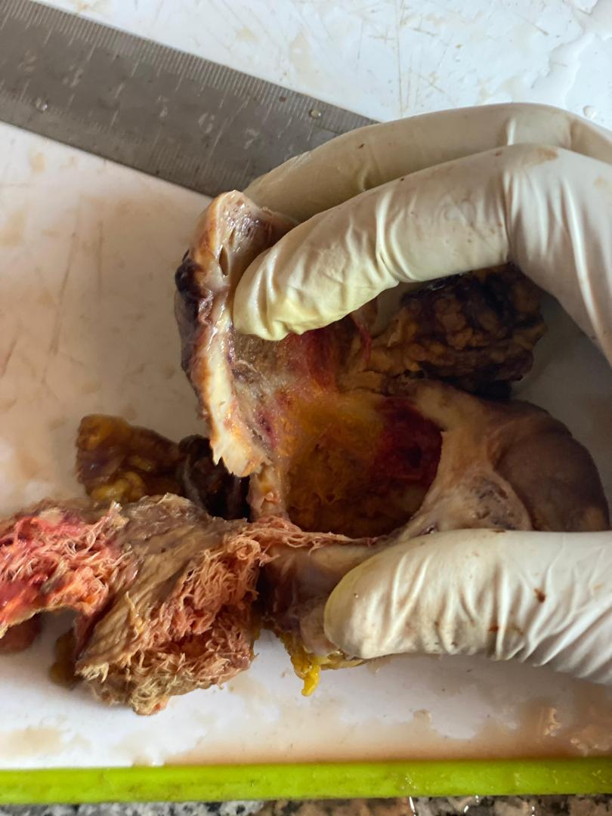
Figure 2: Cut surface of the ovary with the gauze in situ.

DISCUSSION
Gossypiboma commonly occurs following gynaecological surgeries and rarely after a caesarean section. [4] This patient had gossypiboma following an emergency caesarean section. The identifiable risk factors in her are likely uncontrolled haemorrhage from the abruptio placenta and emergency surgery. Other risk factors that can lead to retention of surgical items include longer duration of operation, patient undergoing sub-procedure, lack of or incorrect surgical counts, more than one surgical team, unexpected intraoperative factor,[9] and ignoring count discrepancies during surgery.[10]
Pathophysiologically, there are two forms of body reaction to gossypiboma. The 1st form is an aseptic fibrous inflammatory reaction and adhesion that encapsulates the gossypiboma in the omentum. The second reaction is an exudative inflammatory reaction leading to abscess formation or fistula.[11] Our patient had an aseptic fibrous inflammatory reaction with an adhesion that encapsulates the left ovary, left fallopian tube, and the gauze.
The clinical features of gossypiboma are not specific. The interval between occurrence and diagnosis varies from 2 months to 40 years.[7] Gossypiboma was diagnosed in our patient 8 months after her caesarean section. Abdominal pain and swelling are the common presenting symptoms.[8] Our patient also presented with abdominal pain and swelling. Other symptoms, though not present in her, include nausea, vomiting, anorexia, and weight loss.[1]
Radiological investigations for the identification of gossypiboma include radiography, ultrasound, computerized tomography scan, magnetic resonance imaging, and contrast-enhanced study. Gossypiboma typically has a varied radiologic appearance, which depends on the type of foreign body, its location, and the duration of time the gossypiboma has been in situ.[12] Simple radiography can be used, especially if the material is radioopaque, with a sensitivity of more than 90%. However, sponges, which are the most commonly retained foreign bodies, are radiolucent and thus pose a diagnostic dilemma.[12] A computerized tomography scan is considered the gold standard because of its high resolution. Typically, gossypiboma on a CT scan appears as a well-circumscribed spongiform mass with gas or calcification within the mass, giving it a typical, unmistakable appearance.[2] On ultrasound, gossypiboma usually appears as a mass that produces a sharp acoustic shadow, often with wavy internal echoes as seen in this index case. [2,7]
The modality of treatment of gossypiboma depends on the clinical presentation of the patient and the associated complications. Open surgery, endoscopy, and laparoscopy are management options. Endoscopy is indicated in case of transmural migration of the gossypiboma to the stomach or colon, while laparoscopy surgery is indicated if the retained foreign body is identified in the immediate postoperative period. However, in case of suspected erosion or fistula formation, an open surgery should be performed. Our patient had an exploratory laparotomy with left adnexectomy because the gauze had formed a complex with the left ovary and fallopian tube. On a few occasions, spontaneous expulsion of the gauze had been reported with complete resolution of symptoms. Also, real-time movement of the gauze during radiological study with expulsion of the gauze after completion of the study had been reported.[2]
Gossypiboma is associated with physical and psychological complications to patients, relatives, and healthcare providers.[5] The medicolegal issues surrounding it also necessitate putting measures in place to prevent it. The USA Association of Registered Nurses recommends that surgical counts be done at different times during the course of the surgery. The recommendations include that a count should be performed before the start of any procedure, at the time of adding another item, before the closure of a cavity within a cavity, at the time of closure of the incision, and at skin closure. They emphasized that if any discrepancy is noted, the entire surgical team has to look for the missing item.[13] The WHO developed the surgical safety checklist in 2009, which also recommends that, before the patient leaves the operating room, in the presence of the perioperative nurse, the surgeon, and the anaesthetist, the perioperative nurse should confirm that the instruments, sponges, and needle counts are complete.[14]This has gone a long way in reducing morbidity and mortality and enhancing patient safety. In addition, the curriculum of the surgical residency program and training of operating room staff should include proper operating room guideline training.[15]
Conclusion: Gossypiboma is associated with significant physical, psychological, economic, and medicolegal complications; thus, all measures should be put in place to mitigate its occurrence. It should be seen as a collective responsibility of the entire surgical team.
Consent
As per international standards or university standards, patient(s) written consent has been collected and preserved by the author(s).
Disclaimer (Artificial intelligence)
Option 1:
Author(s) hereby declare that NO generative AI technologies such as Large Language Models (ChatGPT, COPILOT, etc.) and text-to-image generators have been used during the writing or editing of this manuscript.
Option 2:
Author(s) hereby declare that generative AI technologies such as Large Language Models, etc. have been used during the writing or editing of manuscripts. This explanation will include the name, version, model, and source of the generative AI technology and as well as all input prompts provided to the generative AI technology
Details of the AI usage are given below:
1.
2.
3.

REFERENCES
- Dinsa LH, Workineh BB, Hunde CR. Gossypiboma with enterocutaneous fistula after caesarean section: A case report and review of the literature. J Med Case Rep. 2024;18(1):515. doi: 10.1186/s13256-024-04783-x.
- Butt UI, Shafiq AB, Umar M, Ashfaq M, Ayyaz M. Transmigration and spontaneous passage of a gossypiboma documented on contrast study. Ann Med Surg. 2018;38:42-44.
- Agrawal N, Sodhi M, Malik N. Case report gossypiboma : A rare case report. 2021. Available from https://www.researchgate.net/publication/350560862. [Accessed 12th March 2025]
- Nishimura N, Mizuno M, Shimoda Y. Gossypiboma with bleeding
from fistula to the colon observed by colonoscopy. Clin J Gastroenterol. 2017;10(1):37–40.
- Schwappach D, Pfeiffer Y. Root causes and preventability of unintentionally retained foreign objects after surgery: A national expert survey from Switzerland. Patient Saf Surg. 2023 Jun 9;17(1):15. doi: 10.1186/s13037-023-00366-9.
- Weprin S, Crocerossa F, Meyer D, Maddra K, Valancy D, Osardu R, et al. Risk factors and preventive strategies for unintentionally retained surgical sharps: A systematic review. Patient Saf Surg. 2021;15:1–10.
- Han Y, Yang W, Dai W, Ma Q, Yuan T, Yang Y, Lu Y, Zhang B, Zhang M. Case Report: Laparoscopy-assisted resection for intra-abdominal gossypiboma masquerading as a jejunal tumor (with video). Front Oncol. 2023;13:1326032. doi: 10.3389/fonc.2023.1326032.
- Hempel S, Maggard-Gibbons M, Nguyen DK, Dawes AJ, Miake-Lye I, Beroes JM, et al. Wrong-site surgery, retained surgical, items, and surgical fires a systematic review of surgical never events; JAMA Surg. 2015;150(8):796–805.
- Moffatt-Bruce SD, Cook CH, Steinberg SM, Stawicki SP. Risk factors for
retained surgical items: A meta-analysis and proposed risk stratification system. J Surg Res. 2014;190:429–436.
- Takahashi K, Fukatsu T, Oki S, Iizuka Y, Otsuka Y, Sanui M, et al. Characteristics
of retained foreign bodies and near-miss events in the operating room: A ten-year experience at one institution. J Anesth. 2022;37:49–55.
- Sankpal J, Tayade M, Rathore J, Parikh A, Gadekar D, Shaba FS et al. Oh, My Gauze !!!-
a rare case report of laparoscopic removal of an incidentally discovered gossypiboma during laparoscopic cholecystectomy. Int J Surg Case Rep. 2020;72:643–6.doi. org/ 10. 1016/j. ijscr. 2020. 04. 058.
- Farias LD, Menezes DC, Ferreira RHQ, Raimundo EC, Arruda PH, Santos MM et al. Gossypiboma: foreign bodies that radiologists cannot forget. ECR 2018. doi:10.1594/ecr2018/C-3078
- Fencl JL. Guideline implementation, prevention of retained surgical items. AORN J. 2016; 104 (1): 37–48.
- WHO. WHO surgical safety checklist. 2009. Available from https://www.who.int. [Accessed 12th March 2025]
- Alemu BN, Tiruneh AG. Gossypiboma: Case series and literature review. Ethiop J Health Sci.2020;30(1):147.doi:http:// dx.doi.org/10.4314/ejhs.v30i1.19

