Original Research Article

Zinc fertilization effect on fine rice, BRRI dhan50 under Bangladesh condition

ABSTRACT
Zinc is an essential micronutrient that plays a crucial role in rice growth and yield. An experiment was conducted at the research field of Hajee Mohammad Danesh Science and Technology University, Dinajpur, to evaluate the effect of zinc on the yield and quality of BRRI dhan50. The study was designed using a Randomized Complete Block Design with three replications. The results showed that plant height, number of tillers hill⁻¹, panicle length, number of effective tillers per hill, number of non-effective tillers per hill, number of grains per panicle, number of sterile grains per panicle, Tthousand grains
weight, straw yield, biological yield, and grain yield (t ha⁻¹) were significantly influenced by zinc application. However, the highest grain yield (7.19 t ha⁻¹) was obtained from the treatment Zn4T2, where 10.70 kg ha⁻¹ of zinc was applied at 50 DAT (days after transplanting). In contrast, the lowest yield was recorded in the control treatment, where no zinc fertilizer was applied at 75 DAT. Overall, the Zn4T2 treatment demonstrated superior performance compared to other treatments. Therefore, the findings suggest that applying zinc at 10.70 kg ha⁻¹ at 50 DAT can be an effective strategy for enhancing rice production. Based on these results, farmers in the subtropical environment of Bangladesh may be advised to apply zinc at the recommended rate to achieve higher rice yields.

Keywords: Micronutrient, Zinc, Rice, Yield, Quality

1. INTRODUCTION
Rice (Oryza sativa L.) is the most important staple food in Bangladesh (Mishu et al. 2016; Kayess et al. 2020; Misu et al. 2025) and serves as the primary source of nutrition for more than two billion people across Asia (Afroz et al. 2024a; 2024b; 2024c; Yesmin et al. 2017; Basunia et al. 2017; Hien et al., 2006). Globally, it contributes about 21% of dietary energy and 15% of dietary protein per capita (Maclean et al., 2002). In Bangladesh, rice is cultivated intensively, occupying nearly 80% of the country’s arable land. However, rice yield in Bangladesh remains comparatively lower than in other rice-growing countries such as South Korea (7.0 t ha⁻¹) and Japan (6.22 t ha⁻¹) (FAO, 2010). National average productivity is approximately 4.2 t ha⁻¹, which is substantially lower than China (6.30 t ha⁻¹), Japan (6.22 t ha⁻¹), and South Korea (7.00 t ha⁻¹) (FAO, 2010).
Rice yield in Bangladesh varies widely across regions and seasons, largely due to several constraints, including imbalanced fertilizer use, soil moisture stress, insect pest infestations, and disease incidence (Latif et al. 2024; 2025a; 2025b; 2025c). At the same time, the demand for rice continues to rise due to population growth, urbanization, and dietary changes. Rice contributes between 35% and 80% of daily caloric intake in many regions, and global demand for rice is increasing annually by about 6% in Western and African countries (Carriger & Vallee, 2007). Given its nutritional importance, improving rice yield and quality remains a national priority.
The Bangladesh Rice Research Institute (BRRI), Joydebpur, Gazipur, has developed several high-yielding fine and aromatic rice varieties to replace traditional low-yielding genotypes (1.5–2.0 t ha⁻¹). Currently, eight fine and aromatic rice varieties have been released, namely BR5 (Dulabhog), BRRI dhan34, BRRI dhan37, BRRI dhan38, BRRI dhan70, BRRI dhan75, BRRI dhan80, and BRRI dhan50. These varieties are widely accepted by farmers across the country due to their high yield potential, excellent cooking qualities, and suitability for multiple cropping systems, thereby contributing to a significant increase in rice production.
Agriculture in Bangladesh, dominated by rice cultivation, faces major challenges. Population growth, urbanization, and industrialization have significantly reduced cultivable land, creating pressure to increase yield per unit area rather than through horizontal expansion. Rice-based cropping systems are crucial in the Eastern Indo-Gangetic Plain for ensuring food security. However, in recent decades, rice yield has stagnated due to imbalanced fertilizer use, soil degradation, unsustainable cropping systems, and the lack of suitable rice varieties adapted to low moisture and resistant to pests and diseases (Prakash, 2010).
Among essential nutrients, zinc (Zn) is particularly important for rice cultivation (Yin et al. 2016). Zinc is a critical micronutrient required for plant growth, especially in rice grown under submerged conditions, as it functions as both a structural component and an activator of several enzymes involved in metabolic activities. Zinc deficiency is prevalent in both temperate and tropical climates (Zulfiqar et al. 2021; Fageria et al., 2003; Slaton et al., 2005) and is a key constraint to rice production in several regions of Bangladesh (Chaudhary et al., 2007). Its deficiency can inhibit plant growth, reduce grain quality, and cause significant yield losses (Tripathi et al., 2015). Rice is particularly prone to zinc deficiency compared to other crops, making it highly susceptible to nutritional disorders (Tuiwong etal. 2022; Dobermann & Fairhurst, 2000).
Globally, zinc deficiency is not only a plant nutrition problem but also a serious human health issue. Approximately one-third of the world’s population suffers from zinc deficiency due to inadequate dietary intake (Panomwan et al., 2013). Reports suggest that around 30% of the world’s soils are zinc-deficient, leading to more than two billion people being deprived of sufficient dietary zinc (Kandil et al. 2022; Cakmak et al., 1999). As a result, enriching staple crops such as rice with higher zinc content has become an ethical and agronomic necessity (Ghouri et al. 2023; Prasad et al., 2014). The problem is particularly acute in calcareous soils, where zinc deficiency is widespread, especially in Asian rice-growing regions. Previous studies have also shown that zinc fertilization significantly improves rice grain quality, particularly in terms of protein content and cooking characteristics.
Recent advances in agricultural production technologies offer opportunities to improve fertilizer management practices, potentially reducing production costs while enhancing nutrient uptake (El-Metwally and Saudy, 2021). Among these, zinc plays a vital role not only in increasing rice yield but also in maintaining the aroma and quality of aromatic rice. Hence, integrated nutrient management along with the selection of suitable varieties can contribute significantly to yield improvement and consumer acceptability.
Under these circumstances, the present research was undertaken to study the effect of zinc application on the growth and yield performance of BRRI dhan50. The specific objectives were to determine the appropriate level of zinc application for maximizing yield, to evaluate the effect of different doses of zinc on yield, and to assess the interaction effect of zinc dose and time of application on the yield of BRRI dhan50.

2. MATERIALS AND METHODS

2.1 Location and Experimental Materials

Geographically, the experimental field is situated at 25.13° N latitude and 88.230° E longitude, with an elevation of 37.5 meters above mean sea level (Map 1). This land falls within the Old Himalayan Piedmont Plain, classified under Agro-ecological Zone-1 (AEZ-1). The field’s topography is characterized as medium high. Specifically, the experiment was conducted at the agronomy research field of Hajee Mohammad Danesh Science and Technology University, Dinajpur. The soil of the experimental plot was sandy loam, comprising 51.6% sand, 29% silt, and 17.2% clay particles. The initial soil pH was measured at 5.81, indicating slightly acidic conditions. Additionally, the soil contained 0.30% organic matter, 0.014% total nitrogen (N), 20.67 ppm phosphorus (P), and 1 ppm sulfur (S). The experiment was carried out between November 2021 and March 2022 at the agronomy research field of the Department of Agronomy, Hajee Mohammad Danesh Science and Technology University, Dinajpur. The rice variety BRRI dhan50 was utilized for the study, specifically in the winter season. The seeds, procured from the Bangladesh Agriculture Development Corporation (BADC) in Nashipur, Dinajpur, were developed by the Bangladesh Rice Research Institute (BRRI), Gazipur, on November 9, 2021.
2.2 Treatments

The research employed a factorial design with two experimental factors. Factor A consisted of four levels of zinc fertilizer application: Zn1 (no zinc), Zn2 (3.5 kg ha⁻¹ zinc fertilizer), Zn3 (7.0 kg ha⁻¹ zinc fertilizer), and Zn4 (10.70 kg ha⁻¹ zinc fertilizer). Factor B represented the timing of zinc fertilizer application at three different stages: T1 (25 days after transplanting), T2 (50 days after transplanting), and T3 (75 days after transplanting).

2.3 Crop Husbandry

The experimental field was initially prepared on November 30, 2021, using a power tiller and subsequently left exposed to sunlight for one week. Following this, the land underwent harrowing, ploughing, cross-ploughing multiple times, and laddering to achieve a well-puddled condition. All weeds and stubbles were thoroughly removed prior to planting.
Basal fertilization involved the full application of triple superphosphate (TSP), muriate of potash (MOP), and gypsum. Urea was applied in three equal splits: the first third as basal fertilizer before transplanting (15 days after transplanting [DAT]) on February 22, 2022; the second third at the active tillering stage (30 DAT) on March 8, 2022; and the final third before the panicle initiation stage (45 DAT) on March 22, 2022.
The zinc fertilizer requirements per plot were calculated based on treatment specifications. Zinc was supplied as zinc sulphate monohydrate, which contains 36% zinc. Applications were made at 25, 50, and 75 DAT at doses of 3.5 5 kg ha⁻¹, 7.5 kg ha⁻¹, and 10.70 kg ha⁻¹, respectively, according to the treatments. Standard intercultural operations were performed throughout the cropping period to ensure optimal crop growth, and necessary plant protection measures were implemented as required.

2.4 Data Collection

Various growth and yield parameters were recorded to evaluate treatment effects. These included plant height at 25, 50, and 75 DAT, and at harvest (measured in centimetres), as well as the number of tillers per hill at the corresponding stages. Panicle length (cm) was also measured. Yield components such as the number of effective tillers per panicle, non-effective tillers per panicle, number of grains per panicle, number of sterile grains per panicle, and the weight of 1,000 grains were assessed. Additionally, grain yield (t ha⁻¹) and straw yield (t ha⁻¹) were quantified.
Biological yield (t ha⁻¹), and harvest index (%) were measured to evaluate the overall performance of the crop. Biological yield was calculated by using the following formula: Biological yield (t ha⁻¹) = Grain yield (t ha⁻¹) + Straw yield (t ha⁻¹). Harvest index was determined by dividing the economic yield (seed yield) to the biological yield (seed + straw yield) from the same area and then multiplied by 100.
Harvest Index (%) =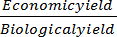 × 100

2.5 Data Analysis

Data collected from different parameters were compiled and tabulated in proper form. Appropriate statistical analysis was made by Statix-10 computer package program and the treatment means were compared by least significance difference (LSD) at 5% level of significance (Gomez and Gomez, 1984).

3. Result and Discussion

Plant height was significantly influenced by the application of different levels of zinc. Although variations in plant height across different days after sowing (DAT) were generally non-significant, certain treatments produced notable differences. At 25 DAT, the tallest plants (26.30 cm) were observed in the Zn1T2 treatment. Subsequently, at 50 and 75 DAT, the Zn4T2 treatment resulted in the tallest plants (66.25 cm and 86.38 cm, respectively). At harvest, the Zn3T1 treatment produced the tallest plants overall (91.67 cm). In contrast, the shortest plants were consistently recorded in the control treatment Zn1T1, measuring 22.35 cm, 59.98 cm, and 82.30 cm at 25, 50 DAT, and harvest while 79.83 cmat 75 DAT, respectively (Table 1). Similar observation was made by Islam et al. 2021.
Similarly, a significant variation was recorded in the number of total tillers hill⁻¹ due to the application of different levels of zinc (Table 2). At 25 DAT, the highest number of total tillers hill⁻¹ (6.067) was observed in Zn1T2, which was statistically different from some other treatments. Furthermore, at 50 DAT, Zn4T3 produced the maximum number of tillers hill⁻¹ (31.83), and Zn4T2 treatment recorded the highest total number of tillers(18.67) . Conversely, the minimum number of total tillers hill⁻¹ (3.533, 22.63, and 16.00) was observed in Zn1T1. Similar report was made by Islam et al. 2024.
In the case of panicle length, the treatments showed significant differences among them (Figure 1). Nevertheless, the maximum panicle length (23.20 cm) was recorded in the Zn4T2 treatment, whereas the minimum panicle length was observed in Zn1T1. Saikh et al. 2022 found similar observation for panicle length.
Likewise, the number of effective tillers hill⁻¹ did not vary significantly due to different zinc levels (Figure 2). However, the maximum number of effective tillers hill⁻¹ (15.53) was recorded in Zn4T₃, while the minimum (12.60) was observed in Zn4T1. Higher zinc concentration in the rhizosphere, maintained through consistent application, was associated with a greater number of productive tillers hill⁻¹ (Muthukumararaja and Sriramachandrasekharan, 2012; Jena et al., 2006). Mustafa et al. (2011) also reported that adequate zinc supply enhances nutrient uptake and metabolic processes, thereby increasing the number of effective tillers.
On the other hand, different levels of fertilizers had a significant effect on the number of non-effective tillers hill⁻¹ (Table 3). The maximum number (2.133) was recorded in Zn2T3 and Zn3T2, whereas the minimum (0.933) was observed in Zn2T1, which was statistically similar to Zn4T2. The higher number of non-effective tillers may be attributed to the higher supply of zinc, which is essential for promoting effective tiller production. Higher doze may show higher non-effective tiller may be due to toxic effect.
Furthermore, the number of total grains per panicle showed statistically significant variation (Table 3). Nevertheless, the maximum number of total grains per panicle (112.4) was recorded in Zn4T2, which was statistically similar to all other treatments except Zn1T1 which showed minimum grains (94.10) . Increasing zinc levels were generally associated with higher grain numbers, consistent with Khan et al. (2012), who reported a similar trend up to 9 kg Zn ha⁻¹.
In terms of sterile grains per panicle, significant differences were observed. The highest number (13.40) was recorded in Zn1T1, which was significantly different from all other treatments, excluding Zn2T2 whereas the lowest (8.333) was observed in Zn3T3. These findings are in agreement with Gul et al. (2015), who reported that foliar application of zinc combined with N and K increased grain number per spike compared to control.
Similarly, different levels of zinc had a significant effect on 1000-grain weight (Table 4). The maximum weight (23.02 g) was recorded in Zn4T2, which showed statistical similarity with other treatments in most of the cases, while the minimum (20.96 g) was recorded in Zn1T1 statistically alike to some other treatments. These results corroborate previous studies by Siddika et al. (2016) and Nawaz et al. (2004), who reported that zinc and copper fertilization increased 1000-grain weight. Moreover, zinc application improved weight by 13.39% over control (Mustafa et al., 2011), in agreement with findings of Naik and Das (2007), Narimani et al. (2010), and El-Nahhal (2004).
Significant variation was also observed in grain yield (Figure 3). Zn4T2 produced the highest grain yield (7.190 t ha⁻¹), followed by Zn2T3 (7.16 t ha⁻¹), whereas Zn1T3 recorded the lowest yield (5.36 t ha⁻¹), statistically similar to Zn1T1 and Zn2T1. The higher yield may be attributed to improved growth and physiological processes resulting from adequate zinc availability (Suresh and Salakinkop, 2016; Tabassum et al., 2013; Babu et al., 2007). Rahman et al. (2006) also reported yield increases of 15–16.5% upon zinc application. Additionally, zinc plays a key role in enzyme regulation, auxin production, carbohydrate transformation, and sugar regulation, ultimately enhancing grain production (Muthukumararaja and Sriramachandrasekharan, 2012; Mustafa et al., 2011; Fageria et al., 2011; Khan et al., 2007; Chaudhary et al., 2007; Jena et al., 2006).
Straw yield differ significantly (Table 4). The highest straw yield (19.55 t ha⁻¹) was observed in Zn1T2, statistically similar to Zn1T1 and Zn2T3, while the lowest (13.55 t ha⁻¹) was recorded in Zn2T1. Similarly, biological yield was also significantly affected, with the maximum (26.06 t ha⁻¹) in Zn1T2 and the minimum (18.95 t ha⁻¹) in Zn2T1, consistent with findings of Mustafa et al. (2011) and Gupta and Kala (1992).
Finally, different zinc levels had no significant effect on harvest index (Figure 4). Numerically, the maximum harvest index (30.37%) was recorded in Zn3T3, similar to Zn3T2 and Zn2T1, whereas the minimum (22.76%) was observed in Zn1T1 (Figure 4).

4. Conclusion
Based on the results of the present study, it can be concluded that zinc fertilization had a substantial impact on the growth and yield of BRRI dhan50. Among the treatments, Zn4T2 produced the highest grain yield (7.19 t ha⁻¹) along with superior performance in growth and yield-related parameters. Therefore, this treatment could be recommended as an effective production package for rice growers across Bangladesh. Further studies could include evaluating additional zinc levels, either alone or in combination with other nutrients, to confirm their effects on yield and nutrient performance.

COMPETING INTERESTS DISCLAIMER:
Authors have declared that they have no known competing financial interests OR non-financial interests OR personal relationships that could have appeared to influence the work reported in this paper.

Disclaimer (Artificial intelligence)

Author(s) hereby declare that NO generative AI technologies such as Large Language Models (ChatGPT, COPILOT, etc.) and text-to-image generators have been used during the writing or editing of this manuscript.

REFERENCES

Afroz, N., Akter, K., Zomo, S. A., Zaman, J., & Kayess, M. O. (2024c). Determination of Ideal Spacing for the Growth and Development of Boro rice BRRI dhan47. Asian Journal of Advances in Agricultural Research, 24(6), 89–95. https://doi.org/10.9734/ajaar/2024/v24i6516
Afroz, N., Mitu, A. I., Zaman, J., Zomo, S. A., & Kayess, M. O. (2024a). Effect of Varying Level of Nitrogen and Spacing on the Yield of Boro rice cv. BRRI dhan47. Asian Journal of Agricultural and Horticultural Research, 11(2), 153–159. https://doi.org/10.9734/ajahr/2024/v11i2322
Afroz, N., Mitu, A. I., Zaman, J., Zomo, S. A., & Kayess, M. O. (2024b). Effect of Varying Level of Nitrogen and Spacing on the Yield of Boro rice cv. BRRI dhan47. Asian Journal of Agricultural and Horticultural Research, 11(2), 153–159. https://doi.org/10.9734/ajahr/2024/v11i2322
Babu, P. P., Shanti, M., Prasad, R. B., & Minhas, P. S. (2007). Effect of zinc on rice in rice–black gram cropping system in saline soils. Andhra Agricultural Journal, 54(1–2), 47–50.
Basunia, S. C., Sarker, B. C., Kayess, M. O., Rahman, M. I., Kajal, M., & Alam, M. R. (2017). Biochemical investigation and seedling mortality rate of some selected Boro rice cultivars at low temperature stress. Journal of Bioscience and Agriculture Research, 12(1), 976–985. https://doi.org/10.18801/jbar.120117.120
Cakmak, I., Kalayci, M., Ekiz, H., Braun, H. J., Kilinc, Y., & Yilmaz, A. (1999). Zinc deficiency as a practical problem in plant and human nutrition in Turkey: A NATO-Science for Stability Project. Field Crops Research, 60(1–2), 175–188. https://doi.org/10.1016/S0378-4290(98)00139-7
Carriger, S., & Vallee, D. (2007). More crop per drop. Rice Today, 6, 10–13.
Chaudhary, S. K., Thakur, S. K., & Pandey, A. K. (2007). Response of wetland rice to nitrogen and zinc. Oryza, 44(1), 31–34.
Dobermann, A., & Fairhurst, T. (2000). Rice: Nutrient disorders and nutrient management. Handbook Series. Potash and Phosphate Institute (PPI), Potash and Phosphate Institute of Canada (PPIC) and International Rice Research Institute, Los Baños, 191 pp.
El-Metwally, I. M., & Saudy, H. S. (2021). Interactive application of zinc and herbicides affects broad-leaved weeds, nutrient uptake, and yield in rice. Journal of Soil Science and Plant Nutrition, 21(1), 238–248. https://doi.org/10.1007/s42729-020-00354-0
El-Nahhal, Y. (2004). Contamination and safety status of plant food in Arab countries. Journal of Applied Sciences, 4, 411–417. https://doi.org/10.3923/jas.2004.411.417
Fageria, N. K., Santos, D. A. B., & Cobucci, T. (2011). Zinc nutrition of lowland rice. Communications in Soil Science and Plant Analysis, 42, 1719–1727. https://doi.org/10.1080/00103624.2011.584580
Fageria, N. K., Slaton, N. A., & Baligar, V. C. (2003). Nutrient management for improving lowland rice productivity and sustainability. Advances in Agronomy, 80, 63–152. https://doi.org/10.1016/S0065-2113(03)80003-2
FAO (Food and Agriculture Organization). (2010). Yearbook of production. FAO Statistics Division, pp. 605–607.
Ghouri, F., Shahid, M. J., Liu, J., Lai, M., Sun, L., Wu, J., Liu, X., Ali, S., & Shahid, M. Q. (2023). Polyploidy and zinc oxide nanoparticles alleviated Cd toxicity in rice by modulating oxidative stress and expression levels of sucrose and metal-transporter genes. Journal of Hazardous Materials, 448, 130991. https://doi.org/10.1016/j.jhazmat.2023.130991
Gomez, K. A., & Gomez, A. A. (1984). Statistical procedures for agricultural research (2nd ed.). New York: Wiley.
Gul, K., Yousuf, B., Singh, A. K., Singh, P., & Wani, A. A. (2015). Rice bran: Nutritional values and its emerging potential for development of functional food—A review. Bioactive Carbohydrates and Dietary Fibre, 6(1), 24–30. https://doi.org/10.1016/j.bcdf.2015.06.002
Gupta, V. K., & Kala, R. (1992). Response of paddy to zinc application and its effect on Zn, Cu, Mn and Fe concentration and uptake. Journal of Agronomy, 8, 81–84.
Hien, N. L., Yoshihashi, T., & Sarhadi, W. A. (2006). Evaluation of aroma in rice (Oryza sativa L.) using KOH method, molecular markers and measurement of 2-acetyl-1-pyrroline concentration. Japanese Journal of Tropical Agriculture, 50, 190–198.
Islam, M. M., Islam, M. R., & Khan, M. T. (2024). Comparative study of zinc doses and application methods ensuring maximum productivity of Boro rice. International Journal of Scientific Research in Multidisciplinary Studies, 10(8). https://doi.org/10.5281/zenodo.13349276
Islam, M. R., Sultana, A., Jahiruddin, M., & Islam, S. (2021). Effect of soil application of zinc on growth, yield and zinc concentration in rice varieties. European Journal of Agriculture and Food Sciences, 3(6), 117–122. https://doi.org/10.24018/ejfood.2021.3.6.384
Jena, P. K., Rao, C. P., & Subbiah, G. (2006). Effect of zinc management practices on growth, yield and economics in transplanted rice. Oryza, 43(4), 326–328.
Kandil, E. E., El-Banna, A. A., Tabl, D. M., Mackled, M. I., Ghareeb, R. Y., Al-Huqail, A. A., Ali, H. M., Jebril, J., & Abdelsalam, N. R. (2022). Zinc nutrition responses to agronomic and yield traits, kernel quality, and pollen viability in rice (Oryza sativa L.). Frontiers in Plant Science, 13, 791066. https://doi.org/10.3389/fpls.2022.791066
Kayess, M. O., Hassan, M. M., Nurhasan, M., & Ahmed, K. (2020). Effect of low temperature on chlorophyll and carotenoid content on the seedlings of some selected boro rice varieties. American Journal of Plant Sciences, 11(2), 125. https://doi.org/10.4236/ajps.2020.11201
Khan, M. U., Qasim, M., & Khan, K. (2007). Effect of Zn fertilizer on rice grown in different soils of Dera Ismail Khan. Sarhad Journal of Agriculture, 23(4), 34–38.
Khan, P., Memon, M. Y., Emtiaz, M., Depar, N., Aslam, M., Mernon, M. S., & Saha, J. A. (2012). Determining the zinc requirements of rice genotype Sarshar evolved at NIA, Tandojam. Sarhad Journal of Agriculture, 28(1), 1–7.
Latif, M. A., Hera, M. H. R., Rahman, L., Bhuiyan, M. R., Kayess, M. O., Rashid, M. M., Hasan, M. A. I., & Khan, M. A. I. (2024b). Pyramiding of multiple resistance genes for bacterial blight and blast diseases in premium quality rice, BRRI dhan81 through marker-assisted selection. Plant Pathology. https://doi.org/10.1111/ppa.14112
Latif, M. A., Kayess, M. O., Hasan, R., & Rahman, L. (2024a). Molecular marker assisted gene stacking for multiple diseases resistance in an elite rice cultivar, BRRI dhan48. Plant Gene. https://doi.org/10.1016/j.plgene.2025.100505
Latif, M. A., Kayess, M. O., Rahman, L., Hasan, R., & Khan, M. A. (2025). Introgression of multiple disease resistant genes in the genetic background of high‐yielding rice variety through marker‐assisted backcross breeding. Journal of Phytopathology, 173(2), e70053. https://doi.org/10.1111/jph.70053
Latif, M. A., Rahman, L., Islam, N., Kayess, M. O., Rashid, M. M., Hasan, M. A. I., & Khan, M. A. I. (2024). Pathotypic diversity of Xanthomonas oryzae pv. oryzae, and stringent evaluation of resistance lines of rice in Bangladesh. European Journal of Plant Pathology, 1–14. https://doi.org/10.1007/s10658-024-02900-6
Maclean, J. C., Dawe, D. C., Hardy, B., & Hettel, G. P. (2002). Rice almanac (3rd ed.). CABI Publishing, Wallingford, p. 253.
Mishu, M. F. K., Rahman, M. W., Azad, M. A. K., Biswas, B. K., Talukder, M. A. I., Kayess, M. O., Islam, M. R., & Alam, M. R. (2016). Study on Genetic Variability and Character Association of Aromatic rice (Oryza sativa L.) Cultivars. International Journal of Plant & Soil Science, 9(1), 1–8. https://doi.org/10.9734/IJPSS/2016/22006
Misu, I. J., Kayess, M. O., Siddiqui, M. N., Gupta, D. R., Islam, M. N., & Islam, T. (2025). Microbiome engineering for sustainable rice production: Strategies for biofertilization, stress tolerance, and climate resilience. Microorganisms, 13(2), 233. https://doi.org/10.3390/microorganisms13020233
Mustafa, G., Ehsanullah, Akbar, N., Qaisrani, S. A., Iqbal, A., Khan, H. Z., Jabran, K., Chattha, A. A., Trethowan, R., Chattha, T., & Atta, B. M. (2011). Effect of zinc application on growth and yield of rice (Oryza sativa L.). International Journal of Agriculture and Veterinary Medical Sciences, 5(6), 530–535.
Muthukumararaja, T. M., & Sriramachandrasekharan, M. V. (2012). Effect of zinc on yield, zinc nutrition and zinc use efficiency of lowland rice. Journal of Agricultural Technology, 8(2), 551–561.
Naik, S. K., & Das, D. K. (2007). Effect of split application of zinc on yield of rice in an inceptisol. Archives of Agronomy and Soil Science, 53, 305–313. https://doi.org/10.1080/03650340701304883
Narimani, H., Rahimi, M. M., Ahmadikhah, A., & Vaezi, B. (2010). Study on the effects of foliar spray of micronutrient on yield and yield components of durum wheat. Archives of Applied Science Research, 2(6), 168–176.
Nawaz, M. S., Oasim, M., Bakhsh, A., & Gurmani, A. H. (2004). Effect of zinc and copper fertilization on rice yield and soil/plant concentrations. Journal of Soil Science, 23(1–2), 13.
Panomwan, B., Ismail, C., Benjavan, R., & Chanakan, P. T. (2013). Effect of different foliar zinc application at different growth stages on seed zinc concentration and its impact on seedling vigor in rice. Soil Science and Plant Nutrition, 59(2), 180–188. https://doi.org/10.1080/00380768.2013.764405
Prakash, N. B. (2010). Different sources of silicon for rice farming in Karnataka. Paper presented at the Indo-US Workshop on Silicon in Agriculture, University of Agricultural Sciences, Bangalore, India, 25–27 February 2010, p. 14.
Prasad, R., Shivay, Y. S., & Kumar, D. (2014). Agronomic biofortification of cereal grains with iron and zinc. Advances in Agronomy, 125, 55–91. https://doi.org/10.1016/B978-0-12-800137-1.00002-4
Rahman, A. V., Reddy, S. D., & Reddy, K. R. (2006). Influence of mulching and micronutrient management practices on upland rice. Karnataka Journal of Agricultural Sciences, 19(4), 785–788.
Saikh, R., Murmu, K., Sarkar, A., Mondal, R., & Jana, K. (2022). Effect of foliar zinc application on growth and yield of rice (Oryza sativa) in the Indo-Gangetic Plains of India. Nusantara Bioscience, 14(2). https://doi.org/10.13057/nusbiosci/n140203
Siddika, M. A., Mian, M. J. A., Hoque, T. S., Hanif, M. A., & Ray, P. C. (2016). Effect of different micronutrients on growth and yield of rice. International Journal of Plant & Soil Science, 12(6), 1–8.
Slaton, N. A., Normon, R. J., & Wilson, C. E., Jr. (2005). Effect of Zn source and application time on Zn uptake and grain yield of flood-irrigated rice. Agronomy Journal, 92, 272–278. https://doi.org/10.2134/agronj2005.0272
Suresh, S., & Salakinkop, S. R. (2016). Growth and yield of rice as influenced by biofortification of zinc and iron. Journal of Farm Sciences, 29(4), 443–448.
Tabassum, S., Khamparia, R. S., & Singh, S. (2013). Effect of zinc and organic manures on yield attributes and yield of rice. Bioinfolet, 10(3), 879–881.
Tripathi, D. K., Singh, S., Singh, S., Mishra, S., Chauhan, D. K., & Dubey, N. K. (2015). Micronutrients and their diverse role in agricultural crops: advances and future prospective. Acta Physiologiae Plantarum, 37, 139. https://doi.org/10.1007/s11738-015-1870-3
Tuiwong, P., Lordkaew, S., Veeradittakit, J., Jamjod, S., & Prom-U-Thai, C. (2022). Efficacy of nitrogen and zinc application at different growth stages on yield, grain zinc, and nitrogen concentration in rice. Agronomy, 12(9), 2093. https://doi.org/10.3390/agronomy12092093
Yesmin, M. H., Sarker, B. C., Kayess, M. O., Sagor, M. S. A., Rahman, M. I., & Alam, M. R. (2017). Performance Evaluation of Five Boro rice cultivars Based on Some Morpho-chemical Characters. Asian Research Journal of Agriculture, 3(2), 1–11. https://doi.org/10.9734/ARJA/2017/31039
Yin, H., Gao, X., Stomph, T., Li, L., Zhang, F., & Zou, C. (2016). Zinc concentration in rice (Oryza sativa L.) grains and allocation in plants as affected by different zinc fertilization strategies. Communications in Soil Science and Plant Analysis, 47(6), 761–768.
Zulfiqar, U., Hussain, S., Maqsood, M., Ishfaq, M., & Ali, N. (2021). Zinc nutrition to enhance rice productivity, zinc use efficiency, and grain biofortification under different production systems. Crop Science, 61(1), 739–749. https://doi.org/10.1002/csc2.20307

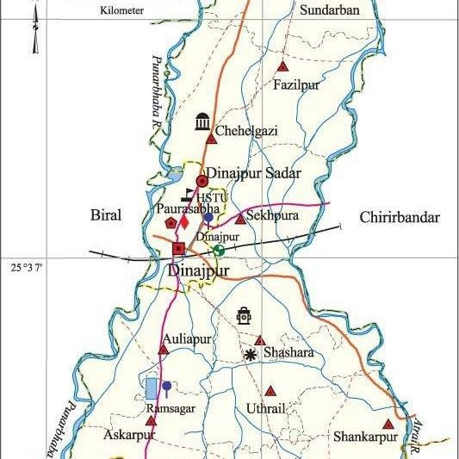

Map 1: The experimental area

Table 1. Effects of different level of Zn and time of application on plant height (cm) at different DAT

Treatments | Plant height (cm)
Treatments | 25 DAT | 50 DAT | 75 DAT | At harvest
Zn1T1 | 22.35 b | 59.98 b | 81.08 b | 82.30 b
Zn1T2 | 26.30a | 61.55 b | 80.67 b | 88.40ab
Zn1T3 | 26.27a | 63.10 ab | 79.89 b | 84.71ab
Zn2T1 | 23.85ab | 63.30 ab | 82.82 ab | 87.67ab
Zn2T2 | 24.29ab | 60.38 b | 80.24 b | 87.70ab
Zn2T3 | 24.98ab | 61.40 b | 79.83 b | 88.50ab
Zn3T1 | 24.06ab | 60.97 b | 82.23 ab | 91.67a
Zn3T2 | 25.92a | 61.68 b | 79.88 b | 88.03ab
Zn3T3 | 25.62ab | 60.02b | 79.90 b | 83.63 b
Zn4T1 | 24.17ab | 61.80b | 81.85 b | 87.80 ab
Zn4T2 | 23.25ab | 66.25a | 86.38 a | 87.37
Zn4T3 | 23.85ab | 63.28ab | 82.15ab | 89.33 ab
LSD | 3.048 | 3.615 | 4.888 | 6.456
CV % | 7.33 | 3.44 | 3.55 | 4.37
Here, LSD = Least Significant Difference, CV (%) = Coefficient of Variation, Zn1T1 = 0 g of zinc applied at 25 DAT, Zn3T1 = 10 g of zinc applied at 25 DAT, Zn1T2 = 0 g of zinc applied at 50 DAT, Zn3T2 = 10 g of zinc applied at 50 DAT, Zn1T3 = 0 g of zinc applied at 75 DAT, Zn3T3 = 10 g of zinc applied at 75 DAT, Zn2T1 = 5 g of zinc applied at 25 DAT, Zn4T1 = 15 g of zinc applied at 25 DAT, Zn2T2 = 5 g of zinc applied at 50 DAT, Zn4T2 = 15 g of zinc applied at 50 DAT, Zn2T3 = 5 g of zinc applied at 75 DAT, Zn4T3 = 15 g of zinc applied at 75 DAT

Table 2. Effects of different level of Zn on number of tillers hill⁻¹at different DAT
Treatments | At 25 DAT | At 50 DAT | At 75 DAT
Zn1T1 | 3.533 d | 22.63d | 16.00 b
Zn1T2 | 6.067 a | 25.13cd | 17.33ab
Zn1T3 | 5.133 ab | 24.47cd | 17.67ab
Zn2T1 | 3.800 bcd | 23.90cd | 17.67ab
Zn2T2 | 4.933 abc | 24.23cd | 17.00ab
Zn2T3 | 4.767 abcd | 24.47cd | 16.67ab
Zn3T1 | 3.633 cd | 31.02ab | 16.33ab
Zn3T2 | 4.433 bcd | 24.97cd | 17.00ab
Zn3T3 | 4.633bcd | 26.70 abcd | 17.33ab
Zn4T1 | 3.733cd | 25.83 bcd | 17.33ab
Zn4T2 | 4.333bcd | 29.84 abc | 18.67 a
Zn4T3 | 4.300bcd | 31.83 a | 16.33ab
LSD | 1.200 | 5.262 | 2.100
CV % | 15.95 | 9.65 | 7.26
Here, LSD = Least Significant Difference, CV (%) = Coefficient of Variation, Zn1T1 = 0 g of zinc applied at 25 DAT, Zn3T1 = 10 g of zinc applied at 25 DAT, Zn1T2 = 0 g of zinc applied at 50 DAT, Zn3T2 = 10 g of zinc applied at 50 DAT, Zn1T3 = 0 g of zinc applied at 75 DAT, Zn3T3 = 10 g of zinc applied at 75 DAT, Zn2T1 = 5 g of zinc applied at 25 DAT, Zn4T1 = 15 g of zinc applied at 25 DAT, Zn2T2 = 5 g of zinc applied at 50 DAT, Zn4T2 = 15 g of zinc applied at 50 DAT, Zn2T3 = 5 g of zinc applied at 75 DAT, Zn4T3 = 15 g of zinc applied at 75 DAT

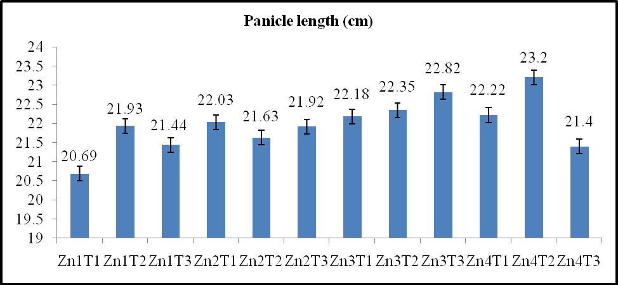

Figure 1 Effect of different levels of zinc on panicle length (cm) at different DAT
Here, LSD = Least Significant Difference, CV (%) = Coefficient of Variation, Zn1T1 = 0 g of zinc applied at 25 DAT, Zn3T1 = 10 g of zinc applied at 25 DAT, Zn1T2 = 0 g of zinc applied at 50 DAT, Zn3T2 = 10 g of zinc applied at 50 DAT, Zn1T3 = 0 g of zinc applied at 75 DAT, Zn3T3 = 10 g of zinc applied at 75 DAT, Zn2T1 = 5 g of zinc applied at 25 DAT, Zn4T1 = 15 g of zinc applied at 25 DAT, Zn2T2 = 5 g of zinc applied at 50 DAT, Zn4T2 = 15 g of zinc applied at 50 DAT, Zn2T3 = 5 g of zinc applied at 75 DAT, Zn4T3 = 15 g of zinc applied at 75 DAT

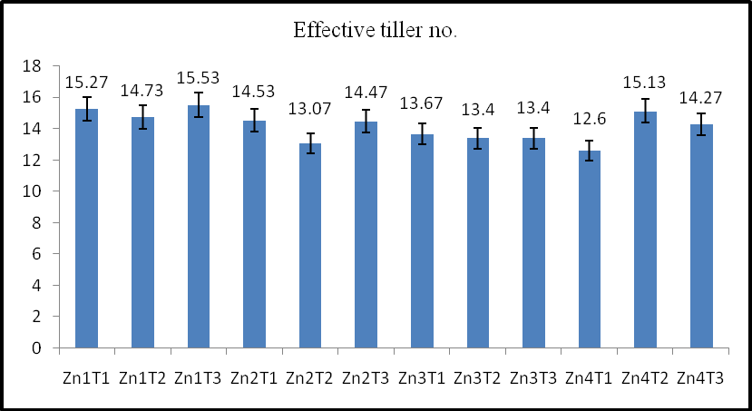

Figure 2. Effect of different levels of zinc on effective tillers hill⁻
Here, LSD = Least Significant Difference, CV (%) = Coefficient of Variation, Zn1T1 = 0 g of zinc applied at 25 DAT, Zn3T1 = 10 g of zinc applied at 25 DAT, Zn1T2 = 0 g of zinc applied at 50 DAT, Zn3T2 = 10 g of zinc applied at 50 DAT, Zn1T3 = 0 g of zinc applied at 75 DAT, Zn3T3 = 10 g of zinc applied at 75 DAT, Zn2T1 = 5 g of zinc applied at 25 DAT, Zn4T1 = 15 g of zinc applied at 25 DAT, Zn2T2 = 5 g of zinc applied at 50 DAT, Zn4T2 = 15 g of zinc applied at 50 DAT, Zn2T3 = 5 g of zinc applied at 75 DAT, Zn4T3 = 15 g of zinc applied at 75 DAT

Table 3. Effect of different level of zinc on non-effective tiller hill⁻¹, number of sterile grains panicle⁻¹ and number of grains panicle⁻¹
Treatments | Non-Effective Tiller  hill-1 | Number of grains panicle-1 | Number of sterile grains panicle-1
Zn1T1 | 1.600 bc | 94.10 b | 13.40 a
Zn1T2 | 1.600 bc | 107.8ab | 9.400c
Zn1T3 | 1.600 bc | 97.93ab | 10.27bc
Zn2T1 | 0.9333 d | 104.1ab | 9.467c
Zn2T2 | 1.933 ab | 103.0ab | 10.37bc
Zn2T3 | 2.133 a | 102.0ab | 11.73ab
Zn3T1 | 1.533 bc | 108.3ab | 9.067c
Zn3T2 | 2.133 a | 104.1ab | 9.500c
Zn3T3 | 1.633 abc | 110.4a | 8.333c
Zn4T1 | 1.233 cd | 104.9ab | 10.03bc
Zn4T2 | 1.000 d | 112.4a | 9.067c
Zn4T3 | 1.800 ab | 104.7ab | 8.467c
LSD | 0.4699 | 12.91 | 1.953
CV % | 14.45 | 7.30 | 11.62
Here, LSD = Least Significant Difference, CV (%) = Coefficient of Variation, Zn1T1 = 0 g of zinc applied at 25 DAT, Zn3T1 = 10 g of zinc applied at 25 DAT, Zn1T2 = 0 g of zinc applied at 50 DAT, Zn3T2 = 10 g of zinc applied at 50 DAT, Zn1T3 = 0 g of zinc applied at 75 DAT, Zn3T3 = 10 g of zinc applied at 75 DAT, Zn2T1 = 5 g of zinc applied at 25 DAT, Zn4T1 = 15 g of zinc applied at 25 DAT, Zn2T2 = 5 g of zinc applied at 50 DAT, Zn4T2 = 15 g of zinc applied at 50 DAT, Zn2T3 = 5 g of zinc applied at 75 DAT, Zn4T3 = 15 g of zinc applied at 75 DAT

Table 4. Effect of zinc fertilizer on thousand grain weight, total straw yield and biological yield
Treatments | Thousand grains  weight (g) | Total straw yield/plot | Biological yield
Zn1T1 | 20.96 b | 18.81 a | 24.29 abc
Zn1T2 | 21.31 b | 19.55 a | 26.06 a
Zn1T3 | 21.75ab | 14.65 ab | 20.01 bc
Zn2T1 | 21.78ab | 13.55 b | 18.95c
Zn2T2 | 21.75ab | 16.97 ab | 23.25 abc
Zn2T3 | 21.18 b | 19.04 a | 25.97 a
Zn3T1 | 22.07ab | 16.89 ab | 22.86 abc
Zn3T2 | 21.92ab | 17.83 ab | 24.99 ab
Zn3T3 | 22.12ab | 16.01 ab | 22.99 abc
Zn4T1 | 21.52 b | 15.52 ab | 21.44 abc
Zn4T2 | 23.02 a | 18.25 ab | 25.44 ab
Zn4T3 | 21.24 b | 16.17 ab | 21.99 abc
LSD | 1.283 | 4.210 | 4.853
CV % | 3.50 | 14.68 | 12.36

Here, LSD = Least Significant Difference, CV (%) = Coefficient of Variation, Zn1T1 = 0 g of zinc applied at 25 DAT, Zn3T1 = 10 g of zinc applied at 25 DAT, Zn1T2 = 0 g of zinc applied at 50 DAT, Zn3T2 = 10 g of zinc applied at 50 DAT, Zn1T3 = 0 g of zinc applied at 75 DAT, Zn3T3 = 10 g of zinc applied at 75 DAT, Zn2T1 = 5 g of zinc applied at 25 DAT, Zn4T1 = 15 g of zinc applied at 25 DAT, Zn2T2 = 5 g of zinc applied at 50 DAT, Zn4T2 = 15 g of zinc applied at 50 DAT, Zn2T3 = 5 g of zinc applied at 75 DAT, Zn4T3 = 15 g of zinc applied at 75 DAT

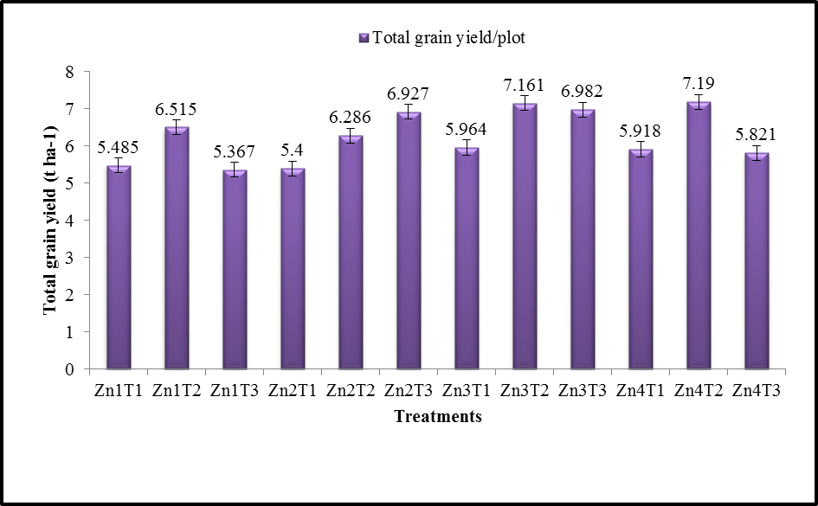

Figure 3. Effect of different level of fertilizers on grain yield (t/ha)

Here, LSD = Least Significant Difference, CV (%) = Coefficient of Variation, Zn1T1 = 0 g of zinc applied at 25 DAT, Zn3T1 = 10 g of zinc applied at 25 DAT, Zn1T2 = 0 g of zinc applied at 50 DAT, Zn3T2 = 10 g of zinc applied at 50 DAT, Zn1T3 = 0 g of zinc applied at 75 DAT, Zn3T3 = 10 g of zinc applied at 75 DAT, Zn2T1 = 5 g of zinc applied at 25 DAT, Zn4T1 = 15 g of zinc applied at 25 DAT, Zn2T2 = 5 g of zinc applied at 50 DAT, Zn4T2 = 15 g of zinc applied at 50 DAT, Zn2T3 = 5 g of zinc applied at 75 DAT, Zn4T3 = 15 g of zinc applied at 75 DAT

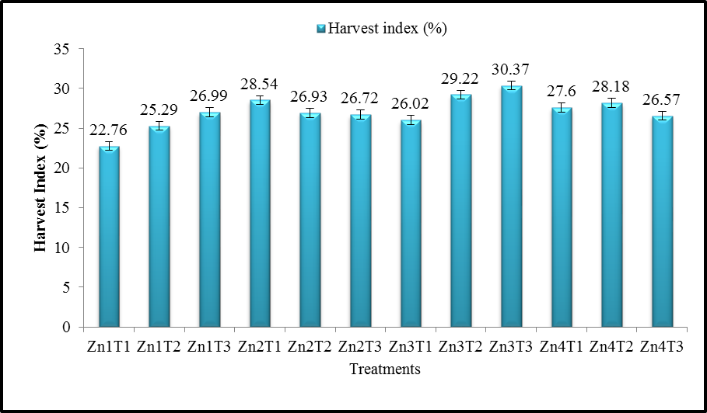

Figure 4. Effect of different level of fertilizers on harvest index

Here, LSD = Least Significant Difference, CV (%) = Coefficient of Variation, Zn1T1 = 0 g of zinc applied at 25 DAT, Zn3T1 = 10 g of zinc applied at 25 DAT, Zn1T2 = 0 g of zinc applied at 50 DAT, Zn3T2 = 10 g of zinc applied at 50 DAT, Zn1T3 = 0 g of zinc applied at 75 DAT, Zn3T3 = 10 g of zinc applied at 75 DAT, Zn2T1 = 5 g of zinc applied at 25 DAT, Zn4T1 = 15 g of zinc applied at 25 DAT, Zn2T2 = 5 g of zinc applied at 50 DAT, Zn4T2 = 15 g of zinc applied at 50 DAT, Zn2T3 = 5 g of zinc applied at 75 DAT, Zn4T3 = 15 g of zinc applied at 75 DAT

