Economic and Environmental Evaluation of IoT-Based Smart Irrigation Systems for Rice Cultivation in South Korea
Abstract :
Rice serves as a primary food source for more than half of the world’s population, but its production demands large amounts of water, raising concerns about food security. This study examines the impact of IoT-enabled smart irrigation systems (MIS) in South Korea, focusing on paddy field areas and rice yields across different provinces. Implementation of MIS led to a 20–50% reduction in water usage, up to an 88% decrease in labor requirements, and lower fuel and energy consumption, while boosting rice yields by around 39% and reducing the water footprint per unit of production by 29%. Despite these benefits, high initial costs and technical complexity may limit adoption among small-scale farmers. Overall, the results highlight the potential of MIS to enhance economic efficiency, environmental sustainability, and productivity, contributing to climate-smart and sustainable rice cultivation.

1. Introduction
Only around 0.01% of the Earth's water is readily accessible for human use, underscoring the extreme scarcity of water resources. As a result, conserving water in agriculture has become a pressing global challenge. Rice, in particular, is a staple for more than half of the world’s population and requires a large volume of water for cultivation (Vijayakumar et al., 2022). Rising water demand in rice-growing regions, coupled with limited availability, poses a significant threat to food security. With agriculture accounting for roughly 70% of global freshwater use, intensive groundwater extraction and the energy needed for irrigation impose a substantial burden on farmers, particularly in arid and semi-arid areas (Udimal et al., 2017; Sarker et al., 2021).
Since the pre-industrial era, atmospheric CO₂ levels have climbed from 250–300 ppm to over 410 ppm after 2020. This rise in greenhouse gases drives climate change, affecting agricultural water availability through shifts in precipitation, temperature increases, and more frequent extreme weather events. Higher temperatures accelerate evaporation, lower soil moisture, and can exacerbate drought conditions. Additionally, industrialization, urbanization, water pollution, and land-use changes intensify competition for freshwater, further straining supply (Teng et al., 2011; Surendran et al., 2021; Vijayakumar et al., 2021).
Traditionally, paddy field irrigation has been managed manually, requiring farmers to operate water gates on-site. This approach poses challenges, especially during hot summers, making coordinated water management difficult. Conflicts may arise when multiple farmers compete for water, and fieldwork during the rainy season can be hazardous. Furthermore, rice cultivation is a notable source of methane, a greenhouse gas with more than 25 times the global warming potential of CO₂. Methane emissions tend to increase with deeper water levels, highlighting the need for careful water depth management to mitigate environmental impacts.
In response, IoT-based smart irrigation systems have gained attention, enabling farmers to manage water levels remotely and more precisely. These systems deliver water according to crop needs, enhancing irrigation efficiency while reducing water and energy consumption. Equipped with IoT sensors, farmers can monitor soil moisture, temperature, and humidity in real time and control irrigation equipment from a distance. Compared to conventional methods, automated smart irrigation can cut water wastage by up to 95%, whereas traditional irrigation may waste 20–70% of water (Pernapati, 2018; Rajkumar et al., 2017).
Nevertheless, the successful implementation of smart irrigation depends on farmer acceptance, cost-effectiveness, and designs suited to local soil and climate conditions. This underscores the need for thorough evaluation and system optimization (García et al., 2020; Mallareddy et al., 2023). Recent advances in IoT technology have greatly enhanced the potential for developing smart irrigation solutions by enabling real-time data collection and analysis of crops and farming infrastructure, facilitating efficient resource use and optimized water and energy management (López et al., 2021).
Against this backdrop, the present study investigates the design and feasibility of IoT-based smart irrigation systems and proposes strategies to enhance both water and energy efficiency in agriculture. The goal is to identify practical solutions that support sustainable agricultural production while addressing the global challenges of climate change and limited freshwater availability.

2. Current Status of Rice Cultivation and Irrigation Management and Prospects for Smart Irrigation Adoption
2.1. Status of Paddy Rice Cultivation Area and Farmland Area by Province
In this study, the 2024 paddy rice cultivation area and farmland area by province in South Korea were examined (Fig. 1), and their impact on polished rice yield was analyzed (Fig. 2). The results indicate that rice cultivation is heavily concentrated in Jeollanam-Do, Chungcheongnam-Do, and Jeollabuk-Do. Among these, Jeollanam-Do had the largest areas with a cultivation area of 147,714 ha (129,000 ha in 2025) and a farmland area of 161,878 ha, followed by Chungcheongnam-Do (129,786 ha cultivation; 139,686 ha farmland) and Jeollabuk-Do (104,343 ha cultivation; 121,610 ha farmland) (KOSIS, 2024). Correlation analysis showed strong relationships between farmland area and polished rice yield (r = 0.9945) and between cultivation area and yield (r = 0.9955), indicating that larger cultivation areas generally correspond to higher production.
In the major rice-producing provinces, over 85% of farmland is allocated to paddy rice, reflecting a rice-centric agricultural structure. High productivity in these regions is supported by favorable soil quality, adequate water resources, suitable climate conditions, and well-established infrastructure. In contrast, urban areas and Jeju Island, with smaller cultivation areas and lower farmland utilization, do not maintain such a rice-centered structure.
Extensive rice cultivation translates into high irrigation demand, making efficient water management directly relevant to economic outcomes in agriculture. Rice farming typically relies on substantial freshwater irrigation, during which over-irrigation, water losses, and methane emissions can occur. As previously noted, smart irrigation technologies have been shown to reduce water wastage by up to 95% compared with conventional methods. Similar patterns have been observed in ongoing water management studies in Uiryeong, Gyeongsangnam-Do, where traditional irrigation reportedly wastes 20–70% of water (Pernapati, 2018).
In South Korea, average paddy field sizes are approximately 2,700 m² or 5,000 m². For larger fields (5,000 m²), introducing IoT-based irrigation systems is expected not only to decrease water and labor inputs but also to enhance yield potential. For small- to medium-sized fields, 3–4 fields can be managed per unit by utilizing elevation differences or, in flat terrain, a single water gate can control 3–4 fields. By implementing real-time soil moisture monitoring, automated irrigation control, and growth-stage-specific water management, unnecessary irrigation can be minimized, reducing labor and water use while maintaining or improving productivity.
In regions with extensive rice cultivation such as Jeollanam-Do and Chungcheongnam-Do, smart irrigation technology can contribute to water conservation and support carbon-neutral farming. Additionally, IoT-based systems can be integrated with techniques like Alternate Wetting and Drying (AWD) and precision water management, evolving into climate-resilient agricultural practices.
Fig. 1. Status of paddy rice cultivation area and farmland area by province in South Korea, 2024 (KOSIS, 2024)

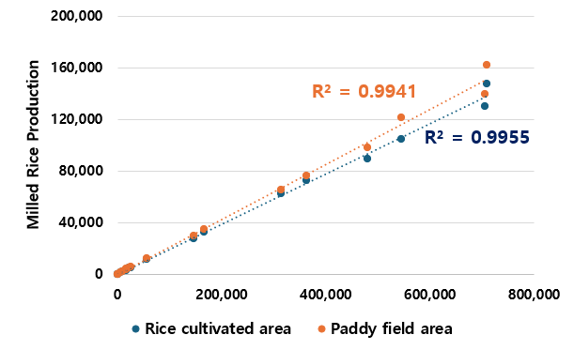
Fig. 2. Correlation between cultivation/farmland area and polished rice yield by province (KOSIS, 2024)

2.2. Current Status of Water Management and Prospects for Smart Irrigation Adoption
Analysis of paddy irrigation volumes by province in 2022 (Fig. 3) revealed that Jeollanam-Do recorded the highest water usage at 2,294,306 × 1,000 m³ per year, followed by Chungcheongnam-Do with 1,847,975 × 1,000 m³ and Jeollabuk-Do with 1,671,375 × 1,000 m³ (KOSIS, 2022). These findings suggest that provinces with larger cultivation and farmland areas require greater amounts of irrigation water.

Figure 4 summarizes the frequency and duration of water management activities per week (KOSIS, 2024). About 37% of farms managed irrigation fewer than three times weekly, 39% did so three to six times, and 10.5% six times or more, indicating that most farmers irrigate roughly three to six times per week. Regarding time spent on irrigation, 43.5% of farms devoted one to three hours per week, followed by three to five hours (16%) and five to ten hours (12%). Some farms required more than six irrigation events or over 20 hours per week, demonstrating that the labor burden varies depending on field size and regional conditions.

During the cultivation season, the average labor input for water management in paddy fields was estimated at 15.2 days per person per hectare, representing approximately 11.7% of total working hours (Jung et al., 1995). For upland crops, studies indicate an average of 8.5 labor hours per unit area for irrigation, indirectly confirming that rice cultivation also entails substantial labor demands (Heitkämper et al., 2015).

Consequently, in areas with extensive rice cultivation, both water usage and labor requirements are high, highlighting the importance of efficient water management for maintaining agricultural profitability and productivity. The implementation of sensor-based real-time soil moisture monitoring, automated irrigation control, and growth-stage-specific water scheduling can minimize unnecessary irrigation, reduce labor and water consumption, and sustain or even enhance crop yields.
Fig. 3. Irrigation Water Use by Province in South Korea (KOSIS, 2022)
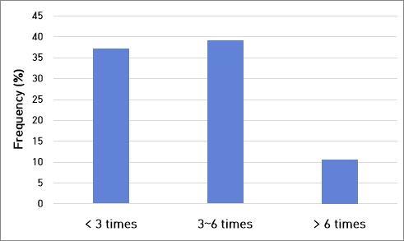

Fig. 4. Weekly frequency and duration of water management activities (RDA, 2025)
2.3. Evolution of Irrigation and Drainage Systems in Korean Rice Cultivation
Historically, farmers managed paddy irrigation by manually digging water channels on bunds using shovels or similar tools. With the introduction of chemical products and nylon materials, items such as fertilizer bags or plastic sheets were also employed to control irrigation and drainage. These approaches, however, were labor-intensive and made precise water-level management challenging. Up until roughly a decade ago, more advanced systems incorporating stainless steel water gates were used. In recent years, IoT-based irrigation systems leveraging remote sensing technology have been developed and tested, allowing a single farmer to simultaneously manage irrigation and drainage for anywhere from 20 to 100 paddy fields.
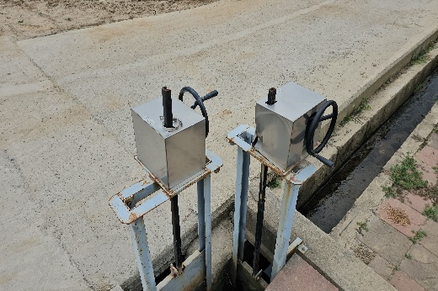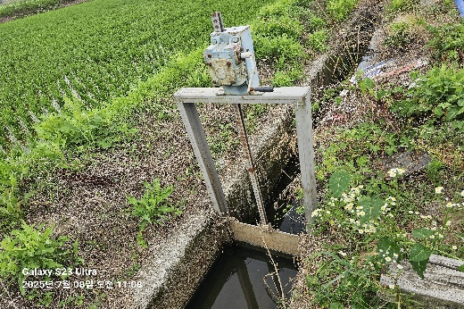
Fig. 5. Conventional mid-separating manual device (left) and individual water irrigation gate in Milyang-City, Korea.
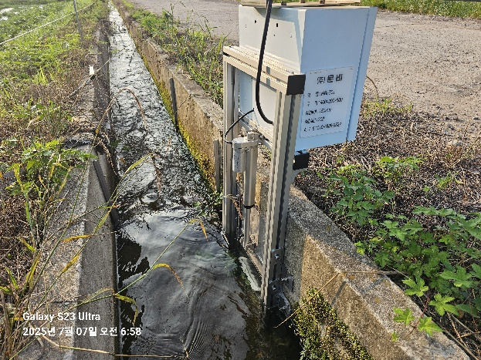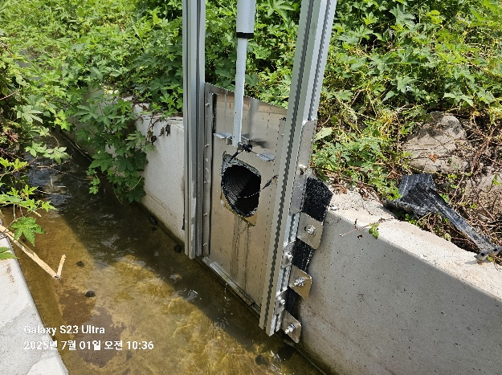
Fig. 6. Smart IoT based irrigation and drainage system in Uiryung-Gun, Korea.
3. Efficiency, Economic, and Environmental Benefits of IoT-Based Smart Irrigation Systems
Traditional rice cultivation has often relied on continuously flooding entire paddy fields, which results in excessive water, labor, and energy consumption and leads to high costs relative to productivity (Kumar et al., 2019). Such unnecessary flooding also increases fuel use, labor demands, and greenhouse gas emissions (Siopongco et al., 2013; Nalley et al., 2015).
In contrast, IoT-enabled smart irrigation systems (MIS) employ soil moisture and water-level sensors, automated valves, and remote monitoring technologies to assess field conditions and weather in real time, allowing irrigation to be precisely adjusted according to crop growth stages. This approach minimizes over-irrigation, reducing water use by 20–50% compared with conventional methods (Kazuyuki Yagi et al., 1996). Fuel consumption per growing season has been reported to decrease by up to 30 L ha⁻¹ (Siopongco et al., 2013). Automated water management also substantially lowers labor requirements, with reductions of 82–88% for flush irrigation and up to 57% for traditional flooding (Binayao et al., 2024; Smarter Irrigation for Profit, 2021), alleviating labor burdens significantly.
Laphatphakkhanut et al. (2021) reported that MIS can increase yields by roughly 39% compared to conventional flooding while using less water. The water footprint per ton of rice was 2,343 m³ under MIS, approximately 29% lower than the 3,310 m³ per ton observed with traditional irrigation. These improvements reflect the system’s capacity to reduce unnecessary water loss and maintain optimal water levels, even during high-temperature periods, thereby enhancing both productivity and resource efficiency.
Additionally, real-time monitoring and automated alerts enable farmers to promptly identify and resolve irrigation issues, reducing costs associated with management errors. Dependence on manual labor is also decreased, allowing optimal water management that supports higher yields and improved crop quality. Overall, automated irrigation systems not only conserve labor, water, and energy but also contribute to long-term farm profitability (Masseroni et al., 2017).
In summary, IoT-based smart irrigation offers clear advantages over conventional flooding, including improved water conservation, labor and energy efficiency, enhanced productivity, and greater climate resilience, highlighting its potential as a sustainable solution for rice cultivation and agricultural water management.

4. Economic Evaluation and Cost–Benefit Analysis of MIS
Although IoT-based smart irrigation systems (MIS) involve initial installation costs, the resulting reductions in water, labor, and energy usage can offset these expenses, leading to lower long-term operational costs and improved farm profitability (Palis et al., 2004; Kumar et al., 2019). MIS proves especially cost-effective in areas where water scarcity and energy costs are significant concerns. Additionally, minimizing over-irrigation helps reduce greenhouse gas emissions, such as methane, supporting climate-smart agricultural practices (Siopongco et al., 2013; Nalley et al., 2015; Bwire et al., 2024).
For instance, Champness et al. (2023) reported that in Australia, the initial cost of installing a smart irrigation system was approximately AUD 700 per hectare, while annual savings ranged from AUD 1,600 to 2,000 per hectare, resulting in a payback period of about one year. This demonstrates the technology’s short-term economic feasibility.
In conventional gravity-fed surface irrigation, farmers spend roughly 40% of their daily working hours operating water gates to maintain paddy water levels (Sekozawa, 2010), which increases the need for hired labor and associated costs. In contrast, automated and remotely controlled systems greatly reduce repetitive management tasks, leading to significant labor savings. Platforms such as BayDrive and FarmConnect® also enhance water-use efficiency and limit unnecessary water runoff, further lowering irrigation costs (Gonçalves et al., 2011; Smith et al., 2016).
The economic advantages of MIS can be more rigorously assessed through cost–benefit and sensitivity analyses that take into account factors such as farm size and fluctuations in water and energy prices. These evaluations enable farmers and policymakers to make more informed decisions regarding technology adoption.
Conclusion
IoT-based smart irrigation systems provide distinct economic and environmental benefits over traditional irrigation methods, including savings in water, labor, and energy, higher productivity, economic feasibility, and enhanced climate resilience. These benefits emphasize the potential of MIS as a central tool for sustainable rice cultivation and agricultural water management, while economic assessments of MIS adoption can directly inform policy decisions related to national food security and climate-smart agriculture.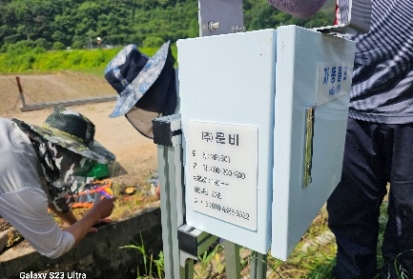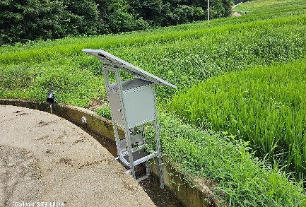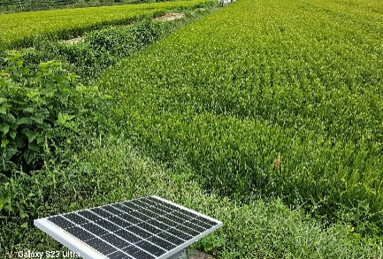
Fig. 7. Installation of IoT-based irrigation systems in Geochang, Uiryeong, and Hamyang.

5. Limitations of IoT-Based Smart Irrigation Systems and Future Research Directions
IoT-based smart irrigation systems provide notable benefits, including water savings, reduced labor and energy requirements, and higher crop productivity. Nevertheless, several challenges remain. Most previous studies have focused on countries such as India, China, and the United States, and their applicability across a wide range of agricultural environments has not been extensively validated (Abdelmoneim et al., 2025). Research has largely concentrated on technical components, such as sensor technologies, communication protocols, and automation frameworks. Furthermore, effective IoT-based decision-making depends on comprehensive, high-quality datasets; however, in some regions, limited information on soil moisture, weather, and crop growth can reduce the accuracy of predictive models.
High initial costs for devices, sensors, communication infrastructure, and computing resources can discourage adoption among small-scale farmers. The technical complexity of installation and maintenance requires specialized knowledge, which can be a financial and operational burden for smallholders. Continuous operation can also be impeded by constraints such as sensor power limitations, battery life, and unstable electricity or internet connections in remote areas. Additionally, unpredictable factors like extreme weather events, pest or disease outbreaks, and compatibility issues with existing irrigation infrastructure can limit system performance. Cybersecurity risks, as well as data privacy and protection concerns, further complicate widespread adoption (A. Villa-Henriksen et al., 2020; K. Obaideen et al., 2022; Ghareeb et al., 2023).
Future research should address these challenges by integrating IoT systems with emerging technologies such as AI, edge computing, and blockchain, creating more adaptive and predictive irrigation solutions. Empirical validation across diverse agricultural contexts and interdisciplinary collaboration will be essential to develop scalable systems. Studies should also examine the effects of IoT-based irrigation on crop physiology, nutrient status, and soil health, while continuously refining the systems to maximize water and energy efficiency and support sustainable water management. Evaluating cost-effectiveness for small-scale farmers and designing support strategies informed by policy measures will be crucial. These efforts will help advance the practical implementation of smart irrigation technologies and promote long-term agricultural sustainability.

Disclaimer (Artificial intelligence)

Option 2:

Author(s) hereby declare that generative AI technologies such as Large Language Models, etc. have been used during the writing or editing of manuscripts. This explanation will include the name, version, model, and source of the generative AI technology and as well as all input prompts provided to the generative AI technology

Details of the AI usage are given below:
1. ChatGPT-5

References

Abdelmoneim, A. A., Kimaita, H. N., Al Kalaany, C. M., Derardja, B., Dragonetti, G., & Khadra, R. (2025). IoT sensing for advanced irrigation management: A systematic review of trends, challenges, and future prospects. Sensors (Basel, Switzerland), 25(7), 2291.
A. Villa-Henriksen, G. T. Edwards, L. A. Pesonen, O. Green, and C. A. G. Sørensen, "Internet of Things in arable farming: Implementation, applications, challenges and potential," Biosystems engineering, vol. 191, pp. 60-84, 2020.
BDA Group. 2007. Cost benefit analyses of research funded by the CRDC. Report to Cotton Research and Development Corporation, BDA Group, Manuka, ACT, Australia. Available from: http://www.crdc.com.au/sites/default/files/pdf/BDA% 20FINAL%20Hero%20Report%20(5-11).pdf
Binayao, R. P., Mantua, P. V. L., Namocatcat, H. R. M. P., Seroy, J. K. K. B., Sudaria, P. R. A. B., Gumonan, K. M. V. C., & Orozco, S. M. M. (2024). Smart water irrigation for rice farming through the Internet of Things. arXiv preprint arXiv:2402.07917.
Bwire, D., Saito, H., Sidle, R. C., & Nishiwaki, J. (2024). Water management and hydrological characteristics of paddy-rice fields under alternate wetting and drying irrigation practice as climate smart practice: a review. Agronomy, 14(7), 1421.
Champness, M., Vial, L., Ballester, C., & Hornbuckle, J. (2023). Evaluating the performance and opportunity cost of a smart-sensed automated irrigation system for water-saving rice cultivation in temperate Australia. Agriculture, 13(4), 903.
Garcia, L.; Parra, L.; Jimenez, J.M.; Lloret, J.; Lorenz, P. IoT-based smart irrigation systems: An overview on the recent trends on sensors and IoT systems for irrigation in precision agriculture. Sensors 2020, 20, 1042.
Ghareeb, A. Y., Gharghan, S. K., Mutlag, A. H., & Nordin, R. (2023). Wireless sensor network-based artificial intelligent irrigation system: Challenges and limitations. Journal of Techniques, 5(3), 26-41.
Gillies M.H., Smith R.J. 2015. SISCO: surface irrigation calibration and optimisation. Irrig. Sci. 33:339-55.
Gonçalves J.M., Pereira L.S. 2009. Decision support system for surface irrigation design. J. Irrig. Drain. Eng. 135:343-56.
Heitkämper, K., Stehle, T., & Schick, M. (2015). Working time requirement for different field irrigation methods. International Journal of Agricultural Management, 4(2), 50-54.
Kazuyuki Yagi, Ken-ichi Kanda and Katsuyuki Minami,1996. Effect of water management on methane emission from a Japanese rice paddy field: Automated methane monitoring. Global biogeochemical cycles.10 (2): 255-267.
K. Obaideen, B. A. Yousef, M. N. AlMallahi, Y. C. Tan, M. Mahmoud, H. Jaber, and M. Ramadan, "An overview of smart irrigation systems using IoT," Energy Nexus, p. 100124, 2022.
Kumar, K. A., & Rajitha, G. (2019). Alternate wetting and drying (AWD) irrigation-a smart water saving technology for rice: a review. International Journal of Current Microbiology and Applied Sciences, 8(3), 2561-2571.
Lampayan, M.R.; Yadav, S.; Humphreys, E. Saving Water with Alternate Wetting Drying (AWD). International Rice Research Institute (IRRI). 2005. Available online: http://www.knowledgebank.irri.org/training/fact-sheets/water-management/savingwater-alternate-wetting-drying-awd (accessed on 3 February 2023).
Laphatphakkhanut, R., Puttrawutichai, S., Dechkrong, P., Preuksakarn, C., Wichaidist, B., Vongphet, J., & Suksaroj, C. (2021). IoT-based smart crop-field monitoring of rice cultivation system for irrigation control and its effect on water footprint mitigation. Paddy and Water Environment, 19(4), 699-707.
López-Morales, J. A., Martínez, J. A., & Skarmeta, A. F. (2021). Improving energy efficiency of irrigation wells by using an iot-based platform. Electronics, 10(3), 250.
Masseroni, D., Uddin, J., Tyrrell, R., Mareels, I., Gandolfi, C., & Facchi, A. (2017). Towards a smart automated surface irrigation management in rice-growing areas in Italy. Journal of Agricultural Engineering, 47(585), 42-48.
National Water Resources Management Information System (2025). Irrigation Water Use for Paddy and Dryland Fields (2022). https://www.wamis.go.kr/wks/wks_flndwaa_lst.do
Nalley, L.L.; Linquist, B.; Kovacs, K.F.; Anders, M.M. The economic viability of alternate wetting and drying irrigation in Arkansas rice production. Agron. J. 2015, 107, 579–587.
Palis, F.G., Cenas, P.A., Bouman, B.A.M., Lampayan, R.M., Lactaoen, A.T., Norte, T.M., Vicmudo, V.R., Hossain, M and Castillo, G.T. 2004. A farmer participatory approach in the adaptation and adoption of controlled irrigation for saving water: a case study in Canarem, Victoria, Tarlac, Philippines. Philippine Journal of Crop Science. 29(3): 280-288.
Pernapati, K. (2018, April). IoT based low cost smart irrigation system. In 2018 Second International Conference on Inventive Communication and Computational Technologies (ICICCT) (pp. 1312-1315). IEEE.
Rajkumar, M. N., Abinaya, S., & Kumar, V. V. (2017, March). Intelligent irrigation system—An IOT based approach. In 2017 International Conference on Innovations in Green Energy and Healthcare Technologies (IGEHT) (pp. 1-5). IEEE.
Rural Development Administration (2025). Development of simple automatic water gates for paddy water management [PDF]. Accessed 20 August 2025.
Sarker, B.; Keya, K.N.; Mahir, F.I.; Nahiun, K.M.; Shahida, S.; Khan, R.A. Surface and ground water pollution: Causes and effects of urbanization and industrialization in South Asia. Sci. Rev. 2021, 7, 32&#8211;41.
Sekozawa T. 2010. A fully automated water management system for large rice paddies. Proceedings of the 14th WSEAS International Conference on Systems: part of the 14th WSEAS CSCC multiconference. World Scientific and Engineering
Statistics Korea (2024). Agricultural Area Survey. Area of paddy rice cultivation by city/county. Accessed 20 August 2025
Statistics Korea (2024). Agricultural Area Survey. National (by province) area of paddy and dryland fields. Accessed 20 August 2025.
Statistics Korea (2024). Crop Production Survey. Rice production (milled rice, 92.9%). Accessed 20 August 2025.
Academy and Society (WSEAS), Stevens Point, WI, USA, I:325-330.
Siopongco, J.D.L.C.; Wassmann, R.; Sander, B.O. Alternate Wetting and Drying in Philippine Rice Production: Feasibility Study for a Clean Development Mechanism; IRRI Technical Bulletin No. 17; International Rice Research Institute: Los Banos, Philippines, 2013; 18p.
Smarter Irrigation for Profit. Smart Irrigation Control in Rice Growing Systems. Smarter Irrigation for Profit Phase II Fact Sheet:Rice. Available online: https://smarterirrigation.com.au/wp-content/uploads/2021/08/Smart-Irrigation-control-inrice-growing-systems_Case-Study_July-2021.pdf (accessed on 6 June 2022).
Smith R.J., Uddin J.M, Gillies M.H., Moller P., Clurey K. 2016. Evaluating the performance of automated bay irrigation. Irrig. Sci. [In press].
정하우, 이남호, 김성준, 최진용, 한형근 & 김대식. (1995). 자동물꼬의 개발. 한국농공학회지, 37(1), 49-54
Surendran, U.; Raja, P.; Jayakumar, M.; Subramoniam, S.R. Use of efficient water saving techniques for production of rice in India under climate change scenario: A critical review. J. Clean. Prod. 2021, 309, 127272.
Takayoshi, Y.; Tuan, L.M.; Kazunori, M.; Shigeki, Y. Alternate Wetting and Drying (AWD) Irrigation Technology Uptake in Rice Paddies of the Mekong Delta, Vietnam: Relationship between Local Conditions and the Practiced Technology. Asian Afr. Area Stud. 2016, 15, 234–256.
Teng, Y.; Yang, J.; Zuo, R.; Wang, J. Impact of urbanization and industrialization upon surface water quality: A pilot study of Panzhihua mining town. J. Earth Sci. 2011, 22, 658&#8211;668.
Touil, S., Richa, A., Fizir, M., Argente Garcia, J. E., & Skarmeta Gomez, A. F. (2022). A review on smart irrigation management strategies and their effect on water savings and crop yield. Irrigation and Drainage, 71(5), 1396-1416.
Udimal, T.B.; Jincai, Z.; Ayamba, E.C.; Owusu, S.M. China’s water situation; the supply of water and the pattern of its usage. Int. J. Sustain. Built Environ. 2017, 6, 491&#8211;500.
Van der Lelij, A. Causes and Effect of Deep Percolation Losses in the Murrumbidgee Region. In Irrigation Efficiency Seminar; Australian National Committee International Commission on Irrigation and Drainage: Sydney, Australia, 1979; pp. 1-8
Vijayakumar, S.; Nayak, A.K.; Ramaraj, A.P.; Swain, C.K.; Geethalakshmi, V.; Pazhanivelan, S.; Tripathi, R.; Sudarmanian, N.S. Rainfall and temperature projections and their impact assessment using CMIP5 models under different RCP scenarios for the eastern coastal region of India. Curr. Sci. 2021, 121, 222.
Vijayakumar, S.; Kumar, D.; Ramesh, K.; Jinger, D.; Rajpoot, S.K. Effect of Potassium fertilization on water productivity, irrigation water use efficiency, and grain quality under direct seeded rice-wheat cropping system. J. Plant Nutr. 2022, 45, 2023&#8211;2038.

