Original Research Article
Forest and Identity: The Enduring Traditional Livelihood Practices of the Kukis in Kangpokpi District of Manipur, India.

ABSTRACT:
This paper attempts to assess the types, amount and uses of Non-Timber Forest Products (NTFPs) by the Kuki Community of Kangpokpi district of Manipur. The study finds that forest resources plays an integral part for the Kukis in maximum ways like other tribal groups of Indian sub-continent. Out of the total 43 different types of NTFPs collected by the Kuki community, 20 items are leaves, 7 items are wild fruits, 3 items are flower parts, 3 items are roots, 2 items shoot and fuel, and the remaining 5 items for other valuable parts. Mushroom is the most favourite NFTPs collected by the Kukis. This study adopts a qualitative research approach to explore the role of Non-Timber Forest Products (NTFPs) in the traditional livelihoods of the Kuki community in Kangpokpi District, Manipur. The methodology emphasizes ethnographic insights, participatory engagement, and in-depth understanding of socio-cultural and economic practices related to forest dependence. The study suggests that the Kuki ethnic community are more dependent on forest NTFPs due to historical factors, social and economic factors prevalent among the community.
Keywords: Non-Timber Forest Products, Kangpokpi, Kuki, Livelihood and Forest resources

1. INTRODUCTION
Ecosystems provide the foundation for all human survival as they provide the material support for life (Rees W. E. 2021). This becomes more pronounced among the rural poor who have a unique and special relationship with their particular habitat, as their harvest from forests, fisheries and farm fields are the primary source of income and sustenance all over the worldwide (UNDP, 2005). The rural poor often generate goods and services from their natural system such as forests, grasslands, lakes, rivers etc., besides agriculture (Wassie S. B., 2020). Forest resources are one of the most important economic resources for the rural population in India (Savita K. M et al, 2018) in general, and for the rural tribal population, in particular. It is interesting to note that for many decades, the forest resources have always been evaluated in terms of timber. It is from early 1990s that the role of Non-Timber Forest Products (NTFPs) for sustainable forest use and poverty alleviation has received worldwide attention (Peters et al. 1989). The term Non Timber Forest Products encompasses all biological materials other than timber which are extracted from forest for human use (Smith-Hall C et al, 2023). These include food, medicines, spices, essential oils, resin, gum, latexes, tannins, dyes, ornamental plants wildlife (products and live animals including fish), fuel wood and raw materials particularly rattans, bamboos, small woods and fibres. NTFPs play a vital role in the life of the tribal people and provide a source of cash income and support subsistence living (Peters et al. 1989; Hegde et al. 1996). However, the rural tribal people do not depend only on timber extraction from forests, in every respect, for their livelihood; but the livelihood of these people also depends upon the extraction of a large variety of Non-Timber Forest Products (Pandey et al, 2016). Forest resources plays an integral part for the Kuki Community in Kangpokpi district of Manipur in maximum ways like other tribal groups of Indian sub-continent. NTFPs have evolved from being mere survival resources to important components of rural livelihoods, offering both economic and cultural benefits, particularly for forest-dependent communities (Shanley et al., 2015).
In many developing countries, non-timber forest products (NTFPs) function as vital livelihood buffers for rural households, ensuring both subsistence and supplementary income during agricultural lean seasons or periods of economic vulnerability (FAO, 2000; Sarma et al, 2019). Beyond household consumption, their commercialization provides pathways for value addition, innovation in local markets, and livelihood diversification without the ecological costs associated with large-scale timber extraction (Shackleton & Pandey, 2014).
Despite these contributions, the economic and ecological role of NTFPs often remains undervalued, primarily because a large proportion of trade occurs informally and is not systematically captured in national statistics (Ros-Tonen, 1999; Shaanker et al, 2004). Additionally, unsustainable harvesting, insecure tenure, and unequal access to markets frequently undermine both conservation outcomes and fair benefit sharing, with consequences ranging from biodiversity decline to socio-economic disparities among forest-dependent populations (Pandey & Saini, 2007; Belcher & Schreckenberg, 2007).
Considering these complexities, there is a pressing need for rigorous and interdisciplinary inquiry into NTFPs. Such research should encompass ecological evaluations of resource distribution, systematic documentation of indigenous knowledge, and the design of sustainable harvesting practices. It should also focus on value-addition processes, market integration, and the development of equitable governance mechanisms and supportive policies. Collectively, these efforts can foster sustainable forest management, enhance rural livelihoods, and strengthen the adaptive capacity of forest-dependent communities.
2. GEOGRAPHICAL BACKGROUND OF THE STUDY AREA

Kangpokpi district is located in northern Manipur, India, bordered by Senapati district to the north, Imphal West and Imphal East to the south, Ukhrul to the east and Churachandpur to the west. It lies approximately between 24.8°N to 25.3°N latitude and 93.7°E to 94.1°E longitude, covering an area of about 1,698 sq. km. The district is part of the Indo-Myanmar border region, with rugged terrain dominated by the Barail and Naga hill ranges. Key rivers include the Iril and Leimatak which support agriculture in the valley areas. The elevation varies from 800 to 2,500 meters above sea level, contributing to its cool, subtropical climate. Predominantly inhabited by the Kuki tribes, along with Nagas and Meiteis, Kangpokpi is known for its rich tribal culture, terraced farming and forest resources. The district faces challenges like poor road connectivity, ethnic tensions and deforestation, but its potential lies in horticulture, eco-tourism and sustainable development. Kangpokpi town serves as the administrative hub, while other key settlements include T. Vaichong, Champhai and Saitu-Gamphazol.
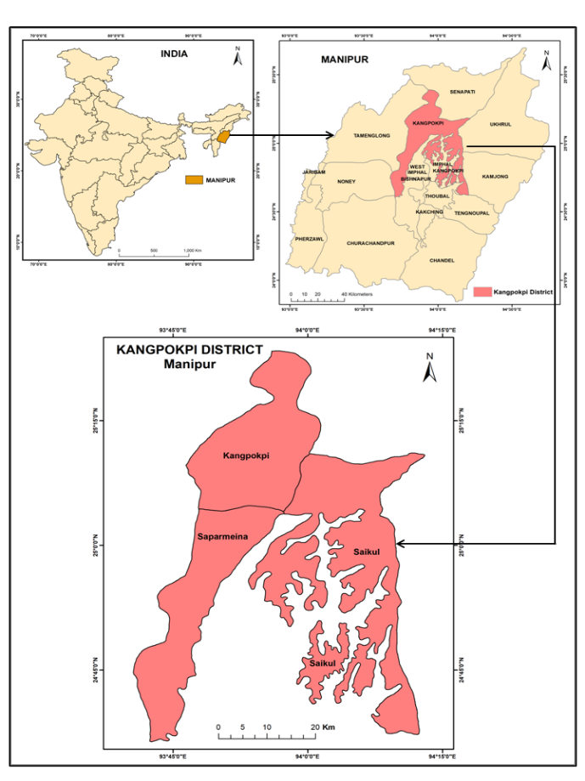

Fig. 1. Location map of the study area (Kangokpi district).

In Northeast India, many tribal communities rely heavily on forest resources for their livelihood. They depend on hunting, gathering fruits, herbs and medicinal plants, as well as shifting agriculture (Jhum cultivation). Forests provide food, fuelwood and materials for handicrafts and housing (Marchang R. 2018). However, deforestation and land-use changes threaten their traditional way of life. Sustainable forest management is crucial to preserve both biodiversity and tribal livelihoods in the region. Apart from Manipur, in Meghalaya, (Bora, D., & Mahanta, A. 2024) high dependency of forest resources by the Garo tribes can also be seen.
NTFPs play a vital role in India’s rural economy, providing livelihoods for millions, especially tribal and forest-dwelling communities (Uprety et al 2016). These include medicinal plants, bamboo, resins, gums, fruits, honey and wild spices, sourced from diverse forest ecosystems. NTFPs contribute to food security, traditional medicine and sustainable income while promoting biodiversity conservation (Talukdar et al, 2021). India is a major global supplier of products like tendu leaves, lac and amla (Mandal, 2022). Government initiatives like Van Dhan Yojana aim to enhance NTFP value chains, ensuring fair trade and ecological balance while supporting forest-dependent communities.
As mentioned earlier, the study is conducted among the Kuki Community of Kangpokpi district of Manipur. The district is mainly dominated by the Kukis and the Nagas. The Kukis constitute 71 per cent of the total population of the district, while Naga shares 16 per cent and the remaining 13 is shared by others. In terms of geography, Kangpokpi district is a hilly district, located in the north-central part of the state of Manipur. Kangpokpi district has a total geographical area of 1698 sq. km and lies between a geographical co-ordinate of 24⁰37’ N to 25⁰14’ N latitude and 93⁰29’ E to 94⁰07’ E longitude respectively. The district is bounded on the south by Imphal district, on the east by Ukhrul, on the west by Tamenglong and on the north by Senapati district. It is carved out from Senapati district in 2016. The headquarter of the district is Kangpokpi town which is located 45 km away from Imphal, the capital of the state. It lies on the Imphal-Dimapur road by the side of National Highway No. 2. The district is almost entirely hilly with elevation ranging from 388 m to 2831 m above mean sea level. The highest point in the district is Leikot with 2831 m above the mean sea level.
Three main types of forest cover are found in this district viz., open forest (70.78 %), dense forest (25.75) and scrub forest (2.65). Due to these rich forest cover areas, the Kuki Community who live in and around this forest practice collection of NTFPs as an important source of their livelihood.
3. METHODOLOGY
This study makes an attempt to assess the major types, amount and uses of Non-Timber Forest Products by the Kuki Community of Kangpokpi district of Manipur. Forest resources play an integral part for the Kukis in maximum ways like other tribal groups of Indian sub-continent. The NTFPs often termed as minor forest products are integral part of day-to-day livelihood activities of the tribal people of India (Saxena and Farrington 2003; Sarmah 2006; Saha and Sundriyal 2013).
The objective of the study is to assess the types, amount and uses of NTFPs among the Kuki Community of Kangpokpi district of Manipur. The study was conducted in three Kuki villages in Kangpokpi district of Manipur, viz. A. Songpijang, Haijang and Y. Langkhong belonging to three different administrative blocks Saitu-Gamphazol, Kangpokpi and Saikul respectively, which have high concentration of NTFPs utilization. The total number of Kuki households surveyed is 128. A stratified random sampling technique has been used. Based on the samples derived from these selected villages, an attempt has been made to achieve the objective of the study.
This study adopts a qualitative research approach to explore the role of Non-Timber Forest Products (NTFPs) in the traditional livelihoods of the Kuki community in Kangpokpi District, Manipur. The methodology emphasizes ethnographic insights, participatory engagement, and in-depth understanding of socio-cultural and economic practices related to forest dependence.
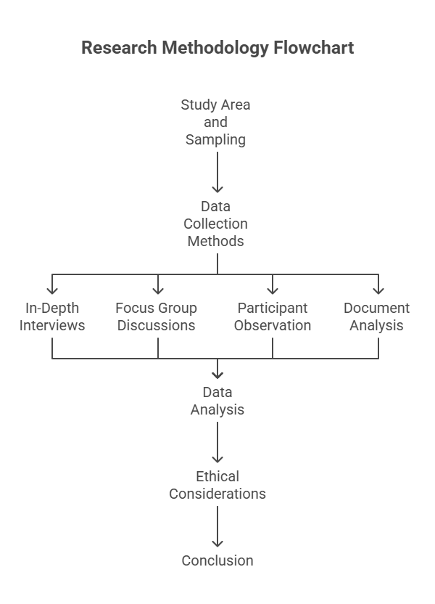
Fig. 2. Framework of Methodological Process.

The qualitative research approach to examine the role of Non-Timber Forest Products (NTFPs) in the traditional livelihoods of the Kuki community in Kangpokpi District, Manipur. Data was collected through in-depth interviews (30 - 40 key respondents), focus group discussions (4 - 6 FGDs) and participant observation to explore NTFP collection, usage and socio-economic significance. Purposive sampling ensured representation from elders, gatherers, women and traditional healers. Thematic analysis was applied to identify patterns in traditional knowledge, livelihood dependence and challenges like deforestation and policy impacts. Ethical considerations included prior informed consent and community engagement to ensure reciprocity. While the methodology provided deep cultural insights, limitations included potential subjectivity and seasonal variations in NTFP availability. The approach emphasized participatory and ethnographic methods to capture the community’s forest-based practices comprehensively​
4. RESULTS AND DISCUSSION
The study covers a wide range of the area which collected 43 different types of NTFPs from the Kuki Community in Kangpokpi district of Manipur. Table 1 shows the types and seasons of NTFPs collected by Kuki Community in Kangpokpi district.
Table 1. The types and seasons of NTFPs collected by Kuki Community
Sl. no | Name of the items | Local Name | Seasons
1 | Antung | Antung | Spring
2 | Arundinella Khaseana | Joumaotoi | Monsoon
3 | Asparagus Racemosus | Aipah | Spring
4 | BambusaTulda | Gotoi | Monsoon
5 | Banana Flower | Naagai | Throughout
6 | Bee-Hive | Khoiphang | Autumn
7 | Broom | Muntheh | Spring
8 | Calamustenuis | Tingga | Spring
9 | Centella Asiatica | Changkongche | Throughout
10 | Charcoal | Meitan | Winter
11 | Clorendrum colebrookianum | Anphui | Throughout
12 | Cycaspectinata | Lusu | Spring
13 | Drypteris marginate | Chekoh | Throughout
14 | Dysoxyllumgobara | Thingthupi | Monsoon
15 | Elaeocarpus floribandus | Chorpon | Spring
16 | Elatostema Sessile | Ansonglung | Throughout
17 | Entadascadens | Kangdo | Throughout
18 | Eryngium toetidum | Patikhom | Autumn
19 | Eurya acuminata | Sijou | Throughout
20 | Ficus aurilata | Theichang | Monsoon
21 | Ficus semicordata | Heirit | Throughout
22 | Firewood | Shing | Winter
23 | Grewia Nervosa | Heituk | Monsoon
24 | Hedychium Coronarium | Aigetil | Spring
25 | Honey | Khoi-hee | Spring
26 | Houttuynia cordata | Aithanglou | Throughout
27 | Kenbar | Kenbar | Spring
28 | Khaoche | Khaoche | Spring
29 | Kobuche | Kobuche | Spring
30 | Lengpumdo | Lengpumdo | Spring
31 | Lengtedo | Lengtedo | Spring
32 | Mimosa himalayansis | Khangkhu | Throughout
33 | Musa sapientum | Nachang | Throughout
34 | Mushroom | Mushroom | Monsoon
35 | Phynchotechum ellipticum | Chehlep | Throughout
36 | Phyllunthus emblica | Heigru | Winter
37 | Polygonum chinense | Theidonche | Throughout
38 | Rhushookeru | Khongma | Winter
39 | Spondias acuminata | Theikhongchom | Spring
40 | Thatch | Bi | Spring
41 | Trichosanthes cordata | Anthudul | Throughout
42 | Wendlandia glabra | Ahthipah | Spring
43 | Zanthoxylum acanthopodium | Lingnamse | Throughout

The different types of NTFPs collected are used for different purposes. Out of these 43 items, 20 items consist of leaves, 7 different items are fruits, 3 are flower parts, 3 items are roots, 2 items shoot, 2 for fuel wood, 1 item is stem and the remaining 5 items are not from plants but various insects as well as honey. Among these 43 different items, mushroom is the most favourite NTFP collected by the Kukis. Mushroom of varying edible sub-species is the most collected item among the Kukis (Haokip T. & Aiyadurai A. 2023).
Again, out of these 43 items collected by the Kukis, 45 per cent are leaves, 7 per cent from flowers, 2 per cent from stem, 5 per cent from shoots, 17 per cent from fruits, 7 per cent from roots, 5 per cent
Fig. 3. The various NTFPs collected by the Kuki Community

from fuel wood and 12 per cent from other valuable parts. Figure 2 shows the number of NTFPs collected by Kuki Community. The district is one of the populous area for the Kuki community since time immemorial Doungel T., Purkayastha S., & Haokip T. L. 2025). Apart from Kangpokpi, the rugged terrain (90 per cent hills and mountains) in Churachandpur district, where the Kuki population predominates, inhabitants there rely significantly on forest resources. They cultivate Jhum, gather fuelwood, timber and wild foods and use woods for traditional medicine, same like the Kangpokpi. However, their sustainable way of life is in danger due to land conflicts and deforestation (Haokip T. L., Gangte P. L., Prasad T. K., Haokip K., & Shah M. B. (2025).
With regard to the seasons of collection, most of the items are collected during spring season. About 37.22 per cent of the items are collected during spring season, and 34.89 per cent of the items are obtained throughout the year. 11.6 per cent of the NTFPs are gathered during monsoon, and about 9.3 per cent is collected during winter season and the remaining 6.99 per cent is gathered during autumn season.
4.1 The Amount and Uses Of NTFPS collected among the Kuki Community
The Kuki ethnic community collects the different NTFPs in different amount depending upon their various needs. Table 2 shows the amount and uses of NTFPs collected by Kuki Community in Kangpokpi district.
Table 2. The amount and uses of NTFPs collected among the Kuki Community
Sl. No | Name of the items | Local Name | Amount (in Kg) | Uses
1 | Antung | Antung | 105 | Consumption,  Commercial (food items)
2 | Arundinella Khaseana | Joumaotoi | 9024 | Consumption,  Commercial (food items)
3 | Asparagus Racemosus | Aipah | 2826 | Consumption,  Commercial (food items)
4 | Bambusa Tulda | Gotoi | 171 | Consumption,  Commercial (food items)
5 | Banana Flower | Naagai | 3906 | Consumption,  Commercial (food items)
6 | Bee-Hive | Khoiphang | 654 | Consumption,  Commercial (food items)
7 | Broom | Muntheh | 1239 | Commercial
8 | Calamus tenuis | Tingga | 360 | Consumption,  Commercial (food items)
9 | Centella Asiatica | Changkongche | 300 | Consumption,  Commercial (food items)
10 | Wood for Charcoal | Meitan | 5235 | Consumption,  Commercial (food items)
11 | Clorendrum colebrookianum | Anphui | 126 | Consumption,  Commercial (food items)
12 | Cycas pectinata | Lusu | 250 | Consumption,  Commercial (food items)
13 | Drypteris marginate | Chekoh | 100 | Consumption,  Commercial (food items)
14 | Dysoxyllum gobara | Thingthupi | 552 | Consumption,  Commercial (food items)
15 | Elaeocarpus floribandus | Chorpon | 350 | Consumption,  Commercial (food items)
16 | Elatostema Sessile | Ansonglung | 3522 | Consumption,  Commercial (food items)
17 | Entada scadens | Kangdo | 123 | Consumption,  Commercial (food items)
18 | Eryngium toetidum | Patikhom | 70 | Consumption,  Commercial (food items)
19 | Eurya acuminata | Sijou | 175 | Consumption,  Commercial (food items)
20 | Ficus aurilata | Theichang | 450 | Consumption,  Commercial (food items)
21 | Ficus semicordata | Heirit | 80 | Consumption,  Commercial (food items)
22 | Firewood | Shing | 559000 | energy
23 | Grewia Nervosa | Heituk | 120 | Consumption,  Commercial (food items)
24 | Hedychium Coronarium | Aigetil | 2280 | Consumption,  Commercial (food items)
25 | Honey | Khoi-hee | 205 | Medicine,  Commercial (food items)
26 | Houttuynia cordata | Aithanglou | 195 | Consumption,  Commercial (food items)
27 | Kenbar | Kenbar | 60 | Commercial (food items)
28 | Khaoche | Khaoche | 150 | Consumption,  (food items)
29 | Kobuche | Kobuche | 340 | Consumption,  Commercial (food items)
30 | Lengpumdo | Lengpumdo | 250 | Consumption,  Commercial (food items)
31 | Lengtedo | Lengtedo | 135 | Consumption,  Commercial (food items)
32 | Mimosa himalayansis | Khangkhu | 278 | Consumption,  Commercial (food items)
33 | Musa sapientum | Nachang | 15320 | Consumption,  Commercial (food items)
34 | Mushroom | Mushroom | 5891 | Consumption,  Commercial (food items)
35 | Phynchotechum ellipticum | Chehlep | 670 | Consumption,  Commercial (food items)
36 | Phyllunthus emblica | Heigru | 2650 | Consumption,  Commercial (food items)
37 | Polygonum chinense | Theidonche | 235 | Consumption,  Commercial (food items)
38 | Rhus hookeru | Khongma | 360 | Consumption,  Commercial (food items)
39 | Spondias acuminata | Theikhongchom | 500 | Consumption,  Commercial (food items)
40 | Thatch | Bi | 40 | Income, house construction
41 | Trichosanthes cordata | Anthudul | 430 | Consumption,  Commercial (food items)
42 | Wendlandia glabra | Ahthipah | 150 | Consumption,  Commercial (food items)
43 | Zanthoxylum acanthopodium | Lingnamse | 200 | Consumption,  Commercial (food items)

Among these different items collected, the largest amount of item collected is firewood. About 5.5 lakh kg of firewood is collected by the 128 sampled households. The second most collected item is musa sapientum which amounts to 15,320 kg by the sampled households. The third largest amount of item gathered is arundinella khaseana which is about 9024 kg. On the other hand, the least amount of NTFPs collected is thatch which is only about 40 kg and around 60 kg of kenbar.
Each of the NTFPs collected has its own specific use that could be either for self-consumption and commercial use as well as both the purposes. Majority of the NTFPs are gathered for both consumption as well as commercial purposes. About 88.37 per cent of the items are collected basically for consumption and commercial purposes. And about 9.30 per cent of the NTFPs are obtained exclusively for consumption purposes and the remaining 2.33 per cent of the items collected are meant for commercial purposes.
4.2 Contribution of NTFPs Collection
About 37.62 per cent of the annual income is generated by the Kukis from the collection of various NTFPs. The NTFPs collected by the Kuki Community have its own specific purposes viz. house construction, energy source, medicinal purpose, and some for income generation and as food items. However, majority of the items collected are used for generation of income. It has to be kept in mind that, the collected NTFPs have been used for food item side by side for income generation. Figure 3 shows the uses of NTFPs collected by Kuki Community.
Fig. 4. The uses of NTFPs among the Kukis

4.4 Factors leading to higher dependency on forest by the Kuki community
There are two main factors that lead to the dependency on forest by the Kuki Community. They are historical factor and economic factor. I shall briefly mention below.
4.4.1 Historical factor:
When we look from a historical perspective, we would find that Kukis migrate from place to place in search of suitable place such as availability of food and water, and in search of fertile land for jhum field cultivation. This has led them to depend hugely on forest products.

4.4.2 Economic factor:
The present field survey suggests that 12.5 per cent of the Kuki community do not own agricultural land and work on lease land as share croppers. Hence, lower access to land may have a role to play in the higher dependency towards the forest by the Kuki community. Further field data suggest that Kukis have higher share of households belonging to the lowest income group of > Rs 25000 annually in comparison to other communities. Hence, the Kukis collect more NTFPs to sustain themselves.

5. CONCLUSION
In order to asses and compare the types, amount and uses of NTFPs by the Kuki Community, the different types of NTFPs collected in different seasons in the last 365 days from the date of the survey has been taken into consideration from which, the actual amount of the NTFPs collected in the last 365 has also been computed.
Empirical data reveals that there are 43 different types of NTFPs collected by the Kuki ethnic community. From these 43 different types, 20 items are leaves, 7 items are wild fruits, 3 items are flower parts, 3 items are roots, 2 items shoot and fuel and the remaining 5 items for other valuable parts. Among the items collected, mushroom is the most favourite NFTPs collected by the Kukis. In regard to the seasons of collection, most of the items are collected during spring season that accounts for 37.22 per cent of the items collected during this period. 34.89 per cent of the items are obtained throughout the year. 11.6 per cent are collected during monsoon, 9.3 per cent is collected during winter season and the remaining 6.99 per cent is gathered during autumn season.
This suggest that the Kuki ethnic community are more dependent on forest NTFPs which can be attributed to historical factors, social and economic factors prevalent among the communities. Historical records suggest that the Kuki were more of a nomadic group alien to permanent agriculture during the colonial period.
The poorer the people, the higher will be the dependency on NTFPs among the forest dwellers as it is in this case. The ignorance on the scientific uses of these NTFPs hampers the people from benefiting the maximum potential of the NTFPs collected. Hence this calls for attention and policy changes where the NTFPs collected by these tribal population needs to be researched thereby adding value to these products whereby the local population will be able to generate better income and have a sustainable livelihood thereby improving their socio-economic condition.

COMPETING INTERESTS DISCLAIMER:
Authors have declared that they have no known competing financial interests OR non-financial interests OR personal relationships that could have appeared to influence the work reported in this paper.

Disclaimer (Artificial intelligence)

Option 1:

Author(s) hereby declare that NO generative AI technologies such as Large Language Models (ChatGPT, COPILOT, etc.) and text-to-image generators have been used during the writing or editing of this manuscript.

REFERENCES
Belcher, B., & Schreckenberg, K. (2007). Commercialisation of non-timber forest products: A reality check. Development Policy Review, 25(3), 355–377. https://doi.org/10.1111/j.1467-7679.2007.00374.x
Bora, D., & Mahanta, A. (2024). Rural livelihood diversification among tribal communities of North-Eastern Region of India: A systematic review. Journal of Asian and African Studies, 59(3), 842–857.
Dattagupta, S., & Gupta, A. (2016). Non-timber forest product (NTFP) in northeast India: An overview of availability, utilization, and conservation. In Bioprospecting of Indigenous Bioresources of North-East India (pp. 311–322). Springer.
Doungel, T., Purkayastha, S., & Haokip, T. L. (2025). Ethnic tensions and displacement: The Kuki-Naga conflict and the redistribution of Kuki communities in Manipur, India. [Manuscript in preparation].
FAO. (2000). Non-wood forest products and income generation. Food and Agriculture Organization of the United Nations.
Haokip, T., & Aiyadurai, A. (2023). Thinglhang Lou: Linkages between swidden, culture, and ecology in Manipur, Northeast India. Journal of Ethnobiology, 43(4), 386–393. https://doi.org/10.2993/0278-0771-43.4.386
Haokip, T. L., Gangte, P. L., Prasad, T. K., Haokip, K., & Shah, M. B. (2025). Integrating remote sensing and GIS for land use land cover detection and terrain evaluation in Churachandpur District, Manipur, India. Manipur, India Conference Proceedings.
Hegde, R., Suryaprakash, S., Achoth, L., & Bawa, K. S. (1996). Extraction of non-timber forest products in the forests of Biligiri Rangan Hills, India: Contribution to rural income. Economic Botany, 50(3), 251–269. https://doi.org/10.1007/BF02860928
Wikipedia contributors. (2025, July 27). Kangpokpi district. In Wikipedia. https://en.wikipedia.org/wiki/Kangpokpi_district
Mandal, D. (2022). Medicinal plants: Consumption, supply chain, marketing, and trade in India. In M. H. A. Khan (Ed.), Medicinal plants (pp. 485–506). Apple Academic Press.
Marchang, R. (2018). Land, agriculture and livelihood of scheduled tribes in North-East India. Journal of Land and Rural Studies, 6(1), 67–84. https://doi.org/10.1177/2321024917736543
Pandey, A. K., & Saini, R. P. (2007). Sustainable management of non-timber forest products in India: Strategies and practices. Indian Forester, 133(4), 475–488.
Pandey, A. K., Tripathi, Y. C., & Kumar, A. (2016). Non-timber forest products (NTFPs) for sustained livelihood: Challenges and strategies. Research Journal of Forestry, 10(1), 1–7. https://doi.org/10.3923/rjf.2016.1.7
Peters, C. M., Gentry, A. H., & Mendelsohn, R. O. (1989). Valuation of an Amazonian rainforest. Nature, 339(6227), 655–656. https://doi.org/10.1038/339655a0
Rees, W. E. (2021). Achieving sustainability: Reform or transformation? In R. White (Ed.), The Earthscan reader in sustainable cities (pp. 22–52). Routledge.
Ros-Tonen, M. A. F. (1999). NTFP research in the Tropenbos Programme: Results and perspectives. The Tropenbos Foundation.
Saha, D., & Sundriyal, R. C. (2013). Perspectives of tribal communities on NTFP resource use in a global hotspot: Implications for adaptive management. Journal of Natural Sciences Research, 3(2), 125–169.
Sarma, K., Badola, R., & Hussain, S. A. (2019). Dependence of rural households on forests in the buffer zone of Manas National Park, Assam, India. International Forestry Review, 21(1), 77–90. https://doi.org/10.1505/146554819825863691
Sarmah, R. (2006). Non-timber forest products and their utilization pattern in Changlang district of Arunachal Pradesh (Doctoral dissertation). Rajiv Gandhi University, Itanagar, India.
Savita, K. M., & Kushwaha, S. P. S. (2018). Forest resource dependence and ecological assessment of forest fringes in rainfed districts of India. Indian Forester, 144(3), 211–220.
Saxena, N. C., & Farrington, J. (2003). Trends and prospects for poverty reduction in rural India: Context and options (Working Paper). Overseas Development Institute.
Shaanker, R. U., Ganeshaiah, K. N., & Bawa, K. S. (Eds.). (2004). Forest genetic resources: Status, threats, and conservation strategies. Oxford & IBH Publishing.
Shackleton, C. M., & Pandey, A. K. (2014). Positioning non-timber forest products on the development agenda. Forest Policy and Economics, 38, 1–7. https://doi.org/10.1016/j.forpol.2013.07.004
Shanley, P., Pierce, A. R., Laird, S. A., Binnqüist, C. L., & Guariguata, M. R. (2015). From lifelines to livelihoods: Non-timber forest products into the twenty-first century. In M. Klein (Ed.), Tropical forestry handbook (pp. 1–50). Springer. https://doi.org/10.1007/978-3-642-41554-8_1
Smith-Hall, C., & Chamberlain, J. (2023). Environmental products: A definition, a typology, and a goodbye to non-timber forest products. International Forestry Review, 25(4), 491–502. https://doi.org/10.1505/1465548234210651
Talukdar, N. R., Choudhury, P., Barbhuiya, R. A., & Singh, B. (2021). Importance of non-timber forest products (NTFPs) in rural livelihood: A study in Patharia Hills Reserve Forest, northeast India. Trees, Forests and People, 3, 100042. https://doi.org/10.1016/j.tfp.2020.100042
Uprety, Y., Poudel, R. C., Gurung, J., Chettri, N., & Chaudhary, R. P. (2016). Traditional use and management of NTFPs in Kangchenjunga Landscape: Implications for conservation and livelihoods. Journal of Ethnobiology and Ethnomedicine, 12(1), 19. https://doi.org/10.1186/s13002-016-0099-3
Wassie, S. B. (2020). Natural resource degradation tendencies in Ethiopia: A review. Environmental Systems Research, 9(1), 1–29. https://doi.org/10.1186/s40068-020-00180-4

