Exploring the Roles of African Textiles in Cultural Expression and Heritage Preservation

Abstract
Textiles play a vital role in cultural identity, and their significance has evolved greatly over time. Ethiopia, one of Africa's oldest civilizations, demonstrates the enduring importance of textiles and clothing. In the past, textiles mainly served practical purposes such as clothing and home décor. However, recently, they have become significant means of cultural expression. This study explores the role of fabric and clothing in cultural expression and heritage preservation, with a particular focus on African textiles. It considers the historical significance of African textiles, the symbols used in textile art, modern adaptations, and how African textiles influence global fashion. Across cultures, textiles have long represented identity, status, and ethnicity, and are often used to celebrate history and family roots. African textiles are especially meaningful, featuring carefully selected designs, patterns, and materials that convey specific messages. Traditional crafts like ikat, batik, tie-dye, and block printing demonstrate great variety and vibrancy. Reviving these traditional designs provides an opportunity to explore the history and culture behind each craft while integrating them into modern contexts.

Keywords: African textiles, heritage, ready-to-wear clothing, cultural identity, block printing

Introduction

Textiles serve as a vital link between generations across diverse cultures and continue to hold relevance in contemporary society. Increasingly, individuals utilize cultural textiles to express personal identity and creativity. It is essential to recognize both the historical significance of textiles and their expanding role in contemporary self-expression.
Textiles serve as a vital link between generations across diverse cultures and continue to hold relevance in contemporary society. Increasingly, individuals are utilizing cultural textiles to express their personal identity and creativity. It is essential to recognize both the historical significance of textiles and their expanding role in contemporary self-expression.

In India, cultural textiles such as traditional saris are integral to ceremonial practices, including weddings. Similarly, Navajo communities in the United States have produced intricate weavings for centuries to convey narratives about landscapes and animals. In Pakistan, the shalwar-kameez serves as the national dress and symbolizes both cultural tradition and regional identity. These traditions persist in contemporary society through the adoption of modern artistic techniques, including machine-based embroidery and hand dyeing.

Textiles represent culture and identity, and their role has undergone significant evolution. Historically, textiles primarily served functional purposes, such as clothing and home furnishings. In recent years, however, they have increasingly functioned as forms of cultural expression. The introduction of modern technologies, including digital printing and dye sublimation, enables the creation of textiles that reflect contemporary ideas, trends, and beliefs. Textiles now serve as a means of communication, conveying narratives and promoting political messages.

Textiles are significant carriers of cultural identity and visually represent the evolution of cultures over time. Whether used for expressive or ritual purposes, woven fabrics continue to be influential in contemporary society.

Decorative Uses:

Using Cultural Textiles to Adorn a Space
Textiles do more than just provide clothing and shelter – they also add value to interior spaces and reflect a person's cultural heritage. The use of color and design in textiles plays a key role in shaping and expressing one's identity.

Colors:
Colors have a key role in cultural expression, as their meanings differ across societies. For example, red may stand for luck and prosperity, while yellow can symbolize royalty. Using specific colors in textiles helps communicate emotions and cultural identity.

Textiles as Symbols of Identity and Pride:
Textiles have played a vital role in various cultures around the world for thousands of years, serving to represent identity, social status, and ethnicity. Despite societal shifts, cultural textiles remain deeply rooted in communities as symbols of cultural pride. Many civilizations have conveyed their values and beliefs through textile patterns, motifs, iconography, and embroidery.

Embarrassing Cultural Heritage:
Textiles play a significant role in preserving cultural heritage in many communities. For example, the Chadar of Kashmir is used in cultural performances to share historical stories and promote a sense of identity and empowerment among women. In Zimbabwe, the Chidenge – a colorful wrap skirt worn by some Shona women – represents ancestral heritage and roots.

Celebrating Customary Traditions
Textiles from different cultures often hold significant meaning and represent important life events and traditions. For example, in Hmong culture, brides typically wear custom-made clothes in shades of blue during their wedding ceremonies. These outfits symbolize not only marriage but also the bride's family heritage and social status, especially in rural areas where these customs are still widely practiced.
Textiles are closely associated with diverse cultures worldwide and function as enduring symbols of identity, heritage, pride, and tradition within contemporary societies.
Across cultures, textiles serve functions beyond aesthetics, often marking significant life milestones such as rites of passage. For example, bar and bat mitzvahs in Jewish tradition and quinceañeras in Latin American tradition incorporate special attire or fabric embellishments as integral elements of these celebrations.
This is because cultural textiles can also be used to symbolize great life events or customs within cultures. In Hmong culture, for example, special cultural fabric garments are traditionally made for the bride in shades of blue for her wedding day celebration, despite being a very vivid culture overall. These garments not only signify marriage but also family lineage, providing social structure, particularly within rural communities, where this practice remains strong today.
Textiles play a crucial role in many cultures, representing status, identity, and spiritual connection. For example, unique hand-knit fabrics are often worn during significant life events, such as coming of age or getting married. In Japan, braided cords with decorative tassels, known as hakama, are a staple in the wardrobes of those who practice martial arts. This item is more than just a piece of everyday clothing – it's a meaningful symbol that transcends generations, bringing people together through shared cultural heritage.
Textiles with cultural significance extend beyond merely representing identity and can help revive and reconnect with ancient traditions. Techniques such as ikat, batik, tie-dye, and block printing showcase a wide range of variety and color, offering a fresh take on traditional culture through modern design.
These crafts have always been part of cultural identity, but in the past decades, they have been reimagined into something fresh:
· Ikat has grown in popularity—it’s the perfect blend of traditional technique combined with updated design elements.
· Batik is being used to create bold and beautiful fabrics, which can be turned into clothing or wall hangings.
· Tie-dye has seen a resurgence as creator use it to create one-of-a-kind pieces that make a statement.
· Block printing has also found its modern niche as people look for ways to infuse fabrics with unique patterns and designs.

Historical Significance of African Textiles
“African textiles are an integral part of the continent’s cultural history, with deep roots that trace back to ancient society. Far more than mere fabric, these textiles tell stories of the people who made them, reflecting societal hierarchies, regional histories, religious beliefs, and artistic prowess. The art of textile production across Africa varies greatly, from weaving techniques to dyeing methods, each of which holds special significance and is often region-specific. By examining the history behind African textiles, we gain valuable insights into the continent’s rich cultural heritage and the role these textiles play in preserving it” (Lemi, 2024).
“The term African textile is broad, covering a variety of fabrics, from woven materials like Kente in Ghana to detailed, hand-dyed Adire from Nigeria. These textiles have been more than just decorations or practical items; they have often served as currency, symbols of status, and ways of communicating. In ancient societies across Africa, textiles played an important role in trade, with some fabrics, such as the highly valued Kente cloth, representing wealth and power. Textiles were not only used within communities but also traded extensively, highlighting the historical importance of African fabrics in global commerce” (Mastamet-Mason et al., 2017).

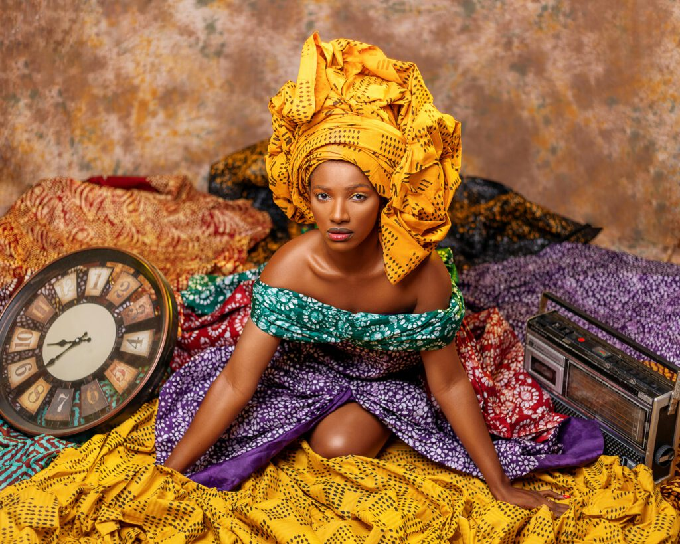
FIG 1. Kente cloth, an African textile artistry
“One of the most well-known examples of African textile art is Kente cloth, which originated with the Ashanti people in present-day Ghana. Kente weaving is a detailed process where artisans create complex patterns using narrow strips of fabric. Traditionally, this fabric was woven from silk, a luxurious material that was hard to obtain, which added to Kente’s reputation as a fabric for the elite. Today, Kente cloth symbolizes Ghanaian pride and identity, with each pattern conveying specific meanings. Colors in Kente are also symbolic: yellow often represents wealth, green signifies fertility, black indicates spiritual maturity, and blue stands for peace. While modern versions of Kente may use different materials, the traditional patterns and symbolic meanings still remain. The significance of Kente cloth extends beyond its aesthetic qualities, encompassing profound cultural and spiritual meanings. Historically, Kente was reserved for royalty and individuals of high status, worn exclusively during important ceremonies. The weaving process was regarded as a sacred art, with each cloth conveying messages that linked the wearer to ancestors, spirituality, and community. The intricate designs function as a visual language that remains integral to contemporary Ghanaian society and its diaspora” (Sylvanus, 2007).
“West Africa is also home to the iconic Adire cloth, a textile made by the Yoruba people of Nigeria. Adire is crafted using a resist-dyeing method where parts of the fabric are covered to block the dye, resulting in unique patterns. Typically, indigo, a natural plant-based dye with a long history in African textile production, is used to dye Adire. The patterns on Adire can be straightforward or intricate, depending on the dyeing technique. The indigo dye not only gives Adire its rich, deep color but also holds symbolic significance. For Yoruba artisans, indigo represents longevity and stability, often conveying messages about resilience and the continuity of life. Adire production is a team effort, with men typically weaving the fabric and women taking care of the dyeing. This division of labor mirrors the community values of Yoruba society. The designs of Adire patterns draw from nature, spirituality, and social values, with certain patterns representing wealth, good luck, or protection. These designs can also indicate the wearer’s status, profession, or clan affiliation. Although it's a labor-intensive process, making Adire results in textiles that are both visually stunning and culturally rich. Today, Adire cloth is recognized worldwide, highlighting the craftsmanship of Yoruba artisans. East Africa is where you'll find the Kikoi cloth, a one-of-a-kind African textile that originated in Kenya and Tanzania. Historically, men wore the Kikoi, a rectangular piece of cotton cloth often with stripes. It's a versatile item that has been used as clothing, a headwrap, or even a multipurpose piece throughout the years. The Kikoi's vibrant colors and patterns reflect the culture and lifestyle of the Swahili people along East Africa's coast, an area with strong trade ties to the Arab world and India. Unlike the intricate weaving techniques of Kente and the complex dyeing of Adire, the Kikoi is a straightforward piece of clothing that still represents identity and tradition for East Africans” (Lemi, 2024).
“Mudcloth, or Bogolanfini, from Mali exemplifies a distinctive West African textile tradition. Created using fermented mud, this process produces earthy tones and enables the incorporation of symbolic designs. Each piece is handcrafted, with symbols representing proverbs, historical events, or spiritual beliefs. Labor-intensive production is regarded as a spiritual practice, and the resulting patterns are intended to protect the wearer or mark significant life transitions, such as marriage or childbirth. The international recognition of Mudcloth today highlights the enduring relevance of African textile heritage. African textiles served functions beyond personal adornment, including ceremonial use and home decoration, thereby reinforcing their cultural importance. During significant rites of passage such as weddings, childbirth, and funerals, specific fabrics were selected to reflect the occasion’s significance. These textiles were frequently passed down through generations, preserving familial and communal histories. The craftsmanship embodied in these textiles functioned as both creative expression and a means of sustaining cultural continuity. In North Africa, fabrics like the Tuareg Tagelmust (or cheche) hold cultural importance for the desert-dwelling Tuareg people. This indigo-dyed headscarf serves as protection against the harsh desert climate, but it also represents identity and resilience. The blue dye, which often rubs off onto the skin, gives the Tuareg people their nickname, “the Blue People of the Sahara.” The indigo staining is seen as a mark of pride and signifies a connection to the harsh but beautiful desert environment that defines the Tuareg way of life. In this way, African textiles serve not only practical purposes but also spiritual and symbolic ones, linking people to their land and heritage” (Barton, 2007).

Symbolism in African Textile Art
Textiles in Africa carry deep significance. Artisans carefully choose colors, patterns, and materials to convey specific messages. In African cultures, textiles do more than just cover the body – they reflect a person's identity, commemorate important events, and express social status, beliefs, and spiritual values. As time passes, artisans have honed these designs, passing down their skills and techniques, which represent the values, histories, and worldviews of their communities. This section explores how African textile art conveys meaning, focusing on the symbolism of color, pattern, and material.
Symbolic Meanings of Colours in African Textiles
In African textile art, colors are selected intentionally, with each hue carrying distinct cultural significance. For example:
· Black is often associated with maturity, wisdom, and spiritual energy. It represents ancestral reverence and a deep respect for the past. In many communities, black can also represent mystery and the unknown, making it a colour frequently used in ceremonial attire.
· White represent purity, peace, and cleanliness. It is a colour often associated with positive spiritual energy and is used in rituals and celebrations for purity and blessings. Many African communities use white for newborn ceremonies or celebrations of life events to promote harmony and invoke the protection of their ancestors.
· Red signifies life, energy, and power, often connected to blood, vitality, and sacrifice. In several cultures, red is worn during initiation ceremonies or by warriors as a symbol of courage and resilience. It’s also used in attire for rituals that integrity ancestors and express passion or spiritual force.
· Green is a universal symbol of growth, fertility, and renewal. In African textiles, it represents prosperity and the natural world, frequently used in agricultural societies to celebrate a fruitful harvest season.
Although the meanings of colors vary across different regions, color symbolism remains a vital aspect of understanding African textiles. For instance, in Ghana, the Ashanti people assign specific meanings to the colors in Kente cloth, which can convey the mood of the wearer or the occasion. In Kente, the combination of black, red, and green often represents harmony and balance within a community, while gold and white frequently symbolize wealth and royalty.
Geometric Patterns and Symbols in African Textiles
Textiles from Africa are known for their intricate patterns, which often serve as visual metaphors. These complex designs showcase the technical skill and artistic eye of African artisans. The examples below highlight specific patterns and their significance in different cultures:
1. Kuba Cloth Patterns, KANTE: Kuba cloth from the Democratic Republic of the Congo is renowned for its vibrant, geometric designs that symbolize spirituality, growth, and community unity. This traditional cloth is created through a collaborative process, where men weave the raffia base and women add geometric embroidery and applique. The patterns often depict daily life, religious beliefs, or the natural world. For example, the “squares” pattern represents social order, reflecting how community members respect their roles and hierarchy. The "checkerboard" pattern, on the other hand, signifies unity and equality, with its uniform shapes representing harmony among community members.
2. Adinkra Symbols in Ghana: Adinkra cloth from Ghana uses symbols known as “Adinkra” to convey specific messages. These symbols are deeply rooted in Akan culture, each carrying a distinct and meaningful significance. For example, the “Gye Nyame” symbol, meaning “Except for God,” reflects the Akan people’s faith and belief in divine protection. The “Sankofa” symbol, shaped like a heart or a bird with its head turned. kuba cloth Patterns, KANTE: Kuba cloth from the Democratic Republic of the Congo is famous for its vibrant, geometric designs that symbolize spirituality, growth, and community unity. This traditional fabric is made through a collaborative process, where men weave the raffia base and women add geometric embroidery and appliqué. The patterns often depict daily life, religious beliefs, or the natural world. For example, the “squares” pattern represents social order, reflecting how community members respect their roles and hierarchy. The "checkerboard" pattern, on the other hand, signifies unity and equality, with its uniform shapes symbolizing harmony among community members. regressively, means “Go back and fetch it,” representing the value of learning from the past to inform the future. These Adinkra symbols turn textiles into visual storytelling tools, passing down ancestral wisdom.
3. Traditional Mudcloth (Bogolanfini) Patterns: Mudcloth, also known as Bogolanfini, is a fabric from Mali that's made by dyeing with fermented mud and plant dyes. Each symbol on the cloth has its own special meaning, and people often choose them based on their personal story or the message they want to share. For example, certain patterns might represent a significant life event, like coming of age, getting married, or having a child. The “fishbone” pattern is commonly found in Mudcloth and symbolizes good luck, while the “ladder” pattern represents growth and ambition. Since these symbols can reflect personal accomplishments or life experiences, each Mudcloth piece is unique to the person who wears or uses it, adding a personal touch to the fabric.
Spirituality and Rituals in African Textile Art
In African cultures, textiles are closely linked to spirituality, with certain fabrics reserved for rituals and ceremonies. Many communities regard textiles as a bridge between the physical and spiritual worlds. Wearing specific patterns is believed to invoke ancestral protection, seek blessings, or facilitate connection with the spiritual realm.
For example, in Nigeria, the YIn Nigeria, the Yoruba people produce Aso Oke, a ceremonial textile woven from silk or cotton and used in significant events such as weddings, funerals, and initiation ceremonies. The colors and patterns of Aso Oke are selected according to the event’s purpose. White is used for traditional ceremonies, while brighter colors symbolize joy and abundance during celebrations. Aso Oke functions as a sacred garment, connecting individuals to the divine and highlighting cultural and spiritual identity.an culture of the Maasai, African textile art plays a significant role in spiritual practices. The Maasai wear Shúkà, a traditional cloth, during rites of passage such as circumcision or elder ceremonies. The colours on the Shúkà often represent the different phases of life, reinforcing cultural values around growth, dignity, and community solidarity.

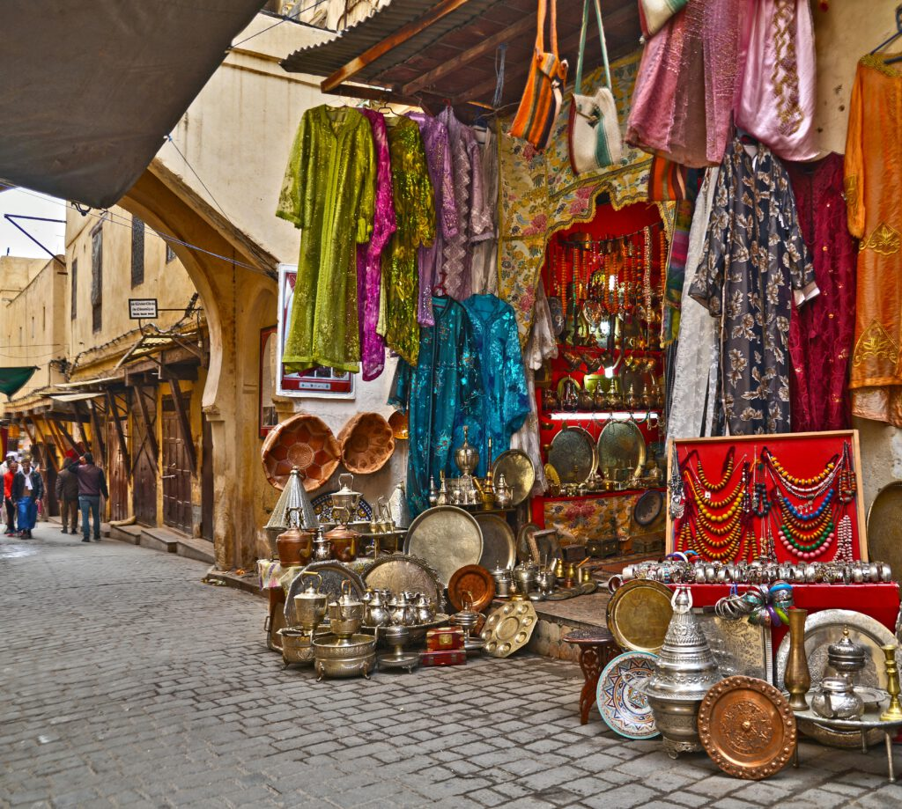

FIG 2. A market stall displaying colourful cloths and luxury items

Social Status and Identity in African Textiles
The symbolism embedded in African textiles serves to denote the wearer’s social status, wealth, and identity. In numerous African societies, textiles function as luxury items; finer materials and intricate designs indicate elevated social standing. This is exemplified by Kente cloth, which was historically reserved for Ghanaian royalty and elites. In contemporary contexts, Kente remains associated with respect, pride, and a pronounced sense of identity, and is worn during significant events to honor heritage and unity.
Similarly, in Cameroon, the Bamileke people wear “Ndop” cloth, which is traditionally hand-dyed using indigo. Ndop is a marker of prestige and is often worn by tribal leaders and respected figures within the community. The patterns on Ndop represent aspects of Bamileke history, heritage, and values, such as courage, strength, and resilience. The fabric’s color and pattern indicate the wearer’s status and honor, connecting the individual to both their community and the legacy of their ancestors.
Another example is the Tuareg people of the Sahara Desert, who use veils and robes dyed with indigo as symbols of status. The indigo dye imparts a distinctive blue tint to the fabric, which is highly valued and often associated with wealth. The darker the blue, the higher the wearer's status, as the indigo dye is both expensive and time-consuming to produce. For the Tuareg, wearing blue-dyed fabric is a means of displaying social rank, wealth, and identity within the tribe.

Modern Adaptations of African Textiles in Contemporary Culture
“In recent years, African textiles have undergone a resurgence, generating global interest and inspiring contemporary designers, artists, and cultural practitioners. As fashion, interior design, and visual arts increasingly incorporate African textiles, the core elements of African culture, tradition, and heritage are celebrated and preserved through innovative approaches. This section examines the adaptation of African textile art in contemporary design, its influence on identity formation, its role in fostering economic development, and its capacity to bridge cultural divides worldwide” (Akrofi et al., 2016).

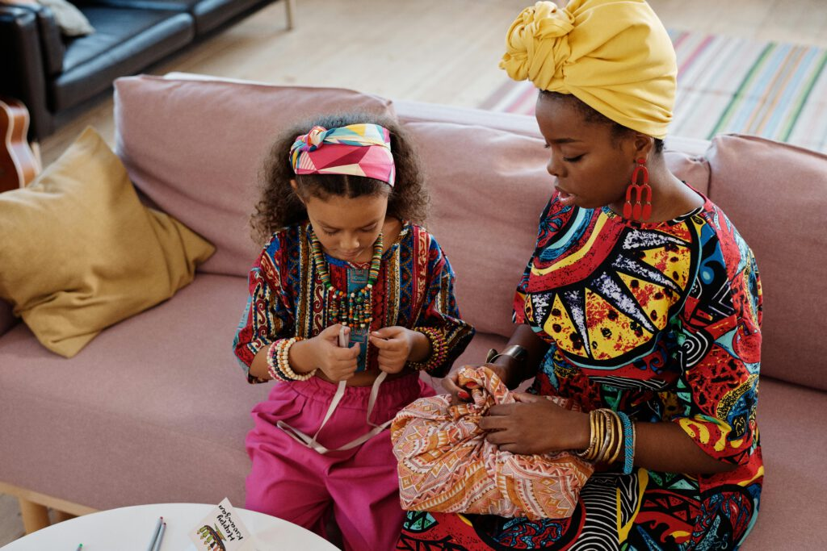
FIG 3. Ankara fabric, with its bold and colourful patterns, is a popular choice for clothing

African Textiles in Global Fashion
Fashion designers worldwide are increasingly incorporating African textiles into their collections, highlighting the detailed craftsmanship, bright colors, and unique patterns typical of these fabrics. The integration of African textile patterns into global fashion fosters a deeper appreciation of African cultural heritage and artisanal skills. Iconic fabrics such as Ankara, Kente, Adire, and Mudcloth are now featured in high-fashion, ready-to-wear collections, and casual streetwear.
Ankara, known for its bold patterns and vibrant colors, has become a major material in the mainstream fashion industry for clothing and accessories. Originally from West Africa, Ankara has been worn for generations as a symbol of cultural pride and identity. While its design technique was initially inspired by Indonesian batik, Ankara has evolved its own distinct African motifs that reflect the region's stories and traditions. By incorporating Ankara fabrics into global fashion, their cultural importance is highlighted, making them more accessible to a modern international audience. Now, both African and non-African designers are creating Ankara-inspired collections that appeal to people who value both style and cultural heritage.
Just like Kente cloth, traditionally worn by royalty in Ghana, has become a part of modern fashion. This fabric is famous for its vibrant colors and intricate patterns, and it was once reserved for special occasions like weddings and funerals. Each color and pattern in a Kente cloth has a symbolic meaning - gold represents wealth, green symbolizes growth, and blue represents peace. Today, designers have found innovative ways to incorporate Kente into their work, from high-end dresses to casual clothing, creating pieces that honor the fabric’s traditional significance while giving it a modern twist. Laduma Ngxokolo, a South African fashion designer and founder of the luxury brand Maxhosa Africa, is a great example of blending tradition with contemporary fashion. His designs feature patterns inspired by Xhosa beadwork, a traditional craft rooted in his cultural heritage. Ngxokolo’s knitwear collections have gained international recognition, turning traditional Xhosa designs into modern fashion pieces. Through his work, Ngxokolo showcases the beauty of African textiles and promotes a greater appreciation and respect for African culture within the global fashion industry.
African textiles have also become increasingly prominent in streetwear, a style of casual clothing associated with urban youth culture. International streetwear brands are now incorporating African-inspired patterns and fabrics into their collections, thereby integrating cultural heritage into everyday fashion. For instance, Daily Paper, a Dutch label established by designers of African descent, draws on their heritage to incorporate African textiles and motifs into their clothing. This trend enables African textiles to engage younger audiences and connect traditional culture with contemporary fashion trends.
The influence of African textiles extends beyond fashion. Designers and homeowners are increasingly drawn to African textiles in home décor, adding elements of cultural significance, warmth, and bold colour to interior spaces. From throw pillows and wall hangings to upholstery and bed linens, African textiles such as Adire, Mudcloth, and Kente bring rich textures and patterns to modern interiors.
The use of African textiles in interior design creates an eclectic style that merges traditional richness with modern aesthetics. These textiles enable individuals to express appreciation for African culture and history while enhancing the warmth, depth, and character of interior spaces.
Cultural Exchange and Bridging the Gap
Using African textiles in global fashion and design also fosters cultural exchange and understanding. When people wear or decorate with African fabrics, they not only appreciate the beauty of the material but also connect with the cultural stories woven into the designs. By learning about the significance of colors, patterns, and symbols, people develop a deeper appreciation for African traditions, values, and perspectives.
As African textiles become more popular, they're also helping to break down misconceptions and stereotypes about Africa. Many people outside the continent have limited exposure to Africa's rich cultural diversity, often seeing Africa as a single, uniform entity. However, the intricate patterns and unique designs of African textiles reveal the depth and breadth of African cultures, highlighting the distinct artistic expressions, spiritual traditions, and historical experiences of African communities.
The widespread adoption of African textiles in contemporary culture promotes a more nuanced understanding of Africa and its people. This appreciation of African art and heritage fosters respect for African cultures, helping to build connections across geographical and cultural boundaries. Through African textiles, people around the world can celebrate the continent’s diversity and resilience, creating a shared sense of cultural pride and global unity.
Modern fashion, interior design, and the global market showcase how African textiles are used as cultural ambassadors, connecting African heritage with contemporary style. As these fabrics become more visible and appreciated, local artisans benefit economically, cultural exchange is promoted, and traditional crafts are preserved. With African textiles still inspiring modern design, they remain strong symbols of cultural identity, passing down Africa's stories, values, and beauty.
Engagement with textiles that feature unfamiliar designs can foster curiosity and appreciation for diverse cultural aesthetics.
Textiles are more than just a fashion statement – they're a powerful form of expression that transcends the world of fashion. In many cultures, textiles act as a means of communication and a way to preserve long-held traditions and values. This discussion looks at how handcrafted cultural textiles help us understand societal identities and how communities shape their own sense of self.
The analysis will address how textiles utilize symbols and color palettes to convey historical values while integrating contemporary trends. Additionally, it will consider how textiles function at the intersection of cultures, fostering cross-cultural connections through their aesthetic qualities and the preservation of generational traditions.

Celebrating Customary Traditions
Cultural textiles also serve to symbolize important life events or customs within various cultures. In Hmong culture, for example, special traditional fabric garments are typically made for the bride in shades of blue for her wedding day celebration, even though the culture is generally very colorful. These garments not only represent marriage but also family lineage, supporting social structures, especially in rural communities where this tradition remains strong today.
Put simply, textiles are closely tied to many cultures worldwide and act as strong symbols of identity, heritage, pride, and tradition that continue to be deeply rooted in today’s cultural societies.

Textiles as Markers of Milestones
Looking at different cultures shows that textiles have purposes beyond just looking good. They often mark important life events, like coming-of-age ceremonies. For instance, in Jewish traditions, bar and bat mitzvahs involve special clothes, while in some Latin American traditions, fabric decorations are a key part of celebrations.
This is because cultural textiles can also be used to symbolize great life events or customs within cultures. In Hmong culture, for example, special cultural fabric garments are traditionally made for the bride in shades of blue for her wedding day celebration, despite being a very colorful culture overall. These garments not only signify marriage but also family lineage and provide social structure, particularly within rural communities where this practice is still held strong today.
have the power to signify status, identity, and even spiritual connection in many cultures. For instance, special hand-woven fabrics may be given to a person upon their initiation into adulthood or marriage. This is evident in Japanese braided cords featuring decorative tassels. In summary, textiles provide a tangible representation of the transformation associated with rites of passage, remaining integral to cultural wardrobes throughout adulthood. They also serve as enduring symbols that connect individuals across generations, reinforcing shared cultural identities in people by connecting them to a common heritage.

Revival and Reimagining of Traditional

Textile Crafts
Traditional textiles aren't just expressions of identity - they're also a way to connect with and revitalize ancient traditions. Crafts like ikat, batik, tie-dye, and block printing showcase a lot of diversity and energy. These crafts provide great chances to rework cultural heritage into modern design.
While these crafts have long contributed to cultural identity, recent decades have witnessed their transformation through innovative reinterpretations.
Ikat has gained more popularity as it successfully combines traditional methods with modern design features.
Batik is now used to create visually striking fabrics that are then made into garments or decorative wall hangings.
Tie-dye has undergone a resurgence, with artists employing the technique to create distinctive, expressive works.
Block printing has taken on a modern significance as designers try to incorporate one-of-a-kind patterns and motifs into fabrics.
The revival of traditional textile designs enables a deeper exploration and appreciation of the historical and technical nuances inherent in each craft, while simultaneously adapting them to contemporary aesthetics. This process both preserves cultural practices and fosters the creation of innovative textile works.
Conclusion
Textiles act as lasting symbols of the major life changes that come with rites of passage. Instead of being short-lived, they become a crucial part of a culture's material history. These clothes create lasting ties between generations by honoring shared cultural customs.

Disclaimer (Artificial intelligence)
Option 1:
Author(s) hereby declare that NO generative AI technologies such as Large Language Models (ChatGPT, COPILOT, etc.) and text-to-image generators have been used during the writing or editing of this manuscript.
Option 2:
Author(s) hereby declare that generative AI technologies such as Large Language Models, etc. have been used during the writing or editing of manuscripts. This explanation will include the name, version, model, and source of the generative AI technology and as well as all input prompts provided to the generative AI technology
Details of the AI usage are given below:
1.
2.
3.

References
American Institute for Conservation (AIC). (2020). Conservation Terminology. Retrieved from https://www.culturalheritage.org
Avrami, E., Mason, R. and Torre, M. (2000). Values and heritage conservation. Getty Conservation Institute.
https://scholar.google.com/scholar?hl=de&as_sdt=0%2C5&q=%22Avrami%2C+E.%2C+Mason%2C+R.+and+Torre%2C+M.+%282000%29.+Values+and+heritage+conservation.+Getty+Conservation+Institute.%22&btnG=
Barber, E. J. W. (1994). Women's Work: The First 20,000 Years. W. W. Norton.
https://scholar.google.com/scholar?hl=de&as_sdt=0%2C5&q=%22Barber%2C+E.+J.+W.+%281994%29.+Women%27s+Work%3A+The+First+20%2C000+Years.+W.+W.+Norton.%22&btnG=
British Museum. (2018). Textile conservation: Challenges and innovations. https:// https://www.britishmuseum.org/
Burnham, D. K. (1980). Cut My Cote. Royal Ontario Museum. • Cameron, F. and Kenderdine, S. (2007). Theorizing digital cultural heritage: A critical discourse. MIT Press. • Canadian Conservation Institute. (2016). Agents of deterioration. Retrieved from https://www.canada.ca/en/conservationinstitute/services/agents-deterioration.html •
Caple, C. (2011). Conservation skills: Judgement, method and decision making (2nd ed.). Routledge. [ZITATION]
https://scholar.google.com/scholar?hl=de&as_sdt=0%2C5&q=%22Burnham%2C+D.+K.+%281980%29.+Cut+My+Cote.+Royal+Ontario+Museum.+%E2%80%A2+Cameron%2C+F.+and+Kenderdine%2C+S.+%282007%29.+Theorizing+digital+cultural+heritage%3A+A+critical+discourse.+MIT+Press.+%E2%80%A2+Canadian+Conservation+Institute.+%282016%29.+Agents+of+deterioration.+Retrieved+from+https%3A%2F%2Fwww.canada.ca%2Fen%2Fconservationinstitute%2Fservices%2Fagents-deterioration.html+%E2%80%A2+%22&btnG=

Eastaugh, N., Walsh, V., Chaplin, T. and Siddall, R. (2008). Pigment compendium: A dictionary and optical microscopy of historical pigments. Elsevier. • [CITATION]
https://scholar.google.com/scholar?hl=de&as_sdt=0%2C5&q=%22Eastaugh%2C+N.%2C+Walsh%2C+V.%2C+Chaplin%2C+T.+and+Siddall%2C+R.+%282008%29.+Pigment+compendium%3A+A+dictionary+and+optical+microscopy+of+historical+pigments.+Elsevier.+%E2%80%A2%22&btnG=
Eastop, D. and Brooks, M. M. (1996). Handbook of Textile Conservation. Routledge. • Eicher, J. B. and Ross, D. (2010). Encyclopedia of World Dress and Fashion. Oxford University Press. •
Florian, M. L. (2002). Fungal Facts: Solving Fungal Problems in Heritage Collections. Archetype Publications. https://www.amazon.de/-/en/Fungal-Facts-Problems-Heritage-Collections/dp/1873132638
Flury-Lemberg, M. (1988). Textile conservation and research: A documentation of the textile department on the occasion of the twentieth anniversary of the Abegg Foundation. Abegg-Stiftung. https://scholar.google.com/scholar?hl=de&as_sdt=0%2C5&q=%22Flury-Lemberg%2C+M.+%281988%29.+Textile+conservation+and+research%3A+A+documentation+of+the+textile+department+on+the+occasion+of+the+twentieth+anniversary+of+the+Abegg+Foundation.+Abegg-Stiftung.%22&btnG
Gillow, J. and Sentance, B. (2004). World Textiles: A Visual Guide to Traditional Techniques. Thames & Hudson. https://pdfs.semanticscholar.org/2967/a74339f4bfb51c284035eb7780feb8563db9.pdf
ICCROM. (2020). Funding mechanisms for cultural heritage preservation. https://www.iccrom.org • https://www.iccrom.org/
ICOM (International Council of Museums) (2013). Key Concepts of Museology. • ICOM-CC. (2018). Textile Working Group: State of the field report. International Council of Museums.
https://scholar.google.com/scholar?hl=de&as_sdt=0%2C5&q=%22ICOM+%28International+Council+of+Museums%29+%282013%29.+Key+Concepts+of+Museology%22&btnG=
ICOM-CC. (2008). Terminology to characterize the conservation of tangible cultural heritage. International Council of Museums – Committee for Conservation. https://scholar.google.com/scholar?hl=de&as_sdt=0%2C5&q=%22ICOM-CC.+%282008%29.+Terminology+to+characterize+the+conservation+of++tangible+cultural+heritage.+International+Council+of+Museums+%E2%80%93+Committee+for+Conservation.%22&btn
ICOMOS. (2019). Sustaining heritage: Funding and policy perspectives. Retrieved from https://www.icomos.org/
Kalay, Y. E., Kvan, T. and Affleck, J. (2008). New heritage: New media and cultural heritage. Routledge. https://scholar.google.com/scholar?hl=de&as_sdt=0%2C5&q=%22Kalay%2C+Y.+E.%2C+Kvan%2C+T.+and+Affleck%2C+J.+%282008%29.+New+heritage%3A+New+media+and+cultural+heritage.+Routledge.%22&btnG=
Landi, S. (1998). The textile conservator’s manual (2nd ed.). Butterworth-Heinemann
https://scholar.google.com/scholar?hl=de&as_sdt=0%2C5&q=%22Landi%2C+S.+%281998%29.+The+textile+conservator%E2%80%99s+manual+%282nd+ed.%29.+Butterworth-Heinemann.%22&btnG=
Pearce, S. M. (1992). Museums, Objects and Collections: A Cultural Study. Smithsonian Institution Press. https://scholar.google.com/scholar?hl=de&as_sdt=0%2C5&q=%22Pearce%2C+S.+M.+%281992%29.+Museums%2C+Objects+and+Collections%3A+A+Cultural+Study.+Smithsonian+Institution+Press.%09%
Rivers, S. and Umney, N. (2007). Conservation of furniture. Routledge.
https://scholar.google.com/scholar?hl=de&as_sdt=0%2C5&q=%22Rivers%2C+S.+and+Umney%2C+N.+%282007%29.+Conservation+of+furniture.+Routledge.%22&btnG=
Smithsonian Institution. (2021). Museum Conservation Institute: Emerging Technologies in Conservation. https://mci.si.edu/
Staniforth, S. (2011). Conservation: Principles, Dilemmas and Uncomfortable Truths.
https://scholar.google.com/scholar?hl=de&as_sdt=0%2C5&q=%22Staniforth%2C+S.+%282011%29.+Conservation%3A+Principles%2C+Dilemmas+and+Uncomfortable+Truths.+Routledge.+Stanley-Price%2C+N.+%282009%29.+Cultural+heritage+in+postwar+recovery%3A+Papers+from+the+ICCROM+Forum.+ICCROM.%22&btnG=
Routledge. Stanley-Price, N. (2009). Cultural heritage in postwar recovery: Papers from the ICCROM Forum. ICCROM.
Tétreault, J. (2003). Airborne Pollutants in Museums, Galleries, and Archives. Canadian Conservation Institute. [CITATION]
https://scholar.google.com/scholar?hl=de&as_sdt=0%2C5&q=%22T%C3%A9treault%2C+J.+%282003%29.+Airborne+Pollutants+in+Museums%2C+Galleries%2C+and+Archives.+Canadian+Conservation+Institute.%22&btnG=
Timar-Balazsy, A. and Eastop, D. (1998). Chemical principles of textile conservation. Butterworth-Heinemann. https://scholar.google.com/scholar?hl=de&as_sdt=0%2C5&q=%22Timar-Balazsy%2C+A.+and+Eastop%2C+D.+%281998%29.+Chemical+principles+of+textile+conservation.+Butterworth-Heinemann.%22&
Lemi, L. D. (2024). Commemorative textiles: an African narrative of identity and power. Humanities and Social Sciences Communications, 11(1), 1-9.
Mastamet-Mason, A., Müller, K., & van der Merwe, N. (2017). History of African indigenous costumes and textiles: towards decolonising a fashion design curriculum. DEFSA contact details, 143.
Sylvanus, N. (2007). The fabric of Africanity: Tracing the global threads of authenticity. Anthropological Theory, 7(2), 201-216.
Barton, W. D. (2007). African Mud Cloth. The Bogolanfini Art Tradition of Gneli Traore of Mali. African Studies Review, 50(1), 210-211.
Akrofi, M., Ocran, S. P., & Acquaye, R. (2016). Decoding the symbolism of bogolanfini, korhogo and Fon fabrics. African Journal of Applied Research, 2(2).

