Original Research Article

Genetic Diversity of African oil palm (Elaeis guineensis Jacq.) accessions across Agro-climatic regions of Tanzania by Microsatellite (SSR) markers.

ABSTRACT
The genetic diversity of African oil palm (Elaeis guineensis Jacq.) accessions in four agroecological zones of Tanzania using 16 microsatellite (SSR) markers was conducted for breeding. The study involved sixty-five (65) oil palm genotypes selected from the Tabora, Mbeya, Morogoro, and Kigoma regions. The CTAB and PCR were used for extract genomic DNA, and amplification, respectively. Analysed result showed that, at an average of 1.64 alleles per locus, 23 alleles were found across 14 polymorphic markers. Polymorphism information content (PIC) was varied from 0.0000 to 0.4192, indicating low to moderately informative markers. A limited genetic base among the genotypes was confirmed from the low mean gene diversity of 0.1748. Apart from accessions being categorized into five primary clusters, their band were not exactly corresponded with their geographic origin, suggesting historical seed exchanges and gene flow between regions. Limited allelic richness and moderate genetic diversity underscore the necessity of conserving and larger germplasm collection initiatives to strengthen the genetic foundation for upcoming breeding initiatives. The identified better oil palm genotypes are the bases for sustainable farming and genetic enhancement breeding programs in Tanzania.

This study assessed the genetic diversity of African oil palm (Elaeis guineensis jacq.) accessions in four agro-climatic regions of Tanzania. Microsatellite (SSR) markers used to provide insightful for breeding progams. The study involved sixty five (65) oil palm accessions selected from Tabora, Mbeya, Kigoma, and Morogoro regions. A total of 23 alleles were found across 14 polymorphic markers,with an average of 1.64 alleles per locus. Polymorphic Information Content (PIC) ranged from 0.0000 to 0.4192, this indicating that, low to moderately informative markers. A limited genetic base among the oil palm accessions was confirmed by the low mean gene diversity of 0.1748. Apart from accessions being categorized into five clusters, their grouping did not exactly correspond to their geographic origin, suggestiong historical seed exchanges and gene flow between regions. Limited allelic richness and moderate genetic diversity underscores the necessity of conserving germplasm and establishing larger germplasm collection initiatives to strengthen the genetic bases for next breeding initiatives. The identified promising oil palm genotypes provide and foundation for sustainable farming and genetic enhancement breeding programs in Tanzania.

Keywords: Oil palm, Parental material, Tanzania, SSR markers, and Genetic diversity

INTRODUCTION
Oil palm (Elaeis guineensis Jacq. 2n = 32 ) is native to the tropical oil crop, particularly in the south-eastern regions of Nigeria, however, it is also grown extensively in Africa and Southeast Asia (Barcelos et al., 2015). It is one of the most well-known and promising oil crops worldwide (Yarra itlic 2019). Oil palm cultivation has increased considerably, contributed to the growth of agricultural economies in South-eastern Asia, particularly in Indonesia and Malaysia (Murphy et al., 2021; James et al., 2023), it is currently grown in more than 43 nations (Soh et al., 2018a). The global demand for vegetable oils is predicted to increase to 240 million tons by 2050 (Barcelos et al., 2015), highlighting the need for increasing production (Murphy et al., 2021; Azuokwu et al., 2024). Oil palm yield of 10 tonnes ha⁻¹ year⁻¹ is three times higher than yield from rapeseed and soya (Ntsefong et al., 2016). For instance a cumulative 4.8, 5.4 and 7.6 ha of rapeseed, sunflower, and soybean, respectively, are required to produce the same amount of oil produced from 1 ha of oil palm (Soh et al., 2017a).

Oil palm in Tanzania has the ability to significantly strengthen it’s economy, minimize dependency on imported edible oils, and give farmers a means of subsistence (Sultan et al., 2025). Apart from the high yield, variation in performance due to variety, environment and agronomic practices were reported to have significant contribution. Moreover, high productivity of oil palm is enhanced by its ability to thrive well under a range of agricultural practices and environmental conditions (Jin et al., 2016). To improve oil palm productivity it is necessary to research on the genetic diversity pattern, genetic composition, and agronomical requirements (Ganesan et al., 2014). Studies on oil palm's genetic diversity in Cameroon has exposed an interesting trends and a wealth of genetic resources, underscoring the country's importance as a possible hub for variation within species (Constantin et al., 2024). This indicates most of populations from different parts of Africa lack a distinct genetic structure or polymorphism and genotype by environment interaction which hindered effective profiling due to the dispersal of these accessions across continent without significant geographical barriers, however, the magnitude of their diversity is less reported (Arias et al., 2015; Zhou et al., 2015; Murugesan et al., 2017 ).

In Tanzania oil palm production is highly produced in Kigoma Region, which accounts for more than 73% of all oil palm production in the country (Andrea & Mishili, 2023). Other producing regions include Mbeya, Tabora, Morogoro, Kagera, Tanga, Dar es Salaam, Coast, Katavi, Ruvuma, Mara, Geita, Mwanza, and Zanzibar. Despite its potential, production of oil palm in Tanzania is very low and far below the country’s domestic demand for edible oil (NBS, 2022). The current production of oil palm in Tanzania is 1.6 tons per hectare which is lower compared to 6 – 8 tons per hectare produced in Malaysia and other countries (Kannan, 2020). The low palm oil production is contributed by the use of low yielding oil palm varieties, poor agronomic practices, use of low-quality planting material, old palm trees which have not been replanted for over a century, poor processing facilities and insufficient extension services (Mwatawala et al., 2022). The country heavily relies on imported oil which account to 650,000 metric tons, representing 63% of the total demand of edible oil used in the country as only 290,000 metric tons of edible oil are produced annually (Reuben & Meliyo, 2022).

Studies in genetic diversity among and within populations has been done using various techniques including morphological assessment, biochemical markers (isozymes) and molecular markers (Natawijaya et al., 2019). Rapid development of molecular technology has facilitated genetic evaluation of oil palm populations using various markers like, isozymes (Jin et al., 2016), restriction fragment length polymorphism (RFLP) (Zhou et al., 2015), amplified fragment length polymorphism (AFLP; (Mondjeli Constantin et al., 2024), and Simple Sequence Repeats (SSR) (Zhou et al., 2015). The ability of SSR markers being co-dominantly inherited, can detect heterozygosity as well as genetic relationships among individuals (Bai et al., 2018). This allows detection of oil yield, fruit quality and susceptibility/resistance to diseases and abiotic stresses (Benoit et al., 2016). The objective of the recent study was to evaluated the magnitude of genetic diversity of African oil palm (Elaeis guineensis Jacq.) accessions across four agroecology of Tanzania, using SSR markers. This will categorizing superior breeding lines with high yielding, resistant to diseases, and environmental stresses (Xiao et al., 2017).

MATERIALS AND METHODS

2.1 Description of the study Area
The study was conducted in four purposively Tanzania selected oil palm growing regions; Kigoma, Mbeya, Morogoro, and Tabora (Figure 1). Kigoma is located 4° 51’ 0” S, 30° 22’ 0” E on the Eastern coastline of Lake Tanganyika, the region experienced a tropical climate with a bimodal rainfall pattern of 1,200mm to 1,800mm per annum. Mbeya is found 7°-11° S, 32°-36° E. it has a bimodal rainfall pattern ranged from 1,000 to 1,500mm. Morogoro (6°-10° S, 36°-39° E) had a bimodal rainfall pattern of 1,200mm to 1,800mm per year. Except Tabora, the long and short rains begin from March to May, and October to December, respectively. Lastly, Tabora is located 5° 4' S, 32° 50' E of the semi-arid regions receiving an average annual rainfall ranging from 800 mm to 1,200 mm.

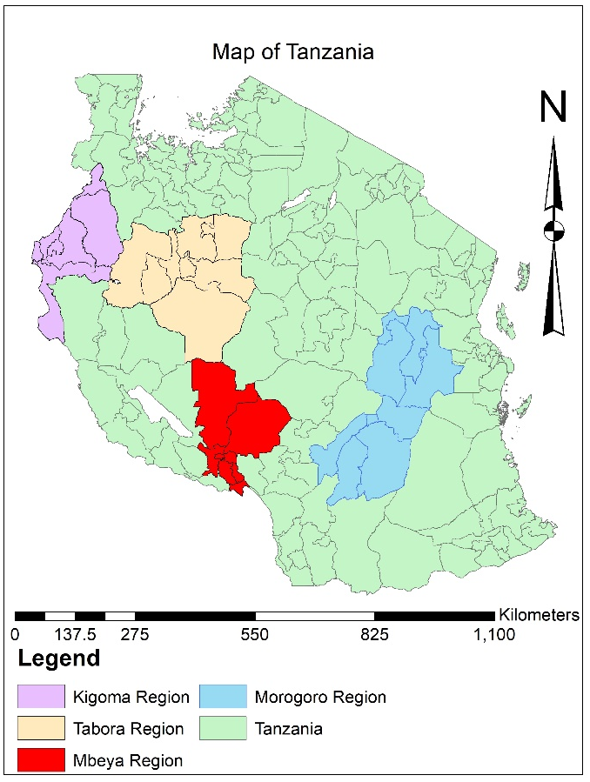 | 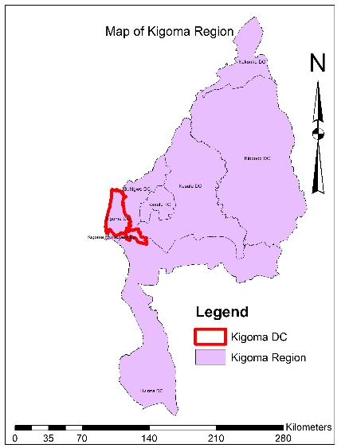
 | 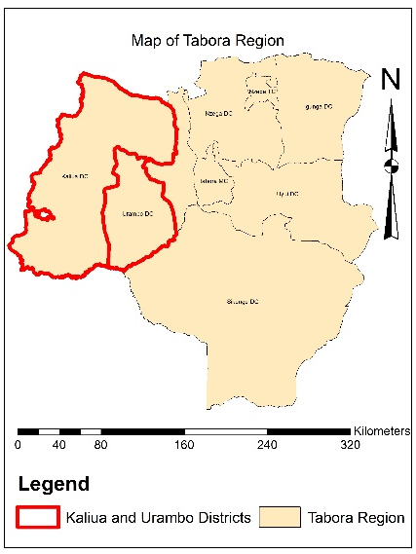
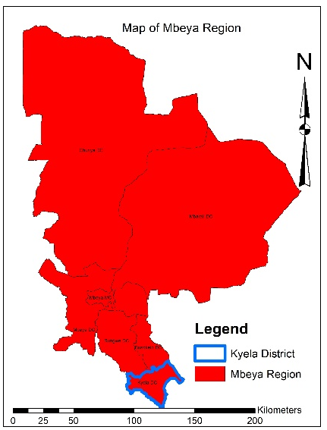 | 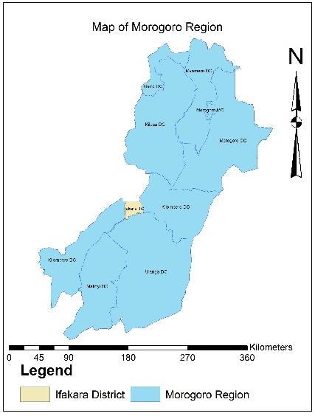

Figure1: The map showing distribution of collected oil palm samples from four regions of Tanzania

2.2 Plant Materials
A total of sixty-five (65) fresh oil palm leaf samples were collected from the selected trees in farmers-owned oil palm trees plantations planted traditionally in different regions of Kigoma Tabora, Mbeya and Morogoro. The samples collected in this study was the leaflets from each youngest fronds of the oil palm tree in zig zag way and were preserved in transparency plastic bags with silica gel (blue crystals) before sent to TARI Mikocheni laboratory for DNA extraction.

2.3 Isolation of oil palm genomic DNA
Total nucleic acids were extracted from sixty-five (65) leaf samples using Cetyl-trimethyl u1ML of CTAB extracting buffer (2% CTAB, 100mM Tris-HCL pH 8.0, 20mM EDTA pH 8.0, 1.4M NaCl, 20% SDS, 1%PVP and 2% 2-mercaptoethanol v/v) which was added to the samples and mixed thoroughly by vortexing. About 800 µl of each sample was transferred to a 2 ml new Eppendorf tube. Incubation was done at 65⁰C for 1 hour and inverted after every 10 minutes. The extract was mixed with an equal volume (800µl) of chloroform: Octanol (24:1), mixed thoroughly, and centrifuged at a speed of 13000 rpm for 10 min at 4 ⁰C. The supernatant (750µl) was transferred to a 2 ml new Eppendorf tube. Total nucleic acids were precipitated using cold isopropanol at -20 ⁰C and centrifuged for 10 min at 13000 rpm. The nucleic acids pellet was washed in 500µl 70% ethanol by vortexing and incubated at -20⁰C for 10min and centrifuged at 13000 rpm for 5min. Then nucleic acids were re-suspended in 50µl of nucleus free water after air-dried.

2.4 Quality control determination
The spectrophotometric readings of DNA were denoted to check the concentration (ng/ µl) and purity at 260/280 and 260/230 absorbance ratios using Nanodrop 2000c UV–vis Spectrophotometer (Thermo Scientific, Wilmington, DE, USA). The extinction coefficient for double-stranded DNA (50 ng-cm/µL) was selected according to the Beer-Lambert equation.

2.5 PCR Amplification using SSR Marker
A total of 65 DNA samples were amplified using highly polymorphic 16 SSR markers (Table 1). The amplifications were done in 25 𝜇L final reaction volumes containing 0.5 µl of each primer, 12.5 µl of Taq DNA Polymerase Master Mix RED with Standard Buffer (Appliqon PRC Enzymes and Reagents), 10.5 µl Nuclease-free water and 1 µl (200ng) of DNA template. PCR amplification was carried out in a thermal cycler programmed for initial denaturation at 95°C for 5 min, followed by 35 cycles of denaturation at 95°C for 30 s, annealing temperature varied depending on SSR marker used for 40 s, and extension at 72°C for 30 sec. The last extension was accomplished at 72°C for 5 min at the end of the amplification reaction. The amplified product was resolved in 1.5% agarose gel at 150V for 1 hr.

2.6 Agarose gel electrophoresis
Prior separations of DNA in 1.5% agarose gel, the samples were normalized to the concentration composed of 200ng/µL, and 10µL, and the diluted samples were run in the agarose gel electrophoresis. This gives a total of 2000 ng loaded for all samples as the optimal. A total of sixteen (16) SSR primer pairs in specific to oil palm were used (Table 1). One genomic DNA were used as controls for each gel along with two lanes for 10 bp size ladder to facilitate scoring of allele in gel and to link one gel to another in the same locus.

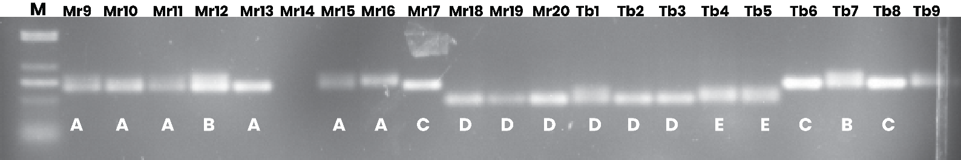

Figure 2: Amplification profiles of primer pair mgCIR3785 from 20 oil palm samples. M is a low range DNA ladder. The capital letters A~ E represent the five different types of banding pattern.

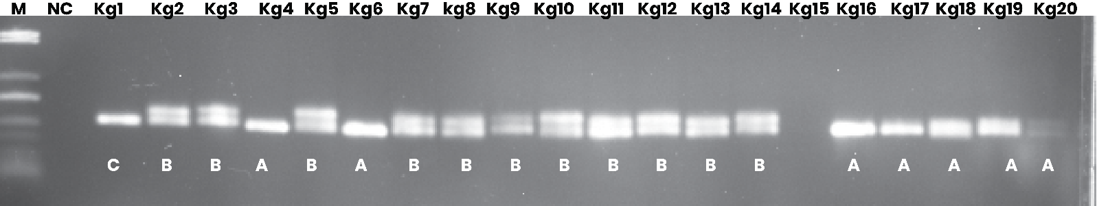

Figure 3: Amplification profiles of primer pair mgCIR3543 from 19 oil palm samples. M is a low range DNA ladder. The capital letters A ~ C represent the three different types of banding pattern.

2.8 Data analysis
The PCR-amplified products from SSR analyses were qualitatively assessed using 0 and 1 for absence and presence, respectively. After generating a binary data matrix, the original document was converted using POPGENE version 1.32 which used to calculate genetic diversity parameters, such as the observed number of alleles (NA), Shannon's information index (I), and the observed heterozygosity (Ho) of polymorphic markers (Yu et al., 2014 ; Xiaouet al., 2014 ) The unweighted pair-group with arithmetic averaging (UPGMA) were constructed using the distance matrix imported using PowerMarker v3.25 (Tamura et al., 2007). Moreover, the genetic diversity measures and polymorphism information content (PIC) were determined for every primer pair, using the following formulas:
k
Gene diversity (D) = (1− ∑ p²)/ (1−(1 + f)/n);
u=1
Polymorphism Information Content (PIC) = ∑(1—pi²)/n.
where n is the total number of genotypes and pi is the frequency of the ith allele.

RESULTS

3.1 Diversity
A total of 14 SSR markers were used to measure the genetic diversity and assessing the polymorphism of 65 oil palm accessions using codominant markers (Table 1). Following that, 23 alleles were amplified, with the number of alleles per locus ranging from 1 to 3, and a mean value of 1.6429. The most informative marker was mEgCIR3363, which had the greatest three alleles per locus. The least informative markers were mEgCIR0173, mEgCIR0802, mEgCIR1730, mEgCIR3282, mEgCIR3300, mEgCIR3574, and mEgCIR3886, each detected one allele per locus (Table 1). The average number of effective alleles (Ne) determined throughout loci was 1.3195, with a range of 1.0000 to 1.9995. The most effective alleles (1.9995) were located in marker mEgCIR3362, but no diversity was discovered in several markers, including mEgCIR0173, mEgCIR0802, mEgCIR1730, mEgCIR3282, mEgCIR3300, mEgCIR3574, and mEgCIR3886, to have the lowest value of 1.0000 (Table 1). Markers like mEgCIR0173, mEgCIR0802, mEgCIR1730, mEgCIR3282, mEgCIR3300, mEgCIR3574, and mEgCIR3886 had the least number of different alleles, each displayed 1.0000, implying an absence of allelic variations at those loci. However, markers such as mEgCIR3363 and mEgCIR3785 had the maximum number of different alleles, every displayed 3.0000, (Table 1).

Inversely, there was a significant variation between the observed and effective number of alleles, which is calculated as the opposite of homozygosity. Between the tested markers, mEgCIR3362 was the most informative, with an effective allele count ranging from 1.0000 to 1.9995. Seven markers (mEgCIR0173, mEgCIR0802, mEgCIR1730, mEgCIR3282, mEgCIR3300, mEgCIR3574, and mEgCIR3886) had the lowest number of effective alleles (Ne = 1.0000), contradicting with mEgCIR3362 with the highest number of effective alleles (1.9995).

Diversity indices, allelic richness and evenness were high and had the highest Shannon index in a marker mEgCIR3785 (I =0.8175) which had a mean value of 0.2764 and ranged from 0.0000 to 0.8175. It was in line with mEgCIR0173, mEgCIR0802, and mEgCIR1730 with 0.0000 indicating an evenness at those loci. Between markers, there was a significance differences when Nei’s gene diversity was used. Only mEgCIR3362 displayed the maximum heterozygosity value of (H=0.4999) with the mean gene diversity of 0.1748 than other markers. The markers exhibited 50% of their polymorphism in all accessions. Although, a proportion of the SSR loci failed to capture the diversity across sampled oil palm genotypes attributed to most of markers being monomorphic.

Table 1: The magnitude of genetic diversity among 65 Oil palm accessions collected from four growing regions of Tanzania
Marker | Major. Allele.  Frequency | Genotype  No | Sample  Size | No. of obs. | Allele No | Availability | Gene Diversity
mEgCIR0173 | 1.0000 | 1.0000 | 65.0000 | 62.0000 | 1.0000 | 0.9538 | 0.0000
mEgCIR0802 | 1.0000 | 1.0000 | 65.0000 | 60.0000 | 1.0000 | 0.9231 | 0.0000
mEgCIR1730 | 1.0000 | 1.0000 | 65.0000 | 60.0000 | 1.0000 | 0.9231 | 0.0000
mEgCIR1753 | 0.6780 | 2.0000 | 65.0000 | 59.0000 | 2.0000 | 0.9077 | 0.4367
mEgCIR3292 | 0.9444 | 2.0000 | 65.0000 | 54.0000 | 2.0000 | 0.8308 | 0.1049
mEgCIR3282 | 1.0000 | 1.0000 | 65.0000 | 65.0000 | 1.0000 | 1.0000 | 0.0000
mEgCIR3300 | 1.0000 | 1.0000 | 65.0000 | 62.0000 | 1.0000 | 0.9538 | 0.0000
mEgCIR3543 | 0.5738 | 2.0000 | 65.0000 | 61.0000 | 2.0000 | 0.9385 | 0.4891
mEgCIR3362 | 0.5082 | 2.0000 | 65.0000 | 61.0000 | 2.0000 | 0.9385 | 0.4999
mEgCIR3363 | 0.7391 | 3.0000 | 65.0000 | 46.0000 | 3.0000 | 0.7077 | 0.4187
mEgCIR3546 | 0.9839 | 2.0000 | 65.0000 | 62.0000 | 2.0000 | 0.9538 | 0.0317
mEgCIR3574 | 1.0000 | 1.0000 | 65.0000 | 62.0000 | 1.0000 | 0.9538 | 0.0000
mEgCIR3785 | 0.6984 | 3.0000 | 65.0000 | 63.0000 | 3.0000 | 0.9692 | 0.4656
mEgCIR3886 | 1.0000 | 1.0000 | 65.0000 | 53.0000 | 1.0000 | 0.8154 | 0.0000
Mean | 0.8661 | 1.6429 | 65.0000 | 59.2857

3.2 Polymorphic information content (PIC)
The polymorphic values ranged from 0.0000 to 0.4192, and had a mean of 0.1440. mEgCIR3785 and mEgCIR3363 Markers had the maximum PIC value of 0.4192 and 0.3800 consecutively. Other markers, mEgCIR0173, mEgCIR0802, mEgCIR1730, mEgCIR3282, mEgCIR3300, mEgCIR3574, and mEgCIR3886, displayed the smallest PIC value of 0.0000 reflecting no polymorphism (Table 2). Five markers used had PIC values larger than or equal to 0.3, underscoring a narrow level of allelic variations among available markers.

Table 2: Summary statistics of individual SSR markers used in the study
Primer(markers) | Number of amplified bands | Number of polymorphic bands | Number  of band patterns | PIC
mEgCIR0173 | 1 | 0 | 1 | 0.0000
mEgCIR0802 | 1 | 0 | 2 | 0.0000
mEgCIR1730 | 1 | 0 | 1 | 0.0000
mEgCIR1753 | 2 | 1 | 5 | 0.3413
mEgCIR3292 | 2 | 1 | 2 | 0.0994
mEgCIR3282 | 1 | 0 | 2 | 0.0000
mEgCIR3300 | 1 | 0 | 2 | 0.0000
mEgCIR3543 | 2 | 1 | 3 | 0.3695
mEgCIR3362 | 2 | 1 | 3 | 0.3749
mEgCIR3363 | 3 | 2 | 3 | 0.3800
mEgCIR3546 | 2 | 1 | 4 | 0.0312
mEgCIR3574 | 1 | 0 | 2 | 0.0000
mEgCIR3785 | 3 | 2 | 5 | 0.4192
mEgCIR3886 | 1 | 0 | 2 | 0.0000
TOTAL | 22 | 7
AVERAGE | 1.375

3.3 Cluster analysis
The data set of 14 SSR markers were used in genotyping 65 oil palm parental materials. The first clusters had 21 samples of oil palm accessions, displayed in yellow colour while highlighted samples representing their significant degree genetic relatedness. In this cluster, there are two different subclusters; One had 13 samples; 19, 17, 16, 26, 44, 45, 18, 48, 43, 46, 52, 25, and 30. Other subcluster had 8 samples including 49,65,50,53,22,9,12 and 31. The second largest group had 17 samples of oil palm accessions which were partitioned into two subclusters. The first subcluster had 13 accessions; 57,28,47, 64,59,54,61, 63,40,56,6,55, 32 and the second had 4 sub-cluster; 62,58,4, and 21. Moreover, each subcluster of oil palm accessions had exceptional genetic characters. The third cluster is of purple colour which is very small than the other clusters, comprised 7 oil palm accessions. Its smallest cluster composed of two subclusters the first containing six samples (39, 36, 38, 37, 35, and 34) and the second being autonomous and merely included one accession (33). The fourth cluster is indicated by blue colour had eight accessions which are genetically similar, and are subdivided into two clusters. Its first cluster had seven samples (42,11,5,23,27,20 and 24) and the second had one accession. The fourth cluster is indicated in green colour, had 12 accessions in two subclusters. The first subcluster comprised of eleven oil palm accessions, containing 29, 14, 3, 10, 60, 51, 7, 13, 8, 41, and 2, and the second had one accessions (15). These accessions were grouped in modal that do not correspond with the geographical distribution of the sample collections, indicating contribution apart from geographic closeness.

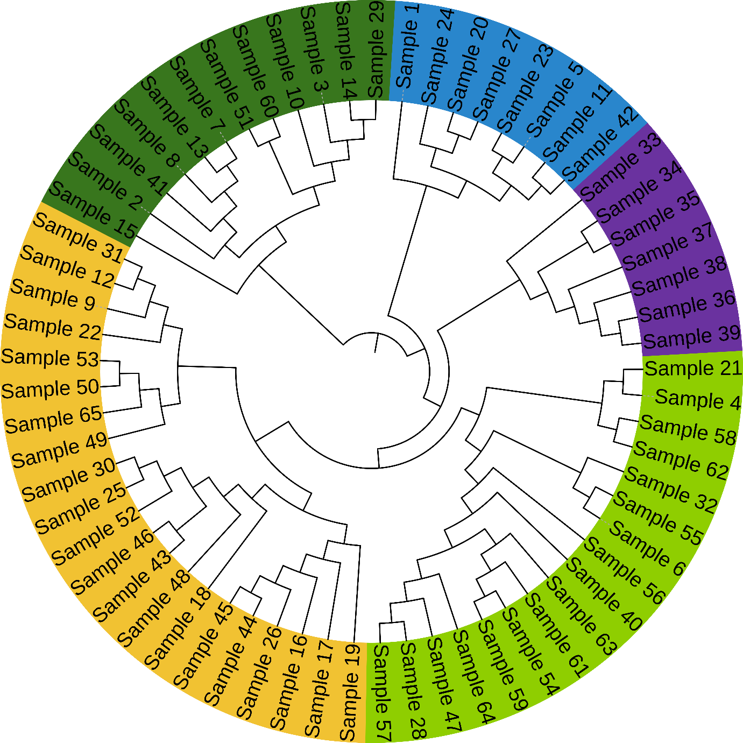

Figure 4: Dendrogram representing genetic relationships among 65 samples based on 14 SSR markers

Table 3: The sample size per marker, observed number of alleles (Na), effective number of alleles (Ne), effective number of alleles (Ne), Nei’s gene diversity (h), and Shannon’s Information Index (I).
Markers | Sample Size | Na | Ne | h | I
mEgCIR0173 | 62 | 1.0000 | 1.0000 | 0.0000 | 0.0000
mEgCIR0802 | 60 | 1.0000 | 1.0000 | 0.0000 | 0.0000
mEgCIR1730 | 60 | 1.0000 | 1.0000 | 0.0000 | 0.0000
mEgCIR1753 | 59 | 2.0000 | 1.7751 | 0.4367 | 0.6284
mEgCIR3292 | 54 | 2.0000 | 1.1172 | 0.1049 | 0.2146
mEgCIR3282 | 65 | 1.0000 | 1.0000 | 0.0000 | 0.0000
mEgCIR3300 | 62 | 1.0000 | 1.0000 | 0.0000 | 0.0000
mEgCIR3543 | 61 | 2.0000 | 1.9574 | 0.4891 | 0.6822
mEgCIR3362 | 61 | 2.0000 | 1.9995 | 0.4999 | 0.6930
mEgCIR3363 | 46 | 3.0000 | 1.7203 | 0.4187 | 0.7511
mEgCIR3546 | 62 | 2.0000 | 1.0328 | 0.0317 | 0.0826
mEgCIR3574 | 62 | 1.0000 | 1.0000 | 0.0000 | 0.0000
mEgCIR3785 | 63 | 3.0000 | 1.8713 | 0.4656 | 0.8175
mEgCIR3886 | 53 | 1.0000 | 1.0000 | 0.0000 | 0.0000
Mean | 59 | 1.6429 | 1.3195 | 0.1748 | 0.2764
St. Dev | —

3.4 Shannon diversity index
According to Shannon Statistics Summary (Table 4), oil palm genotypes have a total genetic diversity (sH) of 0.347, of which 92.94% is found within populations (sH = 0.322) and only 7.06% is found among populations (sH = 0.024). Within-population variance contributes more to the overall predicted diversity (exp(sH)) of 1.415 (1.380). Allele overlap (O′) is substantial (0.916), suggesting common genetic structure, whereas scaled diversity values (D′) further support minimal among-population differentiation (0.084). Among-population variance is substantial, according to the G-test (p = 0.010).

Table 4: A table summary of Shannon statistics
Source  of Inf. | Df | Chi² | sH | % | Exp(sH) | D'  (0,1) | O'=1-D'  (0,1) | p value
Among  Pops | 1 | 3.183 | 0.024 | 7.059 | 1.025 | 0.084 | 0.916 | 0.010
Within Pops | 63 | 41.901 | 0.322 | 92.941 | 1.380 | 0.282 | 0.718 | 0.991
Total | 64 | 45.084 | 0.347 | 100.00 | 1.415 | 0.298 | 0.702
Df: degree of freedom; Chi²: Chi-square; sH: Shannon diversity index; %: total information; exp (sH): Diversity estimate; D’: Scaled diversity; (O'=1-D'): Scaled overlap.

Figure 5: The figures show the partitioning of genetic diversity among and within populations based on Shannon Information Index (sH) and scaled diversity components (D’ and O’).

The Shannon Information Index (sH) was computed to assess the partitioning of genetic diversity scale diversity components (D’ and O’) oil palm genotypes across agroecological zones of Tanzania. The Figure 5, shows both percentage of shannons information and the scaled diversity and overlap, where as 93% displayed the genetic diversity conserved within populations and, whereas only 7% is found among populations in Percentage of Shannon information (sH), and the scaled diversity (D’) displayed how the greater the genetic variability shown within and among populations through, the overlap (O’) used to reflect the extensive shared genetic information of oil palm genotypes and its minimal variations.This indicating low genetic variations.

DISCUSSION

4.1 Allelic diversity of African oil palm
Allelic diversity, is one of the measure genetic variations in a population. An average number of 1.6429 and a range of 1 to three alleles per locus identified among 23 alleles Indicated limited allelic variability within the genotypes. This could associate with limited genetic base, low adaptive gene flow of various genotypes, or excessive oil palm inbreeding or clonal propagation techniques. The recent findings contradicted to Pacheco Diaz et al. (2014) and Gan et al. (2021) who reported high allelic diversity, of 8.67 and 8.433 alleles per locus, respectively. Similarly, Tasma et al. (2016) have reported the higher allelic richness per locus of Aleis guineensis jacq in Cameroon compared to Tanzanian oil palm germplasm that displayed to have narrower genetic base.

Additionally, seven markers used in the recent study (mEgCIR0173, mEgCIR0802, mEgCIR1730, mEgCIR3282, mEgCIR3300, mEgCIR3574, and mEgCIR3886) detected only one allele for each (Na = 1.000) indicating an existence of monomorphism. The used markers did not eliminate polymorphism; rather, the genotypes themselves, which were probably highly conserved in the group being studied.

Fairly balanced distribution of alleles at this locus, at a ranged of 1.0000 to 1.9995, and a mean of 1.3195 indicated a functional genetic diversity. Myint et al. (2021) and Gan et al. (2021) reported an average Ne of 2.653 and a range of 1.96 to 3.34 in in Senegal and Nigerian-based oil palm germplasm, respectively. These indicated the importance of using microsatellite markers in assessing genetic diversity and identifying rare alleles for conservation. However, Ne values of 1.0000 for the same seven monomorphic markers indicated un effective diversity which confirm absence of variation at their loci. Moreover, the differences between effective (Ne) and number of alleles denoted unequal distribution of allele frequencies in many loci. The differences identified dominant alleles or those with small numbers, which could obscure rare alleles and lower the overall genetic diversity index. Similar consistently disparity between the number of alleles (Na) and effective alleles (Ne), indicating the presence of rare alleles and uneven allele frequency distribution.

Apart from mEgCIR3363, mEgCIR3362, and mEgCIR3785 markers to provide useful polymorphism and ought to be given priority in subsequent research and analysis, oil palm population under investigation had moderate to low levels of allelic as an overall. Angkat et al. (2021) reported moderate genetic diversity among individuals within populations. Lack of variation limits the genetic pool availability for breeding and selection. To broadening genetic basis there is a need of incorporating more varied oil palm germplasm from other Tanzanian regions or gene banks using marker-assisted breeding (SSR) techniques.

4.2 Polymorphic information content (PIC)
The polymorphic information content values ranged from 0.0000 to 0.4192, and had a mean of 0.1440. This indicated a low level of marker informativeness across oil palm accessions. Five markers had a PIC value greater than or equal to 0.3, showing limited genetic variation among accession. mEgCIR3785 and mEgCIR3363 markers had highest PIC values at 0.4192 and 0.3800, respectively, suggesting their higher discriminatory power and their potential utility in genetic diversity for breeding. The values of polymorphic information content was ranged from low to high. Pootakham et al. (2013) discovered PIC values of 0.066-0.375 for SNP markers, in line with G, (2024) who reported a mean of 0.22 using SSR markers. González Chavarro et al. (2016) and Tasma & Arumsari, (2020) reported higher PIC averages of 0.58 and 0.80 using SSR markers, respectively. According to González Chavarro et al., (2016) reported that, high genetic diversity in oil palm population from Cameroon and Zaire when used microsatellite markers in the study with the mean PIC value of 0.58 and 90% polymorphic loci, this is equivalent to the findings done by (G, 2024), as showed by the PIC values, which extended from 0.14 to 0.60 in ten oil palm hybrids each with the mean value of 0.22. This highlights that, the increase in PIC values results to the high genetic diversity between the oil palm accessions. In comparison to Malaysian oil palm populations which exhibited superior informativeness of SSR markers due to the use of various breeding lines (Okoye et al., 2016).This differences highlights the moderately limited informativeness of SSR markers between Tanzanian accessions.

In contrast, mEgCIR0173, mEgCIR0802, mEgCIR1730, mEgCIR3282, mEgCIR3300, mEgCIR3574, and mEgCIR3886 markers had PIC value of 0.0000, indicating monomorphism lacking variability among accessions. (Hama-Ali & Tan, 2014) reported un used monomorphic SSR markers to be useful in identifying illegitimate children in oil palm breeding programs. The low average PIC value indicated limited allelic diversity, attributed to homogeneity or restricted genetic foundation among the used accessions. This highlighted the need for more studies using diverse germplasm generated from wider sampling.

4.3 Cluster analysis
The UPGMA dendrogram generated from 14 SSR markers across 65 oil palm genotypes generated five major genetic clusters, demonstrating significant genetic variability within the studied population. The largest cluster reported in yellow had 21 accessions, suggesting a high level of genetic similarity, reflecting a common genetic background or breeding history. The light green, green, blue, and purple clusters showed varying levels of relatedness, with the purple cluster being the most genetically divergent. Sunilkumar et al.(2020) reported two major clusters separating E. oleifera and E. guineensis species, with Nigerian dwarf tenera and Tanzanian dura showing maximum diversity within E. guineensis. Tasma et al. (2016) found nine (9) clusters among 50 Cameroon-originated accessions, with genetic diversity between accessions ranging from 4-82%. Despite of oil palm accession being collected from different agroecological zones in Tanzania, their distribution across clusters did not consistently align with their geographic origins, indicating the possibility of their genetic similarity to be influenced by factors like narrow genetic base, historical seed exchange and gene flow rather than geographic proximity. Though clustering of African oil palm accessions into five distinct groups postulates valuable guidance for parental selection in breeding programs, due to its genetically distant to certain characteristics,this exploit heterozygosity,improving yield and adaptability,comparable to the advances used in Malaysia, where diverse African germplasm was introgressed into breeding populations to widen the genetic bases.

The observed genetic pattern is consistent with the role of migration and gene exchange in shaping genetic relationships among oil palm populations. The presence distinct accessions within the same cluster suggests exchange of planting material, either formally or informally. Okoye et al. (2016) reported SSR markers revealed genetic relationships between elite oil palms from Malaysia and Nigeria, showing of genotypes derived from similar ancestor.These findings are different from Tanzanian oil palm where clustering patterns displayed narrower genetic bases and limited divergence.

4.4 Shannon diversity index
According to the findings, Tanzanian oil palm genotypes have a moderate level of overall genetic diversity, with within-population variation predominating. This is most likely the result of outcrossing and gene flow. Mild genetic structure, maybe due to restricted seed exchange barriers or regional adaptation, is implied by the minimal but statistically significant divergence among populations (p = 0.010). A common genetic background across zones is indicated by the substantial allele overlap. These results emphasize how crucial cross-regional sampling and intra-population conservation are to breeding and genetic resource management plans.

These results support the notion that breeding practices and historical accessions migration, rather than merely geographic dispersion, drive genetic diversity in oil palm populations. Limited genetic difference observed highlighted the value of employing molecular markers to direct breeding and conservation efforts, especially to identify genetically distinct individuals regardless of their place of origin. In relation to Nigeria and Cameroon known as the centre of origin with high natural diversity, these underscore the need to increase the germplasm bases for potential breeding efforts in Tanzania.

CONCLUSION
Conclusively, the analysis of allelic diversity derived from the recent studies provided important new information about on the present genetic makeup of Tanzanian oil palm accession. To improve resilience and production of oil palm there is a need of preserving the current germplasm, outsourcing elite genotypes, and guarantee the genetic enrichment of breeding populations (Tasma et al., 2020).

DISCLOSURE STATEMENT
The authors declare that, there is no conflict of interest

STATEMENT OF DATA AVAILABILITY
The corresponding author can provide the data upon reason logical request.
Disclaimer (Artificial intelligence)
Option 1:
Author(s) hereby declare that NO generative AI technologies such as Large Language Models (ChatGPT, COPILOT, etc.) and text-to-image generators have been used during the writing or editing of this manuscript.
Option 2:
Author(s) hereby declare that generative AI technologies such as Large Language Models, etc. have been used during the writing or editing of manuscripts. This explanation will include the name, version, model, and source of the generative AI technology and as well as all input prompts provided to the generative AI technology
Details of the AI usage are given below:
1.
2.
3.

REFERENCES

Andrea M. M., & Mishili M.A. (2023). Profitability of Oil Palm Farming in Kigoma Rural District, Tanzania. Tanzania Journal of Agricultural Sciences 22(2): 211–221.
Angkat, N. U., Luthfi Aziz Mahmud Siregar, Mohammad Basyuni, Dadang Afandi, & Syahputra, I. (2021). DNA intensity and genetic diversity of oil palm (Elaeis guineensis) to determine an elite low lipase line. Biodiversitas Journal of Biological Diversity 22(2).
Azuokwu, A., Igbafe, A., Yerima, Y., Akpobi, E., Ngubi, F., Azike, R., & Onoji, S. (2024). A Comparative Study of the Physicochemical Properties of Oils Extracted from Common Species of the Niger Delta &lt;i&gt;Raphia &lt;/i&gt;Palm Fruits and &lt;i&gt;Elaeis guineensis&lt;/i&gt; American Journal of Chemical Engineering 12(3): 34–51.
Bai, B., Wang, L., Zhang, Y. J., Lee, M., Rahmadsyah, R., Alfiko, Y., Ye, B. Q., Purwantomo, S., Suwanto, A., Chua, N.-H., & Yue, G. H. (2018). Developing genome-wide SNPs and constructing an ultrahigh-density linkage map in oil palm. Scientific Reports 8(1): 691.
Barcelos, E., Rios, S. D. A., Cunha, R. N. V., Lopes, R., Motoike, S. Y., Babiychuk, E., Skirycz, A., & Kushnir, S. (2015). Oil palm natural diversity and the potential for yield improvement. Frontiers in Plant Science 2015: 1-6.
Benoit, C. L.-L.-N., Joseph, M. B., Georges, F. N.-E., Godswill, N. N., & Hermine, B. N. (2016). Genetic determinism of oil acidity among some DELI oil palm (Elaeis guineensis Jacq.) progenies. African Journal of Biotechnology 15(34):1841–1845.
Gan, S. T., Teo, C. J., Manirasa, S., Wong, W. C., & Wong, C. K. (2021). Assessment of genetic diversity and population structure of oil palm (Elaeis guineensis Jacq.) field genebank: A step towards molecular-assisted germplasm conservation. PloS One 16(7): e0255418.
Ganesan, S. K., Singh, R., Roy Choudhury, D., Bharadwaj, J., Gupta, V., & Singode, A. (2014). Genetic diversity and population structure study of drumstick (Moringa oleifera Lam.) using morphological and SSR markers. Industrial Crops and Products 60: 316–325.
González Chavarro, C. F., León Lozano, M. E., Morillo Coronado, A. C., Ochoa, E. I., & Morillo Coronado, Y. (2016). Caracterización molecular de palma de aceite Elaeis guineensis Jacq., procedente de diferentes orígenes (Zaire y Camerún) usando marcadores microsatélites. Acta Agronómica 65(3): 276–283.
Hama-Ali & Tan. (2014). Using Monomorphic Microsatellite Markers in Oil Palm (Elaeisguineensis Jacq.).
James, F., Patrick, D., Aiah, L., & Richard, W. (2023). Effect of density and management of oil palm plantations on the avifauna of Southeastern Sierra Leone. International Journal of Biodiversity and Conservation 15(4):145–154.
Jin, J., Lee, M., Bai, B., Sun, Y., Qu, J., Rahmadsyah, Alfiko, Y., Lim, C. H., Suwanto, A., Sugiharti, M., Wong, L., Ye, J., Chua, N.-H., & Yue, G. H. (2016). Draft genome sequence of an elite Dura palm and whole-genome patterns of DNA variation in oil palm. DNA Research 23(6):527–533.
Kannan, P. (2020). A review on malaysian sustainable palm oil certification process among independent oil palm smallholders. [https://doi.org/10.21894/jopr.2020.0056] site visited on 14/3/2025.
Mondjeli Constantin, Ardha Apriyanto, Sadou Ismaël, Sobir Ridwani, Ajambang Walter Nchu, Sobda Gonne, Muhamad Syukur, Ebouelle Ngothy Arsene Belmond, & Willy Bayuardi Suwarno. (2024). Genome wide association study reveals key genic regions controlling oil palm vegetative characters in wild population of Cameroon. Global Journal of Engineering and Technology Advances 18(2): 042–048.
Murphy, D. J., Goggin, K., & Paterson, R. R. M. (2021). Oil palm in the 2020s and beyond: Challenges and solutions. Agriculture and Bioscience 2(1): 1-39.
Murugesan, P., Aswathy, G. M., Kumar, K. S., Masilamani, P., Kumar, V., & Ravi, V. (2017). Oil palm (Elaeis guineensis) genetic resources for abiotic stress tolerance: A review. The Indian Journal of Agricultural Sciences 87(5).
Mwatawala, Maguta, & Kazanye. (2022). Factors Influencing the Adoption of Improved Oil Palm Variety in Kigoma Rural District of Tanzania. 24(2).
Myint, K. A., Yaakub, Z., Rafii, M. Y., Oladosu, Y., Samad, M. Y. A., Ramlee, S. I., Mustaffa, S., Arolu, F., Abdullah, N., Marjuni, M., & Amiruddin, M. D. (2021). Genetic Diversity Assessment of MPOB‐Senegal Oil Palm Germplasm Using Microsatellite Markers. BioMed Research International 2021(1): 6620645.
Natawijaya, A., Ardie, S. W., Syukur, M., Maskromo, I., Hartana, A., & Sudarsono, S. (2019). Genetic structure and diversity between and within African and American oil palm species based on microsatellite markers. Biodiversitas Journal of Biological Diversity 20(5).
NBS (2022). National Sample Census of Agriculture 2019/20: National Report; National Bureau of Statistics (NBS): Dodoma, Tanzania, 2021.
Ntsefong, G. N., Ngalle-Bille, H., Ajambang, W., Likeng-Li-Ngue, B. C., Kingsley, T.-M., Bell, J. M., & Youmbi, E. (2016). Brief review on the controversies around oil palm (Elaeis Guineensis Jacq.) production and palm oil consumption. International Journal of Regional Development 3(2): 1- 60.
Okoye, M. N., Bakoumé, C., Uguru, M. I., Singh, R., & Okwuagwu, C. O. (2016). Genetic relationships between elite oil palms from Nigeria and selected breeding and germplasm materials from Malaysia via Simple Sequence Repeat Markers. Journal of Agricultural Science 8(2): 159.
Pacheco Diaz, J. E., Arias Moreno, D. M., Ojeda Perez, Z. Z., & Romero Angulo, H. M. (2014). Diversidad y estructura genética de accesiones de palma de aceite (Elaeis guineesis Jacq.) provenientes de Camerún. Revista Colombiana de Biotecnología 16(2): 57–67.
Pootakham, W., Uthaipaisanwong, P., Sangsrakru, D., Yoocha, T., Tragoonrung, S., & Tangphatsornruang, S. (2013). Development and characterization of single‐nucleotide polymorphism markers from 454 transcriptome sequences in oil palm (Elaeis guineensis ). Plant Breeding 132(6): 711–717.
Reuben, F. M., & Meliyo, J. L. (2022). Unlocking opportunities in edible oil crop production and market dynamics to accelerate agricultural investment in Kagera Region, Tanzania. International Journal of Environment, Agriculture and Biotechnology 7(3): 128–132.
Soh, A. C., Mayes, S., & Roberts, J. (2017a). Introduction to the Oil Palm Crop. In: A. C. Soh, S. Mayes, & J. Roberts (Eds.), Oil Palm Breeding. (pp. 1–6). CRC Press.
Sultan, M. S., Shimelis, H., Kagimbo, F. M., & Mrema, E. J. (2025). An Appraisal of the Constraints, Opportunities, and Farmers’ Needs and Preferences of Oil Palm for Sustainable Production and Improvement in Tanzania. Sustainability 17(8): 3546.

Sunilkumar, K., Murugesan, P., Mathur, R. K., & Rajesh, M. K. (2020). Genetic diversity in oil palm (Elaeis guineensis and Elaeis oleifera) germplasm as revealed by microsatellite (SSR) markers. The Indian Journal of Agricultural Sciences 90(4): 741–745.

Tamura, K., Dudley, J., Nei, M., & Kumar, S. (2007). MEGA4: Molecular evolutionary genetics analysis (MEGA) Software Version 4.0. Molecular Biology and Evolution 24(8): 1596–1599.

Tasma, I. M., & Arumsari, S. (2020). Analisis diversitas genetik aksesi kelapa sawit kamerun berdasarkan marka ssr. Journal Penelitian Tanaman Industri 19(4): 194.

Tasma, I. M., Warsun, A., Satyawan, D., Syafaruddin, S., & Martono, B. (2016). Analisis Kekerabatan 50 Aksesi Kelapa Sawit (Elaeis guineensis Jacq.) Asal Kamerun Berdasarkan Marka Mikrosatelit. Journal AgroBiogen 9(1): 1- 19.

Xiao, Y., Zhou, L., Lei, X., Cao, H., Wang, Y., Dou, Y., Tang, W., & Xia, W. (2017). Genome-wide identification of WRKY genes and their expression profiles under different abiotic stresses in Elaeis guineensis. PloS One 12(12):

Xiao, Y., Zhou, L., Xia, W., Mason, A. S., Yang, Y., Ma, Z., & Peng, M. (2014). Exploiting transcriptome data for the development and characterization of gene-based SSR markers related to cold tolerance in oil palm (Elaeis guineensis). BMC Plant Biology 14(1): 384.

Yarra, R., Jin, L., Zhao, Z., & Cao, H. (2019). Progress in Tissue Culture and Genetic Transformation of Oil Palm: An Overview. International Journal of Molecular Sciences 20(21): 5353.

Yu, J., Jing, Z. B., & Cheng, J. M. (2014). Genetic diversity and population structure of Stipa bungeana, an endemic species in Loess Plateau of China, revealed using combined ISSR and SRAP markers. Genetics and Molecular Research 13(1): 1097–1108.

Zhou, L. X., Xiao, Y., Xia, W., & Yang, Y. D. (2015). Analysis of genetic diversity and population structure of oil palm (Elaeis guineensis) from China and Malaysia based on species-specific simple sequence repeat markers. Genetics and Molecular Research 14(4): 16247–16254.

