Short communication

Phytochemical Profiling of Syzygium haemisphericum Leaf Extract Using FT-IR and GC–MS Techniques
ABSTRACT

Syzygium haemisphericum, a medicinal plant native to the Western Ghats of India, is traditionally utilized for the management of diabetes and kidney stones due to its hypoglycemic and bioactive properties. This research presents the phytochemical analysis, Fourier Transform Infrared (FT-IR) spectroscopy, and Gas Chromatography-Mass Spectrometry (GC-MS) of the methanol leaf extract. The presence of carbohydrates, tannins, alkaloids, vitamin C, terpenoids, and resins has been revealed through phytochemical analysis. The FT-IR technique identifies all the functional groups, including alcohols, esters, carboxylic acids, ketones, and aromatic amines. A GC-MS study identified six bioactive compounds, including neophytadiene, hexadecanoic acid, and globulol. The findings corroborate the notion that the plant possesses medicinal capabilities and indicate the necessity for further investigation to identify and characterize its bioactive constituents.
Keywords: Phytochemicals, Syzygium haemisphericum, FT-IR spectroscopy, GC-MS.
1. INTRODUCTION
India is globally recognized for its extensive array of medicinal plants, which are vital for culture, the economy, and health. Approximately 80% of individuals in developing nations utilize traditional medicine as their primary form of health treatment. [1] Syzygium haemisphericum, commonly referred to as the "Hemispheric Rose-apple," is recognized for its therapeutic properties. This plant has been mainly located in Maharashtra, Sri Lanka, and in the Western Ghats, a UNESCO World Heritage site. It highlights antidiabetic effects via blood glucose reduction and use in nephrolithiasis treatment in traditional Indian medicine, attributing benefits to flavonoids and polyphenols. [2]
Majorly, this plant has been utilized in traditional medicine for its capacity to reduce blood glucose levels, particularly in the treatment of diabetes mellitus and nephrolithiasis. It is a significant component of holistic health therapies due to its accessibility, affordability, and few adverse effects. [3] Examining the bioactive constituents of S. haemisphericum is essential to validate its therapeutic potential. A phytochemical study elucidates the medicinal properties of a plant by identifying the compounds responsible for biological action. Generally chemical composition and functional groups are examined by FT-IR spectroscopy and GC-MS analytical techniques in plant extracts with precision. [4] These approaches are essential in elucidating the phytochemical composition; hence, facilitating novel applications in medicinal and natural product research [5-6] plays a vital role. The green synthesis of ZnO nanoparticles using Syzygium hemisphericum bark extract via a solution combustion method was established.If we compare ZnO NPs, the crude bark extract showed stronger antioxidant and antidiabetic activity (α-amylase, α-glucosidase inhibition) and was less toxic in hemolysis assays. ZnO NPs, however, were exhibiting notable antibacterial and anticancer effects against A431 carcinoma cells, indicating complementary biomedical applications. [7]
Similarly, Syzygium formosum leaves also have been used in traditional medicine for the treatment of skin-related diseases such as atopic dermatitis and psoriasis.[8] Syzygium cumini (Java plum) aqueous leaf extract was used as a stabilizing and reducing agent to synthesize zinc oxide nanoparticles (ZnO NPs), and it’s in vitro antioxidant and cytotoxic potential was analyzed. [9] We present the bioactive components derived from methanol extracts of S. haemisphericum leaves, along with subsequent analyses utilizing FT-IR and GC-MS techniques. FT-IR facilitates the evaluation of functional groups inside a substance, which correlates with the compound's chemical and physical properties. [10] GCMS is extensively utilized in forensics, drug discovery, medicine, and environmental monitoring by analyzing each component separately following the separation of individual components using gas chromatography. [11]

2. MATERIALS AND METHODS
2.1 Acquiring and Designating Plant Material
We obtained leaves from the Syzygium haemisphericum plant in the Thiruvananthapuram area of Kerala, India. A botanist verified the authenticity of the plant, and voucher specimens were deposited in the herbarium of the PG & Research Department of Chemistry at Jamal Mohamed College. The leaves were shade-dried for 7 to 10 days, thereafter milled into a fine powder, and stored in sealed containers for future analysis.
2.2 Extraction of Plant Material
We have used methanol (500 mL) as the solvent to conduct a Soxhlet extraction for a duration of 6 hours on the powdered leaves (100 g) to ensure the complete extraction of all bioactive constituents. To concentrate the extract under reduced pressure, a rotary evaporator was employed, and the percentage yield was determined as follows:
Yield (% calculation = (Mass of crude extract / Mass of desiccated leaves) × 100
Qualitative Phytochemical Examination
Conventional techniques were employed for the first phytochemical analysis to identify phytoconstituents such as carbohydrates, proteins, amino acids, alkaloids, tannins, flavonoids, glycosides, terpenoids, resins, and vitamin C.
2.3 Examination of GC-MS analysis
We employed a Thermo Scientific Trace 1300 Gas Chromatograph in conjunction with an ISQ-QD Mass Spectrometer and a TG-5MS column (30 m × 0.25 mm, 0.25 µm film thickness) for the GC-MS study. The carrier gas utilized was helium, flowing at a rate of 1 mL/min. The oven was calibrated to the specified temperature:
• Initial temperature: 60°C (maintained for 2 minutes)
• Heating ramp: 10°C/min to 280°C (maintained for 10 minutes)
We utilized the NIST 17 library to analyse the mass spectra and identify the chemicals.
2.4 Examination of FT-IR Spectroscopy
We utilized a PerkinElmer Spectrum. Two instruments for conducting FT-IR analysis. We centrifuged, filtered, and analysed the methanol leaf extract in the range of 4000 to 400 cm⁻¹ to identify functional groups. We examined the peaks to ascertain the associated chemical bonds.
2.5 Extract Yield Percentage
The methanol extraction yielded 18% of the dried leaf material, indicating its efficacy. Due to its polarity, methanol may solubilize both polar and nonpolar compounds. This enables the separation of several phytochemicals, including alkaloids, tannins, terpenoids, and secondary metabolites. The substantial yield indicates that S. haemisphericum leaves contain numerous bioactive chemicals, hence affirming their potential therapeutic utility. The yield is influenced by factors such as the extraction method, solvent polarity, and phytochemical composition. Methanol is effective for this plant.

3. RESULTS AND DISCUSSION
3.1 Phytochemical Analysis
Initial screening indicated the presence of several bioactive compounds (Table 1):
• Carbohydrates: They serve as energy reserves and provide structural support, indicating potential health benefits.
Tannins are polyphenolic compounds that facilitate wound healing and promote gastrointestinal health. They possess antioxidant, antimicrobial, and anti-inflammatory properties.
Alkaloids are compounds that may alleviate pain, treat malaria, and combat cancer.
• Vitamin C: An antioxidant that facilitates collagen synthesis, enhances immunological function, and safeguards against oxidative stress.
• Terpenoids: Anti-inflammatory, antibacterial, and anticancer properties are exhibited by the presence of various terpenoids, which also contribute to the plant's aroma and therapeutic characteristics.
• Resins: Infections and wounds are treated historically with various resins, and also they possess antibacterial and anti-inflammatory attributes.

Type of Phytochemical | Available status
Carbohydrates | Present
Proteins | Absent
Amino acids | Absent
Alkaloids | Present
Tannins | Present
Flavonoids | Absent
Glycosides | Absent
Terpenoids | Present
Resins | Present
Vitamin C | Present

Table 1. Phytochemical constituents detected in Syzygium haemisphericum methanol leaf extract

Hence these results are suggesting that S. haemisphericum leaves have diverse therapeutic potential, including antimicrobial, anti-inflammatory, and antioxidant activities.

3.2 GC-MS Analysis
The methanol extract contained six major bioactive compounds as identified by GC-MS (Table 2).
• Neophytadiene (RT: 13.156 min, 2.695%): It is antioxidant and antimicrobial in nature, meaning it prevents free radicals from causing harm.
• Hexadecanoic acid, 3, 7, 11, 15-tetramethyl-2-hexadecenyl ester (RT: 14.375 min, 50.174%): A fatty acid ester that combats inflammation and safeguards cells from damage, ensuring cell membranes are kept healthy.
3-Buten-2-one, 3-methyl-4-(1,3,3-trimethyl-7-oxabicyclo[4.1.0] heptan-1-yl) (RT: 14.594 min, 10.612%): This compound likely is antimicrobial in nature and may be used as a natural preservative.
Humulane-1,6-dien-3-ol (RT: 14.772 min, 17.637%): An alcohol sesquiterpene with anti-inflammatory and antioxidant properties. It might be beneficial for arthritis and heart issues.
• Globulol (RT: 15.650 min, 18.881%): Present in essential oils, it is noted for having strong antimicrobial, anti-inflammatory, and antioxidant activities.
• Epiglobulol (not measured): Most likely has the same biological activities as globulol, contributing to the therapeutic value of the extract.

Compound | Retention Time (min) | Area (%) | Bioactivity
Neophytadiene | 13.156 | 2.695 | Antioxidant, Antimicrobial
Hexadecanoic acid ester | 14.375 | 50.174 | Anti-inflammatory, Antioxidant
3-Buten-2-one derivative | 14.594 | 10.612 | Antimicrobial
Humulane-1,6-dien-3-ol | 14.772 | 17.637 | Anti-inflammatory, Antioxidant
Globulol | 15.650 | 18.881 | Antimicrobial, Anti-inflammatory
Epiglobulol | – | – | Antimicrobial, Anti-inflammatory

Table 2. Bioactive compounds identified by GC-MS in Syzygium haemisphericum methanol leaf extract
These compounds highlight the plant’s potential for treating conditions involving inflammation, infections, and oxidative stress.
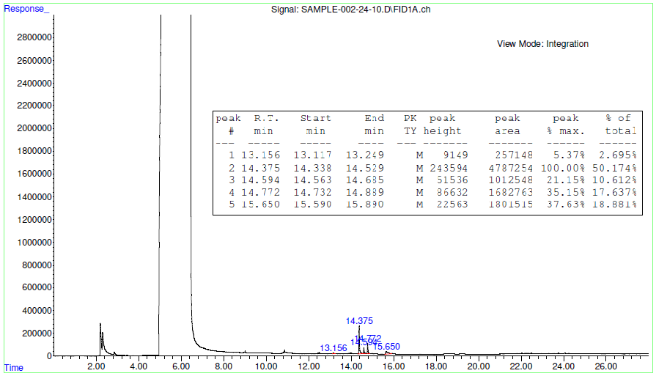

Figure 1. GCMS chromatogram of Syzygium haemisphericum methanol leaf extract

Table 3. GC-MS Analysis of methanol extract of syzygium hemisphericum leaves

3.3 FT-IR Spectroscopy Analysis
FT-IR spectroscopy showed important functional groups in the methanol extract (Table 3).
• O-H Stretch (3411.58 cm⁻¹): Shows hydroxyl groups in alcohols and carboxylic acids, which help them work as antioxidants.
• C=O Stretch (1735.63 cm⁻¹): This is a sign of esters and ketones, and it is linked to anti-inflammatory and antioxidant effects.
• C-H Stretch (2949.23 cm⁻¹): This is a common feature of alkanes in fatty acids that helps keep cell membranes strong.
• C-N Stretch (1204.62 cm⁻¹): Shows that alkaloids have amines, which are associated with pain relief, killing bacteria, and fighting cancer.

Wavenumber (cm−¹) | Functional Group
3411.58 | O-H Stretch (Alcohols, Carboxylic acids)
2949.23 | C-H Stretch ( Alkanes )
1735.63 | C=O Stretch (Esters, Ketones)
1204.62 | C-N Stretch ( Amines )

Table 4. FT-IR spectral peaks and corresponding functional groups

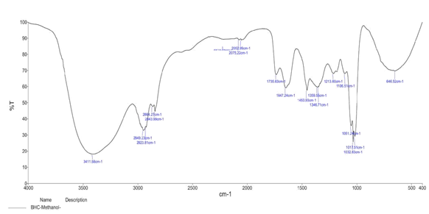

Figure 2. FT-IR spectra for methanol extract of syzygium hemisphericum leaves

These functional groups confirm the presence of bioactive compounds responsible for the plant’s medicinal potential.

4. LIMITATIONS
This research has several limitations. The analysis was conducted just on Syzygium haemisphericum Leaves from herbal nursery, hence restricting the research findings to this particular species from the specified area. Secondly, our research aimed solely at qualitative analysis and did not endeavor to quantify the phytochemicals in the samples. The environmental variables of Indian country that may influence the composition of Syzygium haemisphericum leaves were not evaluated.

5. CONCLUSION
The leaves of Syzygium haemisphericum are abundant in bioactive chemicals possessing various therapeutic characteristics. The 18% yield of the methanol extract, together with the presence of carbohydrates, tannins, alkaloids, vitamin C, terpenoids, and resins, highlights its therapeutic potential. GC-MS analysis showed significant substances, including neophytadiene, hexadecanoic acid ester, and globulol, whilst FT-IR spectroscopy validated the presence of functional groups such as alcohols, esters, and amines. These findings corroborate the plant's historical application in the treatment of diabetes and nephrolithiasis and indicate potential uses in antibacterial, anti-inflammatory, and antioxidant therapy. Subsequent investigations should concentrate on isolating and characterizing these bioactive chemicals to clarify their modes of action and to formulate innovative plant-derived medicines.

COMPETING INTERESTS DISCLAIMER:
Authors have declared that they have no known competing financial interests OR non-financial interests OR personal relationships that could have appeared to influence the work reported in this paper.
Disclaimer (Artificial intelligence)
Author(s) hereby declare that NO generative AI technologies such as Large Language Models (ChatGPT, manuscript.

REFERENCES
- Krishna, C. S.; Chandra, R.; Khaleel, K. M. Phytochemical Screening and GC–MS Studies of Syzygium dhaneshiana Leaf and Bark Extracts. Int. J. Pharm. Sci. Res. 2017, 8 (5), 2277–2281. https://doi.org/10.13040/IJPSR.0975-8232.8(5).2277-81.
- Ravishankara, M. N.; Shylaja, M. D.; Saxena, A. K. Syzygium hemisphericum (Wight) Alston: A Review on Phytochemistry and Pharmacology. J. Ethnopharmacol. 2018, 225, 1–12.
- Rahim, E. N. A. A.; Ismail, A.; Omar, M. N.; Rahmat, U. N.; Ahmad, W. A. N. W. GC–MS Analysis of Phytochemical Compounds in Syzygium polyanthum Leaves Extracted Using Ultrasound-Assisted Method. Pharmacogn. J. 2018, 10 (1), 110–119. https://doi.org/10.5530/pj.2018.1.20.
- Deepikaa, N.; Saranyaa, J.; Eganathana, P.; Puthiyapurayila, S. Antimicrobial Activity of Syzygium zeylanicum (L.) DC. and Syzygium hemisphericum (Walp.) Alston. J. Biol. Act. Prod. Nat. 2014, 4 (2), 120–124. https://doi.org/10.1080/22311866.2014.890065.
- Rameshkumar, K. B.; Aravind, A. P. A.; Vinodkumar, T. G. Leaf Essential Oil Composition of Six Syzygium Species from the Western Ghats, South India. Rec. Nat. Prod. 2015, 9 (4), 592–596.
- Narayanan, R.; Shareef, S. M.; Shaju, T.; Sivu, A. R.; Sujana, K. A.; Nandakumar, M. K.; Satheesh, K. T. A New Species of Syzygium (Myrtaceae) from the Southern Western Ghats of Kerala. Int. J. Adv. Res. 2014, 2 (3), 1055–1058.
- Sushmitha, C. H.; Krishnakumar, G.; Navada, K. M. Solution Combustion Method for Synthesis of ZnO NPs from Syzygium hemisphericum Bark Extract and a Comparative Analysis of the Same with the Crude Bark Extract for Biomedical Applications. Chem. Pap. 2024, 78, 3443–3462. https://doi.org/10.1007/s11696-024-03319-3.
- Hoang, K. H. T.; Lim, J.; Nguyen, M. T. T.; Lee, N.-Y.; Lee, C.-K.; Nguyen, V. D.; Kim, H.-L.; Park, J.-T.; Kim, J. Comparative Phytochemical Analysis of Syzygium formosum (Wall.) Masam Leaf and Its Biological Activities. Appl. Sci. 2021, 11, 10552. https://doi.org/10.3390/app112210552.
- Arumugam, M.; Manikandan, D. B.; Dhandapani, E.; Sridhar, A.; Balakrishnan, K.; Markandan, M.; Ramasamy, T. Green Synthesis of Zinc Oxide Nanoparticles (ZnO NPs) Using Syzygium cumini: Potential Multifaceted Applications as Antioxidants, Cytotoxic, and Nanonutrients for the Growth of Sesamum indicum. Environ. Technol. Innovation 2021, 23, 101653. https://doi.org/10.1016/j.eti.2021.101653.
- Abubakar, A.; Haque, M. Preparation of Medicinal Plants: Basic Extraction and Fractionation Procedures for Experimental Purposes. J. Pharm. Bioallied Sci. 2020, 12 (1), 1–10. https://doi.org/10.4103/jpbs.jpbs_175_19.
- Olivia, N. U.; Goodness, U. C.; Obinna, O. M. Phytochemical Profiling and GC-MS Analysis of Aqueous Methanol Fraction of Hibiscus asper Leaves. Fut. J. Pharm. Sci. 2021, 7 (1), 10.1186/s43094-021-00208-4.

