Original Research Article

Natural Rhizogenesis Boosters for the Vegetative Propagation and Conservation of Dalbergia baronii and Dalbergia normandii Species

ABSTRACT
The Dalbergia genus belongs to the Fabaceae family. Four species of Madagascar’s Dalbergia are called rosewood, including D. baronii Baker, D. louvelii R. Vig., D. maritima R. Vig., D. normandii. Their woods are classified in the first category of natural forest wood in Madagascar. Rosewoods are becoming endangered due to overexploitation and the destruction of their habitat. For this reason, a vegetative propagation technique has been developed through this work in order to optimize the vegetative propagation and to ensure the perpetuation of the two species in their natural habitat. This method consists of macerating Dalbergia cuttings in two biostimulants, of Aloe macroclada gel or Curcuma longa powder, for 30 minutes before planting. To verify the effectiveness of the technique, control cuttings were grown at the same time as the macerated cuttings. The two-way ANOVA results revealed significant effects on treatment, and their interaction for both root and shoot development (p < 0.001). Among the treatments, Curcuma longa powder notably enhanced root and growth development, particularly in D. baronii, while Aloe macroclada gel was most effective in D. normandii. Principal Component Analysis (PCA) supported these findings, with the first principal component (PC1) explaining 91.5% of the total variance, followed by PC2 at 8.5%. The biplot clearly distinguished the treated groups, highlighting the superior performance of Curcuma longa in both root and growth development. This study demonstrated the significant influence of two natural rhizogenesis boosters, Curcuma longa powder and Aloe macroclada gel, on the vegetative propagation of Dalbergia baronii and Dalbergia normandii. Therefore, obtaining a new Dalbergia plant is possible even if we do not have seeds, and subsequently ensuring their conservation. These preliminary results promising for the case of Dalbergia normandii, which is currently endangered.

KEYWORDS: Rhizogenesis; Dalbergia baronii; Dalbergia normandii; Aloe macroclada gel; Curcuma longa powder

- INTRODUCTION

The Dalbergia is a tree belonging to the Fabaceae family, and grows in tropical regions such as South Asia, Central America, Africa, and especially in Madagascar, where it has the highest diversity. Out of the 275 global species (Cowell et al., 2022), 55 species are endemic to Madagascar (Bosser and Rabevohitra 1996, 2002, 2005; Wilding et al., 2021a, 2021b; Crameri et al., 2022; and Rakotonirina et al., 2023). Four out of these 55 species are called rosewood: D. baronii Baker, D. louvelii R. Vig., D. maritima R. Vig., and D. normandii Bosser & R. Rabev, (Bosser and Rabevohitra, 2002). The Dalbergia wood is valuable for its technological, physical, mechanical, and aesthetic qualities. Its color and hue a perfect polishing and uniformity make it a sought-after product, increasing supply and demand. This growing demand has led to intensive logging and illegal trafficking, particularly in Madagascar, making a severely threatening the species of the Dalbergia genus. The trade of this wood, whether legal or illegal, places considerable pressure on Madagascar's rosewoods, making these species endangered due to overexploitation and habitat destruction. Among the 55 Dalbergia species endemic to Madagascar, 10 are critically endangered, 14 are endangered, and 10 others are vulnerable according to the International Union for Conservation of Nature (IUCN, 2013). The genus is therefore fully listed in Appendix II of the Convention on International Trade in Endangered Species of Wild Fauna and Flora (CITES 2022). Nevertheless, the Dalbergia genus is the most valuable of the woods classified in the first category of natural forest woods in Madagascar (MEDD, 2021).
Besides the current situation, the natural populations of Dalbergia have dangerously decreased. The trees have become isolated and no longer produce seeds for various reasons, making natural regeneration difficult (CITES, 2013). Some species are doomed to extinction; such is the case for Dalbergia normandii and Dalbergia baronii in the Mahatsara forest station. But the most popular and simple method for propagating forest tree species is rooting of stem cutting which is also a very commonly used propagation technique for Eucalyptus species (Barthwal et al, 2025), and some studies explain the genetic and biochemical mechanisms of root formation, particularly the action of auxins naturally present in certain plants like willow (Jay-Allemand, 2000) which leads us to consider the effects of Aloe macroclada and Curcuma longa on Dalbergia cuttings. In this research, the overall objective is to gather all information on the reproductive biology of the target species and to propose a sustainable solution for their vegetative propagation and conservation. To achieve to this goal, our hypothesis is based on the use of natural rhizogenesis boosters. Aloe macroclada is among the rare species in the world containing essential elements for the survival of an organism. It possesses more than 75 nutrients and 200 other components, including 20 minerals, 18 amino acids, and 12 vitamins, such as anthraquinones (aloïn), resins (aloresins, aloinines), tannins, polysaccharides, and aloetins (Rakotomanana, 2018). While Curcuma longa contains particularly curcumin and other curcuminoids, which exert beneficial effects on plant growth and development thanks to their antioxidant and antimicrobial properties (Saada, 2023). This conservation strategy was designed to ensure the sustainability of the two studied Dalbergia species in the remnant natural forest of Mahatsara. The subsequent reintroduction of these Dalbergia cuttings into the forest will serve as a future source of enrichment for the forest station.

- MATERIAL AND METHODS
  - Study Area

The experiments were conducted at the FOFIFA research station in Mahatsara (17°63'4.02''S, 49°48'4.66''E), located in the Antsinanana region (fig. 1). The station covers 36 hectares of dense, evergreen, low-altitude humid forest between 0 and 20 m. It lies in a hot perhumid tropical zone with annual rainfall exceeding 1500 mm and an average annual temperature between 21°C and 24°C (Antananarivo meteorological service, 2024).

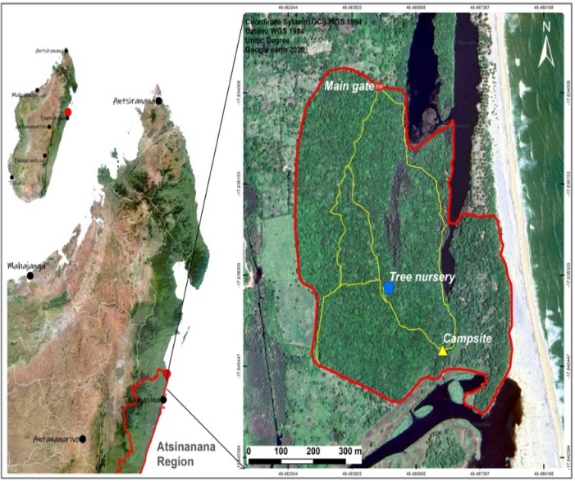
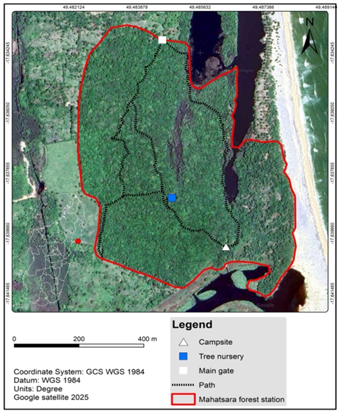

Fig. 1. Localization of the Dalbergia baronii and Dalbergia normandii at the Mahatsara station forest

2.2 Plant Material

The two species, D. baronii and D. normandii, were chosen for this study due to their ecological statuses according to the IUCN Red List in 2006, with D. normandii being an endangered species under the category [En, B2 ab (i, ii, iii, iv)] and D. baronii being a vulnerable species under category [Vu, A1cd+2cd].

Dalbergia baronii Baker is a plant known by the Malagasy names “voamboana” or “hazovola”. It is a deciduous tree of medium to large size, reaching 25-30 m in height. The trunk is also short, branchless up to a height of 6-20 m, with a diameter up to 100-140 cm; bark is whitish to pale brown, sapwood white-yellowish, heartwood dark brown to purplish and centered; young shoots are short-haired, brown, older branches glabrous. Leaves are imparipinnate compound, deciduous, 3-7.5 cm long, composed of 17-25 leathery leaflets with yellowish pubescence on the underside. Inflorescence is an axillary panicle. Flowers are hermaphroditic and whitish in color; lobes shorter than the tube. Fruit is a flat pod 4-5 cm long, glabrous, pale brown with indistinct veins. Seeds are kidney-shaped, dark reddish brown.

Dalbergia normandii Bosser & Rabevohitra or “Andramena” in his Malagasy name, is a tree can reach 15 m in height; shoots are glabrous, sapwood is yellowish-white, heartwood is reddish purple. The leaves, 7-10 cm long, are glabrous, with 5-7 (to 9) alternate leaflets; petioles and rachis are glabrous with a flat blade. The leaf shape is oval to elliptic, acuminate. Inflorescences are terminal, panicle-like, with ultimate branches in small flower clusters. The keel is slightly longer than the other petals, with vexillary lobes forming a distinctly notched piece at the top. The fruits are reddish-brown pods, oblong, apiculate or more or less rounded at the top, tapering at the base, mono- or (di)spermic. Seeds number 1-2, kidney-shaped.
The Stem cuttings used in this experiment were collected from healthy, disease-free mother trees with a Diameter at Breast Height (DBH) greater than 20 cm. Each cutting was approximately 20 cm in length. A total of twelve (12) cuttings were used per treatment group to ensure adequate replication and statistical power.

2.3 Biostimulants Description

Two biostimulants were selected as natural growth boosters based on their known regenerative properties. Aloe macroclada, locally known as “Vahona”, is a succulent species endemic to Madagascar, belonging to the Aloeaceae family. Widely used for medicinal purposes, the plant’s gel is rich in bioactive compounds such as anthraquinones, polysaccharides, vitamins, amino acids, and enzymes, all of which are believed to promote root induction and growth (Rakotomanana, 2018).
On the other hand, Curcuma longa, also referred as "Tamotamo", is a tropical rhizomatous herb from the Zingiberaceae family. Its rhizome contains curcuminoids (especially curcumin), flavonoids, and terpenoids, which exhibit strong antioxidant and regenerative properties, making it a suitable plant-based rooting stimulant (Dosoky et al, 2018).

  - Experimental Design and Cutting Preparation

The experimental setup aimed to assess the effects of two natural boosters on the vegetative propagation of Dalbergia cuttings. Both the apical and basal ends of each cutting were soaked for 30 minutes in one of the following treatments: 20 ml of Aloe macroclada gel, 10 g of Curcuma longa roots powder dissolve in 100 ml of warm water, or no treatment as a control. Following treatment, all cuttings were immediately transplanted into pre-prepared nursery plots. The six experimental groups included 12 cuttings per group, allowing for replicated observations and comparative analysis.
A propagation trial was conducted under controlled conditions in an in-situ nursery, measuring 6.0 m in width and 13.5 m in length. The nursery was subdivided into uniform plots, each 0.95 m in width (Fig. 2), to facilitate consistent spatial allocation. Treatments, including control and experimental cuttings, were randomly assigned to plots following a Completely Randomized Design (CRD), which was considered the most appropriate design to minimize positional bias and control for spatial variability in relatively homogeneous experimental units.
The choice of an in-situ nursery was deliberate. This setting provided environmental conditions closely resembling the natural habitats where the species will ultimately be established, ensuring that the propagation outcomes are ecologically relevant and directly applicable to field restoration efforts. Moreover, the in-situ nursery was more cost-effective and logistically feasible under local resource constraints compared to greenhouse facilities, while still allowing adequate control of critical factors. Key environmental parameters, including light intensity and relative humidity, were continuously monitored and regulated to optimize rooting success and vegetative growth.

Fig. 2. Completely Randomized Design (CRD) layout for Dalbergia propagation trial with 72 cuttings across 12 plots

Data Analysis

Three primary parameters were assessed to evaluate the performance of each treatment. For each species, twelve (12) cuttings per treatment were randomly selected for detailed measurements of root and growth development.

- Root Development: Rooting performance was evaluated by determining the average number of roots per cutting. Root length and dry biomass were also measured to assess overall rooting quality.
- Vegetative growth: Vegetative growth rate was assessed by recording the average number of shoots per plot for each treatment. Additional indicators, including shoot length and number of leaves, were measured to evaluate general plant vigor.
- Vegetative Propagation Success (%): This parameter was calculated using the entire set of cuttings per treatment group. Success was defined as the proportion of cuttings that developed either roots or shoots, expressed as a percentage:

$$Propagation success \left(\%\right)=\frac{Number of successful cuttings}{Total number of cuttings}X100$$

All analyses were performed in Python (v3.10) using standard libraries (pandas, statsmodels, scikit-learn, scikit-posthocs, matplotlib, seaborn) to ensure reproducibility. Assumptions of normality and homogeneity were tested with the Shapiro–Wilk and Bartlett’s tests, respectively, before conducting a two-way ANOVA on species (D. baronii, D. normandii) and treatments (A. macroclada gel, C. longa powder, control). Significant effects (p < 0.05) were further examined with Tukey’s HSD. Model reliability was assessed with the Coefficient of Variation (CV) and Coefficient of Determination (R²). Principal Component Analysis (PCA) was also applied to explore multivariate trait structure, including rooting success and vegetative growth, with biplots visualizing treatment species relationships.

- RESULTS

3.1 Vegetative Propagation

Table 1 presents the vegetative propagation success rates of the two species under Aloe macroclada and Curcuma longa treatments.

Table 1: Success rate of Dalbergia baronii, Dalbergia normandii under treatments

Treatment | Species | No successful cuttings | No failed cuttings | Success rate (%)
Aloe macroclada | D. baronii | 4 | 8 | 33
Aloe macroclada | D. normandii | 12 | 0 | 100
Curcuma longa | D. baronii | 7 | 5 | 58
Curcuma longa | D. normandii | 7 | 5 | 59
Control | D. baronii | 0 | 12 | 0
Control | D. normandii | 6 | 6 | 50

The success rates of vegetative propagation varied markedly between species and treatments, indicating differential responses of Dalbergia baronii and Dalbergia normandii to the applied natural rhizogenesis boosters. Dalbergia normandii exhibited the highest success rate (100%) when treated with Aloe macroclada, demonstrating a strong stimulatory effect of this natural booster on root initiation and overall propagation success. In contrast, Dalbergia baronii showed only 33% success under the same treatment, suggesting a species-specific sensitivity to Aloe macroclada. Under Curcuma longa, both species responded moderately well, with D. baronii achieving a 58% success rate and D. normandii slightly higher at 59%. These results indicate that Curcuma longa can serve as an effective rhizogenic agent for both species, though not as potent for D. normandii as Aloe macroclada. In the absence of any treatment (control), D. baronii failed to develop any successful cuttings (0%), confirming its dependence on external rhizogenic stimulation for vegetative propagation. Conversely, D. normandii achieved a 50% success rate even in the control group, highlighting a stronger innate rooting potential. These findings underscore the critical role of natural rhizogenesis boosters in improving propagation efficiency, especially for species with low natural rooting ability like D. baronii. Moreover, the superior response of D. normandii to Aloe macroclada positions this species-booster combination as a promising strategy for large-scale propagation and conservation.

3.2 Root development

Table 2 shows the rooting performance rate during the vegetative propagation of the two species according to the two treatments.

Table 2: Rhizogenesis response of Dalbergia baronii and Dalbergia normandii to natural boosters

Species | Treatment | Root Development
D. baronii | Aloe macroclada | 5.00 ± 0.82b
D. baronii | Control | 0.71 ± 0.49d
D. baronii | Curcuma longa | 9.86 ± 0.69a
D. normandii | Aloe macroclada | 5.14 ± 0.69b
D. normandii | Control | 1.29 ± 0.49d
D. normandii | Curcuma longa | 2.14 ± 0.69c
R² |  | 0.964
CV (%) |  | 16.27%
Source of variation
Species |  | < 0.001 ***
Treatment |  | < 0.001 ***
Species × Treatment |  | < 0.001 ***
Values ​​in the same column followed by a different letter are significantly different (p<0.05). Significant at the probability level: *** P< 0.001

The two-way ANOVA revealed statistically significant effects (p < 0.001) of species, treatment, and their interaction on root development (Table 2). The model demonstrated strong explanatory power, with a coefficient of determination (R²) of 0.964, and a coefficient of variation (CV) of 16.27%,The allowable CV% is determined by the level of variability acceptable for biological experiments; in this study, a CV of 16.27% is considered acceptable given the inherent biological differences between species and treatments, indicating reasonable precision and consistency of the data . Mean comparison using Tukey’s HSD test showed that Dalbergia baronii treated with Curcuma longa powder achieved the highest root development (9.86 ± 0.69a), significantly outperforming all other species-treatment combinations. Both D. baronii and D. normandii treated with Aloe macroclada gel showed similar and moderate rooting (5.00 ± 0.82b and 5.14 ± 0.69b, respectively). Root development under control conditions was significantly lower in both species, with D. baronii (0.71 ± 0.49d) and D. normandii (1.29 ± 0.49d) not statistically different. The significant interaction effect between species and treatment further indicates that the impact of the rhizogenic substances was species-dependent, with D. baronii exhibiting a more pronounced response, particularly to Curcuma longa.

3.3 Vegetative Growth

Vegetative growth rate was recorded by the average number of shoots per plot for each treatment. Table 3 shows the results of the effect of biostimulants on Dalbergia cuttings.

Table 03: Vegetative growth of Dalbergia baronii and Dalbergia normandii under treatments

Species | Treatment | Vegetative Growth
D. baronii | Aloe macroclada | 2.86 ± 0.69c
D. baronii | Control | 0.00 ± 0.00e
D. baronii | Curcuma longa | 6.86 ± 0.69a
D. normandii | Aloe macroclada | 4.71 ± 0.49b
D. normandii | Control | 1.29 ± 0.49d
D. normandii | Curcuma longa | 4.71 ± 0.49b
R² |  | 0.957
CV (%) |  | 15.48%
Source of variation
Species |  | 0.048 *
Treatment |  | < 0.001 ***
Species × Treatment |  | < 0.001 ***
Values ​​in the same column followed by a different letter are significantly different (P<0.05). Significant at the probability level: * P< 0.05, *** P< 0.001

The two-way ANOVA revealed that species, treatment, and their interaction had significant effects on growth development in cuttings (p < 0.05 for species; p < 0.001 for treatment and interaction). The model exhibited high explanatory power (R² = 0.957) and acceptable precision (CV = 15.48%). The allowable coefficient of variation depends on the expected biological variability; a CV of 15.48% in this experiment is considered acceptable, demonstrating that the results are consistent and reliable despite inherent differences among species and treatments. According to Tukey’s HSD test, D. baronii treated with Curcuma longa powder achieved the highest growth development (6.86 ± 0.69a), followed by D. normandii treated with Aloe macroclada and Curcuma longa, both recording 4.71 ± 0.49b and showing no statistical difference between them. A lower, but statistically significant, growth was observed in D. baronii treated with Aloe macroclada (2.86 ± 0.69c). Meanwhile, D. normandii under control conditions displayed limited growth (1.29 ± 0.49d), and D. baronii control had no observable growth at all (0.00 ± 0.00e). These differences further confirm that growth development is both treatment- and species-dependent.

3.4 Principal Component Analysis of root and shoot development

The Principal Component Analysis (PCA) is mainly used to explore the multivariate data of the collected parameters (Average number of roots per cutting, Root length, Root dry biomass; Average number of shoots per unit, Shoot length, Number of leaves per shoot) and to identify the main combinations of traits that explain the variation observed in root and shoot development of the two species of Dalbergia. The Principal Component Analysis conducted on root development (RD) and shoot development (GD) parameters revealed distinct patterns of vegetative propagation performance among the six groups representing Dalbergia baronii and Dalbergia normandii under three treatments: Control, Aloe macroclada gel, and Curcuma longa powder (fig 3).

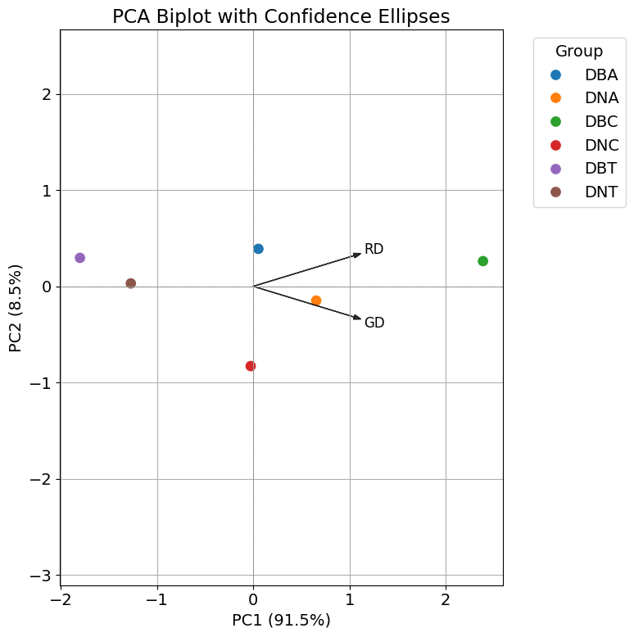

DBA: Dalbergia baronii + Aloe macroclada gel
DNA: Dalbergia normandii + Aloe macroclada gel
DBC: Dalbergia baronii + Curcuma longa powder
DNC: Dalbergia normandii + Curcuma longa powder
DBT: Dalbergia baronii (Control)
DNT: Dalbergia normandii (Control)

Fig. 3. Principal Component Analysis on root development and shoot development
Principal Component 1 (PC1), explaining 91.5% of the total variance, mainly differentiated groups based on overall root and shoot growth magnitude, while Principal Component 2 (PC2) accounted for 8.5% of the variance, capturing additional variation related to treatment effects within species. Groups treated with Curcuma longa powder (DBC for D. baronii and DNC for D. normandii) scored highest on PC1, indicating enhanced root and shoot development compared to other treatments. Aloe macroclada gel treatments (DBA and DNA) showed intermediate scores, while control groups (DBT and DNT) had the lowest scores, reflecting poor propagation success. Species separation was also evident, with D. baronii generally exhibiting higher PC1 values than D. normandii under the same treatments. Confidence ellipses illustrated the variability within each group, with tighter clusters observed for Curcuma-treated groups, suggesting more consistent propagation responses.
The present study highlights significant differences in the vegetative propagation success of Dalbergia baronii and Dalbergia normandii when treated with natural rhizogenesis boosters Aloe macroclada and Curcuma longa. Notably, D. normandii achieved a remarkable 100% success rate with Aloe macroclada, whereas D. baronii showed moderate success under Curcuma longa (58%) and lower response to Aloe macroclada (33%). The control treatments yielded poor rooting success, especially for D. baronii, confirming the necessity of booster application for effective propagation. These results corroborate earlier work by Nhung et al. (2019) who reported species-specific variability in rooting success among Asian rosewood, emphasizing that rooting enhancers improve propagation but responses vary considerably by species. In a study of Dalbergia melanoxylon (Amri et al., 2010) demonstrated that natural plant extracts such as Aloe vera significantly improved rooting success compared to controls, resonating with the current findings where Aloe macroclada boosted rooting in D. normandii.
The efficacy of Curcuma longa observed here supports the growing evidence of its role as a natural auxin-like compound, as reported by Enders & Strader (2015), who showed turmeric extract enhances rooting by modulating endogenous hormone levels and antioxidant activity in woody plants. The similar rooting rates of D. baronii and D. normandii under Curcuma longa indicate this booster’s broader applicability across related species.
The intrinsic rooting ability of D. normandii observed in the control (50%) contrasts with the complete failure of D. baronii, a pattern also noted in the work of Ramananjatovo et al. (2019) on Malagasy Dalbergia species, which underlines the challenges in propagating some species without external stimulants.
Taken together, these findings emphasize the importance of selecting species-specific natural rooting boosters to optimize propagation protocols. The successful use of Aloe macroclada and Curcuma longa as eco-friendly alternatives to synthetic hormones not only advances conservation strategies for threatened Dalbergia species but also offers sustainable approaches compatible with local community practices in Madagascar.

DISCUSSION

The present study provides strong evidence for the effectiveness of natural rhizogenesis boosters in promoting root development in two endangered Malagasy Dalbergia species. The superior performance of Curcuma longa in D. baronii may be attributed to its auxin-like activity and antimicrobial properties, which have been reported to enhance adventitious rooting (Maduakor et al., 2022). These findings are consistent with studies demonstrating the positive effect of turmeric powder on rooting in difficult-to-propagate hardwood species.
The moderate yet statistically significant effect of Aloe macroclada gel in both species aligns with previous research highlighting the presence of growth-promoting compounds in Aloe vera, such as gibberellins, salicylic acid, and amino acids that facilitate root induction (Surjushe et al., 2008). Aloe-based biostimulants have similarly been shown to enhance rooting in tropical and subtropical woody species.
The low rooting rates in control treatments underscore the limited natural rooting capacity of both species when propagated vegetatively, especially under nursery conditions. This highlights the importance of external supplementation with rooting agents for successful propagation.
Importantly, the species-specific response particularly the higher rooting observed in D. baronii may reflect underlying physiological or anatomical differences affecting root initiation. Such variation has been reported in related species, including Dalbergia sissoo, where genotype-dependent differences in rooting were observed under various hormonal treatments (Husen, 2004).
Taken together, these findings support the practical use of low-cost, environmentally friendly biostimulants in the vegetative propagation of threatened Dalbergia species. This approach offers a viable conservation strategy for the restoration and sustainable management of endangered populations in the Mahatsara forest station and other regions in Madagascar.
The results demonstrate that natural biostimulants, especially Curcuma longa, significantly enhance the vegetative growth development of Dalbergia cuttings. The pronounced effect of Curcuma longa in D. baronii suggests that its active compounds including curcumin and other phenolics may stimulate cell division and elongation, as previously reported in vegetative propagation studies involving medicinal and woody plants (Dosoky et al, 2019). The superior performance of Curcuma longa over the control reinforces its potential as a low-cost, effective tool for conservation propagation efforts.
The growth-promoting role of Aloe macroclada although not as strong as that of Curcuma longa is still notable, particularly in D. normandii. This finding aligns with research by Drapeau et al. (2015), which showed that Aloe extracts promote plant growth through phytohormones and bioactive molecules such as salicylic acid and polysaccharides. In our study, the response of D. normandii to Aloe gel was stronger than that of D. baronii, suggesting species-specific sensitivity to biostimulant composition.
The extremely limited or null growth under control conditions especially in D. baronii highlights the importance of external input to trigger successful vegetative development. These findings mirror similar trends reported in Dalbergia sissoo, where exogenous application of growth regulators significantly influenced shoot and root development (Yadav et al., 2005).
In sum, this study confirms the efficacy of natural rhizogenic substances not only for rooting but also for overall vegetative growth in endangered Dalbergia species. The outcomes advocate for the integration of Curcuma longa and Aloe macroclada into propagation protocols as part of a sustainable conservation strategy at Mahatsara and similar ecological restoration projects in Madagascar.
These PCA results confirm that natural rhizogenesis boosters significantly influence vegetative propagation success in Dalbergia species. Curcuma longa powder emerged as the most effective treatment, substantially improving root and shoot growth compared to Aloe macroclada gel and control treatments. The generally stronger response of D. baronii suggests species-specific physiological differences affecting rooting ability or treatment sensitivity, underscoring the importance of tailored propagation protocols.
Our findings align with previous studies demonstrating the efficacy of natural plant extracts in enhancing vegetative propagation. For instance, research by (Ferrari, 2020) showed that Curcuma longa extracts significantly increased rooting percentage and growth parameters in other species of plats, highlighting the potential of turmeric-derived compounds as natural rooting stimulants. Similarly, Aloe vera gel has been reported to promote root initiation and elongation in various horticultural crops, albeit with variable efficiency depending on species and application methods (Hendi, 2021).
While Aloe macroclada gel demonstrated moderate benefits in our study, its effect was less pronounced, indicating that Curcuma longa powder may be preferable for practical applications in the conservation of Dalbergia species. The poor performance of control groups further emphasizes the necessity of using such natural biostimulants to enhance propagation success.
Overall, these findings provide valuable insights for conservation strategies targeting Dalbergia baronii and Dalbergia normandii at the Mahatsara forest station. The application of effective natural rhizogenesis boosters can significantly improve vegetative propagation outcomes, thereby supporting sustainable reforestation and conservation efforts for these threatened timber species.

CONCLUSION

This study demonstrated the significant influence of two natural rhizogenesis boosters Curcuma longa powder and Aloe macroclada gel on the vegetative propagation of Dalbergia baronii and Dalbergia normandii. The two-way ANOVA results revealed highly significant effects of species, treatment, and their interaction on both root and shoot development (p < 0.001). Among the treatments, Curcuma longa powder notably enhanced root and growth development, particularly in D. baronii, while Aloe macroclada gel was most effective in D. normandii. In contrast, the control groups exhibited minimal rooting success.Principal Component Analysis (PCA) supported these findings, with the first principal component (PC1) explaining 91.5% of the total variance, followed by PC2 at 8.5%. The biplot clearly distinguished the treated groups, highlighting the superior performance of Curcuma longa in both root and shoot development. These natural treatments represent promising, cost-effective alternatives to synthetic rooting hormones. Being locally available, biodegradable, and non-toxic, they are particularly suited for low-resource settings and environmentally sustainable practices.
Given the critical conservation status of Malagasy rosewoods and the ecological importance of Dalbergia species, the successful use of Curcuma longa and Aloe macroclada opens new avenues for large-scale propagation efforts. These low-cost biostimulants can be readily adopted in local nurseries to support community-based restoration programs and forest rehabilitation initiatives.
To further advance this propagation strategy, future research should focus on refining application protocols (e.g., concentration, treatment duration), assessing long-term survival and vigor of propagated plants, and evaluating performance under field conditions. Integration with advanced propagation methods, such as tissue culture or hydroponics, may further boost efficiency.
Scaling up propagation using these biostimulants not only enhances the survival of endangered Dalbergia species but also promotes sustainable forest management, supports biodiversity conservation, and provides socio-economic benefits to local communities involved in reforestation and agroforestry systems.

Disclaimer (Artificial intelligence)
Option 1:
Author(s) hereby declare that NO generative AI technologies such as Large Language Models (ChatGPT, COPILOT, etc.) and text-to-image generators have been used during the writing or editing of this manuscript.
Option 2:
Author(s) hereby declare that generative AI technologies such as Large Language Models, etc. have been used during the writing or editing of manuscripts. This explanation will include the name, version, model, and source of the generative AI technology and as well as all input prompts provided to the generative AI technology
Details of the AI usage are given below:
1.
2.
3.

REFERENCES

- Amri E, Lyaruu H, Nyomora AS, Kanyeka ZL. (2010). Vegetative propagation of African blackwood (Dalbergia melanoxylon Guill. & Perr.): effects of age of donor plant, IBA treatment and cutting position on rooting ability of stem cuttings. New Forests 39: 183–194. doi: 10.1007/s11056-009-9163-6.
- Barthwal, S., Singh, S., Saha, R., Tadiya, R., & Rawat, S. (2025). Vegetative Propagation of Forest Tree Species. In Textbook of Forest Science (pp. 679-701). Singapore: Springer Nature Singapore
- Bosser, J., Rabevohitra R. (1996). Taxa et noms nouveaux dans le genre Dalbergia (Papilionaceae) à Madagascar et aux Comores. Bull. Mus. Natl. Hist. Nat. 4 (18): 171 212.
- Bosser, J., Rabevohitra, R. (2002). Tribe Dalbergieae. Pp. 321–361 in Du Puy, D. J., J. N. Labat, R. Rabevohitra, J. F. Villiers, J. Bosser, J. Moat. J. M. Lock & R. Linklater (editors). The Leguminosae of Madagascar. Royal Botanic Gardens, Kew, United Kingdom.
- Bosser, J., Rabevohitra, R. (2005). Espèces nouvelles dans le genre Dalbergia (Fabaceae, Papilionoideae) à Madagascar. Adansonia (3) 27: 209–215.
- CITES. (2013). The Convention on International Trade in Endangered Species of Wild Fauna and Flora. Consideration of Proposals for Amendment of Appendices I and II. Retrieved from CITES: https://www.cites.org/sites/default/files/eng/cop/16/prop/E-CoP16-Prop-58.pdf and https://www.cites.org/sites/default/files/eng/cop/16/prop/E-CoP16-Prop-63.pdf.
- CITES. (2022). The Convention on International Trade in Endangered Species Available online: https://www.cites.org.
- Cowell C., Williams, E., Bullough, L.A., Grey, J., Klitgaard, B., Govaerts, R., et al. (2022). CITES Dalbergia Checklist. Commissioned by the CITES Secretariat. Royal Botanic Gardens, Kew, Surrey.
- Cowell, L. G., et al. (2022). A dated phylogeny of the pantropical genus Dalbergia L.f. (Leguminosae: Papilionoideae) and its implications for historical biogeography. Plants, 12(7), 1612. https://doi.org/10.3390/plants12071612.
- Crameri, S., Phillipson, P. B., Rakotonirina, N., Wilding, N., Andriamiarisoa, R. L., Lowry II, P. P., et al. (2022). Taxonomic studies on Malagasy Dalbergia (Fabaceae). III. Two new species from south eastern Madagascar and an emended description of the rosewood species D. maritima R. Vig. Syst. Bot. 47 (2): 397–416.
- Dosoky N. S & Setzer W. N. (2018). Chemical composition and biological activities of essential oils of Curcuma species. Nutrients, 10(9), 1196.
- Drapeau, C., Benson, K. F., James, J., & Jensen, G. S. (2015). Aloe macroclada from Madagascar Triggers Transient Bone Marrow Stem Cell Mobilization. Journal of Stem Cell Research & Therapy, 5(6), Article 287. https://doi.org/10.4172/2157-7633.1000287.
- Enders, T. A., & Strader, L. C. (2015). Auxin activity: Past, present, and future. American Journal of Botany, 102(2), 180–196.
- Ferrari, M. P. de S., Queiroz, M. dos S., Andrade, M. M. de, Trettel, J. R., & Magalhães, H. M. (2020). Growth regulators, sucrose and potassium in the growth and biochemical activity of Curcuma longa L. micropropagated. Scientia Agraria Paranaensis, 19(1), 18–26. https://doi.org/10.18188/sap.v19i1.21983.
- Ferrari, M. P. de S., Queiroz, M. dos S., Andrade, M. M. de, Trettel, J. R., & Magalhães, H. M. (2020). Growth regulators, sucrose and potassium in the growth and biochemical activity of Curcuma longa L. micropropagated. Scientia Agraria Paranaensis, 19(1), 18–26. https://doi.org/10.18188/sap.v19i1.21983:contentReference[oaicite:4]{index=4}.
- Hendi, D. M. G. (2021). Utilization of Aloe Vera Gel as Growth Enhancer on Micropropagation of Eucalyptus citriodora Hook Plant. Scientific Journal of Flowers and Ornamental Plants, 8(1), 55–63. https://doi.org/10.21608/sjfop.2021.155059.
- Husen, A. (2004). Clonal propagation of Dalbergia sissoo Roxb. by softwood nodal cuttings: Effects of genotypes, application of IBA and position of cuttings on shoots. Silvae Genetica, 53(2), 50–55. https://doi.org/10.1515/sg-2004-0009
- IUCN. (2013). Documentation standards and consistency checks for IUCN Red List assessments and species accounts. Cambridge, UK and Gland, Switzerland: IUCN Red List Committee and IUCN SSC Steering Committee. 65 p.
- IUCN., (2006). Red List of Threatened Species. Récupéré de https://www.iucnredlist.org.
- Jay-Allemand, C., Breton, C., & Cornu, D. (2000). Études génétique et moléculaire de la rhizogenèse adventive. INRA, UR Amélioration, Génétique, Physiologie Forestières. https://agritrop.cirad.fr/488975/1/ID488975.pdf
- Maduakor, U. C., Onuora, C. L., Okonkwo, I. N., & Maduakor, C. J. (2022). Evaluation de l'activité antimicrobienne in vitro et du profil phytochimique de l'extrait méthanolique de Curcuma longa Linn contre certaines souches cliniques. European Journal of Medicinal Plants, 33(2), 43–51. https://doi.org/10.9734/ejmp/2022/v33i230452.
- MEDD (Ministère de l’Environnement et du Développement Durable). (2021). Proposition de mise à jour de la classification des essences forestière à vocation d’exploitation de bois de Madagascar. Rapport final de consultance du BNC Redd+. 206 p.
- Nong Phuong Nhung, Pham Quang Thu, Brian Dell, Nguyen Minh Chi. (2019). Vegetative propagation of Dalbergia tonkinensis, a threatened, high-value tree species in South-east Asia. Southern Forests: a Journal of Forest Science, 81(3):195–200,. DOI: 10.2989/20702620.2019.1679462.
- Rakotomanana, H. (2018). Etude des propriétés pharmacologiques de Aloe macroclada : Utilisation ethnopharmacologique, activités antioxydante et antimicrobienne, et composition chimique. Editions Universitaires Européennes. ISBN 978-3-639-47998-0.
- Rakotonirina, N., Phillipson, P.B., Crameri, S.F., Wilding, N., Lowry II, P.P., Rakouth B., et al. (2023). Taxonomic Studies on Malagasy Dalbergia (Fabaceae). IV. A New Species from Central and Southern Madagascar and a Narrowed Circumscription for D. emirnensis. Nov. 31: 73–87. DOI: 10.3417/2023790.
- Ramananjatovo, R., Ramamonjisoa, L., Rajoelison, G., Ratsirarson, J., Rabarison, H. (2019). Species-based approach to biodiversity conservation: An innovative step in Madagascar. International Journal of Biodiversity and Conservation, 11(9), 286–305. https://doi.org/10.5897/IJBC2019.1323.
- Saada, K. (2023). Étude phytochimique des extraits aqueux et méthanoliques des rhizomes du Curcuma longa L. Mémoire de fin d'études, spécialité Biochimie, Université Mohamed Khider, Algérie https://fac.umc.edu.dz/snv/bibliotheque/biblio/mmf/2023/Etude%20phytochimique%20des%20extraits%20aqueux%20et%20m%C3%A9thanolique%20des%20rhizomes%20du%20Curcuma%20longa%20L.pdf
- Surjushe, A., Vasani, R., & Saple, D. G. (2008). Aloe vera: A short review. Indian Journal of Dermatology, 53(4), 163–166. https://doi.org/10.4103/0019-5154.44785
- Wilding, N, Phillipson, P.B, Crameri, S. (2021) a. Taxonomic studies on Malagasy Dalbergia (Fabaceae). II. A new name for D. mollis and the reinstatement of D. chermezonii. Candollea. 76 (2): 251–257. DOI: 10.15553/c2021v762a5.
- Wilding, N, Phillipson, P.B., Crameri, S., Andriambololonera, S., Bernard, R., Rakotonirina, N., et al. (2021) b. Taxonomic studies on Malagasy Dalbergia (Fabaceae). I. Two new species from northern Madagascar, and an emended description for D. manongarivensis. Candollea. 76 (2): 237–249. DOI: 10.15553/c2021v762a4.
- Yadav, M. K., Dhillon, R. S., & Singh, V. P. (2005). Effect of age, diameter class and growth regulators on rooting of Shisham (Dalbergia sissoo Roxb.). Legume Research, 28(1), 26–29. https://arccjournals.com/journal/legume-research-an-international-journal/ARCC3700.

Appendix of CITES

Appendix of CITES includes all Dalbergia species, meaning their trade is controlled to prevent over-exploitation and ensure their survival. For Dalbergia, a specific annotation requires an export permit or re-export certificate for all parts except leaves, flowers, fruits, and seeds. However, a 10kg exemption applies to finished products made of Dalbergia wood, provided they are truly finished and the amount of each species is 10kg or less. CITES regulates 61 species of Dalbergia, including 1 species listed in Appendix I, 55 species listed in Appendix II, and 5 species listed in Appendix III. Dalbergia baronii and Dalbergia normandii are listed in Appendix II."

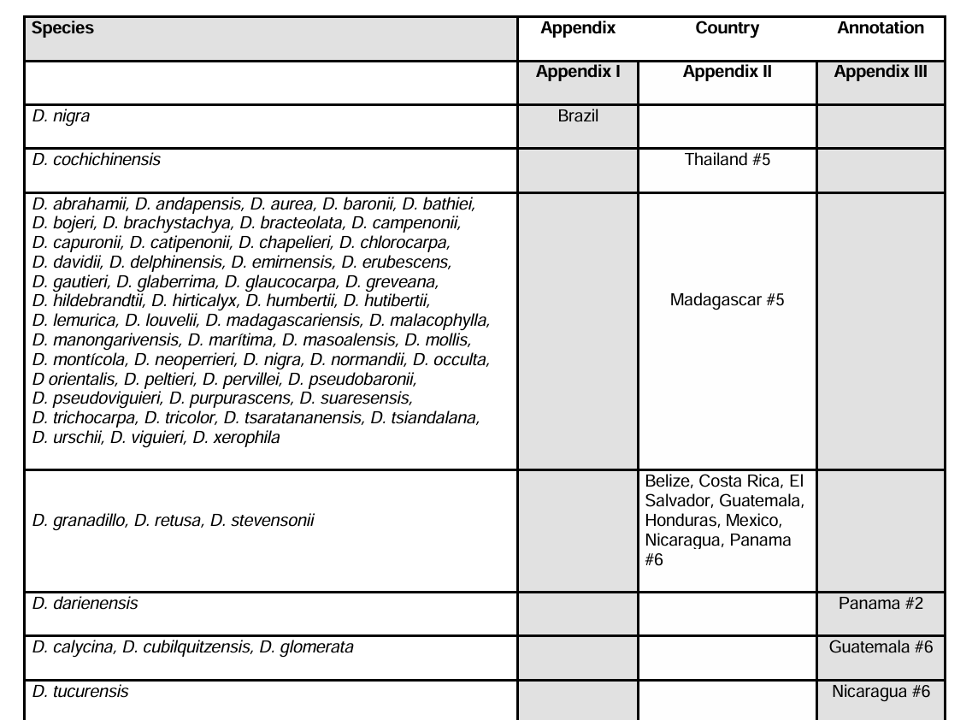

Annotations: #2 All parts and derivatives except seeds and pollen and finished products packaged and ready for retail trade; #5 logs, sawn wood and veneer sheets; #6 logs, sawn wood, veneer sheets and plywood

