Original Research Article
The role of N6-methyladenosine (m6A) methylation in the development and progression of nasopharyngeal carcinoma

Abstract

Aims: to investigate the correlation between m6A methylation and clinical characters of NPC patients, as well as, it`s development and progression, because N6-methyladenosine (m6A) methylation was a post-transcriptional modification that regulates gene expression, and had been implicated in various cancers. However, its role in nasopharyngeal carcinoma (NPC) remains poorly understood.
Study design: A cross-sectional study.
Place and Duration of Study: Otolaryngology department, University hospital between January 2004 and January 2025.
Methodology: Sample: included 22 patients (14 males, and 8 females, age range 35-70 years) diagnosed with nasopharyngeal carcinoma (NPC), who underwent biopsy. Clinical data, including; age, gender, tumor stage, and metastasis status were collected from medical records. The tumor and adjacent normal tissues were obtained for analysis. The m6A methylation status of key genes was assessed using quantitative polymerase chain reaction via reverse-transcription quantitative (RT-qPCR), and methylation-specific sequencing.
Results: A significantly higher m6A methylation level in NPC tumor tissues (72.3%), compared to adjacent normal tissues (27.3%), with significant association (p = 0.03), with higher level in ( NPC stage III/IV), and with distant metastasis (p = 0.02), yet, no significant correlation with age and gender (p > 0.05), expression levels of key m6A methylation-related regulators METTL3 and METTL14 were significantly upregulated in malignant versus un-affected tissues (p < 0.05), while, FTO downregulated in tumor tissues, without statistical significance (p > 0.05).
Conclusions: A significantly higher m6A methylation level in malignant tissues in comparison to adjacent normal tissues, so it’s a crucial part in NPC and could works for a possible management objective and diagnostic biomarker in early detection and treatment.

Key words: Nasopharyngeal carcinoma, N6-methyladenosine, RNA modification

- INTRODUCTOON
Nasopharyngeal carcinoma (NPC) exotic malignancy of head and neck regions, often originates in fossa of Rosenmuller, it has an elevated prevalence in China, while low-medium rate was found in Asia, Canada, North Africa, and Middle East, with bimodal peaks character, with a top at 40-59 years of age ^{[1]}.
Epstein-Barr virus (EBV) considered is the main causative element in its pathogenesis, as “Human Leukocyte Antigen (HLA) gene” appears to be crucial part relating to genes or heredity contributors, moreover decennium of researches has also admitted it’s an essential agent in malignant neoplastic evolution, the epigenetic variations, as; DNA methylation, are deliberately involved in NPC development, and its hyper-methylation often detected in de-differentiated, stem-like state ^{[2,3]}.
Beside, to above-mentioned facts, the ep-transcriptomic regulation annexes other grade of epigenetic monitor upon gene exhibition, further progress in transcriptome- extensive sequencing modalities have make a thorough perception into the RNA modification landscape is conceivable, many researches on RNA modification modifiers—writers, erasers, and readers—have shown that these RNA modifications are dynamic and reversible, and play a critical role in RNA metabolism, influencing a wide range of physiological/ pathological activities. In malignant variations of RNA modulations with their adjusting function found, that implying neoplastic-development or neoplastic-suppressive impacts, RNA modification scenery with concentration on m6A changed the modifiers in NPC ^{[4,5]}.
The latest researches have imparted RNA modulation in vanguard epigenetic process, leading to its comprehensive malignancy participation. The RNA modulation could result in co- replicate/post- replicate activities, in addition to complicatedness of gene regulation, RNA modifications frequently detected remarkably between normal tissues or cells and that of malignant issues, relating with various patient consequences or disorder status, within these alteration, N6- methyl adenosine (m6A) is the main item studied modification, which occurred in different RNA subspecies likes; mRNAs, lncRNAs, miRNAs, and rRNAs., which influences essential molecular activities ^{[6]}.
Whole scale of m6A modifications is notably elevated in NPC in comparison to normal nasopharyngeal epithelium (NPE), both primary/recurrent NPC, in mRNAs, m6A modifications are mainly detected about the stop codon, in the coding area, while, in non-coding RNAs that’s performs an essential part in adjusting the cellular activities, in lncRNAs, m6A can alter regulatory functions through the “m6A-switch” mechanism, which modifies RNA-protein interactions by changing the local structure of lncRNAs, a significant differences m6A modulation are detected nasopharyngeal cancer versus normal nasopharyngeal eipthelium ^{[7]}.
The m6A modifications in rRNA’s constitute a remarkable role in RNA modifications, becoming apparent confirmation propose that, its fundamental in ribosome genesis, so, thumping ribosome formation is usually found tumor creation and malignant development, participate to non-controlled NPC cellular-growth, the above-mentioned notices designate that m6A modifications in rRNA are essential for NPC beginning and progression ^{[8]}.

The purpose of this study was to investigate the correlation between m6A methylation and clinical characters in NPC patients, as well as, it`s development and progression.

- MATERIALS AND METHODS
This cross-sectional study included 22 adult patients, who diagnosed with nasopharyngeal carcinoma (NPC)., were underwent biopsy at study institution. Clinical data, including age, gender, tumor stage, metastasis status, and overall survival, were collected from medical records.
The tumor and adjacent normal tissues were obtained for analysis. Whole RNA was extracted from the tissue samples, and the m6A methylation status of key genes was assessed by quantitative PCR, methylation-specific sequencing. Gades of m6A-related genes were estimated through RT-qPCR.
The statistical analysis was used to examine correlations between methylation levels and clinical characteristics of nasopharyngeal carcinoma.
Nasopharyngeal carcinoma samples, were collected at the time of surgery, also, normal tissues were collected as adjacent non-malignant tissues. All specimens were handled using the approved and the ordinary applied procedures.
Quantitative reverse transcription polymerase chain reaction (RT-qPCR):
Whole RNA is initially transcribed into complementary DNA (cDNA), which utilized as form for quantitative (PCR), where, the quantity of amplification outcome is estimated in every PCR rotation utilizing fluorescence, so, it is utilized different implementations s; gene expression analysis, RNA validation, microarray validation, pathogen detection, genetic testing, and disease research.

RT-qPCR:
In the current study, 1-step assays RT-qPCR was performed via joining the reverse transcription right with DNA polymerase and PCR in a one tube, just using concatenation-particular primers.
It`s advantages lower the risk of contamination occurs in the same tube, so that, they appropriate for rise amount of material passing through a system or process of action of making multiple copies of a gene or DNA sequence and checking, as well as, quick and exceedingly ability to be copied.
While it`s disadvantages were out of the question to make the best or most effective use of the 2 responses individually, lesser sensitive than 2-step, and due to the response status, as well as, minimal target through specimen detection.
Techniques steps:
First-step in qPCR and RT-qPCR pipeline was sterilization of conceivably specimen segregation, because contaminated initial material will lead to inaccurate consequences, a favorable-data of the sample when isolating DNA for qPCR, usually extraction was performed utilizing commercially accessible, equipment’s, there advantages are simple and quick, while the sort of RNA extraction performed based on its sort requirement, most usual extraction modality utilized was with whole RNA extraction tools, where the secluded messenger RNA, transfer RNA, and ribosomal RNA, but often (not always) fails to isolate smaller RNAs such as non-coding RNA (ncRNA; functional RNA, and micro RNAs).

Through isolation of sample degeneration was constantly probable regarding the distinctive characteristic possessed by pipeline control phases for its estimation, this performed rapidly by analyzing the A260/280 ratio), and the A260/230 ratio (260 vs 230 nm, after that, they conveyed to a computer tool via utilizing an algorithm, which yields RNA integrity number that indicates the specimen quality; considering number 10 was maximum. Last step in specimen elaboration for RT-qPCR is the creation of cDNA.
Methylation Sequencing:
Usefulness of it to find out methylation style throughout the individual genome judgment, especially each cytosine in genome covering bulk species with whole-genome bisulfite sequencing (WGBS), a genome-wide approach captures full sample diversity with small amounts of DNA, cover established issues of concern in the human genome science, and the epigenomics road-map association with selected methylation sequencing.
Evaluation:
The methylation sequencing was evaluated by using sodium bisulfite to detect the DNA methylation status, of both the starting DNA strand, and the DNA methylation patterns of the resulting double-stranded DNA (post-amplification), where analyzing it`s results, see figure 1, a comprehensive overview of DNA methylation patterns across the genome is uncovered, also, it gave elevated standard and sensibility of NGS for methylation evaluation, thus, reveal the un-methylated cytosines alters to uracil, and transformed rules were specified post (PCR), as thymine arranged in a particular order, thus, careful examination were utilized to estimate the percent of methylated cytosines.

2.1 STATSTICAL ANALYSIS
SPSS-29 (IBM Statistical Packages, Chicago, Illinois, United State), and were introduced as mean, standard deviation (SD), comparisons between the studied groups were measured utilizing the student’s t-test, and P-value less than 0.05 was noted as significant difference.

- RESULTS
Among 22 enrolled adult patients diagnosed with nasopharyngeal carcinoma (NPC), their age group was 35-70 years, the mean age of 53.4± 1.62 SD years, males were 14 (63.6%) and 8 females (36.4%), the clinical characteristics such as age, gender, tumor stage, and histopathological features were recorded. Among these patients, depending on TNM staging system, had a significant difference with P=.02, as it was shown in table 1.
Study found altered m6A methylation patterns of cancer tissues in comparison to adjacent normal tissues, via quantitative analysis test, which it was assessed using quantitative polymerase chain reaction, and methylation-specific sequencing, and reverse-transcription quantitative PCR (RT-qPCR).
So, this study found a significantly higher m6A methylation level in malignant tissues in comparison to adjacent normal tissues, with significant finding, see table 2, this suggests important part for m6A methylation in NPC pathogenesis, the analysis revealed that 16 out of 22 (72.7%) NPC tissues showed an increased level of m6A modification, while the remaining 6 (27.3%) exhibited relatively low methylation levels.
The analysis of the relationship between m6A methylation levels, and clinical characteristics showed a significant association with tumor stage, with higher methylation levels observed in advanced-stage NPC cases (stage III/IV). However, non-significant correlation was found between m6A methylation and other clinical parameters, such as age or gender (P = .05).
Figure 2, shown the correlation between m6A methylation and clinical sample.
Additionally, higher m6A methylation was observed in patients who had distant metastasis (n = 6) when compared to those without metastasis (P = .02), with significant results This finding supports the hypothesis that m6A methylation might be linked to the aggressiveness of NPC.
Expression levels of key m6A methylation-related regulators (METTL3, METTL14, and FTO) were analyzed in both tumor and normal tissues. METTL3 and METTL14 were significantly increase the rate or level by upregulation in tumor tissues in comparison to normal tissues (P=.05), suggesting an active role in the m6A methylation process in NPC. On contrary, the expression of FTO was downregulated in tumor tissues, although, the difference was non- statistically significance (P=.05).

- Discussion
Current study found altered m6A methylation patterns in NPC tissues versus nearby normal tissues, and this detection agreed to Wanga YM, et ^{[5]} al study.
Over the years, understanding the molecular mechanisms underlying NPC has been a major focus, and the latest researches have pay attention to the function of RNA modulations in cancer biology. One such modification was N6-methyladenosine (m6A), and its involvement in the regulation of NPC progression had recently garnered attention.
Overview of m6A in Cancer:
It was a reversible modification that occurs predominantly on mRNA, but can also, be found in other types of RNA including non-coding RNAs, it is stimulated by a set of enzymes, these enzymes regulate different RNA-related processes likes; splicing, translation, stability, and decay, thus, alterations in the levels or activity of these enzymes have influenced in pathologies of various cancers, likes NPC ^{[9]}.
Role of m6A in NPC:
Recent researches have suggested that m6A modulation are implicated in various aspects of NPC biology, including cell proliferation, migration, invasion, and impedance to apoptosis. Several key findings include:
Regulation of NPC development/ propagation: m6A modification in mRNA, affects the expression of genes involved in cell cycle regulation and survival, in NPC, overexpression of METTL3 (a key methyltransferase) has been shown to contribute to cell proliferation and tumorigenesis, by enhancing the stability of specific mRNAs that are involved in oncogenic pathways ^{[10]}.
Epithelial-Mesenchymal Transition (EMT) and metastasis: m6A modification is enrolled in regulating EMT, process that facilitates metastasis, so, studies have revealed that YTHDF2, which is an m6A reader protein, was upregulated in NPC and promotes the progression of metastasis by stabilizing mRNAs that regulate EMT-related genes ^{[11]}.
Role in EBV-Associated NPC: Epstein-Barr virus (EBV) infection is a common hazard element for NPC, it had been suggested that it alters the m6A landscape in NPC cells, as, the EBV-encoded latent membrane protein 1 (LMP1), which influences m6A modification patterns, enhancing the translation of pro-survival genes and contributing to tumor progression ^{[12]}.
Resistance to chemotherapy and radiotherapy: m6A modification had also, been linked to resistance to chemotherapy and radiotherapy in NPC, so, the regulation of key mRNA stability and translation processes by m6A, can influence the sensibility of NPC cells to these treatments, as, FTO demethylase has been reported to modulate the sensibility of NPC cells to cisplatin by altering certain mRNAs stability ^{[13]}.
The discovery of m6A's role in NPC, opens up exciting possibilities for therapeutic intervention, therefore, targeting the enzymes that regulate m6A modification, could represent a novel strategy for the treatment of NPC, as inhibition of METTL3 or YTHDF2 could potentially decrease tumor cell proliferation and metastasis, while targeting FTO may sensitize NPC cells to chemotherapy or radiotherapy ^{[14]}.

While the evidence linking m6A modifications to NPC is promising, several challenges remain, one of the main hurdles is the complexity of the m6A regulatory network, with multiple enzymes and factors interacting in a highly circumstances determined style, so, the development of small-molecule inhibitors or activators, which could precisely purposed specific components of the m6A machinery remains a significant challenge ^{[15]}.
N6‐methyladenosine (m6A) is a widespread regulator in non-messenger RNAs, also in non‐coding RNAs. m6A can be reversibly methylated and unmethylated by “m6A writer” and “m6A eraser” proteins. The methylated RNA is identified by m6A “readers” protein, and then to modulate cancer progression. Target m6A regulators has been becoming a promising approach for cancer diagnosis and treatment ^{[16]}.
Zhao Y, et al ^{[17]} concluded that, The epi-transcriptomic machinery had utmost importance role in regulating different biological processes and cancer development, while, global RNA modiﬁcation levels might be unreliable as biomarkers for tumor progression and potential therapeutic targets, as the RNA modiﬁcations, particularly the METTL3-METTL14, the overall upregulation of m6A modiﬁcations in mRNAs, lncRNAs, and rRNAs compared to NPE indicates a signiﬁcant part in NPC development.
Limitations
Relatively small sample size, single study center, and no intra-operative findings. Additionally, further researches especially clinical trials, are required to advocate the possibility of m6A-based management strategies in NPC.

CONCLUSIONS
This study revealed that, m6A modification has emerging, as a fundamental player in the regulation of nasopharyngeal cancer, enzymes and pathways associated with m6A modification influence various aspects of tumor biology, including; evidence of elevated m6A methylation in NPC tissues, which correlates with advanced tumor stage, and distant metastasis so, it elucidates the role of m6A is a new biomarkers for early detection for diagnosis, novel and potential therapeutic target progression, and it`s aggressiveness for this challenging tumor.

PATIENTS CONSENT
Author declare that ‘written informed consent was obtained from the all patients for publication of this manuscript.
ETHICAL APPROVAL:
The ethical approval from the Institutional Ethic committee protocol number 321 at 5-1-2024 was obtained.
The author declare that all experiments have been examined and approved by the appropriate ethics committee and have therefore been performed in accordance with the ethical standards laid down in the 1964 Declaration of Helsinki.
Animal study: N/A
All datasets utilized and analyzed in the current study are available from the author on reasonable request

COMPETING INTERESTS DISCLAIMER:
Author have declared that no known competing financial interests or non-financial interests or personal relationships that could have appeared to influence the work reported in this paper.
Artificial intelligence
Author declare that no generative AI technologies such as Large Language Models (Chat GPT, COPILOT, etc.) and text-to-image generators have been used during the writing or editing of this manuscript.

REFERENCES
- Donovan Eu, Thomas Loh. (2021). Benign and malignant tumors of the nasopharynx. In: Paul W. Flint, Howard W. Francis, Bruce H. Haughey, Marci M. Lesperance, Valerie J. Lund, K. Thomas Robbins, J. Regan Thomas. Cummings Otolaryngology Head and Neck Surgery. Seventh edition. Volume two. Philadelphia: Elsevier Inc: P 1394-1398.
- Bruce JP, Yip K, Bratman SV, Ito E, Liu FF. (2015). Nasopharyngeal cancer: molecular landscape. J Clin Oncol, 33:3346–3355.
- Gondhowiardjo SA, Adham M, Rachmadi L, Atmakusuma TD, Tobing DL, Auzan M, et al. (2022). Immune cells markers within local tumor microenvironment are associated with EBV oncoprotein in nasopharyngeal cancer. BMC Cancer, 22(1):887.
- Xie J, Wang Z, Fan W, Liu Y, Liu F, Wan X, et al. (2021). Targeting cancer cell plasticity by HDAC inhibition to reverse EBV-induced dedifferentiation in nasopharyngeal carcinoma. Signal Transduct Target Ther, 6(1):333.
- Deng X, Qing Y, Horne D, Huang H, Chen J. (2023). The roles and implications of RNA m (6)A modification in cancer. Nat Rev Clin Oncol, 20:507–526.
- Wang YM, Peng ZY, Zhang LY, Wang YX, Fan RH, Zhang H, et al. (2022). N6-Methyladenosine RNA modification landscape in the occurrence and recurrence of nasopharyngeal carcinoma. World J Oncol, 13:205–215.
- Li L, Tang Q, Ge J, Wang D, Mo Y, Zhang Y, et al. (2024). METTL14 promotes lipid metabolism reprogramming and sustains nasopharyngeal carcinoma progression via enhancing m (6)A modification of ANKRD22 mRNA. Clin Transl Med, 14: e1766.
- Chen B, Huang Y, He S, Yu P, Wu L, Peng H. (2023). N (6)-methyl adenosine modification in 18S rRNA promotes tumorigenesis and chemoresistance via HSF4b/HSP90B1/ mutant p53 axis. Cell Chem Biol, 30:144–158.
- Huang H, Weng H, Chen J. (2020). m6A Modification in coding and non-coding RNAs: Roles and therapeutic implications in cancer. Cancer Cell, 37(3):270-288.
- Zhao W, Cui Y, Liu L, Ma X, Qi X, Wang Y, Liu Z, et al. (2020). METTL3 Facilitates Oral Squamous Cell Carcinoma Tumorigenesis by Enhancing c-Myc Stability via YTHDF1-Mediated m6A Modification. Mol Ther Nucleic Acids, 20:1-12.

- Chen X, Zhou X, Wang X. (2022). m6A binding protein YTHDF2 in cancer. Exp Hematol Oncol,11(1):21.
- Lo AK, Dawson CW, Lung HL, Wong KL, You LS. (2021). The role of EBV-encoded LMP1 in the NPC tumor microenvironment: From function to therapy. Front Oncol, 11:640207.
- Huang WM, Li ZX, Wu YH, Shi ZL, Mi JL, Hu K, et al. (2023). m6A demethylase FTO renders radio resistance of nasopharyngeal carcinoma via promoting OTUB1-mediated anti-ferroptosis. Transl Oncol, (27):101576.
- Huang W, Chen TQ, Fang K, Zeng ZC, Ye H, Chenet YQ. (2021). N6-methyladenosine methyltransferases: functions, regulation, and clinical potential. J Hematol Oncol, (14):117.
- Gao R, Ye M, Liu B, Wei M, Ma D, Dong K. (2021). m6A modification: A double-edged sword in tumor development. Front Oncol,11:679367.
- Wang Z, Zhou J, Zhang H, Ge L, Li J, Wang H. (2023). RNA m6 A methylation in cancer. Mol Oncol, 17(2):195-229.
- Zhao Y, Li J, Dian M, Bie Y, Peng Z, Zhou Y, et al (2024). Role of N6-methyladenosine methylation in nasopharyngeal carcinoma: current insights and future prospective. Cell Death Discov. 18;10(1):490.

Table 1: Average m6A methylation according to tumor stages

m6A methylation depending on TNM staging system | early-stage (stage I/II) | advanced stage (stage III/IV) | P- value
m6A methylation depending on TNM staging system | 9 patients  40.9% | 13 patients  59.1% | 0.02

Table 2: Average m6A methylation in tumor tissues compared to adjacent normal tissues

m6A methylation in tissue | Tumor  tissues | normal tissues | P-value
m6A methylation in tissue | 16 patients  72.7% | 6 patients 27.3% | 0.03

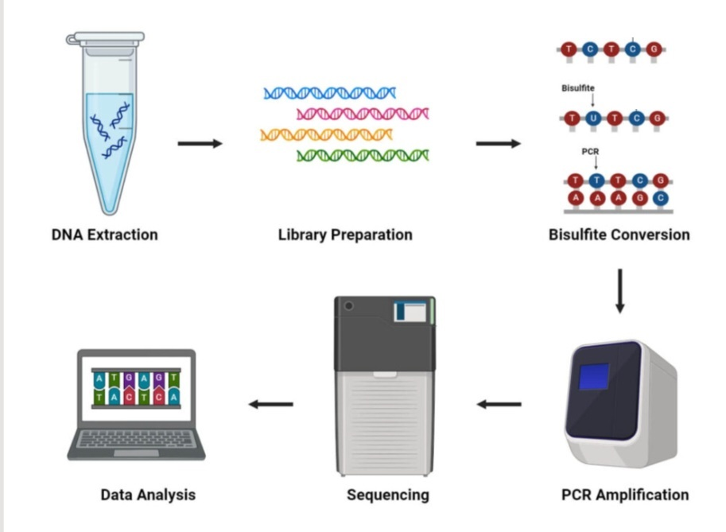
Figure 1: methylation sequencing

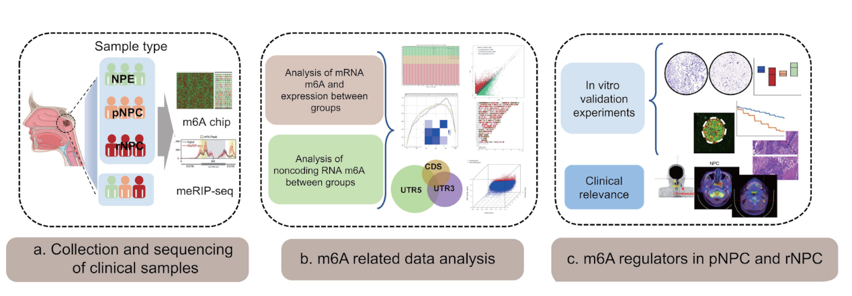
Figure 2: correlation between m6A methylation and clinical sample

