Case report

Gum Bleeding as an Unusual Initial Manifestation of Carcinoma Oesophagus: A Case Report

Abstract
Bone marrow metastasis from solid tumours typically occurs in advanced disease stages and rarely presents as the initial clinical manifestation.
Herein, we are reporting that a 65-year-old man was admitted with a history of gum bleeding during dental work. His medical history was reviewed, revealing clinical signs such as pallor and gum hypertrophy. Blood tests showed anaemia, leucocytosis, thrombocytopenia, and abnormal coagulation parameters. Based on these findings, a blood disorder was suspected, leading to a bone marrow examination. Unexpectedly, the marrow showed signs of metastatic deposits. To locate the primary tumour, a whole-body FDG PET-CT scan was performed, revealing FDG-avid enlarged lymph nodes in the para-aortic, para-oesophageal, and perigastric regions, as well as multiple abdominal lymph nodes. This case is presented to clinicians to highlight the importance of understanding metastatic patterns. The presentation posed a diagnostic challenge due to its rarity. Despite being metastatic initially, the tumour responded favourably because it harboured a targetable mutation. Recent advances in oncology indicate that a poor prognosis for metastatic disease is no longer inevitable if a targetable mutation is present.
Keywords: rare presentation, stage 4, Barrett’s oesophagus, bone marrow metastases, gum bleeding, adenocarcinoma, oesophageal carcinoma, micro metastases

Introduction
Oesophageal cancer patients often present at an advanced stage when diagnosed. The most frequent sites of metastasis are the liver, followed by the lungs and bones [1]. Bone marrow metastasis in oesophageal cancers usually occurs in later stages and rarely appears as the initial symptom. In this case, we report a patient with oesophageal cancer who presented with haematological issues—such as anaemia, thrombocytopenia, and leucocytosis—due to widespread bone marrow involvement, rather than the common symptom of dysphagia associated with oesophageal carcinoma.
Case Presentation
A gentleman in his seventies visited our outpatient department with a history of excessive gum bleeding during a dental procedure at a peripheral centre. He was first investigated at that centre, where labs showed anaemia, thrombocytopenia, and leucocytosis—raising suspicion of a haematological disorder. A bone marrow aspiration was performed, revealing the presence of atypical cells.
He later visited us with the results of his prior investigation. His medical history was documented, and he underwent a thorough evaluation. Physical examination revealed pallor and gum hypertrophy. His blood tests showed haemoglobin at 8.3 g/dl, TLC at 28,170 per mm³, platelet count at 38,000 per microliter, reticulocyte count at 1.3, LDH at 1358, albumin at 2.4, calcium at 10.8, aPTT at 30.6, INR at 1.4, and D-Dimer at 9399. Based on these results, a haematological disorder was suspected, so we repeated the bone marrow exam. To our surprise, it indicated a metastatic deposit, as illustrated in Figure 1, with FDG-avid hypodense liver lesions in segments VI and VII of the right lobe and diffuse patchy increased marrow uptake across the axial and appendicular skeleton, shown in Figure 2.
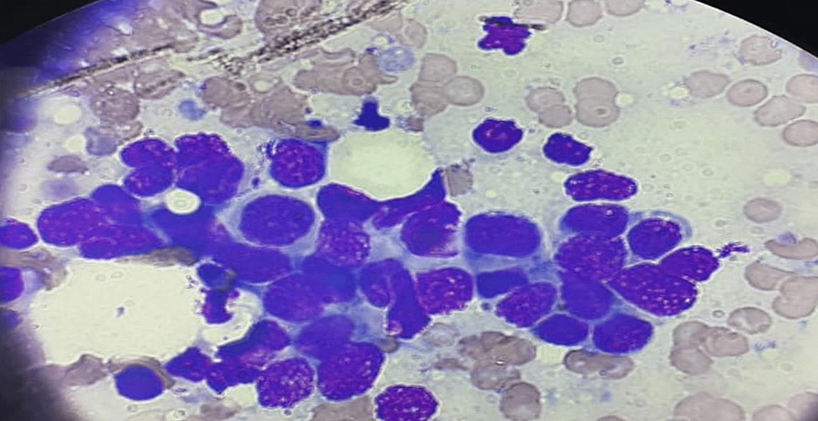
FIGURE 1: Bone marrow aspiration showing metastatic deposits (Jenner/Giemsa stain)

Whole-body FDG PET-CT (18F-Fluorodeoxyglucose positron emission computed tomography) revealed FDG-avid enlarged lymph nodes near the para-aortic and para-oesophageal regions, abutting the oesophagus. It also showed FDG-avid enlarged lymph nodes around the stomach and multiple lymph nodes in the abdomen, as illustrated in Figure 2.

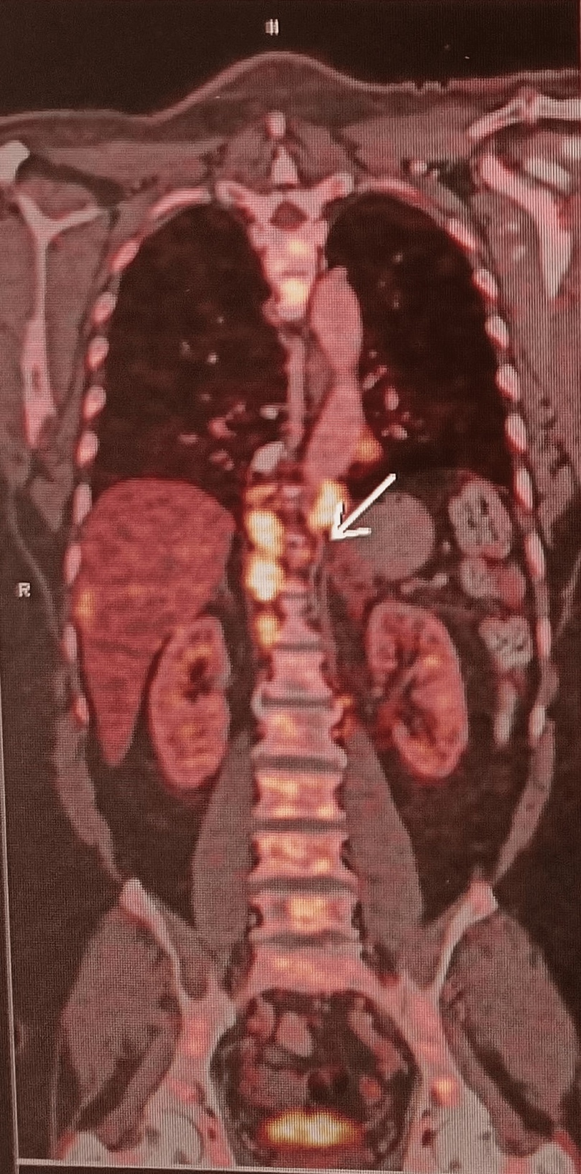
FIGURE 2: Coronal PET-CT images showing FDG-avid para-aortic and para-oesophageal lymph nodes
PET-CT (Positron emission tomography)
CT (Computed tomography) FDG (18-Fluorodeoxyglucose)
FDG avid hypodense liver lesions in segments VI and VII of the right lobe. Diffuse patchy areas of increased marrow uptake are observed in the axial and appendicular skeleton, as shown in Figure 3.

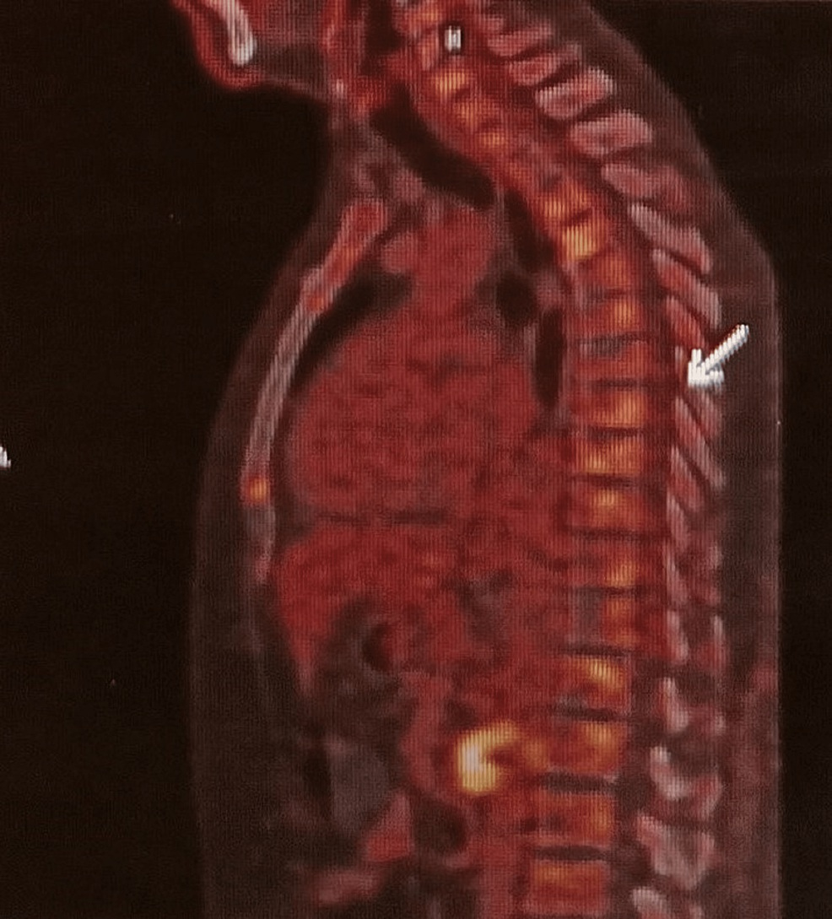
FIGURE 3: Diffuse patchy areas of increased marrow uptake in the axial and appendicular skeleton.
His serum CEA level was elevated at 3582 ng/ml, while CA19-9 (Cancer antigen 19 9) and AFP (Alpha-fetoprotein) remained within normal ranges. Further investigation with UGIE (upper gastrointestinal endoscopy) revealed a large hiatus hernia and a long segment of Barrett’s oesophagus at the lower oesophagus. A 1cm x 1.5cm eccentric, friable, flat, elevated lesion was found in the Barret’s segment, located 36 cm from the incisors. The stomach and duodenal mucosa appeared normal.
A biopsy of the oesophageal growth revealed moderately differentiated adenocarcinoma. Additionally, EUS-guided FNAC from the precaval lymph node confirmed metastatic adenocarcinoma, as shown in Figure 4.

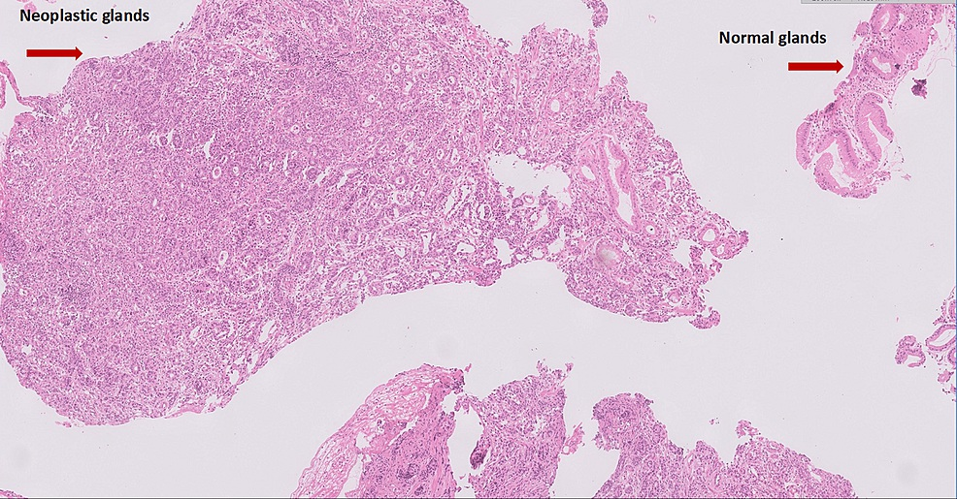
FIGURE 4: H&E 10X fragments showing normal glands replaced by neoplastic glands
H&E (Hematoxylin and Eosin)
IHC (Immunohistochemistry) on the cell block was performed and reported as 3+ for Her2neu (Human epidermal growth factor receptor-2), as shown in Figure 5.
The cancer-targeted gene panel identified a TP53 (Tumour protein-53) mutation in Exon-8, a low likelihood of MSI-H (Microsatellite Instability-High), and no significant oncogenic variants for KRAS (Kirsten rat sarcoma virus), HRAS (Harvey Rat Sarcoma Virus), NRAS (Neuroblastoma ras viral oncogene), BRAF (Raf murine sarcoma viral oncogene homolog B), PTEN (Phosphatase and TENsin homolog deleted on chromosome 10), and PIK3CA (phosphatidylinositol-4,5-bisphosphate 3-kinase catalytic subunit alpha). His PD-L1 (Programmed Death Ligand 1) was positive, with a TPS (Tumour Proportion Score) of 8% and a CPS (Combined Positive Score) of 9.
He was started on chemotherapy combined with targeted therapy (FOLFOX + Trastuzumab). He received a loading dose of Trastuzumab 6 mg/kg, followed by 4 mg/kg every two weeks, along with Oxaliplatin 85 mg/m², Leucovorin 400 mg/m², and 5-FU 2400 mg/m². (Initially, 65% of the calculated dose was administered in the first cycle due to his advanced age and poor performance status.) The patient responded well, allowing dose escalation in subsequent cycles based on his tolerance. After two chemotherapy sessions, his anaemia and thrombocytopenia improved (platelet count: 94,000/μL), indicating a response in his bone marrow to the treatment. He is currently on the same regimen, with a plan to complete twelve chemotherapy sessions.

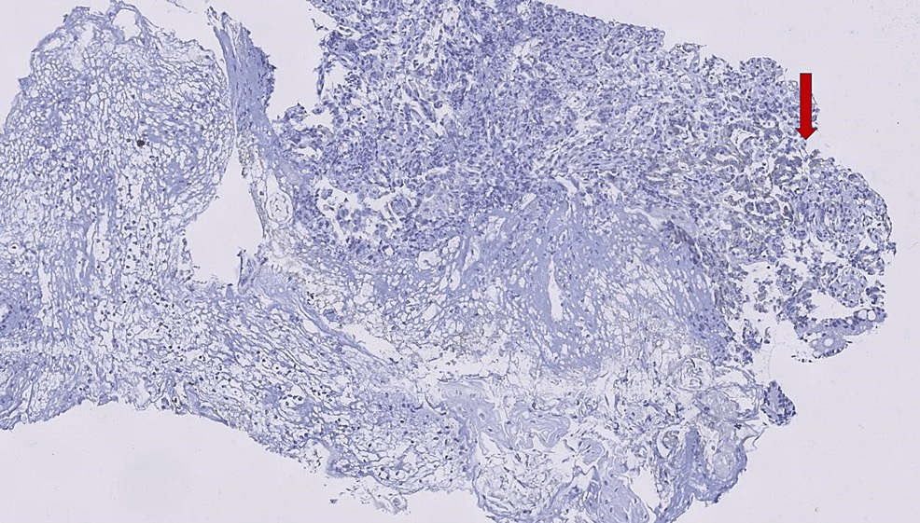
FIGURE 5: Immunohistochemistry for Her neu 10 X: Brown staining right-hand corner
This patient was initially assessed for a haematological disorder, but ultimately diagnosed with oesophageal cancer that had metastasised to the bone marrow. While oesophageal cancer commonly spreads to the lung, liver, bone, and brain, metastasis to the bone marrow is uncommon. In this case, the patient exhibited symptoms only related to this rare metastatic site.
Discussion
Carcinoma of the oesophagus ranks as the 8th most common cancer worldwide [2]. Its primary metastatic sites are lymph nodes and viscera, mainly the liver and lungs [3]. Bone marrow metastases are rare and usually occur in advanced stages [4]. Disseminated carcinomatosis involves widespread cancer cell infiltration in the marrow, leading to haematological issues and bone destruction [5], and is associated with a poor prognosis. Literature indicates that solid organ malignancies with disseminated carcinomatosis most often include gastric cancer, followed by lung, breast, and prostate cancers. Occasionally, oesophageal cancer may also cause diffuse marrow involvement [6,7]. Although dysphagia is the most common presenting symptom in oesophageal carcinoma [8,9], our patient presented with bleeding instead.
Oesophageal carcinoma is classified histopathologically into squamous cell carcinoma and adenocarcinoma. Among these, adenocarcinoma is the most common subtype to invade the bone marrow. Other primary sites with adenocarcinoma histology that frequently involve the marrow include the breast, stomach, prostate, and lung [6, 7, 10, 11].
Advanced-stage oesophageal cancer typically shows lymph node and visceral metastases. Bone involvement is seen in only 5% of patients. Several studies examining bone marrow involvement in oesophageal carcinoma indicate a high prevalence of BMM (bone marrow micro metastases) in locally advanced cases [12-14].
Bonavia et al.’s study [13] reported that 79.1% of patients with localised oesophageal cancer had positive bone marrow involvement, confirmed immunohistochemically, which contrasts with the low positivity of bone marrow aspirates. Therefore, there is a possibility that bone marrow micro-metastasis exists without any abnormalities being detected in bone scans, radiographic images, serum biochemistry, or haematological parameters.
Chen YH's 2014 case report described a patient with oesophageal carcinoma exhibiting dural and bone marrow metastases, with a history of smoking and alcohol consumption. This patient experienced dysphagia and weight loss, unlike our case. Our patient had no history of smoking or alcohol, and did not present with dysphagia. Instead, bleeding was the only symptom. This makes the presentation markedly different from Chen YH's report. In that case, bone marrow micro metastases were identified during the metastatic work-up for oesophageal carcinoma; in contrast, we initially diagnosed bone marrow involvement, which was later confirmed to originate from oesophageal cancer.
After reviewing various studies, we find that diffuse bone marrow involvement in oesophageal carcinoma cases is quite common. However, it is typically identified only in surgical or autopsy specimens [12-14]. Assessing bone marrow before surgery or neoadjuvant treatment is an important prognostic tool, as reported by Thorban et al [15]. Bone marrow micro metastases can be predicted with the help of angiogenic markers like VEGF in blood as well [16]; however, it is still not routinely practised. Bone marrow metastasis is not commonly diagnosed during initial metastatic assessments because guidelines prioritise detecting visceral metastases, which are the most frequently affected sites.
Conclusions
This rare case of metastatic oesophageal adenocarcinoma presented solely with gum bleeding as the initial symptom. It aims to remind clinicians of possible metastatic patterns. The main point is that, despite presenting at an advanced stage and initial diagnostic challenges, our patient responded very well to treatment. Advances in therapy and targeted treatments have improved outcomes, making metastatic disease less grim.
Consent
As per international standards or university standards, patient(s) written consent has been collected and preserved by the author(s).

Disclaimer (Artificial intelligence)
Option 1:
Author(s) hereby declare that NO generative AI technologies such as Large Language Models (ChatGPT, COPILOT, etc.) and text-to-image generators have been used during the writing or editing of this manuscript.
Option 2:
Author(s) hereby declare that generative AI technologies such as Large Language Models, etc. have been used during the writing or editing of manuscripts. This explanation will include the name, version, model, and source of the generative AI technology and as well as all input prompts provided to the generative AI technology
Details of the AI usage are given below:
1.
2.
3.

References
- Quint LE, Hepburn LM, Francis IR, et al.: Incidence and distribution of distant metastases from newly diagnosed oesophagal carcinoma. Cancer. 1995, 76:2. 10.1002/1097-0142(19951001)76:7<1120::aid cncr2820760704>3.0.co;2-w
- Torre LA, Bray F, Siegel RL, Ferlay J, Lortet-Tieulent J, Jemal A: Global cancer statistics. 20122015, 65:87- 108. 10.3322/caac.21262
- Mandard AM, Chasle J, Marnay J, et al.: Autopsy findings in 111 cases of oesophagal cancer. Cancer. 1981, 48:329-35. 10.1002/1097-0142(19810715)48:2<329::aid-cncr2820480219>3.0.co;2-v
- Chen Y-H: Oesophagal squamous cell carcinoma with dural and bone marrow metastases. World Journal of Gastroenterology. 2014, 20:12691. 10.3748/wjg.v20.i35.12691
- Rhee J, Han S-W, Oh D-Y, Im S-A, Kim T-Y, Bang Y-J: Clinicopathologic features and clinical outcomes of gastric cancer that initially presents with disseminated intravascular coagulation: A retrospective study. Journal of Gastroenterology and Hepatology. 2010, 25:1537-42. 10.1111/j.1440-1746.2010.06289.x
- Singh G, Krause JR, Breitfeld V: Bone Marrow Examination for metastatic tumour aspirate and biopsy. Cancer. 1977, 40:2317-21. 10.1002/1097-0142(197711)40:5<2317::aid-cncr2820400546>3.0.co;2-z
- Ringenberg QS: Tumours of unknown origin in the bone marrow. Archives of Internal Medicine. 1986, 146:2027.
- Daly JM, Fry WA, Little AG, et al.: Esophageal cancer: Results of an American College of Surgeons Patient Care Evaluation study1.Journal of the American College of Surgeons.2000,190:562-72. 10.1016/s1072- 7515(00)00238-6
- Portale G, Hagen JA, Peters JH, et al.: Modern 5-year survival of resectable esophageal adenocarcinoma: Single institution experience with 263 patients. Journal of the American College of Surgeons. 2006, 202:588- 96. 10.1016/j.jamcollsurg.2005.12.022
- Ozkalemkas F, Ali R, Ozkocaman V, et al.: The bone marrow aspirate and biopsy in the diagnosis of unsuspected nonhematologic malignancy: A clinical study of 19 cases. BMC Cancer. 2005, 5:10.1186/1471- 2407-5-144
- Kucukzeybek BB, Calli AO, Kucukzeybek Y, et al.: The prognostic significance of bone marrow metastases: Evaluation of 58 cases. Indian Journal of Pathology and Microbiology. 2014, 57:396. 10.4103/0377- 4929.138728
- Ryan P, McCarthy S, Kelly J, et al.: Prevalence of bone marrow micrometastases in esophagogastric cancer patients with and without neoadjuvant chemoradiotherapy. Journal of Surgical Research. 2004, 117:121-6. 10.1016/j.jss.2003.12.008
- Bonavina L, Soligo D, Quirici N, et al.: Bone marrow—disseminated tumour cells in patients with carcinoma of the oesophagus or Cardia. Surgery. 2001, 129:15-22. 10.1067/msy.2001.109503
- O'Sullivan GC, Sheehan D, Clarke A, et al.: Micrometastases in esophagogastric cancer: High detection rate in resected rib segments. Gastroenterology. 1999, 116:543-8. 10.1016/s0016-5085(99)70175-7
- Thorban, S., Rosenberg, R., Busch, R., & Roder, R. J. (2000). Epithelial cells in bone marrow of oesophageal cancer patients: a significant prognostic factor in multivariate analysis. British journal of cancer, 83(1), 35-39 https://www.nature.com/articles/6691199
- Spence, G. M., Graham, A. N., Mulholland, K., Maxwell, P., McCluggage, W. G., Sloan, J. M., & McGuigan, J. A. (2004). Bone marrow micrometastases and markers of angiogenesis in esophageal cancer. The Annals of thoracic surgery, 78(6), 1944-1949 https://www.sciencedirect.com/science/article/pii/S0003497504008094

