Impact of Soil Properties on Different Fractions of Iron (Fe) Under Saline Soil of Navsari District

ABSTRACT
This study investigates the distribution and interrelationship of iron (Fe) fractions in salt affected soils of Navsari District, Gujarat, during the summer 2023-24. A total of 60 soil samples were collected from two depths (0-20 cm and 20-40 cm) across saline prone villages, including coastal high salinity zones. Samples were analysed for pH, Electrical Conductivity of saturation extract (ECe), calcium carbonate (CaCO₃), Cation Exchange Capacity (CEC), Exchangeable Sodium Percentage (ESP) and various Fe fractions viz., Fe- Mn-O-Fe, Org-Fe, CO₃- Fe, Exch-Fe and WS-Fe. Soil pH ranged from neutral to strongly alkaline, with higher ECe observed in coastal region areas. The dominant Fe fractions followed the order under coastal region areas were: Fe- Mn-O-Fe > Org-Fe > CO₃- Fe > Exch-Fe > WS-Fe. All the Fe fractions were lower in saline areas as compared to non-saline areas except CO₃-Fe, which was higher under salinity. Correlation analysis revealed significant and depth-dependent relationship among soil properties and Fe fractions. Notably, pH was negatively correlated with ECe and Exch-Fe at the surface, while WS-Fe showed contrasting relationship with other Fe forms. These results highlight complex interactions influencing Fe availability in saline soils.
Introduction
Micronutrient deficiency in soils is one of the significant problems at the regional and global level affecting more than two billion people (Suchdev et al., 2011, Bailey et al. 2015). Though the chemical fertilizer has made a significant contribution to the continuous supply of nutrients, it has imbalanced the concentrations of micronutrients in the soil (Aulakh et al., 2008). The availability and transformation of micronutrient fractions in the soil are affected by the physicochemical properties of the soil and the cropping system. In soil, essential elements such as copper (Cu), zinc (Zn), iron (Fe), and manganese (Mn) are present in different chemical forms. Fluctuation in micronutrients in soils is a global phenomenon and caused by several governing factors that affect the movement and transformation of these elements in soils such as organic matter content, pH, salinity, and exchangeable capacity (Shukla et al., 2015). It is essential to determine different fractions of nutrients found in the soil since the transformation and bioavailability of these elements are dependent upon the chemical and physical processes in the soil. Fractions of Fe influence nutrient cycling and trace mobility (since Fe oxides can absorb other metals).
In arid and semiarid regions, salinity in soil and water has been considered a severe problem adversely affecting plant growth and nutrient availability. High salinity compresses the electrical double layer, leading to desorption of Fe from particles. Also, Na⁺, Mg²⁺, Ca⁺² compete with Fe for adsorption sites on clays/organic matter, shifting Fe into dissolved/mobile forms. Salinity often increases pH slightly in estuarine mixing enhancing Fe precipitation as hydroxides or carbonates. The fractionation of micronutrients in saline soils is vital to understanding the micronutrient’s behaviour, mobility, and bioavailability. Thus, the crops grown on such soils are deficient in micronutrients (Eskandari et al., 2014).
Material and Methods
Collection of soil samples from saline areas under different villages of Jalalpore taluka in Navsari district was selected for the present study. Navsari district lies between 20.07’ North latitude to 21.00’ North latitude and 72.43’ East longitude to 73.00’ East longitude covering a geographical area of 606.06 ha. Navsari has a tropical, humid monsoon climate and a varied topography ranging from fertile coastal plains to undulating uplands, making it suitable for diverse agriculture. Total 60 soil samples were collected from coastal plain (high salt: ECe > 4 dS m⁻¹) of South Gujarat from 0-20 cm and 20-40 cm depths with the help of screw-auger. Since, 1966, the Coastal Soil Salinity Research Station of NAU has been doing research on crops, fertilizer, irrigation and reclamation techniques of salt affected soils. Location for each sample area is indicated by the map in Fig.1. All the soil sampling areas are under the jurisdiction of Navsari Agricultural University under south Gujarat Heavy Rainfall Zone, AES-III. The samples were air-dried and ground followed by passing through a 2mm sieve and analysed for different soil chemical properties and fractions of Fe.

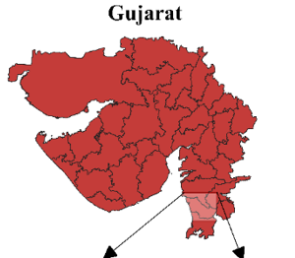 | 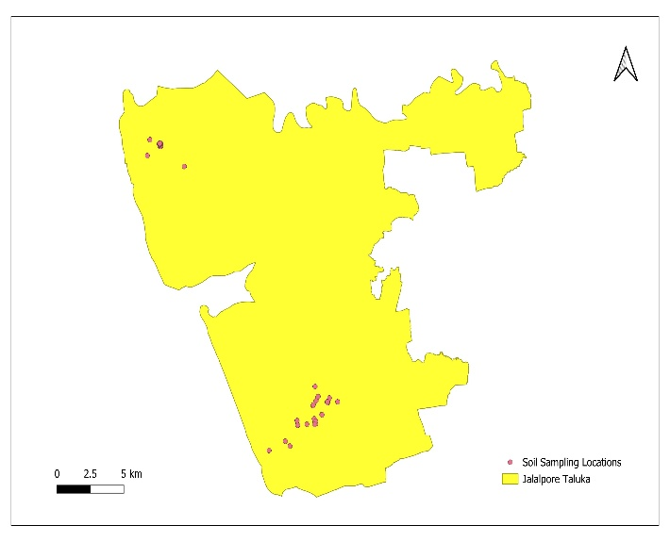
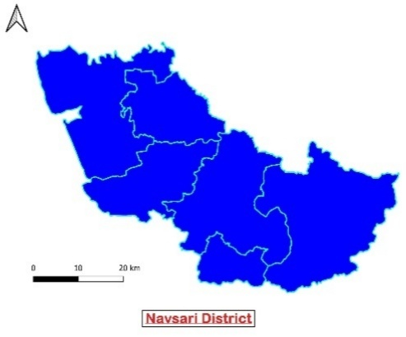
Fig.1 Geographical location of soil samples
The soil pH was measured in a 1:2.5 soil-to-water suspension using a glass electrode electric pH meter (Jackson, 1973), while the electrical conductivity of saturated paste (EC_{e}) estimated using an electrical conductivity meter (Jackson, 1973) (Saturation Paste preparation- Slowly add distilled water to a soil sample while stirring until the paste is saturated, glistening and flows freely from a spatula without dripping or standing water. Calcium carbonate analysed by neutralization with 0.5 N HCl followed by titration with 0.25 N NaOH (Allison and Moodie, 1965). CEC determined by 1N NH₄OAC method (Jackson, 1973). Analytical procedure of sequential extraction of various Fe fractions (Tessier et al., 1979), Water soluble (F₁): Samples of soil 1 g were extracted at 20°C for 1 hr with 10 ml distilled water. Exchangeable (F₂): The residue of F₁ was extracted at room temperature for 1 hour with 10.0 ml of magnesium chloride solution (1.0 M MgCl₂) at pH 7. Carbonate bound (F₃): The residue of F₂ was extracted with 10.0 ml of 1.0 M sodium acetate/acetic acid buffer at pH 5.0 for 5 hours at room temperature. Fe & Mn oxide bound (F₄): The residue from F₃ was extracted with 10.0 ml of 0.4 M NH₂OH.HCl in 25 % (v/v) acetic acid (pH 2.0) with agitation at 96°C in a water bath for 5 hours. Organic bound (F₅): The residue from F₄ was oxidized as follows: 7.5 ml of 30% (v/v) hydrogen peroxide, which has been adjusted to pH 2 with HNO3, was added to the residue. The mixture was heated to 85°C in a water bath for 5 hours with occasional agitation and allowed to cool down. Then 2.5 ml of 3.2 M ammonium acetate in 20 % (v/v) nitric acid was added, shaken for 0.5 hours and centrifuged. After extraction of each fraction, Fe concentrations are measured by AAS (Atomic Absorption Spectroscopy). Simple correlation was made between soil properties & fractions of Fe by using SPSS v.29 software. Spatial distribution of each soil sample at Jalalpore taluka Navsari district were mapped by using QGIS v.3.38. Spatial distribution of all soil properties and fraction Fe at 0-20 cm and 20-40 depths under Jalalpore Taluka showed in Fig 2.
Result and Discussion
pH and ECe of Soil
The data in Table 1 also demonstrated that Jogeshwar Faliya village had the highest pH in saline areas, with values of 8.65 and 8.85 at depths of 0–20 cm and 20–40 cm, respectively. In contrast, Mandaliya and Danti farm had the lowest pH in high-saline regions, with similar values of 7.84 and 7.94 at 0–20 cm and 20–40 cm depths, respectively. When considering the mean pH of the soil in saline areas at depths of 0-20 cm and 20-40 cm, corresponding values of 8.17 and 8.46 obtained. The soil reactions were ranged from neutral to strongly alkaline with a pH ranging from 7.20 to 8.60 with a mean value of 7.90 at 0-20 cm and 20-40 cm depths recorded by Worku and Bedadi (2016).

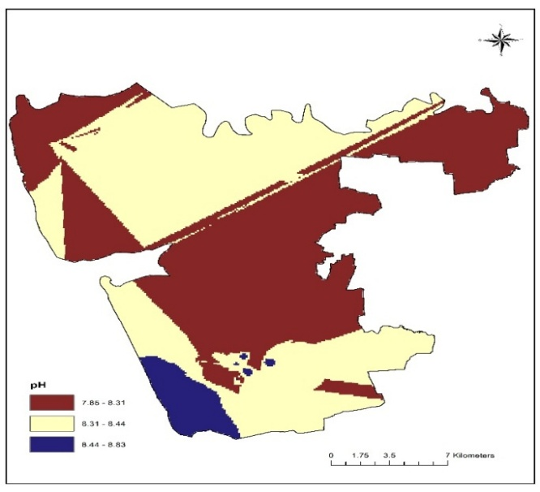  Spatial Distribution of pH | 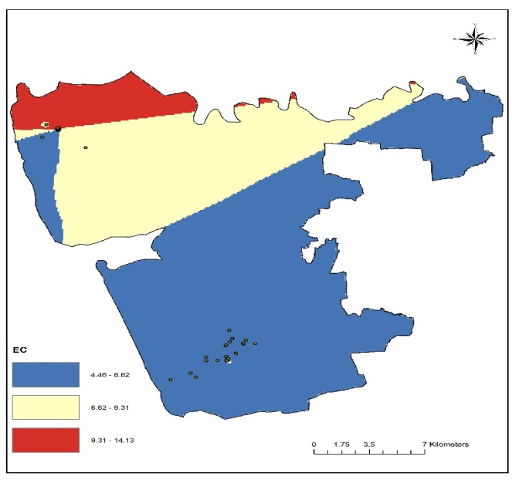  Spatial Distribution of ECe (dS/m)
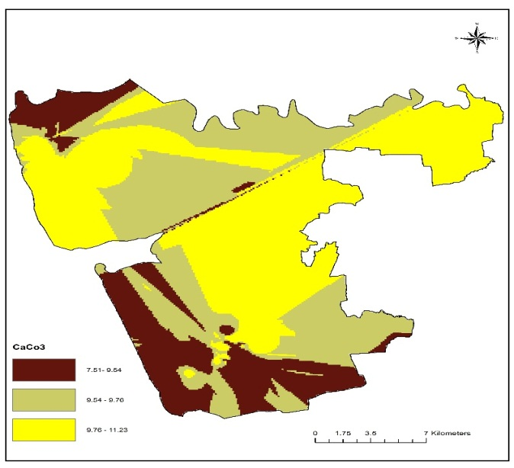  Spatial Distribution of CaCO₃ (%) | 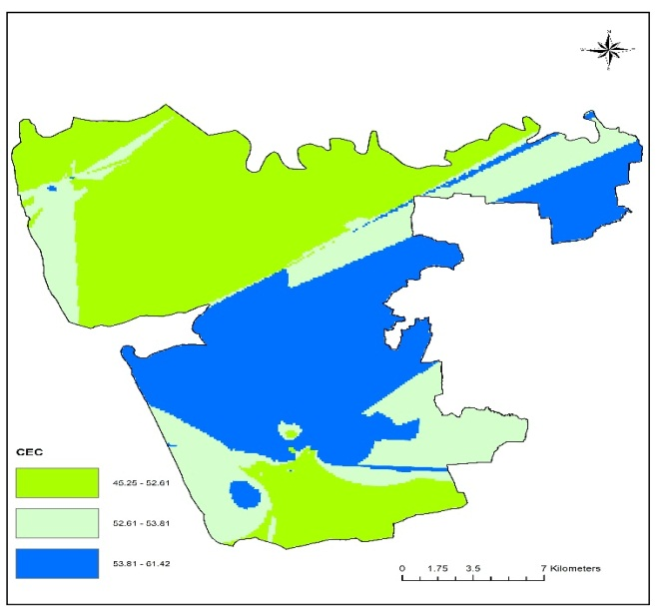  Spatial Distribution of CEC (me 100 g⁻¹)

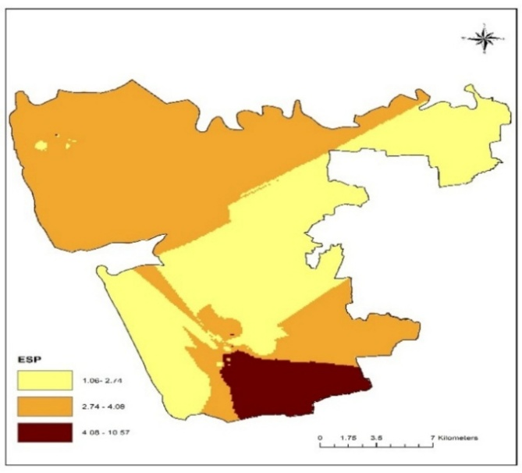 | 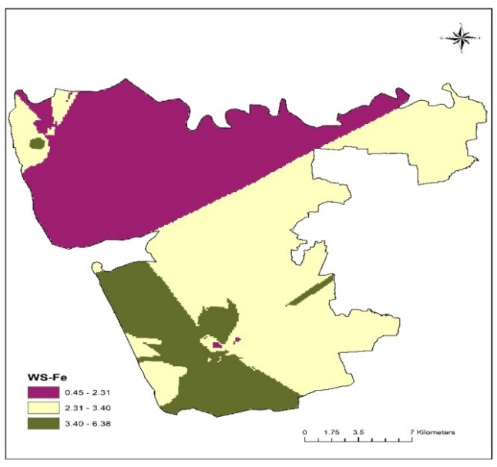
Spatial Distribution of ESP | Spatial Distribution of WS-Fe (mg kg⁻¹)
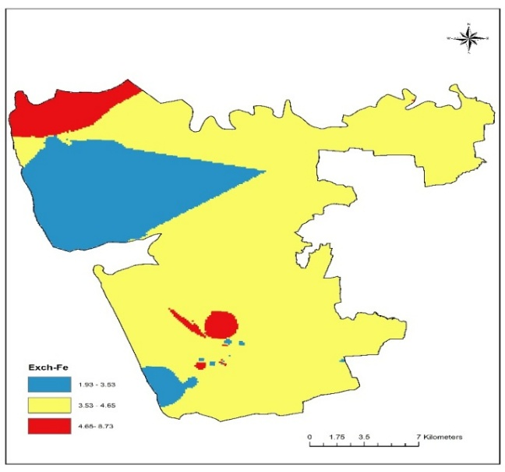 | 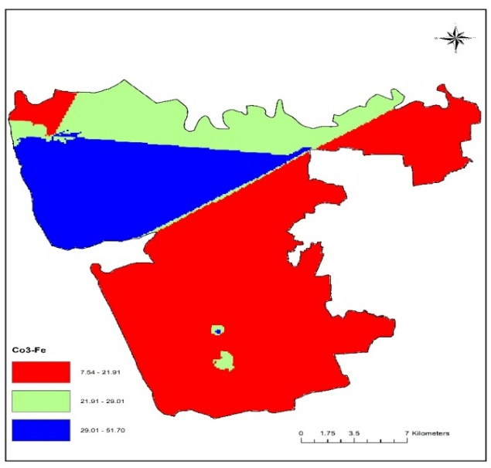
Spatial Distribution of Exch-Fe (mg kg⁻¹) | Spatial Distribution of CO₃-Fe (mg kg⁻¹)
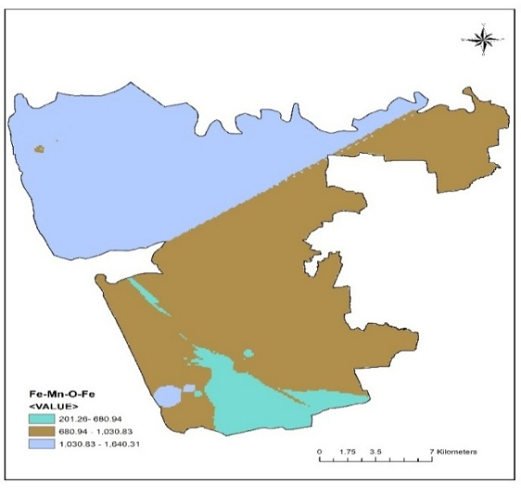 | 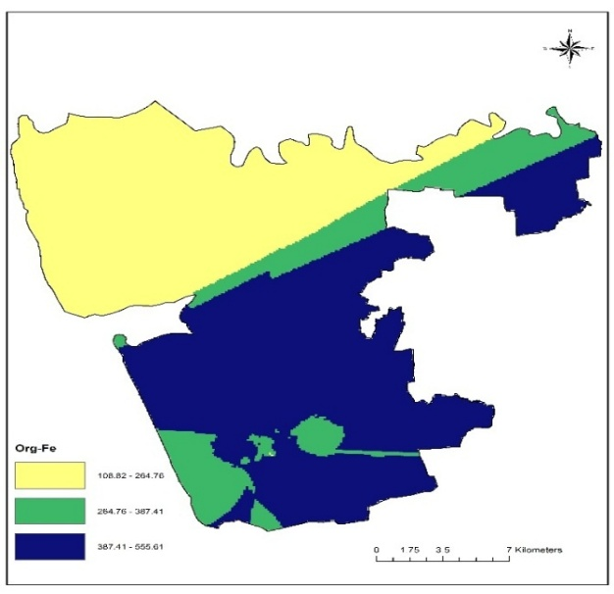
Spatial Distribution of Fe-Mn-O-Fe (mg kg⁻¹) | Spatial Distribution of Org-Fe (mg kg⁻¹)
Fig. 2. Spatial distribution of soil properties and fractions of Fe at 0-20 cm and 20-40 cm depths
The maximum ECe of saturated soil paste was measured in Danti farm under saline area, with corresponding values 42.985 and 37.378 at 0-20 cm and 20-40 cm depths. At depths of 0–20 cm and 20–40 cm, Mandaliya village had the lowest ECe, with corresponding values of 4.067 and 4.113 dS m⁻¹ (Table 1). Taking into account the average value in the saline regions, the upper depth (0–20 cm) had a higher mean value of ECe (7.227 dS m^{–1}) than the lower depth (20–40 cm), which had a value of 6.663 dS m^{–1}. In salt-affected soil, ECe ranged from 1.23 to 19.1 dS m⁻¹ upto 100cm due to the accumulation of salts recorded by Sandhu et al. (2016).
CaCO₃ (%)
In Danti farm, the greatest CaCO₃ content was 9.25 and 11.25 per cent at 0–20 cm and 20–40 cm depths, respectively (Table 1). Mandaliya and Onjal village had the lowest CaCO₃ level in soil from high-saline regions, with 7.25 and 9.25 per cent at 0–20 and 20–40 cm depths, respectively. Taking into account the average CaCO₃ concentration, values of 8.40 and 10.44 per cent were found at depths of 0–20 and 20–40 cm, respectively. Higher amount of calcium carbonate at lower depths might be due to the process of leaching of calcium carbonate and subsequently precipitation at lower depths. Similar results were also registered by Gupta et al. (2003) and Datta et al. (2015).
CEC (me 100 g⁻¹) and ESP
In saline areas, maximum CEC was determined with a value of 55.23 me 100 g⁻¹ and 61.91 me 100 g⁻¹ at 0-20 cm and 20-40 cm depths, respectively (Table 1). However, a minimum value of CEC was recorded in Onjal and Danti farm with respective values of 38.47 me 100 g⁻¹ and 45.25 me 100 g⁻¹ at 0-20 cm and 20-40 cm depths, respectively under saline areas. Data further showed that in saline areas, maximum ESP at 0-20 cm and 20-40 cm depths was recorded in Jogeshwar faliya with respective values of 10.99 and 7.55. The result is in agreement with the findings of Kumar et al. (2018).
Fractions of Fe
Different fractions of Fe were estimated from soil samples collected under salt-affected soil of Navsari district saline areas at 0-20 cm and 20-40 cm depths. The results related to different fractions of Fe i.e, Water Soluble Fe-fraction (WS-Fe), Exchangeable Fe (Exch.-Fe), Carbonate bound Fe (CO₃-Fe), Fe and Mn oxide bound Fe (Fe-Mn-O-Fe) and Organic bound Fe (Org-Fe) are presented in Table 2. Spatial distribution of all soil properties and fraction Fe at 0-20 cm and 20-40 depths under Jalalpore Taluka showed in Fig 2.
Water Soluble Fe (WS-Fe)
In the case of saline areas (Table 2) the maximum value of WS-Fe was found in Sultanpur with corresponding values of 8.6 and 5.62 mg kg⁻¹ at 0-20 cm and 20-40 cm depth, respectively. The result also revealed that the minimum value of WS-Fe was recorded in Danti farm with respective values of 1.23 and 0.45 mg kg⁻¹ at 0-20 cm and 20-40 cm depth in saline areas. Similarly in saline areas result showed that mean value of WS-Fe was high at 0-20 cm depth than 20-40 cm depth with a corresponding value of 4.09 mg kg⁻¹, respectively. The low value of WS may also be attributed to the lower amount of organic matter in the soils as studies have reported that the addition of FYM/organic matter tends to increase the WS and EX-Fe content (Maskina et al., 1998 and Hellel, 2007).
Exchangeable Fe (Exch-Fe)
In saline area, the maximum value of Exch-Fe was recorded in Danti farm and Jogeshwar faliya with corresponding values of 13.01 mg kg⁻¹ and 4.96 mg kg⁻¹ at 0-20 cm and 20-40 cm depths, respectively (Table 2). Similarly, the minimum value of Exch-Fe was found in Onjal and Danti farm at 0-20 cm and 20-40 cm depths with corresponding values of 1.46 mg kg⁻¹ and 0.80 mg kg⁻¹ in high saline areas. The results showed that the decrement in the mean value of Exch-Fe content at 20-40 cm depth was 54.91 per cent over 0-20 cm depth in the high saline areas. Because of their respective hydroxides and oxides occur under specific conditions, the exchangeable and acid extractable portions of iron are typically low. Dhaliwal et al. (2019) revealed that pH and redox potential regulate the change of Fe fractions in the soil.
Carbonate Bound Fe (CO₃-Fe)
A perusal of data presented in Table 2 regarding carbonate bound Fe showed that in saline areas showed that the maximum value of CO₃-Fe content at 0-20 cm and 20-40 cm depths was found in Onjal and Danti farm with values 40.46 and 51.86 mg kg⁻¹, respectively. However, the minimum value of CO₃-Fe was found in Danti farm and Jogeshwar faliya with corresponding values of 0.83 and 7.16 mg kg⁻¹ at 0-20 cm and 20-40 cm depths, respectively. The result also showed that the magnitude of increase in of CO₃-Fe content at lower depths was 57.45 per cent over upper depth in saline areas.
Fe and Mn oxide Bound Fe (Fe-Mn-O-Fe)
Maximum value of Fe-Mn-O-Fe in the high saline areas was found in Danti farm with corresponding values of 2067.60 and 1689.60 mg kg⁻¹ at 0-20 cm and 20-40 cm depths, respectively (Table 2). While, the minimum value of Fe-Mn-O-Fe content was recorded at 0-20 cm and 20-40 cm depths in Mandaliya and Jogeshwar faliya with a tune of 165.60 and 147.60 mg kg⁻¹ in high saline areas. The results further showed the mean value of 0-20 depth is higher than 20-40 cm depth with a value of 1107.22 mg kg⁻¹ in saline areas.
Organic Bound Fe (Org-Fe)
Looking to the organic bound Fe content in soil of saline areas at 0-20 cm and 20-40 cm depths is presented in Table 2 the maximum values of Org-Fe were found in Jogeshwar faliya with corresponding values of 596.76 and 409.56 mg kg⁻¹ at 0-20 cm and 20-40 cm depths. However, the minimum value Org-Fe was recorded at 0-20 cm and 20-40 cm depths with corresponding of 90.00 mg kg⁻¹ and 58.80 mg kg⁻¹, respectively in high saline areas. The Org-Fe content ranged from 90.00 to 596.76 and 58.80-409.56 mg kg⁻¹ at 0-20 cm and 20-40 cm depths in high saline areas. Iron fractions differed in saline soils in the order of organic bound > Fe + Mn bound > carbonate bound > exchangeable > water soluble were reported by Mohiddin et al. (2022).
Correlation between different soil properties and Fe fractions
The data presented in Table 3 shows the association analysis for pH, ECe, CaCO_{3,} CEC, ESP and Fe fractions for 0-20 cm in saline areas. At the 5 per cent significance level, there was a negative and significant correlation between the pH of the soil and both ECe (r = -0.315*) and Exch-Fe (r = -0.293*). As pH increase Fe precipitates as Fe-oxide or carbonates decreases soluble/mobile fractions and increase in Ece Na⁺, Ca⁺², Mg⁺² compress the electrical double layer and reduce Fe solubility. At the 5 per cent significance level, there was a positive and significant correlation between CEC and ESP (r= 0.330*). WS-Fe positively and significantly correlated with CO₃-Fe (r = 0.335**) and Org-Fe (r = 0.458**) at 1 per cent level of significance. Additionally, at the 1 per cent level of significance, there was a negative and significant correlation between WS-Fe and Fe-Mn-O-Fe (r = -0.358*). CO₃-Fe had positive and significant correlation with Org-Fe (r = -0.665**) and negative and significant correlation with Fe-Mn-O-Fe (r = -0.601**) at 1 per cent level of significance. While, Fe-Mn-O-Fe negatively correlated with Org-Fe (r = -0.509**) at 1 per cent level of significance.
In case of 20-40 cm depths (Table 4), soil pH negatively and significantly correlated with CaCO₃ (r= -0.435**) at 1 per cent level of significance. Because CaCO₃ acts as a pH buffer. EC had positive correlation with CaCO₃ (r = 0.284*) and CO₃-Fe (r = 0.297*) while, negative correlation with CEC (r = -0.281*) at 5 per cent level of significance. CaCO₃ negatively and significantly correlated with Org-Fe (r = -0.263*) at 5 per cent level of significance. Also, negative and significant correlation was found between CEC and ESP (r = -0.292*) at 5 per cent level of significance. WS-Fe positive and significant correlation found with Exch-Fe (r = 0.377*) and Org-Fe (r = 0.444**) at 5 per cent and 1 per cent level of significance and negatively and significantly correlated with CO₃-Fe (r = -0.438**) and Fe-Mn-O-Fe (r = -0.404**) at 1 per cent level of significance. Also, Exch-Fe, negatively and significantly correlated with CO₃-Fe (r = -0.508**) and Fe-Mn-O-Fe (r = -0.363**) at 1 per cent level of significance and positively correlated with Org-Fe (r = 0.312*) at 5 per cent level of significance. The CO₃-Fe was positively and significantly correlated with Fe-Mn-O-Fe (r = 0.586**) at 1 per cent level of significance. The Fe-Mn-O-Fe negatively and significantly correlated with Org-Fe (r = -0.575**) at 1 per cent level of significance.

CONCLUSION
The correlation analysis across 0-20 cm and 20-40 cm depths in saline soils revealed depth-dependent and complex interactions between soil properties and Fe fractions. In the surface layer (0-20 cm), soil pH showed negative associations with salinity (ECe) and exchangeable Fe, while CEC was positively linked with ESP. Because CEC is the denominator in ESP calculation. Higher CEC menas more exchange sites available. So, if Na⁺ occupies a significant share of those sites, ESP rises with CEC. Interactions among Fe fractions indicated that water-soluble Fe and carbonate-bound Fe were strongly associated with organic Fe, whereas Fe-Mn oxide-bound Fe was negatively related to these fractions, suggesting competition among Fe pools. At the sub-surface layer (20-40 cm), pH was negatively associated with CaCO₃, while EC showed opposite trends with CaCO₃ and CEC. WS-Fe exhibited positive links with Exch-Fe and Org-Fe, but negative links with CO₃-Fe and Fe-Mn-O-Fe. Exch-Fe also showed contrasting relationship with CO₃-Fe and Org-Fe. Overall, these results suggest that soil salinity, pH, CaCO₃ and CEC strongly influence the distribution and transformation of Fe fractions, with distinct interactions patterns at different soil depths.
Table 1: Soil pH, ECe, CaCO₃, CEC and ESP in sample of saline area of Navsari district

Sr.  No. | Name of village | 0-20 cm |  |  |  |  | 20-40 cm
Sr.  No. | Name of village | pH | ECe  (dS/m) | CaCO3  (%) | CEC  (me 100 g⁻¹) | ESP | pH | ECe  (dS/m) | CaCO3  (%) | CEC  (me 100 g⁻¹) | ESP
1 | ONJAL | 8.50 | 4.314 | 8.50 | 47.28 | 2.84 | 8.84 | 4.489 | 9.75 | 55.92 | 1.07
2 | ONJAL | 8.21 | 4.586 | 8.00 | 38.47 | 1.61 | 8.59 | 4.816 | 10.00 | 55.52 | 1.08
3 | ONJAL | 8.33 | 4.440 | 8.75 | 44.49 | 1.92 | 8.75 | 4.641 | 9.25 | 48.46 | 1.04
4 | ONJAL | 8.20 | 4.660 | 8.50 | 42.23 | 1.17 | 8.56 | 4.307 | 9.50 | 57.26 | 1.27
5 | JOGESHWAR  FALIYA | 8.48 | 4.975 | 8.75 | 48.97 | 3.51 | 8.81 | 4.586 | 10.25 | 57.79 | 1.06
6 | JOGESHWAR  FALIYA | 8.22 | 4.382 | 9.25 | 45.39 | 3.02 | 8.85 | 4.806 | 10.00 | 50.79 | 1.26
7 | JOGESHWAR  FALIYA | 8.17 | 4.625 | 8.50 | 44.94 | 4.58 | 8.35 | 6.634 | 10.75 | 51.41 | 7.55
8 | JOGESHWAR  FALIYA | 8.25 | 4.249 | 9.00 | 46.92 | 3.28 | 8.23 | 4.806 | 10.50 | 51.77 | 1.07
9 | JOGESHWAR  FALIYA | 8.43 | 4.845 | 8.50 | 47.39 | 8.00 | 8.45 | 4.955 | 10.00 | 60.49 | 1.06
10 | JOGESHWAR  FALIYA | 8.08 | 4.596 | 8.00 | 45.20 | 1.86 | 8.14 | 6.304 | 10.75 | 51.37 | 1.03
11 | JOGESHWAR  FALIYA | 8.65 | 4.485 | 7.75 | 46.69 | 10.26 | 8.26 | 4.904 | 10.50 | 54.75 | 2.87
12 | JOGESHWAR  FALIYA | 8.58 | 5.464 | 7.50 | 47.87 | 10.82 | 8.46 | 4.952 | 10.25 | 57.38 | 3.37
13 | JOGESHWAR  FALIYA | 8.12 | 8.611 | 8.75 | 44.33 | 10.74 | 8.78 | 4.887 | 10.00 | 50.17 | 5.04
14 | JOGESHWAR  FALIYA | 8.09 | 4.411 | 9.00 | 53.92 | 10.99 | 8.58 | 6.184 | 10.25 | 53.75 | 5.39
15 | JOGESHWAR  FALIYA | 8.24 | 4.648 | 8.75 | 55.09 | 6.90 | 8.40 | 5.954 | 10.25 | 58.14 | 5.41
16 | JOGESHWAR  FALIYA | 8.11 | 14.737 | 8.75 | 49.48 | 7.28 | 8.48 | 7.030 | 10.50 | 47.39 | 2.47
17 | MANDALIYA | 8.13 | 4.067 | 7.25 | 55.23 | 8.04 | 8.37 | 6.349 | 10.00 | 54.30 | 2.82
18 | MANDALIYA | 8.02 | 7.892 | 7.75 | 50.47 | 7.25 | 8.25 | 4.113 | 11.00 | 56.67 | 1.74
19 | MANDALIYA | 8.08 | 4.178 | 7.50 | 50.52 | 6.77 | 8.48 | 6.268 | 10.75 | 60.83 | 2.37
20 | MANDALIYA | 8.07 | 5.085 | 7.50 | 53.02 | 6.32 | 8.46 | 4.495 | 10.25 | 61.91 | 2.43
21 | MANDALIYA | 7.89 | 5.267 | 8.75 | 54.37 | 5.36 | 8.45 | 6.508 | 10.75 | 59.96 | 1.31
22 | MANDALIYA | 7.84 | 5.882 | 9.00 | 50.75 | 4.29 | 8.05 | 7.736 | 10.50 | 58.09 | 1.58
23 | MANDALIYA | 8.11 | 5.48 | 8.50 | 47.29 | 4.91 | 8.39 | 4.346 | 11.00 | 54.80 | 1.26
24 | MANDALIYA | 8.13 | 4.495 | 8.00 | 50.85 | 4.39 | 8.34 | 6.56 | 10.25 | 54.30 | 3.28
25 | MANDALIYA | 8.12 | 4.748 | 8.25 | 49.04 | 4.51 | 8.00 | 4.524 | 10.75 | 52.29 | 1.65
26 | MANDALIYA | 8.00 | 6.916 | 8.00 | 48.9 | 2.08 | 7.99 | 6.492 | 10.50 | 56.77 | 1.70
27 | SULTANPUR | 8.17 | 6.975 | 7.75 | 51.37 | 3.39 | 8.37 | 5.27 | 10.00 | 56.31 | 0.80
28 | SULTANPUR | 8.32 | 6.213 | 7.50 | 45.20 | 4.99 | 8.65 | 5.286 | 9.75 | 58.27 | 1.51
29 | SULTANPUR | 8.48 | 6.083 | 9.00 | 50.53 | 4.58 | 8.65 | 4.586 | 10.75 | 61.19 | 1.39
30 | SULTANPUR | 8.04 | 4.790 | 8.75 | 53.09 | 3.35 | 8.54 | 4.952 | 11.00 | 59.93 | 0.85
31 | SULTANPUR | 8.33 | 4.622 | 8.50 | 46.88 | 3.08 | 8.66 | 5.743 | 10.25 | 59.63 | 1.78
32 | SULTANPUR | 8.41 | 4.460 | 8.75 | 44.62 | 3.45 | 8.42 | 6.206 | 10.50 | 56.40 | 1.01
33 |  | 7.86 | 22.66 | 7.50 | 46.33 | 3.34 | 8.25 | 12.458 | 10.75 | 58.31 | 1.02
34 |  | 7.98 | 12.876 | 8.00 | 42.77 | 2.24 | 8.56 | 4.628 | 10.25 | 56.69 | 1.47
35 |  | 8.04 | 6.618 | 7.75 | 50.49 | 6.03 | 8.54 | 5.182 | 11.00 | 56.21 | 2.14
36 | DANTI | 8.22 | 4.599 | 8.75 | 51.43 | 5.84 | 7.94 | 5.367 | 11.25 | 54.30 | 1.95
37 |  | 7.99 | 10.595 | 9.25 | 46.82 | 4.12 | 8.3 | 7.467 | 11.00 | 57.67 | 1.51
38 |  | 7.96 | 10.455 | 9.00 | 46.88 | 3.61 | 8.40 | 6.903 | 9.75 | 54.05 | 1.28
39 |  | 8.23 | 4.696 | 9.25 | 47.93 | 7.97 | 8.54 | 5.779 | 11.00 | 56.57 | 2.37
40 |  | 8.20 | 5.429 | 8.50 | 49.05 | 6.27 | 8.47 | 5.169 | 10.00 | 55.48 | 2.09
41 |  | 8.11 | 9.496 | 8.75 | 48.83 | 4.18 | 8.34 | 8.854 | 10.75 | 55.05 | 1.66
42 |  | 8.16 | 7.282 | 8.50 | 49.65 | 6.25 | 8.40 | 7.684 | 10.25 | 55.25 | 2.11
43 |  | 8.16 | 4.09 | 7.75 | 43.30 | 5.96 | 8.57 | 6.54 | 10.75 | 56.60 | 4.55
44 |  | 7.96 | 8.835 | 8.50 | 50.53 | 6.21 | 8.30 | 7.461 | 10.50 | 53.42 | 1.40
45 |  | 8.08 | 9.794 | 8.75 | 52.29 | 4.98 | 8.42 | 9.211 | 11.00 | 49.89 | 3.93
46 |  | 8.21 | 6.754 | 8.25 | 45.59 | 6.19 | 8.52 | 6.200 | 10.00 | 52.09 | 4.06
47 |  | 8.22 | 5.429 | 8.50 | 47.72 | 4.50 | 8.48 | 5.354 | 10.50 | 58.18 | 3.19
48 |  | 8.24 | 4.472 | 8.00 | 51.45 | 3.17 | 8.76 | 6.077 | 10.25 | 56.40 | 2.43
49 |  | 8.18 | 7.386 | 7.75 | 48.96 | 3.32 | 8.58 | 6.077 | 11.00 | 55.73 | 3.12
50 |  | 8.26 | 4.842 | 9.00 | 46.03 | 3.90 | 8.63 | 4.91 | 10.75 | 50.13 | 2.41
51 | DANTI | 8.15 | 9.127 | 9.25 | 51.52 | 3.76 | 8.6 | 6.508 | 10.00 | 56.37 | 1.79
52 |  | 8.29 | 4.139 | 8.50 | 52.02 | 6.37 | 8.41 | 5.331 | 10.25 | 57.46 | 1.95
53 |  | 8.13 | 9.156 | 8.00 | 44.39 | 4.38 | 8.4 | 8.958 | 11.00 | 60.34 | 2.15
54 |  | 8.18 | 4.129 | 7.50 | 48.05 | 3.64 | 8.64 | 4.826 | 10.00 | 56.33 | 2.86
55 |  | 8.22 | 4.482 | 8.75 | 49.23 | 7.24 | 8.49 | 6.219 | 10.25 | 53.62 | 2.24
56 |  | 8.01 | 4.317 | 9.00 | 46.36 | 4.54 | 8.48 | 6.822 | 11.00 | 59.85 | 1.79
57 |  | 8.14 | 5.600 | 9.25 | 46.01 | 5.09 | 8.53 | 5.218 | 10.5 | 53.48 | 2.36
58 |  | 8.11 | 4.372 | 8.00 | 48.61 | 5.72 | 8.6 | 5.565 | 10.75 | 53.83 | 2.31
59 |  | 8.32 | 23.902 | 7.75 | 52.44 | 4.71 | 8.48 | 17.949 | 10.25 | 45.25 | 3.57
60 |  | 7.95 | 42.985 | 9.25 | 51.13 | 3.40 | 8.37 | 37.378 | 11.25 | 50.63 | 3.73
 | Max. | 8.65 | 42.985 | 9.25 | 55.23 | 10.99 | 8.85 | 37.378 | 11.25 | 61.91 | 7.55
 | Min. | 7.84 | 4.067 | 7.25 | 38.47 | 1.17 | 7.94 | 4.113 | 9.25 | 45.25 | 0.8
 | Mean | 8.17 | 7.227 | 8.40 | 48.44 | 5.04 | 8.46 | 6.663 | 10.44 | 55.39 | 2.28

Table 2: Different fractions of Fe (mg kg⁻¹) in soils of saline areas at 0-20 and 20-40 cm depth
Continue…
Sr.no | Name of Village | Depth: 0-20 cm |  |  |  |  | Depth: 20-40 cm
Sr.no | Name of Village | WS-Fe | Exch-Fe | CO₃-Fe | Fe-Mn-O-Fe | Org-Fe | WS-Fe | Exch-Fe | CO₃-Fe | Fe-Mn-O-Fe | Org-Fe
1 | ONJAL | 7.54 | 6.48 | 26.44 | 716.40 | 528.84 | 4.55 | 3.00 | 15.90 | 566.40 | 341.64
2 | ONJAL | 5.62 | 1.46 | 27.29 | 1449.60 | 545.88 | 2.63 | 4.07 | 21.64 | 1275.60 | 358.68
3 | ONJAL | 2.54 | 6.22 | 24.32 | 1678.80 | 486.36 | 2.25 | 3.07 | 25.07 | 1340.40 | 299.16
4 | ONJAL | 3.56 | 5.69 | 40.46 | 1174.80 | 570.00 | 2.56 | 2.54 | 9.95 | 973.20 | 382.80
5 | JOGESHWAR FALIYA | 6.95 | 7.01 | 32.81 | 441.60 | 568.80 | 3.96 | 3.86 | 19.57 | 388.80 | 381.60
6 | JOGESHWAR FALIYA | 5.88 | 8.87 | 29.84 | 991.20 | 596.76 | 2.89 | 4.39 | 19.23 | 841.20 | 409.56
7 | JOGESHWAR FALIYA | 5.81 | 7.80 | 20.07 | 898.80 | 401.40 | 2.82 | 4.65 | 16.48 | 748.80 | 214.20
8 | JOGESHWAR FALIYA | 6.06 | 3.31 | 34.94 | 487.20 | 558.00 | 3.07 | 2.59 | 14.76 | 457.20 | 370.80
9 | JOGESHWAR FALIYA | 7.41 | 6.48 | 31.54 | 762.00 | 511.20 | 4.42 | 3.33 | 13.73 | 612.00 | 324.00
10 | JOGESHWAR FALIYA | 7.00 | 4.37 | 21.35 | 394.80 | 426.96 | 4.01 | 4.81 | 7.16 | 244.80 | 239.76
11 | JOGESHWAR FALIYA | 4.68 | 3.05 | 24.32 | 1174.80 | 486.36 | 1.69 | 3.19 | 17.17 | 781.20 | 299.16
12 | JOGESHWAR FALIYA | 2.09 | 4.10 | 27.71 | 853.20 | 554.28 | 2.10 | 4.96 | 14.42 | 703.20 | 367.08
13 | JOGESHWAR FALIYA | 3.05 | 6.22 | 29.42 | 165.60 | 588.36 | 1.67 | 3.07 | 18.80 | 147.60 | 401.16
14 | JOGESHWAR FALIYA | 7.39 | 4.10 | 21.35 | 427.20 | 426.96 | 4.40 | 3.23 | 18.82 | 277.20 | 239.76
15 | JOGESHWAR FALIYA | 2.68 | 5.42 | 16.67 | 212.40 | 333.48 | 2.12 | 2.27 | 20.36 | 373.20 | 146.28
16 | JOGESHWAR FALIYA | 4.30 | 4.63 | 29.42 | 165.60 | 588.36 | 1.31 | 2.76 | 17.00 | 162.00 | 401.16
17 | MANDALIYA | 3.12 | 10.45 | 17.10 | 165.60 | 342.00 | 1.14 | 4.71 | 15.97 | 374.40 | 154.80
18 | MANDALIYA | 4.30 | 7.80 | 26.87 | 165.60 | 537.36 | 1.31 | 3.06 | 19.84 | 255.60 | 350.16
19 | MANDALIYA | 4.57 | 9.66 | 20.50 | 441.60 | 409.92 | 1.58 | 3.13 | 18.29 | 291.60 | 222.72
20 | MANDALIYA | 3.15 | 8.34 | 24.32 | 441.60 | 486.36 | 1.01 | 3.46 | 16.22 | 291.60 | 299.16
21 | MANDALIYA | 3.64 | 9.92 | 29.42 | 762.00 | 588.36 | 0.89 | 4.08 | 13.38 | 612.00 | 401.16
22 | MANDALIYA | 5.62 | 8.87 | 32.81 | 898.80 | 548.40 | 2.63 | 2.99 | 13.90 | 748.80 | 361.20
23 | MANDALIYA | 3.45 | 6.22 | 23.05 | 487.20 | 460.92 | 0.46 | 3.07 | 14.68 | 337.20 | 273.72
24 | MANDALIYA | 3.89 | 7.01 | 30.26 | 349.20 | 547.20 | 1.91 | 3.86 | 16.48 | 199.20 | 360.00
25 | MANDALIYA | 3.82 | 6.36 | 26.03 | 1214.40 | 520.68 | 1.27 | 3.21 | 14.16 | 1064.40 | 333.48
26 | MANDALIYA | 4.99 | 2.47 | 12.06 | 1328.40 | 539.42 | 2.00 | 3.05 | 13.90 | 1178.40 | 352.22
27 | SULTANPUR | 3.55 | 2.70 | 12.29 | 931.20 | 556.80 | 0.56 | 3.10 | 15.45 | 781.20 | 369.60
28 | SULTANPUR | 5.11 | 5.45 | 11.83 | 760.80 | 496.09 | 2.12 | 2.30 | 14.42 | 610.80 | 308.89
29 | SULTANPUR | 5.12 | 5.45 | 10.68 | 987.60 | 585.60 | 2.13 | 2.40 | 13.12 | 789.60 | 398.40
30 | SULTANPUR | 8.61 | 11.18 | 18.47 | 1214.40 | 540.00 | 5.62 | 3.07 | 10.28 | 975.60 | 352.80
31 | SULTANPUR | 5.55 | 9.34 | 9.77 | 1158.00 | 559.20 | 2.56 | 3.66 | 11.06 | 957.60 | 372.00
32 | SULTANPUR | 6.58 | 8.88 | 4.04 | 1101.60 | 409.43 | 3.59 | 4.24 | 11.57 | 832.80 | 222.23
33 | DANTI | 2.68 | 6.36 | 14.81 | 703.20 | 340.74 | 0.69 | 3.00 | 39.07 | 553.20 | 153.54
34 | DANTI | 2.37 | 9.57 | 19.39 | 1556.40 | 271.46 | 1.34 | 3.07 | 40.10 | 1406.40 | 84.26
35 | DANTI | 3.31 | 13.01 | 15.04 | 1044.00 | 90.00 | 0.92 | 3.66 | 37.01 | 894.00 | 100.80
36 | DANTI | 2.64 | 7.28 | 11.82 | 817.20 | 124.09 | 5.41 | 4.13 | 51.86 | 667.20 | 126.00
37 | DANTI | 2.65 | 10.26 | 13.43 | 1498.80 | 193.37 | 0.97 | 4.78 | 40.66 | 1348.80 | 133.20
38 | DANTI | 3.68 | 9.80 | 8.85 | 1839.60 | 228.13 | 1.05 | 4.65 | 23.81 | 1689.60 | 104.40
39 | DANTI | 3.04 | 10.26 | 12.52 | 1556.40 | 96.00 | 0.91 | 4.27 | 24.84 | 1406.40 | 115.20
40 | DANTI | 1.95 | 5.45 | 13.89 | 1044.00 | 148.80 | 1.18 | 2.30 | 43.85 | 894.00 | 118.80
41 | DANTI | 3.49 | 6.59 | 12.52 | 987.60 | 228.13 | 0.50 | 1.99 | 47.86 | 837.60 | 78.00
42 | DANTI | 4.66 | 4.53 | 13.89 | 1783.20 | 164.40 | 0.67 | 2.52 | 40.66 | 1633.20 | 81.60
43 | DANTI | 3.02 | 3.62 | 12.52 | 1897.20 | 176.11 | 0.71 | 2.32 | 27.02 | 1483.20 | 88.80
44 | DANTI | 2.70 | 2.93 | 11.83 | 1953.60 | 120.00 | 0.76 | 2.45 | 46.25 | 1590.00 | 105.60
45 | DANTI | 4.66 | 6.12 | 9.53 | 1442.40 | 124.09 | 0.45 | 1.93 | 29.42 | 1233.60 | 118.80
46 | DANTI | 2.03 | 7.74 | 8.85 | 1783.20 | 228.13 | 0.81 | 2.18 | 41.45 | 1636.80 | 100.80
47 | DANTI | 1.23 | 6.59 | 9.77 | 1897.20 | 374.40 | 0.91 | 2.79 | 40.66 | 1518.00 | 58.80
48 | DANTI | 2.06 | 2.93 | 8.62 | 1726.80 | 366.00 | 0.61 | 1.62 | 30.24 | 1576.80 | 178.80
49 | DANTI | 2.37 | 4.99 | 9.53 | 1612.80 | 346.80 | 0.96 | 2.61 | 41.45 | 1462.80 | 159.60
50 | DANTI | 3.71 | 7.05 | 7.25 | 987.60 | 292.80 | 0.72 | 2.19 | 37.44 | 837.60 | 105.60
51 | DANTI | 4.01 | 5.67 | 9.53 | 1044.00 | 318.00 | 1.02 | 2.13 | 29.42 | 894.00  Continue… | 130.80
52 | DANTI | 5.60 | 1.55 | 6.56 | 1272.00 | 344.40 | 2.61 | 1.59 | 36.65 | 1122.00 | 157.20
53 | DANTI | 4.22 | 6.36 | 4.04 | 1442.40 | 121.20 | 1.23 | 1.44 | 42.24 | 1292.40 | 109.20
54 | DANTI | 2.88 | 10.49 | 4.96 | 1726.80 | 312.00 | 0.89 | 2.76 | 33.43 | 1576.80 | 124.80
55 | DANTI | 3.14 | 6.36 | 1.75 | 1669.20 | 357.60 | 0.66 | 0.80 | 50.26 | 1519.20 | 170.40
56 | DANTI | 2.36 | 7.51 | 6.56 | 2067.60 | 321.60 | 0.97 | 1.62 | 40.66 | 1627.20 | 134.40
57 | DANTI | 2.58 | 6.14 | 0.83 | 1839.60 | 117.60 | 0.91 | 2.50 | 30.24 | 1689.60 | 99.60
58 | DANTI | 3.65 | 4.53 | 1.75 | 1953.60 | 345.60 | 0.66 | 1.38 | 43.85 | 1563.60 | 158.40
59 | DANTI | 3.03 | 7.74 | 1.97 | 1328.40 | 126.00 | 0.69 | 0.99 | 45.46 | 1178.40 | 187.20
60 | DANTI | 4.02 | 9.80 | 3.12 | 1556.40 | 333.50 | 1.03 | 1.95 | 39.84 | 1406.40 | 146.30
Max. |  | 8.61 | 13.01 | 40.46 | 2067.60 | 596.76 | 5.62 | 4.96 | 51.86 | 1689.60 | 409.56
Min. |  | 1.23 | 1.46 | 0.83 | 165.60 | 90.00 | 0.45 | 0.80 | 7.16 | 147.60 | 58.80
Mean |  | 4.09 | 6.61 | 16.71 | 1107.22 | 381.84 | 1.79 | 2.98 | 26.31 | 945.54 | 229.00

Table 3: Correlation between PH, EC, CaCO₃, CEC, ESP and fractions of Fe
 | 0-20 cm depth
 | PH | EC | CaCO₃ | CEC | ESP | WS-Fe | Exch-Fe | CO₃-Fe | Fe-Mn-O-Fe | Org-Fe
PH | 1
EC | -0.315* | 1
CaCO₃ | -0.068 | 0.070 | 1
CEC | -0.172 | 0.095 | 0.002 | 1
ESP | 0.189 | -0.121 | -0.099 | 0.330* | 1
WS-Fe | 0.204 | -0.154 | 0.186 | -0.002 | -0.119 | 1
Exch-Fe | -0.293* | 0.164 | 0.116 | 0.145 | -0.063 | -0.039 | 1
CO₃-Fe | 0.077 | -0.249 | -0.015 | -0.115 | 0.073 | 0.335** | -0.053 | 1
Fe-Mn-O-Fe | -0.077 | 0.089 | 0.133 | -0.284* | -0.276* | -0.358** | -0.045 | -0.601** | 1
Org-Fe | 0.224 | -0.203 | -0.053 | -0.061 | -0.082 | 0.458** | -0.168 | 0.665** | -0.509** | 1
 | 20-40 cm depth
PH | 1
EC | -0.150 | 1
CaCO₃ | -0.435** | 0.284* | 1
CEC | 0.004 | -0.281* | 0.100 | 1
ESP | 0.057 | 0.199 | 0.100 | -0.292* | 1
WS-Fe | -0.014 | -0.201 | -0.115 | 0.123 | -0.142 | 1
Exch-Fe | -0.153 | -0.251 | -0.030 | 0.095 | -0.086 | 0.377* | 1
CO₃-Fe | -0.020 | 0.297* | 0.246 | -0.177 | 0.104 | -0.438** | -0.508** | 1
Fe-Mn-O-Fe | 0.114 | 0.175 | 0.025 | -0.051 | -0.030 | -0.404** | -0.363** | 0.586** | 1
Org-Fe | 0.080 | -0.223 | -0.263* | 0.070 | -0.249 | 0.444** | 0.312* | -0.775* | -0.575** | 1
**. Correlation is significant at the 0.01 level (2-tailed).
*. Correlation is significant at the 0.05 level (2-tailed).

Disclaimer (Artificial intelligence)

Option 1:

Author(s) hereby declare that NO generative AI technologies such as Large Language Models (ChatGPT, COPILOT, etc.) and text-to-image generators have been used during the writing or editing of this manuscript.

Option 2:

Author(s) hereby declare that generative AI technologies such as Large Language Models, etc. have been used during the writing or editing of manuscripts. This explanation will include the name, version, model, and source of the generative AI technology and as well as all input prompts provided to the generative AI technology

Details of the AI usage are given below:
1. I don’t use AI
2.
3.

REFERENCE
Allison, L. E. and Moodie, C. D. (1965). Carbonate. Methods of Soil Analysis: Part 2 Chemical and Microbiological Properties, 9: 1379-1396.
Aulakh, M.S. and Grant, C.A. (Eds.) (2008). Integrated Nutrient Management for Sustainable Crop Production; The Haworth Press/Taylor & Francis Group: New York, NY, USA, 2.
Bailey, R.L.; West, K.P., Jr. and Black, R.E. (2015). The epidemiology of global micronutrient deficiencies. Annals of nutrition and metabolism, 66(Suppl. 2): 22-33 [CrossRef]
Datta, A.; Basak, N.; Chaudhari, S. K. and Sharma, D. K. (2015). Effect of horticultural land uses on soil properties and organic carbon distribution in a reclaimed sodic soil. Journal of the Indian Society of Soil Science, 63(3): 294-303.
Dhaliwal, S.; Naresh, R.; Mandal, A.; Singh, R. and Dhaliwal, M. (2019). Dynamics and transformations of micronutrients in agricultural soils as influenced by organic matter build-up. Environmental and Sustainability Indicators, 1: 100007.
Eskandari, S. and Mozaffari, V. (2014). Interactive effect of soil salinity and copper application on growth and chemical composition of pistachio seedlings (cv. Badami). Communications in Soil Science and Plant Analysis, 45: 688–702. [CrossRef]
Gupta, N.; Trivadi, S. K.; Bansal, K. N. and Kaul, R. K. (2003). Vertical distribution of micronutrient cations in some soil series of northern Madhya Pradesh. Journal of the Indian Society of Soil Science, 51: 517-522.
Hellel, F. A. (2007). Composite of rice straw and its influences on Fe availability in calcareous soil. Journal of Agricultural and Biological Science, 3: 105-114.
Jackson, M. L. (1973). Soil Chemical Analysis. Prentice Hall of India Pvt. Ltd., New Delhi. pp. 183-192.
Kumar, S.; Salimath, S. B.; Channagouda, R. F. and Gurumurthy, K. T. (2018). Physical and chemical properties of salt affected soils of Vani Vilas command area of Hiriyur taluk, Chitradurga district. Journal of Pharmacognosy and Phytochemistry, 7(1): 1379-1383.
Maskina, M. S.; Singh, B.; Singh, Y.; Baddesha, H. S. and Meelu, O. P. (1998). Fertilizer requirement of rice - wheat and maize - wheat rotation on coarse textured soils amended with farm yard manure. Fertilizer Research, 17: 153-164.
Mohiuddin, M.; Irshad, M.; Sher, S.; Hayat, F.; Ashraf, A.; Masood, S. and Waseem, M. (2022). Relationship of selected soil properties with the micronutrients in salt-affected soils. Land, 11(6): 845.
Sandhu, O. P.; Jassal, H. S.; Narender, S. D. and Rolaniya, L. K. (2016). Fractionation and distribution of iron in the salt-affected soils of muktsar district of Punjab. The Ecoscan, 10(2): 33-39.
Shukla, A.K.; Malik, R.; Tiwari, P.K.; Prakash, C.; Behera, S.K.; Yadav, H. and Narwal, R. (2015). Status of micronutrient deficiencies in soils of Haryana. Indian Journal of Fertilisers, 11(5: 16-27.
Suchdev, P.S.; Jefferds, M.E.D.; Ota, E.; da Silva Lopes, K. and De-Regil, L.M. (2011). Home fortification of foods with multiple micronutrient powders for health and nutrition in children under two years of age. Cochrane database of systematic reviews,2: CD008959. [CrossRef]
Tessier, A.; Campbell, P.G. and Bisson, M. (1979). Sequential extraction procedure for the speciation of particulate trace metals. Analytical Chemistry, 51: 844–851. [CrossRef]
Worku, A. and Bedadi, B. (2016). Studies on soil physical properties of salt affected soil in Amibara area, central rift valley of Ethiopia. International Journal of Agricultural Sciences and Natural Resources, 3(2): 8-17.

