Short Research Article

Soil Vulnerability to Water Erosion in the Baobolong Watershed, Nioro Du Rip, Senegal: A Soil Science and Principal Component Analysis Approach

Abstract
Agricultural sustainability has become a major challenge in West Africa due to soil degradation exacerbated by anthropogenic and climatic pressures. Water erosion causes considerable land loss on denuded soils and recently cleared slopes of the Nioro du Rip region in Senegal. This soil study conducted in the Baobolong watershed aims to characterise the physical and chemical properties of soils in relation to their sensitivity to water erosion. Several soil sampling missions were organised in the Nioro du Rip area, and five (5) transects were developed. For physicochemical analyses, the granulometric analysis, carried out using the Robinson method, combines sieving (sandy fraction) and decantation (silt, clay). Principal component analysis (PCA) was applied to identify correlations between variables and highlight the factors determining the organisation and spatial dynamics of soils. The results show a predominance of loamy textures, low organic matter content, variable saturation levels, and high to very high erodibility (K > 0.45). PCA highlights four structuring factors (F1, F2, F3 and F4 with values 46.7%, 25.1%, 9.4%, and 7.2%, respectively), including organic matter decomposition and acidification. These data underscore the risks to the sustainability of local agricultural systems. The variability of soil profiles in terms of depth and physico-chemical properties is influenced by the topography, which determines water and erosion dynamics. The soils derive from a uniform parent material, clayey sandstone.

Keywords: Water erosion; Principal Component Analysis; Erodibility; Nioro du Rip; Tropical soils

Introduction
Scientific and technological revolutions today have offered mankind a greater domination over nature, which has left indelible environmental imprints on some parts of the planet (soil degradation), which had since yesteryears, become a source of human concern (Siyir & Nfor, 2023). The dynamics of soil degradation in West Africa, exacerbated by anthropogenic and climatic pressures, are a major challenge for agricultural sustainability (Bationo et al., 2023). Anthropogenic activities, in addition to natural processes, enhance land degradation; these processes are also complex and site-specific. The socio-economic implications of land degradation can be attributed to continuous loss of agricultural land, decreasing agricultural productivity, worsening food security, and slower economic activity, which results in low standards of living and poor health status (Suryawanshi et al., 2023; Cao et al., 2023). The Nioro du Rip region in Senegal illustrates these transformations, with intensive farming practices on fragile ferruginous soils. The intensive use of land has recently led to decreased grain yields and increased transformation and change in land use, especially the conversion of forests into agriculture or pastures. Deterioration in pasture areas that have been poorly managed over long periods has resulted not only in soil quality deterioration but also in low animal and pasture productivity (Babur et al., 2021; Lamane et al., 2022). In addition, water erosion causes considerable land loss on denuded soils and recently cleared slopes (AFD, 2006), due to the torrential nature of the rains, the high vulnerability of the terrain (soft rocks, fragile soils, steep slopes and degradation of vegetation cover) and the adverse impact of human activities (deforestation, fires, poor agricultural practices, chaotic urban development, etc.) (B. Barthès., E. Roose, 2001).
This study aims to diagnose the condition of these soils through a pedological and statistical approach, in relation to their vulnerability to water erosion.

Study method
As part of the study, several soil sampling missions were organised in the Nioro du Rip area. We developed five (5) transects (Figure 1).

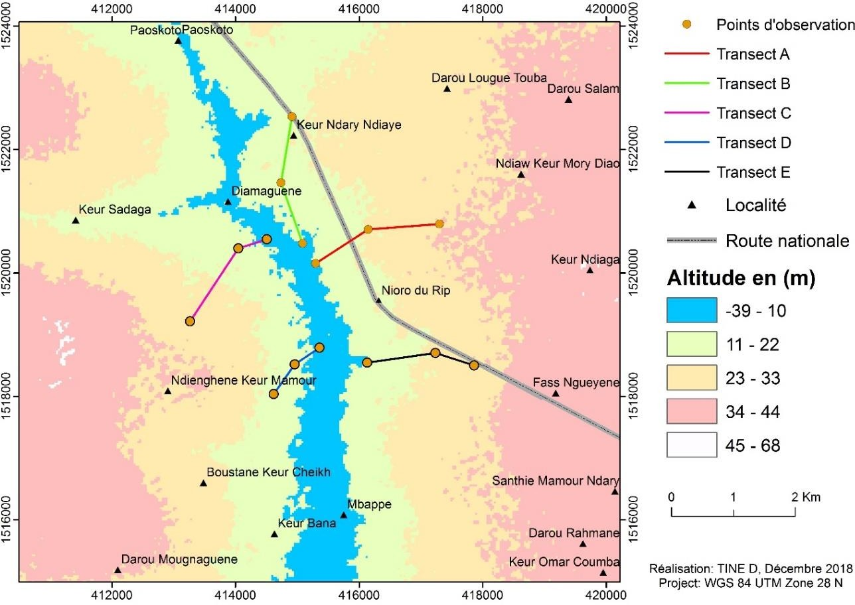

Figure 1: Map of transects covered in the Baobolong watershed

Description of soil profiles and sampling
Fifteen soil pits were dug (three per transect: plateau, slope, lowland) according to the topography (Figure 2). Each profile (80 × 80 cm, 150 cm deep, except in the lowland where water was reached at < 1 m) was described using a soil data sheet and the Munsell code, photographed, georeferenced by GPS and positioned on the map. One sample per horizon, taken from bottom to top, enabled forty samples to be collected, packaged and labelled (area, profile, horizon, date), then sent to the laboratory.
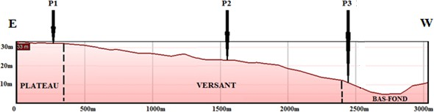

Figure 2: Position of soil profiles according to topography

Physicochemical analyses
The granulometric analysis, carried out using the Robinson method, combines sieving (sandy fraction) and decantation (silt, clay). The data obtained were used to establish cumulative curves, which were used to estimate the permeability coefficient and the erodibility coefficient of the soils of Nioro (Soutter et al., 2007).

Chemical analyses focused on pH, electrical conductivity (EC), exchangeable bases (Ca²⁺, Na⁺, Mg²⁺, K⁺), organic carbon (C), total nitrogen (N), iron (Fe) and aluminium (Al). The pH and EC were determined in soil-water suspension, exchangeable bases by extraction with ammonium acetate (pH
< 7) or sodium acetate (pH > 7), organic carbon using the Anne method, nitrogen by Kjeldahl, and Fe and Al by total acid attack (HF-HClO₄). Organic matter (OM) and the C/N ratio were calculated from these data.

Soil compaction index
The battance index (BI), which reflects the destruction of surface aggregates in silty soils (Boiffin, 1984; Le Bissonnais & Le Souder, 1995), was estimated according to the ratio proposed by Rémy & Marin-Laflèche (1974), allowing the sensitivity of soils to this phenomenon and, consequently, their structural stability to be assessed.
(1.5 × % fine strings) + (0.75 × % coarse silts)
𝐼𝑛𝑑𝑖𝑐𝑒𝑑𝑒 𝑏𝑎𝑡𝑡𝑎𝑛𝑐𝑒 𝐼𝐵 = - C
(% clays) + (10 × % organic matter)

IB > 2: very compact soil; IB between 1.8 and 2: compact soil; IB between 1.6 and 1.8: compact soil; IB between 1.4 and 1.6: slightly compact soil; IB < 1.4: non-compact soil; If pH < 7, C= 0; If pH> 7, C = 0.2 (pH – 7)

Soil erodibility (K)
The erodibility factor (K) of a soil expresses its sensitivity to water erosion and depends on its intrinsic properties, namely its texture, structure and permeability. It is determined experimentally for a given soil sample using the relationship established by Wishmeier, W.H., and Smith, D.D. (1978):
100K = 2.1 M^{1.14} x 10⁻⁴ (l2-am ) +3.25(bp -2) +2.5(cs -3) M = (Sf + Li) x (100-Ar)
Sf: Fine sand fraction; Li: Silt fraction; Ar: Clay fraction; am: Percentage of organic matter in the soil sample; Cs: Soil sample structure code (Table 1); bp: Soil sample permeability code (Table 2).
The soil erodibility factor (K) was estimated using the nomogram developed by Wischmeier et al. (1971) and reproduced by Soutter, Mermoud and Musy (2007). This method, based on particle size (silt, sand), organic matter content, structure and permeability of the soil, provides accurate values for K. The Anglo-Saxon unit obtained was converted to the metric system ([t·h/(MJ·mm)]) for the purposes of the analysis.

Table 1: Soil structure coding (Cs)

Nature of the structure | Structure code Cs

Highly structured or particulate | 1
Fairly structured | 2
Not very structured | 3
Unstructured | 4

Table 2: Soil permeability coding (bp)

Degrees of permeability | Permeability code (bp)
Rapid | 1
Moderate to fast | 2
Moderate | 3
Moderate to slow | 4
Slow | 5
Very slow | 6

Soil texture was determined based on the particle size distribution of the samples, while permeability and its associated classes were assessed using the triangle developed by Cook et al. (1985). The erodibility coefficient (K) and soil class were then obtained by integrating the granulometric parameters, organic matter, structure and permeability into the nomogram of Wischmeier et al. (1971). The K factor values are divided into four classes:

If: K > 0.45; Class 1, very high erodibility; If: 0.45 > K > 0.35; Class 2, high erodibility;

If: 0.35 > K > 0.25; Class 3, medium erodibility; If: K < 0.25; Class 4, low and very low erodibility.

Principal component analysis (PCA)
Transect A, chosen as a test area due to the intensity of water erosion, was sampled and sixteen physicochemical and edaphic parameters were measured, including grain size fractions, exchangeable bases, cation exchange capacity (CEC), pH, electrical conductivity, carbon, nitrogen and organic matter. Principal component analysis (PCA) was applied to identify correlations between variables and highlight the factors determining the organisation and spatial dynamics of soils.
PCA, a widely used multivariate analysis method (Chamussy et al., 1994; Béguin & Pumain, 2000), allows the synthesis of information from large data sets and reveals similarities and differences between units as well as linear relationships between variables. Statistical processing was performed using R software.

Results

Soil typology of the Baobolong watershed
The survey identified three soil types:
- Leached tropical ferruginous soils (plateaus/slopes, silty-sandy to clayey texture, colour contrasts due to leaching).
- Beige ferruginous colluvial soils (bottom of slopes, poorly drained, sometimes hydromorphic).
- Hydromorphic gley soils (waterlogged areas, permanent reducing conditions, close to water tables).

The landscape is characterised by low plains, hills, plateaus and lateritic crusts. (Bertrand, 1971).

Physical analyses
    - Grain size
The texture of the plateau soils is mainly silty-sandy. The soils on the slopes have a variable texture: silty-sandy and silty-sandy-clayey. The soils in the lowlands are mainly silty-clayey-sandy and sandy- clayey.

Chemical analyses
Soils vary chemically depending on the topography. The pH ranges from slightly acidic (≈5) to basic (≈8), with a slight decrease in the intermediate horizons before rising again at depth. Electrical conductivity is generally low (<500 µS/cm), except in the shallows, where it reaches 2175 µS/cm. Organic matter is low to moderate (0.3–3.4%), and total nitrogen remains low (0.01–0.18%), resulting in C/N ratios between 6 and 19 depending on topographical position. Assimilable phosphorus is generally low (0.1–13.6 ppm), with higher levels in soils on the slope. Iron (0.3–5.7%) is generally more abundant than aluminium (0.1–1.7%), increasing in depth on the plateau and slope, but decreasing in the shallows. Exchangeable bases are more concentrated at the surface (1.7–42.4 méq/100g), dominated by Ca²⁺ and Mg²⁺, while CEC is higher at depth (3.1–50.5 méq/100g). The saturation rate varies between 34 and 88%, with the highest values recorded on the plateau and slope.

Determination of the battance index
Battance mainly affects surface horizons containing less than 3% organic matter (Annabi, 2005). Analysis of the first two soil horizons of the plateau and slope (20 samples), exposed to erosion, enabled the battance index to be calculated and the risk to be assessed. The results show that 70% of the soils are highly clayey, clayey or fairly clayey, located in the centre, in the downstream parts of the catchment area and on steep slopes, while soils that are not very clayey or non-clayey, representing 30% of the area, are found at the bottom of slopes and in accumulation zones.

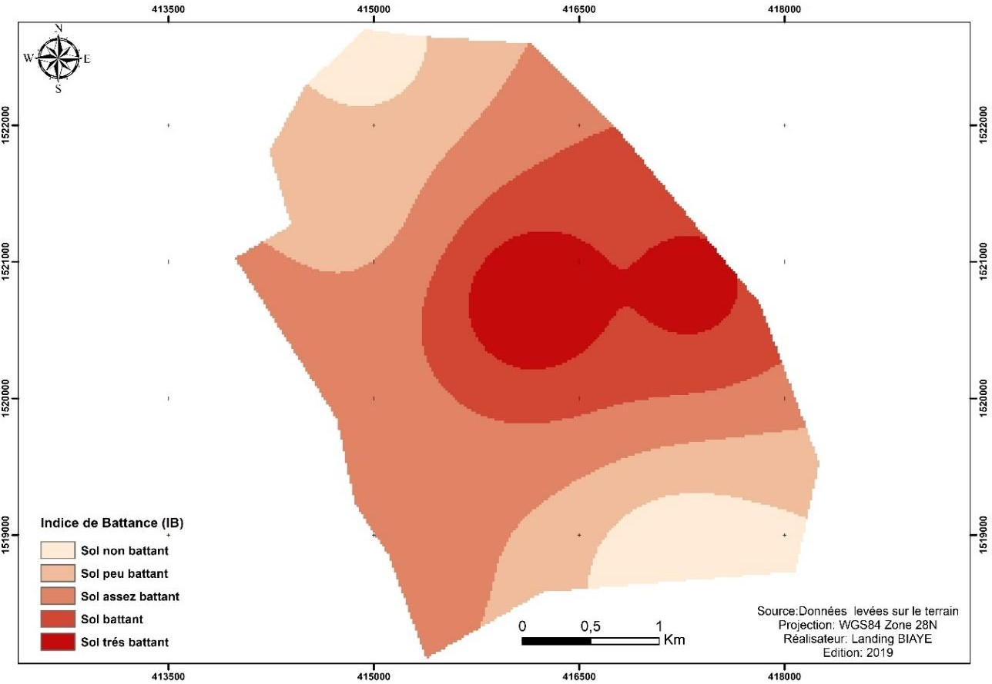
Figure 3: Map of the beating index in the watershed

Determination of the erodibility factor (K)
The nomograph method is used to obtain the values of the erodibility factor and soil class. Erodibility increases from downstream to upstream in the watershed, with maximum indices on steep slopes with low vegetation cover (Figure 4). The lowest values occur on terraces and in low-lying areas. The K coefficient varies between 0.05399 and 0.08429 t.ha.h/ha.MJ.mm. The results reveal two classes of erodibility: the majority of soils (80%) are thick loamy soils with very high erodibility, while a minority (20%) are stony loamy soils with high erodibility (Bollinne & Rosseau, 1978).

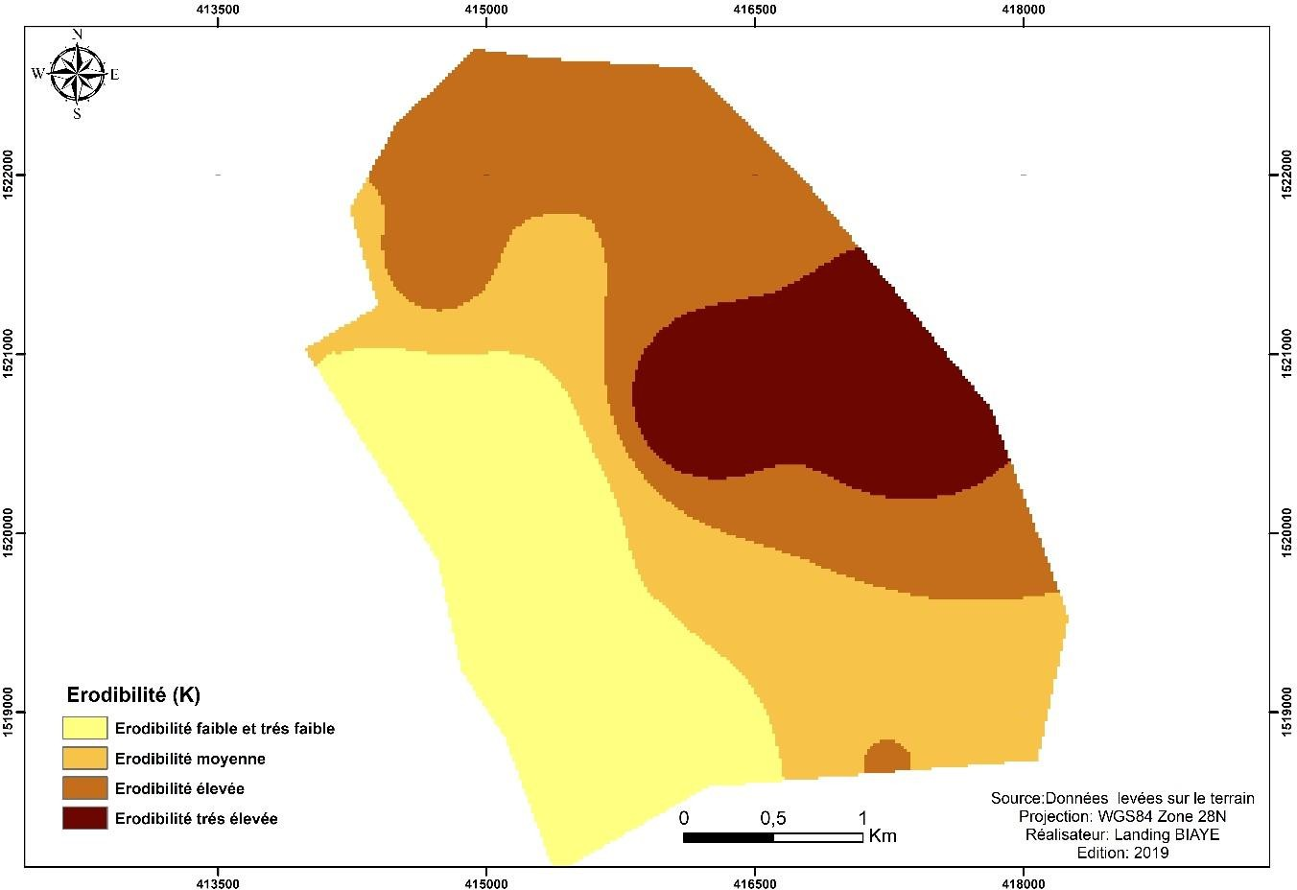
Figure 4: Soil erodibility map of the catchment area

Results of the principal component analysis
The PCA (Table 3) highlights four main factors explaining 71.8% of the variance:
- F1 (46.7%): related to variables C, N, OM, Ca²⁺, K⁺, T, S and V, reflecting mineral fertility and organic matter decomposition (low Mg² input⁺ due to excess Ca and K).
- F2 (25.1%): linked to particle size (clay, silt, sand), associated with structural deterioration of the soil.
- F3 (9.4%): associated with Mg²⁺, Na⁺, water pH and acid pH, reflecting acidification and sodium accumulation.
- F4 (7.2%): linked to electrical conductivity (EC), interpreted as a factor in salinisation. The factorial projection (F1–F2) distinguishes between:
- Lowland and terrace soils, characterised by a high degree of saturation and high acidity (pH and EC).
- Certain plateau and slope soils grouped by their texture, pH, OM and exchangeable bases.
- An individualisation of plateau soils on the F1 axis, linked to their OM, K, N and C contents.
Table 3: Contributions of factors

 | F1 | F2 | F3 | F4 | F5 | F6 | F7 | F8 | F9 | F10 | F11
Eigenvalue | 5.407 | 3.622 | 1,353 | 1,067 | 0.933 | 0.372 | 0.102 | 0.091 | 0.047 | 0.005 | 0.001
Variability (%) | 46.7 | 25.1 | 9.409 | 7.205 | 5.177 | 4.860 | 0.782 | 0.502 | 0.159 | 0.041 | 0.065
Cumulative % | 46.7 | 71.8 | 81.209 | 88.414 | 93.591 | 98.451 | 99.233 | 99.735 | 99.894 | 99.935 | 100,000

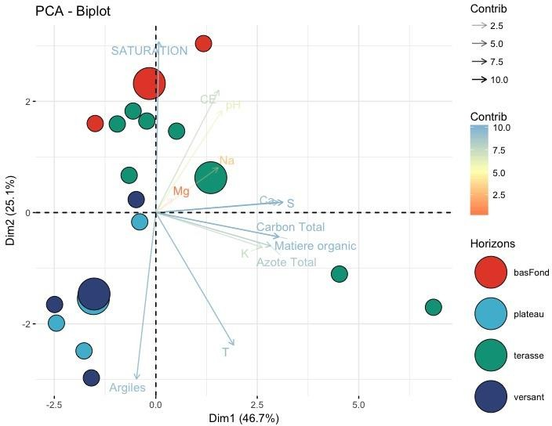

Figure 5: Clouds of variables and individuals in the l-2 factorial plan (overall treatment)
Table 4: Contributions of variables

 | F1 | F2 | F3 | F4
Clays | 1,493 | 19,510 | 5,583 | 2,020
Silt | 3,776 | 16,308 | 5,770 | 1,153
Sand | 0.336 | 22,059 | 6,601 | 0.908
Ca²+ | 15.888 | 0.644 | 0.116 | 4.571
Mg²+ | 0.304 | 2.050 | 20.312 | 4.573
K+ | 11,312 | 1,997 | 1,490 | 8,393
Na⁺ | 4,211 | 0.943 | 16,047 | 2,475
pH  Water | 7.201 | 8.228 | 18.710 | 4.212
pH KCl | 7.233 | 8.854 | 16.434 | 4.485
EC | 6,070 | 10,825 | 0.217 | 48,213
C | 14,638 | 2,525 | 3.832 | 3,102
N | 12,899 | 3,531 | 1,056 | 2,792
MO | 14,638 | 2,525 | 3,832 | 3,102
S | 13,242 | 4,485 | 3,340 | 2,136
T | 14,234 | 0.342 | 0.121 | 5.64
V | 17.390 | 0.482 | 5.384 | 0.663

Discussion

Physicochemical analyses reveal a high C/N ratio (>10), indicating an excess of carbon and poor decomposition of organic matter, which can lead to oxygen deficiency (Bonneau, 1995). The soils of the plateau (0.3–3.4%) and the slope (0.4–3.4%) have low organic matter content, reducing their structural stability and biological activity (Le Bissonnais, 2000), as a result of land clearing and erosion (Dabin, 1981; Pieri, 1989). In contrast, the surface horizons of the lowlands are richer due to hydromorphism, but this promotes acidity and a decrease in CEC (Lavigne et al., 1996).
CEC and saturation (V) indicate that the soils are oligo-, meso- or sub-saturated (Baize, 2000), reflecting marked acidity and low fertility. Tropical ferruginous soils generally have low levels of available phosphorus (Laurent & Brossard, 1991; Duchaufour, 1997). When the pH falls below 5, aluminium and ferruginous toxicity severely limits agricultural yields (Boyer, 1976; Quang et al., 1996).
Structural instability (battance index) makes soils susceptible to water erosion: surface crusting, runoff and soil loss (Annabi, 2005; Boiffin, 1984; Leguédois, 2003). The impacts are both biological and chemical (hypoxia, slower germination: Rathore et al., 1982; Richard, 1988) and physical (impeded seedling emergence: Souty & Guerif, 1988). Sheet erosion affects the plateau (Roose, 1989; Dautrebande et al., 2006), gully erosion affects the slopes (Poesen et al., 1996; 2003), and waterlogging weakens the lowlands (Jabiol et al., 1999).
Loamy soils are the most vulnerable to rutting and erosion (Roose et al., 1990), exacerbated by low organic matter content (Monnier & Stengel, 1982; Guerif, 1982; Boiffin & Fleury, 1974) and free oxides (Roose, 1994).
ACP has shown that the decomposition of organic matter is the dominant process, followed by structural deterioration, then acidification and latent salinisation (Bertrand, 1971, 1972; AGETIP, 1996; AFD, 2006). These results confirm the work of D'Hoore (1964), Maignien (1965) and Brouwers (1987).
Finally, the soils of Nioro present major constraints: acidity, structural fragility, low chemical fertility (CEC, S, MO), erosion and flooding of lowlands (BPS, 1998). Improvement is still possible through the addition of organic matter (compost, manure).

Conclusion
The soils in the study area have low structural stability, combined with low organic matter content, a loamy texture and low exchangeable base content. Erodibility (K) is mainly classified in categories 1 (K > 0.45, very high) and 2 (0.35 < K < 0.45, high), reflecting high sensitivity to water erosion.
The variability of soil profiles in terms of depth and physico-chemical properties is influenced by the topography, which determines water and erosion dynamics. The soils derive from a uniform parent material, clayey sandstone (BPS, 1998).
- Plateau and slopes: leached tropical ferruginous soils, poor in nutrients and highly susceptible to erosion, with ferric horizons with hard concretions or nodules limiting agricultural productivity (FAO, 1998).

- Lowlands: hydromorphic gley soils, highly acidified and sometimes sulphated with jarosite, unsuitable for cultivation but usable as rangeland or for rice cultivation with appropriate water and salinity management (Charreau et al., 1966).

Disclaimer (Artificial intelligence)

Option 1:

Author(s) hereby declare that NO generative AI technologies such as Large Language Models (ChatGPT, COPILOT, etc.) and text-to-image generators have been used during the writing or editing of this manuscript.

Option 2:

Author(s) hereby declare that generative AI technologies such as Large Language Models, etc. have been used during the writing or editing of manuscripts. This explanation will include the name, version, model, and source of the generative AI technology and as well as all input prompts provided to the generative AI technology

Details of the AI usage are given below:
1.
2.
3.

References
AFD. (2006). Water erosion and soil degradation. French Development Agency.
Annabi, M. (2005). Characterisation of the structural stability of Tunisian agricultural soils: relationships with physico-chemical and biological properties (Doctoral thesis). National Agronomic Institute of Tunisia.
Arrivets, J. (1976). The clay-humic complex and soil fertility. Paris: Masson.
Baize, D. (2000). Guide to common analyses in pedology (2nd ed.). Paris: INRA Éditions. Bationo, A., et al. (2023). Sustainable management of West African soils. Springer.
Bertrand, R. (1971). Leached tropical ferruginous soils. ORSTOM.
Bertrand, R. (1972). Soil and cartographic study in the Sudano-Sahelian zone. ORSTOM. Boiffin, J. (1984). The formation of rinds on loamy soils. Paris: INRA.
Boiffin, J., & Fleury, A. (1974). Structural stability of soils and organic matter. Paris: INRA. Bonneau, M. (1995). The fertility of forest soils. Paris: ENGREF.
Bollinne, A., & Rosseau, A. (1978). The erodibility of loamy soils. Gembloux: Faculty of Agricultu ral Sciences.

Boyer, J. (1976). Soil acidity and aluminium toxicity. Paris: ORSTOM.
BPS. (1998). Soil study and agricultural potential of the Baobolong basin. Planning and Monitoring Office.
Chamussy, H., et al. (1994). Introduction to principal component analysis. Paris: Masson. Charreau, C., Nicou, R., &amp; et al. (1966). Rice cultivation in West Africa. IRAT.
Cook, D. J., et al. (1985). Soil permeability evaluation triangle.
Dabin, B. (1981). Organic matter and dynamics of tropical soils. Paris: ORSTOM. Dautrebande, S., et al. (2006). Hydrology and erosion of loamy soils.
Duchaufour, P. (1997). Pedology: soil, vegetation, environment (3rd ed.). Paris: Masson. Durand, R. (1983). Soil salinity: measurement methods.
Eric Roose. (1989). Methods for measuring water erosion. ORSTOM. FAO. (1998). World Reference Base for Soil Resources. FAO. Guerif, J. (1982). Organic matter and soil aggregation. INRA.
Jabiol, B., et al. (1999). Soil and environment. Paris: Dunod.

Laurent, J., & Brossard, M. (1991). Fertility of tropical ferruginous soils. ORSTOM. Le Bissonnais, Y. (2000). Structural stability of soils. Paris: INRA.
Le Bissonnais, Y., & Le Souder, C. (1995). Measuring soil sensitivity to rutting. INRA. Leguédois, S. (2003). Soil crusting in agricultural soils.
Lavigne, F., et al. (1996). Hydromorphism and accumulation of organic matter. Maignien, R. (1965). Tropical soils. ORSTOM.
Monnier, G., & Stengel, P. (1982). Soil colloids and their agronomic role. Paris: Masson. Pieri, C. (1989). Fertility of savannah soils. Paris: CIRAD.
Poesen, J., et al. (1996). Gully erosion in soils.
Poesen, J., et al. (2003). Contribution of gully erosion to sediment production. Quang, P. N., et al. (1996). Aluminium toxicity in acidic soils.
Rémy, J., &amp; Marin-Laflèche, A. (1974). Crusting index and structural stability.

Roose, E. (1994). Introduction to the conservation management of water, biomass and soil fertility. FAO.

Roose, E., et al. (1990). Erosion and soil conservation. ORSTOM.
Soutter, M., Mermoud, A., & Musy, A. (2007). Soil physics. Lausanne: Presses polytechniques et universitaires romandes.
Wischmeier, W. H., & Smith, D. D. (1978). Predicting rainfall erosion losses. USDA Agriculture Handbook No. 537.
Babur, E., Uslu, Ö. S., Battaglia, M. L., Diatta, A., Fahad, S., Datta, R., ... & Danish, S. (2021). Studying soil erosion by evaluating changes in physico-chemical properties of soils under different land-use types. Journal of the Saudi Society of Agricultural Sciences, 20(3), 190-197.
Siyir, K. J., & Nfor, F. (2023). Unsustainable agricultural practices as a driver of soil degradation in Santa Sub-Division, North West Region of Cameroon. Asian Soil Research Journal, 7(2), 19–33.
Suryawanshi, A., Dubey, S., & Sharma, M. (2023). Evaluating soil erosion through geospatial techniques: Difficulties and prospects in the context of the Central Indian Chambal River Basin. International Journal of Environment and Climate Change, 13(11), 4518–4533.
Lamane, H., Moussadek, R., Baghdad, B., Mouhir, L., Briak, H., Laghlimi, M., & Zouahri, A. (2022). Soil water erosion assessment in Morocco through modeling and fingerprinting applications: A review. Heliyon, 8(8).
Cao, Z., Chen, G., Zhang, S., Huang, S., Wu, Y., Dong, F., ... & Jiang, F. (2023). An assessment of soil loss by water erosion in no-tillage and mulching, China. Water, 15(15), 2821.

