Obstructive Laryngeal Sarcoidosis Mimicking a Benign Cyst: Clinical, Radiologic, and Surgical Insights

Abstract
Laryngeal sarcoidosis is an uncommon manifestation of systemic sarcoidosis, accounting for less than 5% of otolaryngological cases. We report the case of a 24-year-old woman, with a history of sliding hiatal hernia and gastroesophageal reflux disease, presenting with progressive dysphonia of four months duration, later complicated by exertional dyspnea and dysphagia. Flexible laryngoscopy revealed a cystic-appearing mass arising from the right aryepiglottic fold, with normal morphology and mobility of the vocal cords. Cervical CT scan demonstrated a well-defined cystic lesion partially obstructing the laryngeal lumen, extended posteriorly to the level of the esophageal inlet, and compressed it, explaining the associated dysphagia. Complete excision of the lesion was achieved with CO₂ laser surgery. Histopathological examination showed chronic inflammatory process with non-caseating epithelioid granulomas. GeneXpert testing for Mycobacterium tuberculosis was negative. The postoperative course was uneventful, with immediate resolution of dyspnea and dysphagia, and significant improvement of dysphonia. Endoscopic follow-up at two weeks and at seven months confirmed a normal laryngeal appearance with clear vocal cord mobility. Systemic evaluation for sarcoidosis involvement in other organs was negative. This case highlights a rare cystic presentation of isolated laryngeal sarcoidosis and underlines the importance of histopathology in guiding diagnosis and management.
Keywords: Laryngeal sarcoidosis, Dysphonia, Dyspnea, Dysphagia, CO₂ laser, Granulomatous disease.

Introduction
Sarcoidosis is a chronic multisystem granulomatous disease of unknown etiology, histologically characterized by non-caseating epithelioid granulomas. Although the respiratory tract is most commonly affected, head and neck manifestations occur in about 10% of cases. Laryngeal involvement is rare, with a reported frequency of less than 5%, but it carries significant morbidity due to potential upper airway obstruction. We describe an unusual presentation of laryngeal sarcoidosis mimicking a benign cystic lesion and manifesting with a triad of dysphonia, dyspnea, and dysphagia.

Case presentation
A 24-year-old woman, with no relevant past medical history, presented with a four-month history of progressive dysphonia, subsequently complicated by exertional dyspnea and dysphagia.
- Endoscopic findings: A cystic lesion encompassing the arytenoid cartilage and the right aryepiglottic fold, covering almost the entire vocal cords, which remain mobile, and leaning backward on the posterior wall of the hypopharynx.
- Imaging: Cervical CT scan revealed a cystic lesion with heterogeneous fluid density, benign in appearance, measuring 18 mm (transverse) × 14.7 mm (anteroposterior) × 26 mm (height). The mass was located within the right supraglottic larynx, closely related to the aryepiglottic fold, partially filling the right vallecula and narrowing the laryngeal lumen. Superiorly, it extended to the level of C3 and inferiorly to the C5–C6 disc, reaching posteriorly to the esophageal inlet and causing compressive dysphagia.
- Management: Complete surgical excision of the lesion was performed endoscopically using a CO₂ laser with clean margins.
- Histopathology: Examination showed chronic inflammatory mucosa with epithelioid granulomas, without necrosis or giant cells.
- Microbiology: GeneXpert PCR assay for Mycobacterium tuberculosis was negative.
- Postoperative course: Recovery was uneventful, with immediate resolution of dyspnea and dysphagia and marked improvement of voice quality. A nasogastric tube was maintained postoperatively to support wound healing and prevent secondary infection, combined with a short course of corticosteroids to reduce laryngeal edema. Oral feeding was resumed after tube removal, and the patient was discharged on postoperative day 4.
- Follow-up: At 2 weeks endoscopic evaluation, the larynx appeared normal, with clear laryngeal margin and mobile vocal cords with slight mucosal edema, which is normal at this stage (fig2). At 7 months endoscopic evaluation, the larynx appeared normal with a pale pink mucosa that looks completely normal and clear, mobile vocal cords.
- Systemic work-up for sarcoidosis showed no evidence of extra-laryngeal disease, including chest CT scan, barium enema, esophagogastroduodenoscopy, and colonoscopy, which were normal, and angiotensin-converting enzyme (ACE) level, which was 24.48 U, thus ruling out associated pulmonary sarcoidosis.

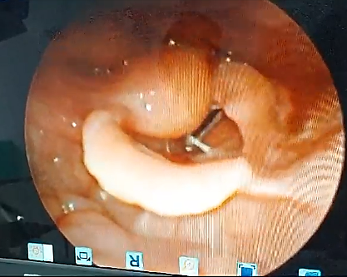
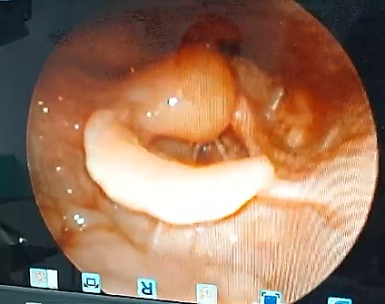
Figure 1: pre operative flexible laryngoscopic view of the laryngeal cyst

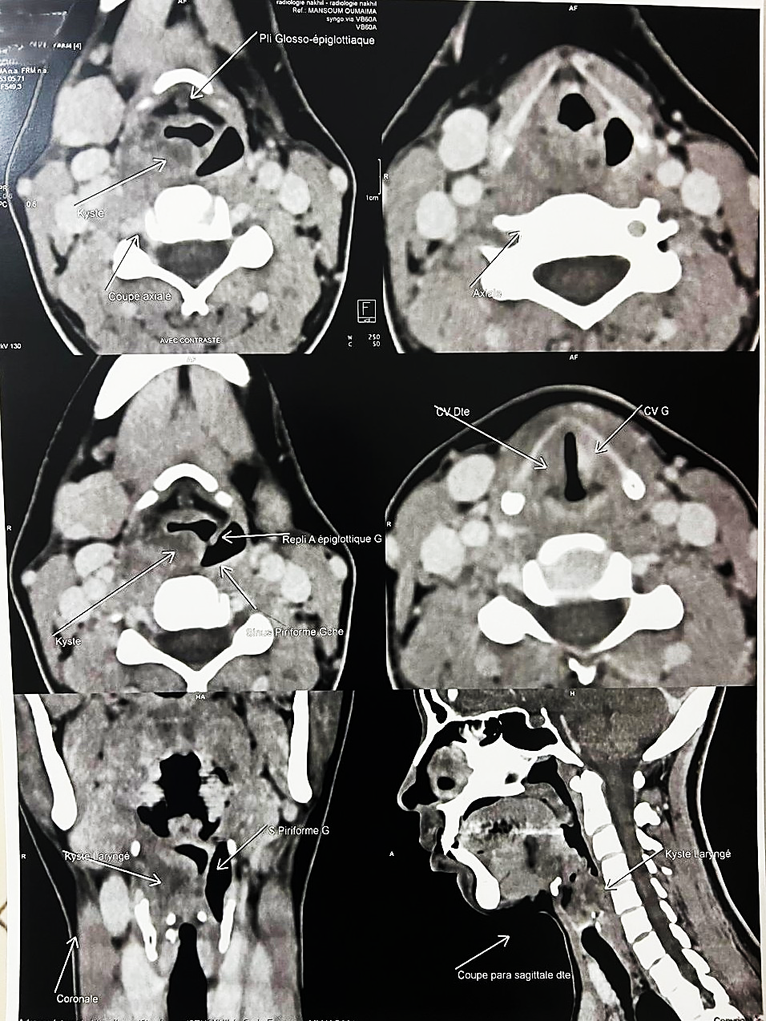
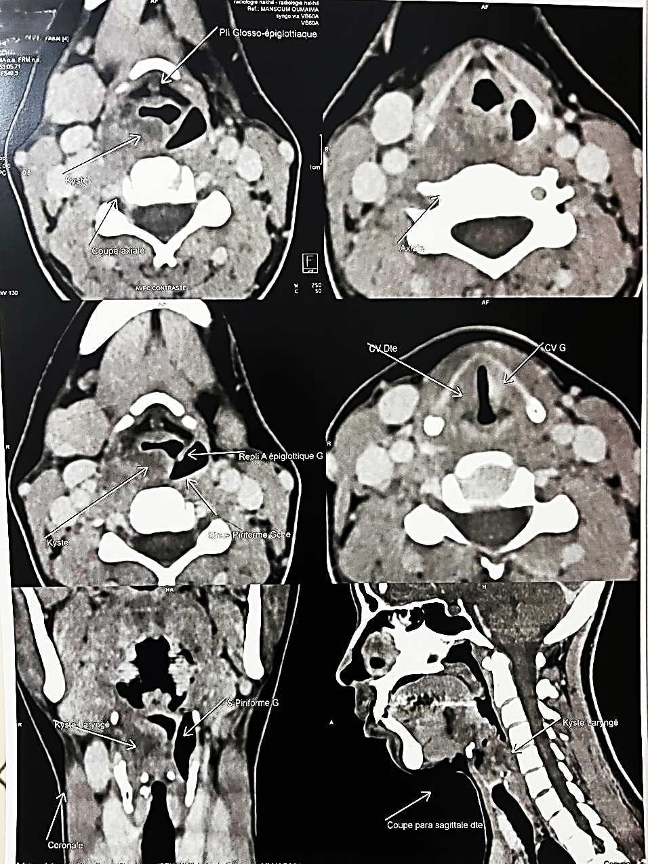
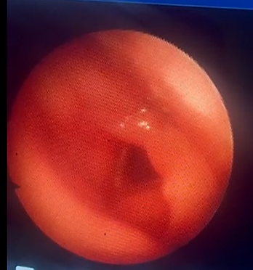
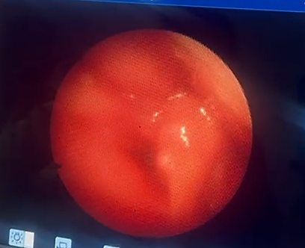
Figure 1: Right parasagittal CT scan demonstrating the vertical extension of the laryngeal cyst (approximately 26 mm in height) with posterior extension compressing the esophageal inlet.lumen.
Figure 4: Coronal CT scan showing the right laryngeal cyst occupying the aryepiglottic fold and partially obstructing the ipsilateral piriform sinus.
Figure 2: 2 weeks post operative flexible laryngoscopic view of the laryngeal vestibule, showing normal and mobile vocal cords with slight edema of the laryngeal mucosa.
Figure 3: Axial CT scan at the level of the supraglottic larynx showing a well-defined cystic lesion of fluid density occupying the right aryepiglottic fold, partially narrowing the laryngeal lumen.
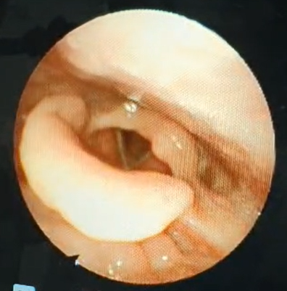
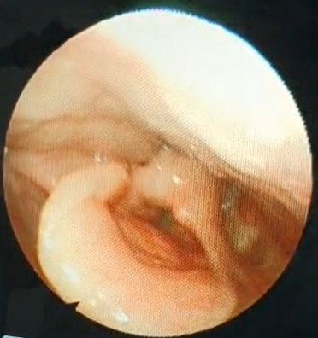
Figure 4: 7 months post operative flexible laryngoscopic view of the laryngeal vestibule, showing normal and mobile vocal cords.

Discussion
Sarcoidosis is a chronic multisystemic granulomatous disease with unknown etiology that commonly affects the lungs, eyes, and lymph nodes 2]. Furthermore, the disease commonly presents in middle-age at the third to the fourth decade of life with a female predominance [3,4]
Laryngeal involvement with sarcoidosis may occur in patients already manifesting disease in other organs, or it may be the first or the only manifestation of the disease which is very uncommon 1]
The clinical features vary from no symptoms to severe symptoms, Patients usually present with dysphagia, dyspnea, pharyngeal globus, dysphonia, and chronic cough. In severe or complicated cases due to delayed diagnosis, patients can present with a life-threatening condition in which the upper airway becomes completely obstructed, and tracheostomy may be needed [5], which fortunately wasn’t the case in our patient who did not have complete obstruction of the upper airway.
Flexible fiberoptic laryngoscopy provides good visualization of the upper airway and the endolarynx and often shows nodular thickening or a “turbanlike” appearance of the epiglottis, arytenoids and aryepiglottic folds, a classic pattern of supraglottic involvement 3]. Involvement of the glottic and subglottic areas is less common, and vocal cord mobility could be affected in approximately 24% of cases either due to sarcoid infiltration of the larynx or direct neural involvement of the disease or by the compressive effect of lymphadenopathy 6]
The differential diagnosis includes malignancy, granulomatous infections, granulomatosis with polyangiitis, Churg-Strauss syndrome, and relapsing polychondritis [7]
The diagnosis of sarcoidosis is made after excluding other differentials by laboratory and histological examination in conjunction with endoscopic findings and histopathological confirmation of noncaseating granulomatous inflammation 8]
The evolution of upper airway sarcoidosis is often gradual, with relapses and remissions occurring less frequently than in other forms of sarcoidosis. 9] , Despite the obvious symptoms associated with this involvement, diagnosis is often delayed because the symptoms are attributed to other disorders, particularly in patients without an established diagnosis of sarcoidosis. 1], This can delay treatment and allow upper airway obstruction to develop and progress to a late stage, possibly requiring a surgical airway 10]
A posteroanterior and lateral chest X-ray should be performed in all patients with potential sarcoidosis. However, there is no specific diagnostic test for sarcoidosis, and any positive laboratory test or abnormal chest X-ray consistent with sarcoidosis must be confirmed by clinical information, biopsies with typical histology, and negative fungal and bacterial stains and cultures, as well as by the exclusion of other diagnoses. Direct laryngoscopy with biopsy under general anesthesia should be performed to establish the diagnosis of laryngeal sarcoidosis and rule out malignancy or other causes of upper airway disease. If the biopsy reveals noncaseating granulomas, it is essential to rule out other granulomatous diseases. [10,19] In the case presented above, all laboratory tests were normal.
Corticosteroids have an important role in the management of patients with sarcoidosis.11] they are the first-line therapy, and prednisone (40–60 mg/day in adults) is the most favorable medication for a total period of 6–12 months 12]. Inhaled corticosteroids can be used either as sole therapy or in combination with lower doses of conventional systemic immunosuppressive drugs. In addition, inhaled corticosteroids could be considered for maintenance therapy after initial treatment with oral corticosteroids or local injection of corticosteroids in patients with laryngeal sarcoidosis. [13]
Cytotoxic drugs such as methotrexate, cyclosporine, hydroxychloroquine, and azathioprine are an option in patients with refractory symptoms or in whom prolonged use of steroids is contraindicated. [2,12]
Alternative systemic options that have proven effective in treating laryngeal sarcoidosis include biologic agents targeting tumor necrosis factor.2,4,14], Studies conducted on TNF-a inhibitors indicate that these drugs provide significant benefits to some patients with sarcoidosis, but not all, including patients with extrapulmonary sarcoidosis.
Local Corticosteroid injection can be used for managing laryngeal sarcoidosis[15]. it improves symptoms quickly with minimal morbidity and reduce the need for systemic corticosteroid treatment in most patients.[16]
For well-circumscribed lesions, surgical excision using cold instruments, CO2 lasers, or micro-debriders has been reported to have good results in most cases and at times can avoid the need for an emergent surgical airway 1,17], in our case the patient was relieved immediately after the surgical excision of the lesion.
Frequent follow-up with serial flexible laryngoscopy to evaluate for stability or progression of the disease is important.

Conclusion
Laryngeal sarcoidosis is an uncommon but potentially serious manifestation of sarcoidosis, with risk of airway and digestive tract compromise. This case illustrates a rare cystic form causing upper airway obstruction and esophageal compression. Histological analysis is essential for diagnosis, while CO₂ laser excision represents an effective therapeutic option in obstructive presentations. Long-term follow-up is necessary to monitor for systemic involvement or recurrence.
Consent
Written informed consent was obtained from the patient for publication of this case report and any accompanying images.
Ethical Approval:
As per international standards or university standards written ethical approval has been collected and preserved by the author(s).
Authors’ Contributions
- Oumaima Mansoum: Drafted the manuscript, collected clinical data, and contributed to patient follow-up.
- M. Zalagh, J. Oubenjah: Assisted in surgical management and critically reviewed the manuscript.
- B. Hemmaoui, S. Ouraini, A. Rouihi, M. Sahli, F. Benariba, N. Errami: Supervised clinical care and provided final approval of the manuscript.
All authors read and approved the final version of the manuscript.

Competing interests
Authors have declared that they have no known competing financial interests OR non-financial interests OR personal relationships that could have appeared to influence the work reported in this paper.
Disclaimer (Artificial Intelligence)
Author(s) hereby declares that NO generative AI technologies such as Large Language Models (ChatGPT, COPILOT, etc.) and text-to-image generators have been used during the writing or editing of this manuscript.

References
- Bower JS, Belen JE, Weg JG, Dantzker DR. Manifestations and treatment of laryngeal sarcoidosis. Am Rev Respir Dis. 1980 Aug;122(2):325-32. doi: 10.1164/arrd.1980.122.2.325. PMID: 7416609. https://pubmed.ncbi.nlm.nih.gov/7416609/
- Kelleher KJ, Russell J, Killeen OG, Leahy TR. Treatment-recalcitrant laryngeal sarcoidosis responsive to sirolimus. BMJ Case Rep. 2020 Aug 26;13(8):e235372. doi: 10.1136/bcr-2020-235372. PMID: 32847880; PMCID: PMC7451481. https://pmc.ncbi.nlm.nih.gov/articles/PMC7451481/
- Hong SA, Bell JR. Progressive Upper Airway Obstruction and Dysphagia in a Child With Supraglottic Edema. JAMA Otolaryngol Head Neck Surg. 2020 Nov 1;146(11):1073-1074. doi: 10.1001/jamaoto.2020.2577. PMID: 32880610. https://pubmed.ncbi.nlm.nih.gov/32880610/
- Edriss H, Kelley JS, Demke J, Nugent K. Sinonasal and Laryngeal Sarcoidosis-An Uncommon Presentation and Management Challenge. Am J Med Sci. 2019 Feb;357(2):93-102. doi: 10.1016/j.amjms.2018.11.007. Epub 2018 Nov 22. PMID: 30665498. https://pubmed.ncbi.nlm.nih.gov/30665498/
- Ahmadi A, Dehghani Firouzabadi F, Dehghani Firouzabadi M, Roomiani M. Isolated laryngeal sarcoidosis. Respirol Case Rep. 2019 Nov 17;8(1):e00502. doi: 10.1002/rcr2.502. PMID: 31832198; PMCID: PMC6859255. https://pmc.ncbi.nlm.nih.gov/articles/PMC6859255/
- Hintze JM, Gnagi SH, Lott DG. Sarcoidosis Presenting as Bilateral Vocal Fold Immobility. J Voice. 2018 May;32(3):359-362. doi: 10.1016/j.jvoice.2017.05.017. Epub 2017 Jul 3. PMID: 28684250. https://pubmed.ncbi.nlm.nih.gov/28684250/
- Helliwell, T.R. Non-infectious Inflammatory Lesions of the Sinonasal Tract. Head and Neck Pathol 10, 32–39 (2016). https://doi.org/10.1007/s12105-016-0689-6
- Leedman SR, Hendriks T, Leahy TW, Hall D. Supraglottic laryngeal sarcoidosis masquerading as supraglottitis. BMJ Case Rep. 2020 Jan 13;13(1):e232369. doi: 10.1136/bcr-2019-232369. PMID: 31937627; PMCID: PMC7021116. https://pubmed.ncbi.nlm.nih.gov/31937627/
- Neel HB, McDonald TJ. Laryngeal Sarcoidosis: Report of 13 Patients. Annals of Otology, Rhinology & Laryngology. 1982;91(4):359-362. doi:10.1177/000348948209100406
- Edriss H, Kelley JS, Demke J, Nugent K. Sinonasal and Laryngeal Sarcoidosis-An Uncommon Presentation and Management Challenge. Am J Med Sci. 2019 Feb;357(2):93-102. doi: 10.1016/j.amjms.2018.11.007. Epub 2018 Nov 22. PMID: 30665498. https://pubmed.ncbi.nlm.nih.gov/30665498/
- Brito-Zerón, P., Pérez-Alvarez, R., Pallarés, L., Retamozo, S., Baughman, R. P., & Ramos-Casals, M. (2016). Sarcoidosis: an update on current pharmacotherapy options and future directions. Expert Opinion on Pharmacotherapy, 17(18), 2431–2448. https://doi.org/10.1080/14656566.2016.1258061
- de Moraes, B. T., Neves, L. R., do Brasil, O. D. O. C., de Sá Pedroso, J. E., & de Melo Junior, J. E. S. (2011). Laryngeal sarcoidosis: literature review. Arquivos Internacionais de Otorrinolaringologia, 15(03), 359-364. https://www.thieme-connect.com/products/ejournals/html/10.1590/S1809-48722011000300015
- Pietinalho A, Tukiainen P, Haahtela T, et al. Oral prednisolone followed by inhaled budesonide in newly diagnosed pulmonary sarcoidosis: a double-blind, placebo-controlled multicenter study. Finish pulmonary sarcoidosis study group. Chest. 1999;116:424–431. https://doi.org/10.1378/chest.116.2.424
- Barba T, Marquet A, Bouvry D, Cohen-Aubart F, Ruivard M, Debarbieux S, Khouatra C, Vighetto A, de Parisot A, Valeyre D, Sève P. Efficacy and safety of infliximab therapy in refractory upper respiratory tract sarcoidosis: experience from the STAT registry. Sarcoidosis Vasc Diffuse Lung Dis. 2017;34(4):343-351. doi: 10.36141/svdld.v34i4.5817. Epub 2017 Apr 28. PMID: 32476867; PMCID: PMC7170073. https://pubmed.ncbi.nlm.nih.gov/32476867/

- Krespi YP, Husain S, Mitrani M, Meltzer CJ. Treatment of Laryngeal Sarcoidosis with Intralesional Steroid Injection. Annals of Otology, Rhinology & Laryngology. 1987;96(6):713-715. doi:10.1177/000348948709600622
- Butler CR, Nouraei SAR, Mace AD, Khalil S, Sandhu SK, Sandhu GS. Endoscopic Airway Management of Laryngeal Sarcoidosis. Arch Otolaryngol Head Neck Surg. 2010;136(3):251–255. doi:10.1001/archoto.2010.16
- Dean CM, Sataloff RT, Hawkshaw MJ, et al. Laryngeal sarcoidosis. J Voice. 2002;16:283–288. https://doi.org/10.1016/S0892-1997(02)00099-1
- Edriss, H., Kelley, J. S., Demke, J., & Nugent, K. (2019). Sinonasal and laryngeal sarcoidosis—an uncommon presentation and management challenge. The American Journal of the Medical Sciences, 357(2), 93-102.

