Hepatic cystadenocarcinoma: a case report and literature review

Abstract
Hepatic cystadenocarcinoma is a rare malignant cystic tumor of the liver, characterized by diagnostic and therapeutic challenges and an unpredictable prognosis. This clinical entity deserves attention due to its rarity and the nonspecific nature of its clinical presentation. Imaging has helped overcome this issue in approximately 80% of cases.
Through the case we report and in light of the available literature, we aimed, on one hand, to highlight the diagnostic difficulties of hepatic cystadenocarcinoma due to its clinical latency in most cases reported in the literature and its lack of specificity, especially considering that cystic liver lesions are predominantly hydatid cysts. On the other hand, we emphasize the importance of radical surgical treatment to prevent the risk of distant metastases and recurrence.
Key words: Hepatic cystadenocarcinoma, tumor, therapeutic
Introduction
Cystic tumors of the liver are uncommon, and malignant cystadenocarcinomas account for only a small fraction of all hepatic cysts (well under 5%) with a more favorable prognosis than other malignant liver tumors [1,2,3]. They may arise de novo or, more commonly, from the malignant transformation of a preexisting biliary cystadenoma (a mucinous cystic neoplasm) [2,4,3,5]. Some cases have been reported in patients with congenital biliary anomalies (such as choledochal cysts) or congenital hepatic fibrosis, but most occur sporadically. These tumors typically present in middle-aged or older adults (the average age is in the 50s) and can affect both sexes [3,6]. The growth is usually indolent, requiring many years to become clinically evident.
Clinically, patients often have vague symptoms – most commonly dull right upper quadrant discomfort or a palpable mass [1,7,6]. Jaundice is uncommon unless the tumor invades the bile ducts. Laboratory tests are generally non-specific: liver enzymes are often normal or only mildly elevated, and tumor markers (CEA, AFP, CA19-9) are usually within normal limits [3,5]. Because there are no distinguishing clinical or serologic features, imaging studies play a critical role [8]. Ultrasound, CT and MRI typically show a unilocular or multilocular cystic liver mass with thickened, irregular walls, internal septations, mural nodules or papillary projections [5,9]. However, no imaging finding is absolutely specific, so definitive diagnosis usually requires histopathological examination after surgical resection[5].
Given how rare cystadenocarcinoma is and how similar it appears to other cystic liver lesions (especially hydatid cysts in endemic areas), a thorough review of the literature is warranted to clarify its features and optimal management.

Case presentation
The patient is a 67-year-old woman, married with seven children, unemployed, with a history of two hepatic surgeries in 2013 and 2015 for a cyst initially presumed to be hydatid but with negative serology, treated by resection of the prominent dome. In 2018, she presented with a recurrent cystic lesion for which a left hepatectomy was performed; histopathological examination concluded a biliary cystadenoma with high-grade dysplasia containing two foci of invasive adenocarcinoma.
In February 2019, the patient consulted for severe right upper quadrant pain. Physical examination was unremarkable, and biological and tumor marker assessments were normal. Imaging (CT and MRI) revealed two cystic masses in the left lobe, measuring 7 cm and 4 cm, with thickened, irregular walls showing enhancement and diffusion restriction, suggestive of tumor recurrence. A diagnosis of recurrent cystadenocarcinoma was established.
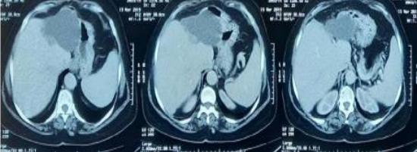
Figure 1: Axial non-contrast abdominal CT images showing two cystic masses located in the left hepatic lobe; they exhibit soft-tissue density, homogeneous content, and well-defined walls, without septations or mural nodules, suggestive of tumor recurrence.
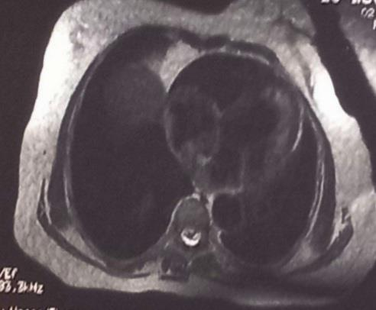
Figure 2: Axial T2-weighted hepatic MRI showing a 7 cm cystic lesion contiguous with another 4 cm lesion, the latter exhibiting a thick, irregularly enhancing wall with diffusion restriction, consistent with tumor recurrence.
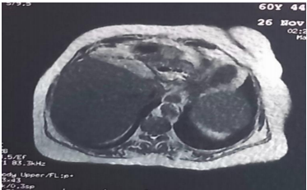
Figure 3: Axial hepatic MRI after gadolinium injection showing part of one of the two cystic liver lesions: a fluid-signal mass, heterogeneous, without internal mural nodules; adjacent to the liver, located at the hepatic dome, with peripheral enhancement..

Surgical exploration revealed a cystic mass adherent to the stomach, necessitating resection of the gastric serosa, along with completion of the left hepatectomy to remove the lesions en bloc. Histopathological examination confirmed invasive mucinous hepatic cystadenocarcinoma.
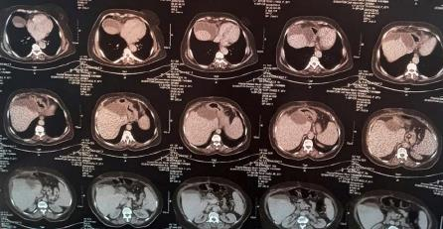
Six months later, the patient presented with a new recurrence and deterioration of general condition. Chemotherapy with Gemox (Gemcitabine + Oxaliplatin) was initiated; however, the course was complicated by severe hepatic cytolysis, cholestasis, and markedly elevated tumor markers (CA 19-9 at 12,000 IU/ml). Morphological assessment (CT, MRI, 18-FDG PET) revealed a locally advanced recurrence with hepato-gastric involvement, duodenal invasion, and pulmonary metastatic dissemination. The disease course resulted in the patient’s death four months after the initiation of chemotherapy.

Figure 4: Axial non-contrast abdominopelvic CT showing a bilobed cystic mass with homogeneous content and a thickened wall containing calcifications; without mural nodules or septations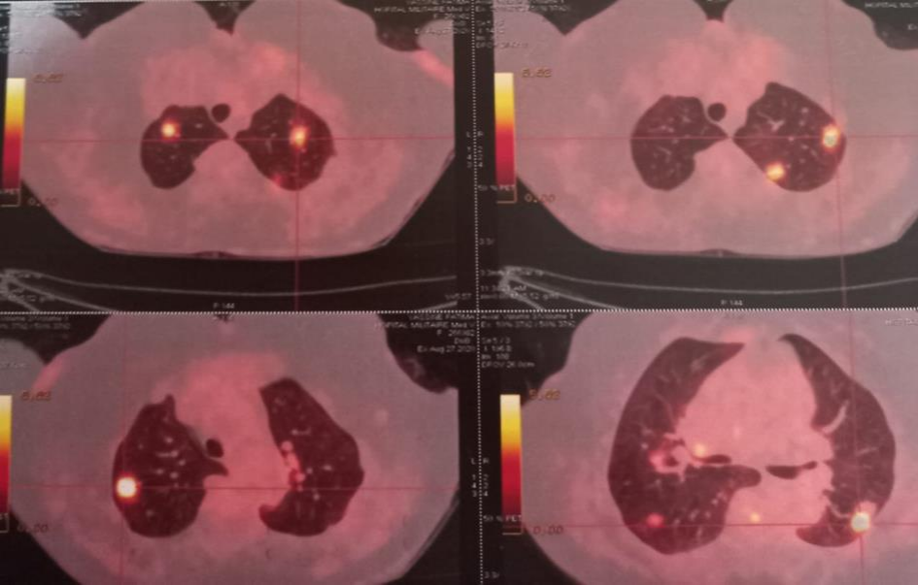
Figure 5: Axial 18-FDG PET images of the thorax showing multiple pathologically hypermetabolic pulmonary parenchymal foci, ranging from 5 mm to 24 mm, with heterogeneous uptake, involving both lungs.

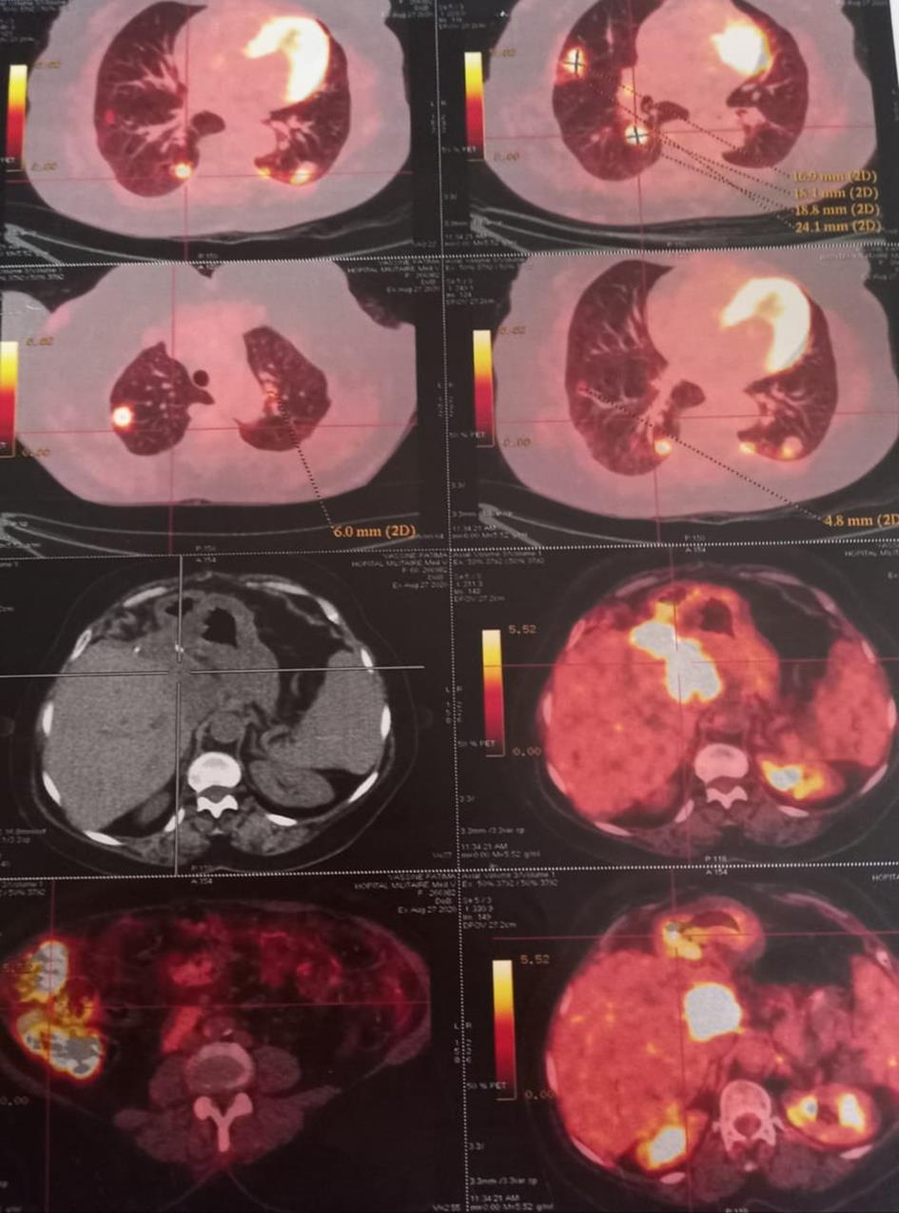
Figure 6: Axial 18-FDG PET images of the thoraco-abdomino-pelvic region showing multiple pathologically hypermetabolic pulmonary parenchymal foci, ranging from 5 mm to 24 mm with heterogeneous uptake, involving both lungs, and intense pathological hepatic hypermetabolism (SUVmax = 17.7) overlying the surgical clips; extending as a contiguous area in the hepato-gastric region (84 × 44 mm in transverse axes), at the hepatic hilum and involving the posterior duodenal wall (D1-D2); highly suspicious (compared to hepatic background uptake SUVmax = 3.7) and with diffuse pathological right colonic hypermetabolism (SUVmax = 12.9).

Top of Form
Discussion
Hepatic cystadenocarcinoma is a rare malignant cystic tumor, with only about fifty cases reported. Its prevalence is very low, and it most often results from the malignant transformation of a hepatobiliary cystadenoma, although it may also arise in association with congenital biliary tract anomalies or in the absence of preexisting pathology [10]. Our patient, who had no congenital anomaly but a history of cystadenoma, illustrates the likelihood of malignant transformation.
This tumor typically affects adults over 60 years of age, with no sex predilection, reflecting the long latency required for malignant degeneration. The clinical presentation is nonspecific, most commonly right upper quadrant pain and sometimes a palpable mass. Jaundice is rare, and laboratory findings are often normal, with tumor markers (CEA, AFP, CA 19-9) usually within normal limits.
Because of this non-specificity, imaging studies are critical for raising suspicion. On ultrasound, cystadenocarcinomas may appear as complex cystic lesions with internal septations and occasional mural nodules. On CT and MRI, the typical features include a multilocular cystic mass with thickened enhancing walls, enhancing septa, internal papillary projections or calcifications [5,9]. In one review of 112 cases, CT/MRI consistently showed a multilocular cyst with septa and/or mural nodules; coarse calcifications within the cyst wall or septa were also described [6]. These imaging characteristics – especially new wall nodularity or irregular septa – help distinguish cystadenocarcinoma from a simple cyst. MRI is preferred for preoperative evaluation because it better delineates the biliary anatomy and the cyst contents[5]. However, even with advanced imaging, definitive diagnosis often requires histology.
The differential diagnosis is broad and includes any complex cystic liver lesion. Important considerations are:
- Hydatid liver cyst – especially in endemic regions, hydatid disease is far more common. It can mimic cystadenoma/carcinoma but usually has daughter cysts or calcified walls [3,7]. In our case, multiple surgeries had presumed hydatid disease.
- Biliary cystadenoma – the benign counterpart of these tumors. Imaging of cystadenoma and cystadenocarcinoma can overlap. Unlike carcinoma, cystadenomas lack invasive nodules but may still have septa[3].
- Complex hepatic cysts – such as hemorrhagic (bleeding) cysts, infected cysts or abscesses, or post-traumatic cysts. These may show internal debris or thick walls.
- Cystic metastases or tumors – metastases (e.g. from ovarian or pancreatic cancer) or primary cystic tumors (like cystic sarcomas) can present as cystic masses.
- Other cystic diseases – polycystic liver disease, biliary intraductal papillary mucinous neoplasms (IPMN-B), and rarer lesions like embryonal sarcoma.
In practice, any cystic lesion with suspicious features (thick septations, enhancing mural nodules, or rapid growth) should raise concern[11,12,13].
Percutaneous cytological aspiration is rarely performed because of the risk of peritoneal dissemination. Definitive confirmation relies on histopathological examination, which distinguishes between invasive and non-invasive forms [14,15].
The treatment of choice is complete surgical resection with adequate margins [3,6]. A formal hepatectomy (segmentectomy or lobectomy) is preferred. Incomplete excision or mere enucleation of the cyst is associated with high recurrence rates. One review found that the best outcomes – 100% 5-year survival and only 13% recurrence – were seen in patients who had complete resection of the tumor [6]. By contrast, cases with partial resection or peritoneal spillage did poorly. In our case, the patient had two prior incomplete resections (for suspected hydatid cyst), which likely contributed to recurrence. For advanced or metastatic disease, there is no standard therapy; chemotherapy regimens (often based on biliary tract or pancreatic cancer protocols, e.g. gemcitabine with platinum agents) or even radiotherapy may be attempted, but benefit is uncertain [3,6].
After curative resection, the prognosis is relatively favorable compared to other liver cancers. Recurrence rates are fairly low if excision is complete [3,6]. Long-term survival is much higher than for typical hepatocellular carcinoma or cholangiocarcinoma. Some series quote 5-year survival in the range of 70–100% after complete resection [6]. However, invasive cystadenocarcinomas (those that have penetrated the cyst wall and invaded liver or beyond) carry a worse prognosis than non-invasive ones. In general, absence of ovarian-type stroma and presence of invasive carcinoma predict more aggressive behavior.
Conclusion
Hepatic cystadenocarcinoma is a rare tumor, occurring predominantly in middle-aged women but also observed in men. Its etiology remains poorly understood, and its progression is typically slow. Clinical presentation is nonspecific, limited to abdominal pain or a palpable mass. Imaging (ultrasound, CT, MRI) plays a key role, usually showing a unilocular or multilocular cystic mass with septations or papillary structures, but the differential diagnosis remains challenging in contexts where hydatid liver cysts and biliary cystadenomas are more common.
Cytological aspiration is not recommended; definitive diagnosis relies on histopathological examination of the surgical specimen. Treatment is surgical, consisting of partial hepatectomy with safety margins, to prevent recurrence and metastatic spread. Any recurrence of a hepatic cyst after surgery should raise suspicion of cystadenocarcinoma.
Prognosis is favorable in non-invasive forms following complete resection but remains unpredictable for invasive forms.

Ethical Approval:
As per international standards or university standards written ethical approval has been collected and preserved by the author(s).
Consent
As per international standards or university standards, patient(s) written consent has been collected and preserved by the author(s).

COMPETING INTERESTS DISCLAIMER:
Authors have declared that they have no known competing financial interests OR non-financial interests OR personal relationships that could have appeared to influence the work reported in this paper.

Disclaimer (Artificial intelligence)
Author(s) hereby declare that NO generative AI technologies such as Large Language Models (ChatGPT, COPILOT, etc.) and text-to-image generators have been used during the writing or editing of this manuscript.

References
1] Del Poggio, P., & Buonocore, M. (2008). Cystic tumors of the liver: a practical approach. World Journal of Gastroenterology: WJG, 14(23), 3616.
[2] Sang, X., Sun, Y., Mao, Y., Yang, Z., Lu, X., Yang, H., ... & Huang, J. (2011). Hepatobiliary cystadenomas and cystadenocarcinomas: a report of 33 cases. Liver International, 31(9), 1337-1344.
[3] Management of Mucinous Cystic Neoplasms of the Liver, Aziz, Hassan et al. Journal of Gastrointestinal Surgery, Volume 27, Issue 9
[4] Manouras A, Markogiannakis H, Lagoudianakis E, Katergiannakis V. Cystadénome biliaire avec stroma mésenchymateux : rapport d'un cas et revue de la littérature [Biliary cystadenoma with mesenchymal stroma: Report of a case and review of the literature] . World J Gastroenterol. 2006 ; 12 : 6062-9.
[5] Alshaikhli A, Al-Hillan A. Liver Cystic Disease. [Updated 2023 Apr 24]. In: StatPearls [Internet]. Treasure Island (FL): StatPearls Publishing; 2025 Jan-.
[6] Läuffer JM, Baer HU, Maurer CA, Stoupis C, Zimmerman A, Büchler MW. Biliary cystadenocarcinoma of the liver: the need for complete resection. Eur J Cancer. 1998 Nov;34(12):1845-51. doi: 10.1016/s0959-8049(98)00166-x. PMID: 10023304.

[7] Ahmad Z, Uddin N, Memon W, Abdul-Ghafar J, Ahmed A. Intrahepatic biliary cystadenoma mimicking hydatid cyst of liver: a clinicopathologic study of six cases. J Med Case Rep. 2017 Nov 10;11(1):317. doi: 10.1186/s13256-017-1481-2. PMID: 29121977; PMCID: PMC5680786.

[8] Bassou, D., Darbi, A., Goasdoué, P., & El Kharras, A. (2007). Cystadénome biliaire intra-hépatique: apport de l’imagerie. Feuillets de radiologie, 47(6), 387-391.

[9] Ren XL, Yan RL, Yu XH, Zheng Y, Liu JE, Hou XB, Zuo SY, Fu XY, Chang H, Lu JH. Biliary cystadenocarcinoma diagnosed with real-time contrast-enhanced ultrasonography: report of a case with diagnostic features. World J Gastroenterol. 2010 Jan 7;16(1):131-5. doi: 10.3748/wjg.v16.i1.131. PMID: 20039461; PMCID: PMC2799910

[10] Hepato-biliary cystadenoma and cystadenocarcinoma : a single Center experience. Tumori, 99:261-265, 2013.86 Xin Li, Jia-Lin Zhang, Yong-Hong Wang, Shao-Wei Song, Feng-Shan Wang, Rui Shi, and Yong- Feng Liu. Department of General Surgery, the First Affiliated Hospital, China.Medical University, Shenyang. 110001, Liaoning Province, China.
[11] Radiology Key : Hepatobiliary cystadenocarcinoma; the fastest radiology engine. 16 November 2016/ Published by Admin in GASTRO-INTESTINAL IMAGE
[12] Suwan Z. Sonographic findings in hydatid disease of the liver: comparison with other imaging methods. Ann Trop Med Parasitol. 1995 Jun;89(3):261-9. doi: 10.1080/00034983.1995.11812951. PMID: 7668917.

[13] Taourel P, Marty-Ane B, Charasset S, Mattei M, Devred P, Bruel JM. Hydatid cyst of the liver: comparison of CT and MRI. J Comput Assist Tomogr. 1993 Jan-Feb;17(1):80-5. doi: 10.1097/00004728-199301000-00014. PMID: 8419444.

[14] Seo JK, Kim SH, Lee SH, Park JK, Woo SM, Jeong JB, et al. Appropriate diagnosis of biliary cystic tumors: Comparison with atypical hepatic simple cysts. Eur J Gastroenterol Hepatol. 2010 ; 22:989–96.
[15] Alobaidi M, Shirkhoda A: Malignant cystic and necrotic li ver lesions: a pattern approach to discrimination. Curr Probl Diagn.

