Original Research Article
Short-term Outcome of Laparoscopic Ventral Hernia Repair : our experience in a resource limited centre

Abstract:
Background: Ventral hernias are common problem in surgical practice. Repair of hernia by a prosthetic mesh is a well-recognized procedure. But whether the procedure is to be done by open or laparoscopic technique is still a topic of discussion. Laparoscopic intraperitoneal onlay mesh (IPOM) and IPOM Plus hernioplasty provide a novel approach to the management of ventral hernias. The purpose of the present study was to evaluate the usefulness of this procedure as routine operation for ventral hernias.
Results: There were 50 cases included in this study which was conducted in Dhaka Medical College and Hospital, Dhaka, Bangladesh from January 2022 to December 2024. Most of the patients were female (78%). Mean age of the patients was 51 ± 5 years. Majority of the patients presented with incisional hernia (26 out of 50). IPOM Plus was done in 38 patients were defect size was< 4 cm while 12 patients under IPOM. 2 patients were converted to open methods due severe adhesion. Mean duration of surgery was 113 ± 23 mins. There was no per-operative complications like bowel or vascular injury. Mean duration of hospital stay was 1.8±3 days. Major post-operative complications were seroma formation (6%), haematoma (4%) and port site infection (4%). There was no recurrence in 12 months follow up.
Conclusion: Laparoscopic intraperitoneal onlay mesh (IPOM and IPOm Plus) hernioplasty has proved to be an effective surgical procedure for ventral hernia repair.
Key words: Ventral hernia, Laparoscopic intraperitoneal onlay mesh repair,
IPOM and IPOm Plus

Introduction:
“Ventral hernia is defined as any protrusion through abdominal wall with the exception of hernia through the inguinal and femoral regions” .¹ “Ventral hernia can be classified as spontaneous (primary) or acquired (secondary) or by their site on the abdominal wall. Spontaneous hernias are classified as epigastric hernia, umbilical hernia, and paraumbilical hernia. Acquired hernias frequently arise following surgical incisions, so they are referred to as incisional hernias”.²
“A ventral hernia can be umbilical, paraumbilical, epigastric, or incisional. The healthcare system is heavily burdened by abdominal wall hernias. According to a 2019 survey, the general population has a 20.9% prevalence of abdominal wall hernias.³Ten percent of all abdominal hernias are umbilic and epigastric hernias respectively.⁴ There have been reports of incisional hernias in 1% to 5% of laparoscopic port-site incisions and 10% to 50% of laparotomy incisions”.⁴
“Patients with ventral hernias frequently experience pain, discomfort, and the feeling of a mass emerging from their belly when they cough or sneeze”.^{4 “}Usually, a comprehensive abdominal examination is sufficient to make a diagnosis. In rare instances, the bowel may incarcerate or strangulate presenting with severe abdominal pain, fever, and obstructive signs and requiring emergency surgery”.³ “Computed tomography (CT) is the most accurate diagnostic tool to evaluate the ventral hernia. CT scans show the precise location and size of the abdominal wall defect, the extent of muscle atrophy surrounding the defect site, and the connection between the intraperitoneal organs and the abdominal wall defect or hernia sac”.⁵
“In 1740, William Cheselden published the first method for repairing an umbilical hernia”.⁵ “The recurrence rate has remained between 10%-30% despite the use of either simple closure or the Mayo procedure, which was first described by William J. Mayo in 1901 and involved suturing by overlapping fascia using nonabsorbable sutures”.⁶ “A randomized clinical trial comparing mesh use with simple closure for umbilical hernia surgery found the use of mesh resulted in a considerably decreased rate of recurrence”.⁷
“The main challenges in hernia management lie in deciding the surgical approach and type of repair procedure to do: laparoscopic or open surgery; anatomical or mesh repair and type of mesh to use, and where to place the mesh to guarantee the strongest possible repair with the least probability of recurrence” .⁸ “Open hernioplasty has a recurrence rate of 12.5% -19%. Moreover, this method has several drawbacks, such as, extensive soft tissue dissection, raising of flaps, and placement of drains”.^{9 “}This leads to a complication rate of up to 20% involving the wound, exposure and infection of mesh, fistula formation and other problems”.¹⁰
“The use of laparoscope in the treatment of abdominal wall hernia repair,was first reported in 1993 by LeBlanc and Booth” .¹¹ Laparoscopic intraperitoneal onlay mesh (IPOM) and IPOM Plus hernioplasty provide a novel approach to the management of ventral hernias. The intra-peritoneal onlay mesh (IPOM) repair employs a composite mesh to bridge the defect from the peritoneal side. If the defect is minor, intracorporeal suturing is used to close the defect which is known as IPOM Plus. This may offers benefits for the patients from the use of laparoscopic surgery in which there is less operative time, shorter hospital stay, improved the patient outcome and fewer complications in comparison to open hernia repair.
The present study was conducted assess the sort-term outcome of laparoscopic ventral hernia repair by IPOM and IPOM Plus.

Materials and Methods:
The present study was a prospective study which conducted in Dhaka Medical College and Hospital, Dhaka, Bangladesh to assess the sort-term outcome of laparoscopic ventral hernia repair by IPOM and IPOM Plus. A total number of 50 patients were included in this present study by purposive sampling method. All patients with non-complicated ventral hernia was included in this study. Exclusion criteria included complicated ventral hernia, patients unfit for general anesthesia and pregnancy. All cases were done by an expert surgical team of Dhaka Medical College and Hospital. An ethical approval was taken from institutional ethical committee. All patients provided informed consent to participate in the study and for the surgical procedure.
Operative Procedure:
Location of the hernia was traced, position of the ports marked and expected location of mesh mapped, and just before the patient is mounted on operation table. IPOM and IPOM Plus were performed using three puncture technique. Pneumoperitoneum was established by placement of a Veress needle into left subcostal area in mid-clavicular line. A 10mm port was introduced in left anterior axillary line at the level of the defect, and two 5mm ports were created depending on the position of hernia. Contents were reduced by external pressure and internal traction. Adhesions were cut at avascular line using scissors and cautery. If the defect is small (< 4 cm) then the defect was closed by intracorporeal suturing (IPOM plus). Mesh was marked at center, suture ligatures were placed at corners. The center was fixed with atraumatic suture with straight needle. Then the mesh was rolled and introduced through the 10mm port. The needle was pushed out through skin puncture at the center of the defect. Suture passer puncture was done over the corners of the mesh and ligature ends were brought through the same skin puncture wound at each corner keeping intervening tissue in between separate puncture sites in inner parietal wall. The suture ends were tied, cut and the knot allowed to slip within tissue through the external puncture points. Margins of the mesh were fixed with parietal wall from inside using titanium spiral tack (Figure-1).
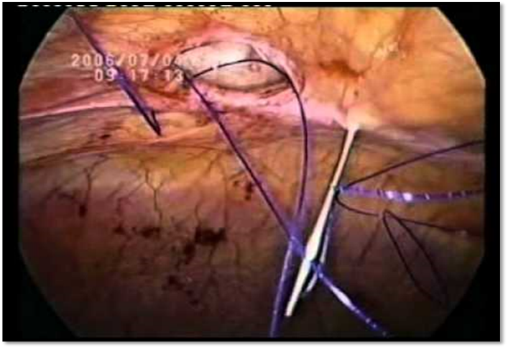
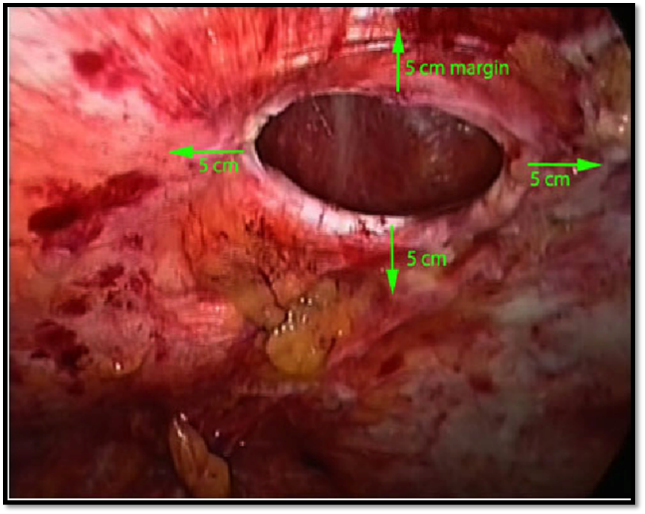
(A) (B)

(C)
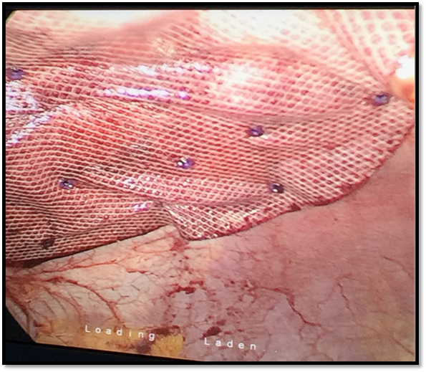

Figure -1 peroperative view of laparoscopic ventral hernia repair
(A) Ventral hernia defect (B) Suturing of defect by suture passer (C) Mesh placement
Patient’s age, sex and comorbidities were noted. Per-operative complications were documented. Operative time and duration of hospital stay were along with post-operative complications like seroma formation, port site infection, hernia recurrence were also observed. Patients were followed up for 12 months for any other complications.
Statistical analysis was done by SPSS version 26.0 Windows (SPSS Inc, Chicago, IL, USA). Qualitative data was presented as number and percent. Comparison between groups was done by Chi-Square test. Quantitative data was presented as mean ± SD and range. Student t-test was used to compare between two groups. P < 0.05 was considered to be statistically significant.

Result:
This was a prospective non-randomized study which was conducted for 24 months where 50 patients were included. Mean age of the patients were 51 ± 5 years. (Fig-2) Most of the patients were female (39 out of 50). 38 patients were obese as evidenced by BMI > 30kg/m². 26 (52%)
26 patients presented with incisional hernia. Among them 8 patients has undergone previous surgery for incisional hernia repair by open method and 2 patients had multiple surgeries. 16(32%) patients had paraumbillical hernia and 8(16%) patients had epigastric hernia. Lower abdominal defect was present in 35(70%) patients there upper abdominal defect was present in 15(30%) patients. (Table-1)

Fig-2 age distribution of the patients

Table-1 demographic characteristics of the patient

Characteristic | Number | Percentage
Sex
Male | 11 | 22%
Female | 39 | 78%
Hernia type
Incisional hernia  Para umbilical hernia  Epigastric hernia  Upper abdominal defect  Lower abdominal defect  Obesity (BMI> 30kg/m² | 26  16  8  35  15  26 | 52%  32%  16%  70%  30%  52%
All patients operated laparoscopic for inguinal hernia were ASA (American Society of Anesthesiology risk class) I and II. Comorbidities were represented by blood high pressure, chronic kidney disease and type 2 diabetes mellitus. (Fig-3)

Fig-3 co-morbidities of the patients
38(76%) patients were operated by IPOM Plus where the defect size was < 4 cm. Mean operative time was 113 ± 31 mins. There was no per-operative injuries like bowel or vascular injuries. Mean duration of hospital stay was 1.8±3 days. 2 patients were converted to open method due to huge adhesion. (Table-2)

Variable | Number
Mean duration of surgery | 113 ± 31 mins.
Total Number of IPOM Plus | 38(76%)
Total Number of IPOM | 12(245)
Converted to Open Method | 2(4%)
Bowel Injury | 0(0.00%)
Vascular Injury | 0(0.00%)
Mean duration of hospital stay | 1.8±3 days.
Table-2: peroperative variables of the patients
Seroma formation was noted in 2(4%) patients were port site infection was present in 2 (4%) patients. One patient developed Trocar haematoma. There was no mesh infection, mesh eventration and recurrence in 6 months follow up. (Table-3)

Complications | Number | Percentage
Seroma | 3 | 6%
Haematoma | 2 | 4%
Port site infection | 2 | 4%
Mesh infection | 0 | 0%
Mesh eventration | 0 | 0%
Recurrence | 0 | 0%
Table-3 post-operative complications of the patients

Discussion:
Ventral hernia is a common disease in our country which requires surgical attention. The use of mesh has been reduced the surgical failure. Before the introduction of prosthesis, recurrence rate exceeded 50% of cases.¹² Repair of hernia by a prosthetic mesh is a well-recognized, low recurrence procedure but whether the procedure is to be done by open or laparoscopic technique is still a topic of debate. Besides, reduced daily activities and high socioeconomic expenditures for procedures are linked to ventral hernias.
Infection, seroma/hematoma formation, postoperative discomfort, recurrence, and extended hospital stays can all complicate surgical treatment of ventral hernias. The repair can be performed laparoscopically or openly. A shorter hospital stay, a lower likelihood of recurrence, and fewer postoperative problems are all linked to laparoscopic repair. Because of the improved post-operative results, the laparoscopic method of ventral hernia repair, has gained widespread acceptance.¹³ In laparoscopic IPOM and IPOM Plus hernioplasty, the surgical wound is small. Hence, there is short hospital stay, lower wound complications, reduced post-operative pain and early recovery. In addition, in IPOM and IPOM Plus hernioplasty, the mesh is placed intraperitoneally. So, extensive tissue dissection is not required. The mesh overlaps the defect by at least 3-5cm margin, giving a strong support. Hence, a better post-operative outcome.¹⁴
We conducted this study to analyze the short term outcome of laparoscopic IPOM and IPOM plus in midline ventral hernia repair in terms short term complications. Our results also demonstrated a significant reduction in both seroma formation and the incidence of recurrence in the patients undergoing laparoscopic IPOM and IPOM-Plus.
More than three fourth of the patients in our study were female which coincided with other studies.¹⁵This is probably due to lax and weak anterior abdominal wall in females due to repeated child birth. In addition, history of caesarean section in females is an important predisposing factor.
The majority of patients were aged between 40 and 59 years. Similar findings were also noted in other studies conducted by Costana MJ and Bellucci I.¹⁶Most of the cases in the present study was incisional hernia (26 out of 50).Similar findings were also noted in other studies.¹⁷
Mean operative time was 113 ± 31 mins and mean hospital stay was 2±3 days. Similar findings were also noted by studies conducted by Amid PK and Graham L.¹⁷
In our study 4% of laparoscopic cases were converted to open repair due to huge adhesion. Open conversion represented as 11.1 % in Asencio (2009), 13.6% in Itani (2010) 8.5 % in Eker (2013), 2.5% and 2.7% .^{18,19,20} The indication of conversion varied, among studies, from unsafe procedure with laparoscopic adhesionlysis, obesity with inability to reduce the hernia content or due to bowel injury.
This study reported no hollow viscera or vascular injury. The result of this study matches with many studies such as Misra and Olmi (2007) and Navarra (2007).^{21,22}Other studies showed variable rates of bowel injuries like, Rogmark (2013) with 4.6% Barbaros (2007) with 4.3% for laparoscopic surgery.^{23,24}
Recurrence is 0% in our study, in comparison to other studies (3%-11%), it is much less.^{25,26}This difference is probably due to the large number of cases in different studies, and because large complex hernias were attempted for laparoscopic repair. According to a study by Sadava et al. in the case of all ventral hernias, the rate of recurrence decreased with defect closure laparoscopically, from 18% to 6% (P = 0.07) compared to open mesh repair .²⁷ Another study by Tandon A et al., demonstrated a significant decrease in the recurrence rate, from 24% to 5% (P = 0.04).²⁸
Resorption, persistence, or complications are the three natural ways that postoperative seroma might develop. BMI (obesity), prior surgery, SSI, number of prior surgeries, prior hernia repair, defect size, and overuse of cauterization were risk factors for seroma. Colavita PD et al. assessed the defect size in 315 patients who had hernias between 5 and 15 cm in size.²⁹ With a threshold of 10 cm, the defect's magnitude served as an independent predictor of recurrence. Seroma and port site infection rate was6% and 4% respectively which was also observed by Ahonen S and Erek M.³⁰ While other studies showed a higher rate of seroma and infection rate ranging between 8%-11%.^{31,32}
There are a few limitations of the study. It was single center study with a small study population and duration of follow-up was only for 12 months. Longer follow-up period would be necessary to assess the long-term outcomes of the procedures. A large scale multicenter study should be conducted to provide a better outcome to the patients.

Conclusion:
Laparoscopic intraperitoneal onlay mesh (IPOM and IPOM Plus) repair was observed to be an effective surgical procedure for ventral hernia repair. It provides much benefits with low complications and less recurrence rate in experienced hands. Hence it can be considered as primary procedure for ventral hernia repair.
CONSENT:
Patient’s informed written consent was taken to publish her case for academic purpose.
ETHICAL APPROVAL:
As per international standards or university standards written ethical approval has been collected from Institutional ethical committee and preserved by the authors.
DISCALIMER (ARTIFICIAL INTELLEGENCE):
Author(s) hereby declare that NO generative AI technologies such as Large Language Models (ChatGPT, COPILOT, etc.) and text-to-image generators have been used during the writing or editing of this manuscript.

COMPETING INTERESTS DISCLAIMER:
Authors have declared that they have no known competing financial interests OR non-financial interests OR personal relationships that could have appeared to influence the work reported in this paper.

References:
- Petro CC, O’Rourke CP, Posielski NM, Criss CN, Raigani S, Prabhu AS, Rosen MJ. Designing a ventral hernia staging system. Hernia, 2016; 20(1), 111-117.
- Zhang Y, Zhou H, Chai Y, Cao C, Jin K, and Hu Z. Laparoscopic versus open incisional and ventral hernia repair: a systematic review and meta-analysis. World journal of surgery, 2014; 38(9), 2233-2240.
- Juo Y , Skancke, M , Holzmacher J , Amdur R. Laparoscopic versus open ventral hernia repair in patients with chronic liver disease. Surgical endoscopy, 2017; 31(2), 769-777.
- Tsimoyiannis EC. Seroma and recurrence in laparoscopic ventral hernioplasty. JSLS 2018; 12:51–57.
- Anderson L, Klein M, Gogenur I. Long term recurrence and complication rates after Incisional hernia repair with onlay technique. BMC Surgery 2009; 9:6.
- Heniford BT, Park A, Ramshaw BJ, Voeller G. Laparoscopic repair of ventral hernias: nine years' experience with 850 consecutive hernias. Ann Surg. 2013;238(3):391–9.
- Rodriguez JA, Hinder RA. Surgical management of umbilical hernia. Operat Tech Gen Surg. 2014;6:156–164
- Escker B. Laparoscopic versus open ventral hernia repair: longitudinal outcomes and cost analysis using statewide claims data. Surgical endoscopy, 2016; 30(3), 906-915.
- Wassenaar E, Schoemaeckers E, Raymakers J. Mesh fixation methods and pain and quality of life after laparoscopic ventral or incisional repair: a randomized trial of three fixation techniques. Surg Endosc 2010; 24: 1296-1302.
- Ferrari G, Miranda A, Sansonna F. Laparoscopic management of Incisional hernia ≥ 15cm in diameter. Hernia 2008; 12:571-576.
- LeBlanc, K.A. and Booth, W.V. Laparoscopic Repair of Incisional Hernias Using Expanded Polytetrafluoroethylene: Preliminary Findings. Surgical Laparoscopy Endoscopy. 1993;(3):39-41.
- Ali F, Sandblom G, Wikner A, Wallin G.Laparoscopic ventral and incisional hernia repair using intraperitoneal onlay mesh with peritoneal bridging. Hernia. 2022;26:635–646.
- Lomanto D, Iyer SG, Shabbir A, Cheah WK. C laparoscopic versus open ventral hernia mesh repair: a prospective study. Surg Endosc. 2016;20(7):1030–5.
- Pierce RA, Spitler JA, Frisella MA, et al. Pooled data analysis of laparoscopic vs open ventral hernia repair: 14 years of patient data accrual. Surg Endosc. 2007;21:378–86
- Christoffersen MW, Westen M, Rosenberg J, Helgstrand F, Bisgaard T. Closure of the fascial defect during laparoscopic umbilical hernia repair: a randomized clinical trial. Br J Surg. 2020;107:200–208.
- Costanza MJ, Bellucci I. Laparoscopic repair of recurrent ventral hernia. Am Surg 1998; 64: 1121-27.

- Amid PK, Graham M. Abdominal hernia: Emerging trends in diagnosis and management. Patient Care 2015; 39:43.
- Asencio F, Aguilo J, Peiro S. Open randomized clinical trial of laparoscopic versus open incisional hernia repair. Surg Endosc 2019; 23:1441–1448.
- Itani K. M. Comparison of laparoscopic and open repair with mesh for the treatment of ventral incisional hernia: a randomized trial. Archives of surgery, 2020; 145(4):322-328.
- Eker HH, Hansson BM, Buunen M. Laparoscopic vs. open incisional hernia repair: a randomized clinical trial. JAMA Surg 2013; 148:259–263.
- Misra MC, Olmi S,Bansal VK, Kulkarni MP. Comparison of laparoscopic and open repair of Incisional and primary ventral hernia: results of prospective randomized study Surg Endosc 2016; 20:1839-1845.
- Navarra G, Musolino C, De Marco ML. Retromuscular sutured Incisional hernia repair: a randomized controlled trial to compare open and laparoscopic approach. Surg Laparosc Endosc Percut Tech 2017; 17:86-90.
- Rogmark P, Petersson U, Bringman S, Eklund A. Short term outcomes for open and laparoscopic midline incisional hernia repair: a randomized multicenter controlled trial: the ProLOVE (prospective randomized trial on open versus laparoscopic operation of ventral eventrations) trial. Annals of surgery, 2015; 258(1), 37-45.
- Barbaros U, Asoglu O, Seven R. The comparison of laparoscopic and open ventral hernia repairs: a prospective randomized study. Hernia 2017; 11:51-56.
- Israelson LA, Smedberg S, Montgomery A. Incisional hernia repair in Sweden 2002. Hernia 2006; 10:258261.
- Stickel M, Rentsch M, Clevert DA. Laparoscopic mesh repair of incisional: an alternative to the conventional open repair. Hernia 2017; 11: 217-222.
- Sadava EE, Peña ME, Schlottmann F .Should we routinely close the fascial defect in laparoscopic ventral and incisional hernia repair? J Laparoendosc Adv Surg Tech A. 2019;29:856–859.
- Tandon A, Pathak S, Lyons NJ, Nunes QM, Daniels IR, Smart NJ. Meta-analysis of closure of the fascial defect during laparoscopic incisional and ventral hernia repair. Br J Surg. 2016;103:1598–1607.

- Colavita PD, Tsirline VB, Belyansky I. Prospective, long-term comparison of quality of life in laparoscopic versus open ventral hernia repair. Ann Surg 2012; 256:714–23.
- Ahonen-Siirtola M , Erik M, Ward J., Kössi J, Ohtonen P, Mäkelä J. Complications in laparoscopic versus open incisional ventral hernia repair. A retrospective comparative study. World journal of surgery, 2015; 39(12), 2872-2877.
- Suwa K, Okamoto T, Yanaga K. Closure versus non-closure of fascial defects in laparoscopic ventral and incisional hernia repairs: a review of the literature. Surg Today. 2016;46(7):764–773.
- Froylich D, Segal M, Weinstein A, Hatib K, Shiloni E. Laparoscopic versus open ventral hernia repair in obese patients: a long-term follow-up. Surgical endoscopy, 2016; 30(2), 670-675.

