Solitary Fibrous Tumor Prostate: A Rare Case Report

Abstract
Solitary fibrous tumors (SFTs) most commonly present in the fifth and sixth decades of life and are frequently diagnosed incidentally. A 57-year-old gentleman presented with lower abdominal pain and difficulty in passing urine for six months, and the examination revealed a suprapubic hard mass, which was bimanually palpable. Then he underwent resection of the pelvic tumor along with prostatectomy and permanent suprapubic cystostomy. Postoperative histology confirmed the preoperative diagnosis, and the patient completed adjuvant radiotherapy. He has been disease-free for the last 30 months. Surgical management of SFTs is similar to most soft tissue sarcomas, with a goal of wide resection margins and preservation of any critical surrounding organs. It is highly variable based on the location and involved structures. A multidisciplinary team approach with surgeons experienced in sarcoma surgery is recommended for the treatment and management of these tumors.
Keywords: Solitary fibrous tumours, Surgical management, Case Report, Treatment, Malignant tumours

Introduction:
Solitary fibrous tumor (SFT) is a rare soft tissue neoplasm (1:10,000,000 people/year in incidence originally) of mesenchyme origin. Solitary fibrous tumors (SFTs) occurs equally in both men and women. It most commonly presents in the fifth and sixth decades of life and frequently diagnosed incidentally [1]. Complete surgical excision with negative margin is the established standard protocol. The literature review mentions that intrathoracic is the most common location; only 25 tumors of prostatic origin have been reported [2]. In a 2012 review of solitary fibrous tumors (SFT) that included an analysis of 110 patients from MD Anderson Cancer Center, the overall 5-year and 10-year disease-specific survival rates were reported as 89% and 73%, respectively [3].
Case report:
A 57-year-old gentleman presented with complaints of lower abdominal pain and difficulty in passing urine for 6 months, and the examination revealed a suprapubic hard mass that was bimanually palpable. MRI (Magnetic Resonance Imaging) of the pelvis showed a large 10.5 cm (CC) x 14 cm (AP) x 9.4 cm (ML) sized, well-defined, well-circumscribed, encapsulated mass lesion noted in the pelvis arising from the prostate, displacing the urinary bladder and right and left seminal vesicles antero-superiorly and extending laterally to the pelvic side wall (figures 1a, 1b).
Guided core biopsy from the prostate revealed a high-grade spindle cell neoplasm, possibly a solitary fibrous tumor (Figure 2), with STAT6, CD-34, and pan-cytokeratin positivity and PSA, SSX SS18, smooth muscle actin, progesterone receptor, desmin, and MDM2negativity. The patient underwent resection of the pelvic tumor along with prostatectomy and permanent suprapubic cystostomy (Figure 3). Postoperative histology confirmed the preoperative diagnosis, and the patient completed adjuvant radiotherapy. He has been disease-free for the last 30 months.
Discussion:
Solitary fibrous tumors (SFTs) typically arise from the pleura and are often pedunculated, representing about 30% of cases; other commonly affected areas include the meninges (27%), the abdominal cavity (20%), the trunk (10%), the extremities (8%), and the head and neck (5%) [1]. “SFT is classified as a neoplasm associated with translocations, consistently linked to NAB2-STAT6 gene fusions that result from recurrent intrachromosomal rearrangements on chromosome 12q. Additionally, mutations in the promoter of the telomerase reverse transcriptase (TERT) gene have been identified in 28% of SFT cases” [4].
“Grossly,SFTs are often well-circumscribed, partially encapsulated, multinodular, whitish, and firm on the cut surface. Myxoid change and hemorrhage may be seen in some cases. Malignant and locally aggressive tumors may show irregular infiltrative borders and necrotic areas. SFTs are usually asymptomatic and are slow-growing tumors found incidentally on imaging” [5].
Tumors range between 5 and 8 cm in the head and neck but can range up to 40 cm when found in the abdomen and produce pressure symptoms depending on the region [6]. SFTs have a low malignant potential of 35% in literature, with the most common sites being the lungs and the liver. Older age, larger tumor size, increased cellularity, increased mitotic activity (≥4/10 HPFs or > 2 mitoses / 2 mm²), nuclear pleomorphism, tumor necrosis, and infiltrative borders are the features suggestive of malignancy [5].
“Surgical management of SFTs is similar to most soft tissue sarcomas, with a goal of wide resection margins and preservation of any critical surrounding organs. It is highly variable based on the location and involved structures. Anti-angiogenic agents (temozolomide and bevacizumab) are the best therapeutic option for advanced disease, and chemotherapy (dacarbazine (DTIC) and doxorubicin) has been reported to have limited efficacy. Neoadjuvant or adjuvant radiotherapy has been suggested to improve the local control of tumors” [1].
“Recurrent tumors, whether macro- or microscopically positive at the resection margins, tumor sizes exceeding 10 cm, more than 4 mitoses per 10 high-power fields, increased nuclear pleomorphism, increased cellularity, and the existence of a malignant component are all indicators of a poor prognosis, adequate negative margins has been shown to decrease the rate of local disease recurrence and improve survival. The recurrence rates for benign and malignant SFT were 3% and 22%, respectively. Histological malignancy and female sex were associated with higher risk. Benign SFT has a 1-year survival rate of 91%, 85% at 3 years, and 76% at 5 years, whereas malignant SFT has a 1-year survival rate of 84%, 67% at 3 years, and 55% at 5 years” [8].
CONCLUSION: SFTs are difficult to diagnose and easy to treat when they are detected early. Surgery is the mainstay of treatment. A multidisciplinary team approach with surgeons experienced in sarcoma surgery is recommended for the treatment and management of these tumors.
Figure legends:
Figures 1a and 1b: T2-weighted MRI pelvis (sagittal, axial) sections show a well-defined, well-circumscribed encapsulated mass lesion noted in the pelvis arising from the prostate, displacing the urinary bladder anterosuperiorly. The peripheral region appears hypointense; the central region appears hyperintense.
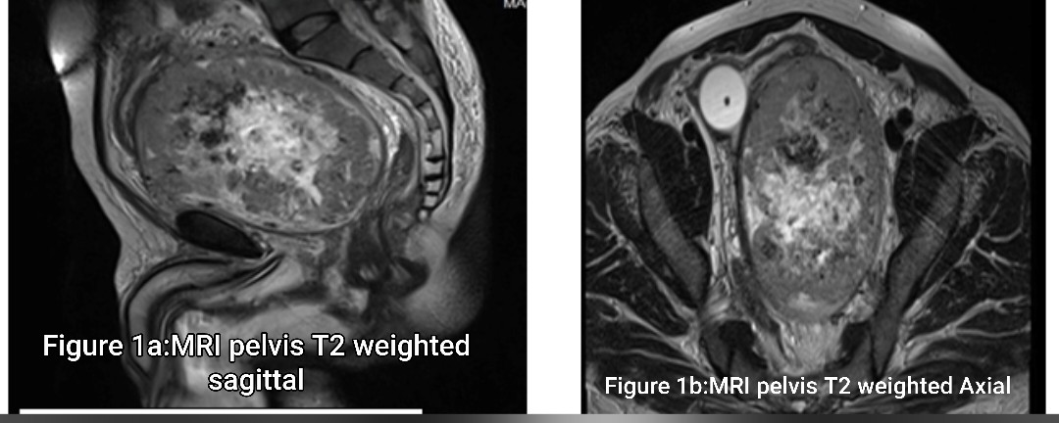9

Figure 2: High-power view (H & E, X400) showing tumor cells arranged in sheets and fascicles. The individual tumor cells are oval to spindle-shaped, showing moderate atypia, scanty cytoplasm, hyperchromatic nuclei, and mitoses. The surrounding area shows hyalinized vessels and fibrin.
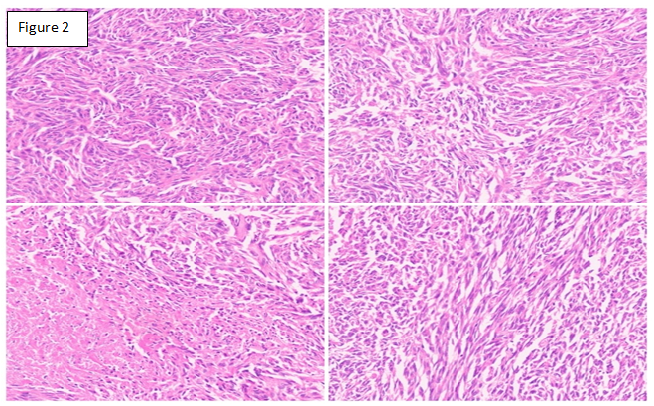
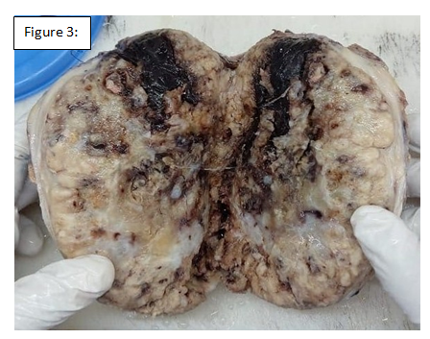

Figure 3: The gross specimen shows a single grey-white to dark brown soft tissue mass measuring 14.3x13.5x3.7cm. The external surface is congested and grey-white with a capsule; the inner surface appears grey-white to yellowish with areas of hemorrhage and necrosis. Focally sa grey-white myxoid area.

DECLARATIONS:

Ethics approval
This is a case report. The Institutional Ethics Committee (IEC) has confirmed that no ethical approval is required.

Consent to participate
Written informed consent was obtained from the patient and bystanders.

Consent to publish
The authors certify that they have obtained all appropriate patient consent forms. In the form, the patient has given the consent for his images and other clinical information to be reported in the journal. The patient understands that his names and initials will not be published and due efforts will be made to conceal their identity, but anonymity cannot be guaranteed.

Disclaimer (Artificial intelligence)

Option 1:

Author(s) hereby declare that NO generative AI technologies such as Large Language Models (ChatGPT, COPILOT, etc.) and text-to-image generators have been used during the writing or editing of this manuscript.

Option 2:

Author(s) hereby declare that generative AI technologies such as Large Language Models, etc. have been used during the writing or editing of manuscripts. This explanation will include the name, version, model, and source of the generative AI technology and as well as all input prompts provided to the generative AI technology

Details of the AI usage are given below:
1.
2.
3.

REFERENCE:
1. Abodunrin FO, Collier SA, Killeen RB. Solitary Fibrous Tumors. In: StatPearls [Internet]. Treasure Island (FL): StatPearls Publishing; 2025 [cited 2025 Jul 3]. Available from: http://www.ncbi.nlm.nih.gov/books/NBK585038/
2. Takeuchi Y, Kato D, Nakane K, Kawase K, Takai M, Iinuma K, et al. Solitary Fibrous Tumor of the Prostate: A Case Report and Literature Review. Medicina (Mex). 2021 Oct 23;57(11):1152.
3. Demicco EG, Park MS, Araujo DM, Fox PS, Bassett RL, Pollock RE, et al. Solitary fibrous tumor: a clinicopathological study of 110 cases and proposed risk assessment model. Mod Pathol Off J U S Can Acad Pathol Inc. 2012 Sep;25(9):1298–306.
4. Robinson DR, Wu YM, Kalyana-Sundaram S, Cao X, Lonigro RJ, Sung YS, et al. Identification of recurrent NAB2-STAT6 gene fusions in solitary fibrous tumor by integrative sequencing. Nat Genet. 2013 Feb;45(2):180–5.
5. Ronchi A, La Mantia E, Gigantino V, Perdonà S, De Sio M, Facchini G, et al. A rare case of malignant solitary fibrous tumor in prostate with review of the literature. Diagn Pathol. 2017 Jul 7;12(1):50.
6. Tariq MU, Din NU, Abdul-Ghafar J, Park YK. The many faces of solitary fibrous tumor; diversity of histological features, differential diagnosis and role of molecular studies and surrogate markers in avoiding misdiagnosis and predicting the behavior. Diagn Pathol. 2021 Apr 20;16(1):32.
7. Stacchiotti S, Tortoreto M, Bozzi F, Tamborini E, Morosi C, Messina A, et al. Dacarbazine in solitary fibrous tumor: a case series analysis and preclinical evidence vis-a-vis temozolomide and antiangiogenics. Clin Cancer Res Off J Am Assoc Cancer Res. 2013 Sep 15;19(18):5192–201.
8. Liu WL, Wu W, Hong QC, Lv K. Recurrence rates of surgically resected solitary fibrous tumours of the pleura: a systematic review and meta-analysis. Interact Cardiovasc Thorac Surg. 2021 May 27;32(6):882–8.

