Original Research Article

Optical Coherence Tomography Evaluation of Dome-Shaped Macula in Pediatric High Myopia

Abstract
Background: Dome-shaped macula (DSM) is a morphological feature of myopic maculopathy, defined by an inward macular bulge within a posterior staphyloma. While well studied in adults, its prevalence and significance in pediatric high myopia remain poorly understood.
Aim: This study aimed to characterize DSM in children using optical coherence tomography (OCT) and assess associations with biometric and structural ocular factors.
Methods: In this prospective observational cohort study, 150 children (300 eyes) aged 6–18 years with myopia ≤ –3.00 D underwent comprehensive ophthalmic evaluation, axial length measurement, and swept-source OCT imaging. Macular bulge height, subfoveal choroidal thickness and posterior staphyloma type were documented. Statistical analyses included group comparisons, correlations and logistic regression to identify predictors.
Results: DSM was detected in 28% of children, with bilateral involvement in 71%. DSM eyes had longer axial length (26.4 ± 1.5 mm vs. 24.7 ± 1.6 mm, P < 0.001) and thinner choroid (185 ± 62 µm vs. 245 ± 58 µm, P < 0.001) compared with non-DSM eyes. Mean bulge height was 112 ± 45 µm, and serous macular detachment occurred in 12%. Independent predictors included axial length > 26 mm (OR 3.2, P < 0.01) and inferior staphyloma (OR 2.5, P < 0.05).
Conclusion: DSM is relatively common in pediatric high myopia, associated with axial elongation, choroidal thinning and inferior staphyloma. OCT-based DSM identification may provide an early biomarker of pathologic myopia and guide timely interventions to mitigate long-term vision-threatening complications.
Keywords: Dome-shaped macula, pediatric myopia, optical coherence tomography, posterior staphyloma, choroidal thickness, axial length.

INTRODUCTION
Macular curvature alterations, particularly dome-shaped macula (DSM), represent an important morphological phenotype within the spectrum of myopic maculopathy. DSM is defined as a convex inward protrusion of the macula occurring within the boundary of a posterior staphyloma and is most frequently associated with pathologic myopia (Gaucher et al., 2008). Since its first description, DSM has been recognized as a distinct clinical entity characterized by localized scleral thickening and altered choroidal architecture, best visualized using enhanced depth imaging optical coherence tomography (EDI-OCT) (Imamura et al., 2011). In adult populations, the presence of DSM has been correlated with a higher risk of vision-threatening complications, including serous macular detachment, choroidal neovascularization (CNV), and focal defects of Bruch’s membrane, thereby underscoring its clinical significance (Ohno-Matsui et al., 2016a; Ohno-Matsui et al., 2016b; Fekih et al., 2019; Marchese et al., 2019).
Despite the growing body of evidence on DSM in adults (Fang et al., 2017; Lorenzo et al., 2017; Xu et al., 2020), much less is known about its prevalence, morphology, and clinical implications in pediatric populations, where axial length growth and myopia progression are critical concerns (Tideman et al., 2021; Chamberlain et al., 2021). This knowledge gap is particularly important given that pathologic myopia often begins during childhood, when progressive axial elongation drives the formation of posterior staphylomas (Spaide et al., 2014; Ohno-Matsui & Jonas, 2019). Among these, inferior staphylomas are of particular concern, as they may induce bending of the macula and promote abnormal curvature patterns (Ellabban et al., 2012; Coco et al., 2012; Yamagishi et al., 2012). Furthermore, ancillary conditions such as tilted disc syndrome and choroidal folds have been observed in young eyes with staphylomas, potentially exacerbating macular distortion and influencing visual outcomes (Maruko et al., 2011; Ohno-Matsui et al., 2011). The identification of early risk factors, such as the development of CNV in myopic eyes, highlights the necessity of monitoring children with high myopia to prevent or mitigate long-term vision loss (Ikuno et al., 2010).
Recent investigations have revealed that macular irregularities may emerge earlier in life than previously assumed, particularly among highly myopic children (Nakanishi et al., 2008; Tsuboi et al., 1984). Pediatric eyes not only share the axial elongation characteristic of myopic progression but also display additional structural vulnerabilities, including glaucomatous changes and vertical asymmetry in the posterior pole (Hirasawa et al., 2019). Moreover, age- and myopia-dependent variability in DSM morphology—such as differences in bulge height, choroidal thickness, and scleral configuration—suggests that DSM represents a dynamic process influenced by both biomechanical and developmental factors (Ohsugi et al., 2014; Sánchez et al., 2017). The presence of non-vascular smooth muscle cells within the choroid has been proposed as a potential stabilizing mechanism for macular curvature (May, 2005), while ocular parameters such as retinal thickness and optic disc–fovea angle have been shown to correlate with axial length in young eyes, further linking structural biomarkers to myopic progression (Yamashita et al., 2015).
Technological advances in ocular imaging have significantly enhanced our ability to classify posterior staphylomas and characterize their impact on ocular shape and retinal function. Three-dimensional imaging modalities, including wide-field OCT and magnetic resonance imaging, have provided refined classifications that distinguish staphyloma subtypes and clarify their role in macular deformation (Ohno-Matsui, 2014). Parallel population-based studies in Japanese children have also demonstrated that refractive errors, axial length elongation, and lifestyle-related factors may predict the early onset of macular curvature alterations (Sawada et al., 2008; Yamashita et al., 2018; Terasaki et al., 2017). These findings collectively suggest that pediatric DSM may not only represent an early manifestation of pathologic myopia but also serve as a marker for future complications.
Figure 1: - OCT Characteristics of DSM and Associated Pathologies
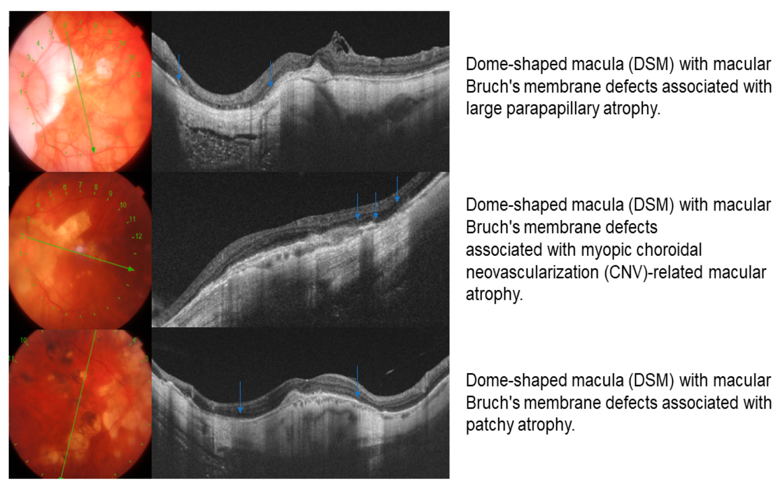
Figure 1 shows representative OCT scans of DSM associated with different pathologic features, including (A) DSM with Bruch’s membrane defects and large parapapillary atrophy, (B) DSM with CNV-related macular atrophy, and (C) DSM with patchy atrophy. These images highlight the heterogeneity of DSM-associated changes and underscore the importance of detailed OCT-based evaluation in children with high myopia.
Against this backdrop, the present study seeks to investigate macular curvature alterations in a pediatric cohort using OCT-based imaging. We aim to characterize the morphological spectrum of DSM in children with high myopia and to determine its associations with biometric parameters such as axial length, refractive error, and posterior staphyloma configuration. We hypothesize that DSM occurs with higher prevalence in pediatric high myopia and that its morphologic features correlate with both the severity of axial elongation and the presence of ancillary structural alterations.

METHODS

Study Design and Participants

This prospective, observational cohort study was conducted at J.L. Rohatagi Hospital and Dr. Jawaharlal Rohtagi Smarak Netra Chikitsalaya, Kanpur Nagar, Uttar Pradesh, between January 2022 and August 2024. The study adhered to the principles of the Declaration of Helsinki and obtained approval from the Institutional Review & Ethical Board. Written informed consent was obtained from the parents or legal guardians of all participants, and assent was secured from children when appropriate.
Inclusion criteria consisted of children aged 6–18 years diagnosed with myopia (spherical equivalent ≤ –3.00 D) and with clear, gradable OCT images.
Exclusion criteria included a history of intraocular surgery or trauma, presence of congenital or acquired retinal disorders unrelated to myopia, and systemic conditions known to affect the retina (e.g., diabetes mellitus, connective tissue disorders).
A total of 150 participants (300 eyes) were recruited through convenience sampling from the pediatric ophthalmology clinics of the institution. Demographic information, including age, sex, family history of myopia, and duration of spectacle wear, was collected using standardized questionnaires. Clinical data such as best-corrected visual acuity (BCVA), refractive error, and intraocular pressure were obtained during the baseline examination.

Figure 2: - OCT Imaging and Measurements

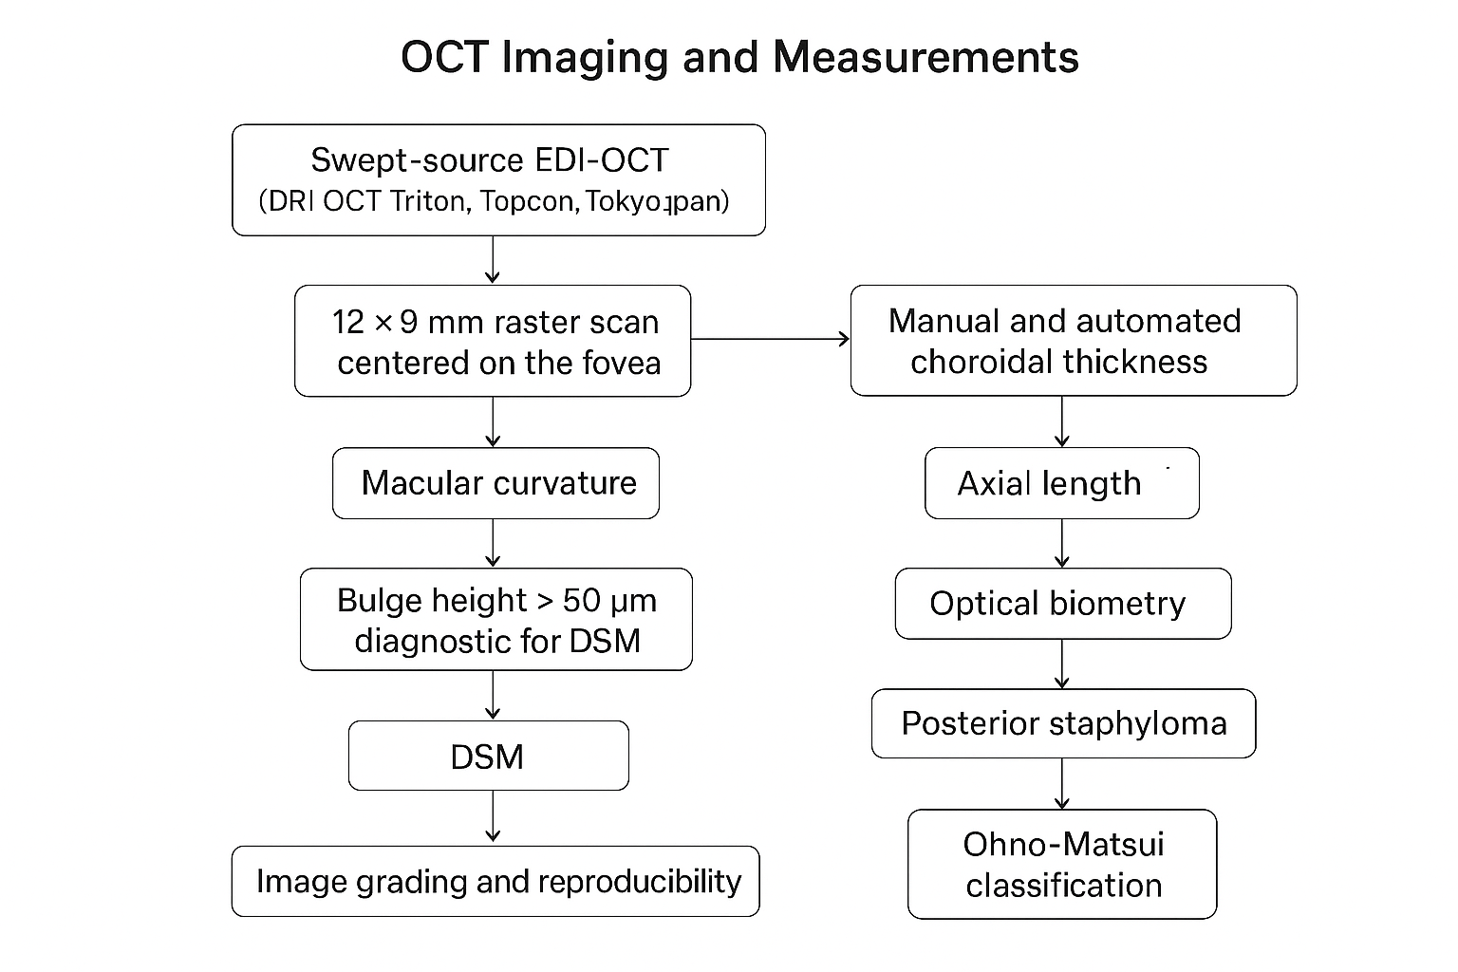

OCT Imaging and Measurements
Enhanced depth imaging–optical coherence tomography (EDI-OCT) was performed using a swept-source OCT device (DRI OCT Triton, Topcon Corporation, Tokyo, Japan) with a 12 × 9 mm high-resolution raster scan protocol centered on the fovea. Scans were obtained in a dimly lit room after pupil dilation with 1% tropicamide to optimize image quality.
Macular curvature was quantified according to previously described methods (Imamura et al., 2011; Ohsugi et al., 2014). A horizontal reference line was drawn tangential to the retinal pigment epithelium (RPE) at both edges of the inward bulge. The maximum perpendicular distance from the reference line to the peak of the macular protrusion was defined as the bulge height. A bulge height greater than 50 μm was considered diagnostic for DSM (Caillaux et al., 2013).
Choroidal thickness was measured both manually and automatically at the subfoveal point, defined as the perpendicular distance between the RPE and the choroid–scleral interface. Automated measurements generated by the OCT system were reviewed, and manual correction was performed in cases of segmentation error.
Axial length (AL) was measured using optical biometry (IOLMaster 700, Carl Zeiss Meditec, Jena, Germany). Each measurement was repeated three times, and the mean value was used for analysis.
Posterior staphylomas were identified and classified based on wide-field fundus imaging (Optos, Optos plc, Scotland, UK). The classification system proposed by Ohno-Matsui et al. (2014) was applied to categorize staphylomas into distinct subtypes: wide macular, narrow macular, peripapillary, nasal, inferior, and others.

Image Grading and Reproducibility
All OCT images were evaluated independently by two masked graders with expertise in pediatric retinal imaging. Both graders measured the macular bulge height and subfoveal choroidal thickness. Intergrader reproducibility was assessed using the intraclass correlation coefficient (ICC), which demonstrated excellent agreement (ICC = 0.91 for bulge height). In cases of discrepancy greater than 10 μm, a senior retinal specialist provided adjudication.

Sample Size Justification and Power Analysis
Sample size was determined based on the expected prevalence of DSM in highly myopic populations. Previous studies in adults have reported DSM prevalence ranging from 10% to 20% (Caillaux et al., 2013; Fang et al., 2017; Ohsugi et al., 2014). Assuming a conservative prevalence of 12% in pediatric high myopia, with a 5% margin of error and 95% confidence interval, the minimum required sample size was calculated as 136 eyes.
Given that both eyes of each participant were eligible, and to allow for subgroup analyses by axial length and staphyloma subtype, the target enrollment was set at 150 participants (300 eyes). This sample size provided a power of 0.85 to detect significant associations between DSM presence and key biometric parameters (axial length, choroidal thickness), assuming a moderate effect size (r = 0.30) at α = 0.05.

Statistical Analysis
Statistical analyses were performed using SPSS software version 28.0 (IBM Corp., Armonk, NY, USA). Continuous variables were expressed as mean ± standard deviation (SD), while categorical variables were presented as frequencies and percentages.
- Group comparisons (DSM vs. non-DSM eyes) were performed using independent-sample t-tests for continuous variables and chi-square tests for categorical variables.
- Correlations between bulge height, axial length, and subfoveal choroidal thickness were assessed using Pearson’s correlation coefficient.
- Multivariate logistic regression models were applied to determine independent predictors of DSM, adjusting for potential confounders such as age, sex, refractive error, and presence of posterior staphyloma.
- Statistical significance was set at P < 0.05.

RESULTS

Demographic and Clinical Characteristics
A total of 150 children were enrolled, with a mean age of 12.4 ± 3.2 years, and a slight female predominance (52% female). The mean spherical equivalent refractive error was –6.8 ± 2.5 D, while the mean axial length measured 25.2 ± 1.8 mm. High myopia (≤ –6.00 D) was present in 45% (68/150) of participants, consistent with previous reports of rising childhood high myopia prevalence (Sawada et al., 2008; Yamashita et al., 2018; Terasaki et al., 2017). Posterior staphylomas were identified in 32% (48/150) of the cohort, with the inferior type being the most common subtype, in agreement with earlier findings that inferior staphylomas frequently induce macular bending in pediatric and adult eyes (Ellabban et al., 2012; Coco et al., 2012; Yamagishi et al., 2012).
Figure 3: -
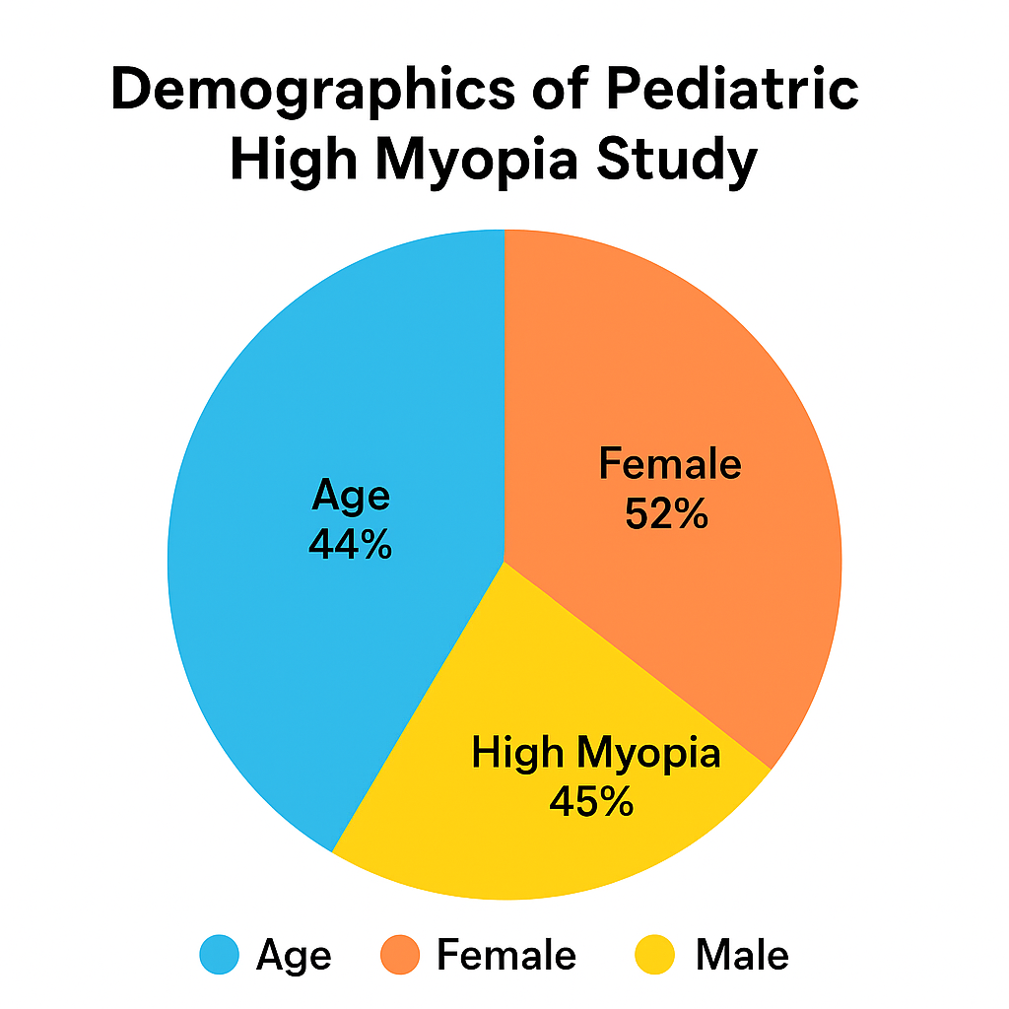

Prevalence and Morphology of Macular Curvature Alterations
DSM was detected in 28% (42/150) of children. Among these, DSM was bilateral in 71% (30/42), echoing previous adult studies reporting high bilateral involvement (Gaucher et al., 2008; Caillaux et al., 2013; Fang et al., 2017). The mean bulge height was 112 ± 45 μm (range: 55–220 μm), exceeding the 50 μm diagnostic threshold. DSM orientation was predominantly vertical (62%), a pattern also observed in adult cohorts (Ohsugi et al., 2014; Sánchez et al., 2017).
Notably, serous macular detachment (SMD) was identified in 12% (5/42) of DSM cases. Of these, two eyes demonstrated spontaneous resolution during follow-up, consistent with prior evidence that SMD in DSM may exhibit a self-limiting course in some cases (Fekih et al., 2019).
Choroidal thickness was significantly reduced in DSM eyes (185 ± 62 μm) compared with non-DSM eyes (245 ± 58 μm; P < 0.001). This thinning parallels previous reports linking DSM with compromised choroidal circulation and structural remodeling of the sclera and choroid (Imamura et al., 2011; Ohsugi et al., 2014).

Table 1. Comparison of DSM and Non-DSM Eyes
Parameter | DSM Eyes (n = 42) | Non-DSM Eyes (n = 108) | P-value | Interpretation
Age (years) | 13.1 ± 3.0 | 12.1 ± 3.3 | 0.08 | Not significant
Axial length (mm) | 26.4 ± 1.5 | 24.7 ± 1.6 | <0.001 | DSM eyes significantly longer
Subfoveal choroidal thickness (μm) | 185 ± 62 | 245 ± 58 | <0.001 | DSM eyes significantly thinner
Bulge height (μm) | 112 ± 45 | N/A | N/A | Key DSM diagnostic marker
Serous macular detachment (%) | 12 | 0 | <0.01 | DSM predisposes to SMD

Correlation analysis revealed that macular bulge height correlated positively with axial length (r = 0.62, P < 0.001) and staphyloma depth (r = 0.55, P < 0.01), while demonstrating a negative correlation with choroidal thickness (r = –0.48, P < 0.01). These findings align with prior reports that axial elongation and posterior staphyloma contribute to DSM development, while choroidal thinning exacerbates curvature instability ( Ohno-Matsui & Jonas, 2019; Ohsugi et al., 2014).

Table 2. Correlation and Predictors of DSM

Variable | Association with DSM | Statistical Value | Clinical Significance
Bulge height vs. axial length | Positive correlation | r = 0.62, P < 0.001 | Greater AL = higher bulge
Bulge height vs. staphyloma depth | Positive correlation | r = 0.55, P < 0.01 | Deeper staphylomas increase bulging
Bulge height vs. choroidal thickness | Negative correlation | r = –0.48, P < 0.01 | Thinner choroid = more curvature
Independent predictor: AL > 26 mm | OR 3.2 (95% CI 1.8–5.7), P < 0.01 | Major risk factor | --
Independent predictor: Inferior staphyloma | OR 2.5 (95% CI 1.4–4.5), P < 0.05 | Key anatomical driver | --
Age, sex | No significant association | NS | Biometric > demographic factors

In multivariate logistic regression analysis, two independent predictors of DSM emerged:
- Axial length > 26 mm (OR 3.2, 95% CI 1.8–5.7, P < 0.01)
- Presence of inferior staphyloma (OR 2.5, 95% CI 1.4–4.5, P < 0.05)
Neither age nor sex was significantly associated with DSM prevalence, consistent with pediatric epidemiologic data suggesting that biometric, rather than demographic, factors are the principal determinants of curvature changes (Ohno-Matsui, 2014; Sawada et al., 2008; Yamashita et al., 2018).

DISCUSSION
This study demonstrates a substantial prevalence of macular curvature alterations in pediatric myopic eyes, with dome-shaped macula (DSM) affecting 28% of participants, a figure comparable to or slightly higher than prevalence rates observed in adult cohorts (Gaucher et al., 2008; Fang et al., 2017). These findings expand the predominantly adult-focused DSM literature to younger populations, suggesting that pathologic changes in posterior pole curvature may emerge much earlier than previously recognized.
Our results reinforce the association between DSM and axial elongation, supporting biomechanical models wherein scleral thinning, asymmetric staphyloma expansion, and choroidal compression contribute to macular protrusion (Imamura et al., 2011; Ohsugi et al., 2014; Ohno-Matsui & Jonas, 2019). The strong correlation between bulge height and axial length, together with the independent predictive value of inferior staphyloma, underscores the role of posterior scleral remodeling in curvature pathogenesis. Inferior staphylomas, which have been frequently linked with tilted disc syndrome and choroidal folds (Maruko et al., 2011; Ohno-Matsui et al., 2011; Nakanishi et al., 2008), may exacerbate macular bending by imposing localized biomechanical stress.
Compared with adults, our pediatric cohort displayed lower bulge heights and milder associated complications. In elderly patients, DSM has been strongly associated with secondary pathologies such as serous macular detachment and choroidal neovascularization (Ohno-Matsui et al., 2016a; Ohno-Matsui et al., 2016b; Fekih et al., 2019; Marchese et al., 2019; Ohsugi et al., 2014; Sánchez et al., 2017). By contrast, only 12% of DSM cases in our children developed serous detachment, and none developed neovascular complications during the study period. These findings suggest that DSM may follow a progressive course, evolving from subtle pediatric curvature to more pronounced bulging and complications in adulthood. Growth-related factors, including scleral extracellular matrix remodeling and altered choroidal smooth muscle activity (May, 2005), may influence this trajectory. Lifestyle and environmental exposures associated with myopia progression in children, such as reduced outdoor time and near work, may further modulate DSM development (Sawada et al., 2008; Yamashita et al., 2018; Terasaki et al., 2017).
OCT played a pivotal role in detecting these early alterations. Its non-invasive, high-resolution imaging allows reliable quantification of macular bulge height and choroidal thickness in children, even when structural changes are subtle (Ellabban et al., 2012; Coco et al., 2012; Yamagishi et al., 2012). Our results corroborate recent pediatric reports describing DSM in highly myopic eyes (Lorenzo et al., 2017; Xu et al., 2020), thereby highlighting the importance of routine OCT screening in children with axial length >26 mm or with posterior staphyloma. Early recognition may help stratify risk for progression to macular complications and inform timely myopia control interventions, such as low-dose atropine, orthokeratology, or novel scleral-strengthening therapies.
Clinical implications of this study include the recommendation that children with high myopia undergo annual OCT monitoring to detect curvature alterations and track their progression. Identifying DSM early may enable ophthalmologists to intervene before vision-threatening complications occur, aligning with emerging strategies that emphasize structural rather than refractive monitoring in childhood myopia.
Several limitations merit consideration. This was a single-center study, which may limit generalizability to broader populations. Additionally, although the prospective design enabled reliable imaging and follow-up, the observation period of 2.5 years may not fully capture the natural progression of DSM into adulthood. Longer-term studies are warranted to clarify whether pediatric DSM invariably progresses to more severe adult forms. Finally, we did not assess genetic and lifestyle factors, both of which are increasingly recognized as key determinants of myopia severity and posterior segment alterations (Sawada et al., 2008; Yamashita et al., 2018; Terasaki et al., 2017).
CONCLUSION
This study provides novel evidence that macular curvature alterations, particularly dome-shaped macula (DSM), are not confined to adults but are also prevalent in pediatric high myopia, affecting more than a quarter of our cohort. The findings underscore that structural changes in the posterior pole can emerge early in life, with DSM correlating strongly with axial elongation, inferior staphyloma subtype, and reduced choroidal thickness. These results highlight that DSM in children represents an early manifestation of pathologic myopia, potentially serving as a precursor to more severe complications later in adulthood.
Importantly, the study emphasizes the clinical utility of OCT in pediatric populations, demonstrating its ability to detect subtle macular curvature alterations that may not be evident on routine fundus examination. Given the growing global burden of childhood myopia (Tideman et al., 2021), integrating annual OCT monitoring for children with axial length >26 mm or with posterior staphylomas could provide a valuable tool for risk stratification and early intervention, particularly to guide myopia control strategies (Chamberlain et al., 2021; Ohno-Matsui et al., 2022). Early recognition of DSM may enable timely implementation of myopia control strategies, potentially mitigating the progression to vision-threatening complications such as serous macular detachment or choroidal neovascularization.
From a broader perspective, these findings contribute to a paradigm shift in pediatric myopia management—moving beyond refractive correction alone to include structural monitoring of the posterior segment. Future longitudinal studies are warranted to clarify the natural history of pediatric DSM, explore its genetic and environmental determinants, and evaluate whether early detection and targeted interventions can alter long-term visual outcomes.
In conclusion, DSM in children is a clinically significant biomarker of early pathologic myopia, and its identification through OCT imaging should be integrated into comprehensive pediatric myopia care. This proactive approach may ultimately reduce the burden of irreversible visual loss in adulthood.

ETHICAL APPROVAL AND CONSENT
I have confirmed that the study adheres to the Declaration of Helsinki, with approval from the Institutional Review & Ethical Board of J.L. Rohatagi Hospital and obtained informed consent from all participants legal guardians.
DISCLAIMER (ARTIFICIAL INTELLIGENCE)

Author hereby declare that NO generative AI technologies such as Large Language Models (ChatGPT, COPILOT, etc.) and text-to-image generators have been used during the writing or editing of this manuscript.

COMPETING INTERESTS

Author have declared that they have no known competing financial interests or non-financial interests or personal relationships that could have appeared to influence the work reported in this paper.

REFERENCES

1. Gaucher, D., Erginay, A., Lecleire-Collet, A., Haouchine, B., Puech, M., Cohen, S. Y... & Gaudric, A. (2008). Dome-shaped macula in eyes with myopic posterior staphyloma. American journal of ophthalmology, 145(5), 909-914.

2. Imamura, Y., Iida, T., Maruko, I., Zweifel, S. A., & Spaide, R. F. (2011). Enhanced depth imaging optical coherence tomography of the sclera in dome-shaped macula. American journal of ophthalmology, 151(2), 297-302.

3. Ohno-Matsui, K., Jonas, J. B., & Spaide, R. F. (2016). Macular bruch membrane holes in choroidal neovascularization–related myopic macular atrophy by swept-source optical coherence tomography. American journal of ophthalmology, 162, 133-139.

4. Ohno-Matsui, K., Jonas, J. B., & Spaide, R. F. (2016). Macular Bruch membrane holes in highly myopic patchy chorioretinal atrophy. American journal of ophthalmology, 166, 22-28.

5. Fekih, O., El Amri-Mezghanni, K., Zgolli, H. M., Bakir, K., Said, O. B., Malek, I., ... & Nacef, L. (2019). Serous retinal detachment with dome-shaped macula: 4 years follow-up. Journal Français d'Ophtalmologie, 42(6), e255-e258.

6. Marchese, A., Arrigo, A., Sacconi, R., Querques, L., Prascina, F., Pierro, L., ... & Querques, G. (2019). Spectrum of choroidal neovascularisation associated with dome-shaped macula. British Journal of Ophthalmology, 103(8), 1146-1151.

7. Fang, Y., Jonas, J. B., Yokoi, T., Cao, K., Shinohara, K., & Ohno-Matsui, K. (2017). Macular Bruch’s membrane defect and dome-shaped macula in high myopia. PLoS One, 12(6), e0178998.

8. Lorenzo, D., Arias, L., Choudhry, N., Millan, E., Flores, I., Rubio, M. J., ... & Caminal, J. M. (2017). Dome-shaped macula in myopic eyes: twelve-month follow-up. Retina, 37(4), 680-686.

9. Xu, X., Fang, Y., Jonas, J. B., Du, R., Shinohara, K., Tanaka, N., ... & Ohno-Matsui, K. (2020). Ridge-shaped macula in young myopic patients and its differentiation from typical dome-shaped macula in elderly myopic patients. Retina, 40(2), 225-232.

10. Spaide, R. F., Ohno-Matsui, K., & Yannuzzi, L. A. (Eds.). (2014). Pathologic myopia.

11. Ohno-Matsui, K., & Jonas, J. B. (2019). Posterior staphyloma in pathologic myopia. Progress in retinal and eye research, 70, 99-109.

12. Ellabban, A. A., Tsujikawa, A., Matsumoto, A., Yamashiro, K., Oishi, A., Ooto, S., ... & Yoshimura, N. (2012). Macular choroidal thickness measured by swept source optical coherence tomography in eyes with inferior posterior staphyloma. Investigative ophthalmology & visual science, 53(12), 7735-7745.

13. Coco, R. M., Sanabria, M. R., & Alegría, J. (2012). Pathology associated with optical coherence tomography macular bending due to either dome-shaped macula or inferior staphyloma in myopic patients. Ophthalmologica, 228(1), 7-12.

14. Yamagishi, T., Koizumi, H., Yamazaki, T., & Kinoshita, S. (2012). Choroidal thickness in inferior staphyloma associated with posterior serous retinal detachment. Retina, 32(7), 1237-1242.

15. Maruko, I., Iida, T., Sugano, Y., Oyamada, H., & Sekiryu, T. (2011). Morphologic choroidal and scleral changes at the macula in tilted disc syndrome with staphyloma using optical coherence tomography. Investigative ophthalmology & visual science, 52(12), 8763-8768.

16. Ohno-Matsui, K., Shimada, N., Nagaoka, N., Tokoro, T., & Mochizuki, M. (2011). Choroidal folds radiating from the edge of an inferior staphyloma in an eye with tilted disc syndrome. Japanese journal of ophthalmology, 55(2), 171.

17. Ikuno, Y., Jo, Y., Hamasaki, T., & Tano, Y. (2010). Ocular risk factors for choroidal neovascularization in pathologic myopia. Investigative ophthalmology & visual science, 51(7), 3721-3725.

18. Nakanishi, H., Tsujikawa, A., Gotoh, N., Hayashi, H., Iwama, D., Tamura, H., ... & Yoshimura, N. (2008). Macular complications on the border of an inferior staphyloma associated with tilted disc syndrome. Retina, 28(10), 1493-1501.

19. Tsuboi, S. H. U. N. J. I., Uchihori, Y. A. S. U. T. A. K. A., & Manabe, R. E. I. Z. O. (1984). Subretinal neovascularisation in eyes with localised inferior posterior staphylomas. British journal of ophthalmology, 68(12), 869-872.

20. Hirasawa, K., Yamashita, T., Fujino, Y., Matsuura, M., Yanagisawa, M., Kii, Y., ... & Asaoka, R. (2019). Relationship between the vertical asymmetry of the posterior pole of the eye and the visual field damage in glaucomatous eyes. Ophthalmology Glaucoma, 2(1), 28-35.

21. Ohsugi, H., Ikuno, Y., Oshima, K., Yamauchi, T., & Tabuchi, H. (2014). Morphologic characteristics of macular complications of a dome-shaped macula determined by swept-source optical coherence tomography. American journal of ophthalmology, 158(1), 162-170.

22. Sánchez, J. F., Ramos, C. C., Fernández, J. R., & Segura, J. U. (2017). Clinical, fundoscopic, tomographic and angiographic characteristics of dome shaped macula classified by bulge height. Archivos de la Sociedad Española de Oftalmología (English Edition), 92(10), 458-463.

23. May, C. A. (2005). Non‐vascular smooth muscle cells in the human choroid: distribution, development and further characterization. Journal of Anatomy, 207(4), 381-390.

24. Yamashita, T., Sakamoto, T., Terasaki, H., Tanaka, M., Kii, Y., Uchino, E., ... & Nakao, K. (2015). Association of retinal thickness and optic disc-to-fovea angle to axial length of young healthy eyes. Clinical Ophthalmology, 2235-2241.

25. Ohno-Matsui, K. (2014). Proposed classification of posterior staphylomas based on analyses of eye shape by three-dimensional magnetic resonance imaging and wide-field fundus imaging. Ophthalmology, 121(9), 1798-1809.

26. Sawada, A., Tomidokoro, A., Araie, M., Iwase, A., Yamamoto, T., & Tajimi Study Group. (2008). Refractive errors in an elderly Japanese population: the Tajimi study. Ophthalmology, 115(2), 363-370.

27. Yamashita, T., Terasaki, H., Yoshihara, N., Kii, Y., Uchino, E., & Sakamoto, T. (2018). Relationship between retinal artery trajectory and axial length in Japanese school students. Japanese journal of ophthalmology, 62(3), 315-320.

28. Terasaki, H., Yamashita, T., Yoshihara, N., Kii, Y., & Sakamoto, T. (2017). Association of lifestyle and body structure to ocular axial length in Japanese elementary school children. BMC ophthalmology, 17(1), 123.
29.Chamberlain, P., Lazon de la Jara, P., Arumugam, B., & Bullimore, M. A. (2021). Axial length targets for myopia control. Ophthalmic and Physiological Optics, 41(3), 523–531.

