Efficacy of posterior myopexy (Fadenoperation) combined with conventional horizontal strabismus surgery for esotropia with distance–near incomitance: A retrospective observational study

.
ABSTRACT

Aims: To evaluate the postoperative outcomes of posterior myopexy in terms of surgical success and stability at short, medium, and long-term follow-up
Study design: Retrospective observational study.
Place and Duration of Study: Ophthalmology Department, Regional Hospital of Kasserine, Tunisia; surgeries performed between 2019 and 2021, with follow-up ranging from 5 months to 2 years (mean: 1.2 years).
Methodology: We retrospectively reviewed the medical records of 20 patients with concomitant esotropia associated with distance-near incomitance and/or medial rectus muscle spasm who underwent posterior myopexy combined with conventional horizontal strabismus surgery. Pre- and postoperative deviations were measured using prism cover testing. Postoperative alignment was assessed at 3, 6, and 12 months of follow-up. Surgical success was defined as a residual deviation ≤ 10 prism diopters (PD). Stability was defined as a difference ≤ 6 PD in distance deviation between the 1-month and 12-month postoperative assessments.
Results: Twenty patients were included (mean surgical age: 8.9 ± 2.1 years; mean follow-up: 1.2 ± 1.1 years), of whom 8 had early esotropia, 11 partially accommodative esotropia, and 1 acquired non-accommodative esotropia. Preoperatively, the mean deviations under full optical correction were 30.4 PD at distance, 37.2 PD at near, with a mean distance–near incomitance of 9 PD. All patients underwent bilateral posterior myopexy, performed as an isolated procedure in 3 cases and combined with horizontal muscle surgery in 17 cases. Postoperatively, the mean residual deviations were ≤ 7.5 PD at all follow-ups, and distance–near incomitance was nearly abolished. The reduction in mean distance deviation from preoperative values was statistically significant at all time points (30.4 PD to 6.75 PD at 3 months; p < 0.001. Surgical success (residual deviation and incomitance < 10 PD) was achieved in 95% of patients at 3 months and 85% at 12 months, with stable alignment (≤6 PD change between 1 and 12 months) in 19 of 20 cases. No significant intraoperative or postoperative complications were observed, and patients reported high aesthetic and psychological satisfaction
Conclusion: Posterior myopexy combined with conventional horizontal strabismus surgery appears to provide a high rate of surgical success and long-term angular stability in patients with concomitant esotropia associated with distance-near incomitance greater than 10 PD or medial rectus
.

Keywords: [Posterior myopexy; Fadenoperation; Cüppers’ suture procedure; Distance-near incomitance; Partially accommodative esotropia; Non-accommodative esotropia]

1. INTRODUCTION

The Fadenoperation, also referred to as posterior myopexy or Cüppers' suture procedure, was first introduced in the 1960s by Cüppers (Cüppers, 1981). This technique, applied to a hyperkinetic rectus muscle, restrains its action by modifying the effective lever arm rather than altering muscle force. Unlike conventional strabismus procedures that primarily act on active or passive muscle forces, posterior myopexy produces a progressive limitation of motility within the operative field (von Noorden, 1976). Its main indication is concomitant esotropia with variable deviation, particularly cases presenting with distance–near incomitance, where it is often combined with conventional surgery addressing the minimum distance deviation (Ing & Costenbader, 1976). However, reported outcomes are inconsistent, with a tendency for the effect on distance–near disparity to decrease over time. These discrepancies may be related to the type of strabismus, the surgical technique used, or tissue remodeling processes at the myopexy site (Freitas-da-Costa et al., 2023).
The purpose of the present study was therefore to evaluate the short-, medium-, and long-term effectiveness of posterior myopexy combined with conventional strabismus surgery in patients with partially accommodative or non-accommodative esotropia associated with distance–near incomitance.

2. material and methods
This is a retrospective study including 20 cases of esotropia surgically treated by a single surgeon. Medical records were reviewed at the Ophthalmology Department of the Regional Hospital of Kasserine over a two-year period, from 2019 to 2021.
Inclusion criteria
-Diagnosis of concomitant esotropia with a distance-near incomitance > 10 prism diopters (PD).
-Availability of a complete preoperative orthoptic assessment.
-A minimum postoperative follow-up period of 3 months.

Exclusion criteria
-Incomitant or paralytic strabismus.
-Strabismus associated with anatomical restrictions (e.g., Duane syndrome, thyroid eye disease, orbital fracture).
-History of previous strabismus surgery.
-Neurological disorders or developmental delay affecting cooperation.
-Pure accommodative esotropia fully corrected by spectacles.
-Incomplete medical records or missing key data points.
All patients underwent a detailed medical history, comprehensive ophthalmological examination, preoperative and postoperative sensory and motor orthoptic evaluation. This assessment was completed in all cases by an intraoperative examination under deep general anesthesia.
Management included a medical component aimed at treating amblyopia and improving binocular function, and a surgical component targeting orthotropia.
Surgical procedure
All surgeries were performed under deep general anesthesia by the same surgeon.
1. Surgical equipment
All procedures were performed using an operating microscope. Absorbable sutures (Vicryl 6-0, 3/8 circle, double-armed with spatulated needle) were used for extraocular muscles. Posterior myopexy was performed using non-absorbable 4-0 suture, and conjunctival closure was performed with 10-0 suture.
2. Preoperative tests
2.1. Anesthesia sign
For unilateral or asymmetric bilateral surgery, the anesthesia sign was used to identify the eye to operate on(the eye showing the greatest deviation under deep general anesthesia). Figure 1
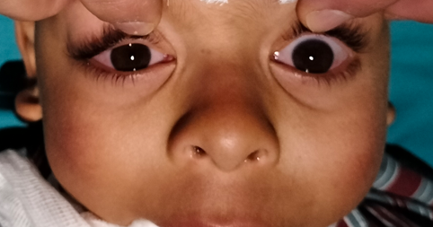

Figure 1: Bilateral orthotropia observed under general anesthesia in a patient with manifest esotropia.
2.2. Forced duction test
Performed prior to conjunctival incision, this test assessed the mobility of the muscle and its capsulotenon system. It was particularly important in cases of consecutive or residual strabismus to detect conjunctivo-tenon adhesions from previous surgeries.
2.3. Muscle elongation test
Performed systematically, this test allowed evaluation of hypo- or hyper-elongation of the muscle. A hook was placed under the muscle, and movement was referenced to an instrument aligned with the pupillary center or the center-light reflex under the microscope.
3. Surgical protocols
Conventional surgery was performed to correct the minimum distance deviation. Depending on the angle, this consisted of unilateral or bilateral medial rectus recession; when bilateral recession was insufficient, lateral rectus plication was added. In amblyopic cases, a unilateral medial rectus recession combined with lateral rectus plication was performed on the amblyopic eye.
Posterior myopexy (Fadenoperation) was performed using Quéré’s muscle slinging technique with a non-absorbable 5-0 Ethilon suture. Two symmetric scleral passes were made 11.5–14 mm posterior to the medial rectus insertion, near the Tenon’s pulley, beginning 2 mm lateral to the muscle edge. The needle was passed at mid-scleral thickness over 4–5 mm, between the vortex vein and the course of the long posterior ciliary artery. The sling was then passed beneath and above the muscle and tied over its belly. If necessary, medial rectus recession was performed after sling placement, followed by tightening of the suture (Figure 2).

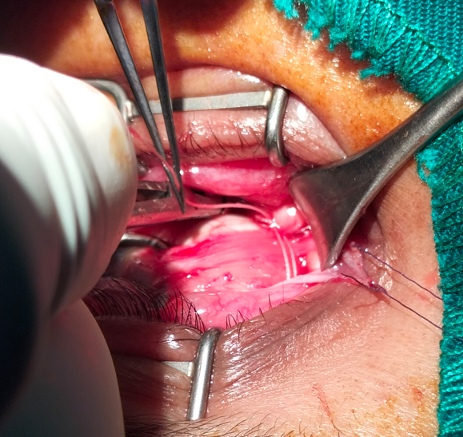

Figure 2: Posterior Myopexy according to Castiella and Polenghi

4-Postoperative evaluation
The surgical success rate was defined as the percentage of patients with a postoperative distance deviation and distance–near incomitance of less than 10 prism diopters (PD)
(Figure 3).


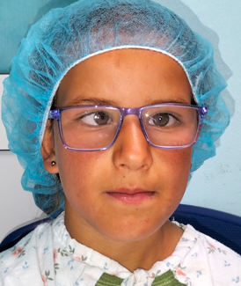
Figure 3. Early esotropia associated with angle variability.
Surgical protocol: bilateral medial rectus recession combined with bilateral Fadenoperation. a: preoperative appearance; b: postoperative day 1; c: 1-year postoperative appearance
c
b
a
Data analysis
Data were entered and analyzed using IBM© SPSS Statistics version 21. Simple and relative frequencies (%) were calculated for qualitative variables. Means, medians, standard deviations, and ranges (minimum–maximum) were calculated for quantitative variables. Associations between qualitative variables were assessed using the χ² test. For quantitative variables, Pearson correlation coefficient was used for normally distributed data and Spearman’s test for non-normal data, ranging from -1 (perfect negative correlation) to +1 (perfect positive correlation). Associations between quantitative and qualitative variables were analyzed using one-way ANOVA (F-test).

3. results

Among the 20 patients, 8 presented with early esotropia (ET), 11 with partially accommodative esotropia (PAET), and 1 with acquired non-accommodative esotropia (ANAET). The preoperative examination of these children, performed under full optical correction, revealed a mean minimum distance deviation of 30.4 PD, a mean minimum near deviation of 37.2 PD, and a mean distance-near incomitance of 9 PD. The mean age at surgery was 8.9 years. All patients were followed for a minimum period of 6 months. The mean follow-up duration was 1.2 years (Table 1).

Table 1: Preoperative clinical data and strabismic angles under full optical correction
 | Value | Unit
Mean Preoperative Angles with FC
-Distance | 30.4 (±3.4) | PD
-Near | 37.2 (±5.8) | PD
-Distance-Near Incomitance | 9 (±3.1) | PD
Mean Surgical Age | 8.9 (±2.1) | years
Mean Follow-up Duration | 1.2 (±1.1) | years
FC: Full Correction; PD: Prism Diopters.
Surgical Protocol:
-Posterior myopexy (retroequatorial myopexy) was performed to correct the distance-near incomitance concurrently with conventional horizontal muscle surgery targeting the minimum distance angle.
-Posterior myopexy was performed as an isolated procedure in 3 cases for deviation angles ranging from 15 to 30 PD (mean 21.6 PD).
-Posterior myopexy combined with horizontal muscle surgery was performed in 17 cases for deviation angles ranging from 20 to 70 PD (mean 42.8 PD).
-Bilateral posterior myopexy was performed in all cases.

Table 2: Surgical protocol according to the clinical type of esotropia (ET)
Surgical Procedure | Early-ET (n=8) | PAET (n=11) | ANAET (n=1)
-Isolated posterior myopexy | 1 | 3 | 0
-Posterior myopexy  + horizontal surgery | 7 | 8 | 1
Postoperatively, the mean distance angle was 6.75 PD (p < 0.001) at 3 months, 6.2 PD at 6 months, and 7.1 PD at 1 year. The mean near angle was 6.7 PD at 3 months, 7.2 PD at 6 months, and 7.1 PD (p < 0.05) at 1 year.The mean distance-near incomitance was nearly eliminated: 0 PD at 3 months, 1 PD at 6 months, and 0.3 PD at 1 year (Figure 3).

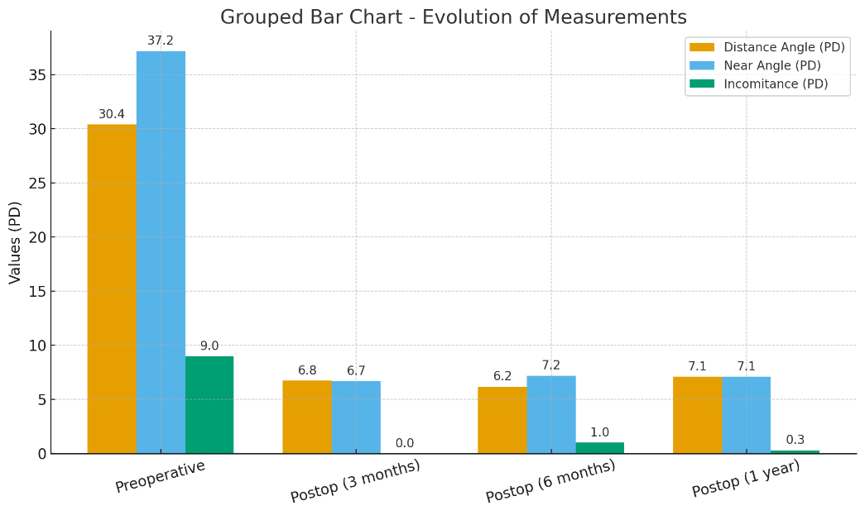
Figure 4. Mean preoperative and postoperative (3, 6, and 12 months) prism diopter (PD) values for the distance deviation, near deviation, and distance-near incomitance.

The success rate, defined as the percentage of patients with a postoperative distance deviation and a distance-near incomitance each less than 10 PD, was 95% at 3 months, 85% at 6 months, and 85% at 1 year, respectively (Figure 3). A satisfactory ocular alignment (deviation ≤ 10 PD for both distance and near) was achieved with a single surgical procedure in 19 patients (95%).
A second surgical intervention was required in one case of acquired non-accommodative esotropia, which recurred 6 months postoperatively. The initial deviation in this case was 45 PD. The reoperation consisted of a bilateral lateral rectus resection for a deviation of 35 PD, which yielded a good surgical outcome.
Aesthetic outcomes:
All patients, including those with a residual angle, reported a high degree of satisfaction.
Psychological outcomes:
A marked improvement was observed in the majority of our patients, characterized by easier social interaction, smiling, the disappearance of feelings of inferiority, and improved behavior and academic performance.
Postoperative diplopia:
No cases of postoperative diplopia were reported.
Complications:
No serious intraoperative complications were observed. Specifically, there were no cases of scleral perforation (even in highly myopic eyes), muscle injury, or significant hemorrhage. No cases of postoperative conjunctival granuloma were observed.

DISCUSSION

The management of esotropia with distance-near incomitance is not yet standardized. Conventional surgery based solely on the distance deviation often leads to undercorrection at near (Oguz et al., 1999; Gharabaghi & Zanjani, 2006). Several surgical approaches have been proposed to address this issue, including augmented medial rectus recession, additional oblique muscle reinsertion, or posterior myopexy. These different procedures have been reported with highly variable success rates.
When posterior myopexy is combined with conventional surgery, it mainly acts by restraining muscle action through scleral anchoring behind the arc of contact, thereby reducing incomitance related to medial rectus overaction in its field of action (Bérard et al., 1976; Quéré et al., 1977; Clark et al., 1999; Freitas-da-Costa et al., 2023). However, Fadenoperation may exert a minor effect on the distance angle, while conventional surgery can also influence distance–near incomitance (Klainguti et al., 1991; Steffen et al., 1998; Ha et al., 2021). This overlap makes it difficult to distinguish the individual contribution of each procedure to the final outcome.
Our patients presented with partially accommodative and non-accommodative esotropia associated with distance–near incomitance. This incomitance may result from excessive accommodative convergence in patients with a high AC/A ratio or from non-accommodative convergence spasm with a normal AC/A ratio (Steffen et al., 1998; Stärk et al., 1999). A near deviation greater than 10 PD may become persistent and lead to loss of binocular potential, with an increased risk of suppression, anomalous retinal correspondence, and amblyopia (Leitsch et al., 1990).
Treatment involves full optical correction to address the distance and near deviation as much as possible. The minimum distance angle is managed by conventional surgery, either medial rectus recession or lateral rectus plication (De Decker, 1981; Oguz et al., 1999). Excessive accommodative convergence can be treated either with posterior myopexy or with a near addition of approximately +2.50 to +3.00 D if the AC/A ratio is elevated. A +3.00 D addition to full optical correction is more appropriate in purely accommodative esotropia with convergence excess, which does not require conventional surgery for the distance deviation unlike in our cohort. In contrast, when conventional surgery is indicated for distance deviation, posterior myopexy may be added to simultaneously address accommodative convergence excess (Steffen et al, 1998; Klainguti et al., 1998; Akar et al., 2013).
In our series, consecutive exotropia occurred in 5% of cases, a result comparable to reports in the international literature despite our relatively limited sample size (Happe & Suleiman, 1999; Paliaga & Braga, 1989). This early-onset persistent exotropia likely resulted from surgical overcorrection and required reoperation, occasionally involving removal of the Cüppers' suture (Happe & Suleiman, 1999). This condition should be differentiated from transient postoperative exotropia, more frequently observed, which is due to hysteresis and transient inhibition of muscles subjected to posterior fixation. The latter tends to regress as muscle function normalizes and may ultimately prove beneficial in the long term (Happe & Suleiman, 1999; Steffen et al, 1998).
The effectiveness of posterior myopexy combined with conventional surgery is known to be effective in the short term but can vary in its long-term durability. Our findings of high initial success (95% at 3 months) aligning with satisfactory results reported in earlier series (78% at 10 months; Gharabaghi & Zanjani, 2006) and (86% at 2 years; Oguz et al., 1999). However, the gradual decline in success to 85% at one year in our cohort, consistent with the 62% rate reported at 6 years by Klainguti et al. (1991), underscores a well-documented challenge: the tendency for the effect to wane over time. This phenomenon has been historically attributed to mechanical factors such as anterior suture migration and tissue remodeling at the myopexy site, which disrupt the initial restrictive effect (Happe & Suleiman, 1999; Paliaga & Braga, 1989; Freitas-da-Costa et al., 2023).
Recent analyses have revisited these biomechanical principles. A comprehensive review by Freitas-da-Costa et al. (2023) confirms that while posterior fixation sutures effectively reduce the torque of a muscle by altering its arc of contact, the long-term integrity of the suture attachment is indeed a primary factor influencing stability. This reinforces the mechanical theories proposed by earlier foundational studies (Cüppers, 1981) and provides a modern context for our observed outcomes.
The debate on the optimal surgical approach for managing distance-near incomitance continues. Contemporary studies directly comparing medial rectus (MR) recession with versus without a Faden procedure provide valuable insights. For instance, Ha et al. (2021), in a longer-term study, found that while the addition of a Faden operation to MR recession offered superior initial correction of the accommodative component, the long-term alignment stability was comparable to larger bilateral MR recessions alone. This suggests that patient selection is crucial, and the added complexity of a myopexy may be most beneficial for specific presentations. A recent comparative study by Chaudhuri and Demer (2019) on surgical techniques for near-distance disparity further emphasizes that augmented MR recession and posterior myopexy remain the two leading techniques, with comparable efficacy but potentially different indications based on the AC/A ratio and the degree of incomitance.
Our results contribute to this ongoing discussion by demonstrating that the combined approach remains a highly viable and effective option, particularly for cases with significant incomitance. The high patient satisfaction and functional outcomes we observed are significant benefits. Nevertheless, the slight regression observed over our follow-up period aligns with the broader literature, reminding us that the procedure's effectiveness evolves over time. Future studies with longer follow-up and comparative designs, as exemplified by the recent literature, are needed to further refine surgical indications and perhaps modify techniques to improve the longevity of the posterior myopexy effect.
Furthermore, the force exerted by the muscle on posterior fixation sutures beyond the normal arc of contact can be resolved into a decreasing rotational component and an increasing tearing component as the globe rotates toward the operated muscle. This tearing force may disrupt scleral fixation or cause its progressive anterior migration, thereby diminishing the long-term effectiveness of posterior myopexy (Bérard et al., 1976; Quéré et al, 1977; Clark et al., 1999; Klainguti et al., 1991; Freitas-da-Costa et al, 2023).

4. Conclusion

Posterior myopexy combined with conventional horizontal strabismus surgery appears to provide a high rate of surgical success and long-term angular stability in patients with concomitant esotropia associated with distance–near incomitance greater than 10 prism diopters or medial rectus spasm. Our findings confirm that this combined approach not only corrects the primary deviation but also attenuates tonic overaction of the medial rectus, thereby improving binocular alignment in different gaze positions. Nevertheless, the gradual decline in success rates observed over extended follow-up highlights the influence of long-term muscle biomechanics, tissue remodeling, and suture migration on surgical outcomes. These results underscore the importance of individualized surgical planning, long-term follow-up, and further prospective studies to optimize the indications, techniques, and durability of posterior myopexy in complex forms of esotropia

Ethical approval

Ethical approval for this retrospective review was granted by the Institutional Review Board of the Regional Hospital of Kasserine with a waiver for informed consent.

Consent

The patients have given their written informed consent on admission to use their data base and files for research work

Disclaimer (Artificial intelligence)
Author(s) hereby declares that NO generative AI technologies such as Large Language Models (ChatGPT, manuscript.

References

Akar S, Gokyigit B, Sayin N, Demirok A, Yilmaz OF. Medial rectus Faden operations with or without recession for partially accommodative esotropia associated with a high accommodative convergence to accommodation ratio. Br J Ophthalmol. 2013;97(1):83-87. doi:10.1136/bjophthalmol-2012-302186
Chaudhuri Z, Demer JL. Outcomes of Medial Rectus Recession with and without Posterior Fixation Suture for Convergence Excess Esotropia. Journal of AAPOS. 2019;23(5):271.e1-271.e6. doi:10.1016/j.jaapos.2019.07.007
Clark RA, Isenberg SJ, Rosenbaum AL, Demer JL. Posterior fixation sutures: a revised mechanical explanation for the Fadenoperation based on rectus extraocular muscle pulleys. Am J Ophthalmol. 1999;128(6):702-714. doi:10.1016/s0002-9394(99)00274-1
Cüppers C. The so-called "Fadenoperation": a new approach to strabismus surgery. Dev Ophthalmol. 1981;2:70-75. doi:10.1159/000400464
Freitas-da-Costa M, Cronin TB, Nusz KJ. Revisiting posterior fixation sutures: a narrative review. J AAPOS. 2023;27(2):65-70. doi:10.1016/j.jaapos.2022.12.006
Gharabaghi D, Zanjani LK. Comparison of results of medial rectus muscle recession using augmentation, Faden procedure, and slanted recession in the treatment of high accommodative convergence/accommodation ratio esotropia. J Pediatr Ophthalmol Strabismus. 2006;43(2):91-94. doi:10.3928/0191-3913-20060301-09
Ha SG, Lee J, Jung JH, Kim SH. Comparative study of medial rectus recession with and without posterior fixation suture for convergence excess esotropia. Sci Rep. 2021;11(1):10563. doi:10.1038/s41598-021-90048-2
Happe W, Suleiman Y. Early and delayed consecutive exotropia following a medial rectus Faden operation. Ophthalmologe. 1999;96(7):509-512. doi:10.1007/s003470050413
Ing MR, Costenbader FD. Posterior fixation sutures in the treatment of esotropia with distance-near disparity. Arch Ophthalmol. 1976;94(5):738-742. doi:10.1001/archopht.1976.03910050102005
Klainguti G, Chamero J, Deller M. Short- and intermediate-term angular results of Cüppers retro-equatorial myopexy, with or without additional simultaneous recession. Klin Monatsbl Augenheilkd. 1991;198(6):382-385. doi:10.1055/s-2008-1046349
Leitsch R, Burke JP, Strachan IM. Convergence excess esotropia treated surgically with Fadenoperation and medial rectus muscle recessions. Br J Ophthalmol. 1990;74(5):278-281. doi:10.1136/bjo.74.5.278
Steffen H, Auffarth GU, Kolling GH. Posterior fixation suture and convergence excess esotropia. Strabismus. 1998;6(3):117-126. doi:10.1076/stra.6.3.117.702

