Original Research Article

The decision to operate in Functional Gall Bladder Disease :Pain as a critical factor

Abstract:
Background: Pain arising from the gall bladder (GB) or biliary tract in the absence of structural disease seems to be an uncommon clinical condition. It constitutes three varieties of disorders of the biliary tract, namely GB hypokinesia. Gallbladder (GB) pain is commonly caused by gallstone disease, but some patients have functional pain of GB origin and are labelled as functional gallbladder disease (FGBD). Treatment of this disease is not widely standardised.
Aim: To evaluate the need for cholecystectomy in subjects with FGBD. This paper aims to investigate functional gall bladder disease, where pain is the critical factor for decision-making.
Material & Methods: Subjects with RUQ pain and a negative workup (absence of gallstones and ulcer disease) were evaluated for FGBD. Diagnosis was based on GBEF <45% by scintigraphy. It is a retrospective analysis done during the period Jan 2020 to June 2023. 5 mCi of Tc-99 Mebrofenin was administered intravenously, and sequential images were acquired with dual-head gamma camera. A fatty meal was given, and post-meal static images were acquired 1 hour later, and GBEF was calculated. Surgery was carried out in patients with severe symptoms; those with minor symptoms followed up.
Results: 116 patients with suspected FGBD were evaluated by HIDA scan. 69/116 had low GBEF, and 47/116 had GBEF >45. Out of 69 patients with low GBEF, data were obtained in 52. Severe symptoms were noted in 20, and 32 had milder symptoms. Those with severe symptoms at presentation or within 4 weeks were subjected to laparoscopic cholecystectomy, and subjects with milder symptoms were followed up. Subjects who underwent surgery (19/20) had significant relief from symptoms, whereas 30/32 with mild symptoms had an uneventful course. A statistically significant difference was found in the ejection fraction between operated and non-operated patients, where the p-value is 0.0142, which the comparison of the Ejection Fraction. Cholecystectomy was carried out in the low GBEF group only if they suffered moderate to severe pain. Patients with milder pains (Pain scale) were asked to follow up, and surgery was not carried out. This approach was based on our earlier experience of finding satisfactory response responses in patients with significant abdominal pain who underwent cholecystectomy.
Conclusion: FGBD patients with severe symptoms benefit from cholecystectomy; those with milder pain may be managed symptomatically, thereby avoiding surgery. Presence of severe pain appeares appears to be the predictive indicator of successful outcome in patients with low GBEF.
Key Words: GB dyskinesia, Chronic acalculous Cholecystitis, Cholecystectomy, RUQ pain, Biliary scintigraphy.

Introduction:
Biliary dyskinesia (BD) refers to a functional disorder of the gallbladder characterised by biliary pain in the absence of a structural cause such as cholelithiasis. Biliary dyskinesia is a relatively recent term and previously had been described as acalculous gallbladder disease, hypokinetic gallbladder, gallbladder dysfunction, or functional gallbladder disorder. Biliary hyperkinesia has also been described within the spectrum of biliary dyskinesia (Kulaylat et al., 2024; Whitaker et al., 2022). Pain arising from the gall bladder (GB) or biliary tract in the absence of structural disease seems to be an uncommon clinical condition. It constitutes three varieties of disorders of the biliary tract, namely GB hypokinesia (also known as biliary dyskinesia), GB hyperkinesia and Sphincter of Oddi dysfunction (List 1). Biliary dyskinesia is a functional gallbladder disorder characterised by altered gallbladder motility. This often presents as a history of biliary symptoms without imaging evidence of gallstones, sludge, or other structural pathology. The diagnosis is made by demonstration of abnormal gallbladder emptying on hepatic iminodiacetic acid analogue scan with cholecystokinin administration (HIDA-CCK) (Popover et al., 2025). Each of these disorders has its own diagnostic criteria, but basically present as right upper quadrant pain (RUQ) with a negative diagnostic workup. The Rome IV criteria have defined these gall bladder disorders as Functional Gall Bladder Disease (FGBD), and the sphincter of Oddi disorder as Functional Biliary Sphincter disorder (FBSD)^{1.} The present study focuses on the FGBD and mainly biliary dyskinesia (BD) or hypokinesia. Biliary dyskinesia is by definition a functional disorder and is therefore not associated with any specific anatomic or pathologic findings such as gallstones or features of cholecystitis (Table 2).
Biliary dyskinesia (GB hypokinesia) has been a confusing disorder with varied terminologies that have been used over a period of time, like chronic acalculous cholecystitis, acalculous biliary disease, gall bladder dyskinesia, gall bladder spasm, cystic duct syndrome and finally, the Rome IV criteria have defined and termed it as FGBD.
List 1. ROME IV criteria for biliary pain¹
Must include episodes of pain in the epigastrium and/or right upper quadrant and all of the following:
Episodes build up to a steady level and last 30 minutes or longer
Episodes occur at different intervals (not daily)
Episodes are severe enough to interrupt the patient’s activities or lead to emergency room visits
Episodes are not significantly (< 20%) related to bowel movements
Episodes are not significantly (< 20%) relieved by postural change or acid suppression.
Supportive Criteria:
The pain may be associated with:
Nausea and/ or vomiting
Radiation to the back and/or right infrascapular area
Waking up from sleep

List 2. ROME IV criteria for Functional GB Disorder
Must include all of the following:
1) Criteria for biliary pain are met
2) Absence of gallstones or other structural pathology.
Supportive Criteria:
1) Low ejection fraction on gall bladder scintigraphy
2) Normal liver enzymes, conjugated bilirubin, and amylase/ lipase.
A general approach to patients with epigastric or RUQ would be a detailed history, physical examination, ultrasonography, endoscopy & lab evaluation. Abnormal findings could be dealt with accordingly, and the patients with a negative workup are subjected to gall bladder scintigraphy for evaluation of gall bladder ejection fraction (GBEF). On documentation of a low GBEF, adequate observation, reassessment and/or cholecystectomy is carried out based on symptom severity and clinical judgement³. Cholecystectomy remains a commonly applied treatment for BD, despite a lack of high-quality evidence supporting the practice (Richmond & Walker, 2021). There could be further evaluation for selected subjects or wherever essential in the form of endoscopic ultrasound (EUS), CT scan, MRCP or bile analysis for microlithiasis.
The testing of GB scintigraphy could also differ, and it could be a fatty meal-enhanced HIDA scan or cholecystokinin (CCK) enhanced HIDA scan based on the local availability and practices. The validation of the tests and acceptance of abnormal values of GBEF range from <35% to < 65 % based on various studies, and may add to the dilemma of the clinical situation.
The society of nuclear medicine practice guidelines for hepatobiliary scintigraphy have been published for the determination of GBEF, table no. 3 summarises these guidelines.

List 3: SNM guidelines for GBEF⁴
The study should be performed ideally as an outpatient in a non-sick patient
Nothing by mouth 4-6 hours prior to study
No opiates 6 hours prior to study
Drugs to be withheld (which inhibit GB contraction): Atropine, calcium channel blockers, octreotide, progesterone, indomethacin, theophylline, benzodiazepines, H₂ receptor antagonists.
Tc-99m mebrofenin or disofenin, 3-5 mci, is injected IV while the patient lies under the gamma camera
Image acquisition over 60 minutes
If GB fills, sincalide (CCK) 0.02 µg/kg is infused at a slow rate over 60 minutes, with images acquired during the same period.
The region of interest is drawn on a computer around GB
GBEF % = GB counts (maximum) - GB counts (minimum) x 100
GB counts (maximum)
Abnormal GBEF is less than 38%

The problem with the CCK-HIDA scan is the cost of CCK, which may be up to 1000 dollars per test, making it prohibitively expensive. Flick et al suggested that stimulation of GB contraction with a fatty meal during HIDA scan is a more affordable and reliable alternative to cholecystokinin for patients undergoing evaluation for GB dysmotility.⁵ Majority of the centres in India use fatty meal-stimulated GB scintigraphy in view of the very high cost of cholecystokinin.

Materials and Methods
1) Patient selection:
116 subjects with RUQ pain who underwent biliary scintigraphy were analysed. The criteria for undergoing the test were a negative evaluation (lab, ultrasonography and endoscopy) in patients with RUQ pain. It is a retrospective analysis done during the period Jan 2020 to June 2023. Ethical committee approval was obtained. Patients were contacted telephonically and in person during their routine visit to the hospital.

HIDA technique:
Patient preparation: Among the patients scheduled for the scan, overnight fasting was ensured. Patients on opioids (morphine) were advised to stop medication 6 hours before the scan, as it interferes with biliary clearance.
Procedure: Following intravenous injection of Tc-99m Mebrofenin (5 mCi/185 MBq in adults; 0.2 mCi/kg or 7.4 MBq/kg body weight in children), sequential dynamic images (Frame rate 30 sec/frame, 128 x 128 matrix size) were acquired for 30 minutes with Seimens symbia Evo dual head gamma camera (low energy parallel hole colimator, 15-20% over 140 kev peak)⁶. Delayed 1-minute planar antero-posterior static images of the abdomen were acquired at 15-minute intervals till maximum accumulation of tracer is seen in the gall bladder and negligible tracer in the biliary ducts, liver parenchyma. A delayed planar antero-posterior static image showing intense tracer activity in the gall bladder is considered a Pre-meal static image. Thereafter, patients were given a fatty meal. Post-meal planar antero-posterior 1-minute static images were also acquired 1 hour following the ingestion of a fatty meal. Intravenous Sincalide administration can be done alternative to fatty meal, but is not given to our patients due to lack of availability

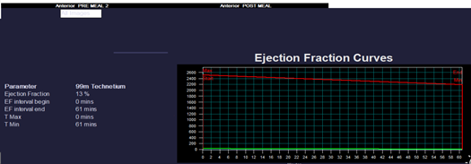

Fig1: GBEF assessment done with Tc99m -Mebrofenin (HIDA scan) shows severely reduced gall bladder ejection fraction with dyskinetic gall bladder.

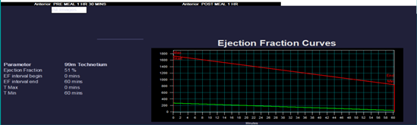

Fig 2: GBEF assessment done with Tc99m - Mebrofenin (HIDA scan) shows adequate contractile function of the gall bladder with preserved ejection fraction

Table 1 Base line Characteristics

 | Operated n = 20 | Not operated n= 30
Male | 7 | 14
Female | 13 | 18
Age<40 | 5 | 13
Age>40 | 9 | 12
Mean EF | 16.42 | 17
Median EF | 25.7 | 27.5

An ROI (Region of interest) is drawn around the gall bladder in the pre-meal and post-meal static images. GBEF (gall bladder ejection fraction) is then calculated by using the following formula;
GBEF = Pre-meal gall bladder counts - Post-meal gall bladder counts / Pre-meal gall bladder counts x 100.
Patients with GBEF values less than 45% were considered abnormal and designated as GB hypo/dyskinesia, and patients with GBEF values greater than 80% were considered to have biliary hyperkinesia⁴. (Fig1 &2)
3) Patient interview
Patients were contacted through telephone and/or during their routine visit to the Gastroenterology department. (Fig 3)
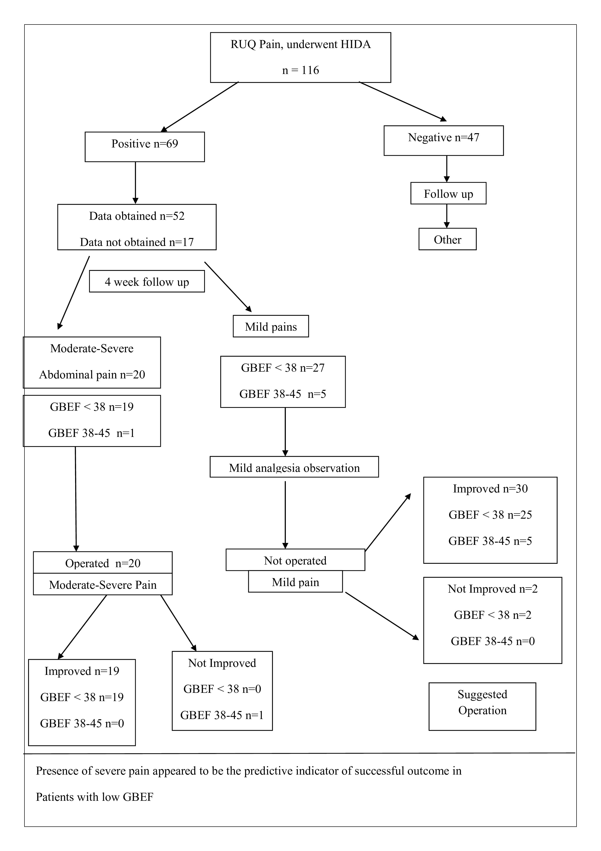
Fig 3: Proposed algorithmic approach for FGBD
Functional gall bladder disease was diagnosed in 69 subjects. 52 of these were followed up for 4 weeks. Patients with milder pain were observed; those with moderate to severe pain were subjected to cholecystectomy. Among those operated (n=20), patients with GBEF < 38 (19/20) improved, while 1 patient with GBEF of 38-45% (1/20) did not improve. The result shows that subjects of FGBD with significant pain and GBEF < 38% are the likely candidates to benefit from cholecystectomy.

Results:
Patients who had RUQ pains (mild to severe intensity) with normal ultrasonography of the abdomen and endoscopy (exclusion of stone and ulcer disease) were subjected to an HIDA scan. A standardised protocol was followed.
A total of 116 patients having RUQ pain underwent HIDA; 69/116 were positive, and the rest 47/116 were negative. GBEF was between 38-45% in 9/69 and less than 38% in 60/69. Data could be obtained in 52/69 & could not be retrieved in 17/69 subjects. Subjects in whom the GBEF was low and had significant symptoms were suggested cholecystectomy (20/52) and underwent the procedure (Table 1). Rest of 32/52 had mild symptoms and were not suggested surgery. Precisely, patients who had moderate & severe pains were operated and the rest were followed up with mild analgesia. Among the patients who were operated (20/52), 19 made good symptomatic improvement, and 1 patient had an unsatisfactory course, with persistence of symptoms. Gall bladder histopathology was normal in 5, acute inflammation in 3, chronic inflammation in 4 and not obtainable in others.
Among the patients who were not operated (32/52), there was symptomatic recovery in (30/32) with simple analgesics, but 2/32 continued to have significant symptoms.
Overall, it was observed that in subjects with RUQ pain and low GBEF, the important indicator for cholecystectomy was the presence & intensity of pain rather than mere detection of low GBEF. Despite the basis of pain being the criteria for selection for cholecystectomy, the GBEF between operated and non-operated patients reached statistical significance. The mean SD GBEF being 16.43±12.02 in operated and 25.50±13.14 in non-operated patients (Tables 2,3)

Table 2: Comparison of Ejection Fraction

Variable | Minimum | Maximum | Mean ± SD | P value
Operated | 0 | 34 | 16.43±12.02 | 0.0142*
Non-operated | 5 | 45 | 25.50±13.14 | 0.0142*

A statistically significant difference was found in the ejection fraction between operated and non-operated patients.
Table 3: Comparison of Pain

Variable | Pain |  | P value
Variable | Present | Absent | P value
Operated | 03 | 18 | 0.4938
Non-operated | 08 | 24 | 0.4938

Statistically significant difference was not found in the pain scale between operated and non-operated patients.

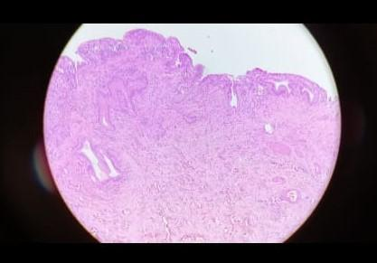
Fig 4 GB wall with mild lamina propria fibrosis and mild chronic inflammation - chronic cholecystitis
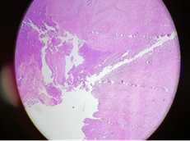
Fig 5 GB wall with focal erosion and occasional neutrophil infiltrate - suggestive of acute cholecystitis

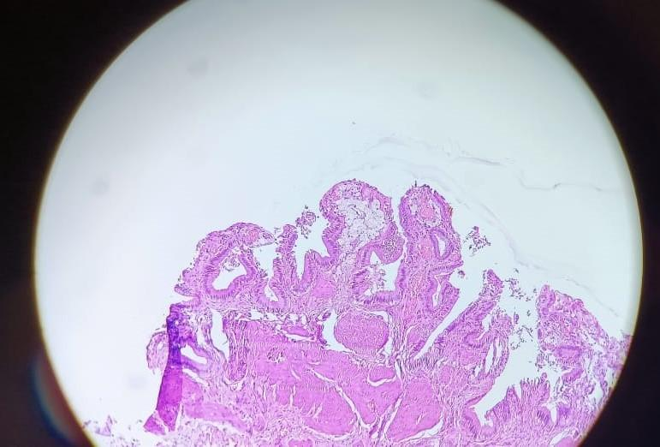
Fig 6 Gall bladder mucosa with cholesteatosis (foamy macrophage aggregates)

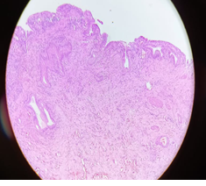
Fig 7 GB wall with reactive Rokitansky Aschoff’s sinuses and lamina propia fibrosis- chronic cholecystitis
Discussion:
FGBD is not a common clinical problem, but it does occur in a proportion of patients, causing significant morbidity. Despite its presence for a long time, clinicians tend to disregard the symptoms and consider it a functional gastrointestinal disorder (FGID) and do not convince patients to undergo the surgical procedure of cholecystectomy, as there is no definite assurance regarding pain relief after the operation. This attitude may be due to the experience in a limited number of cases, and also due to improper selection. There are a few reports of cholecystectomy done for gall bladder dykinesia, and the relief of symptoms was substantial. In an interim analysis reported by Kevin et al in 2024, out of 31 patients operated, 84% reported rapid improvement and 93% showed improvement at 6 months follow-up. The study also suggested that FGBD should no longer be a controversial indication for cholecystectomy. In an older study, out of 199 patients who underwent Cholecystectomy, 26 (13%) did not have gallstones. It was suggested that symptomatic patients who may obtain long-term relief after Cholecystectomy, the accuracy of sonography, oral cholecystography and biliary scintingraphy was 82%, 86% and 38% respectively. This study also inferred that more than one test positivity is required to predict a good result from Cholecystectomy⁸. In a study by Jones et al, 36 patients with recurrent biliary colic and no evidence of cholithiasis by ultrasound were subjected to laparoscopic cholecystectomy. Among this group, low GBEF by scintigraphy was detected in 28/32, and the rest 4/32 had normal GBEF. On follow-up 93% with low GBEF and 75% with normal GBEF had relief of biliary pain ⁹.
In our study, Cholecystectomy was carried out in the low GBEF group only if they suffered moderate to severe pain. Patients with milder pains (Pain scale) were asked to follow up, and surgery was not carried out. This approach was based on our earlier experience of finding satisfactory responses in patients with significant abdominal pain who underwent cholecystectomy. So the comparison was not between operated and those who were not operated. In fact, all the patients who were operated on had significant relief from their symptoms, except one who had developed acute appendicitis in the follow-up. Among those who were not operated and educated about the disease, milder symptoms persisted but were able to be handled with mild analgesia. Hence, it could be presumed that the indication of surgery in FGBD patients who have low GBEF is severe biliary pain. These patients had symptom relief immediately after surgery and also in the follow up ranging from 6 months to 48 months. Gall bladder pathology revealed acute cholecystitis (25%), chronic cholecystitis (35%) and normal (40%) in the operated group. Our study has shown a deviation from the earlier studies in that the selection for surgery in FGBD patients was based on the symptom severity and not the mere presence of disease. This may be relevant for this condition, as the dilemma to suggest surgical treatment for milder symptoms may be deferred and careful observation and selection of patients for appropriate treatment.

Conclusion: FGBD is a clinical entity diagnosed by scintigraphy, after exclusion of organic disease by imaging. Symptoms range from mild to severe. Subjects with severe symptoms benefit from cholecystectomy, whereas those with milder symptoms may be managed with medication, thereby avoiding unnecessary surgical intervention. Presence of severe pain appears to be the predictive indicator of successful outcome in patients with low GBEF.
Ethical Approval:

As per international standards or university standards written ethical approval has been collected and preserved by the author(s).
Consent
As per international standards or university standards, patient(s) written consent has been collected and preserved by the author(s).

Disclaimer (Artificial intelligence)

Option 1:

Author(s) hereby declare that NO generative AI technologies such as Large Language Models (ChatGPT, COPILOT, etc.) and text-to-image generators have been used during the writing or editing of this manuscript.

Option 2:

Author(s) hereby declare that generative AI technologies such as Large Language Models, etc. have been used during the writing or editing of manuscripts. This explanation will include the name, version, model, and source of the generative AI technology and as well as all input prompts provided to the generative AI technology

Details of the AI usage are given below:
1.
2.
3.

References:
1) Cotton PB, Elta GH, CArter CR, Pasricha PJ, Corazziari Es. Gallbladder and sphincter of Oddi disorders. Gastroenterology. 2016;150:1420-1429
2) Bryan K. Richmond, MD, MBA, FACS and Andrew Walker, MD; Biliary Dyskinesia: Current Perspectives and Future Directions- The American Surgeon 2020.
3) Vakil N, Talley N, van Zanten SV, Flook N, Persson T, Björck E, Lind T, Bolling–Sternevald E, STARS I Study Group. Cost of detecting malignant lesions by endoscopy in 2741 primary care dyspeptic patients without alarm symptoms. Clinical Gastroenterology and Hepatology. 2009 Jul 1;7(7):756-61.
4) Tulchinsky M, Ciak B/w, Delbeke D, et al. SNM practice guideline for hepatobiliary scintingraphy 4.0. J. Nucl Med Techol. 2010; 38:210-218.
5) Flick KF, Soufi M, Sublette CM, Sinsabaugh CA, Colgate CL, Tann M, House MG. Optimal hepatobiliary scintigraphy for gallbladder dyskinesia. Surgery Open Science. 2021 Apr 1;4:7-11.
6) Ziessman HA. Hepatobiliary scintigraphy in 2014. J Nucl Med Technol. 2014 Dec;42(4):249-59.
7) Dillehay G, Bar-Sever Z, Brown M, Brown R, Green E, Lee M, Lim JK, Metter D, Trout A, Wagner R, Wani S. Appropriate use criteria for hepatobiliary scintigraphy in abdominal pain: summary and excerpts. J Nucl Med. 2017 Jun 1;58(6):9N-11N.
8) Scott W, McCracken LM. Patients' impression of change following treatment for chronic pain: global, specific, a single dimension, or many?. The Journal of Pain. 2015 Jun 1;16(6):518-26.

9) Kevin J Xu , Josie C Brock , Naeem Goussous , Anne M Sill , Steven C Cunningham Functional gall bladder disorder: Interim analysis of a prospective cohort study. The American Journal of Surgery 2024, Vol 229, Page 129 - 132.
10) V Raptopoulos, C C Compton, P Doherty, E H Smith, C J D'Orsi, N A Patwardhan, R Goldberg. Chronic Acalculous Gallbladder disease. Multiimaging evaluation with clinical. Pathological correlation AJR, 1986. 147: 721 - 724.
11) Jones DB, Soper NJ, Brewer JD, Quasebarth MA, Swanson PE, Strasberg SM, Brunt LM. Chronic acalculous cholecystitis: laparoscopic treatment. Surgical Laparoscopy Endoscopy & Percutaneous Techniques. 1996 Apr 1;6(2):114-22.
12) Popover, J. L., Oulton, Z. W., Brown, Z. G., King, N. E., Sardzinski, E. E., Imam, A., ... & Toomey, P. G. (2025). Biliary Dyskinesia-Is It Real?. JSLS: Journal of the Society of Laparoscopic & Robotic Surgeons, 29(1), e2024-00053.
13) Richmond, B. K., & Walker, A. (2021). Biliary dyskinesia: current perspectives and future directions. The American Surgeon, 87(6), 954-960. Kulaylat, A. N., Lucas, D. J., Chang, H. L., Derderian, S. C., Beres, A. L., Ham III, P. B., ... & Rialon, K. L. (2024). Evaluation and Management of Biliary Dyskinesia in Children and Adolescents: A Systematic Review From the APSA Outcomes and Evidence-Based Committee. Journal of pediatric surgery, 59(11), 161678.
Whitaker, L. F., Bosley, M. E., Refugia, J. M., Powell, M. S., McNatt, S. S., Westcott, C. J., ... & Fernandez, A. Z. (2022). Outcomes after laparoscopic cholecystectomy in hyperkinetic biliary dyskinesia. The American Surgeon, 88(8), 1983-1987.

