Ginkgo biloba Mitigates Methamphetamine-Induced Oxidative Stress and Liver and Intestinal Toxicity in Wistar Rats

Abstract
Methamphetamine, a potent central nervous system stimulant, is associated with addiction and neurotoxicity. In contrast, Ginkgo biloba, a widely used traditional herbal remedy, is reputed for its hepatoprotective, anti-inflammatory, antioxidant, and cognitive-enhancing properties. This study investigated the protective effects of Ginkgo biloba extract on methamphetamine-induced oxidative stress and hepato-ileal toxicity in male Wistar rats. Sixty rats were randomly assigned to five groups (n=12). Group 1 (normal control) received standard chow; Group 2 received Ginkgo biloba (50 mg/kg); Group 3 received methamphetamine (2.0 mg/kg); Group 4 received Ginkgo biloba (50 mg/kg) + methamphetamine (2.0 mg/kg); and Group 5 received Ginkgo biloba (100 mg/kg) + methamphetamine (2.0 mg/kg). All treatments lasted 28 days, after which animals were euthanized for histological and biochemical analyses. Methamphetamine administration elevated oxidative stress markers and liver enzyme levels, accompanied by cytoarchitectural distortion in intestinal and hepatic tissues. In contrast, Ginkgo biloba co-treatment ameliorated these alterations, restoring tissue integrity, modulating liver enzyme activity, and enhancing endogenous antioxidant defenses. In conclusion, the bioactive compounds in Ginkgo biloba may confer hepatoprotective and ileal-protective effects by regulating oxidative stress and enzyme activities, supporting its therapeutic potential against methamphetamine-induced toxicity.
Keywords: Methamphetamine, Gingko biloba, oxidative stress, liver enzymes, hepato-ileal protection, Wistar rats.

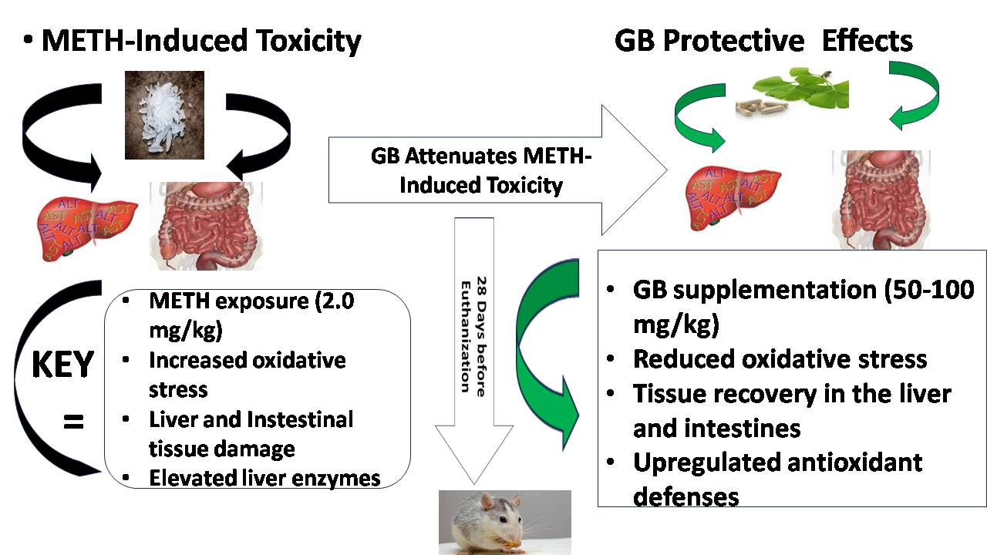
Figure 1: Graphical Abstract
The abstract illustrates the methamphetamine-induced toxicity effects on the stomach, liver, and ileum in Wistar rats, and the mitigating effect of Ginkgo biloba on the animal tissues. The schematic depicts the experimental design, methamphetamine (2.0 mg/kg) administration, and Ginkgo biloba (50 mg/kg and 100 mg/kg) supplementation. Arrows indicate methamphetamine-induced oxidative stress, liver and intestinal tissue damage, and elevated liver enzyme levels/activity. On the other hand, Ginkgo biloba has protective effects, leading to reduced levels of oxidative stress markers, tissue recovery in the liver and intestines, and up-regulated antioxidant defenses.
Introduction
Methamphetamine (METH) is a synthetic, powerful central nervous system (CNS) stimulant known for its high addictive potential (1). Within the CNS, it increases monoamine neurotransmitters—dopamine, norepinephrine, and serotonin—in the synaptic cleft, thereby producing euphoria, excitement, and heightened neuromotor activity (2). Its rising popularity among youths and adolescents has raised serious global public health concerns (3–6). Currently, METH is the second most misused substance worldwide after cannabis (7). Evidence indicates that one in seventeen people aged 15–64 years has engaged in illicit drug use (8). METH can be taken through swallowing, injection, smoking, snorting (9), or anal insertion (10), with oral ingestion being most common (11). Ingested METH undergoes metabolism and absorption along the digestive tract, where even small doses exert harmful effects comparable to cocaine or amphetamines (12). These include elevated oxidative stress, glutamate excitotoxicity, and neuroinflammation (13), all of which damage vital organs such as the liver, kidney, intestine, and vasculature. The overproduction of reactive oxygen/nitrogen species (ROS/RNS) further injures intestinal neurons, causing gastrointestinal dysfunction (14). Ginkgo biloba L., also known as the maidenhair tree, is a widely cultivated medicinal plant with both traditional and contemporary uses. Beyond its medicinal role, it has been used locally as a food additive, an ornamental tree, and in cultural rituals. Its extracts are among the most commercially sold herbal preparations globally (15). Rich in bioactive flavonoids and terpenoids, Ginkgo biloba exhibits antioxidant, anti-inflammatory, hepatoprotective, neuroprotective, and cognitive-enhancing properties (16–19). Previous studies have shown its protective effect against gastrointestinal injury (20), progressive neuronal loss, and vascular disorders (21). Notably, plant-derived therapies have been increasingly explored as adjuncts in combating drug-related toxicities, justifying assessing Ginkgo biloba in the context of METH abuse.
Considering that the gastrointestinal tract and liver are the first organs exposed during oral METH consumption, they are particularly vulnerable to oxidative stress and cytotoxic injury. Hepatotoxicity, reflected in altered liver enzyme activity, often precedes secondary damage to gut epithelium and systemic organs. Thus, investigating agents capable of modulating this injury has clinical and preventive relevance. Therefore, this study aimed to evaluate whether Ginkgo biloba supplementation could attenuate methamphetamine-induced oxidative stress, mucosal injury, and hepato-ileal toxicity in male Wistar rats.

Materials and Methods
Chemicals
The chemicals were obtained from Ranox Laboratories (Dagenham, England) and Sigma (Poole, England). Methamphetamine (10 g) was purchased from the office of the National Drug Law Enforcement Agent (NDLEA). The Ginkgo biloba supplement was obtained from Nutrifirst Biotech Inc. (Qingdao, Shandong, China). The chemicals were stored at a temperature below 25°C for the study.
Experimental animals
Sixty (60) male Wistar rats with an initial weight of 180-200 g were obtained from the animal house, Department of Physiology, Faculty of Basic Medical Sciences, PAMO University of Medical Sciences, Port-Harcourt, Rivers State, Nigeria. The animals were acclimated for seven days before the experiment under controlled experimental conditions.
Ethics, Approval, and Consent to Participate
Ethical approval was given by the PAMO University of Medical Sciences Animal Research Ethics Committee (Approval number: PUMS/REC/2023008). The OECD guideline was strictly adhered to. The experiment was conducted in strict adherence to the National Research Council regulations for the handling of laboratory animals.
Experimental protocol
The 60 male Wistar rats were shared in five (5) groups (n = 12) at random: First group (the normal control) was given normal rat chow; Second group was given Ginkgo biloba (50 mg/kg) body weight in line with method (22); Third group was given Methamphetamine (2.0 mg/kg body weight in line with method (23); Fourth group was given Ginkgo biloba (50 mg/kg) body weight + Methamphetamine (2.0 mg/kg body weight, low dose); Fifth group was given Ginkgo biloba (100 mg/kg body weight) + Methamphetamine (2.0 mg/kg body weight, high dose). The administration was by orogastric intubation, and all were given unrestricted access to rat food and clean drinking water for 28 days.
Blood sampling and evaluation of liver enzymes
Venous blood samples were collected through cardiac puncture under thiopentone sodium anesthesia (Rolex Medica, GMBH, Germany), administered at 60 mg/kg body weight. The blood samples were collected into test tubes and allowed to stand for 30 minutes to clot before being centrifuged at 300 x g for 10 minutes. The serum was extracted and stored at 4 ºC for further evaluation of aspartate aminotransferase (AST), alanine aminotransferase (ALT), and alkaline phosphatase (ALP) enzyme levels. ALP level was analyzed according to the optimized standard method recommended by the Deutsche Gesellschaft für Klinische Chemie DGKC, 1972), using P-nitrophenyl phosphate as substrate while evaluating the phenol liberated by the enzyme. Serum was processed because it is the standard medium for assessing liver enzyme activities, as it provides a clear fluid free from cellular components, ensuring accurate biochemical evaluation (24). The quantities of AST, ALT, and ALP were examined in line with the method of (25), using the Aspartate Aminotransferase Activity Assay Kit, Alanine Aminotransferase Activity Assay Kit, and Alkaline Phosphatase Activity Assay Kit, respectively. Enzyme activity was represented in International Units per liter (IU/L). All analyses were evaluated for accuracy by concurrent analyses of AMES control sera for AST, ALT, and ALP.

Methamphetamine-induced oxidative stress
Antioxidant status and oxidative stress assays
The rats were tranquilized with ketamine (70 mg/kg) and sacrificed by cervical dislocation, after which the liver, stomach, and ileum were collected and washed several times with phosphate-buffered saline to remove any blood debris or clots, kept frozen at -20 °C, and then homogenized. After centrifuging the homogenates, the resulting supernatant was put into Eppendorf tubes and used to test for the activity of nitric oxide (NO), catalase (CAT), superoxide dismutase (SOD), GSH, and malondialdehyde (MDA).

Malondialdehyde estimation
Malondialdehyde (MDA) activity was measured using a modified version of Mateos (26). When MDA, a byproduct of Lipid Peroxidation (LPO), was heated with thiobarbituric acid (TBA) in the presence of an acid, it formed a pink-reddish complex at 532 nm.

Estimation of Catalase
Catalase (CAT) activity was determined based on a modified procedure of (27).
On subjection to heat in the presence of hydrogen peroxide (H₂0₂), dichromate in acetic acid is frequently reduced to chromic acetate, with perchromic acid acting as an unstable intermediate. The amount of chromic acetate that is produced is measured.

Estimation of Superoxide Dismutase
Superoxide dismutase (SOD) activity was evaluated by measuring the repression of nitro blue tetrazolium (NBT) photoreduction by SOD radicals, using a modified version of the procedure (28).

Estimation of Nitric oxide level (NO)
The nitrate level was estimated using the method and principle of (29). By measuring its stable breakdown products, nitrate (NO3-) and nitrite (NO2-), nitric oxide (NO) is frequently measured indirectly. This is usually done using the Griess reaction.

Estimation of Reduced Glutathione Level (GSH)
The Reduced glutathione level was estimated based on a modified procedure of (30).
The most commonly used method to estimate GSH levels is the colorimetric assay, also known as Ellman's reagent. Ellman's reagent reacts with free thiol groups in GSH to turn a yellow-colored product, 5-thio-2-nitrobenzoic acid (TNB), and was estimated spectrophotometrically at 412 nm. The amount of GSH present in the sample is directly linked to the intensity of the color.

Histological analysis
Histological preparation was performed using the method (31). The stomach tissue was quickly excised and fixed in 10% buffered formalin to preserve structural integrity. Tissue samples were then sectioned at a thickness of 5 µm and later stained with hematoxylin and eosin (H&E) to highlight cellular and tissue morphology. A light microscope was used to evaluate the stained sections, and photomicrographs were taken for additional examination.

Statistical Analysis
GraphPad Prism software version 9.02 was used for the results. The outcomes were presented as mean ± standard error of the mean (SEM). The Tukey test was used when the F value was significant. A statistical difference was described as a probability level of p<0.05.

Results
Oxidative stress marker and antioxidant levels in the liver
The outcome of oxidative stress markers, malondialdehyde (MDA), and antioxidant levels in the liver following the administration of methamphetamine (METH) and Ginkgo biloba (GB), low dose (LD) and high dose (HD) to the experimental group is presented in Figure 2 (A-E).
The METH-only treatment group showed a notable increase (P<0.001) in quantity of MDA compared with the first group, GB, and METH + GB (LD), as well as METH + GB (HD) treatment groups. However, a notable reduction (p<0.05) in the MDA level in both METH+ GB (LD & HD) occurred as compared to the METH-only treated group (Figure 2A). Similar trends were observed in SOD, CAT, GSH, and NO levels (Figure 2B-E), respectively.
Figure 3: Oxidative stress marker and antioxidant levels in the liver

Liver antioxidant levels in Control-[1], Ginkgo biloba-[2], Methamphetamine-[3], METH+GB(LD)-[4], and METH+GB(HD)-[5] treated groups of rats; A = MDA Level, **#p<0.001 vs. [1,2,4&5]; B = SOD Level, *#p<0.001 vs. [1,2]; *p<0.05 vs. [3]; C = CAT Level, **p<0.001 vs. [1&2], *#p<0.05 vs. [3]; D = GSH Level, *#p<0.001 vs. [1&2], *p<0.05 vs. [3]; E = NO Level, *p<0.05 vs. [1], **p<0.001 vs. [1,2,4,&5] **#p<0.05 vs. [3], *#p<0.05 vs. [3&4]. Values are mean ± SEM, n = 12.

Levels of MDA and antioxidants in the ileum
The result of malondialdehyde (MDA), superoxide dismutase (SOD), catalase (CAT), glutathione (GSH), and nitric oxide (NO) in the ileum following the administration of methamphetamine (METH) and Ginkgo biloba (GB) to the experimental animal is represented in Figure 4 (A-E). The METH-only treatment group showed a remarkable increase (P<0.05) in the quantity of MDA compared to the first group, GB, and METH+GB (LD) and METH+GB (HD) treatment groups. In contrast to the METH-only experimented animals, the quantity of MDA was notably reduced (p<0.05) in both METH+GB (LD & HD) groups (Figure 3A).
The GB treatment group showed a remarkable rise (P<0.001) in SOD level compared with control, METH-only, and METH+GB (LD) as well as METH+GB (HD) treatment groups. However, there was a notable drop (p<0.05) in the SOD level in METH-only and METH+GB (LD & HD), contrary to GB-treated and control groups, respectively. CAT, GSH, and NO levels showed comparable patterns (Figure 4B-E).

Figure 4: Levels of MDA and antioxidants in the ileum
Ileum antioxidant levels in Control-[1], Ginkgo biloba-[2], Methamphetamine-[3], METH+GB(LD)-[4], and METH+GB(HD)-[5] treated groups of rats. A = MDA Level, *#p<0.05 vs. [1,2,4&5]; B = SOD Level, **p<0.001 vs. [1,3,4&5], *p<0.05 vs. [1&2] *#p<0.05 vs. [2&3], *P<0.05 vs. [4]; C = CAT Level, **#p<0.001 vs. [1,2,4&5], *p<0.05 vs. [3]; E = NO Level, **p<0.05 vs. [1,2,4&5], ##p<0.05 vs. METH. #p<0.05 vs. [3&4] Values are mean ± SEM, n = 12

Liver Enzyme Activity
The results of liver enzyme activities, namely aspartate aminotransferase (AST), alanine aminotransferase (ALT), and alkaline phosphatase (ALP), following methamphetamine (METH) and Ginkgo biloba (GB) administration to the experimental animal are represented in Figure 5(A-C).
The METH-only treatment group showed a remarkable rise (P<0.001) in AST level compared to control, GB, and METH+GB (LD) as well as METH+GB (HD) treatment groups. However, there was no significant change in the AST level in METH+GB (LD & HD) as compared to the control and GB-treated group (Figure 3A). A similar trend was observed in ALT and ALP levels, with significant reductions (p<0.05) in treatment groups METH+GB (LD & HD), respectively (Figure 5B-C).

Figure 5: Liver Enzyme Activity
Liver Enzymes Levels in Control-[1], Ginkgo biloba-[2], Methamphetamine-[3], METH+GB(LD)-[4], and METH+GB(HD)-[5] treated groups of rats. A = AST Level, **#p<0.001 vs. [1, 2, 4&5]; B = ALT Level, *p<0.05 vs. [1, 2, 4&5], #p<0.05 vs. [3], *#p<0.05 vs. [3, 4&5]; C = ALP Level, **#p<0.05 vs. [1, 2.4&5]; *#p<0.05 vs. [1]. Values are mean ± SEM, n = 12

Effect of Methamphetamine and Ginkgo biloba on the liver of experimental animals
The liver photomicrograph in the first group and experimental animals is represented in Figure 4A-E. The centrilobular area (A1) and portal area (A2) of the liver in control revealed a normal hepatic lobule with the central vein (CV), hepatocytes (green arrow), sinusoids (red arrow), and Kupffer cells (black arrow). The portal area demonstrated the portal vein (PV, red arrow), hepatic artery (HA, green arrow), and bile duct (BD, blue arrow), all in the normal state. (B1&B2) showing the centrilobular area and portal area of the liver in the Ginkgo biloba-only treated group
In the methamphetamine-treated group, the centrilobular area (C1) showed spotty fibrosis (red arrow), congested central veins, and sinusoids (black arrowhead).The edematous portal area (C2, red arrowhead) with lymphocytic infiltration (blue arrow). The Methamphetamine + Ginkgo biloba (50 mg/kg) treated group (D1) showed mild focal disruption of the central vein (red arrow); the portal area (D2) showed normal plates of hepatocytes and portal triad. The Methamphetamine + Ginkgo biloba (100 mg/kg) treated group (E1&E2) showed normal centrilobular and portal areas, with noticeable hepatocyte recovery (black arrow) in the group.

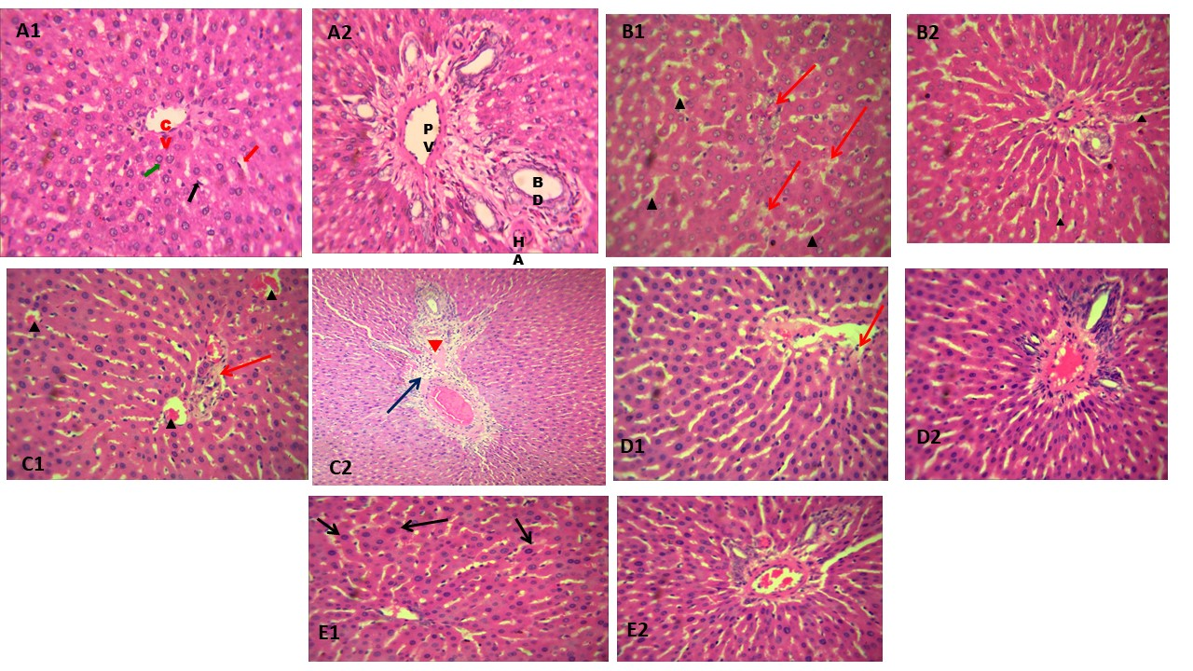

Figure 6: Photomicrograph of the liver showing the graphical representation of Methamphetamine-induced hepatotoxicity and the attenuating effect of Ginkgo biloba
Photomicrograph of the liver in the control and experimental groups (Figure 6A-E). (A = control); A1 = centrilobular area, green arrow = normal hepatic lobule with central vein (CV), hepatocytes; red arrow = normal sinusoids; black arrow = Kupffer cells. A2 = portal area; red arrow = portal vein, green arrow = hepatic artery (HA); blue arrow = bile duct (BD), all intact. B = Ginkgo biloba group; B1 = centrilobular area, B2 = portal area.C = METH; C1 = centrilobular area, red arrow = spotty fibrosis, black arrow = congested central veins, and sinusoids; C2 = portal area, red arrow = edematous, blue arrow = lymphocytic infiltration. D = METH+GB, LD; D1 = centrilobular area, red arrow = mild focal disruption of the central vein, D2 = normal plates of hepatocytes and portal triad. E = METH+ GB, HD E1&E2 = normal centrilobular and portal areas, black arrow = hepatocytes recovery.

Impact of Ginkgo biloba and methamphetamine on ileal section photomicrographs in the experimental and control groups of rats
Photomicrograph of ileum sections in control and experimental groups (Figure 6A-E). The surface epithelium (A1, x100) and mucosa (A2, x400) of the ileum in control showed normal cytoarchitecture, with prominent Payer’s patches (black arrow), tall villi (red arrow), and intestinal glands (green arrow) in the lamina propria. In the group that received only Ginkgo biloba treatment, a section of the ileum's surface epithelium and mucosa (B1, x100) displayed normal cytoarchitecture with noticeable Payer's patches (black arrow). Tall villi (red arrow), atypical villous epithelium (green arrow; E2, x400), and mild villous epithelium dysplasia (blue arrow) were observed in the METH+GB (HD)-treated group (E1, x100).

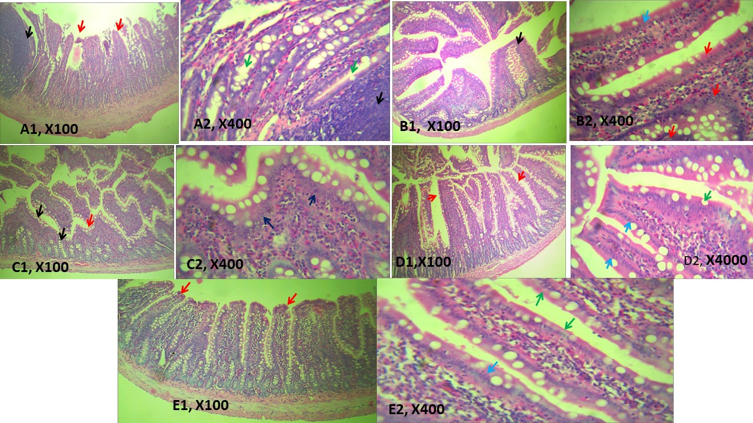

Figure 7: An ileal photomicrograph illustrating the attenuating effect of Ginkgo biloba and the tissue damage caused by methamphetamine.
Photomicrograph showing sections of the ileum in control and experimental groups A1&A2 – D1&D2 (Figure 7). A = control; A1&A2 = sections of ileum viewed at X100 and X400, black arrow = normal Payer’s patches; red arrow = normal tall villi; green arrow = intestinal glands in lamina propria. B = Ginkgo biloba group: B1&B2 = sections of ileum viewed at X100 and X400, black arrow = prominent Payer’s patches, blue arrow =villi with normal simple columnar epithelium. C = METH; C1&C2 = sections of ileum viewed at X100 and X400, red arrow =atypical short villi, black arrow =goblet cell hypertrophy; blue arrow =dysplastic columnar cells making up the enterocytes’ (villous) epithelium. D = METH+GB, LD; D1&D2 = sections of ileum viewed at X100 and X400, red arrow = tall villi, blue arrow = typical villous epithelium (blue arrow; green arrow = atypical dysplastic columnar epithelium. E = METH+ GB, HD E1&E2 = sections of ileum viewed at X100 and X400, red arrow = tall villi; green arrow = atypical villous epithelium; blue arrow = mild dysplasia of the villous epithelium.

Discussion
The findings of this study indicate that methamphetamine (METH) administration in Wistar rats produced adverse effects on the liver, stomach, and ileum. Oxidative stress markers were markedly elevated in METH-treated animals, liver enzyme levels (ALT, AST, and ALP) were significantly increased, and histological analysis revealed pronounced alterations in the centrilobular and portal regions of the liver. Similarly, microscopic examination of ileum sections showed dysplastic columnar epithelium with Goblet cell hypertrophy. Conversely, treatment with Ginkgo biloba extract (EGb761) appeared to exert protective effects, as reflected in improved oxidative stress markers and tissue architecture in both the liver and ileum. Notably, epithelial recovery was evident in the ileum and liver tissues, and liver enzyme levels were reduced toward near-normal values.
METH exposure induced significant oxidative damage in the liver, evidenced by elevated malondialdehyde (MDA) levels alongside marked reductions in the antioxidant defense markers—superoxide dismutase (SOD), catalase (CAT), glutathione (GSH), and nitric oxide (NO). These findings are in agreement with earlier reports (32). Conversely, supplementation with Ginkgo biloba countered these effects in a concentration-dependent way by reducing MDA levels and boosting antioxidant enzyme activities, aligning with previous studies (33). At the ileum, METH administration resulted in increased MDA levels and diminished antioxidant markers, further confirming its detrimental impact on gut physiology. Ginkgo biloba treatment countered these effects, restoring GSH, SOD, CAT, and NO levels, thereby enhancing tissue antioxidant capacity and reducing inflammation. These observations align with previous findings (34–37). The biochemical assays of liver enzyme activities revealed elevated ALT, AST, and ALP in METH-exposed animals, suggesting hepatocellular injury and possible bile duct impairment. However, Ginkgo biloba supplementation reduced these enzyme levels in a dose-dependent manner, indicating hepatoprotective potential. The histological analysis corroborated these biochemical findings. METH exposure caused marked distortion of the liver’s centrilobular and portal regions, while the ileum exhibited dysplastic columnar epithelium and Goblet cell hypertrophy. In contrast, co-administration of METH with both low and high doses of Ginkgo biloba extract resulted in appreciable recovery in the ileum, characterized by improved villous architecture and restoration of epithelial cytoarchitecture.
Conclusion
The findings of this study demonstrate that methamphetamine (METH) administration in Wistar rats induced oxidative damage and tissue injury in both the liver and ileum. This was evidenced by elevated oxidative stress markers, increased liver enzyme levels, and histopathological alterations, including centrilobular and portal area distortion in the liver, as well as dysplastic columnar epithelium with Goblet cell hypertrophy in the ileum. Supplementation with Ginkgo biloba extract (EGb761) exerted protective effects by reducing oxidative stress, restoring antioxidant enzyme activities (SOD, CAT, GSH, and NO), and improving the structural integrity of liver and ileum tissues. The observed dose-dependent ameliorative effects of Ginkgo biloba suggest its potential role in attenuating METH-induced tissue inflammation and oxidative injury.
A limitation of this study was the inability to delineate the specific molecular pathways through which Ginkgo biloba modulates inflammatory responses and enhances antioxidant defenses. Further investigations are warranted to elucidate these mechanisms and better characterize their protective properties.

Conflicts of interest
Authors have declared that they have no known competing financial interests OR non-financial interests, OR personal relationships that could have appeared to influence the work reported in this paper.

Disclaimer (Artificial intelligence)
Option 1:
Author(s) hereby declare that NO generative AI technologies such as Large Language Models (ChatGPT, COPILOT, etc.) and text-to-image generators have been used during the writing or editing of this manuscript.
Option 2:
Author(s) hereby declare that generative AI technologies such as Large Language Models, etc. have been used during the writing or editing of manuscripts. This explanation will include the name, version, model, and source of the generative AI technology and as well as all input prompts provided to the generative AI technology
Details of the AI usage are given below:
1.
2.
3.

References
- Peerzada H, Gandhi JA, Guimaraes AJ, Nosanchuk JD, Martinez LR. Methamphetamine administration modifies leukocyte proliferation and cytokine production in murine tissues. Immunobiology. 2013;218(8):1063-8.
- Der-Ghazarian TS, Charmchi D, Noudali SN, Scott SN, Holter MC, Newbern JM, Neisewander JL. Neural circuits associated with 5-HT1B receptor agonist inhibition of methamphetamine seeking in the conditioned place preference model. ACS Chem Neurosci. 2019;10(7):3271-83.
- Jatau AI, Sha’aban A, Gulma KA, et al. The burden of drug abuse in Nigeria: a scoping review of epidemiological studies and drug laws. Public Health Rev. 2021;42:1603960.
- Dumbili EW, Ebuenyi ID. Methamphetamine (Mkpulummiri) use in eastern Nigeria: a new addition to drug users’ repertoire. Afr J Drug Alcohol Stud. 2021;20(1).
- Harada T, Kanamori S, Baba T, et al. Sociodemographic profiles and determinants of relapse risks among people with substance use disorders in the Philippines. Drug Alcohol Depend. 2023;251:110924.
- National Center for Drug Abuse Statistics. National Center for Drug Abuse Statistics (NACDAS). 2023.
- Radfar SR, Rawson RA. Current research on methamphetamine: epidemiology, medical and psychiatric effects, treatment, and harm reduction efforts. Addict Health. 2014;6(3–4):146–54.
- World Drug Report. United Nations Office on Drugs and Crime. World Drug Report (WDR). 2021. Available from: https://www.unodc.org/unodc/en/data-and-analysis/wdr2021.htm
- Rawson RA, Gonzales R, Marinelli-Casey P, Ang A. Methamphetamine dependence: A closer look at treatment response and clinical characteristics associated with route of administration in outpatient treatment. Am J Addict. 2007;16(4):291–9.
- Salamanca SA, Sorrentino EE, Nosanchuk JD, Martinez LR. The effects of methamphetamine on the host immune system: Implications for infectious disease. Front Neurosci. 2015;8:445. doi: 10.3389/fnins.2014.00445.
- Chomchai C, Chomchai S. Global patterns of methamphetamine use. Curr Opin Psychiatry. 2015;28(4):269–74.
- Ujumadu V. Mkpurummiri: The drug destroying Igbo youths. Vanguard; 2021.
- Yamamoto BK, Bankson MG. Amphetamine neurotoxicity: Causes and consequences of oxidative stress. Crit Rev Neurobiol. 2005;17(1-2):87-117. doi:10.1615/CritRevNeurobiol.v17.i1-2.50.
- Stevens OW, LaSarge CL, Dupree JL, Wilson WA. Methamphetamine and its relationship with neurotoxicity, oxidative stress, and neuroinflammation. J Neurosci Res. 2018;96(3):361–73. doi: 10.1002/jnr.24154.
- Tousson E, Masoud A, Elatrsh AM, Mostafa T. Oral supplementation of aqueous Ginkgo biloba extract inhibits oxidative stress and hippocampus injury associated with methotrexate injection. J Biosci Appl Res. 2016;2(10):651-60.
- Emine E, Sezin G, Mehmet Y. Protective effects of Ginkgo biloba extract on toxic agent-induced organ damage: A review of experimental studies. Toxicol Ind Health. 2019;35(4):271–80. doi:10.1177/0748233719830147.
- Singh SK, Srivastav S, Castellani RJ, Plascencia-Villa G, Perry G. Neuroprotective and antioxidant effect of Ginkgo biloba extract against AD and other neurological disorders. Neurotherapeutics. 2019 Jul;16(3):666-74. doi: 10.1007/s13311-019-00767-8. PMID: 31376068; PMCID: PMC6694352.
- El-Sheikh MM. The role of some natural products in protecting against the effect of gamma irradiation on the gastrointestinal tract in rats. 2012.
- Cicero AFG, Fogacci F, Banach M. Botanicals and phytochemicals active on cognitive decline: The clinical evidence. Pharmacol Res. 2017;130:204-12.
- Sadowska-Krępa E, Kłapcińska B, Pokora I, Domaszewski P, Kempa K, Podgórski T. Effects of six-week Ginkgo biloba supplementation on aerobic performance, blood pro/antioxidant balance, and serum brain-derived neurotrophic factor in physically active men. Nutrients. 2017 Jul 26;9(8):803. doi: 10.3390/nu9080803. PMID: 28933745; PMCID: PMC5579597.
- Ozougwu JC, Eyo JE, Clarence OK, Soniran O, Kelechukwu DM. Investigation of the antihepatotoxic effects of Allium sativum extracts against acetaminophen-intoxicated Rattus norvegicus. World J Med Sci. 2014;11(3):397-404.
- Chan PC, Xia Q, Fu PP. Ginkgo biloba leaf extract: biological, medicinal, and toxicological effects. J Environ Sci Health C. 2007;25(3):211-44.
- Funahashi M, Kohda H, Shikata I, Kimura H. Potentiation of lethality and increase in body temperature by combined use of d-methamphetamine and morphine in mice. Forensic Sci Int. 1988 Mar;37(1):19-26. doi: 10.1016/0379-0738(88)90103-x. Erratum in: Forensic Sci Int 1988 Jul-Aug;38(1-2):155. PMID: 3350457.
- Tietz, N. W. (2012). Tietz Textbook of Clinical Chemistry and Molecular Diagnostics. 5th ed. Elsevier.
- Reitman S, Frankel S. A colorimetric method for the determination of serum glutamic oxaloacetate and glutamic transaminases. Am J Clin Pathol. 1957;28(1):56-63.
- Mateos R, Goya L, Bravo L. Determination of malondialdehyde (MDA) by high-performance liquid chromatography in serum and liver as a biomarker for oxidative stress. Curr Protoc Toxicol. 2020;86(1):e96. doi: 10.1002/cptx.96.
- Singh R, Kumar V, Sharma S. A novel fluorescence-based method for catalase activity determination: Applications in oxidative stress research. Anal Biochem. 2023;635:114458.
- Munteanu IG, Apetrei C. Analytical methods used in determining antioxidant activity: A review. Int J Mol Sci. 2021;22(7):3380. doi: 10.3390/ijms22073380.
- Bryan NS, Grisham MB. Methods to detect nitric oxide and its metabolites in biological samples. Free Radic Biol Med. 2007;43(5):645–57. Available from: https://pubmed.ncbi.nlm.nih.gov/17664129/.
- Noeman SA, Hamooda HE, Baalash AA. A reliable spectrophotometric method for measuring reduced glutathione in tissues: Optimization and validation. J Biochem Technol. 2022;36(3):215-22.
- Ismail HT, El-Meligy MM. Histopathological techniques and their applications in tissue morphology studies. J Histol Methods. 2022;46(2):112-20. doi: 10.1016/j.jhistmeth.2022.01.004.
- Wen S, Liao T. Ephedrine causes liver toxicity in SD rats via oxidative stress and inflammatory responses. Hum Exp Toxicol 2021;40(1):16-24.
- Yang X, Li D, Zhang M, Feng Y, Jin X, Liu D, et al. Ginkgo biloba extract alleviates fatty liver hemorrhagic syndrome in laying hens via reshaping gut microbiota. J Anim Sci Biotechnol 2023;14(1):97. https://doi.org/10.1186/s40104-023-00900-w
- Gupta A, Patel N, Rajput D, Patil UK. A comprehensive review on the molecular mechanism of Ginkgo biloba Linn. activity in various metabolic syndromes. Pharmacol Res - Mod Chin Med. 2024;11:100446. doi: 10.1016/j.prmdc.2024.100446.
- Chen G, Xu J, Wu M, Li H, Yang Q, Feng L. Extract of Ginkgo biloba leaves (EGb) decreases lipid oxidation in fish feed and meat and enhances growth and antioxidant capacity in Jian carp (Cyprinus carpio var. Jian). Fishes. 2023;8(11):564. doi:10.3390/fishes8110564.
- Achete de Souza T, de Almeida FM, de Azevedo TS, dos Santos MM. Protective effects of Ginkgo biloba on gastric tissue in an experimental model of oxidative stress. J Med Plants Res 2020;14(6):260-70.
- Biernacka P, Adamska I, Felisiak K. The potential of Ginkgo biloba as a source of biologically active compounds—A review of the recent literature and patents. Molecules. 2023;28(10):3993. doi:10.3390/molecules28103993.

