Case report

Unmasking A Rare and Fatal presentation of Plasmodium Vivax Malaria as Acute Pancreatitis in a Patient

Abstract
Introduction: Malaria, endemic in large parts of India, can cause a wide spectrum of clinical manifestations, ranging from uncomplicated febrile illness to multiorgan failure and death. Acute pancreatitis as a complication is rare and potentially fatal.
Case Discussion: This case report presents the clinical course of Patient X, a 30-year-old female who succumbed to death following an unusual presentation of Plasmodium vivax malaria as acute pancreatitis
Conclusion: Timely intervention and expert care are crucial for Plasmodium vivax patients to reduce the associated mortality and morbidity.
Clinical Significance: Acute pancreatitis secondary to Plasmodium vivax malaria is a very rare complication. Both conditions are life-threatening and require close monitoring and critical care. This case highlights the importance of considering pancreatitis as a possible complication of vivax malaria in patients from endemic regions
Keywords: Plasmodium Vivax Malaria ,Acute Pancreatitis.
1. Introduction
According to the World Malaria Report 2023, India accounted for approximately 65.7% of all malaria cases in the WHO South-East Asia Region[1]. Malaria is a significant public health problem in several parts of the country. About 95% of the population resides in malaria-endemic areas, and 80% of malaria cases are reported from regions inhabited by 20% of the population living in tribal, hilly, and inaccessible areas.
Acute pancreatitis is most commonly linked to gallstone disease or alcohol consumption, but it can rarely follow infectious diseases like malaria, especially Plasmodium falciparum infection[2][3][4]. A high index of suspicion is required in patients presenting with malaria and abdominal pain. While Plasmodium vivax malaria was traditionally thought to be benign, it now often presents with systemic complications such as cerebral malaria, acute respiratory distress syndrome, acute kidney injury, acute pancreatitis[5], hepatic dysfunction, and disseminated intravascular coagulation, which were previously attributed only to Plasmodium falciparum. Hence, timely intervention and expert care are necessary for Plasmodium vivax patients to reduce associated mortality and morbidity.
2. Case presentation
A 30-year-old non pregnant female with no prior comorbidities, from a malaria-endemic region, presented to the emergency department of Jawaharlal Nehru Medical College, Aligarh. She complained of high-grade fever(102°F) associated with chills/rigors for 4 days and breathlessness for 1 day. There was no history of rash, vomiting, cough, burning micturition, abdominal pain, altered sensorium, or previous hospitalization. On examination, she was conscious, oriented, and febrile, with a temperature of 101°F and BMI of 21. Clinical examination revealed no tenderness over the abdomen, guarding, rigidity, or organomegaly.
Routine biochemical investigations (Table 1) and the presence of Plasmodium vivax schizonts in the peripheral blood smear, with a positive Malarial Parasite Quantitative Buffy Coat (MPQBC) test for Plasmodium vivax, revealed the underlying etiology as malaria with moderate Parasite Index. Blood and urine cultures sent at admission were sterile.Patient was admitted to Intensive Care Unit(ICU), where resuscitation with vasopressor support was started, followed by the initiation of empirical antibiotics.As soon as the diagnosis was made,antimalarials(Artemisinin-based combination therapy) were started.Arterial Blood gas analysis at presentation suggested mild ARDS, which progressed to severe ARDS within 24 hours[6]. The patient was intubated but unfortunately succumbed to death within a few hours.Patient had HbA1c of 5.1 with lipid profile within normal range. A CT scan of the abdomen revealed a bulky pancreas with necrosis, mild ascites,with normal Gall Bladder and common bile duct. 2D Echocardiography showed features of myocarditis(global hypokinesia with reduced left ventricular ejection fraction)
This case highlights the complexity of diagnosing varied presentations of infectious diseases and the challenges posed by simultaneous conditions
3.Discussion: Malaria is a major public health problem in India accounting for seizable morbidity and mortality.Many infections including parasites like toxoplasma,cryptosporidium ,clonorchis,ascariasis have been implicated in acute pancreatitis[7]The pathophysiology of malaria causing pancreatitis is not well understood[8] .The proposed mechanism has been linked to acute ischemic injury to pancreatic parenchyma secondary to obstruction by capillaries by parasite laden red blood cells .Malaria induced hemolysis has also been implemented in the pathogenesis [9].As previously reported in various studies[10] regarding the correlation of parasitemia with morbidity and mortality associated with Plasmodium falciparum malaria[11], our case also points in the same direction, as it too had high parasitemia. However, in this instance, it was Plasmodium vivax, which was previously thought to be a less severe form of malaria.The diagnosis of Plasmodium Vivax induced pancreatitis with BISAP Score of 2 at presentation [12] was made by excluding other common causes of acute pancreatitis .There was no history of any addiction,chronic or binge alcohol consumption,no evidence of gall stones on radiological imaging ,no history of any drug intake known to cause pancreatitis,normal serum calcium and triglycerides levels.Acute Pancreatitis was diagnosed according to Revised Atlanta Classification [13] which states that the diagnosis of acute pancreatitis requires two of following three features :1Abdominal pain 2:Serum amylase/Lipase activity at least three times more than upper normal limit 3:Radiological evidence of acute pancreatitis .
This case highlights the need to recognize rare complications such as acute pancreatitis in patients with malaria, particularly in endemic areas. Clinicians should keep this possibility in mind when patients present with persistent abdominal symptoms like epigastric pain, nausea, or vomiting. Prompt diagnosis and timely intervention can significantly improve outcomes and help reduce the morbidity and mortality linked to this complication.
4. Conclusion
Acute pancreatitis secondary to Plasmodium vivax malaria is a very rare complication. Both conditions are life-threatening and require close monitoring and critical care. This case highlights the importance of considering pancreatitis as a possible complication of vivax malaria in patients from endemic regions.

5. Disclaimer
Author(s) hereby declare that NO generative AI technologies such as Large Language Models (ChatGPT, COPILOT, etc.) and text-to-image generators have been used during the writing or editing of this manuscript.

6.References
[1] World Malaria Report 2023 (Nov, pg. 14).
[2] Khan R, Quaiser S. Plasmodium vivax malaria: An unusual cause of acute pancreatitis. JOP. J Pancreas 2015 Jul 08; 16(4):403-404.
[3] Sehgal I, Agarwal R, Behera D, Dhooria S. Malarial pancreatitis: Case report and systematic review of literature. IJCCM. 2015 Dec;19(12).

[4]Taye, Mrinal Kanti; Saloi, Dilip Kumar; Choudhury, Bikash1. Acute severe pancreatitis in falciparum malaria. Medical Journal of Dr. D.Y. Patil University 9(4):p 512-514, Jul–Aug 2016. | DOI: 10.4103/0975-2870.186061
[5] Sharma V, Sharma A, Aggarwal A, Bhardwaj G, Aggarwal S. Acute pancreatitis in a patient with Vivax malaria. JOP 2012;13:215-6.
[6]Sharma, Alka; Sharma, Vishal. Acute pancreatitis and ARDS complicating Plasmodium vivax malaria. Journal of Vector Borne Diseases 50(4):p 323, Oct–Dec 2013.
[7] Singh Y, Gogtay M. A review on parasitic causes of acute pancreatitis. Acad J Gastroenterol & Hepatol. 2022;3(2).
[8] Glaharn, S., Punsawad, C., Ward, S.A. et al. Exploring pancreatic pathology in Plasmodium falciparum malaria patients. Sci Rep 8, 10456 (2018). https://doi.org/10.1038/s41598-018-28797-w
[9] Seyal A, Marino C. Hemolysis-Induced Acute Pancreatitis: 633. Am J Gastroenterol. 2008 Sep;103(Suppl).
[10] Nicholas J,White. Severe Malaria.White malaria J.2022 Oct;21:284
[11]Abhilash, Kundavaram Paul Prabhakar1,; Ahmed, Atif Shaikh Iqbal1; Sathyendra, Sowmya1; Abraham, Ooriapadickal Cherian1. Acute pancreatitis due to malaria: A case report of five patients and review of literature. Journal of Family Medicine and Primary Care 5(3):p 691-694, Jul–Sep 2016. | DOI: 10.4103/2249-4863.197302
[12] Arif A,Jaleel F,Rashid K.Accuracy of BISAP Score in prediction of severe acute pancreatitis.Pak J Med Sci.2019;35(4)
[13] Zhao K, Adam S, Keswani R, Horowitz J, Miller F. Acute Pancreatitis: Revised Atlanta Classification and Role of Cross-Sectional Imaging. AJR. 2015;205.

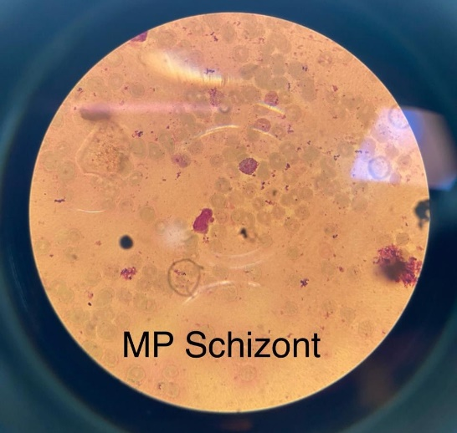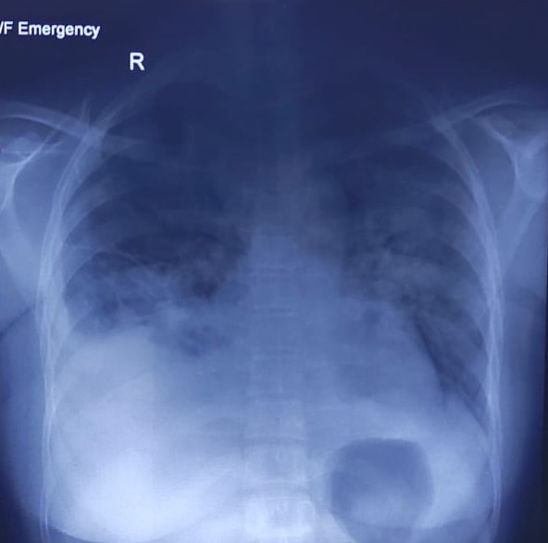
Figure 1: Peripheral blood smear Figure 2: Chest radiograph showing showing Plasmodium vivax schizonts. features of ARDS

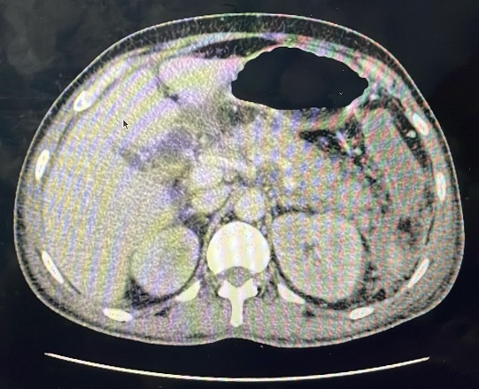
Figure 3: Computed Tomography (CT) scan of the abdomen showing bulky head of the pancreas with necrosis in the uncinate process.

Table.1

Patient and Reference value at different Parameters

Parameters | Pateint Value | Reference Value
Hemoglobin | 4.4 g/dL | 12-16 g/dL
Total leucocyte count | 15,400/mm³ | 4,000- 11,000/mm³
Platelet count | 88,000/mm³ | 150,000-450,000/mm³
BUN | 66 mg/dL | 14-50 mg/dL
S creatinine | 4.0 mg/dL | 0.5-1.4 mg/dL
ALT | 24 U/L | 8-40 U/L
AST | 213 U/L | 10-38 U/L
ALP | 151 U/L | 13-100 U/L
T.Bilirubin | 5.5 mg/dL | 0.3-1.3 mg/dL
D.Bilirubin | 4.3 mg/dL | 0.1-0.4 mg/dL
PT | 12.1sec | 9.5-13.5 sec
S.Calcium | 8.7 mg/dL | 8.5-10.2 mg/dL
Troponin I | 127.4 ng/L | 19 ng/L
D Dimer | 10,000 ng/mL | 500 ng/mL
S.Amylase | 289 U/L | 10-200 U/L
S.Lipase | 1413 U/L | 10-80 U/L
RBS | 58 mg/dL | 60-95 mg/dL
pH | 7.21 | 7.35-7.45
pO2 | 56 mm Hg | 83-108 mm Hg
pCO2 | 61 mm Hg | 35-48 mm Hg
Na+ | 129 mmol/L | 136-145 mmol/L
K+ | 3.2 mmol/L | 3.4-4.5 mmol/L
HCO3+ | 22 mmol/L | 22-26 mmol/L
Lactate | 3.2 mmol/L | 0.5-2.2 mmol/L
Hematocrit | 46% | 35-51%

