Epidemiology of Second-Line Antiretroviral Therapy Use in a Decentralized HIV Care Center in Senegal: A Retrospective Cross-Sectional Study (2019 – 2023)

Abstract:
Background: Human immunodeficiency virus (HIV) drug resistance necessitates second-line antiretroviral therapy (ART) in resource-limited settings. This study assessed the epidemiology of second-line ART use in a decentralized Senegalese HIV care center. Patients and methods: A retrospective cross-sectional study (2019-2023) included 400 records of PLHIV from Cardinal Hyacinthe Thiandoum Health Center. Data on sociodemographics, clinical parameters, and ART history were analyzed using SPSS. Results: Among 400 PLHIV, 20 (5.0%, 95% CI: 4-6%) required second-line ART. Most of them were women (80%), mean age of 58.5±15.5 years. The main switch reasons were treatment failure (55%) and intolerance (45%). Mean viral load pre-switch was 68,387±15,879 copies/mL; mean CD4 count was 293±60 cells/μL. All patients received AZT+3TC+LPV/r. Conclusion: In this cohort of 400 patients followed at the Cardinal Hyacinthe Thiandoum Health Center, we observed that targeted therapeutic education was associated with fewer switches to second-line ART, potentially conserving resources for more complex cases. Decentralized HIV care with reinforced therapeutic education may reduce second-line ART needs, preserving resources for complex cases.
Keywords: HIV, second-line ART, drug resistance, Senegal, decentralized care

Introduction
The emergence and transmission of drug-resistant strains of the human immunodeficiency virus (HIV) have resulted in a significant loss of antiretroviral treatment efficacy. In Senegal, emerging HIV strains resistant to first-line therapy have contributed to treatment challenges, particularly in decentralized care centers like ours. These resistant strains have now become a major public health concern in most low- and middle-income countries (1).
Antiretroviral treatment failure poses a constant threat at both the individual and collective levels, as it can lead to the spread of drug-resistant viruses. The prevalence of primary resistance has been estimated at 10.2% in Europe (2) and 12.2% in North America (3). Among patients experiencing virological failure under treatment, the prevalence of acquired resistance to antiretroviral therapy (ART) reached 56% (4).
In Africa, this prevalence ranges from 17% in West Africa to 23% in Southern Africa (5,6).
The general objective of this work is to analyze the epidemiology of second-line treatment use among people living with HIV (PLHIV) at the previously mentioned center located in Dakar, Senegal.

Patients and Methods
Study setting: This study was conducted at a Health Promotion Center located in Dakar, Northern District.
Study design: We carried out a retrospective cross-sectional study from January 2019 to December 2023, based on medical records of PLHIV.
Inclusion criteria: All PLHIV records followed at the CHT during the study period under one of the following protocols were included.
Table 1 : First-line Protocol
 | Second-line  Preferred | Second-line  Alternative
Adults, Adolescents | AZT+3TC+LPV/r | AZT (or ABC) +
Women of | Or | 3TC+DRV/r
childbearing âge | ABC+3TC+LPV/r | (or RAL ou LPV/r)
Under contraception | AZT+3TC+DTG | AZT (or ABC) +
 | Or | 3TC+ATV/r
 | ABC+3TC+DTG | (or LPV/r ou DRV/r)
Non-inclusion criteria: These were PLHIV records under treatment that were incomplete at the time of initiation of second-line therapy, as well as those transferred to the service already on a second-line protocol at the time of the study.
Data collection: The data collected included: address, occupation, age, sex, marital status, sexual orientation, adherence before initiation of second-line therapy, viral load, CD4 count, and year of initiation of second-line therapy.
Data analysis: Data were collected using the KoboCollect application and analyzed with SPSS software, version 2.0, year 2011. Frequencies were calculated for qualitative variables, and means with standard deviations for quantitative variables. Results were estimated with a 95% confidence interval.
Results
Frequency of second-line treatment use
Out of 400 PLHIV records regularly followed, only 20 were on second-line treatment, representing a prevalence of 5.00% (95% Confidence Interval: 4%–6%).
Distribution by residence
The majority of patients, 65%, came from urban areas, while 35% were from semi-urban areas. One patient resided outside Senegal. Figure 1 illustrates the distribution of patients according to residence.
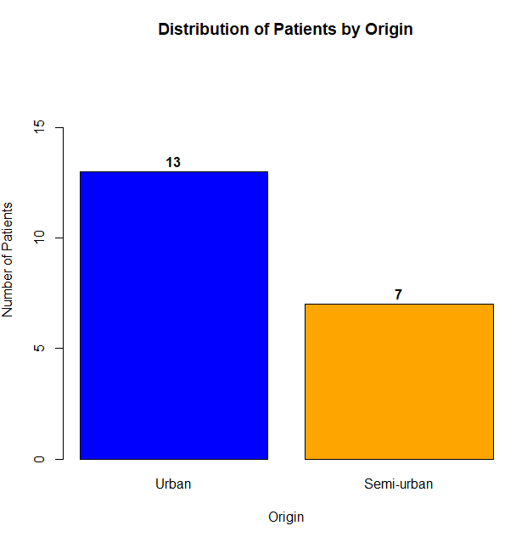
Figure 1: Distribution of PLHIV patients under second-line treatment by residence
Distribution of patients over time
The majority of patients in our study were initiated on second-line treatment in 2023.
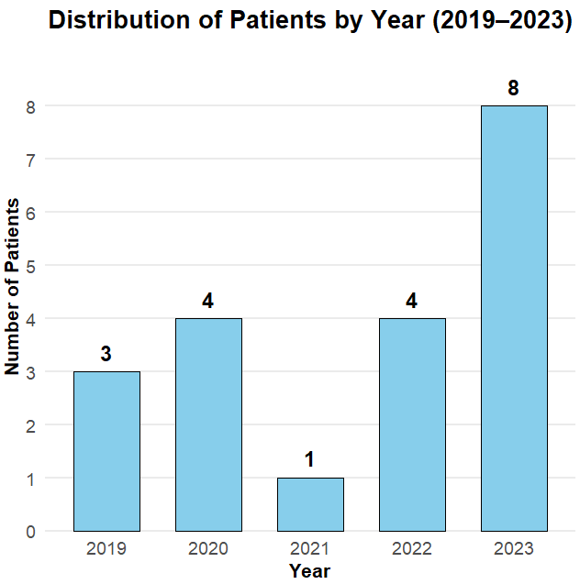

Figure 2: Distribution of PLHIV patients under second-line treatment by year of treatment initiation

Sex: The study population was predominantly female (80%), with a sex ratio of 4:1 (Female to Male).
Age: The mean age was 58.45 years (±15.45 years), ranging from 43 to 74 years. The age group [50–60 years] was the most represented, with 11 cases.
Distribution of patients by occupation
The majority of patients were unemployed, representing 25%, while 20% worked in the informal sector (Figure 3).

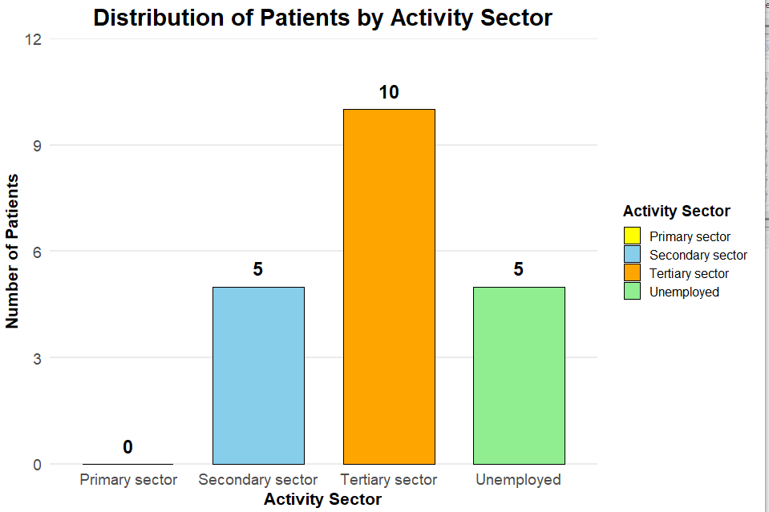 Figure 3: Distribution by occupation

Distribution of patients by sexual orientation
Ninety percent (90%) of patients were heterosexual, 5% were men who have sex with men (MSM), and 5% reported abstinence.
By marital status
The marital status of patients was varied, as shown in Table 2, with 55% of patients being married.

Table 2: Distribution of PLHIV patients under second-line treatment by marital status
marital status | Number | PErcentage (%)
Married | 11 | 55
Divorced | 4 | 20
Widowed | 3 | 15
Single | 2 | 10
Total | 20 | 100

Distribution by serotype: The majority of patients were HIV-1 positive (Table 3).
Table 3: Distribution of PLHIV patients under second-line treatment by HIV type
SErotype | number | Percentage (%)
VIH1 | 11 | 55
VIH2 | 6 | 30
VIH1 and 2 | 3 | 15
Total | 20 | 100

Distribution of patients by protocol used: All patients were on AZT+3TC+LPV/r.
Distribution by associated comorbidities
five patients had diabetes as a comorbidity, representing 25%, one patient had high blood pressure.
Reason for initiation of second-line treatment
Treatment failure was the main reason for switching to a second-line protocol. Table 4 shows the distribution of patients according to the reason for initiation of the second-line protocol.

Table 4: Distribution of PLHIV patients under second-line treatment by reason for initiation of second-line treatment
 | Number | Percentage
First-line treatment failure | 11 | 55
Intolerance | 9 | 45
Total | 20 | 100

Adherence before second-line treatment
The majority of patients were adherent (60%), and 40% of patients were non-adherent to treatment.
Virological and immunological parameters
The mean viral load was high at 68,387 copies (±15,879). The mean CD4 count was 292.88 (±60.14) as shown in (Table 5).
Table 5: Mean virological and immunological parameters for patients regardless of serotype
 | Mean | Standard deviation
Viral load | 68387.00 | 15879.14
CD4 | 292.88 | 60.14

Discussion
In our study, we found an overall prevalence of 5.00%. In the study by Dia et al. in 2015 in Saint Louis, Senegal, the prevalence was 28.63% (8). In Bamako in 2018, Maiga estimated the prevalence of second-line ARV use at 16.66% (9). In sub-Saharan Africa, the prevalence of second-line ART failure ranges widely, with several studies identifying key predictive factors such as adherence and baseline viral load per Ndashimye and al. (10). This difference can be explained by better patient understanding and engagement in their care. Strengthening therapeutic education likely improved adherence and consequently reduced resistance.
Approximately 90% of patients lived in the Dakar region. this result is similar to that observed by Ba at the Institute of Social Hygiene (IHS), Dakar, where 70% of patients came from the dakar region (11). This may be explained by the availability of care sites accessible to the population in the capital. Females represented 80% of the study population. indeed, D.Ba at Institute of Social Hygiene, S. Ba, N. M. Badiane, S. E. Hawes et al. in Senegal, and O. Djibo in Mali reported frequencies of 66%, 66.3%, and a sex ratio f/m of 2.54, respectively. this female predominance could be explained by the feminization of the hiv epidemic globally and particularly in Africa (5, 10, 12, 13).
The mean age in our series was 58.45 years. Most authors in Senegal have observed a younger population under 20 years. Our results can be explained by the overall predominance of patients in their sixties in our cohort and the fact that all young adults followed in our facility received good therapeutic education and actively participated in their care (6, 8, 12).
The patterns of drug resistance observed in our cohort are consistent with findings in West Africa, where second-line therapy failure is often linked to emergent resistance mutations as related by Adetokunboh et al. (14).
Most patients in our cohort were housewives. however, various professional categories were represented. similar results were observed by Touré at the Point G Hospital center in Mali with 39.2% (10).
Married individuals accounted for 55% of our study population. similar frequencies were observed by Djibo and Touré, found 66.8% and 63.5% married participants, respectively, in their studies. poor adherence in many couples could explain these results. Due to the anatomy and physiology of the female genital organ, women are generally more exposed (10, 12).
The main reason for initiating second-line treatment was first-line protocol failure in 55% of cases. This failure was both virological and immunological. this factor was observed by Mbange a. et al. in Dakar and Saint Louis, highlighting the importance of patient monitoring. although patients attended their consultation appointments regularly, some reported not taking their medication as prescribed. poor therapeutic adherence is a risk factor for resistance (13). Similar concerns have been highlighted in multicenter pediatric and adolescent cohorts, where the risk of second-line failure remained particularly high (14).
Resistance mechanisms, including mutations in the reverse transcriptase and protease genes, can reduce the efficacy of first-line regimens and necessitate the initiation of second-line therapy (16).
HIV-1 infection was most prevalent in our cohort, accounting for 55% of cases. our results were similar to those observed by Dia et al. in Senegal, with 83.58% of patients infected with HIV-1. in the cohorts of Touré in Mali and Sarr in senegal, HIV-1 was present in 98% and 64.83% of cases, respectively. This can be explained by the rarity of HIV-2 infection in our cohort (8, 12, 13).
Twenty-five percent of our patients had a comorbidity. indeed, the incidence of diabetes among PLHIV in the early 2010s was close to that of the general population, 10.8% versus 8%. a recent meta-analysis of 44 studies highlighted that diabetes incidence remains high among patients on ART worldwide, at 13.7 per 1,000 person-years, with significant geographical disparities: 19.1 per 1,000 person-years in the Americas, 15.9 in Africa, and 8 in Europe (13).
The mean viral load was 68,387 copies/ml, indicating therapeutic failure according to the adopted definition of virological failure. The viral load in our series was higher compared to that observed in the series by Djibo at the CHU of Point G in 2023, Touré in Bamako in 2022, and Sarr in Ziguinchor in 2020. However, in a multicenter comparative study conducted in Senegal in 2020, A. Mbange, A. Diouara, H. Ndiaye et al. found virological failures with viral loads as high as those observed in our study population. Our high viral loads could be explained by physicians’ reluctance to switch patients to second-line treatment, as they were not specialists and lacked basic training in the management of PLHIV (9, 10, 11, 13). Beyond the clinical determinants, qualitative studies have shown that patients often perceive the transition to second-line therapy as a ‘second chance’, underscoring the psychosocial and motivational dimension of adherence support (18).
Conclusion
Our retrospective cross-sectional study focused on the descriptive epidemiology of second-line ART use among patients followed at the Center in Dakar, Senegal. The study highlighted the predominance of females (16 cases, representing 80% of the study population), patients over 58 years old, and residents living near the facility. Diabetes was the only comorbidity identified. The majority of patients (60%) were adherent; however, all experienced virological failure, with a mean viral load of 68,387 copies/ml. Our results are not generalizable due to the small sample size and the recruitment method of the included patients. Therefore, a multicenter study is needed to better understand the epidemiology of PLHIV in decentralized care sites. Based on these findings, we formulate the following recommendations for all stakeholders involved in the care of PLHIV and for health authorities. These involve coordinated and integrated measures/strategies aimed at preventing the need for second-line treatment.
Disclaimer (Artificial intelligence)
Option 1:
Author(s) hereby declare that NO generative AI technologies such as Large Language Models (ChatGPT, COPILOT, etc.) and text-to-image generators have been used during the writing or editing of this manuscript.
Option 2:
Author(s) hereby declare that generative AI technologies such as Large Language Models, etc. have been used during the writing or editing of manuscripts. This explanation will include the name, version, model, and source of the generative AI technology and as well as all input prompts provided to the generative AI technology
Details of the AI usage are given below:
1.
2.
3.

References
- Doualla-Bell F, Turner D, Loemba H, et al. HIV Drug Resistance – Consequences for Low-Income Countries. Med Sci. 2004 ; 20(10):882‑6.
- Muller F, Taverne B. Perceptions of antiretroviral treatment failure among patients and healthcare professionals in Dakar. Bull Soc Pathol Exot. 2014 ; 107(4):281‑5.
- Hofstra LM, Sauvageot N, Albert J, et al. Transmission of HIV Drug Resistance and the Predicted Effect on Current First- line Regimens in Europe. Clin Infect Dis. 2016; 62(5):655‑63.

- Assoumou L, Charpentier C, Recordon-Pinson P, et al. Prevalence of HIV-1 drug resistance in treated patients with viral load >50 copies/mL: a 2014 French nationwide study. J Antimicrob Chemother. 2017;72(6):1769‑73.
- Ngo-Giang-Huong N, Huynh THK, Dagnra AY, et al. Prevalence of pretreatment HIV drug resistance in West African and Southeast Asian countries. J Antimicrob Chemother. 2023; 74(2):462 ‑ 7.
- Dia N, Lo S, Dia A, et al. Second-Line Antiretroviral Therapy: Prevalence and Epidemioclinical, Therapeutic, and Evolutionary Aspects in 2015 among People Living with HIV in Rural Settings. Med Mal Infect. 2018 ; 48(4, S1): S151‑2.
- Abdourhamane Alhousseini MAIGA. Resistance Profiles of Antiretroviral Therapy in HIV-1 Infected Patients with Second-Line Virological Failure: A Study of 309 Cases in Bamako, Mali. [Pharmacy Thesis]. University of Sciences, Techniques and Technologies of Bamako, Faculty of Pharmacy; 2018. Available at: https://www.mcours.net/cours/pdf/hasclic5/hassaaeclic233.pdf
- Demba BA. Changes in Antiretroviral Therapy among Patients Followed at the Institute of Social Hygiene, Dakar. [FMPOS] [Medical Thesis]: Cheikh Anta Diop University of Dakar; 2012. Available at: http://bibnum.ucad.sn/viewer.php?c=thm&d=thm%5f48114
- Ba S, Dia-Badiane NM, Hawes SE, et al. HIV-2 Infection in Senegal: Virological Failures and Resistance to Antiretroviral Drugs (ARVs). Pan Afr Med J. 2019 ; 33:222.
- Ndashimye E, Hakizimana D, Asiimwe-Kateera B, et al. Prevalence and predictors of second-line antiretroviral therapy failure among adults living with HIV in sub-Saharan Africa: a systematic review and meta-analysis. BMC Infect Dis. 2021;21:123. doi:10.1186/s12879-021-05897-2
- Djibo O. Factors Associated with Non-Adherence to Antiretroviral Therapy among People Living with HIV Followed in the Infectious and Tropical Diseases Department of Point-G University Hospital. Medical Doctorate Thesis. [Faculty of Medicine and Odonto-Stomatology]: University of Sciences, Techniques, and Technologies of Bamako; 2023
- Ekollo Mbange A, Malick Diouara AA, Diop-Ndiaye H, et al. High HIV-1 Virological Failure and Drug Resistance among Adult Patients Receiving First-Line ART for At least 12 Months at a Decentralized Urban HIV Clinic Setting in Senegal before the Test- and-Treat. Infect Dis (Auckl). 2021 ; 14:11786337211014504.
- TOURE Fadimata Mohomodou ATTAHER. Study of the Cohort of Patients on Antiretroviral Therapy Followed in the Infectious and Tropical Diseases Department of Point G University Hospital from March 2021 to February 2022. Medical Doctorate Thesis. [Faculty of Medicine and Odontostomatology]: University of Sciences, Techniques, and Technologies of Bamako; 2022.

- Boerma, R. S., Bunupuradah, T., Dow, D., Fokam, J., Kariminia, A., Lehman, D., ... & Paediatric Second‐line Study Group. (2017). Multicentre analysis of second‐line antiretroviral treatment in HIV‐infected children: adolescents at high risk of failure. J Int AIDS Soc, 20(1), 21930
- Adetokunboh OO, Bigna JJ, Tchounga BK, et al. HIV drug resistance and outcomes among patients on second-line antiretroviral therapy in West Africa: a systematic review. PLoS One. 2020;15(8):e0237987. doi:10.1371/journal.pone.0237987
- Tang MW, Shafer RW. HIV-1 Antiretroviral Drug Resistance: Mechanisms and Clinical Implications. Infect Dis Clin North Am. 2022;36(2):437-457. doi:10.1016/j.idc.2022.01.008

- Sarr GD. HIV Infection in Individuals Aged 60 Years and Older Followed in the Ziguinchor Region: Epidemiological, Clinical, Therapeutic, and Evolutionary Aspects. 2020 [cited 23 Oct 2023]; Available at: http://rivieresdusud.uasz.sn/xmlui/handle/123456789/1675

- Burns, R., Borges, J., Blasco, P., Vandenbulcke, A., Mukui, I., Magalasi, D., ... & Wringe, A. (2019). ‘I saw it as a second chance’: A qualitative exploration of experiences of treatment failure and regimen change among people living with HIV on second-and third-line ART in Kenya, Malawi and Mozambique. Global Public Health, 14(8), 1112-1124.

