Case report
Hepatic amebiasis simulating pleural effusion, diagnostic difficulties

ABSTRACT:
Introduction: Hepatic amebiasis is a serious illness that can be life-threatening if not treated appropriately. It can be complicated by pleural effusion, which in some cases complicates the diagnosis. We report the case of a 43-year-old patient with hepatic amebiasis revealed by a pleural effusion.
Observation: This 43-year-old patient was a known alcoholic and a 10-year tobacco addict who had not weaned himself off the 10 pack-year habit. He had no history of tuberculosis, and had been delirious for a month, after which an undocumented treatment had been prescribed. He was admitted to hospital with diffuse pain associated with a deterioration in general condition, including physical asthenia, non-selective anorexia and weight loss. He also had tenderness of the right hypochondrium in a context of intermittent fever, associated with chills and profuse sweating, all of which had been evolving for 1 month. On admission, physical examination revealed a right basal pleural effusion syndrome, a systemic inflammatory response syndrome, clinical anemia and altered general condition. Laboratory findings included hyponatremia, hyperleukocytosis with neutrophil predominance, normocytic anemia and increased C-reactive protein. Chest X-ray revealed a right basal pleural effusion, confirmed by computed tomography scan (CT scan), with the presence of a liver abscess. Amebic serology came back positive. Surgical drainage was performed, yielding brown pus. The patient was put on metronidazole. We noted a good clinical and biological evolution.
Conclusion: Hepatic amebiasis is a rare but serious condition. It may complicate amebic dysentery. Hepatic amebiasis should be considered in patients with pleural effusion in endemic areas and an interdisciplinary approach. It requires appropriate treatment to prevent complications.

Key words: amebiasis; hepatic; pleural effusion, Liver abscesses

INTRODUCTION
Liver abscesses are a public health problem in developing countries, with morbidity and mortality sometimes linked to delayed diagnosis and the severity of the disease. Amebic liver abscess is the most frequent extrahepatic localization of amebiasis [1]. In intertropical Africa, hospitalization rates vary from 1% to 2% [2,3]. Amebic abscess is the most frequent type of liver abscess in tropical zones. It represents the main extra-intestinal complication of amebiasis, occurring in 3% to 9% of cases [4]. Hepatic amebiasis is one of the emerging infections that can mimic or be complicated by pulmonary involvement, which may be contiguous or secondary. In liver abscesses, pleural effusion develops mainly as a result of inflammation of the diaphragm and increased vascular permeability, or may reveal a secondary location [1, 3]. In certain situations, this pleuropulmonary involvement may lead to a misdiagnosis of liver disease, hence the need for appropriate diagnostic management [5]. We report the case of a 43-year-old patient hospitalized in internal medicine for pleurisy revealing hepatic amebiasis.

CASE PRESENTATION
This 43-year-old patient was a known alcoholic and a 10-year tobacco addict who had not weaned himself off the habit (10 pack-years). He had no history of tuberculosis and had been suffering from delirium for a month, after which an undocumented treatment had been prescribed. The patient revealed a history of dysenteric diarrhoea in the previous month. He was admitted to hospital with diffuse pain associated with a deterioration in general condition, including physical asthenia, non-selective anorexia and weight loss. He also had tenderness of the right hypochondrium in a context of fever of allegation with no fixed schedule, associated with chills and profuse sweating, all of which had been evolving for 1 month.
On admission, physical examination revealed a right basal pleural effusion syndrome, a systemic inflammatory response syndrome, clinical anemia and altered general condition. Laboratory tests revealed hyponatremia at 121 meq/l, hyperleukocytosis at 30300 elements/µl with neutrophil predominance, normocytic anemia with HGB at 7.9g/dl, and increased C-reactive protein. The pleural puncture fluid was macroscopically purulent. It was exudative, with a leukocyte count of 60,000 and red blood cell count of 25,000, and a protein count of 132g. There were no germ on direct exam. Culture was negative. GenXpert was also negative. Chest X-ray revealed a right basal pleural effusion (figure 1). Computed tomography revealed an encysted right pleurisy with peripheral contrast and a posterobasal focus of condensation in the lower lobe of the homolateral lung, and a voluminous liver abscess pushing back the diaphragm (figures 1, 2, 3). Surgical drainage was performed. A voluminous abscessed collection was found perioperatively, with brown pus. Echocardiography revealed a medium-sized pericardial effusion opposite the right ventricle. Amebic serology came back positive with an estimated titre of 1/2560 (1/80) by ELISA test. The patient was started on metronidazole. We noted a good clinical and biological evolution with a decrease in hyperleukocytosis to 20,000 elements/µl and HGB to 11.9g/dl.
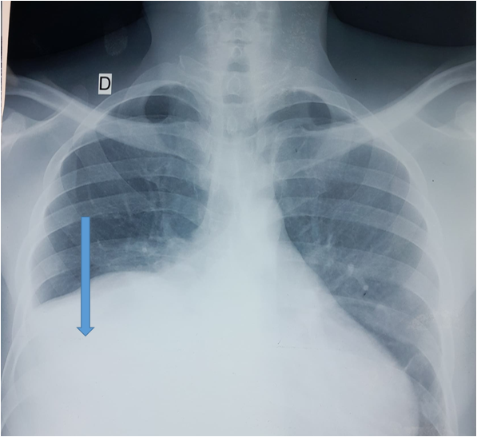
Figure 1: Radiographic image showing the appearance of a right basal pleural effusion (blue arrows).

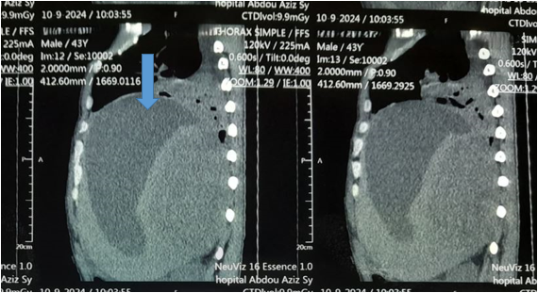
Figure 2: Large intrahepatic abscessed collection (blu arrows), sagittal plane

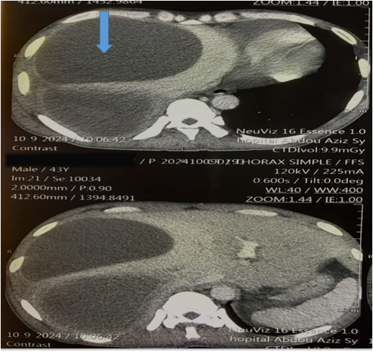
Figure 3: Amebic liver abscess as hypodense intrahepatic images (blue arrows), coronal plane

DISCUSSION
Hepatic amebiasis is the most frequent extra-intestinal complication of Entamoeba histolytica infection, a parasite endemic in many tropical and subtropical regions. Although rare, pleuropulmonary involvement is a severe form of the disease. In our case, the originality lies in the initial revelation of the pathology by pleurisy, whereas the hepatic signs were clinically discrete or even absent [1,2].
In epidemiological terms, it is estimated that around 50 million people are infected with E. histolytica every year, 10% of whom develop an invasive form, mainly liver abscesses [3]. The latter are most common in adult males, mainly between the ages of 18 and 50, with a predominance in India, Mexico, West Africa, Central America and South-East Asia [6]. In Africa, hepatic amebiasis accounts for 30-50% of hospitalized infectious hepatopathies [5]. Hepatic localizations, although less frequent (5-10% of amebic abscesses), are often under-diagnosed due to their misleading clinical presentation [7].
In Senegal, several hospital studies confirm the endemicity of hepatic amebiasis. Halima and al documented 48 cases between 2009 and 2013 in Aristide le Dantec hospital, Dakar [8]. Thioub et al reported 50 cases between 2012 and 2022 at Thies region [9]. Doumbia and al revealed 24 cases between 2013 and 2014 in Bamako, Mali [10].
Extension of liver abscesses into the pleural cavity may occur by direct trans-diaphragmatic contiguity, particularly when the abscess is located in the right lobe, in a sub-diaphragmatic situation. This propagation may lead to an inflammatory pleural reaction, serofibrinous or purulent effusion, or even amebic empyema. Pleurisy may precede liver signs or be isolated, making diagnosis difficult [11,12].
Functional thoracic signs are dominated by right basithoracic pain, fever, dyspnea and sometimes cough. Biologically, a non-specific inflammatory syndrome is common. Standard microbiological examinations of pleural fluid are often negative or show sterile flora, which should alert to a non-bacterial etiology [13].
Diagnosis is based on imaging (ultrasound, CT scan), which reveals liver abscesses, and on amoebic serology, which is highly sensitive in extra-intestinal forms. Pleural puncture may reveal sterile exudative fluid, but direct evidence of the parasite is rare [14,15].
Other bacterial conditions such as pyogenes infections can be ruled out by bacteriology and specific tests. The latter can sometimes complicate amoebiasis. Tuberculosis, which is endemic in our context, should be ruled out by bacteriology and molecular biology[16, 17].
Treatment is based on metronidazole at a curative dose for 10 days, followed by a contact amebicide such as paromomycin to eradicate cystic forms. Percutaneous drainage may be necessary in cases of large collections or poor clinical evolution [18,19].
Recognition of this atypical form is crucial. Any febrile right pleurisy in a patient from an endemic zone or with a digestive history should raise the suspicion of complicated hepatic amebiasis, even in the absence of obvious abdominal manifestations [20].

CONCLUSION:
Hepatic amebiasis is a rare desease, sometimes difficult to diagnose. It may be complicated by pleurisy. Diagnosis is based on imaging combined with microbiological analysis. Early treatment improves prognosis.
Ethical Approval:
As per international standards or university standards written ethical approval has been collected and preserved by the author(s).
Consent
As per international standards or university standards, patient(s) written consent has been collected and preserved by the author(s).

Disclaimer (Artificial intelligence)
Author(s) hereby declare that NO generative AI technologies such as Large Language Models (ChatGPT, COPILOT, etc.) and text-to-image generators have been used during the writing or editing of this manuscript.

REFERENCES

1. Khim G, Em S, Mo S, Townell N. Liver abscess: diagnostic and management issues found in the low resource setting. Br Med Bull. 2019;132(1):45‑52.
2. Diallo VMPC, Déguénonvo LF, Manga NM, Ka D, Diop SA, Seck A, et al. Characteristics of Liver Abscess in Department of Infectious Diseases at Fann Teaching University Hospital in Dakar, Senegal. AID. 2018;08(01):23‑31.
3. Nasrallah J, Akhoundi M, Haouchine D, Marteau A, Mantelet S, Wind P, et al. Updates on the worldwide burden of amoebiasis: A case series and literature review. J Infect Public Health. 2022;15(10):1134‑41.
4. Lardière-Deguelte S, Ragot E, Amroun K, Piardi T, Dokmak S, Bruno O, et al. Abcès hépatiques : diagnostic et prise en charge. J Chir Visc. 2015;152(4):233‑46.
5. Rydzak CE, Lima AS, Meirelles GSP. Endemic Thoracic Infections in Sub-Saharan Africa. Radiol Clin North Am. mai 2022;60(3):461‑79.
6. Maria Kozielewicz D, Sikorska K, Stalke P. Liver abscesses – from diagnosis to treatment. CEH. 2021;7(4):329‑36.
7. Ekabe CJ, Kehbila J, Clinton NA. Giant Amoebic Liver Abscess: A Rare Diagnosis in a Rural Setting of Sub-Saharan Africa. Silveira JF, éditeur. J Parasitol Res. 2021;2021:1‑7.
8. Halim A, Bassène ML, Diallo S, Thioubou MA, Gueye MN, Fall MP, et al. Aspects actuels de l’amibiase hépatique à Dakar à propos de 48 observations. Journal africain d’hépatogastroentérologie. JAHG. 2016 ; 10 : 170-175
9. Thioub D, Lawson ATD, Sarr NA, Mbengue N, Ba PA, Diop SA. Profil et prise en charge de l'abcès amibien du foie en milieu rural sénégalais.
Rev Mali Infect Microbiol. 2024 ; 19(2) : 56-62.

10. Doumbia K, Sow H, Mallé O, Dicko MY, Soumaré G, Katilé D, et al. L’abcès amibiens du foie : aspects cliniques et évolutifs au CHU Gabriel Toure de Bamako. Mali méd. 2018 ; 33(4) : 23-25

.
11. Putri Mega Juwita, Resti Yudhawati, Secondary pleuropulmonary amoebiasis due to liver abscess rupture: A complication case report in low resource setting. Int J Surg Case Rep. 2021 ; 85 : 106231
12. Nunes MC, Guimarães Júnior MH, Diamantino AC, Gelape CL, Ferrari TC. Cardiac manifestations of parasitic diseases. Heart. 2017;103(9):651-658
13. Lyche KD, Jensen WA, Kirsch CM, Yenokida GG, Maltz GS, Knauer CM. Pleuropulmonary manifestations of hepatic amebiasis. West J Med. 1990 ;153(3):275-278
14. Sharma MP, Ahuja V. Management of amoebic liver abscess. Arch Med Res. 2000;31(4 Suppl):S38–41.
15. Wuerz T, Kane JB, Boggild AK, et al. A review of amoebic liver abscess for clinicians in a nonendemic setting. Can J Gastroenterol. 2012;26(10):729–33.
16. Roediger R, Lisker-Melman M. Pyogenic and Amebic Infections of the Liver. Gastroenterol Clin North Am. 2020; 49(2):361-377. doi: 10.1016/j.gtc.2020.01.013. PMID: 32389368
17. Moifo B, Tcheliebou JM, Neossi Guena M, Kowo M, Gonsu FJ. Aspects échographiques d'une série de 58 abcès hépatiques au Cameroun [Ultrasonographic features of liver abscess based on a 58-case series in Cameroon]. Med Trop . 2011; 71(6):624-5
18. Mahmoud A, Abuelazm M, Ahmed AAS, Elshinawy M, Abdelwahab OA, Abdalshafy H, et al. Percutaneous catheter drainage versus needle aspiration for liver abscess management: an updated systematic review, meta-analysis, and meta-regression of randomized controlled trials. Ann Transl Med. 2023;11(5):190.
19. He Y, Huang D, Yang Y. Amoebic liver abscess: diagnosis and management of a single case in Guangdong, China. BMC Infect Dis. 2025; 25: 350
20. Ali IK, Clark CG, Petri WA Jr. Molecular epidemiology of amebiasis. Infect Genet Evol. 2008; 8(5):698-707.

