In vitro antioxidant activities of aqueous extracts of Melia azedarach L. and Vernonia amygdalina Del.

.
ABSTRACT
Aim: The present study was undertaken to evaluate the antioxidant potential of aqueous extracts of Melia azedarach (AEMA) and Vernonia amygdalina (AEVA) against free radical-induced oxidative damage.
Methodology: The antioxidant activities of the extracts were assessed through three in vitro assays, namely DPPH free radical scavenging assay, ABTS cation radical scavenging assay, and superoxide anion radical scavenging assay.
Results: The findings revealed that both AEMA and AEVA exhibited moderate scavenging activity in the DPPH assay, with IC₅₀ values of 149.83 µg/ml and 198.80 µg/ml, respectively. In the ABTS assay, AEMA and AEVA showed IC₅₀ values 83.38 µg/ml and 135.01 µg/ml respectively. In the case of the superoxide anion radical scavenging assay, AEMA and AEVA demonstrated IC₅₀ values of 130.87 µg/ml and 285.36 µg/ml, respectively.
Conclusion: Overall, the results indicate that Melia azedarach (AEMA) extract was more effective in scavenging free radicals compared to Vernonia amygdalina (AEVA) extract, highlighting its potential for further exploration of in vivo antioxidant efficacy and possible applications in the pharmaceutical and food industries.

Keywords: [Melia azedarach, Vernonia amygdalina, Antioxidant, DPPH, Extracts

1. INTRODUCTION

The imbalance between the production of reactive oxygen/nitrogen species (ROS/RNS) and their modulation by cellular antioxidant defences leads to oxidative stress (Valko et al., 2007; Waterman et al., 2002). Oxidative stress is recognised to play a major role in the pathophysiology of many human diseases, including diabetes, cancer, atherosclerosis, ageing, immunosuppression, and neurodegeneration (Harman, 1998; Reuter et Al. 2010). Several biological functions of human depend significantly on these free radicals. However, excessive production free radicals as a result of oxidative stress can start various chain reactions that can damage the cell membrane, obstruct the activity of key enzymes, prevent cellular processes essential for proper body function, inhibit normal cell division, destroy deoxyribonucleic acid (DNA), and prevent energy production if antioxidant system is unable to combat them (Kurutas, 2015). Supplementing the diet with antioxidant substances found in natural plant products is one way to address this issue (Knekt et al., 1996). According to recent studies, there is a negative correlation between the consumption of foods high in antioxidants and the prevalence of human disease (Sies, 1993). Butylated hydroxytoluene (BHT) and butylated hydroxyanisole (BHA), two synthetic antioxidants that are often used as commercially antioxidant are toxic to human body and may cause cancer (Grice, 1988; Wichi, 1986). Because of this, use of natural antioxidants has been increasing day by day. Numerous antioxidants found in plants serve to provide defence against diseases linked to free radicals (Ofoedu et al. 2022; Lawal et al., 2016). Plants make the majority of the antioxidant chemicals as secondary metabolites. They are the chemical substances found in plants (phytochemicals) that are not edible but have a variety of positive health effects and disease-prevention capabilities (Ahmed et al., 2014). They include non-essential nutrients, meaning that the body does not need them to function and maintain life (Rahim et al., 2022). However their consumption by human provide health benefits (Atia, 2014; Ahaotu et al. 2020).
Vernonia amygdalina (Bitter leaf), a member of the order Asterales, is well recognized for its diverse medicinal applications (Toyang & Verpoorte, 2013). The plant contains a wide range of bioactive compounds that contribute to its therapeutic potential. Traditionally, V. amygdalina has been employed in the treatment of typhoid, inflammatory disorders, malaria, kidney ailments, and gastrointestinal problems. Moreover, it has also been reported to play a role in the management of cancer and obesity. (Akah and Ekekwe, 1995; Yedjou et al., 2018; Fadimu et al., 2014; Okpe et al., 2016; Asante et al., 2019; Atangwho et al., 2012).
Melia azedarach, commonly known as the chinaberry tree, is widely valued in traditional medicine for its diverse therapeutic properties. Extracts from various plant parts have exhibited antibacterial, antifungal and anti-inflammatory activities (Akacha et al., 2016). Limonoids isolated from the plant showed potent insecticidal and antifeedant properties, making it a potential natural pesticide (Carpinella et al., 2003). In addition, certain compounds from M. azedarach have shown promising antiviral effects (Alché et al., 2002).

Keeping this in mind, the present study was planned to evaluate antioxidant potential of aqueous extracts of Melia azedarach and Vernonia amygdalina.

2. material and methods

Chemicals
2, 2- Diphenyl-1-picrylhydrazyl (DPPH), Nicotinamide adenine dinucleotide (NADH), Phenazine methosulphate, Nitrobluetetrazolium etc. were purchased from HiMedia Pvt. Limited. Mumbai, India. 2,2-azinobis (3-ethylbenzothiazoline-6-sulfonate) (ABTS) and Potassium persulfate were purchased from Sigma Chemical Co. (St Louis, MO, USA).
Collection of plant material and extraction
The leaves of the Melia azedarach L. and Vernonia amygdalina Del. were collected in the month of June from campus of SD College Barnala, Punjab, India (Fig. 1). Leaves (20 g) of both plants were washed and finely powdered using grinder and percolated in double distilled water (300 mL) for 24h at room temperature. The miscella so obtained was concentrated using rotary vacuum evaporator and finally dried to obtain aqueous extracts of Melia azedarach (AEMA) and Vernonia amygdalina (AEVA).

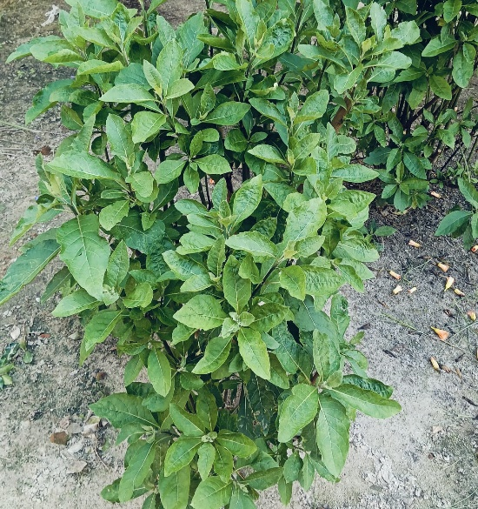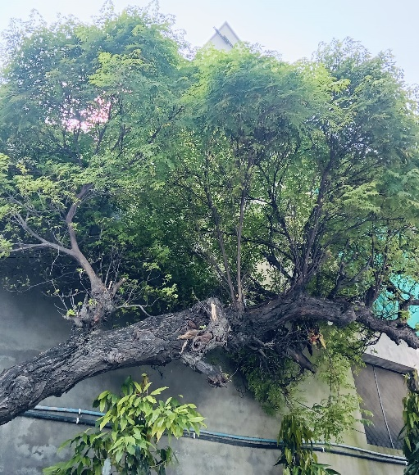

(A) (B)
Fig. 1. Photographs showing plants of Melia azedarach (A) and Vernonia amygdalina (B)

Antioxidant Assays
DPPH radical scavenging assay
DPPH radical scavenging assay was carried out using the method of Blois (1958) with few modifications. Various concentrations of extracts were mixed with methanolic solution of DPPH (2, 2-Diphenyl-1-picrylhydrazyl). After 30 minutes of incubation, absorbance was observed at 517 nm using UV-VIS spectrophotometer.

DPPH radical scavenging potential (%) = S0 - S1/S0 × 100
Where, S0 is the absorbance of DPPH solution containing vehicle solvent (control),
S1 is the absorbance of reaction mixture containing test sample.

ABTS cation radical scavenging assay
ABTS^{ꞏ +} scavenging assay was carried out by the protocol given by Re et al. (1999). The ABTS cation radical was pregenerated by reacting 7 mM ABTS stock solution with 2.45 mM potassium persulfate followed by incubating this solution in the dark at room temperature upto 16 hrs. The absorbance of the ABTS^{.+} solution was then diluted with methanol to bring its absorbance to 0.700 (±0.020). For testing scavenging potential, different concentrations of the extracts (50 to 400 µg/ml) were added to diluted ABTS solution and absorbance of the solution was taken at 734 nm using UV-VIS spectrophotometer.

ABTS^{.+} scavenging potential (%) = S0 - S1/S0 × 100
Where, S0 is the absorbance of ABTS solution containing vehicle solvent (control),
S1 is the absorbance of reaction mixture containing test sample.

Superoxide anion radical scavenging assay
Superoxide anion radical scavenging activity was assessed using a slightly modified method of the Nishikimi et al. (1972). In test tubes, about 1 ml of nitroblue tetrazolium (NBT) solution, 1 ml of NADH solution, and various concentrations of extracts (50-400 μg/ml) were mixed.The reaction was initiated through the addition of 100 μl of a 60 μM solution of phenazine methosulphate (PMS). The reaction mixture was incubated at 25 °C, and a UV-VIS spectrophotometer was used to measure the absorbance at 560 nm.

ABTS^{.+} scavenging potential (%) = S0 - S1/S0 × 100
Where, S0 is the absorbance of reaction mixture containing vehicle solvent (control),
S1 is the absorbance of reaction mixture containing test sample.

STATISTICAL ANALYSIS
Results were shown as the average ± standard error. IC₅₀ values were determined using regression equation. The data was analyzed for statistical significance using analysis of variance (One-way ANOVA) and the difference among means was compared by highly significant difference (HSD) using Tukey’s test. The significance of results was tested at *p ≤ 0.05.

3. results and discussion

Medicinal herbs are well recognised and well-liked for their numerous health advantages, including their ability to lower blood pressure, prevent cardiovascular disorders, and lower the risk of cancer by virtue of their antioxidant properties. High concentrations of antioxidants found in medicinal plants have the ability to prevent or delay the oxidation of lipids and other substances (Škrovánková et al., 2012). In the present investigation, both the extracts viz. AEMA and AEVA showed moderate scavenging activity against DPPH free radicals (Fig. 2). AEMA and AEVA exhibited IC₅₀ values of 149.83 and 198.80 µg/ml in DPPH assay (Table 1). In ABTS assay, extracts viz. AEMA and AEVA showed scavenging activity with inhibition of 89.77 % and 70.89 % respectively (Fig. 3). The IC₅₀ values of 83.38 and 135.01 µg/ml were obtained for AEMA and AEVA respectively in ABTS assay (Table 1). Both the extracts dose dependently and significantly scavenged the DPPH and ABTS radicals. Kumar et al. (2016) studied antioxidant activity of water extract of Henna leaves employing various antioxidant assays. Results demonstrated that extract scavenged the DPPH and ABTS radicals quite effectively with an IC50 of 352.77 and 380.87 μg/ml respectively. Mokoroane et al. (2020) reported antioxidant activity of leaves and stem-bark of Aloiampelos striatula using DPPH assay. It was found that different among various solvent extracts, water extract of the plant leaves showed high DPPH scavenging potential. Rajurkar and Hande (2011) studied antioxidant potential of few traditional Indian medicinal plants using DPPH and ABTS assays along with other assays. They reported that antioxidant activity measured by DPPH method was ranged from 0.20 to 1.50 mg trolox equivalent per g dry weight (mg, TEAC/g dw) while for ABTS assay, the TEAC values ranged from 0.65 to 7.37 mg, TEAC/g dw. The lowest value was obtained in case of Cyperus rotundus (0.65 mg, TEAC/g dw) and highest value in case of Acacia nilotica (7.37 mg, TEAC/g dw). Ramesh et al. (2025) evaluated the antioxidant potential of methanol flower extract of Peltophorum pterocarpum using DPPH and ABTS radical scavenging assays. The extract exhibited moderate activity against DPPH radicals, while showing strong ABTS radical scavenging capacity, with IC₅₀ values of 103.5 μg/ml and 48.60 μg/ml, respectively. Oraibi et al. (2025) assessed the antioxidant properties of root and aerial part extracts of Capparis spinosa L. using DPPH, ABTS, FRAP, and CUPRAC assays. Rutin and root extract exhibited significant antioxidant activity, whereas resveratrol and the aerial parts demonstrated only moderate potential.

Table 1. IC50 values obtained for AEMA and AEVA in various antioxidant assays
Assay | AEMA  (IC₅₀ values in µg/ml) | AEVA  (IC₅₀ values in µg/ml)
DPPH assay | 149.83 | 198.80
ABTS assay | 83.38 | 135.01
Superoxide anion radical scavenging assay | 130.87 | 285.36

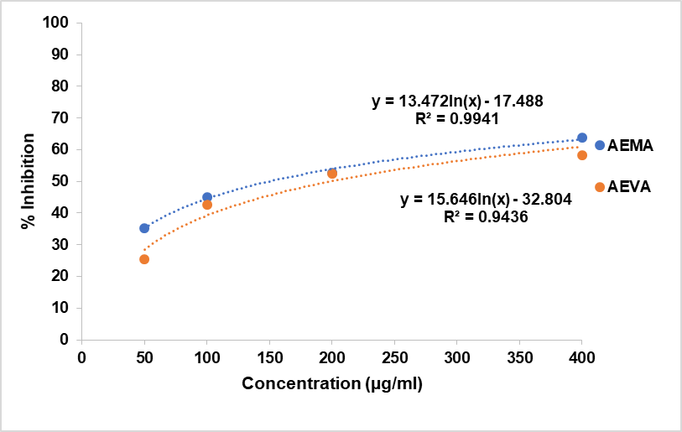

Fig. 2. The scavenging potential of various concentrations of AEMA & AEVA in DPPH assay.

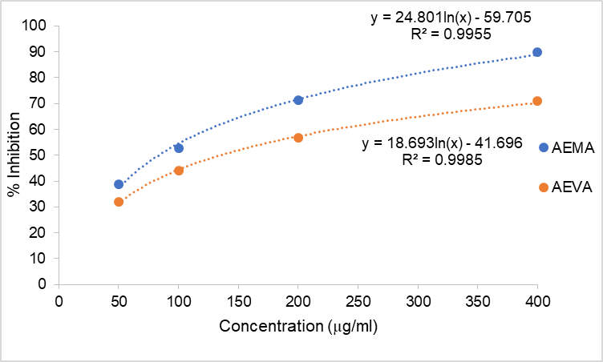

Fig. 3. The scavenging potential of various concentrations of AEMA & AEVA in ABTS assay.

In superoxide anion radical scavenging assay, both extracts showed AEMA (84.97 %) showed higher superoxide anion scavenging potential than AEVA (60.82 %) at highest tested concentration (Fig. 4). Results demonstrated that extracts scavenged the superoxide anion radicals quite effectively with an IC₅₀ of 130.87 and 285.36 μg/ml respectively (Table 1). Both extracts scavenged the radicals in dose depended manner. Kumar et al. (2011) evaluated antioxidant potential of chloroform and ethyl acetate fractions of Koelreuteria paniculata Laxm. It was found that chloroform and ethyl acetate fractions scavenged the superoxide anions by 19.59% and 67.12% respectively, DPPH radicals by 79.96% and 86.04% respectively; ABTS cation radicals by 87.63% and 94.3% respectively. . Irfan et al. (2011) evaluated radical scavenging activity of unripe fruits of Ficus glomerata Roxb. Results from the study revealed that 70% ethanolic extract scavenged superoxide anion and hydroxyl radical in dose dependent fashion. Sangeetha and Raj (2025) conducted an in vitro antioxidant evaluation of the leaf, stem, and root extracts of Plumbago zeylanica using assays such as DPPH, superoxide anion scavenging, and nitric oxide scavenging. Their findings revealed that the root extract exhibited the strongest antioxidant potential compared to the leaf and stem extracts.

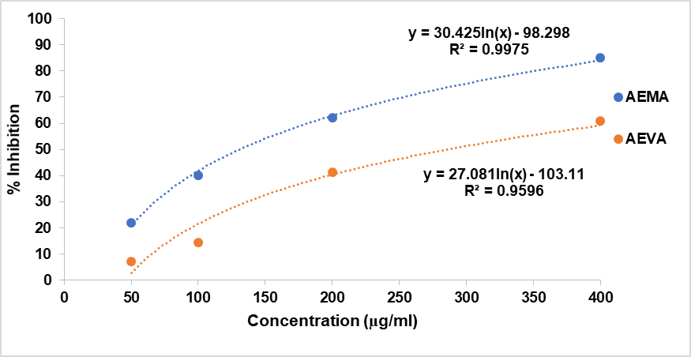

Fig. 4. The scavenging potential of various concentrations of AEMA & AEVA in Superoxide anion scavenging assay.

4. Conclusion

From the present investigation, it was concluded that in comparison to Vernonia amygdalina (AEVA), Melia azedarach (AEMA) was a more effective radical scavenger. In order to employ these extracts in the food and pharmaceutical sectors, more research is required to determine their in vivo antioxidant activity.

AcknowledgEments

Authors are thankful to DBT Star College Scheme, Govt. of India for providing financial support.

Competing interests

Authors have declared that they have no known competing financial interests OR non-financial interests OR personal relationships that could have appeared to influence the work reported in this paper.

Authors’ Contributions

Author 1 & 2 designed and carried out experiments, authors 3, 4 & 5 carried out statistical anlaysis and wrote first draft of manuscript. All authors read and approved the final manuscript.

Disclaimer (Artificial intelligence)
Author(s) hereby declare that generative AI technologies such as ChatGPT and quillbot have been used for editing of manuscript and formatting of references.

References

Ahaotu, N.N., Echeta, C.K., Bede, N.E., Awuchi, C.G., Anosike, C.L., Ibeabuchi, C.J., & Ojukwu, M. (2020). Study on the Nutritional and Chemical Composition of “Ogiri” Condiment Made from Sandbox Seed (Hura Crepitans) as Affected by Fermentation Time. GSC Biological & Pharmaceutical Sciences, 11(2), 105–113.
Ahmed, Y.C., Rokiah, H., Shaida, F.S., Othman, S., Zpa, L., &Kheng, L.O.(2014). Bioprospecting Medicinal Plants for Antioxidant Components. Asian Pacific Journal of Tropical Medicine, 7(Suppl 1), 5553–5559
Akacha, M., Lahbib, K., Remadi, M.D., & Boughanmi, N.G. (2016). Antibacterial, antifungal and anti-inflammatory activities of Melia azedarach ethanolic leaf extract. Bangladesh Journal of Pharmacology, 11, 666–674.
Akah, P.A., & Ekekwe, R.K. (1995). Ethnopharmacology of some Asteraceae family used in Nigerian traditional medicine. Fitoterapia, 66(4), 351–355.
Alché, L.E., Barquero, A.A., Sanjuan, N.A., & Coto, C.E. (2002). An antiviral principle present in a purified fraction from Melia azedarach L. leaf aqueous extract restrains herpes simplex virus type 1 propagation. Phytotherapy Research, 16(4), 348–352.
Asante, D.B., Henneh, I.T., Acheampong, D.O., Kyei, F., Adokoh, C.K., Ofori, E.G., Domey, N.K., Adakudugu, E., Tangella, L.P., & Ameyaw, E.O. (2019). Anti-inflammatory, anti-nociceptive and antipyretic activity of young and old leaves of Vernonia amygdalina. Biomedicine & Pharmacotherapy, 111, 1187–1203.
Atangwho, I.J., Edet, E.E., Uti, D.E., Obi, A.U., Asmawi, M.Z., & Ahmad, M. (2012). Biochemical and histological impact of Vernonia amygdalina supplemented diet in obese rats. Saudi Journal of Biological Sciences, 19(3), 385–392.
Atia, A.E., & Abdullah, A. (2014). Modulation of Nrf2/Keap1 Pathway by Dietary Phytochemicals. International Journal of Research in Medical Sciences, 2, 375–381.
Blois, M.S. (1958) Antioxidant determinations by the use of a stable free radical. Nature, 29, 1199-200.
Carpinella, M.C., Herrero, G.G., Alonso, R.A., & Palacios, S.M. (2003). Antifeedant and insecticide properties of a limonoid from Melia azedarach (Meliaceae) with potential use for pest management. Journal of Agricultural and Food Chemistry, 51(2), 369–374.
Grice, H.P. (1988) Enhanced tumour development by butylated hydroxyanisole (BHA) from the prospective of effect on forestomach and oesophageal squamous epithelium. Food and Chemical Toxicolology, 26, 717–723
Harman D. (1998). Free radical theory of aging. Current status. Amster-dam: Elsevier, p. 3-7.
Irfan, Y., Khan, M.A., & Shivakumar, H. (2011). Study on Anti-oxidant Activity of Unripe Fruit of Ficus glomerata (Roxb.) using In-vitro Models. Free Radicals and Antioxidants, 1, 69-74
Knekt, P., Jarvinen, R., Reunanen, A. & Maatela, J. (1996). Flavonoid intake and coronary mortality in Finland: A cohort study. British Medical Journal, 312, 478–481
Kumar, M., Kumar, S., & Kaur, S. (2011). Investigations on DNA protective and antioxidant potential of chloroform and ethyl acetate fractions of Koelreuteria paniculata Laxm. African Journal of Pharmacy and Pharmacology, 5(3), 421-427.
Kumar, M., Chandel, M., Kaur, P., Pandit, K., Kaur, V., Kaur, S., & Kaur, S. (2016). Chemical composition and inhibitory effects of water extract of Henna leaves on reactive oxygen species, DNA scission and proliferation of cancer cells. EXCLI Journal, 2016 Dec 21;15:842-857.
Kurutas, E.B. (2015). The importance of antioxidants which play the role in cellular response against oxidative/nitrosative stress: current state. Nutrition Journal, 15, 71.
Lawal, B., Shittu, O.K., Obiokpa, F.I., Berinyuy, E.B., & Mohammed, H. (2016)African Natural Products with Potential Antioxidants and Hepatoprotectives Properties: A Review. Clinical Phytoscience, 2016, 2–23.
Mokoroane, K.T., Pillai, M.K., & Magama, S. (2020). 2,2-Diphenyl-1-picrylhydrazyl (DPPH) radical scavenging activity of extracts from Aloiampelos striatula. Food Research, 4 (6): 2062 – 2066.
Nishikimi, M., Appaji, N., & Yagi K. (1972), The occurrence of superoxide anion in the reaction of reduced phenazine methosulfate and molecular oxygen. Biochem Biophys Res Commun. 46, 849-54.
Ofoedu, C.E. Ofoedu, E.O. Chacha, J.S. Owuamanam, C.I., Efekalam, I.S. Awuchi, C.G., & Pandiselvam, R. (2022). Comparative Evaluation of Physicochemical, Antioxidant, and Sensory Properties of Red Wine as Markers of Its Quality and Authenticity. International Journal of Food Science, 2022(8368992), 1–17.
Okpe, O., Habila, N., Ikwebe, J., Upev, V.A., Okoduwa, S.I., & Isaac, O.T. (2016). Antimalarial potential of Carica papaya and Vernonia amygdalina in mice infected with Plasmodium berghei. Journal of Tropical Medicine, 2016, 8738972.
Oraibi, A.I., Dawood, A.H., Trabelsi, G., Mahamat, O.B., Chekir-Ghedira, L., & Kilani-Jaziri, S. (2025). Antioxidant activity and selective cytotoxicity in HCT-116 and WI-38 cell lines of LC-MS/MS profiled extract from Capparis spinosa L. Frontiers in Chemistry, 13, 1540174.
Rahim, M.A.,Umar, M., Habib, A., Imran, M., Khalid, W., Lima, C.M.G., Shoukat, A., Itrat, N., Nazir, A., Ejaz, A., & et. al. (2022). Photochemistry, Functional Properties, Food Applications, and Health Prospective of Black Rice. Journal of Chemistry, 2022: 1–21.
Rajurkar, N.S., & Hande, S.M. (2011). Estimation of phytochemical content and antioxidant activity of some selected traditional Indian medicinal plants. Indian Journal of Pharmaceutical Sciences, 73(2), 146-51.
Ramesh, B.S., Tejaswini, A., Malini Shetty, A.G., Sharon, R., Chandana, U., & Thanuja, D.L. (2025). DPPH and ABTS radical scavenging assay and antibacterial efficacy of methanol flower extract of Peltophorum pterocarpum (DC.) Backer ex K. Heyne. Asian Journal of Biology, 21(8), 39–47.
Re, R., Pellegrini, N., Proteggente, A., Pannala, A., Yang, M., & Rice-Evans, C. (1999). Antioxidant activity applying an improved ABTS radical cation decolorization assay. Free Radical Biology & Medicine, 26,1231-7.
Reuter, S., Gupta, S. C., Chaturvedi, M. M., & Aggarwal, B.B. (2010). Oxidative stress, inflammation, and cancer: how are they linked? Free Radical Biology and Medicine, 49, 1603–1616.
Sangeetha, G., & Raj, N. (2025). Comparative in vitro antioxidant analysis of leaf, stem and root extracts of Plumbago zeylanica L. (Plumbaginaceae). Current Botany, 16, 220–225.
Sies, H., (1993) Strategies of antioxidant defense. European Journal of Biochemistry, 215: 213–219
Škrovánková, S., Mišurcová, L., & Machů, L. (2012). Antioxidant activity and protecting health effects of common medicinal plants. Advances in Food and Nutrition Research, 67, 75-139.
Toyang, N.J., & Verpoorte, R. (2013). A review of the medicinal potentials of plants of the genus Vernonia (Asteraceae). Journal of Ethnopharmacology, 146(3), 681–723.
Valko, M., Leibfritz, D., Moncol, J., Cronin, M.T.D., Mazur, M., & Telser, J. (2007)Free radicals and antioxidants in normal physiological functions and human disease. International Journal of Biochemistry & Cell Biology, 39, 44–84
Waterman, K.C., Adami, R.C., Alsante, K.M., Hong, J., Landis, M.S., Lombardo, F., & Roberts, C.J. (2002). Stabilization of pharmaceuticals to oxidative degradation. Pharmaceutical Development & Technology, 7, 1–32.
Wichi, H.C. (1986). Safety evaluation of butylated hydroxytoluene (BHT) in the liver, lung and gastrointestinal tract. Food and Chemical Toxicolology, 24, 1127–1130
Yedjou, C.G., Sims, J.N., Njiki, S., Tsabang, N., Ogungbe, I.V., & Tchounwou, P.B. (2018). Vernonia amygdalina Delile exhibits a potential for the treatment of acute promyelocytic leukemia. Global Journal of Advanced Engineering Technology and Sciences, 5(8), 1–9.
Yomi, F.O., Mohammed I., & Zurmi S.R.(2014). Ethnomedicinal Survey of Anti-Typhoid Plants in Ijebu Ode Local Government Area of Ogun State, Nigeria. International Journal of Science & Nature, 5:332-336

