Deep Learning-Based Skin Type Identification and Personalized Skincare Recommendations

.
ABSTRACT

The skin is the outermost layer of the body and is crucial for women's beauty and health. Understanding one's skin type is essential for effective skincare, as a lack of knowledge can lead to adverse effects. This study proposes a deep learning-based system designed to identify women's facial skin types and provide personalized skincare recommendations. Leveraging the MobileNetV2 architecture as the base model, a convolutional neural network, the model was trained to classify five skin types: Dry, Oily, Normal, Combination, and Sensitive. Data were collected from cosmetology specialists and online datasets, with preprocessing and image augmentation to enhance the dataset. The approach involved modifying the MobileNetV2 by adding GlobalAveragePooling2D and custom dense layers tailored for skin type classification. The developed model achieved a testing accuracy of 93.78% and was integrated into a Flask-based web application. This application allows users to upload facial images, provide their age and allergy status, and receive tailored skincare routines based on the predicted skin type. User testing demonstrated a high level of satisfaction, with 64% of respondents finding the skin type predictions accurate and 61% considering the skincare recommendations useful. The website's interface received positive feedback, with 95% of respondents rating it as user-friendly. While the model performed well in classifying most skin types, it encountered difficulties in differentiating between visually similar types, such as Combination and Sensitive, where misclassifications occurred due to overlapping visual features. Additionally, the study faced limitations stemming from image quality variability, and the constraints of rule-based recommendations. Furthermore, the current dataset did not fully represent all demographic groups and diverse skin tones. Overall, this study contributes to the scientific community by presenting a practical, real-time application of AI in dermatology that bridges the gap between technology and everyday skincare needs.

Keywords: Skin Type Identification, Skincare Routine, MobileNetV2, Convolutional Neural Networks, Deep Learning

1. INTRODUCTION

Skin is the outermost layer of the human body. It is the largest organ of the integumentary system. It serves as a protective layer for the internal organs of the human body. Facial skin protects the inner part of the face such as the eyes, nose, mouth, and other. It protects the underlying muscles, bones, ligaments, and internal organs with several layers. Human skin is similar to that of most other mammals (Punal. M. Arabi et al., 2015). The face's skin and subcutaneous tissue can be divided into aesthetic units based on the skin's color, texture, thickness, and mobility within each unit (Eyelid and Midcheek Anatomy, n.d.). Maintaining healthy skin is crucial because it acts as a natural filter, helps regulate body temperature, protects the interior from the outside, and always expands.
According to the American Academy of Dermatology (AAD), there are five primary types of skin: oily, dry, normal, combination, and sensitive (What Skin Type Do I Have? | Determine Your Skin Type | CeraVe, n.d.). Each skin type has its unique characteristics and requirements that can impact the appearance and texture of one’s skin. Regarding sensitive skin, Sensitive skin may sting or burn after product use. Normal skin is clear and not sensitive. Dry skin is flaky, itchy, or rough. Oily skin is shiny and greasy. Combination skin is dry in some areas and oily in others. Understanding your skin type will help you learn how to take care of your skin and select skincare products that are right for you.
According to Annie Stuart, skin type depends on how much water is in the skin, which affects its comfort and elasticity, how oily it is, which affects its softness, and how sensitive it is (What’s Your Skin Type?, n.d.). There are five skin types such as normal, oily, dry, sensitive, and combination. Normal skin type is not too dry and not too oily, normal skin has no or few imperfections, no severe sensitivity, barely visible pores, and a radiant complexion. When it comes to oily skin, The skin looks and feels oily, greasy, shiny, and thick. Dry skin is distinguished by a deficiency of sebum, which is the natural oil produced by the skin's sebaceous glands to keep it moisturized. Sensitive skin is a skin type that is prone to irritation and sensitivity. Also, combination skin can be dry or normal in some areas and oily in others, such as the T-zone (nose, forehead, and chin).
Taking care of your skin is essential for maintaining not just your appearance, but also your overall well-being. Your skin acts as a protective barrier, shielding you from environmental pollutants and harmful UV rays, while also regulating body temperature and allowing you to experience sensory touch. Establishing a skincare is crucial, as it allows you to invest time in nurturing and maintaining your skin daily. By committing to skincare, you can attain the benefits of healthy, glowing skin while ensuring its longevity. According to Dr. Wassef of Dermatology & Cutaneous Surgery Institute, good skincare helps keep the skin in good condition (The Importance of Skin Care, n.d.). With proper care and maintenance, skin can look better than ever before. The skin sheds itself daily, which is a major reason to start caring for it. Future skin can be dull with many imperfections if not cared for properly. That is why it is so important to take care of the skin now to protect future skin.
Embracing various skincare steps can help you maintain your skin and radiate charm and confidence. The food we eat affects our skin. Overeating junk food can lead to acne and pimples, while a balanced diet can help maintain healthy skin. Eating seeds and nuts with good fats can keep your skin smooth and glossy. If you notice sudden redness, acne, or unusual patches on your skin, it is best to see a dermatologist. They can accurately diagnose and treat any skin issues. Avoid self-medication and seek professional help from a good skincare clinic. Your hair can also indicate skin problems. If you have an oily scalp or dandruff, it can cause acne on your face. Excess oil clogs pores, leading to pimples. Treating dandruff effectively can help eliminate acne. Seek advice from a hair expert or a skin and hair clinic for the right solutions. There are various treatments available for dandruff that can give you quick results (The Importance Of Maintaining Skin Health, n.d.).
Also, taking care of your skin should be a routine. Cleanse, tone, and moisturize your skin properly. Do not forget to apply sunscreen before going outside to protect your skin from harmful sun rays (The Importance Of Maintaining Skin Health, n.d.). Skincare routine is a set of practices involving the cleansing and application of topical products to maintain and improve the skin's barrier function and integrity (Lichterfeld et al., 2015). This can include washing, showering, and using lotions, creams, or ointments. The Evidence-Based Skin Care research emphasizes that a skincare routine goes beyond just washing your face. It is a regimen that aims to keep your skin healthy by cleansing it, providing hydration, and addressing specific concerns (Lichterfeld et al., 2015).
When starting a skincare routine, it is important to think about your skin type, such as normal, oily, dry, combination or sensitive. The environment also matters, like sun exposure and pollution. Products should match your skin's needs and can be adjusted for different conditions. Using the right ingredients can help keep your skin healthy and protected (Krutmann et al., 2017). To keep a skincare routine effective, consistency is key. Use your products daily and adjust them as needed for different seasons (Fabbrocini et al., 2010). For example, use richer moisturizers in cold weather. Check your skin's needs regularly and make changes if necessary (Berardesca et al., 2006). A balanced diet, drinking plenty of water, and getting enough sleep also help maintain healthy skin.
According to Dr. Leslie Baumann, understanding your skin type is the foundation of a successful skincare routine. Choosing a skincare routine starts with knowing your skin type. For oily skin, use products that control oil. For dry skin, choose hydrating products. Sensitive skin needs gentle, fragrance-free items. Normal skin can use a variety of products but benefits from a balanced routine with gentle cleansers and light moisturizers. Combination skin, which has both oily and dry areas, requires products that can address both concerns, such as oil-free moisturizers and targeted treatments for different zones. Read ingredient labels to know what each product does. Consulting a dermatologist can give you personalized advice and help you pick the best products for your skin (Iraqui & Das, 2022).
Each person has his or her own skin type, which is a combination of dryness, oiliness, and sensitivity. It is important to understand consumer skin type so that consumers can take proper care of it. Figuring out their skin type can be tricky to do on a consumer's own, so it is helpful to consult with professionals like dermatologists or beauticians who have special knowledge about skin. They can help identify consumer’s skin type and suggest a skincare routine that suits you. However, in today's busy world, people often do not have the time to visit skincare experts or cosmetology experts. As a result, they look for convenient solutions, and technology comes to their aid. Automated systems have become increasingly popular for identifying skin types and suggesting suitable skincare products and routines. These systems make the process straightforward and enable individuals to take care of their skin properly. Traditionally, skin typing depended on personal opinions or answers to questionnaires, which often led to inaccurate assessments. However, Artificial Intelligence has revolutionized dermatology. It can make skin typing more reliable and accurate with the help of machine learning and deep learning algorithms. The data analysis performed by these algorithms leads to precise and personalized assessments of skin types, making better recommendations for skincare routines and treatment plans.
Artificial intelligence is a rapidly evolving field that encompasses the development of intelligent agents, which are systems that can reason, learn, and act autonomously. Research in the field of artificial intelligence explores various subfields, including machine learning and deep learning, where algorithms improve performance based on data (Samanta et al., 2024). A study by Samanta et al. (2024) exemplifies this by proposing a multi-layered network approach to solve a complex game scenario in transportation systems . This highlights the ongoing exploration of artificial intelligence in tackling intricate real-world problems.
Machine learning is a field of artificial intelligence involves with developing algorithms that can learn from data without hard-coded instructions. These algorithms improve their performance on a specific task over time by analyzing data and identifying patterns. Recent research in the field explores various aspects, including anomaly detection in real-world data (Bouman et al., 2023). For instance, a paper titled "Unsupervised Anomaly Detection Algorithms on Real-world Data: How Many Do We Need?" investigates the effectiveness of different unsupervised anomaly detection algorithms on various real-world datasets (Bouman et al., 2023). This exemplifies the ongoing exploration of machine learning's capabilities in practical applications.
Machine learning and deep learning have been incorporated into smartphone applications and online platforms, making it easy for people to use these technologies from the comfort of their homes. By simply taking a photo of their skin, these systems can suggest suitable skincare products and routines. These systems save time and effort while providing expert advice. Deep learning is a rapidly growing field that plays a vital role in various industries, including fraud detection, algorithmic trading, and personalized recommendations. These models are used for image and speech recognition, enabling groundbreaking advancements such as autonomous vehicles and personalized virtual assistants. In addition to skin type classification, research has examined broader skin disease identification techniques using machine learning, which further highlights the potential of AI in dermatology (Vayadande et al., 2024). They also play a significant role in cybersecurity and environmental monitoring, addressing climate-related challenges. As technology advances, these models will become even more versatile, leading to fantastic discoveries in numerous fields.
The proposed system integrates the trained CNN model into a Flask-based web application that allows users to upload facial images and input personal data such as age and allergy information. Based on the predicted skin type, the system then provides tailored skincare routine suggestions. This approach makes expert-level skincare advice accessible to the general public in real-time and at no cost.

2. methodology

This section illuminates the research design and methodology applied for this study. The process incorporates data collection, preprocessing, model development, model evaluation, and the integration of the model with a web application for real-time predictions. The methodology for this research consists of four primary components:
- Data Collection and Preprocessing
- Model Development
- Model Evaluation
- Web Application Development
The dataset comprises of five skin types as normal, dry, oily, combination, and sensitive. As noted by Uzair et al., 2015, most of the skin spectral databases are not publicly available. However, Images were collected from both cosmetology specialists and online image datasets. To refine the dataset, low-quality images were filter out. The categorization of these skin types was determined by cosmetology specialists to ensure accuracy and relevance.

Table 1. Data Counts by Skin Type

Skin Type | Count
Normal | 450
Dry | 450
Oily | 450
Combination | 450
Sensitive | 450

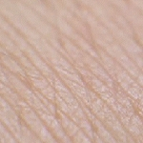  Fig 1. Normal Skin | 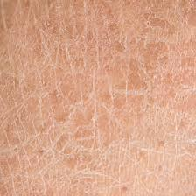  Fig 2. Dry Skin | 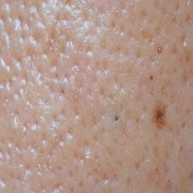  Fig 3. Oily Skin
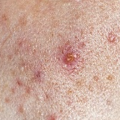  Fig 4. Combination Skin | 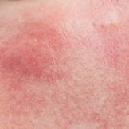  Fig 5. Sensitive Skin
For preprocessing, the images were resized to 224x224 pixels. This step ensured that all images were consistent in size before being fed into the model. To enhance the dataset, augmentation techniques were applied, including:
- Rotations of 90º and 180º
- Horizontal and vertical flips
- Combinations of rotations with flips
After preprocessing and augmentation, the data set is consistent with 2250 images. The dataset was split into training, validation, and testing sets in an 80:10:10 ratio, respectively. Specifically, 360 images per skin type were used for training, while 45 images per skin type were used for both validation and testing. This dataset ensures a balanced representation of each skin type.
In this study, the pre-trained MobileNetV2 architecture on ImageNet has been used as a base model. The last few layers were removed and replaced with custom layers that best suited the classification of skin types. This modified architecture consisted of a GlobalAveragePooling2D layer, dense layers with ReLU activation, and a softmax layer that classified the given input image into any one of five skin types. Adam optimizer and categorical cross-entropy loss function have been adopted in the proposed model for training. It has been trained for 10 epochs, monitoring the performance on the validation set, extracted from the dataset along with a test set, in a proper ratio of 80:10:10 to avoid overfitting.
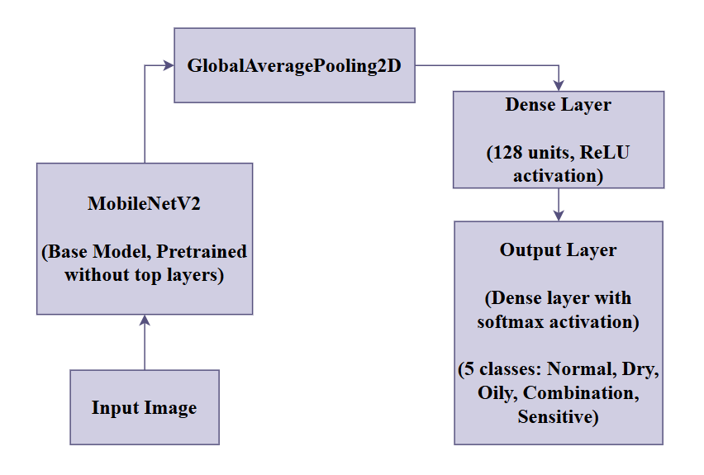
Fig 6. The Proposed Model Architecture

After training the model, it is essential to evaluate its performance to ensure it accurately classifies skin types. The following metrics and methods were used to assess the model's effectiveness of the model: Accuracy helps in reflecting the proportionate number of instances against the total instances that are correctly classified. The accuracy of the model was determined for the training and validation datasets together with the test dataset to make sure that its generalization capability could be determined. A confusion matrix was created to get an overview of the model’s performance. This will give a detailed insight into various true positives, true negatives, false positives, and false negatives for each skin type. This allows us to identify any specific skin types that the model might struggle with. The classification report displays precision, recall, and F1-score for each category. These metrics give an insight into how the model has performed for each skin type: Precision is the ratio of true positive predictions to total positive predictions for a skin type. Recall is the ratio of true positive predictions to actual positive values for a particular skin type. The F1-score is the harmonic mean of precision and recall. Thus, it provides the right balance for both metrics. The loss of the model was monitored to ensure it converged appropriately during training and validation. It used the categorical cross-entropy loss function, which measures the difference between the predicted and actual classification.
These metrics are calculated by training the model on 10 epochs using a dataset of 2,250 images with 80% for training, 10% for validation, and 10% for testing. The performance of the model on these metrics comprehensively briefed the accuracy and generalization ability of this model, thus being suitable for real-world applications in recommending skincare routines.
The trained model is then integrated into the Flask web application. The user can upload an image of their skin, and input their age, and any allergies they have. The system then gives a prediction of their skin type along with some personalized skincare recommendations. Depending on the predicted skin type, age group, and allergy status, a rule-based web application would provide personalized skincare advice.
A workflow diagram of the proposed system is presented in Fig 7 to illustrate the sequential process, from data collection and preprocessing to model training, evaluation, and deployment as a web application.
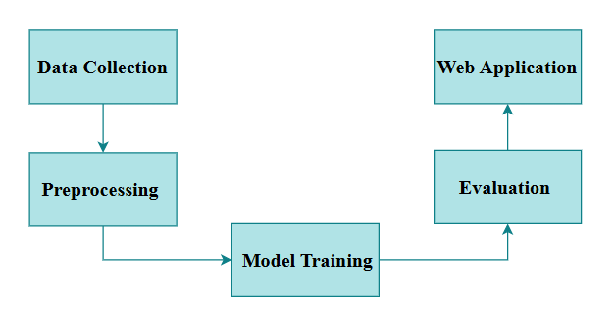
Fig 7. Workflow Diagram
Below is a high-level design diagram of the system, showing the interaction between the user interface, the web application, and the CNN model:
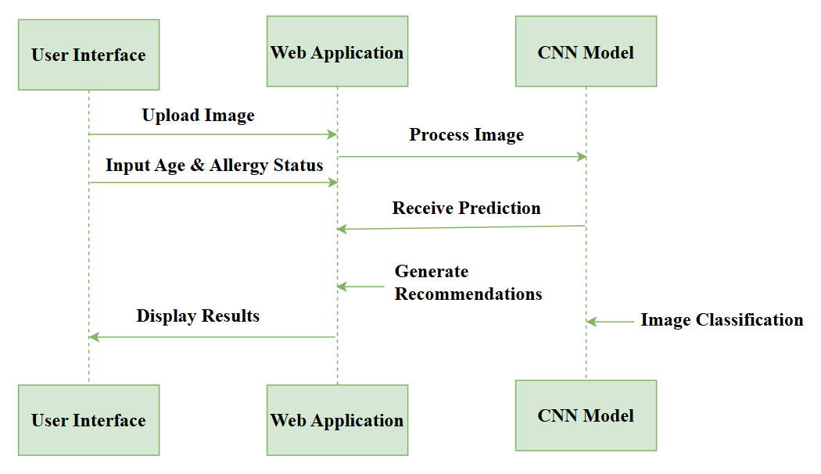

Fig 8. High-level Design Diagram

System design can be seen in the following flowchart:
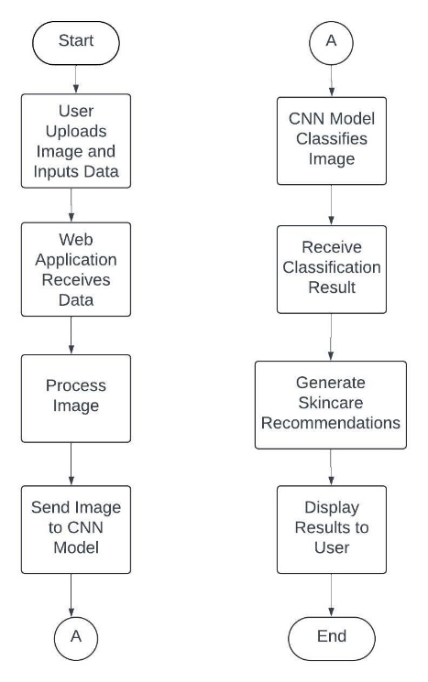

Fig 9. Flowchart of the System

3. results and discussion

This section presents the results obtained by classifying different skin types using the proposed CNN model to develop personalized skincare routines. The model's performance is evaluated using various metrics, including accuracy, loss, confusion matrix, and classification report, which includes precision, recall, and F1-score. Additionally, we conducted usability testing of the web application that integrated the CNN model by collecting feedback from a diverse group of users.
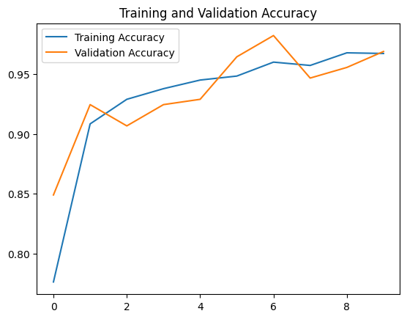
The training, validation, and testing phases with the proposed CNN model showed a high level of accuracy: 97.00% during training, showing how perfectly the model has learned from the data used for training, whereas in validation, it achieved an accuracy of 96.89%, indicating very good generalization on unseen data. This in turn means that test accuracy, as the most vital measure of the model's performance on completely new data, stood at 93.78%. This reflects that the model's robustness in accurately classifying skin types across all phases.

Fig 10. Training and Validation Accuracy Plot


Fig 11. Test Accuracy
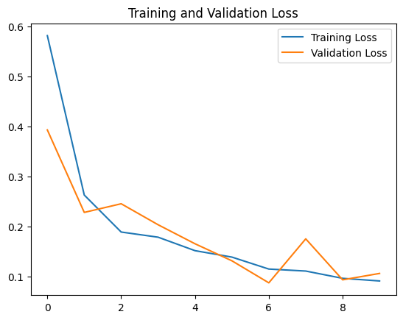
The loss values provide a measure of the performance of this model. While training, the loss was 7.5%, and for the validation, it marginally increased to 10.58%. Test loss keeps increasing and becomes 14.61%. Because the loss increases from the training to the validation and test phases, this proves that though the model performs well, there is a little bit of a tendency toward overfitting. However, this small loss increase does suggest that the model sets a good balance between fitting the training data and generalizing to new data.

Fig 12. Training and Validation Loss Plot

The confusion matrix, as shown in Fig 13, provides a detailed view of the model’s performance across different skin types.

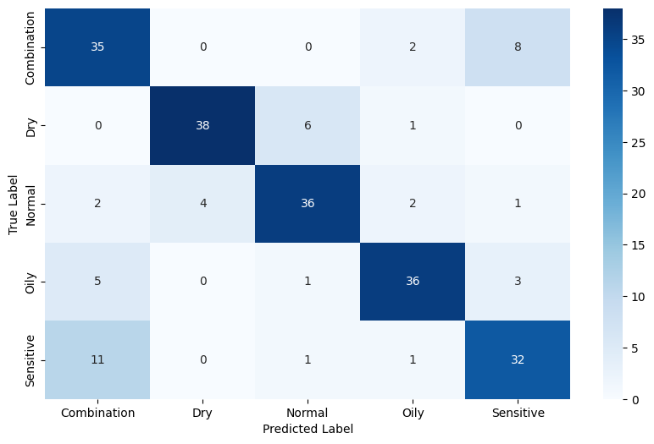
Fig 13. Confusion Matrix

This matrix shows that the model works very well in classifying most types of skin. It did this by classifying the skin type "Combination" correctly for 35 out of 45 samples, 38 out of 45 for "Dry," and 36 out of 45 for “Normal” and "Oily". There is some misclassification between the skin types "Sensitive" and "Combination"; 11 samples of "Sensitive" skin were misclassified as "Combination”, and 8 samples of “Combination” skin were incorrectly classified as “Sensitive”. This indicates that these two skin types may have some similar visual characteristics that cause greater difficulty for the model in discerning between them.
Fig 14 illustrates the precision, recall, and F1-score for each skin type, providing a detailed evaluation of the model's performance.
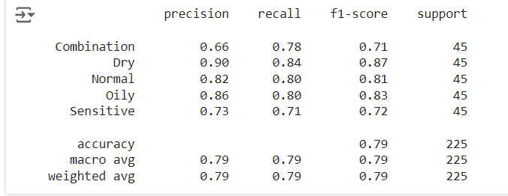

Fig 14. Classification Report
The classification report shows that the best class by the model performed best on the "Dry" skin, with a precision of 0.90 and recall of 0.84; thus, its F1-score for "Dry" skin of 0.87 will be the highest among all other skin types. For "Combination" and "Sensitive" skin types, the precision and recall are a bit lower, which shows that the model is having much more trouble differentiating between them. The overall accuracy, precision, recall, and F1-score are 0.79. The model achieved an overall accuracy of 0.79, indicating that it is effective and well-balanced. However, there is scope for improvement, particularly in distinguishing between skin types that have similar characteristics.
The overall evaluation results show that the proposed CNN model is effective in classifying skin types, with high accuracy rates and a better ability to both fit the training data and perform well on new data. MobileNetV2 has been used successfully in prior skin disease classification tasks (Hestiningsih et al., 2023), showing its effectiveness even in mobile or constrained environments. The performance of MobileNetV2 was compared with other widely used convolutional neural network (CNN) architectures, including EfficientNetV2, InceptionV2, and ResNet-V1 (Saiwaeo et al., 2023). MobileNetV2 achieved a testing accuracy of 93.78% in this study, demonstrating its effectiveness for skin type classification. Its lightweight design makes it particularly suitable for skincare applications, and it also exhibits the fastest learning time compared to the other CNN models, providing an efficient solution for image-based skin type analysis (Saiwaeo et al., 2023). However, there is potential for improvement, particularly in differentiating between skin types with similar visual characteristics. Further refinements to the model architecture and training data may help enhance its performance in these challenging cases.
To evaluate the web application in real-world conditions, the web application was tested on 42 women, randomly selected from the 331 Magalegoda Grama Niladhari Division which has a female population of 626 according to the electoral register 2024. Random sampling method was used to ensure the sample represented a diverse range of skin types and ages. Each participant completed a questionnaire designed to gather general feedback regarding their experience with the application, the accuracy of the skin type predictions, and the relevance of their personalized skincare recommendations provided. This random sample testing was an important validation process to ensure that the website would work in the real world for skin type predictions and personalized recommendations. The data collected from the questionnaires provided valuable insights into the web application's performance. The feedback covered several key aspects, including the accuracy of skin type predictions, the relevance of skincare recommendations, and the overall user experience. This information was analyzed to evaluate the model's effectiveness in real-world scenarios and to identify potential areas for improvement in both the prediction algorithm and the user interface. The following sections present a detailed analysis of the collected data.
Participants were invited to interact with the platform by uploading facial images, entering basic information such as age and allergy status, and receiving personalized skincare recommendations based on the predicted skin type. The responses collected revealed that most users expressed positive experiences with the system. Specifically, 64% of participants reported that the predicted skin type matched their expectations or known diagnoses, indicating a high level of accuracy and trust in the model’s classification capabilities.
Further analysis of user feedback showed that 61% of participants found the skincare recommendations to be relevant and useful, with many noting that the suggestions aligned with their previous skincare experiences. The user interface also received strong approval, with 95% of participants describing it as easy to use, visually appealing, and intuitive for non-technical users. The high usability scores demonstrate that the system is effective not only in terms of technical performance but also in providing a satisfying and accessible user experience. However, key user suggestions included the increase in personalization of skincare routines. Several users also requested more detailed analysis concerning skin conditions. These suggestions will be valuable for future development.
4. Conclusion

Quantitatively, the proposed model for skin type identification achieved a testing accuracy of 93.78% with precision, recall, and F1 scores indicating reliable performance across the different skin types. For "Combination" and "Sensitive" skin types, the precision and recall are a bit lower, which shows that the model is having much more trouble differentiating between them. User testing feedback on the system included a sample of 42 females from the female population of the 331 Magalegoda Grama Niladhari Division. Of this population, 64% of users reported they were highly satisfied with the skin type predictions, while 61% found the skincare routine recommendations useful. A significant majority 88% of users indicated that they had no previous experience with systems similar to this one. Moreover, the website's user interface was rated positively, 95% of the respondents emphasized that the website was easy to use, concluding that the implemented system is more user-friendly compared to existing systems.
Each objective targeted at the beginning of the research was successfully addressed. In the literature review and analysis of the existing techniques for skin type identification and skincare recommendation, there was a gap in providing personalized solutions that integrated skin type and skincare routines. Hence, the development of a model focused on the needs of women's skincare. Then, evaluated the applicability of current solutions for skin type identification and skincare recommendations. MobileNetV2 is selected as the base model due to its balance between accuracy and efficiency in real-time processing. It proved to be very useful for the problem. One of the major objectives of this research is the effective classification of skin types using the deep learning model. So, its quantitative evaluation, and user tests also proved its efficiency. Performance evaluations are based on accuracy metrics; further confirmations from the website show that it serves usefulness, particularly in making good predictions of skin types and personalized skincare routine recommendations, concluding that the implemented system is more user-friendly and accurate compared to existing systems.
While the proposed system demonstrates high accuracy and usability, it has several limitations that indicate significant directions for future improvement. Currently, skincare recommendations are rule-based and lack adaptability to individual variations, making them less dynamic and fully personalized. The system also depends on user-provided inputs, such as age and allergy status, which may be inaccurate and can lead to suboptimal advice. Another notable limitation is the difficulty in accurately distinguishing between combination and sensitive skin types, which may affect the accuracy of the confusion matrix, particularly when analysing the relationship between skin type and product efficacy. Furthermore, the current dataset did not fully represent all demographic groups and diverse skin tones. To address these constraints, future work can focus on integrating a machine learning-based recommendation engine that dynamically updates suggestions based on user feedback and the latest skincare research, thereby enhancing the system's adaptability and long-term utility. Expanding the dataset to include a wider variety of ethnicities, age groups, and skin conditions will also ensure that the system is more inclusive and capable of providing globally applicable skincare recommendations. Additionally, developing a mobile application would improve accessibility, particularly for users who prefer mobile platforms over websites. Including more detailed data on allergies, lifestyle factors, and environmental conditions may further improve the personalization and effectiveness of skincare routine recommendations.

Disclaimer (Artificial intelligence)
Authors hereby declare that NO generative AI technologies such as Large Language Models (ChatGPT, COPILOT, etc.) and text-to-image generators have been used during the writing or editing of this manuscript.

References

- Berardesca, E., Cameli, N., Primavera, G., & Carrera, M. (2006). Clinical and instrumental evaluation of skin improvement after treatment with a new 50% pyruvic acid peel. Dermatologic Surgery, 32(4), 526–531. https://doi.org/10.1111/j.1524-4725.2006.32106.x
- Bouman, R., Bukhsh, Z., & Heskes, T. (2023). Unsupervised anomaly detection algorithms on real-world data: how many do we need? http://arxiv.org/abs/2305.00735
- Vayadande, K., Bhosle, A. A., Pawar, R. G., Joshi, D. J., Bailke, P. A., & Lohade, O. (2024). Innovative approaches for skin disease identification in machine learning: A comprehensive study. Oral Oncology Reports, 10(100365), 100365. https://doi.org/10.1016/j.oor.2024.100365
- Eyelid and Midcheek Anatomy. (n.d.). Retrieved May 2, 2024, from https://www.sciencedirect.com/topics/medicine-and-dentistry/facial-skin
- Fabbrocini, G., Annunziata, M. C., D’Arco, V., De Vita, V., Lodi, G., Mauriello, M. C., Pastore, F., & Monfrecola, G. (2010). Acne scars: Pathogenesis, classification and treatment. In Dermatology Research and Practice (Vol. 2010, Issue 1). Hindawi Publishing Corporation. https://doi.org/10.1155/2010/893080
- Iraqui, P., & Das, M. K. (2022). Herbal cosmeceuticals for beauty and skin therapy. In Nanocosmeceuticals: Innovation, Application, and Safety (pp. 453–480). Elsevier. https://doi.org/10.1016/B978-0-323-91077-4.00018-1
- Punal. M. Arabi, Gayathri Joshi, Rohith. N. Reddy, Anusha S R, & Archa P S. (2015). Categorising Normal Skin, Oily Skin and Dry Skin using 4-Connectivity and 8-Connectivity Region Properties. In 2015 54th Annual Conference of the Society of Instrument and Control Engineers of Japan, SICE 2015 (pp. 37–40). Institute of Electrical and Electronics Engineers Inc. https://doi.org/10.1109/SICE.2015.7285460
- Samanta, S., Kimura, K., & Yokoo, M. (2024). Solving a Stackelberg Game on Transportation Networks in a Dynamic Crime Scenario: A Mixed Approach on Multi-Layer Networks. http://arxiv.org/abs/2406.14514
- The Importance Of Maintaining Skin Health. (n.d.). Retrieved May 6, 2024, from https://www.welona.in/the-importance-of-maintaining-skin-health/
- The Importance of Skin Care. (n.d.). Retrieved June 6, 2024, from https://www.mydcsi.com/2020/08/19/time-to-take-care-of-skin/#:~:text=Skin%20care%20is%20important%20becauseit,look%20better%20than%20ever%20before.
- Uzair, M., Mahmood, A., Shafait, F., Nansen, C., & Mian, A. (2015). Is spectral reflectance of the face a reliable biometric? Optics Express, 23(12), 15160. https://doi.org/10.1364/oe.23.015160
- What Skin Type Do I Have? | Determine Your Skin Type | CeraVe. (n.d.). Retrieved December 15, 2023, from https://www.cerave.com/skin-smarts/skincare-tips-advice/what-skin-type-do-i-have
- What’s Your Skin Type? (n.d.). Retrieved December 18, 2023, from https://www.webmd.com/beauty/whats-your-skin-type
- Krutmann, J., Bouloc, A., Sore, G., Bernard, B. A., & Passeron, T. (2017). The skin aging exposome. In Journal of Dermatological Science (Vol. 85, Issue 3, pp. 152–161). Elsevier Ireland Ltd. https://doi.org/10.1016/j.jdermsci.2016.09.015
- Lichterfeld, A., Hauss, A., Surber, C., Peters, T., Blume-Peytavi, U., & Kottner, J. (2015). Evidence-Based Skin Care: A Systematic Literature Review and the Development of a Basic Skin Care Algorithm. Journal of Wound, Ostomy and Continence Nursing, 42(5), 501–524. https://doi.org/10.1097/WON.0000000000000162
- Hestiningsih, I., Thohari, A. N. A., Kurnianingsih, -., & Kamarudin, N. D. (2023). Mobile skin disease classification using MobileNetV2 and NASNetMobile. International Journal on Advanced Science, Engineering and Information Technology, 13(4), 1472–1479. https://doi.org/10.18517/ijaseit.13.4.18290
- Saiwaeo, S., Arwatchananukul, S., Mungmai, L., Preedalikit, W., & Aunsri, N. (2023). Human skin type classification using image processing and deep learning approaches. Heliyon, 9(11), e21176. https://doi.org/10.1016/j.heliyon.2023.e21176
.

