Dual-Stage Deep Learning Framework for Hybrid Coconut Maturity Classification and Harvest Timeline Prediction

abstract
Coconut maturity estimation is critical in agriculture, as harvesting directly affects product quality, oil yield, and economic returns. Traditional methods, such as tapping or visual inspection, are subjective and inconsistent. This research develops a dual-stage deep learning framework that enables classification of coconut maturity stages and prediction of harvest timelines. The framework integrates a hybrid convolutional neural network (EfficientNetB0 + DenseNet121) for classification with a MobileNetV2-based regression model for predicting harvest time in immature coconuts. Images were collected, preprocessed, and augmented to balance classes. The models were trained and validated using accuracy, F1-score, mean absolute error, and root mean square error. A Gradio-based web application was developed to enable real-time image upload, classification, and timeline estimation. The hybrid classifier achieved over 99% accuracy, outperforming single-model baselines, while the regression model recorded an MAE of 36 days and an RMSE of 27 days, confirming reliable predictions. The web interface demonstrates practical usability and accessibility for farmers. While the dataset was limited in size and scope, which may affect generalizability, this study introduces the first dual-stage coconut framework that combines classification and predictive modeling into a practical, scalable system deployable on mobile and edge devices. Beyond its practical contributions, the study also advances agricultural AI research by extending coconut maturity studies from static classification into predictive modeling, a direction that remains underexplored. Future research will focus on expanding the dataset to diverse environments, integrating multimodal variables such as weather and soil data, and enhancing robustness under real-world conditions.

Keywords: Coconut Classification, Maturity Estimation, Timeline Prediction, Deep Learning, Agricultural AI

1. INTRODUCTION

Coconut maturity classification and harvest timeline prediction play a critical role in agricultural sector, where farmers, processors, and traders rely on accurate assessments to ensure optimal yield quality and profitability. Premature harvesting reduces kernel yield, lowers oil quality, and leads to customer dissatisfaction, while delayed harvesting can cause over-mature nuts and wastage. Farmers typically employ techniques such as tapping the coconut or making visual judgments based on external appearance. These practices in coconut maturity assessment rely heavily on traditional knowledge and highly subjective, vary across regions, and are prone to error, resulting in economic loss and reduced market consistency.
Recent advancements in artificial intelligence (AI) and deep learning have transformed agricultural decision-making in crops such as mangoes and bananas. Convolutional neural networks (CNNs) like EfficientNet[1] and DenseNet[2] have demonstrated strong performance in image classification tasks, while lightweight architectures such as MobileNetV2[3] enable efficient, low-computation deployment on mobile and edge devices. However, existing coconut maturity assessment solutions are limited to static classification and do not incorporate predictive harvest timelines, which are essential for scheduling labor, transportation, and market supply. Moreover, the lack of mobile-ready, field-deployable AI tools restricts adoption among resource-constrained farmers.
To address these limitations, this study introduces a dual-stage deep learning framework that integrates a hybrid CNN model (EfficientNetB0 + DenseNet121) for maturity classification with a MobileNetV2-based regression model to predict the number of days or weeks until immature coconuts reach optimal harvest readiness. This research is significant for the scientific community as it extends coconut maturity studies beyond static classification into predictive modeling, an area that remains underexplored. By combining hybrid CNN and regression architectures, it advances agricultural AI methodologies while ensuring practicality through mobile and edge deployment. The framework also offers transferable insights for other crops, thereby broadening the scope of AI applications in precision agriculture.
This research aims to address the following objectives:
- To develop a hybrid convolutional neural network (EfficientNetB0 + DenseNet121) for accurate classification of Dry, Matured, and Immature coconuts from on-tree images.
- To design and train a MobileNetV2-based regression model for predicting harvest timelines for immature coconuts.
- To evaluate the performance and practicality of lightweight deep learning models for mobile and edge deployment in farming environments.
- To implement a user-friendly, mobile-ready application that enables farmers to make data-driven harvesting decisions in resource-constrained conditions.
This research holds both academic and practical significance. From an academic perspective, it introduces a hybrid CNN model optimized for coconut maturity classification and demonstrates a novel use of MobileNetV2 for predicting harvest timelines in agriculture. From a practical standpoint, the proposed system offers farmers an intelligent tool to make informed harvesting decisions, reducing post-harvest losses and improving kernel quality and oil yield. Its design for mobile and edge deployment ensures accessibility for low-resource users, promoting consistent, scalable, and more profitable coconut farming practices.

2. Literature Review

2.1 Introduction

Artificial intelligence (AI) has reshaped modern agriculture by enabling automated solutions for crop monitoring, disease detection, and harvest management. For example, Lv and colleagues demonstrated how deep learning can track apple tree growth and fruit production through computer vision, showing the potential of AI to support continuous phenological monitoring [4]. In cashew apple farming, Winklmair et al. developed a deep learning model that classified maturity levels with high accuracy, proving the applicability of CNNs to postharvest systems [5]. Similarly, Zhu and co-authors introduced a lightweight olive ripeness detection algorithm using an improved YOLOv11n, highlighting the scalability of edge-suitable models [6].
Despite these advances, coconuts remain underserved by AI-driven maturity solutions. Traditional practices such as tapping, visual inspection, and calendar-based scheduling remain the norm, but studies such as Caladcad and Piedad’s work on acoustic deep learning models have shown how these methods are often unreliable in noisy environments [7]. Fuzzy neural network approaches, such as those discussed by Sattar, further emphasize the challenges of modeling maturity with limited robustness [8]. Although IoT- and machine-learning-based ripeness detection platforms are emerging in other fruits, such as bananas [9], no comprehensive coconut framework currently integrates both classification and predictive modeling.
Researchers in related crops have begun addressing predictive challenges. Liu and colleagues, for example, combined strawberry monitoring with weather data to forecast weekly yields, confirming that hybrid time-series approaches can improve planning accuracy [10]. Similarly, Lin and co-authors applied multi-feature fusion deep learning to predict strawberry harvest dates, showing the strength of data-rich forecasting models [11]. In apple production, the release of large-scale datasets such as AppleGrowthVision has enabled robust classification and prediction pipelines [12]. However, equivalent resources do not yet exist for coconuts.
This gap underscores the need for hybrid frameworks that combine visual classification with temporal forecasting. Approaches such as PhenoFormer, introduced by Garnot and collaborators, demonstrate how transformer models can outperform process-based phenology predictors [13]. Meanwhile, the DeepPhenology system developed by Wang and colleagues illustrates how CNNs can estimate apple flower distributions from imagery [14]. Drawing on these lessons, coconuts present an opportunity to transition from static maturity detection toward predictive, hybrid AI solutions.[10]

2.2 Coconut Maturity Classification

The task of determining coconut maturity is vital for ensuring kernel texture, oil content, and water quality. Traditional reliance on tapping and visual cues has proven subjective, as emphasized by Parvathi and Selvi, who noted the inconsistency of human-based husk color assessment [15]. Studies that formalized tapping into AI methods, such as the acoustic deep learning system developed under the DOST-funded ERDT program, showed that sound-based classification can differentiate maturity stages [8]. Sattar’s subsequent work extended this by applying deep learning to acoustic features, confirming both feasibility and limitations in real-world noise conditions [8].
Computer vision has become the dominant direction. Parvathi and Selvi designed a Faster R-CNN model that classified coconuts in complex outdoor backgrounds with strong accuracy [15]. Mandava and colleagues further advanced this by applying deep learning algorithms across large datasets, highlighting the adaptability of CNNs to different maturity stages [16]. Usman focused on local coconut varieties and demonstrated that classification accuracy improved significantly through augmentation strategies [17]. Specialized work, such as that of Kallapur et al., applied machine learning and image processing to identify aromatic coconuts, proving the applicability of AI to niche coconut products [18].
Beyond experimental studies, practical systems are beginning to appear. Cabaluna and colleagues created a computer-vision platform that linked maturity detection with dashboard visualization for farmers, enabling accessible monitoring in real time [19]. A related system, COCO-Detect, applied image processing for automatic classification in large-scale settings [20]. Divyanth and co-authors expanded the focus to harvesting by developing an attention-guided Faster R-CNN that detected coconut clusters even under occlusion, designed for robotic integration [21].
These advances show that coconuts can be classified effectively through AI, but current methods remain focused on static stage labeling immature, mature, or overmature without extending into predictive harvest readiness.

2.3 Fruit Ripeness Classification Using Deep Learning

Broader research on other fruits demonstrates transferable lessons for coconuts. Winklmair et al. successfully classified cashew apples using CNNs, providing a strong example of maturity modeling [5]. In mangoes, Salazar-Campos and colleagues automated grading in accordance with Peruvian postharvest standards, validating the industrial relevance of CNN-based systems [22]. Tomato research is particularly extensive; Alam and co-authors used Keras-based models to detect ripe fruit in greenhouse environments [23], while Astani and colleagues tested EfficientNet for tomato classification in field conditions, reporting high accuracy [24].
Banana classification has drawn significant attention. Baglat and collaborators reviewed shallow and deep learning systems for ripeness detection, confirming their reliability across datasets [25]. Alam and co-authors constructed a ripening dataset to distinguish between carbide-treated and naturally ripened bananas, thereby improving classification robustness [26]. Chuquimarca’s work on MobileNetV2 combined real and synthetic datasets, proving the strength of lightweight architectures for ripeness classification [27].
DenseNet has also shown versatility. Oil palm ripeness classification with DenseNet, as presented in conference research, delivered strong performance in plantation environments [28]. You and colleagues went further by combining DenseNet with olfactory sensors, producing an olfactory-visual hybrid for fruit ripeness prediction [29]. Enhancements to DenseNet such as attention modules were tested by Hassan and collaborators for date fruit grading, achieving more robust accuracy [30].
Recent advances highlight novel architectures. Wu and co-authors introduced RT-DETR for fruit ripeness detection, improving robustness under dynamic field conditions [31]. You and colleagues applied dynamic detection heads to papaya ripeness, achieving greater localization precision [32]. Ripeness detection has also been pursued in strawberries, where Mi and Yan tested CNN models for classification [33], while Giménez-Gallego applied on-tree automatic tracking to monitor fruit and predict harvest [34].
Although these systems confirm that AI can accurately classify ripeness across multiple crops, most efforts remain limited to static predictions. Models such as EfficientNet [1], DenseNet [2], and MobileNetV2 [3] are proven architectures, but they have yet to be systematically extended into forecasting frameworks.

2.4 Predictive Modeling and Timeline Estimation

Broader research on other fruits demonstrates transferable lessons for coconuts. Winklmair et al. successfully classified cashew apples using CNNs, providing a strong example of maturity modeling [5]. In mangoes, Salazar-Campos and colleagues automated grading in accordance with Peruvian postharvest standards, validating the industrial relevance of CNN-based systems [22]. Tomato research is particularly extensive; Alam and co-authors used Keras-based models to detect ripe fruit in greenhouse environments [23], while Astani and colleagues tested EfficientNet for tomato classification in field conditions, reporting high accuracy [24].
Banana classification has drawn significant attention. Baglat and collaborators reviewed shallow and deep learning systems for ripeness detection, confirming their reliability across datasets [35]. Alam and co-authors constructed a ripening dataset to distinguish between carbide-treated and naturally ripened bananas, thereby improving classification robustness [26]. Chuquimarca’s work on MobileNetV2 combined real and synthetic datasets, proving the strength of lightweight architectures for ripeness classification [27].
DenseNet has also shown versatility. Oil palm ripeness classification with DenseNet, as presented in conference research, delivered strong performance in plantation environments [28]. You and colleagues went further by combining DenseNet with olfactory sensors, producing an olfactory-visual hybrid for fruit ripeness prediction [29]. Enhancements to DenseNet such as attention modules were tested by Hassan and collaborators for date fruit grading, achieving more robust accuracy [30].
Recent advances highlight novel architectures. Wu and co-authors introduced RT-DETR for fruit ripeness detection, improving robustness under dynamic field conditions [31]. You and colleagues applied dynamic detection heads to papaya ripeness, achieving greater localization precision [33]. Ripeness detection has also been pursued in strawberries, where Mi and Yan tested CNN models for classification [32], while Giménez-Gallego applied on-tree automatic tracking to monitor fruit and predict harvest [34].
Although these systems confirm that AI can accurately classify ripeness across multiple crops, most efforts remain limited to static predictions. Models such as EfficientNet [1], DenseNet [15], and MobileNetV2 [3] are proven architectures, but they have yet to be systematically extended into forecasting frameworks.

2.4 Research Gaps and Proposed Contributions

Although coconut maturity classification has advanced through acoustic [7], vision-based [15], and practical system prototypes [20] predictive frameworks remain undeveloped. By comparison, tomato, strawberry , and apple research has successfully integrated classification and forecasting. Moreover, mobile deployment has been explored through lightweight architectures like MobileNetV2 and EfficientNet yet coconut-focused models have not been adapted for edge computing or field usability.

Table 1. Summary of Research Gaps in Coconut Maturity and Timeline Prediction

Study | Classification | Timeline Prediction | Mobile/Edge Deployment | Usability Testing
Caladcad & Piedad (2024) [4] | Yes | No | No | No
Sattar (2024) [8] | Yes | No | No | No
Divyanth et al. (2022) [21] | Yes | No | Partial (robotic focus) | No
Okabe et al. (2025) [36] | Yes | Yes | Partial | No
Proposed Research | Yes | Yes | Yes | Yes

The reviewed studies confirm the effectiveness of deep learning in both classification and predictive tasks across multiple crops. Coconut research has made progress in acoustic and image-based classification, yet no framework integrates these methods with timeline prediction. Advances in fruit ripeness classification demonstrate the adaptability of EfficientNet, DenseNet, and MobileNetV2 to agricultural tasks, while hybrid CNN-LSTM and ARIMA-LSTM models show promise for time-series harvest forecasting.
However, a notable gap remains in applying such hybrid approaches to coconuts, where maturity prediction is vital for optimizing labor, reducing waste, and enhancing value chains. Nondestructive sensing methods further extend the possibilities but are often impractical for resource-constrained farms.
This gap justifies the proposed research: a hybrid framework that combines visual and acoustic classification with regression-based timeline prediction, designed for real-time, low-cost deployment in coconut farming systems.

3. METHODOLOGY

3.1 Model Selection and Benchmarking

A set of candidate deep learning architectures was selected for preliminary benchmarking. For the classification task, five models were evaluated: MobileNetV2, EfficientNetB0, DenseNet121, Xception, and a baseline CNN. For regression, the candidate models included MobileNetV2, Xception, ResNet50, EfficientNetB0, DenseNet121, and a baseline CNN.
Each model was trained on a subset of the dataset and evaluated using standard metrics. Classification models were assessed using accuracy, precision, recall, and F1-score, while regression models were evaluated using Mean Absolute Error (MAE) and Root Mean Squared Error (RMSE). Based on this evaluation, the most suitable models were selected: a hybrid classification model combining EfficientNetB0 and DenseNet121 using a soft voting ensemble, and a regression model based on MobileNetV2 with added dense layers and dropout regularization.

3.2 Data Acquisition and Annotation

Original images of coconuts were collected from plantations, ensuring natural environmental diversity. Expert collaboration was employed to label maturity stages based on field knowledge using visual indicators such as husk color, surface texture, and estimated time-to-maturity. The Immature class was further divided into subcategories (e.g., “1 week”, “2 months”, “9 months”) to facilitate accurate timeline regression. The dataset used in this study comprised 8,010 images for the classification task, balanced across Dry, Matured, and Immature coconuts through extensive augmentation. For the regression task, images from the Immature class were further divided into 15 time-based subcategories, each augmented to 150 samples, resulting in a total of 2,250 images.

3.3 Preprocessing and Augmentation

Images were uniformly resized to 224×224 pixels and normalized to a [0,1] scale. Labels for classification were one-hot encoded. To address class imbalance and improve model generalizability, extensive data augmentation was applied. For classification, dry and mature classes were augmented using techniques such as flipping, rotation, zooming, brightness adjustment, and contrast manipulation.
An 80:20 training-to-testing split was applied, using stratified sampling to preserve class and timeline distributions across both sets.

3.4 Model Architecture and Training

The proposed framework consists of two stages: a hybrid classification model and a regression model for harvest timeline prediction.

Classification Model
The classification model was implemented as a soft voting ensemble combining EfficientNetB0 and DenseNet121. Both models, pretrained on ImageNet, produced probability distributions over three maturity classes (Dry, Matured, Immature). Final predictions were obtained by averaging the outputs. To overcome dataset imbalance where immature coconuts were more represented targeted augmentation (rotations, flips, zoom, brightness/contrast adjustments) was applied. After augmentation, the dataset comprised 8,010 images, balanced across classes, and was split into 80% training and 20% testing. Images were resized to 224×224 pixels and normalized.

Regression Model
The regression model used MobileNetV2 as the base, selected for efficiency and suitability for mobile deployment. A Global Average Pooling layer, dense layer (128 ReLU units), dropout (0.3), and a linear output node were added to predict the time to maturity. The dataset consisted of 15 subcategories of immature coconuts (1 week to 9 months). Augmentation balanced each subcategory to 150 images, resulting in 2,250 samples.

Training Setup.
Both models were trained using the Adam optimizer. The classification model used categorical cross-entropy loss, while the regression model used MAE as the loss function. Early stopping and model checkpointing were employed to prevent overfitting, with training capped at 100 epochs.

3.5 Model Evaluation and Validation

Evaluation of the classification model was conducted on the test set using accuracy, precision, recall, F1-score, and confusion matrices. The regression model was evaluated based on final MAE and RMSE scores.
To ensure the robustness of both models, 5-fold cross-validation was conducted. This allowed for assessment of performance variability and overfitting tendencies. Validation loss and performance metrics were monitored throughout training across all folds.

3.6 Hybrid Inference Pipeline

A sequential hybrid pipeline was implemented for practical deployment. An input image is first passed through the classification model. If the output label is "immature", the image is then forwarded to the regression model, which predicts the estimated number of days or weeks remaining until harvest. If the classification result is either "mature" or "dry", only the predicted class is displayed. The inference flow is illustrated in Figure 1.

3.7 System Deployment and Application

A lightweight web application was developed using the Gradio framework in Python. The interface allows users to upload an image, view the predicted maturity class, and, if applicable, receive a harvest timeline estimation. The backend logic was implemented using a modular app.py structure and custom styling through CSS (Cascading Style Sheets).
Initial deployment was conducted locally via http://127.0.0.1:7860/. The application integrates TensorFlow, NumPy, and PIL (Python Imaging Library) for image handling and model inference. The system is designed with flexibility for future deployment on platforms such as AWS (Amazon Web Services), Heroku, or as a standalone desktop application.

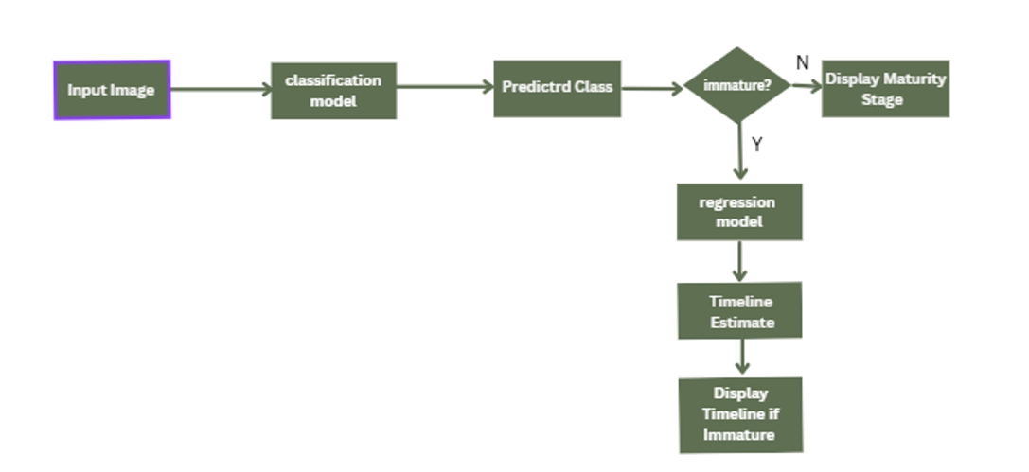

Figure 1: Workflow of the hybrid prediction pipeline. The input image is processed by the classification model. If the predicted class is "immature", the regression model estimates the remaining time to maturity. Otherwise, only the classification result is returned.

4. results and discussion

4.1 Introduction

This section presents a detailed account of the experimental results and performance evaluation of the proposed coconut maturity classification and timeline prediction models. The dual-model architecture was designed to (1) classify on-tree coconuts into Dry, Matured, or Immature stages based on image inputs, and (2) estimate the time remaining for immature coconuts to reach full maturity. Performance is evaluated using both quantitative metrics (accuracy, precision, recall, F1-score, MAE, RMSE) and qualitative demonstrations via a web application interface developed for practical deployment.

4.2 Overall System Performance

The system operates in two sequential stages
- Maturity Classification - Predicts the maturity stage from the uploaded coconut image.
- Timeline Estimation - If the predicted class is Immature, the regression model estimates the time remaining until full maturity.

4.3 Model Comparison Results

1. Classification Models

Multiple CNN models were evaluated. The hybrid approach combining EfficientNetB0 and DenseNet121 outperformed others, achieving 99% validation accuracy with strong generalization and minimal overfitting.

Table 2: Classification Model Comparison Results
Model | Training Accuracy | Validation Accuracy | Remarks
MobileNetV2 | ~99.1% | ~95% | Lightweight; fast convergence; slight overfitting observed.
EfficientNetB0 | ~99.7% | 96.3% | High accuracy; minor overfitting noted; strong feature extraction.
DenseNet121 | ~98.4% | ~95.3% | Stable learning; balanced performance
Xception | ~98.4% | ~94% | Moderate overfitting; lower validation accuracy; less preferred.
ResNet50 | ~53% | ~63% | Poor performance; clear underfitting; unsuitable for this dataset.
Hybrid (EfficientNetB0 + DenseNet121) | ~99.5% | 99% | Best overall performance; minimal overfitting; excellent generalization and stability.

2. Regression Models (Timeline Prediction)

For estimating time until maturity, three models were compared using validation MAE. MobileNetV2 delivered the lowest error, making it ideal for deployment.

Table 3: Regression (Timeline Prediction) Models Comparison Results
Model | Final Validation MAE (Days) | Final Validation RMSE (Days) | Remarks
MobileNetV2 | 36 | 27.01 | Best generalization; reliable prediction
DenseNet121 | 70 | 72 | High error; unsuitable
EfficientNetB0 | 71 | 74 | Underperformed in regression

4.4. Training and Validation Results

1. Classification Model

The final classification model achieved a validation accuracy of 99%, with an overall F1-score of 0.99 across all classes. The confusion matrix indicated only minimal misclassifications, reflecting the model’s strong ability to generalize. As shown in Table X, the model achieved near-perfect performance, with precision, recall, and F1-scores of 0.99 or above for all three classes (dry, immature, and matured). These results confirm the robustness and reliability of the hybrid EfficientNetB0–DenseNet121 ensemble in coconut maturity classification.

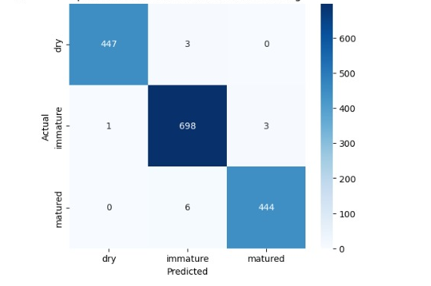
Figure 2: Confusion matrix of the hybrid EfficientNetB0–DenseNet121 model. The diagonal cells represent correctly classified samples for each class (dry, immature, matured), while the off-diagonal cells indicate misclassified instances.

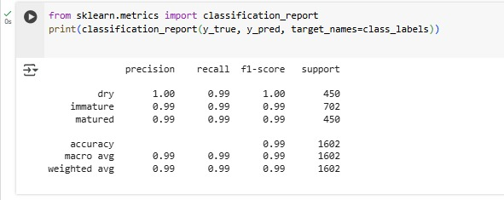
Figure 3: Classification report of the hybrid EfficientNetB0–DenseNet121 model. The model achieved consistently high performance across all classes, with precision, recall, and F1-scores of 0.99 or higher. Overall accuracy on the test dataset was 99%, confirming the robustness of the classification system

2. Regression Model

The regression model based on MobileNetV2 demonstrated stable convergence, with training completing at epoch 99 due to early stopping. The model achieved a validation MAE of 36 days and a validation RMSE of 27.01 days, indicating reliable performance in predicting the time to maturity. The training and validation curves (Figures X and Y) show smooth downward trends, with minimal divergence, confirming that the model generalized well without significant overfitting.
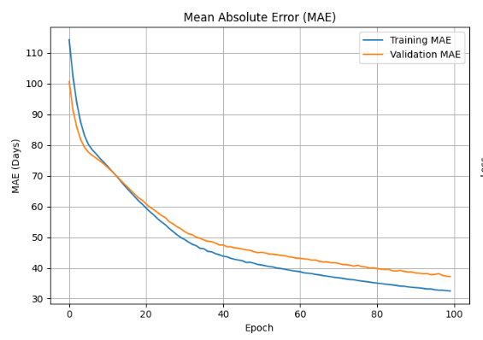
Figure 4: Training and validation Mean Absolute Error (MAE) curves for the regression model.

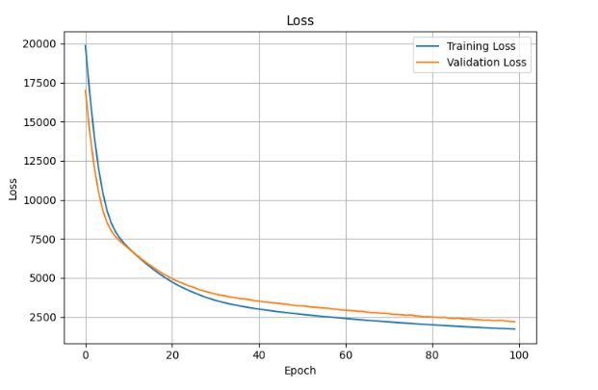
Figure 5: Training and validation loss curves for the regression model.

4.5. Web Application Output Demonstration

A real-time web application was developed using the Gradio framework to demonstrate the practical deployment of the proposed models. The interface allows users to upload coconut images and instantly obtain the predicted maturity stage along with the associated confidence score. For coconuts classified as immature, the system additionally provides a timeline prediction indicating the estimated number of days to maturity, thereby offering both classification and regression outputs in a single integrated platform.

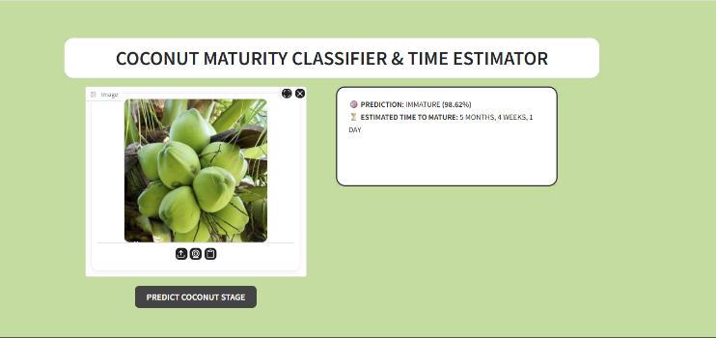

Figure 6: Application Interface Screenshot/Prediction Output — Immature Coconut/ Timeline Estimate — “5 months, 4 weeks, 1 day”

4.6 Performance Evaluation and Cross-Validation

To further validate the reliability of the proposed models, a 5-fold cross-validation strategy was employed for both classification and regression tasks. This approach ensured that the performance was not biased toward a specific train–test split and allowed for a more robust estimation of the models’ generalization ability. The classification model consistently achieved high validation accuracy across all folds, as summarized in Table 3.

Table 4: Cross-Validation Accuracy – Classification
Fold | Validation Accuracy (%)
1 | 98.8
2 | 99.0
3 | 99.1
4 | 98.9
5 | 99.0
Average | 99.0

For the regression task, cross-validation results demonstrated stable prediction performance with only slight variations in the validation MAE across folds. The average MAE was approximately 36.2 days, confirming the model’s robustness in estimating time to maturity. Detailed results for each fold are presented in Table 4.

Table 5: Cross-Validation MAE – Regression
Model | Final Validation MAE (Days)
1 | 37.1
2 | 35.6
3 | 36.4
4 | 36.1
5 | 35.9
Average | 36.2

4.7. Alignment with Research Objectives

The results of this study are well aligned with the stated research objectives. The hybrid EfficientNetB0–DenseNet121 model successfully achieved 99% classification accuracy, addressing the primary goal of maturity stage identification. For immature coconuts, the regression model based on MobileNetV2 achieved a Mean Absolute Error of 36 days, enabling reliable time-to-maturity estimation. Together, these models provide a dual-output framework that supports more informed and optimized harvesting decisions. Furthermore, the deployment of a real-time Gradio-based web application ensures that the system is practical, user-friendly, and accessible to non-technical agricultural users, thereby meeting the final objective of translating research into an applied decision-support tool.

Table 6: Alignment of research objectives with the corresponding achieved outcomes, demonstrating both technical performance and practical applicability of the proposed system.
Objective | Achieved Result
Develop a maturity classification model | Achieved 99% accuracy with hybrid CNN (EffNetB0 + DenseNet121)
Predict time-to-maturity for immature coconuts | Achieved MAE of 36 days using MobileNetV2
Optimize harvesting decision-making | Provided dual output for maturity + timeline estimation
Build a practical and user-friendly system | Real-time Gradio app deployed for non-technical agricultural users

5. Conclusion

This research introduced a dual-stage deep learning framework for coconut maturity classification and harvest timeline prediction, integrating a hybrid EfficientNetB0–DenseNet121 classifier with a MobileNetV2 regression model. The system achieved 99% accuracy in maturity stage classification and a mean absolute error of 36 days for time-to-maturity estimation, demonstrating both technical reliability and practical usability. By enabling farmers to make data-driven harvesting decisions, the framework reduces human error, optimizes yield, and supports scalable agricultural practices. The Gradio-based interface highlights the applicability of AI-powered solutions in real-world, resource-constrained farming environments.

Beyond its practical contributions, this work also offers a step forward for agricultural AI research by moving from static maturity classification toward predictive modeling. The integration of hybrid architectures with field-ready deployment broadens the scope of existing approaches and provides a foundation that can inspire similar methodologies across different crops and contexts.

Future work will focus on expanding the dataset to cover diverse environments, incorporating multimodal variables such as weather and soil data, and improving robustness against occlusions and low-quality images. In addition, efforts will be directed toward optimizing the models for low-power edge devices, deploying the system on cloud and mobile platforms, and extending its applicability to other crops with similar maturity patterns. These advancements will enhance scalability, accessibility, and long-term impact in precision agriculture.

Disclaimer (Artificial intelligence)
Option 1:
Author(s) hereby declare that NO generative AI technologies such as Large Language Models (ChatGPT, COPILOT, etc.) and text-to-image generators have been used during the writing or editing of this manuscript.
Option 2:
Author(s) hereby declare that generative AI technologies such as Large Language Models, etc. have been used during the writing or editing of manuscripts. This explanation will include the name, version, model, and source of the generative AI technology and as well as all input prompts provided to the generative AI technology
Details of the AI usage are given below:
1.
2.
3.

References

[1] M. Tan and Q. V. Le, “EfficientNet: Rethinking Model Scaling for Convolutional Neural Networks,” Sept. 11, 2020, arXiv: arXiv:1905.11946. doi: 10.48550/arXiv.1905.11946.
[2] G. Huang, Z. Liu, L. Van Der Maaten, and K. Q. Weinberger, “Densely Connected Convolutional Networks,” in 2017 IEEE Conference on Computer Vision and Pattern Recognition (CVPR), Honolulu, HI: IEEE, July 2017, pp. 2261–2269. doi: 10.1109/CVPR.2017.243.
[3] M. Sandler, A. Howard, M. Zhu, A. Zhmoginov, and L.-C. Chen, “MobileNetV2: Inverted Residuals and Linear Bottlenecks,” in 2018 IEEE/CVF Conference on Computer Vision and Pattern Recognition, Salt Lake City, UT: IEEE, June 2018, pp. 4510–4520. doi: 10.1109/CVPR.2018.00474.
[4] M. Lv, Y.-X. Xu, Y.-H. Miao, and W.-H. Su, “A Comprehensive Review of Deep Learning in Computer Vision for Monitoring Apple Tree Growth and Fruit Production,” Sensors, vol. 25, no. 8, p. 2433, Jan. 2025, doi: 10.3390/s25082433.
[5] M. Winklmair, R. Sekulic, J. Kraus, P. Penava, and R. Buettner, “A deep learning based approach for classifying the maturity of cashew apples,” PLoS One, vol. 20, no. 6, p. e0326103, June 2025, doi: 10.1371/journal.pone.0326103.
[6] F. Zhu, S. Wang, M. Liu, W. Wang, and W. Feng, “A Lightweight Algorithm for Detection and Grading of Olive Ripeness Based on Improved YOLOv11n,” Agronomy, vol. 15, no. 5, p. 1030, May 2025, doi: 10.3390/agronomy15051030.
[7] J. A. Caladcad and E. J. Piedad, “Deep learning classification system for coconut maturity levels based on acoustic signals,” arXiv preprint, arXiv:2408.14910, Aug. 27, 2024. [Online]. Available: https://arxiv.org/abs/2408.14910 [8] F. Sattar, “Predicting Maturity of Coconut Fruit from Acoustic Signal with Applications of Deep Learning,” Biology and Life Sciences Forum, vol. 30, no. 1, p. 16, 2024, doi: 10.3390/IOCAG2023-16880.
[9] R. M and P. Voola, “Developing an IoT and ML-driven platform for fruit ripeness evaluation and spoilage detection: A case study on bananas,” e-Prime - Advances in Electrical Engineering, Electronics and Energy, vol. 11, p. 100896, Mar. 2025, doi: 10.1016/j.prime.2025.100896.
[10] S. Liu, Y. Ampatzidis, C. Zhou, and W. S. Lee, “AI-driven time series analysis for predicting strawberry weekly yields integrating fruit monitoring and weather data for optimized harvest planning,” Computers and Electronics in Agriculture, vol. 233, p. 110212, June 2025, doi: 10.1016/j.compag.2025.110212.
[11] Z. Lin et al., “Strawberry harvest date prediction using multi-feature fusion deep learning in plant factory,” Computers and Electronics in Agriculture, vol. 234, p. 110174, July 2025, doi: 10.1016/j.compag.2025.110174.
[12] L.-S. von Hirschhausen, J. S. Magnusson, M. Kovalenko, F. Boye, T. Rawat, P. Eisert, S. Pretzsch, A. Hilsmann, and S. Bosse, “AppleGrowthVision: A large-scale stereo dataset for phenological analysis, fruit detection, and 3D reconstruction in apple orchards,” arXiv preprint, arXiv:2505.14029, May 20, 2025. [Online]. Available: https://arxiv.org/abs/2505.14029
[13] V. S. F. Garnot et al., “Deep learning meets tree phenology modelling: PhenoFormer versus process-based models,” Methods in Ecology and Evolution, vol. 16, no. 7, pp. 1489–1506, 2025, doi: 10.1111/2041-210X.70037.
[14] X. (Annie) Wang, J. Tang, and M. Whitty, “DeepPhenology: Estimation of apple flower phenology distributions based on deep learning,” Computers and Electronics in Agriculture, vol. 185, p. 106123, June 2021, doi: 10.1016/j.compag.2021.106123.
[15] S. Parvathi and S. Tamil Selvi, “Detection of maturity stages of coconuts in complex background using Faster R-CNN model,” Biosystems Engineering, vol. 202, pp. 119–132, Feb. 2021, doi: 10.1016/j.biosystemseng.2020.12.002.
[16] R. K. Mandava, H. Mittal, and N. Hemalatha, “Identifying the maturity level of coconuts using deep learning algorithms,” Materials Today: Proceedings, vol. 103, pp. 410–414, Jan. 2024, doi: 10.1016/j.matpr.2023.09.071.
[17] U. Usman, “Improving Classification Accuracy of Local Coconut Fruits with Image Augmentation and Deep Learning Algorithm Convolutional Neural Networks (CNN),” J. Appl. Data Sci., vol. 6, no. 1, pp. 1–19, Jan. 2024, doi: 10.47738/jads.v6i1.389.
[18] S. Kallapur, M. Hegde, A. D. Sanil, R. Pai, and S. Ns, “Identification of aromatic coconuts using image processing and machine learning techniques,” Global Transitions Proceedings, vol. 2, no. 2, pp. 441–447, Nov. 2021, doi: 10.1016/j.gltp.2021.08.037.
[19] S. S. Cabaluna, M. F. P. Bahinting, and L. A. Alindayo, “Computer-Vision-Based Detection and Monitoring System for Mature Coconut Fruits with a Web Dashboard Visualization Platform,” ijacsa, vol. 15, no. 11, 2024, doi: 10.14569/IJACSA.2024.0151175.
[20] K. Siyasinghe, A Coconut Maturity Detection System using Image Processing (COCO-Detect), B.Sc. (Hons) thesis, Informatics Institute of Technology, May 2023. [Online]. Available: doi:10.13140/RG.2.2.16229.37600
[21] L. G. Divyanth, P. Soni, C. M. Pareek, R. Machavaram, M. Nadimi, and J. Paliwal, “Detection of Coconut Clusters Based on Occlusion Condition Using Attention-Guided Faster R-CNN for Robotic Harvesting,” Foods, vol. 11, no. 23, p. 3903, Dec. 2022, doi: 10.3390/foods11233903.
[22] O. Salazar-Campos, J. Moran Ruiz, J. L. Peralta, M. R. Cieza, B. S. Medina, and J. Salazar-Campos, “Deep learning approach for automated ‘Kent’ mango maturity grading in compliance with Peruvian standards,” Results in Control and Optimization, vol. 20, p. 100589, Sept. 2025, doi: 10.1016/j.rico.2025.100589.
[23] Md. S. Alam, Md. R. Ali, and A. Rahman, “Detection and localization of ripe tomato in greenhouse environment using Keras-based deep learning models,” Journal of Agriculture and Food Research, vol. 23, p. 102182, Oct. 2025, doi: 10.1016/j.jafr.2025.102182.
[24] M. Astani, M. Hasheminejad, and M. Vaghefi, “Quality Classification of Tomato Plant in Field Conditions Using Efficientnet Deep Learning Model”.
[25] “Non-Destructive Detection of Soluble Solids Content in Fruits: A Review.” Accessed: Aug. 16, 2025. [Online]. Available: https://www.mdpi.com/2624-8549/7/4/115
[26] E. Alam et al., “Ripen banana dataset: A comprehensive resource for carbide detection and ripening stage analysis to enhance food quality and agricultural efficiency,” Data in Brief, vol. 60, p. 111659, June 2025, doi: 10.1016/j.dib.2025.111659.
[27] L. Chuquimarca, B. Vintimilla, and S. Velastin, “Banana Ripeness Level Classification Using a Simple CNN Model Trained with Real and Synthetic Datasets:,” in Proceedings of the 18th International Joint Conference on Computer Vision, Imaging and Computer Graphics Theory and Applications, Lisbon, Portugal: SCITEPRESS - Science and Technology Publications, 2023, pp. 536–543. doi: 10.5220/0011654600003417.
[28] “Deep Learning for Oil Palm Fruit Ripeness Classification with DenseNet | Request PDF,” in ResearchGate, doi: 10.1109/ICIMTech53080.2021.9534988.
[29] Z. You, M. Zhao, H. Chen, Y. Ying, and Y. Wang, “Olfactory visualization sensor based on densely connected convolutional networks for in-situ fruit ripeness prediction,” Sensors and Actuators B: Chemical, vol. 399, p. 134826, Jan. 2024, doi: 10.1016/j.snb.2023.134826.
[30] E. Hassan, S. A. Ghazalah, N. El-Rashidy, T. A. El-Hafeez, and M. Y. Shams, “Sustainable deep vision systems for date fruit quality assessment using attention-enhanced deep learning models,” Front. Plant Sci., vol. 16, June 2025, doi: 10.3389/fpls.2025.1521508.
[31] M. Wu, Y. Qiu, W. Wang, X. Su, Y. Cao, and Y. Bai, “Improved RT-DETR and its application to fruit ripeness detection,” Front. Plant Sci., vol. 16, Feb. 2025, doi: 10.3389/fpls.2025.1423682.
[32] H. You et al., “Towards Precise Papaya Ripeness Assessment: A Deep Learning Framework with Dynamic Detection Heads,” Agriculture, vol. 15, no. 15, p. 1585, Jan. 2025, doi: 10.3390/agriculture15151585.
[33] Z. Mi and W. Q. Yan, “Strawberry Ripeness Detection Using Deep Learning Models,” Big Data and Cognitive Computing, vol. 8, no. 8, p. 92, Aug. 2024, doi: 10.3390/bdcc8080092.
[34] J. Giménez-Gallego, J. Martínez-del-Rincon, P. J. Blaya-Ros, H. Navarro-Hellín, P. J. Navarro, and R. Torres-Sánchez, “Fruit Monitoring and Harvest Date Prediction Using On-Tree Automatic Image Tracking,” IEEE Trans. Agri. Elect., vol. 3, no. 1, pp. 56–68, Mar. 2025, doi: 10.1109/TAFE.2024.3408912.
[35] P. Baglat, A. Hayat, F. Mendonça, A. Gupta, S. S. Mostafa, and F. Morgado-Dias, “Non-Destructive Banana Ripeness Detection Using Shallow and Deep Learning: A Systematic Review,” Sensors, vol. 23, no. 2, p. 738, Jan. 2023, doi: 10.3390/s23020738.
[36] Y. Okabe, T. Hiraguri, K. Endo, T. Kimura, and D. Hayashi, “Classification of Tomato Harvest Timing Using an AI Camera and Analysis Based on Experimental Results,” AgriEngineering, vol. 7, no. 2, p. 48, Feb. 2025, doi: 10.3390/agriengineering7020048.

