When to Start Antiplatelet Therapy in Patients with Hemorrhagic Stroke and Prior Percutaneous Coronary Intervention: A Clinical Challenge

Abstract

Aims: This case demonstrates the challenges and complexities of managing antiplatelet therapy in the setting of ICH prior to elective PCI. The determination of when to restart antiplatelet therapy and which to use can be more difficult given the absence of clear guidelines due to lack of evidence.

Presentation of Case: A 45-year-old man developed ICH one week after PCI. He had a history of single-vessel coronary artery disease in the left anterior descending artery, which necessitated the implantation of a drug eluting stent. Imaging showed a small hemorrhage in the right lentiform nucleus and a chronic subdural hematoma. The patient, with a history of hypertension, was on dual antiplatelet therapy (DAPT) with aspirin and ticagrelor. Due to life-threatening bleeding, DAPT was temporarily stopped. After discharge, fear of stroke recurrence led to poor follow-up and medication noncompliance. Three months later, he presented with seizures, slurred speech, and weakness. Cardiac assessment showed no acute ischemia, and he was advised to resume DAPT and referred for stroke rehabilitation.

Discussion: This case highlights that management is not limited to acute hemorrhage but also includes the potential emotional consequences that can contribute to difficulties with adherence. Failure to comply with DAPT results in a very high thrombotic risk. Nevertheless, recent meta-analyses show that early reinitiation of antithrombotic drugs post-ICH decreases the risk of rebleeding with no increased incidence of ischemic events. A careful, multidisciplinary assessment is required to manage patient apprehensions and to plan reinitiation of therapy.

Conclusion: A lack of established guidelines for restarting antiplatelet therapy after PCI ICH drives home the need for teamwork and patient instruction. The round, well-considered re-challenge setting is important for preventing poor adherence and backward outcomes. The present case illustrates the need for evidence-based constructs to guide clinical practice based on research.

Keyword: Intracerebral Hemorrhage, Dual Anti Platelet Therapy, Percutaneous Coronary Intervention

Introduction
Cardiovascular disease (CVD) and cerebrovascular disease (CeVD) are the two leading causes of morbidity and mortality. They both have well-established vascular risk factors, such as hypertension, smoking history, and atherosclerotic disease.[1]
Percutaneous coronary intervention (PCI) is a very common minimally invasive procedure used to supply blood to the heart muscle and alleviate symptoms in patients with coronary artery disease. [2] Dual anti-platelet therapy (DAPT), a combination of aspirin and a P2Y12 inhibitor, is essential in post-PCI management with the goal of minimizing stent thrombosis.[3] Nevertheless, the antithrombotic effects of these drugs are accompanied by a significant bleeding risk. [3.4]
Fortunately, post-PCI stroke is a rare event, and its reported incidence varies from 0.2% to 0.5%; however, it is a catastrophic complication with increased short- and long-term mortality and morbidity.[5] For major hemorrhagic stroke, incidence was 14.3% in the triple therapy group vs. 3% in the dual therapy group (adjusted OR 9.0, 95% CI 3.1–26.1).[23]
The therapeutic paradox results from the collision of two mandatory therapeutic concepts: that central and early intervention is necessary to salvage the jeopardized infarcting myocardium, yet that strategy, once implemented, is associated with a quantifiable risk of a second, catastrophic cerebral event.[6] Moreover, it is not a fortuitous incidence; this occurs as an anticipated fallout in a population of patients with both thrombotic and hemorrhagic risk factors, based on their disease burden and common risk factors. We set forth to call attention to this dilemma using a dramatic case and perform a literature review of available data, level of evidence, sparse guidelines, and practical decision-making in this difficult clinical situation.

Presentation of Case
A 45-year-old male with a history of hypertension was admitted for an elective PCI to treat one-vessel coronary artery disease. Coronary angiography (CAG) revealed a single lesion, and a DES EVROSURE 3.5 x 54 mm was successfully implanted in the proximal-mid left anterior descending (LAD) artery. Cineangiography evaluation confirmed TIMI Flow 3 with no residual stenosis. He was prescribed DAPT with aspirin (Aspilet) and ticagrelor for his long-term post-PCI care.

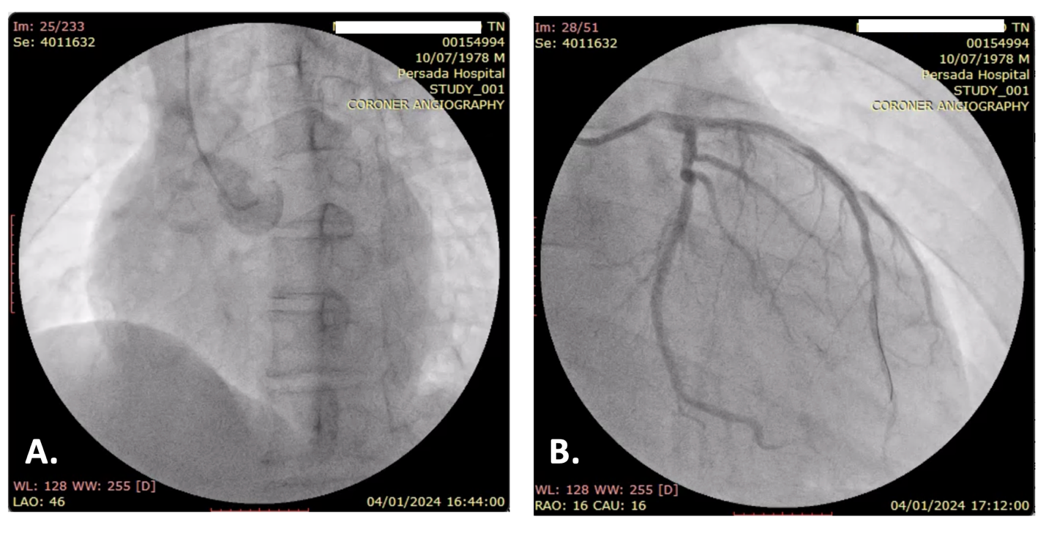
Figure 1.

[A.] CAG reveals occlusion of the proximal left anterior descending artery. [B.] Post PCI, the CAG shows TIMI Flow 3 at left anterior descending artery without residual stenosis.

One week after the elective procedure, the patient developed a new onset of neurological symptoms, and a brain CT scan revealed a punctate ICH at the right lentiform nucleus.

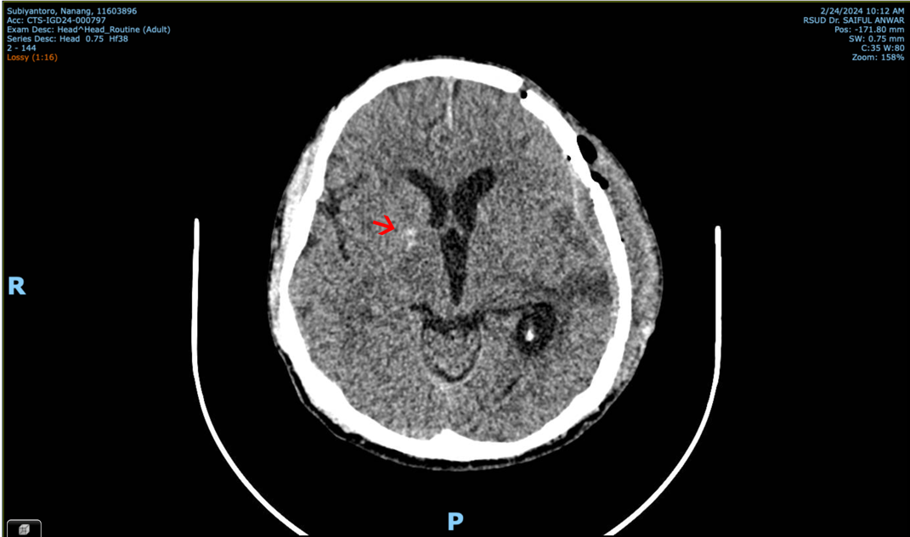
Figure 2.
A punctate hyperdense lesion, measuring approximately 66 Hounsfield units (HU), is identified in the right lentiform nucleus.

The patient’s DAPT was immediately postponed due to the life-threatening bleeding. He was discharged from the hospital after his condition stabilized. However, after being discharged, He was afraid of recurrent stroke, became non-compliant with his cardiovascular medications and did not return for follow-up to the cardiologist. Three months later, he was re-hospitalized due to seizures, slurred speech, and weakness but with no signs of chest pain or shortness of breath. Cardiac enzyme levels remained within the normal range. In response to the patient's non-compliance, the clinical team educated him on the necessity of resuming his medications, particularly DAPT, and began co-management with the neurology department.

Discussion

3.1 The Pathophysiological Imperative: Balancing Risks Beyond the Hospital Stay
The 45-year-old male patient presents an important dilemma in cardiovascular and cerebrovascular medicine beyond the early post-PCI period. Although our patient did not experience acute stent thrombosis, his subsequent non-adherence because of recurrent bleeding anxiety illustrates a distinct but equally important clinical dilemma. The occurrence rate of ICH during PCI is very low, but it is a fatal complication that causes patients to bear enormous psychological stress.[7] As demonstrated in our case, this fear can result in inadequate chronic medication adherence, making the individual highly susceptible to future thrombotic events such as myocardial infarction or ischemic stroke.[8]
The primary goal of DAPT after PCI is to prevent stent thrombosis, a complication that can lead to death or recurrent myocardial infarction/ [9,10] Stent thrombosis is particularly likely to occur with the premature discontinuation of DAPT, especially in the first 30 days post-procedure.[11] The PARIS registry demonstrates that patients who stop DAPT due to bleeding or non-compliance face a sevenfold increased risk of stent thrombosis in the first week after cessation.[12,13]
Conversely, the use of antiplatelet therapy directly increases the risk of ICH, particularly in patients with pre-existing risk factors.[14] DAPT has been shown to increase the risk of ICH by approximately 40% compared to aspirin monotherapy.[15] The pathophysiology of ICH involves the rupture of a blood vessel and the subsequent expansion of the hematoma, which compresses surrounding brain tissue and raises intracranial pressure. [16] Antiplatelet therapy can aggravate such hemorrhage, thereby increasing hematoma volume and the severity of the clinical condition.[17] The clinical conundrum here is not only how to manage acutely a bleeding event, but the long-term, psychological and behavioral sequelae of that event. Although understandable, the patient’s apprehension of re-bleeding resulted in non-adherence, placing him at risk for another, and perhaps fatal, ischemic episode.
An important consideration in the management of such patients is a multidisciplinary team that includes interventional cardiology and stroke neurology, which can result in a risk assessment for bleeding and thrombosis. [15]

3.2 The Evolving Evidence and the Absence of Guidelines
A significant challenge in managing this clinical scenario is the lack of a clear, evidence-based consensus or guidelines from major cardiology and neurology societies. The conventional approach has been to delay the re-initiation of antiplatelet therapy. The RESTART trial, which randomized patients who had intracerebral hemorrhage while on antithrombotic treatment, assigned them either to restart or to avoid antiplatelet therapy. On average, patients resumed single antiplatelet therapy (SAPT) about 2.5 months after their initial intracerebral hemorrhage.[15]
A subsequent meta-analysis demonstrated a 46% reduction in recurrence of hemorrhagic events without an increased major ischemic rate if antiplatelet therapy was initiated within the first 30 days after the onset of ICH.[19] The present study supports the concept that confounds the long-standing dogma that antiplatelet therapy causes re-bleeding. It implies that the selective, tailor-made re-approval of DAPT might not be that hazardous at all, as has been assumed so far, despite the acutely high risk of stent thrombosis.[15]

3.3 Navigating the Dilemma: Patient Education and Shared Decision-Making
Without clear data from a large, randomized trial, the provider's role in the use of ASC for the management of FS becomes one of a model of shared decision-making, patient education, and collaboration in a multidisciplinary setting.[20] This case presentation demonstrates the importance of patient education in addition to the pharmacologic treatment. The fear of having another stroke, perhaps worsened by a memory of the first, causes poor adherence to drugs and can result in poor outcomes. The conversation with the patient and the family must be candid about the risk and benefit, and it has to acknowledge the patient’s fears upfront.
Safe re-initiation of antiplatelet therapy should be based on meticulous patient observation and an assessment of risk/benefit. For patients with prior ICH, quantitative consideration of the risks of thrombosis versus bleeding is required to determine the optimal time to restart antiplatelet therapy to prevent underlying ischemia.

Something like the PRECISE-DAPT score (based on age, creatinine clearance, hemoglobin, white blood cell count, and previous bleeding) and the DAPT score can assist with this risk stratification.[18]

Conclusion
Antiplatelet therapy management in patients experiencing PCI-induced hemorrhagic stroke is a challenging clinical problem for which no consensus or absolute guideline has been established regarding the optimal care.[21] The patient provided here well illustrates the thin line between high-stakes competing risks of preventing life-threatening stent thrombosis and reducing catastrophic hematoma expansion.
The therapeutic dilemma we face in the above case scenario is not restricted simply to controlling the acute bleeding episode but also to establishing the patient's long-term compliance and addressing the fear of recurrent bleeding and the struggle with an impending catastrophic thrombotic event.The choice to cease DAPT after an ICH, though intuitive, may have the opposite effect of non-adherence, as was the case in the patient. The approach should be individualized and maintained through a shared multidisciplinary discussion with a complete patient risk stratification. It is a zero-sum game, and only those who think numerically and provide good, sympathetic patient education are likely to avoid suboptimal long-term outcomes.
Last, but certainly not least, the absence of solid evidence-based recommendations in this critically important area confirms the desperate need for such large-scale RCTs in the future.[22] Such studies should address the appropriate timing and duration of antiplatelet therapy, the selection of agents, and the utility of newer pharmacologic or mechanical approaches in this difficult clinical setting. Improving the care of this complex, vulnerable population is only possible if unambiguous evidence is available to guide clinicians in refining and individualizing therapy.

Ethical Approval:
As per international standards or university standards written ethical approval has been collected and preserved by the author(s).

Consent
As per international standards or university standards, patient(s) written consent has been collected and preserved by the author(s).

Disclaimer (Artificial intelligence)
Author(s) hereby declare that NO generative AI technologies such as Large Language Models (ChatGPT, COPILOT, etc.) and text-to-image generators have been used during the writing or editing of this manuscript.

References

[1]. Brown, J.C., (2023). Risk Factors for Coronary Artery Disease. StatPearls Publishing. Available at: https://www.ncbi.nlm.nih.gov/books/NBK554410/
[2]. El-Menyar, A. et al., (2023). Percutaneous Coronary Intervention. StatPearls Publishing. Available at: https://www.ncbi.nlm.nih.gov/books/NBK556123/
[3]. Neumann, F.J., (2023). Dual Antiplatelet Therapy for the General Cardiologist: Recent Evidence Balancing Ischemic and Bleeding Risks. European Society of Cardiology. Available at: https://www.escardio.org/Councils/Council-for-Cardiology-Practice-(CCP)
[4]. Joo, H.J. et al., (2023). P2Y12 Inhibitor vs Aspirin Monotherapy Following Dual Antiplatelet Therapy Discontinuation After PCI: A Meta-Analysis of Outcomes. IMR Press. doi: 10.31083/j.rcm2410284
[5]. Chandiramani, R., (2025). Determinants of stroke following percutaneous coronary intervention: A systematic review and meta-analysis. Annals of medicine. doi: 10.1080/07853890.2025.2506481
[6]. Sumiyoshi, T. et al., (2022). Optimal Antithrombotic Therapy in Patients Undergoing Percutaneous Coronary Intervention with High Bleeding Risk. Journal of atherosclerosis and thrombosis. doi: 10.5551/jat.RV17066
[7]. Nagai, T. et al., (2021). Intracranial Bleeding After Percutaneous Coronary Intervention. Journal of the American Heart Association. doi: 10.1161/JAHA.120.019637
[8]. Yang, C. et al., (2023). Intracranial Hemorrhage in Hospitalized Patients Following Percutaneous Coronary Intervention. Diagnostics. doi: 10.3390/diagnostics13142422
[9]. Levine, G.N. et al., (2015). Executive Summary - Dual Antiplatelet Therapy Following PCI: A Science Advisory of the American Heart Association. Circulation. Available at: https://www.ncbi.nlm.nih.gov/books/NBK531622/
[10]. Thomas, A., (2023). Antiplatelet Strategies Following PCI: A Review of Trials Informing Clinical Practice. JSCAI. https://doi.org/10.1016/j.jscai.2023.100607 [11]. De Luca, G. et al., (2020). Coronary Stent Thrombosis—Predictors and Prevention. Deutsches Ärzteblatt International. doi: 10.3238/arztebl.2020.0320
[12]. Mehran, R. et al., (2022). Patterns and Outcomes of Dual Antiplatelet Therapy Cessation and Disruption in Patients With Coronary Stents: Insights From the PARIS Registry. Journal of the American College of Cardiology: Cardiovascular Interventions. https://doi.org/10.1016/j.jcin.2022.02.048
[13]. Sorrentino, S. et al., (2020). Bleeding Risk, Dual Antiplatelet Therapy Cessation, and Cardiovascular Outcomes: Insights From the PARIS Registry. Circulation. doi: 10.1161/CIRCINTERVENTIONS.119.008226
[14]. Li, Y. et al., (2023). Effect of Antiplatelet Therapy on the Incidence, Prognosis, and Rebleeding of Intracerebral Hemorrhage. CNS Neuroscience and Therapeutic. doi: 10.1111/cns.14175
[15]. Ha, A.C.T. et al., (2021). Intracranial Hemorrhage During Dual Antiplatelet Therapy. Journal of the American College of Cardiology. https://doi.org/10.1016/j.jacc.2021.07.048
[16]. Kamel, H. and Iadecola, C., (2024). Intracranial Hemorrhage. In: StatPearls. Available at: https://www.ncbi.nlm.nih.gov/books/NBK559173/
[17]. Martínez-Camacho, M. et al., (2012). Antiplatelet therapies are associated with hematoma enlargement and higher mortality in patients with intracerebral hemorrhage: a prospective study. Medicina Intensiva. DOI: 10.1016/j.medine.2012.10.010
[18]. Angiolillo, D.J., (2022). Antiplatelet therapy after percutaneous coronary intervention: Special scenarios and current recommendations. European Heart Journal Supplements. doi.org/10.3390/jcm7040074
[19]. Salman, R.A.S. et al., (2025). Antiplatelet Resumption After Intracerebral Hemorrhage: A Meta-Analysis of Safety and Efficacy. Diagnostics. doi: 10.3390/diagnostics15141780
[20]. De Marzo, L.S., (2023). Management of oral anticoagulant therapy after intracranial hemorrhage: A multidisciplinary stroke team approach. Frontiers Journal. doi: 10.3389/fcvm.2023.1061618
[21]. Shah, Z., et al., (2015). Managing Antiplatelet Therapy and Anticoagulants in Complex Cardiovascular Patients: Balancing Ischemic and Bleeding Risks. JAVIB. doi: 10.4022/jafib.1318
[22]. Chaturvedula, S., (2018). Antiplatelet Therapy in Coronary Artery Disease: Comprehensive Review of Current Practices and Challenges. Journal of Clinical Medicine. doi: 10.3390/jcm7040074
[23] Olson, K. L, et al., (2010). Incidence of hemorrhage among anticoagulated patients receiving antiplatelet therapy after percutaneous coronary intervention. Journal of thrombosis and thrombolysis, 29(3), 316-321. https://link.springer.com/article/10.1007/s11239-009-0343-1

