Neem-Mediated Silver Nanoparticles: Characterization and Biological Applications Against Mosquito Larvae and Pathogenic Bacteria

Abstract
Introduction
Nanotechnology offers sustainable solutions for healthcare and environmental management. Silver nanoparticles (AgNPs) were green-synthesized using Azadirachta indica (Neem) leaf extract, a plant renowned for its broad pharmacological activities.
Aim
To biosynthesize neem-mediated AgNPs, characterize them physicochemically, and evaluate their larvicidal and antibacterial potency.
Materials and Methods
Aqueous neem leaf extract was mixed with AgNO₃; formation was tracked by colour change and UV–Vis spectroscopy (458–459 nm). FTIR identified functional groups, SEM measured morphology/size, and standard bioassays determined larvicidal activity against Culex quinquefasciatus larvae and antibacterial activity against selected pathogens.
Results
UV–Vis confirmed AgNP formation; FTIR showed hydroxyl, carbonyl and amine groups acting as reducing/stabilizing agents. SEM revealed 20–50 nm predominantly spherical particles. Probit analysis gave 24-h LC₅₀ values of 0.0279 mg L⁻¹ (AgNPs) versus 0.1985 mg L⁻¹ (neem extract). Agar-well diffusion assays showed larger inhibition zones for AgNPs than for extract, strongest against Staphylococcus aureus.
Conclusion
These findings demonstrate the potential of neem-mediated AgNPs as eco-friendly agents for mosquito vector control and antibacterial therapy. The dual efficacy underscores their promise as sustainable alternatives in integrated vector management and infection control, warranting further in vivo evaluation and environmental safety studies.
Keywords: Green synthesis, Silver nanoparticles, Azadirachta indica, Culex quinquefasciatus
Larvicidal activity, Antibacterial activity.

1.0 Introduction
Nanotechnology is now recognized as a transformative discipline with far-reaching impact on medicine, agriculture and environmental remediation. At the nanometre scale, materials acquire optical, electronic and physicochemical traits that are unattainable in their bulk form, a direct consequence of the dramatic rise in surface-to-volume ratio (Hussain et al., 2016; Sharma et al., 2003). Silver nanoparticles (AgNPs) are among the most widely studied metallic systems because of their pronounced catalytic, antimicrobial and larvicidal attributes (Tripathi et al., 2009).
Conventional routes to AgNPs frequently require toxic reagents, high energy input or extreme conditions. In contrast, plant-mediated or “green” synthesis capitalises on the intrinsic reducing and stabilising power of phytochemicals, delivering a low-cost, low-risk and sustainable manufacturing platform (Vanlalveni et al., 2021; Narayanan & Sakthivel, 2011). The same secondary metabolites that drive nanoparticle formation can also confer additional bioactivity, thereby amplifying the therapeutic or pesticidal value of the final product (El-Sayed, 2007).
A particularly rich source of such metabolites is Azadirachta indica (Neem), an evergreen member of the Meliaceae family that thrives in tropical and subtropical zones. Its leaves, seeds, bark and oil accumulate limonoids—most notably azadirachtin, nimbin and salannin—that underpin a broad pharmacological spectrum spanning antibacterial, antifungal, antiviral and insecticidal actions (Islas et al., 2020; Shareef et al., 2018; Alzohairy, 2016; Saleem et al., 2018). Commercial formulations such as Neemix and Aza-Direct already exploit these properties for crop and vector protection.
Mosquito-borne diseases—including malaria, dengue and filariasis—continue to exert a heavy global burden. Larvicidal interventions that interrupt juvenile development are a cornerstone of integrated vector management, and neem-based preparations have repeatedly demonstrated high potency against multiple vector species (CDC, 2020). Neem-derived AgNPs appear to synergise the intrinsic toxicity of the phytochemicals with the well-documented antimicrobial action of silver, offering a dual-function platform for mosquito control and antibacterial therapy at a time when antibiotic resistance is escalating (Jindal et al., 2015; Wei et al., 2015).
Precise physicochemical profiling—size, shape and colloidal stability—is essential, as these parameters govern biological uptake, dispersion and persistence. Prior reports confirm that neem-templated AgNPs remain stable under physiological conditions and retain strong bioactivity, underscoring their promise as next-generation, environmentally benign larvicides and antimicrobials (Poulose et al., 2014).
This investigation therefore aimed to synthesise AgNPs using Azadirachta indica leaf extract under ambient conditions, to characterise the resulting nanomaterial, and to quantify its efficacy against mosquito larvae and clinically relevant bacteria. The findings are expected to advance the development of safer, greener tools for vector control and infection prevention.

2.0 Material and Method
2.1 Materials
In compliance with institutional, national, and international guidelines for research involving plant material, leaves of Azadirachta indica were collected from a wild population within the Obafemi Awolowo University campus, Ile-Ife, Nigeria (coordinates: 7.51946, 4.52610). The species is not listed as threatened on the IUCN Red List of Threatened Species and is not included under the Convention on International Trade in Endangered Species of Wild Fauna and Flora (CITES). The collected specimen was deposited at the Herbarium of the Department of Botany, Obafemi Awolowo University, Ile-Ife, where it was identified and authenticated by Mr. G. Ademoriyo. A voucher specimen was assigned the number IFE-18415.
Silver nitrate (AgNO₃) was obtained from Sigma Chemical Company St Louis, USA., Muller Hinton agar (MHA), filter paper (Whatman No. 1), and all other reagents used were of analytical grade.
2.2 Preparation of Neem Extract
Different concentrations of neem leaf powder (1 g, 5 g, and 10 g) were weighed and each dispersed into 100 ml of distilled water. The suspensions were stirred continuously using a glass rod and allowed to stand for several hours at room temperature. The mixtures were filtered using Whatman No. 1 filter paper to obtain the aqueous neem extracts.

2.3 Preparation of Silver Nitrate Solution
A 1 mM silver nitrate solution was prepared by dissolving 0.01698 g of AgNO₃ in 100 ml of distilled water in a volumetric flask. The solution was stored in an amber container and kept away from sunlight to prevent photodegradation (Balagurunathan et al., 2011).
2.4 Green Synthesis of Silver Nanoparticles
For the synthesis of silver nanoparticles (AgNPs), 1 ml of neem extract was added dropwise to 40 ml of 1 mM AgNO₃ solution. The mixture was then exposed to direct sunlight. A gradual color change from yellow to brownish pink within 5 minutes indicated the reduction of Ag⁺ ions to silver nanoparticles. After 30 minutes, the color stabilized, and whitish precipitates were observed at the bottom of the beaker. The suspension darkened after 24 hours, suggestive of nanoparticle formation (Vanlalveni et al., 2021).
2.5 Characterization of Silver Nanoparticles
2.5.1 UV–Visible Spectroscopy
The synthesized AgNPs were analyzed using a UV–Visible double-beam spectrophotometer (Shimadzu UV-1800) in the range of 200–900 nm at a resolution of 1 nm, with distilled water as the blank. Absorption spectra were used to confirm nanoparticle formation based on surface plasmon resonance peaks (Balagurunathan et al., 2011).
2.5.2 Fourier Transform Infrared (FTIR) Spectroscopy
FTIR analysis was carried out using Cary 630 (Perkin Elmer) to identify functional groups in the neem extract responsible for reducing and stabilizing the silver nanoparticles. The spectra were recorded in the range of 4000–400 cm⁻¹ at 4 cm⁻¹ resolution ().
2.5.3 Scanning Electron Microscopy (SEM)
The morphology and size of the AgNPs were examined using SEM (Model JOEL-JSM 7600F). Samples were mounted on stubs and sputter-coated with platinum to enhance conductivity. The coated samples were then examined under high vacuum, providing images of particle shape and size distribution (Poulose et al., 2014).
2.6 Antibacterial Activity
2.6.1 Test Microorganisms
The antibacterial activity of neem extract and AgNPs was assessed against Staphylococcus aureus, Pseudomonas spp., and Klebsiella pneumoniae.
2.6.2 Well Diffusion Method
Antibacterial assays were performed using the agar well diffusion method (El-Sayed, 2007). Bacterial suspensions were standardized to 0.5 McFarland’s standard and inoculated onto sterile Mueller Hinton agar plates using sterile swabs. Wells of 6 mm diameter were bored into the agar using a cork borer. Each well was filled with different concentrations of neem extract and AgNPs. Gentamycin served as the positive control, while distilled water served as the negative control. Plates were incubated at 37°C for 24 h, after which inhibition zones were measured in millimeters.
2.7 Larvicidal Activity
2.7.1 Test Organism
Larvae of Culex quinquefasciatus were cultured and maintained in an insectarium at the Drug Research and Production Unit, Obafemi Awolowo University, Ile-Ife, under ambient conditions. Larvae were continuously fed until they reached late third and early fourth instar stages.
2.7.2 Larval Bioassay
Larvicidal activity was evaluated following the World Health Organization (WHO, 1996) protocol. Ten larvae were placed into separate beakers containing 100 ml of deionized water, into which different concentrations (1 g/dl, 5 g/dl, and 10 g/dl) of neem extract and neem-mediated AgNPs were introduced. Each experiment was performed in triplicate, with deionized water serving as the negative control. Mortality was recorded after 24 h and 48 h. Larvae were considered dead if they failed to respond to probing.
2.8 Dose–Response Bioassay and Statistical Analysis
Mortality percentages were calculated, and the median lethal concentration (LC₅₀) was estimated using probit analysis (Finney, 1971). Data were expressed as mean ± standard deviation (SD). Statistical analyses were performed using SPSS software.

3.0 Results and Discussion

In this study, silver nanoparticles (AgNPs) were synthesized using Azadirachta indica leaf extract under ambient conditions, characterized to confirm their formation and stability, and evaluated for their biological efficacy against mosquito larvae and clinically significant bacteria.

3.1 Biosynthesis and Characterization of Silver Nanoparticles
The biosynthesis of silver nanoparticles (AgNPs) using aqueous neem (Azadirachta indica) leaf extract was successfully achieved. A gradual change in solution color from colorless to yellowish brown and finally to dark brown was observed within minutes of exposure to sunlight, indicating the reduction of silver ions (Ag⁺) to AgNPs. This color transition is attributed to the excitation of surface plasmon resonance (SPR) of silver nanoparticles, confirming nanoparticle formation (Lalitha et al., 2013).

3.2 UV–Visible Spectroscopy
The UV–Vis spectra of the biosynthesized AgNPs showed characteristic SPR absorption peaks around 458–459 nm (Figure 1), which is consistent with the typical absorption range of silver nanoparticles (390–470 nm). The increase in absorbance with higher extract concentration suggests efficient nanoparticle synthesis and stability (Gard et al., 2020).

3.3 Fourier Transform Infrared (FTIR) Analysis
FTIR spectra of neem extract showed functional groups such as hydroxyl (O–H) stretching (3276 cm⁻¹), C–H stretching of aromatic compounds (2918 cm⁻¹), and carbonyl (C=O) stretching (1722 cm⁻¹) (Figure 2a). After nanoparticle formation, shifts in absorption bands were observed, including peaks at 3645 cm⁻¹, 3198 cm⁻¹, 1781 cm⁻¹, 1718 cm⁻¹, 1625 cm⁻¹, and 1032 cm⁻¹, corresponding to O–H, C=O, C=C, and C–N vibrations (Figure 2b). These functional groups indicate the presence of phytochemicals such as phenolics, amines, and proteins, which act as reducing and stabilizing agents during AgNP synthesis (Subapriya & Nagini, 2005; Verma & Singh Mehata, 2016; Bharat et al., 2018; Jacksi et al., 2024).

3.4 Scanning Electron Microscopy (SEM)
SEM micrographs revealed that the AgNPs ranged in size between 20–50 nm, predominantly spherical in shape, although some cuboidal particles were also observed (Figure 3). Aggregation was noted, which is typical of biologically synthesized nanoparticles due to capping biomolecules from plant extracts (Ahmed et al., 2016).

3.5 Antibacterial Activity
The antibacterial efficacy of neem extract and biosynthesized AgNPs was tested against Staphylococcus aureus, Pseudomonas spp., and Klebsiella pneumoniae (Figure 4). The well diffusion assay showed that AgNPs exhibited larger zones of inhibition compared to neem extract, with the strongest activity against Staphylococcus aureus (24 mm at 10 µl concentration). In contrast, neem extract demonstrated moderate antibacterial activity, particularly against Pseudomonas spp.. Gentamycin, used as the positive control, generally produced higher inhibition zones; however, AgNPs displayed competitive antibacterial potential, especially against Gram-positive strains (Figure 4).
The superior antibacterial performance of AgNPs is attributed to their ability to penetrate bacterial cell walls and interact with intracellular components such as DNA and proteins, causing structural alterations and functional disruptions (Ahmed et al., 2016). Moreover, the presence of phytochemicals from neem likely enhanced the antimicrobial potency through synergistic effects.

3.6 Larvicidal Activity
The larvicidal potential of neem extract and neem-mediated AgNPs was evaluated against Culex quinquefasciatus larvae. Mortality rates were dose-dependent, with higher concentrations producing greater larval death. At 10 mg/L AgNPs, mortality reached 90% after 24 h, while neem extract at the same concentration showed significantly lower mortality. Probit analysis revealed LC₅₀ values of 0.1985 mg/L for neem extract and 0.0279 mg/L for AgNPs after 24 h, demonstrating the superior efficacy of AgNPs. Mortality in controls did not exceed 2%, confirming experimental validity (Figure 5).
The enhanced larvicidal activity of AgNPs may be due to their small size, which allows better penetration into larval cuticles and tissues, disrupting cellular structures and interfering with biological processes (Chatterjee et al., 2023; Aremu et al., 2023). Neem-derived compounds, particularly azadirachtin, are known to disrupt insect molting and growth, leading to developmental delays and death (Lai et al., 2014). Plant-mediated AgNPs have been reported to be safe for non-target aquatic organisms, supporting their potential use in eco-friendly vector control (Rawani et al., 2013).

4.0 Conclusion
This study demonstrated that neem leaf extract can be used for the green synthesis of silver nanoparticles, which were confirmed by UV–Vis, FTIR, and SEM analyses. Neem-mediated AgNPs exhibited strong larvicidal activity against C. quinquefasciatus larvae and significant antibacterial activity against human pathogenic bacteria, with higher efficacy than neem extract alone. These findings support the potential application of neem-based AgNPs as eco-friendly larvicides and antibacterial agents. Further in vivo studies are recommended to evaluate toxicity, dosage optimization, and long-term environmental safety.

Highlight
Green synthesis of silver nanoparticles was achieved using Azadirachta indica extract.
Nanoparticles were characterized by UV–Vis, FTIR, and SEM, confirming stability and size.
Neem-mediated AgNPs showed strong larvicidal activity against Culex quinquefasciatus.
The AgNPs exhibited enhanced antibacterial activity compared to neem extract alone.

Author Contributions: Writing - original draft Conceptualization: T. O. A., O.J.A.,; writing – review and editing: O. J. A. T.O.A.; investigation: P.E.K, K.O.O., O.J.A., O.T.A. Resources: A. K.
Funding: This research received no external funding.
Conflicts of Interest: The authors declare no conflict of interest
Ethics: No ethical clearance needed for this work
Consent to participate: Not Applicable
Consent to publish Declaration: All authors agreed to publication of this manuscript
Disclaimer (Artificial intelligence)
Option 1:
Author(s) hereby declare that NO generative AI technologies such as Large Language Models (ChatGPT, COPILOT, etc.) and text-to-image generators have been used during the writing or editing of this manuscript.
Option 2:
Author(s) hereby declare that generative AI technologies such as Large Language Models, etc. have been used during the writing or editing of manuscripts. This explanation will include the name, version, model, and source of the generative AI technology and as well as all input prompts provided to the generative AI technology
Details of the AI usage are given below:
1.
2.
3.

5.0 References
Ahmed, S., Ahmad, M., Swami, B. L., & Ikram, S. (2016). Green synthesis of silver nanoparticles using Azadirachta indica aqueous leaf extract. Journal of radiation research and applied sciences, 9(1), 1-7. https://doi.org/10.1016/j.jrras.2015.06.006
Alzohairy, M. A. (2016). Therapeutics role of Azadirachta indica (Neem) and their active constituents in diseases prevention and treatment. Evidence-Based Complementary and Alternative Medicine, 2016, Article 7382506, 1–11.
https://doi.org/10.1155/2016/7382506
Aremu, H. K., Azeez, L. A., Adekale, I. A., Busari, H. K., Adebayo, Z. A., Disu, A., Usman, H.N., Adeyemo, O.M., & Oyewole, O. I. (2023). Biotoxicity of Azadirachta indica-synthesized silver nanoparticles against larvae of Culex quinquefasciatus. South African Journal of Botany, 153, 308-314. https://doi.org/10.1016/j.sajb.2023.01.021
Balagurunathan R, Radhakrishnan M, Rajendran RB, Velmurugan D. Biosynthesis of gold nanoparticles by actinomycete Streptomyces viridogens strain HM10. Indian J Biochem Biophys. 2011 Oct;48(5):331-5. https://pubmed.ncbi.nlm.nih.gov/22165291/
Bharat, M., Sharma, N., & Singh, A. (2018). Functional group analysis in green synthesized silver nanoparticles. Applied Surface Science, 449, 469–478. https://doi.org/10.1016/j.apsusc.2018.01.243
Centers for Disease Control and Prevention (CDC). (2020). Mosquito control: Larviciding. https://www.cdc.gov/mosquitoes/mosquito-control/larvicides.html
Chatterjee, S., Bag, S., Biswal, D., Paria, D. S., Bandyopadhyay, R., Sarkar, B., ... & Dangar, T. K. (2023). Neem-based products as potential eco-friendly mosquito control agents over conventional eco-toxic chemical pesticides-A review. Acta Tropica, 240, 106858. https://doi.org/10.1016/j.actatropica.2023.106858.
El-Sayed, M. A. (2007). Some interesting properties of metals confined in time and nanometer space of different shapes. Accounts of Chemical Research, 34(4), 257–264. https://doi.org/10.1021/ar960016n
Finney, D. J. (1971). Probit analysis (3rd ed.). Cambridge University Press. https://doi.org/10.1002/jps.2600600940
Garg, D., Sarkar, A., Chand, P., Bansal, P., Gola, D., Sharma, S., Khantwal S., Surabhi, Mehrotra R, Chauhan ,N., & Bharti, R. K. (2020). Synthesis of silver nanoparticles utilizing various biological systems: mechanisms and applications—a review. Progress in Biomaterials, 9(3), 81-95. https://doi.org/10.1007/s40204-020-00135-2
Hussain, I., Singh, N. B., Singh, A., Singh, H., & Singh, S. C. (2016). Green synthesis of nanoparticles and its potential application. Biotechnology letters, 38(4), 545-560. https://doi.org/10.1007/s10529-015-2026-7
Islas, J. F., Acosta, E., Zuca, G., Delgado-Gallegos, J. L., Moreno-Treviño, M. G., Escalante, B., & Moreno-Cuevas, J. E. (2020). An overview of Neem (Azadirachta indica) and its potential impact on health. Journal of functional foods, 74, 104171. https://doi.org/10.1016/j.jff.2020.104171
Jacksi, M., Schad, E., & Tantos, A. (2024). Morphological Changes Induced by TKS4 Deficiency Can Be Reversed by EZH2 Inhibition in Colorectal Carcinoma Cells. Biomolecules, 14(4), 445. https://doi.org/10.3390/biom14040445
Kharissova, O. V., Dias, H. R., Kharisov, B. I., Pérez, B. O., & Pérez, V. M. J. (2013). The greener synthesis of nanoparticles. Trends in biotechnology, 31(4), 240-248. https://doi.org/10.1016/j.tibtech.2013.01.003
Kumar, A. S., Madhu, G., John, E., Kuttinarayanan, S. V., & Nair, S. K. (2020). Optical and antimicrobial properties of silver nanoparticles synthesized via green route using honey. Green Processing and Synthesis, 9(1), 268-274. https://doi/10.1515/gps-2020-0029/html
Lai, D., Wen, L., & Li, S. (2014). Azadirachtin-induced apoptosis in insect cells. Pesticide Biochemistry and Physiology, 113, 60–66. https://doi.org/10.1016/j.pestbp.2014.05.003
Lalitha, A., Subbaiya, R., & Ponmurugan, P. (2013). Green synthesis of silver nanoparticles from leaf extract Azhadirachta indica and to study its anti-bacterial and antioxidant property. Int J Curr Microbiol App Sci, 2(6), 228-235. https://www.ijcmas.com/vol-2-6/A.Lalitha,%20et%20al.pdf
Muthulinggam, Nishan M., & Partiban Subramanian, P. S. (2014). Pharmacological and non-pharmacological activity of Azadirachta indica (Neem) – a review. International Journal of Biosciences, 5(6), 104-112. https://doi.org/10.12692/ijb/5.6.104-112
Narayanan, K. B., & Sakthivel, N. (2011). Green synthesis of biogenic metal nanoparticles by terrestrial and aquatic phototrophic and heterotrophic eukaryotes and biocompatible agents. Advances in Colloid and Interface Science, 169(2), 59–79. https://doi.org/10.1016/j.cis.2011.08.004
Poulose, S., Panda, T., Nair, P. P., & Theodore, T. (2014). Biosynthesis of silver nanoparticles. Journal of nanoscience and nanotechnology, 14(2), 2038-2049. https://doi.org/10.1166/jnn.2014.9019
Rawani, A., Ghosh, A., & Chandra, G. (2013). Mosquito larvicidal and antimicrobial activity of synthesized nano-crystalline silver particles using leaves and green berry extract of Solanum nigrum L.(Solanaceae: Solanales). Acta Tropica, 128(3), 613-622. https://doi.org/10.1016/j.actatropica.2013.09.007
Saleem, S., Muhammad, G., Hussain, M. A., & Bukhari, S. N. A. (2018). A comprehensive review of phytochemical profile, bioactives for pharmaceuticals, and pharmacological attributes of Azadirachta indica. Phytotherapy Research, 32(7), 1241–1272. https://doi.org/10.1002/ptr.6076
Shareef, M., & Akhtar, M. S. (2018). Neem (Azadirachta indica) and its potential for safeguarding health, prevention and treatment of diseases. Matrix Science Medica, 2(1), 04-08. DOI : http://doi.org/10.26480/MSM.01.2018.04.08
Sharma, V. K., Yngard, R. A., & Lin, Y. (2003). Silver nanoparticles: Green synthesis and antimicrobial activities. Advances in Colloid and Interface Science, 145(1–2), 83–96. https://doi.org/10.1016/j.cis.2008.09.002
Subapriya, R., & Nagini, S. (2005). Medicinal properties of neem leaves: A review. Current Medicinal Chemistry – Anti-Cancer Agents, 5(2), 149–156. https://doi.org/10.2174/1568011053174828
Tripathi, A., Chandrasekaran, N., Raichur, A. M., & Mukherjee, A. (2009). Antibacterial applications of silver nanoparticles synthesized by aqueous extract of Azadirachta indica (Neem) leaves. Journal of Biomedical Nanotechnology, 5(1), 93-98. https://doi.org/10.1166/jbn.2009.038
Vanlalveni, C., Lallianrawna, S., Biswas, A., Selvaraj, M., Changmai, B., & Rokhum, S. L. (2021). Green synthesis of silver nanoparticles using plant extracts and their antimicrobial activities: A review of recent literature. RSC advances, 11(5), 2804-2837. https://doi.org/10.1039/D0RA09941D
Verma, A., & Mehata, M. S. (2016). Controllable synthesis of silver nanoparticles using Neem leaves and their antimicrobial activity. Journal of radiation Research and applied sciences, 9(1), 109-115. https://doi.org/10.1016/j.jrras.2015.11.001
Wei, L., Lu, J., Xu, H., Patel, A., Chen, Z. S., & Chen, G. (2015). Silver nanoparticles: synthesis, properties, and therapeutic applications. Drug discovery today, 20(5), 595-601. https://doi.org/10.1016/j.drudis.2014.11.014

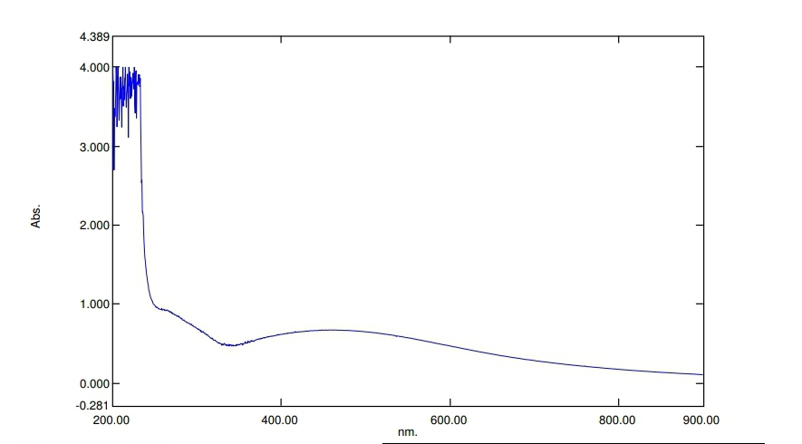
Figure 1: UV spectral of Azadirzctha indica -silver Nanoparticle
The characteristic surface plasmon resonance (SPR) absorption band of biosynthesized neem-AgNPs was obtained at 458nm.

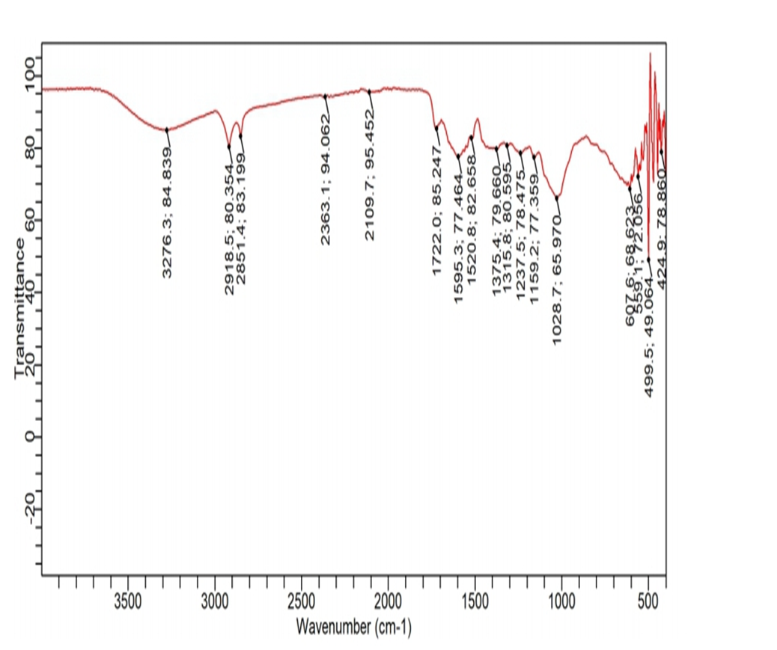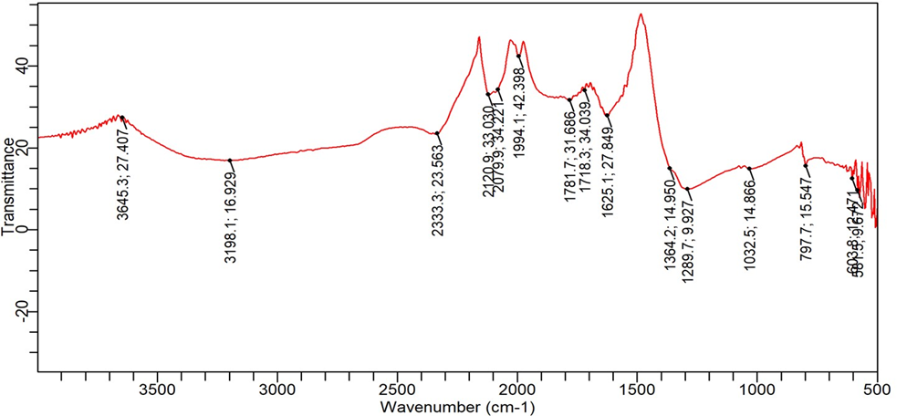
A
B
Figure 2: FTIR spectrum of Azadirzctha indica and Azadirzctha indica -silver nanoparticles
The spectrum analysis was carried out on aqueous neem extract and Neem-silver nanoparticle extract has seen in figure 2 A and B respectively. Different spectral were observed as seen from the figure showing that nanoparticles were formed.
It can be seen from Figure the range of first broad spectra lies between 3276.3 cm-1 to 2918.5 cm-1. This peak is attributed to the O–H stretching modes of vibration in hydroxyl functional group in alcohols and N–H stretching vibrations in amides and amines observed at 2109.7. A carbonyl group C=O is observed at 1722.0

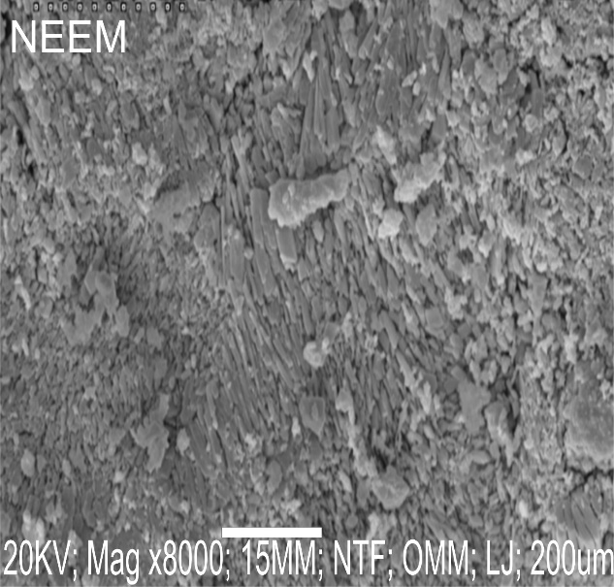

Figure 3: SEM micrograph of Azadirzctha indica -silver nanoparticle
The micrograph of silver nanoparticle of Azadirzctha indica extract was measured by SEM. The synthesized AgNPs are present in aggregate form. The nanoparticles that were observed by SEM were ranged in size from 20-50-nm in which majority of them were in spherical shapes, however some other shapes such as cuboidal were also observed

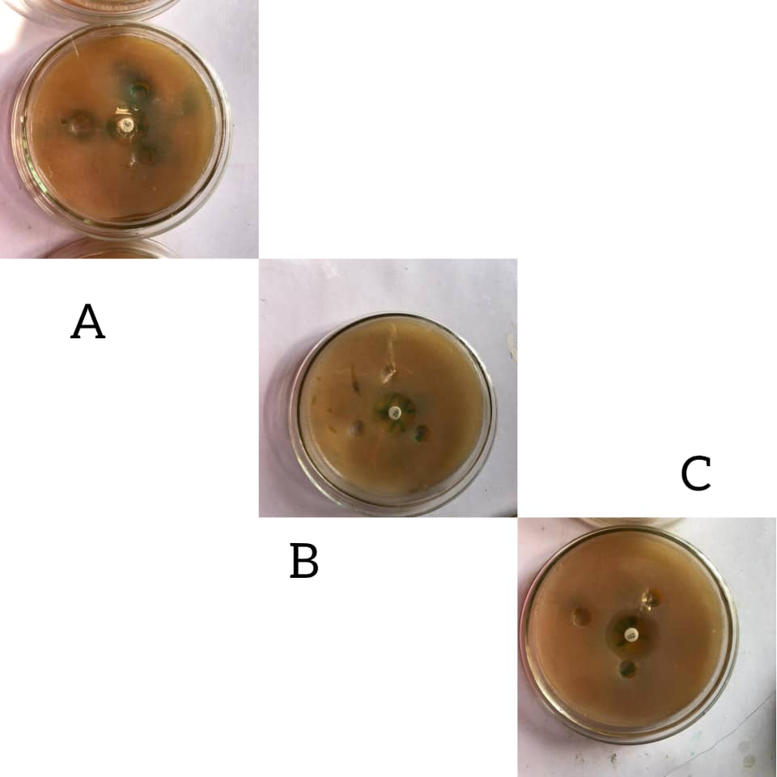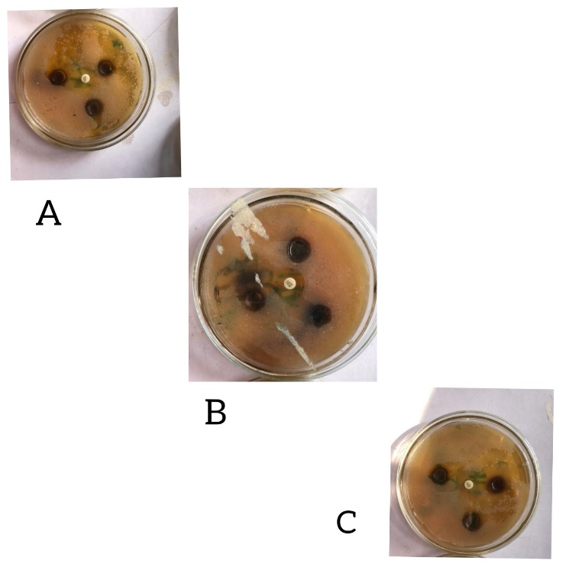
ii
i
Figure 4: Zone of inhibition of Azadirachta indica extract and Azadirachta indica-silver nanoparticles against human pathogenic bacteria. (A) Klebsiella pneumoniae (B)Pseudomonas spp (C) Staphylococcus aureus

Figure 5: Larvicidal activity of of Azadirachta indica leaf extract and Azadirachta indica leaf extract-AgNO₃ Nanoparticles.
The same concentration of extract was used for the experiment. of Azadirachta indica leaf extract possese some larvicidal activity while Azadirachta indica leaf extract-AgNO₃ Nanoparticles shows more potency

Table 1: Bacterial growth inhibition zone of Azadirachta indica leaf extract and Azadirachta indica leaf extract-AgNO₃ Nanoparticles.

Bacterial | Neem-AgNPs |  |  | Extract(MM) |  |  | Gentamyin(MM)
 | 1mM | 5mM | 10mM | 1mM | 5mM | 10mM
Staphylococcus aureus | 15 | 16 | 24 | - | - | 13 | 20
Pseudomonas spp | 13 | 14 | 16 | - | 13 | 14 | 17
Klebsiella pneumoniae | 14 | 15 | 16 | - | - | 10 | -

