Review Article
Epidemiology, Biology, and Control Measures of Trichuris spp. in Small Ruminants: A Review from Bangladesh

ABSTRACT

Trichuris spp., commonly known as whipworms, are a significant group of gastrointestinal nematodes affecting small ruminants in Bangladesh, particularly sheep and goats. They can reduce productivity and growth, resulting in poor appetite and increased morbidity, mainly in young or immunocompromised animals. These parasites reside primarily in the cecum and colon, where they cause variable clinical and subclinical impacts ranging from diarrhea, anorexia, and reduced weight gain to poor feed efficiency and, in severe cases, mortality. This review brings together most of the current knowledge of the taxonomy, morphology, life cycle, and pathogenesis of Trichuris spp. to discuss the current methods that can be used for diagnosis. It also summarizes the current epidemiological studies on infections in Bangladesh, and outlines and discusses some of the pertinent factors that can influence the prevalence of Trichuris spp, including climatic conditions, grazing, and husbandry systems. Controlling whipworm infections can be achieved through various methods, including the strategic application of anthelmintics, pasture management, and emerging options such as biological control strategies and nutrition, as strategies that may help in stomach parasite management both individually and in combination with others for sustainable parasite management.This review highlights knowledge gaps on whipworm infection and emphasizes the need for integrated control programs and further research to reduce the impact of Trichuris infections in small ruminants.

Keywords: : Bangladesh; Parasites; Small Ruminant; Trichuris

Introduction
Bangladesh relies almost entirely on the livestock sector for economic growth, holds 27.12 million goats and 3.9 million sheep (DLS, 2024), but sustained livestock production is challenged by a multitude of animal health challenges (Tariq et al., 2015). Many factors can influence the occurrence of Trichuris spp. infections in small ruminants: climatic factors, management factors, and host immunity (Roeber et al., 2013). The epidemiology of these parasites influences the host-parasite biology, agro-climatic conditions, and husbandry conditions in the area of the world in which they are found. Infection is not always equated with clinical signs but can be associated with clinical signs such as diarrhea, evidence of weight loss, anemia, and death, primarily though, in young and immunocompromised animals (Soulsby, 1982; Radostits et al., 1994). There are a multitude of economic losses caused by Trichuris parasites, including lower fertility, decreased capacity for work, less food intake, reduced weight gains, cost of treatment, and finally losses in terms of death of heavily parasitized animals (Padwal et al. 2011). Trichuris spp. located within the caecum and colon, from the first stage of the colon up to the beginning of the disk-like section (Rehbein et al. 1997). Trichuris infections have been overlooked in terms of veterinary significance because they are overshadowed by major gastrointestinal nematode parasites, including Haemonchus and Trichostrongylus. Control of these infections relies heavily on anthelmintic treatment, but anthelmintic resistance is evolving, and treatment regimens are being implemented incorrectly, thereby reducing the effectiveness of the treatment provided. Challenges also stem from a lack of clarity among farmers regarding the life cycles of the parasites involved and the preventive strategies. Therefore, a thorough understanding of Trichuris spp. biology, epidemiology, and control options are required to establish sustainable strategies to alleviate the impact of Trichuris on the production of small ruminants in Bangladesh.
This review aims to compile information on Trichuris infections in small ruminants, covering aspects of the life cycle, aspects of transmission dynamics, aspects of diagnostic methodologies, along with current control options available, gaps in knowledge, and future steps towards the improved control of parasites in Bangladesh.
Taxonomy and Phylogenetics
The kingdom Animalia includes the genus Trichuris, which is a member of the phylum Nematoda, class Enoplea, order Trichocephalida, family Trichuridae (Soulsby, 1982). Two species, Trichuris globulosa and T. ovis, were identified to infect goats and sheep in Bangladesh (Sissay et al., 2007; Almalaik et al., 2008). Conventional taxonomic characterization of Trichuris spp. has relied primarily on morphological characteristics; however, due to overlapping aspects and a lack of comparative data, species descriptions are often ambiguous (Babero et al., 1990; Suriano et al., 1994; Oliveros et al., 2000). Molecular methods utilizing DNA barcoding, specifically ITS-2 rDNA sequences, are now critical for elucidating species-level relationships as well as assessing cryptic diversity (Zhu et al., 1998; Callejón et al., 2015). Genetic work has provided evidence of host-specific evolution and potential movement of Trichuris spp. along the transmission pathway between humans, livestock, and wildlife (Salaba et al., 2013; Betson et al., 2015).

BIOLOGY OF THE AGENT
Morphology
Trichuris spp., particularly T. globulosa and T. ovis, have a whip-like body that consists of a slender anterior esophageal part and a thickened posterior reproductive segment (Henedi et al. 2024). The anterior end is filiform and often has cuticular striations, transverse grooves, or tuberculate elevations with ventral bacillary bands; these features are less prominent in T. ovis (Farleigh 1966; Afshan et al. 2023). The esophagus can be two-thirds of the body, surrounded by stichocytes, and terminates before the vulva in females (Ismail et al., 2024; Kuchai et al., 2013). The male T. globulosa contains a single spicule (<4.9 mm) with a spicular sheath that ends in a globular expansion covered with conspicuous spines and a bulky bulbous expansion with longer spines on the distal end (Ismail et al. 2024). The retracted coiled male testes lead to a long ejaculatory duct and cloaca, and the female has a smooth vulva located at the esophagus-intestine junction (Ismail et al. 2024). The vagina in T. globulosa is short and convoluted, but more variable for T. ovis, and individuals can be distinguished via vaginal topography and size of the spicule sheath spines (Baylis 1935; Afshan et al. 2023). The eggs are barrel-shaped with bipolar plugs; the T. ovis eggs have a thick brown shell and measure around 70-82 µm × 34-46 µm (Kuchai et al. 2013). Despite overlapping traits, spicule length in males remains a critical identifying feature (Afshan et al., 2023; Ismail et al., 2024).

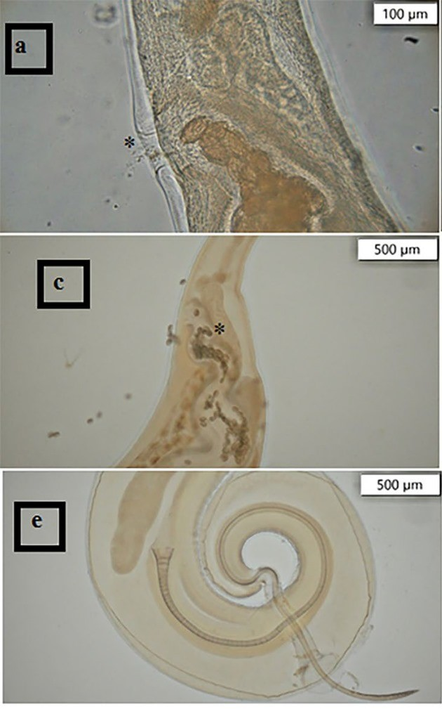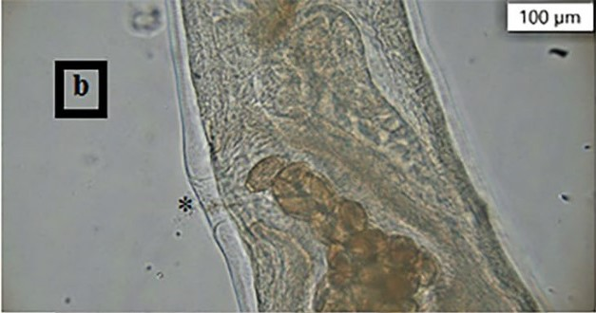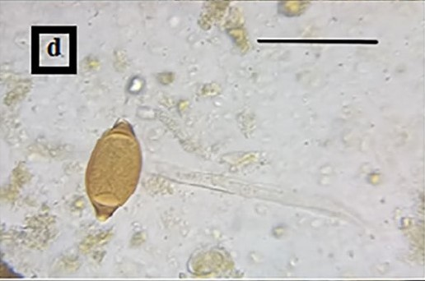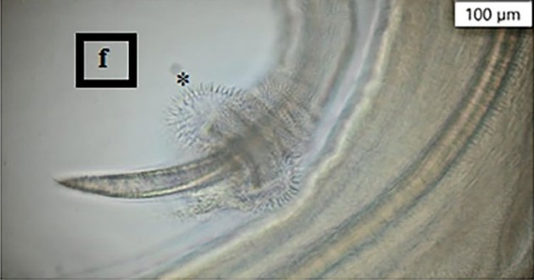
Fig. 1 Trichuris globulosa (a) and (b) female vulva and vagina, (c) and (d) egg, (e) male caudal region showing the spicule, the evaginated spicule sheath, and (f) spherical bulge covered with spines (Source: Ismail et al., 2024).

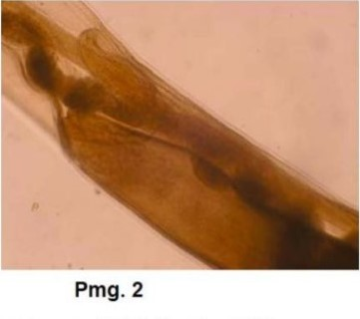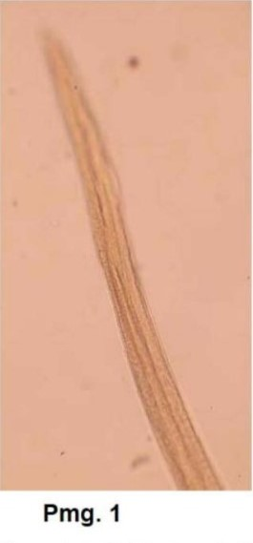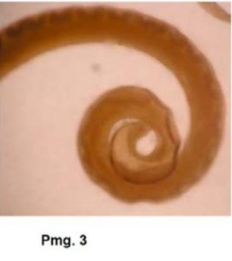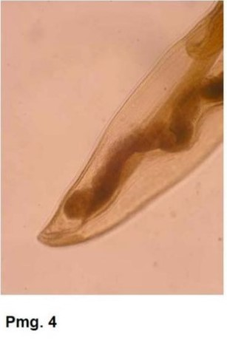
Fig 2 Pmgs 1-4: Trichuris ovis (Abildgard, 1795) Smith, 1908. (1) Anterior end of male. (2) Middle portion of the female. (3) Posterior end of Male. (4) Posterior end of the Female (Source: Kuchai et al. 2013) .

Life cycle
They have a direct life cycle: adult females in the colon and cecum of the host lay unembryonated eggs that are released in the feces, which need to undergo 2–4 weeks to embryonate into infective L1 larvae under favorable warm, moist conditions (Taylor et al., 2016). Small ruminants become infected after consuming embryonated eggs from contaminated pasture and water, as Trichuris eggs in soil enhance transmission (Gul et al., 2014). Once ingested, these embryonated eggs hatch in the small intestine of hosts, releasing larvae that penetrate the mucosal crypts of the cecum and colon, after that a tissue migration phase occur, the larvae leave the tissue, enter the lumen, develop through four successive molts (L2 to L5) into adults, and reside in the lumen with the anterior ends of their bodies embedded into the intestinal mucosa (Yousuf et al., 2023). The prepatent time in the host is between 6 and 12 weeks; after which, gravid females will lay thousands of eggs per day, contributing to the environmental contaminant load (Hansen et al., 2016).

Pathogenesis
According to the life cycle of Trichuris spp., hatched larvae burrow into the tissue of the caecum's mucosal epithelium by releasing cytolytic enzymes from the mouth and bacillary band to continue tissue penetration (Yousuf et al., 2023). The anterior of the worm becomes embedded within a syncytium formed from enterocytes, which results in the ingestion of host tissue, including erythrocytes, leucocytes, and mucosal secretions (Warren et al., 1990). In chronic infections, worms can extend to the appendix, rectum, and distal ileum (Gilman et al., 1982). It was characterized microscopically by catarrhal inflammation, which was linked with epithelial cell destruction and desquamation, but moderate T. ovis infection was characterized by catarrhal inflammation and petechial haemorrhages on the intestinal mucosa, where parasites were firmly attached (Nath et al., 2011).

Epidemiology
Geographic Distribution
Trichuris spp. are known to be endemic across Bangladesh based on their identified presence in many districts, including Mymensingh, Sherpur, Sylhet, Natore, Tangail, and Gopalganj. A study in Mymensingh was included in a total GI parasite prevalence of 74.8% in small ruminants and in Haluaghat Upazila (a hilly part), which also identified Trichuris (Islam et al., 2017), while in Rajshahi, research indicated that Trichuris was among the helminth eggs detected. Its percentage of infection ranged from 11-82% (Islam et al., 2020). In Natore, a study on Black Bengal Goat had an individual prevalence of 8.5% (Chakrabortty et al., 2023). In contrast, research in Tangail reported a prevalence of 2.1% but in Mirzapur Upazila found Trichuris spp. at 4% prevalence in goats and sheep (Sangma et al., 2013).

District | Host | Species reported
- Tangail | Sheep | Trichuris globulosa
- Sherpur | Sheep | Trichuris globulosa
- Sylhet | Goat | Trichuris ovis
- Dhaka | Sheep | Trichuris ovis
- Mymensing | Goat | Trichuris spp.
- Natore | Goat | Trichuris spp.
- Gopalganj | Small ruminants | Trichuris spp.
(Chakrabortty et al., 2023; Sangma et al., 2013; Islam et al., 2017; Dey et al., 2020; Podder et al., 2017; Musa et al., 2021; Mustafa et al., 2022; Akanda et al., 2012)

Factors Influencing Agents
The tropical and subtropical climate of Bangladesh, with its elevated temperatures and humidity, facilitates Trichuris egg incubation and development (Khan et al., 2019). Infection prevalence will peak during the monsoon season when moisture levels are increased and moderate temperatures allow larval development and prolong egg survival in pasture (Dey et al., 2020; Magona and Musisi, 2002). Providing inadequate pasture with poor drainage, muddy conditions, and standard use of contaminated water sources will increase the risk of infection (Urquhart et al., 1996; Chen et al., 2017). In general, young animals are more susceptible (Biu et al., 2009), while adults can be reservoirs for the infections and carry Trichuris; however, females have been documented with higher loads or burdens whilst pregnant and lactating (Rahman et al., 2022). Previous research shows that dietary stress and poor animal health make animals more vulnerable to parasite infestations (Ahmed et al., 2015; Bakunzi et al., 2013). High stocking rates in free-range systems raise the risk of reinfection and pasture pollution (Kantzoura et al., 2012). All things considered, the unclean, muddy living circumstances and the irregular application of anthelmintic deworming promote the growth of infection and resistance (Dey et al., 2020). Parasite infections are made worse by farmers' ignorance, poor feeding practices, and inappropriate fecal disposal (Odoi et al., 2007; Kantzoura et al., 2012). Co-infections with other parasite species inhibit immunity and overall health (Etter et al., 1999). It was found that Black Bengal goats have a lower susceptibility to trichuriasis than other breeds of goats because of the genetic background of the Black Bengal goats may have predisposed them to a lower prevalence of GINs in this breed (Bacha, 2014).

Significance of Small Ruminant Trichuris spp. Infections
Economic significance
Particularly in younger animals, Trichuris species lodge their anterior ends in the caecum and colon, resulting in inflammation, decreased feed efficiency and nutrient absorption, weight loss, and stunted growth (Soulsby, 1982; Taylor et al., 2015). Infected animals frequently exhibit poor body condition, produce fewer meat or milk products, and have lower market value (Taylor et al., 2015; Wall & Taylor, 2016). Additionally, adversely affected is the herd's reproductive efficiency, which includes the fertility and survivability of offspring (Taylor et al., 2015; Bowman, 2020). In severe situations, a high rate of mortality can occur in young or immunocompromised animals (Soulsby, 1982; Bowman, 2020). Farmers, especially small and marginal farmers who depend on cattle for their livelihood, are burdened by the high costs of anthelmintics, veterinary care, and ongoing treatments when faced with diseases (Corwin et al., 1997; Bukhari et al., 2011).
Public Health Significance
There is growing evidence that Trichuris species can spread zoonotically in addition to sharing a common ancestor with the main human parasite, Trichuris trichiura. Dog-adapted T. vulpis (Areekul et al., 2010) and pig-adapted T. suis (Nissen et al., 2012), as well as some evidence of potential interspecies hybridization (Liu et al., 2014; Liu et al., 2012), have been shown to infect humans, according to molecular research. Where there is a high level of human-animal contact, the close genetic resemblance between the species that infect primates (Arizono et al., 2012; Gillespie et al., 2010; Kooriyama et al., 2012) and humans is a significant public health problem. These results highlight the necessity of molecular surveillance to better understand the dynamics of cross-species transmission in endemic areas such as Bangladesh.

Diagnosis and Clinical Signs
To diagnose an infection of Trichuris spp. in small ruminants, fecal evaluation of typical barrel-shaped, brown eggs with polar plugs, using flotation, is the preferred method (Soulsby,1982; Kuchai et al., 2013). Direct smear and sedimentation evaluation may improve sensitivity (Khurana et al., 2021). Clinical signs include loss of appetite, loss of condition, diarrhoea, weight loss, anemia, bottle jaw (Soulsby, 1982; Radostits et al., 1994), abortion, dull hair coat, loss of plasma proteins as well as changes in protein, energy, and mineral metabolism, changes in water balance, enteritis, wool growth, reproduction, and ultimate death (Fowler, 1996; Stephenson et al., 2000). A proper diagnosis can be made by postmortem examination upon finding whip-like worms of the adult stage in the cecum and colon (Ok et al., 2009). Molecular techniques (e.g., PCR) have been developed, but genome sequencing of the parasite and the PCR methods are outside the limitations of cost and infrastructure in Bangladesh (Castellanos-Gonzalez et al., 2018; Dijk NJ et al., 2024).

Control Methods
Albendazole, Ivermectin, and Levamisole (less effective against certain parasites) are highly efficacious against Trichuris spp. and other nematodes, particularly in goats (Sirivichayakul et al., 2003; Bushra et al., 2019; Afzal et al., 2025). Anthelmintic resistance is becoming a global health concern, also in Bangladesh, due to overuse and incorrect dosing options for dewormers, which have led to resistant Trichuris and nematodes (Kapo et al., 2025). Most small farmers are not aware of the appropriate doses to use, how to administer the drugs, schedules for deworming, and the use of dewormers by poor farmers is limited by the high cost of dewormers (Dey et al., 2020). Control requires more than just dewormers, including strategies to time deworming during the times requiring the highest efficacy (e.g., early rainy season) and developing a strategy for deworming symptomatic animals (Panayotova-Pencheva et al., 2024). Effective pasture management (rotating pastures, not overgrazing), quarantining new stock to reduce the risk of infection, as well as having good hygiene in housing and feeding, and providing good nutrition to boost immunity (Dey et al., 2020). Integrated Parasite Management (IPM) is a strategy to lessening dependence on chemicals by combining available methods; like FECRT (faecal egg count reduction test); to monitor efficaciousness of drugs; body condition scoring; using an appropriate treatment based on body scores; exploring alternative controls; such as medicinal facing plants; biological agents; which is an area of research in Bangladesh (Da Cruz et al., 2010).

Future Research Priorities
The limited number of viable Trichuris specimens remains a major obstacle to conducting additional genetic research on small ruminants. Recent advancements in single-cell genomics and micromanipulation may help solve this issue (Dey et al., 2015; Carlsgart et al., 2009). Large-scale molecular surveillance studies are expected to benefit from readily available fecal samples. Molecular-level research should enhance our understanding of host–parasite interactions down to mechanisms of immune evasion, hatching stimuli, and gut-colonization. Comparative transcriptomics in T. suis, T. muris, and Trichuris spp. that infect small ruminants may reveal evidence of conserved or divergent parasitism strategies (Foth et al., 2014; Jex et al., 2014; Vejzagić et al., 2015). Another emerging field is the study of exosome-like vesicles that package RNA and have been proposed to potentially modulate host immunity (Buck et al., 2014; Hansen et al., 2015). If their function were identified, it may be considered as a novel vaccine or immunotherapy platform. Development of point-of-care diagnostics, such as LAMP, is required to detect Trichuris spp. in rural environments. Once further optimized, these types of tools will improve surveillance and targeted control efforts (Watts et al., 2014; Rand et al., 2015).
Conclusion
Small ruminant infections with Trichuris spp. are major health and economic burdens in Bangladesh, given their pervasiveness and impact on productivity. Alternatively, integrated approaches to control such infections should involve better anthelmintic use, improved pasture management, and education of the farmer. Future research should address the epidemiology of Trichuris spp., drug resistance, and vaccine development to enable sustainable control. There are certain gaps in diagnostics and community-level risk factors related to the disease that will enable improved targeted interventions. Prevention, coupled with collaborative approaches and community partnerships, will be essential to help abate the burden posed by trichuriasis on small ruminants and a healthy livestock and food supply system in Bangladesh.

Disclaimer (Artificial intelligence):

We, the authors, hereby confirm that no generative AI technologies, including Large Language Models (such as ChatGPT, Copilot, etc.) or text-to-image generators, were used in the preparation, writing, or editing of this manuscript. All work presented is solely the result of the authors’ own effort.

References

- AFSHAN, K., KHAN, S., KHAN, B., HUSSAIN, S., FIRASAT, S., NARJIS, G., & CHAUDHRY, U. (2023). A new record of the occurrence of Trichuris skrjabini Baskakov, 1924 in goats of Pakistan. PLOS ONE, 18(9), e0290906. https://doi.org/10.1371/journal.pone.0290906
- AFZAL, S., DURRANI, U. F., MAHMOOD, A. K., FATIMA, A., AKHTAR, R., MATEEN, A., & H. HASSENIN, A. S. (2025). Anthelmintic efficacy of mebendazole and levamisole in Olive Baboon (Papio anubis) infected with Trichuris trichiura. PLOS ONE, 20(7), e0326416. https://doi.org/10.1371/journal.pone.0326416
- AHMED, R., BISWAS, P. K., BARUA, M., ALIM, M. A., ISLAM, K., & ISLAM, M. Z. (2015). Prevalence of gastrointestinal parasitism of cattle in Banskhali upazilla, Chittagong, Bangladesh. Journal of Advanced Veterinary and Animal Research, 2(1), 49-55. https://doi.org/10.5455/javar.2015.b49
- AKANDA, M.R., HOSSAIN, F.M.A., UDDIN, M.N., BELAL, S.A. and others, 2012. Prevalence of gastro-intestinal nematodiasis in Black Bengal goats of Sylhet Government Goat Development Farm, Bangladesh.
- ALMALAIK, A. H. A., BASHAR, A. E., & ABAKAR, A. (2008). Prevalence and dynamics of some gastrointestinal parasites of sheep and goats in Tulus area based on post-mortem examination. Asian Journal of Animal and Veterinary Advances, 3(6), 390-399. https://doi.org/10.3923/ajava.2008.390.399
- AREEKUL, P., PUTAPORNTP, C., PATTANAWONG, U., SITTHICHAROENCHAI, P., & JONGWUTIWES, S. (2010). Trichuris vulpis and T. trichiura infections among schoolchildren of a rural community in northwestern Thailand: The possible role of dogs in disease transmission. Asian Biomedicine, 4(1), 49-60. https://doi.org/10.2478/abm-2010-0006
- ARIZONO, N., YAMADA, M., TEGOSHI, T., & ONISHI, K. (2012). Molecular identification of Oesophagostomum and Trichuris eggs isolated from wild Japanese macaques. The Korean Journal of Parasitology, 50(3), 253-257. https://doi.org/10.3347/kjp.2012.50.3.253
- BABERO, B. B., & MURUA, R. B. (1990). A new species of whipworm from a South American hystricomorph rodent. Memórias do Instituto Oswaldo Cruz, 85, 211–213. https://doi.org/10.1590/S0074-02761990000200012
- BACHA, A. (2014). Study on prevalence of gastrointestinal nematodes and coccidian parasites affecting cattle in West Arsi zone, Ormia Regional State, Ethiopia. Global Journal of Animal Scientific Research, 3(2), 77-86.
- BAKUNZI, F. R., NKOMO, L. K., MOTSEI, L. E., NDOU, R. V., & NYIRENDA, M. (2013). A survey on anthelmintic resistance in nematode parasites of communally grazed sheep and goats in a rural area of North West province. Life Science Journal, 10(2), 391-393.
- BAYLIS, H. A. (1935). Note on the cestode Moniezia (Furhmanella) transvoalensis (Baer, 1925). Memoirs of the Indian Museum, 9(8), 248-251.
- BETSON, M., SØE, M. J., & NEJSUM, P. (2015). Human trichuriasis: Whipworm genetics, phylogeny, transmission and future research directions. Current Tropical Medicine Reports, 2, 209–217. https://doi.org/10.1007/s40475-015-0062-y
- BIU, A., MAIMUNATU, A., SALAMATU, A., & AGBADU, E. (2009). A faecal survey of gastrointestinal parasites of ruminants on the University of Maiduguri Research Farm. International Journal of Biological and Health Sciences, 5, 175-179.
- BOWMAN, D. D. (2020). Georgis' parasitology for veterinarians (11th ed.). Saunders.
- BUCK, A. H., COAKLEY, G., SIMBARI, F., MCSORLEY, H. J., QUINTANA, J. F., LE BIHAN, T., KUMAR, S., LEAR, M., HARCUS, Y., CERONI, A., BABAYAN, S. A., BLAXTER, M., IVENS, A., & MAIZELS, R. M. (2014). Exosomes secreted by nematode parasites transfer small RNAs to mammalian cells and modulate innate immunity. Nature Communications, 5(1), 5488. https://doi.org/10.1038/ncomms6488
- BUKHARI, S., & SANYAL, P. K. (2011). Epidemiological intelligence for grazing management in strategic control of parasitic gastroenteritis in small ruminants in India - A review. Veterinary World, 4(2), 92-96. https://doi.org/10.5455/vetworld.2011.92-96
- BUSHRA, M., SHAHARDAR, R. A., ALLAIE, I. M., & WANI, Z. A. (2019). Efficacy of closantel, fenbendazole and ivermectin against GI helminths of cattle in central Kashmir. Journal of Parasitic Diseases, 43(2), 289-294. https://doi.org/10.1007/s12639-019-01091-w
- CALLEJÓN, R., GUTIÉRREZ-AVILÉS, L., HALAJIAN, A., ZURITA, A., DE ROJAS, M., & CUTILLAS, C. (2015). Taxonomy and phylogeny of Trichuris globulosa Von Linstow, 1901 from camels. A review of Trichuris species parasitizing herbivorous. Infection, Genetics and Evolution, 34, 61–74. https://doi.org/10.1016/j.meegid.2015.06.011
- CARLSGART, J., ROEPSTORFF, A., & NEJSUM, P. (2009). Multiplex PCR on single unembryonated Ascaris (roundworm) eggs. Parasitology Research, 104, 939-943. https://doi.org/10.1007/s00436-008-1307-7
- CASTELLANOS-GONZALEZ, A., WHITE, A., MELBY, P., & TRAVI, B. (2018). Molecular diagnosis of protozoan parasites by Recombinase Polymerase Amplification. Acta Tropica, 182, 4-11. https://doi.org/10.1016/j.actatropica.2018.02.002
- CHAKRABORTTY, M., SHOHANA, N. N., BEGUM, N., DEY, A. R., RONY, S. A., AKTER, S., & ALAM, M. Z. (2023). Diversity and prevalence of gastrointestinal parasites of Black Bengal goats in Natore, Bangladesh. Journal of Advanced Veterinary and Animal Research, 10(1), 80-87. https://doi.org/10.5455/javar.2023.j655
- CHEN, J. M., STULL, C. L., LEDGERWOOD, D. N., & TUCKER, C. B. (2017). Muddy conditions reduce hygiene and lying time in dairy cattle and increase time spent on concrete. Journal of Dairy Science, 100(3), 2090-2103. https://doi.org/10.3168/jds.2016-11972
- CORWIN, R. M. (1997). Economics of gastrointestinal parasitism of cattle. Veterinary Parasitology, 72(3-4), 451-460. https://doi.org/10.1016/S0304-4017(97)00110-6
- DA CRUZ, D. G., DA ROCHA, L. O., ARRUDA, S. S., PALIERAQUI, J. G. B., CORDEIRO, R. C., SANTOS, E., MOLENTO, M. B., & DE PAULA SANTOS, C. (2010). Anthelmintic efficacy and management practices in sheep farms from the state of Rio de Janeiro, Brazil. Veterinary Parasitology, 170(3-4), 340-343. https://doi.org/10.1016/j.vetpar.2010.02.030
- DEPARTMENT OF LIVESTOCK SERVICES. (2024). Livestock economy at a glance 2023-2024. Government of Bangladesh. https://file-rajshahi.portal.gov.bd/uploads/0f236d9d-0a28-4fbd-b4d5-593734ed5892/670/9be/f6e/6709bef6e805f380007609.pdf
- DEY, A. R., BEGUM, N., ALIM, M. A., MALAKAR, S., ISLAM, M. T., & ALAM, M. Z. (2020). Gastro-intestinal nematodes in goats in Bangladesh: A large-scale epidemiological study on the prevalence and risk factors. Parasite Epidemiology and Control, 9, e00146. https://doi.org/10.1016/j.parepi.2020.e00146
- DEY, S., KESTER, L., SPANJAARD, B., et al. (2015). Integrated genome and transcriptome sequencing of the same cell. Nature Biotechnology, 33, 285-289. https://doi.org/10.1038/nbt.3129
- ETTER, E., CHARTIER, C., HOSTE, H., PORS, I., BOUQUET, W., LEFRILEUX, Y., et al. (1999). The influence of nutrition on the periparturient rise in fecal egg counts in dairy goats: Results from a two-year study. Revue de Médecine Vétérinaire, 150(11), 975-980.
- FARLEIGH, E. A. (1966). Observation on the pathogenic effects of Trichuris ovis in sheep under drought conditions. Australian Veterinary Journal, 42(12), 462-463. https://doi.org/10.1111/j.1751-0813.1966.tb14475.x
- FOTH, B. J., TSAI, I. J., REID, A. J., BANCROFT, A. J., NICHOL, S., TRACEY, A., ... & BERRIMAN, M. (2014). Whipworm genome and dual-species transcriptome analyses provide molecular insights into an intimate host-parasite interaction. Nature Genetics, 46(7), 693-700. https://doi.org/10.1038/ng.3010
- FOWLER, M. E. (1996). Husbandry and diseases of camelids. Revue Scientifique et Technique (International Office of Epizootics), 15(1), 155-169. https://doi.org/10.20506/rst.15.1.914
- GILLESPIE, T. R., LONSDORF, E. V., CANFIELD, E. P., MEYER, D. J., NADLER, Y., RAPHAEL, J., PUSEY, A. E., POND, J., PAULEY, J., MLENGEYA, T., & TRAVIS, D. A. (2010). Demographic and ecological effects on patterns of parasitism in eastern chimpanzees (Pan troglodytes schweinfurthii) in Gombe National Park, Tanzania. American Journal of Physical Anthropology, 143(4), 534-544. https://doi.org/10.1002/ajpa.21348
- GILMAN, R., CHONG, Y., DAVIS, C., GREENBERG, B., VIRIK, H., & DIXON, H. (1982). The adverse consequences of heavy Trichuris infection. Transactions of the Royal Society of Tropical Medicine and Hygiene, 77(4), 432-438. https://doi.org/10.1016/0035-9203(83)90103-7
- GUL, N., & TAK, H. (2014). Prevalence of Trichuris spp. in small ruminants slaughtered in Srinagar District (J&K). Journal of Parasitic Diseases, 40(3), 741-744. https://doi.org/10.1007/s12639-014-0570-z
- HANSEN, E. P., KRINGEL, H., WILLIAMS, A. R., & NEJSUM, P. (2015). Secretion of RNA-containing extracellular vesicles by the porcine whipworm, Trichuris suis. The Journal of Parasitology, 101(3), 336-340. https://doi.org/10.1645/14-621.1
- HENEDI, A., CHAN, A. H. E., YOUSSEF, W., TAHA, H. A., THAENKHAM, U., & ASHOUR, A. A. (2024). Phylogenetic evidence of a possible Trichuris globulosa species complex in Arabian camels from Kuwait. Parasitology, 151, 546–556. https://doi.org/10.1017/S0031182024000374
- ISLAM, M. S., HOSSAIN, M. S., DEY, A. R., ALIM, M. A., AKTER, S., & ALAM, M. Z. (2017). Epidemiology of gastrointestinal parasites of small ruminants in Mymensingh, Bangladesh. Journal of Advanced Veterinary and Animal Research, 4(4), 356-362. https://doi.org/10.5455/javar.2017.d236
- ISLAM, M. Z., RASHID, M. M., UDDIN, M. Z., HAMID, S. A., NAHAR, L., ALAM, M. E., KHAN, A., MONI, M. I. Z., & RAHMAN, M. (2020). Helminth parasites in small ruminants of sub-urban areas of Rajshahi, Bangladesh. Bangladesh Journal of Agriculture and Life Science, 1(2), 11-19.
- ISMAIL, B. I. B., EL-SEIFY, M. A., KHALAFALLA, R. E., et al. (2024). Trichuris globulosa Von Linstow, 1901 from one-humped camel (Camelus dromedarius) in Egypt: prevalence, morphological and molecular study. BMC Veterinary Research, 20, 240. https://doi.org/10.1186/s12917-024-04078-9
- JEX, A., NEJSUM, P., SCHWARZ, E., et al. (2014). Genome and transcriptome of the porcine whipworm Trichuris suis. Nature Genetics, 46(7), 701-706. https://doi.org/10.1038/ng.3012
- KANTZOURA, V., KOUAM, M. K., THEODOROPOULOU, H., FEIDAS, H., & THEODOROPOULOS, G. (2012). Prevalence and risk factors of gastrointestinal parasitic infections in small ruminants in the Greek temperate Mediterranean environment. Open Journal of Veterinary Medicine, 2(1), 25-33. https://doi.org/10.4236/ojvm.2012.21005
- KAPO, N., SOFTIĆ, A., GOLETIĆ, T., GOLETIĆ, Š., CVETKOVIKJ, A., & OMERAGIĆ, J. (2025). Anthelmintic resistance in livestock farming: Challenges and perceptions of farmers and veterinarians. Pathogens, 14(7), 649. https://doi.org/10.3390/pathogens14070649
- KHAN, M. H. R., RAHMAN, A., LUO, C., KUMAR, S., ISLAM, G. A., & HOSSAIN, M. A. (2019). Detection of changes and trends in climatic variables in Bangladesh during 1988-2017. Heliyon, 5(3), e01268. https://doi.org/10.1016/j.heliyon.2019.e01268
- KHURANA, S., SINGH, S., & MEWARA, A. (2021). Diagnostic techniques for soil-transmitted helminths - Recent advances. Research and Reports in Tropical Medicine, 12, 181-196. https://doi.org/10.2147/RRTM.S278140
- KOORIYAMA, T., HASEGAWA, H., SHIMOZURU, M., et al. (2012). Parasitology of five primates in Mahale Mountains National Park, Tanzania. Primates, 53, 365-375. https://doi.org/10.1007/s10329-012-0311-9
- KUCHAI, J. A., AHMAD, F., CHISHTI, M. Z., DAR, J. A., & TAK, H. (2013). On morphology and morphometry of Trichuris ovis Abildgaard, 1795 recovered from ruminants of Ladakh, India. Journal of Buffalo Science, 2(1), 49-52. https://doi.org/10.6000/1927-520X.2013.02.01.9
- LIU, G. H., GASSER, R. B., SU, A., NEJSUM, P., PENG, L., LIN, R. Q., et al. (2012). Clear genetic distinctiveness between human- and pig-derived Trichuris based on analyses of mitochondrial datasets. PLoS Neglected Tropical Diseases, 6(2), e1539. https://doi.org/10.1371/journal.pntd.0001539
- LIU, G. H., ZHOU, W., NISBET, A. J., XU, M. J., ZHOU, D. H., ZHAO, G. H., ... ZHU, X. Q. (2014). Characterization of Trichuris trichiura from humans and T. suis from pigs in China using internal transcribed spacers of nuclear ribosomal DNA. Journal of Helminthology, 88(1), 64-68. https://doi.org/10.1017/S0022149X12000740
- MAGONA, J., & MUSISI, G. (2002). Influence of age, grazing system, season and agroclimatic zone on the prevalence and intensity of gastrointestinal strongylosis in Ugandan goats. Small Ruminant Research, 44, 187-192. https://doi.org/10.1016/S0921-4488(02)00051-4
- MUSA, S., AKHTER, H., BARUA, P. and MUKUTMONI, M., 2021. Enteric parasites in sheep (Ovis aries) from Gabtoli cattle market, Dhaka. Asian Journal of Research in Animal and Veterinary Sciences, 4(1), pp.1–26. 10.9734/ajravs/2021/v4i1126
- MUSTAFA, M.M.H., ISLAM, M.R., HASHEM, M.A. and ALIM, M.A., 2022. Surveillance and prevalence of gastrointestinal parasite of domestic animals in different abattoirs in Bangladesh. Asian-Australasian Journal of Bioscience and Biotechnology, 7(2), pp.50–56. https://doi.org/10.3329/aajbb.v7i2.60674
- NATH, B. K., ROY, K., SHAILKAT, A. H., SHIL, S. K., & ISLAM, M. Z. (2011). A study on prevalence and pathological effects of intestinal helminths in Black Bengal goat in Chittagong. Veterinary Scan, 6(2), Article 99.
- NISSEN, S., AL-JUBURY, A., HANSEN, T. V., OLSEN, A., CHRISTENSEN, H., THAMSBORG, S. M., & NEJSUM, P. (2012). Genetic analysis of Trichuris suis and Trichuris trichiura recovered from humans and pigs in a sympatric setting in Uganda. Veterinary Parasitology, 188(1-2), 68-77. https://doi.org/10.1016/j.vetpar.2012.03.004
- ODOI, A., GATHUMA, J. M., GACHUIRI, C. K., & OMORE, A. (2007). Risk factors of gastrointestinal nematode parasite infections in small ruminants kept in smallholder mixed farms in Kenya. BMC Veterinary Research, 3(1), 6. https://doi.org/10.1186/1746-6148-3-6
- OK, S., KIM, S., SONG, H., LEE, H., RYU, H., LEE, H., MOON, S., WHANG, H., & LEE, K. (2009). Trichuris trichiura infection diagnosed by colonoscopy: Case reports and review of literature. The Korean Journal of Parasitology, 47(3), 275-280. https://doi.org/10.3347/kjp.2009.47.3.275
- OLIVEROS, R., CUTILLAS, C., DE ROJAS, M., et al. (2000). Characterization of four species of Trichuris (Nematoda: Enoplida) by their second internal transcribed spacer ribosomal DNA sequence. Parasitology Research, 86, 1008–1013. https://doi.org/10.1007/PL00008519
- PADWAL, N., HUMBE, A., JADHAV, S., & BORDE, S. N. (2011). Seasonal variation of intestinal Trichuris sp. in sheep and goats from Maharashtra State. International Multidisciplinary Research Journal, 1(12), 17-18.
- PANAYOTOVA-PENCHEVA, M. S. (2024). Control of helminth infections in captive herbivores: An overview of experience. Journal of Zoological and Botanical Gardens, 5(4), 641-667. https://doi.org/10.3390/jzbg5040043
- PODDAR, P.R., BEGUM, N., ALIM, M.A., DEY, A.R., HOSSAIN, M.S. and LABONY, S.S., 2017. Prevalence of gastrointestinal helminths of sheep in Sherpur, Bangladesh. Journal of Advanced Veterinary and Animal Research, 4(3), pp.274–280.http://doi.org/10.5455/javar.2017.d224
- RADOSTITS, O. M., BLOOD, D. C., & GAY, C. C. (1994). Veterinary medicine: A textbook of diseases of cattle, sheep, pigs, goats and horses (8th ed.). Bailliere Tindall.
- RAHMAN, R., NYEMA, J., IMRANUZZAMAN, M., BANIK, B., PRANTO, P. S., TALUKDER, K., SARKAR, S. R., NATH, S. D., ISLAM, K. M., NATH, T. C., & ISLAM, S. (2022). An update on gastrointestinal parasitic infection in captive wild animals in Bangladesh. Journal of Parasitology Research, 2023(1), 3692471. https://doi.org/10.1155/2023/3692471
- RAND, K. H., TREMBLAY, E. E., HOIDAL, M., FISHER, L. B., GRAU, K. R., & KARST, S. M. (2015). Multiplex gastrointestinal pathogen panels: Implications for infection control. Diagnostic Microbiology and Infectious Disease, 82(2), 154-157. https://doi.org/10.1016/j.diagmicrobio.2015.01.007
- REHBEIN, S., LINDNER, T., KOLLMANNSBERGER, M., WINTER, R., & VISSER, M. (1997). Helminth infection of slaughtered sheep in Upper Bavaria. 3. Distribution of colonization of nematodes in the large intestine of sheep. Berliner und Münchener Tierärztliche Wochenschrift, 110(6), 223-228.
- ROEBER, F., JEX, A. R., & GASSER, R. B. (2013). Impact of gastrointestinal parasitic nematodes of sheep, and the role of advanced molecular tools for exploring epidemiology and drug resistance - an Australian perspective. Parasites & Vectors, 6, 153. https://doi.org/10.1186/1756-3305-6-153
- SALABA, O., RYLKOVÁ, K., VADLEJCH, J., et al. (2013). The first determination of Trichuris sp. from roe deer by amplification and sequencing of the ITS1-5.8S-ITS2 segment of ribosomal DNA. Parasitology Research, 112, 955–960. https://doi.org/10.1007/s00436-012-3215-
- SANGMA, A., BEGUM, N., ROY, B., & GANI, M. (2013). Prevalence of helminth parasites in sheep (Ovis aries) in Tangail district, Bangladesh. Journal of the Bangladesh Agricultural University, 10(2), 235-244. https://doi.org/10.3329/jbau.v10i2.14913
- SIRIVICHAYAKUL, C., POJJAROEN-ANANT, C., WISETSING, P., PRAEVANIT, R., CHANTHAVANICH, P., & LIMKITTIKUL, K. (2003). The effectiveness of 3, 5 or 7 days of albendazole for the treatment of Trichuris trichiura infection. Annals of Tropical Medicine & Parasitology, 97(8), 847-853. https://doi.org/10.1179/000349803225002480
- SISSAY, M. M., UGGALA, A., & WALLER, P. J. (2007). Prevalence and seasonal incidence of nematode parasites and fluke infections of sheep and goats in eastern Ethiopia. Tropical Animal Health and Production, 39, 521-531. https://doi.org/10.1007/s11250-007-9035-z
- SOULSBY, E. J. L. (1982). Helminths, arthropods and protozoa of domesticated animals. Bailliere Tindall.
- STEPHENSON, L. S., HOLLAND, C. V., & COOPER, E. S. (2000). The public health significance of Trichuris trichiura. Parasitology, 121(S1), S73-S95. https://doi.org/10.1017/S0031182000006867
- SURIANO, D. M., & NAVONE, G. T. (1994). Three new species of the genus Trichuris Roederer, 1761 (Nematoda: Trichuridae) from cricetidae and octodontidae rodents in Argentina. Research and Reviews in Parasitology, 54, 39-46.
- TARIQ, K. A. (2015). A review of the epidemiology and control of gastrointestinal nematode infections of small ruminants. Proceedings of the National Academy of Sciences, India Section B: Biological Sciences, 85(2), 693–703. https://doi.org/10.1007/s40011-014-0385-9
- TAYLOR, M. A., COOP, R. L., & WALL, R. L. (2015). Veterinary parasitology. Wiley Blackwell. https://doi.org/10.1002/9781119073680
- TAYLOR, M. A., COOP, R. L., & WALL, R. L. (Eds.). (2016). Veterinary parasitology (4th ed.). Wiley-Blackwell. https://doi.org/10.1002/9781119073680
- URQUHART, G. M., ARMOUR, J., DUNCAN, J., DUNN, A., & JENNINGS, F. (1996). Veterinary parasitology (2nd ed.). Blackwell Publishing.
- VAN DIJK, N. J., HAGOS, D. G., HUGGINS, D. M., CARRILLO, E., AJALA, S., CHICHARRO, C., et al. (2024). Simplified molecular diagnosis of visceral leishmaniasis: Laboratory evaluation of miniature direct-on-blood PCR nucleic acid lateral flow immunoassay. PLoS Neglected Tropical Diseases, 18(5), e0011637. https://doi.org/10.1371/journal.pntd.0011637
- VEJZAGIĆ, N., THAMSBORG, S. M., KRINGEL, H., et al. (2015). In vitro hatching of Trichuris suis eggs. Parasitology Research, 114(7), 2705-2714. https://doi.org/10.1007/s00436-015-4476-1
- WALL, R., & TAYLOR, M. A. (2016). Veterinary ectoparasites: Biology, pathology and control (2nd ed.). Wiley-Blackwell.
- WARREN, K. S., & MAHMOUD, A. A. F. (1990). Tropical and geographical medicine (2nd ed.). McGraw-Hill.
- WATTS, M. R., JAMES, G., SULTANA, Y., GINN, A. N., OUTHRED, A. C., KONG, F., VERWEIJ, J. J., IREDELL, J. R., CHEN, A., & LEE, R. (2014). A Loop-Mediated Isothermal Amplification (LAMP) assay for Strongyloides stercoralis in stool that uses a visual detection method with SYTO-82 fluorescent dye. The American Journal of Tropical Medicine and Hygiene, 90(2), 306-311. https://doi.org/10.4269/ajtmh.13-0583
- YOUSUF, P., PARVAIZ, S., RAZZAK, S., & ZEHBI, N. (2023). Trichuris: A critical review. IntechOpen. https://doi.org/10.5772/intechopen.107112
- ZHU, X. Q., JACOBS, D. E., CHILTON, N. B., SANI, R. A., CHENG, N., & GASSER, R. B. (1998). Molecular characterization of a Toxocara variant from cats in Kuala Lumpur, Malaysia. Parasitology, 117(2), 155–164. https://doi.org/10.1017/S0031182098002856

